**Journey to the New World**

(tentative title)

Developed By:

Renegadeware

Version 1.0.0

# Table of Contents

Contents

Table of Contents 2

Game Overview 4

Target Learning Objective (LO) 4

Demographics - Target Audience 4

Genre / Theme / Setting 4

Core Gameplay Summary 4

Look and Feel 5

Target Platform(s) 6

Game Flow 7

Overworld 7

Summary 7

Mechanics 8

Losing Gameplay / Incorrect Concept Understanding 8

Colony Sim 9

Summary 9

Mechanics 11

Losing Gameplay / Incorrect Concept Understanding 11

Combat Sim 11

Summary 11

Mechanics 12

Losing Gameplay / Incorrect Concept Understanding 13

Spanish Conquest of Mexico 13

L.O. Concept(s) Covered 13

Primary Source(s) Covered 13

Summary 13

Quebec 14

L.O. Concept(s) Covered 14

Primary Source(s) Covered 14

Summary 14

Jamestown, Virginia 14

L.O. Concept(s) Covered 14

Primary Source(s) Covered 14

Summary 14

LO Concept Coverage 16

Academic Concepts 16

Legends of Learning Required Content Practices 19

Checklist Overview 19

Connection Between Gameplay and Learning 21

Role of Text in Learning 21

Characters - Diversity 21

Technical 22

Development Hardware/Software 22

Asset Summary 22

Music and Sounds 22

# Game Overview

### Target Learning Objective (LO)

* [European Colonization of the Americas](https://docs.google.com/document/d/1O9FE1hbP4-OoaPGH2nU9V9uTWJRi62boTV7vdDINLbI)

### Demographics - Target Audience

* Students age 11-14.

### Genre / Theme / Setting

* Top-down view of the American continent to visualize the journey of the respective European nation across time. Certain scenarios will happen here where the player must make a decision. This is akin to games like Oregon Trail.
* The game will take place in three locations, each with their own distinct climate: Quebec, Canada region; Virginia, USA region; Mexico City, Mexico region.
* The game will explore the scenarios for the three nations: Spain, England, France. Each one will emphasize a certain aspect of gameplay.
* Colony sim – basic logistical management for: food, construction, arming.
* Trading/Diplomacy sim – coinciding with the colony sim aspect, there will be trading with the natives.
* Combat – the game will have certain events where the player will be engaged in warfare. The player is responsible with allocating armaments and formation (front to back). Once armament and formation are done, the game will play out the battle automatically. Similar to an auto-battler genre, but in a ‘side-scroller’ view.

### Core Gameplay Summary

* The game starts with choosing which nation to play as: Spain, England, France. Each have a quick overview of their features, location, and timeline.
* Overworld
  + This is shown when a settler travels to a new location. From here, the game can narrate certain events.
  + In this mode, the player learns about historical events from a timeline perspective.
  + During a travel from one place to another, an event can occur here where the player is given a choice to decide what action to take. A hint can be added here to give a historical account to better inform the player the ‘preferred’ choice.
* Colony Sim
  + When the game enters a hotspot in the overworld, it will switch to a side-scroller view where the player will be managing a population of settlers.
  + During this mode, there is a task a player must accomplish at a given timeframe. Here are the general scenarios:
    - Survive – ensure the population does not drop at a threshold.
    - Alliance – send X amount of goods to a tribe to gain their alliance.
    - Export Goods – much like Alliance, the player must accumulate X amount of goods to send to their respective nation overseas.
  + The player must balance their settler’s primary needs: food, shelter, morale.
  + The player can allocate their settler’s role, manage buildings, and trading via the advisor toolbar.
  + Events can also happen in this mode, which reflects historical events. E.g. John Smith’s interactions with the Powhatans.
* Combat Sim
  + Much like Colony Sim, the game will switch to a side-scroller view.
  + The battle is split into rounds, each has two phases: tactical, action.
  + During tactical phase, the player can view the opposing side’s composition. The player is tasked to allocate their troops into roles, as well as formation (front to back).
  + Once the player hits the ‘begin combat’, the game will then play out an auto battle. This has a fixed duration, or when either side is wiped out.
  + The battle is completed after three rounds, or either side has completely lost all troops.
  + Combat scenarios generally explain the technology of Europeans vs. the Natives, along with how each nations conduct warfare. E.g. Spain has more experienced soldiers.
* Each mode interplays on each other based on their outcomes to a certain degree. E.g. Overworld event choices can affect the initial conditions for both Combat and Colony mode, and vice-versa.

### Look and Feel

* The game’s aesthetics will draw mostly from videogames in the 90’s. Allowing for clear illustration of the topics, as well as allow for faster iteration of assets.
* Overview of the world mostly describing the topographical features of the land: mountains, rivers, forests, structures, etc.
* During most of the game, the view will be represented as a ‘side-scroller’, this allows for a more focused view of the events.



Example of how the Overworld can look. Emphasizing general topography, and structures. (screen from Civilization 1)

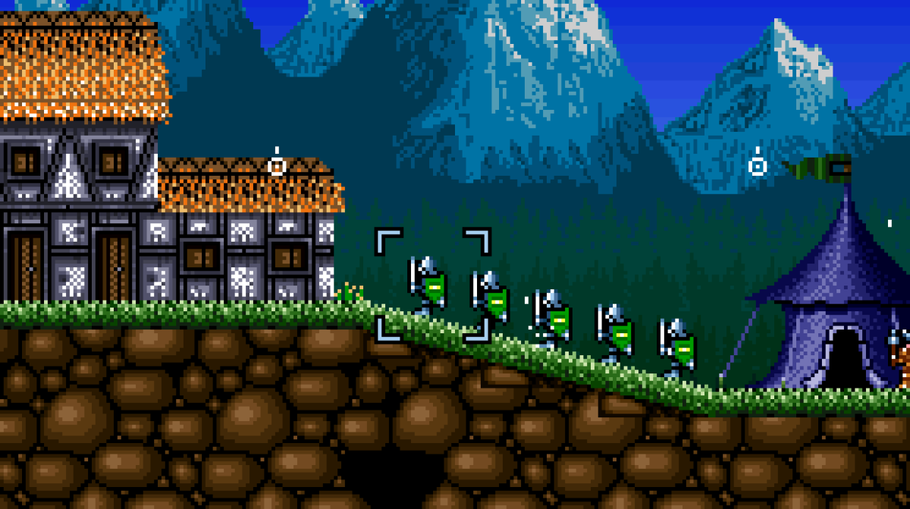

Example of how the Combat/Colony scenario looks. (screen from King Arthur’s World, Super Nintendo)

### Target Platform(s)

* WebGL
* iPad 6 (Note: the game will be using a framework that’s been made with previous Legends of Learning games, which has been proven to work well with this platform)

# Game Flow

## Overworld

### Summary

#### Timeline

* Displays title and short description of an event.
* Date change along a line with icons for special events.
* Travel between location (hotspots), when applicable.
* Hotspot icons indicating events/game mode: Colony, Combat, Scenario.

#### Scenario

* These can be a simple description, and a screen of an event when the player arrives at a hotspot.
* Certain events can also have a multiple choice for the player to choose on how to handle a scenario. Once a selection is made, the game will display a result with specific consequences for the colony. Examples:
  + Additional/subtraction of population
  + Boost morale
  + Addition/subtraction of soldiers
  + Addition/subtraction of food/supplies/products
* A hint dialog can be added here for how the scenario would be handled by important figures around that time.

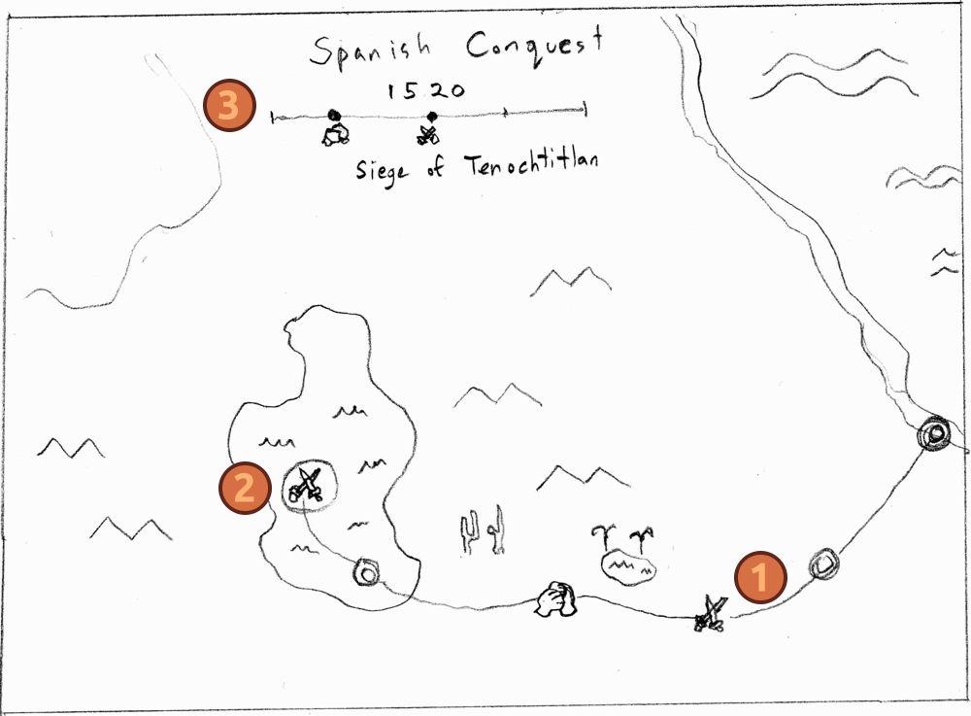

| 1 – Journey guideline: hotspots with their corresponding icon, trail between hotspots. | 2 – Current event. Indicates the current location of the player, highlighted. |
| --- | --- |
| 3 – Timeline information: Title of the entire scenario, date, line with milestone corresponding to the hotspot, title of the current event. |  |

### Mechanics

* For the most part, the timeline simply gives context to the game when entering combat or colony sim.
* Player can interact during scenarios for picking an action much like a multiple-choice question.

### Losing Gameplay / Incorrect Concept Understanding

* Bad consequences based on a choice during scenarios.
* Could also point out what historical figures actually did during those scenarios (alongside the hint system)

## Colony Sim

### Summary

* Depending on the timeline event, the intro can either be: colonials moving towards a spot with wagons, or already established area with pre-built structures.
* As time moves forward, day changes to night and vice-versa. Weather changes, influencing crops. Time moves much like during the Overworld.
* There are multiple cycles within a timeframe (can be adjusted based on scenario, gameplay tweaks). Each cycle will add/subtract from player’s attributes:
  + Population
  + Food
  + Morale
  + Product
* These attributes are all calculated based on allocation of professions, structures, productions.
* Tribes in the map will also have their own colony attributes like the player’s. They will also have an attitude towards the player. The attitude can change based on player action or trade.
* There is a toolbar at the bottom of the screen for the player to interact with:
  + Population
  + Structure
  + Product
  + Trade
* Population: The player can see an overview of the population and professions based on structures built:
  + Builders – these are fixed amount for the colony that gathers materials for building structures.
  + Farmer/Forager – will produce food, these can be made different based on location (or hotspots in the land).
  + Hunter/Trapper – hunts animals around the area.
  + Lumberjack – produce lumber.
  + Blacksmith – produce tools, weapons. These simply boosts other profession’s output.
  + Priest – helps with morale, also with attitudes from other tribes, depending on scenario.
  + Doctor – also helps with morale, and possibly sickness.
  + Guard – guard against bandits, etc.
  + Other – some scenarios will have special professions given to the player. E.g. Powhatans during the England scenario for hunting, foraging.
* Structure: The player can place buildings in the colony’s allotted space. They allow professions to be filled. Each profession requires X amount of population (can be tweaked).
  + House – allow population growth/sustainability.
  + Farm – player can also select what it should produce, also for food.
  + Hunting ground – designated spot for wild game for hunters and trappers.
  + Forge – for blacksmiths.
  + Medic tent – for doctors.
  + Church – for priests.
  + Barracks – for guards.
  + Inn/Tavern – boost morale.
* Product: Lists products the player is producing, also determines how much gets added for the next cycle.
* Trade: Trading with other tribes, import/export from Europe depending on scenario (will arrive after X number of cycles).
* The objective can vary based on the scenario given from the Overworld mode.

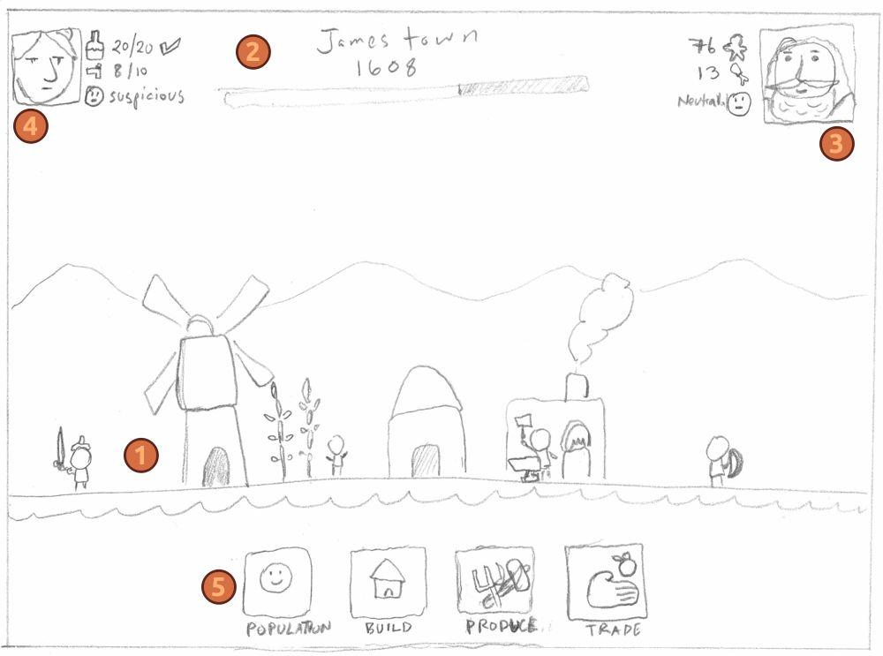

| 1 – Main view. Shows activities of professions and the land. An icon will display for certain POI. Clicking on that will center the screen towards that spot. Other displays are: day/night cycle, weather. | 2 – Timeline. Displays the location/town’s name, date, and progress bar for the entire timeframe. Can also display cycle, weather, etc. if necessary. |
| --- | --- |
| 3 – Portrait of the leader for the colony, as well as important attributes integral to the colony: population, food, morale. | 4 – Contextual objective. Can display certain things needed such as: products, trust. |
| 5 – Player toolbar. These are the tools described from the summary. A modal associated with the tool is displayed upon clicking the button. |  |

### Mechanics

* The player will mainly interact with the toolbar at the bottom of the screen. A modal will pop-up upon pressing a tool button. Interactions will follow standard UI.
* The player can scroll through the land by dragging the screen.
* The player can click on a POI icon to center the screen to a certain location in the game. This can show up depending on the timeline scenario.

### Losing Gameplay / Incorrect Concept Understanding

* The player will lose if the population drops to a certain threshold.
* The player can also lose if they fail to meet an objective after the timeframe has ended.
* The failure can teach the players on why the colonists did certain things during the same scenario.
* If possible, the game could ‘rewind’ to a specific time where the player can rectify their mistakes. Will require iteration on the gameplay to see if this is possible. If not, the game could simply move on, or just restart the whole scenario.

## Combat Sim

### Summary

* Combat is split into three rounds. The objective is to either survive all the rounds with remaining troops, have more troops than the opponent, or wipe out the opponent.
* Each round starts with troop placement. During this time, the player can allocate X number of troops in the battlefield. Troop types are represented as cards at the bottom of the screen.
* When a troop is placed on the battlefield, they are represented as a squad. Each troop type requires a certain amount of allocation from the troop population. In some scenarios, there can be more than one troop population. E.g. During the Spanish Conquest, there can be two troop population: Spaniards, Native Tribes.
* A POI can be pressed to look at the opponent’s composition. This can help the player decide how to allocate their troops.
* Once the player is satisfied with their troop arrangement, they can press the ‘Begin’ button to commence the combat.
* Combat happens automatically. The combat will play for X amount of time, then the round will end with a summary. Then the game goes to the next round, back to troop placement.
* Troop types and population can be added during the Overworld scenarios. E.g. Other Spaniards/Natives captured, allies joining during the Spanish Conquest scenario.

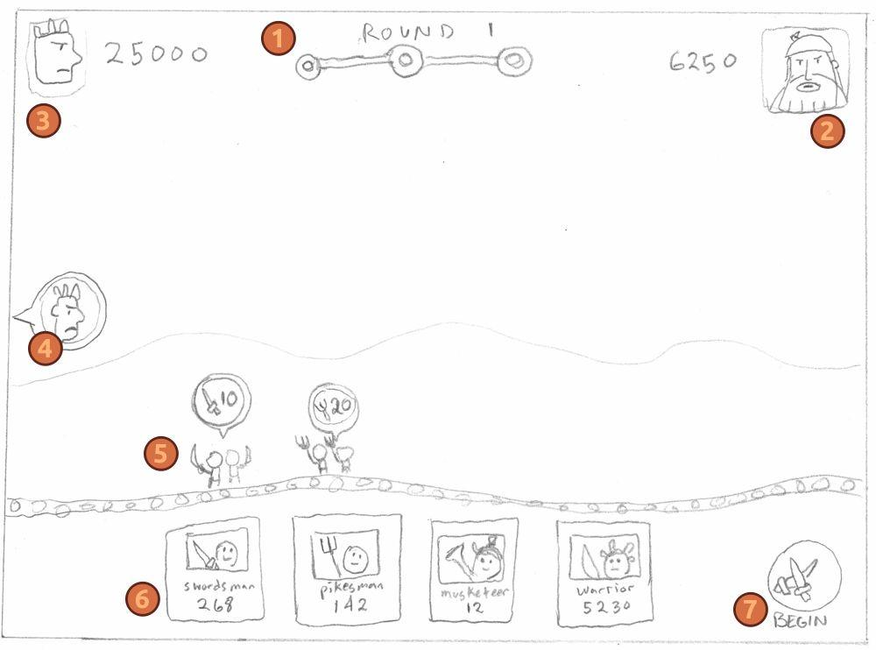

| 1 – Rounds display. Also show the title of the battle. The progress bar is displayed here during action mode. | 2 – Player’s portrait and troop population. Can display more than one troop population (e.g. native allies) |
| --- | --- |
| 3 – Opponent’s portrait and troop population. | 4 – POI. Clicking on this will move the view to the opponent’s troop composition. Similarly, the player’s POI will move the view back. |
| 5 – Battlefield. Player drags troop types to position here. | 6 – Troop type cards. Displays their allocation requirement. |
| 7 – Clicking on this button will commence the combat. |  |

### Mechanics

* Player uses mouse to drag troop type cards to the battlefield to allocate them. This is grayed out if they don’t have enough troop population. Clicking on them can display a modal describing their role in the battlefield.
* Player can drag the view of the battlefield to scroll the screen. Clicking on the POI will move the view towards the opponent, and vice-versa with the player.
* Player can modify the position of the troops by dragging the squad icon. Dragging the squad icon towards the troop type cards area will delete the troop.
* The cards, Begin button will disappear when the battle commences.

### Losing Gameplay / Incorrect Concept Understanding

* Player loses all troops population, have less than opponents after 3 rounds.
* Depending on the Overworld scenario, the player can continue to the next timeline with bad outcome instead of losing the entire scenario.
* Though if the combat is the final scenario, then the game will simply show the player the supposed outcome based on historical facts.
* Hints can be added on how historical figures strategized their attacks, or how their actions from previous timelines helped them win the entire battle. E.g. player should have recruited certain number of tribes, etc.

## Spanish Conquest of Mexico

### L.O. Concept(s) Covered

* Explain the motivations behind European exploration and colonization, including the pursuit of wealth, resources, and religious expansion.
* Compare Spanish, French, Dutch, and English approaches to colonization in the Americas.
* Explain the causes and consequences of Spain’s conquest of the Aztec and Inca Empires.
* Assess the short- and long-term effects of Spanish colonization on Indigenous societies in the Americas.

### Primary Source(s) Covered

* Letters from Mexico – Cortes, Hernan
* The Broken Spears: The Aztec Account of the Conquest of Mexico – Leon Portilla, Miguel
* Bartolomé de Las Casas – TCI

### Summary

* This scenario emphasizes Spain’s military strength over other Europeans during this era. The learning is implicit in terms of how combat/overworld scenario plays out vs. the other scenarios.
* The scenario follows Cortez’s journey from the coast all the way to Tenochtitlan.
* The scenario also emphasizes the motivation of most Spaniards looking to acquire gold/silver through conquest.
* Other scenarios can be added post conquest for a colony sim to show how the natives of Mexico shared their agricultural technology to the Spaniards.

## Quebec

### L.O. Concept(s) Covered

* Analyze how the Columbian Exchange transformed ecosystems, economies, and cultures in Europe and the Americas.
* Compare the goals and outcomes of early Spanish, French, and English colonial ventures.
* Assess how competing claims in the Americas fueled conflicts between European powers.

### Primary Source(s) Covered

* Books by Samuel de Champlain: Oeuvres de Champlain, Voyages of Samuel De Champlain

### Summary

* This scenario follows Samuel de Champlain’s founding of Quebec in Canada.
* Emphasis on trading and alliance with the natives.
* Colony mode primarily as trading. Farms as rent for French farmers.
* Harsh winter weather.
* Battle with main rival Canadian native tribe, and the Dutch colony.

## Jamestown, Virginia

### L.O. Concept(s) Covered

* Describe the establishment and hardships of the English colonies at Roanoke and Jamestown.
* Analyze the role of individuals like John Smith and Pocahontas in the survival of early English colonies.
* Interpret John White’s observations to understand early English perceptions of Native American societies.

### Primary Source(s) Covered

* A Brief and True Report of the New Found Land of Virginia – MGH
* John Smith’s writings on Pocahontas – TCI; MGH

### Summary

* This scenario follows the founding of Jamestown with John Smith.
* Emphasis on living/surviving as a colony in the wilds of Virginia.
* Special integration of natives during Colony mode.
* Combat with other natives, and the French (naturally).

# LO Concept Coverage

### Academic Concepts

| **#** | **Main Concept** | **Prominence** | **Source(s)** | **Primary Source Reference** |
| --- | --- | --- | --- | --- |
| 1 | Explain the motivations behind European exploration and colonization, including the pursuit of wealth, resources, and religious expansion. | Core | TCI (European Colonization in the Americas); MGH (A Changing World; Early Exploration) |  |
| 2 | Describe how technological advances in navigation and shipbuilding enabled European exploration. | Core | MGH (A Changing World) |  |
| 3 | Compare Spanish, French, Dutch, and English approaches to colonization in the Americas. | Core | TCI (European Colonization in the Americas); MGH (Competing for Colonies) |  |
| 4 | Analyze how the Columbian Exchange transformed ecosystems, economies, and cultures in Europe and the Americas. | Core | TCI (European Colonization in the Americas) |  |
| 5 | Evaluate the role of religion—both Catholic and Protestant—in motivating and justifying European colonization. | Core | TCI; MGH (Competing for Colonies) | Marie Guyard letter – MGH (Competing for Colonies) |
| 6 | Explain the causes and consequences of Spain’s conquest of the Aztec and Inca Empires. | Core | MGH (Spain in America) |  |
| 7 | Assess the short- and long-term effects of Spanish colonization on Indigenous societies in the Americas. | Core | TCI; MGH (Spain in America) | Bartolomé de Las Casas – TCI |
| 8 | Describe the establishment and hardships of the English colonies at Roanoke and Jamestown. | Core | TCI; MGH (Roanoke and Jamestown) |  |
| 9 | Analyze the role of individuals like John Smith and Pocahontas in the survival of early English colonies. | Core | TCI; MGH (Roanoke and Jamestown) | John Smith’s writings on Pocahontas – TCI; MGH (Roanoke and Jamestown) |
| 10 | Compare the goals and outcomes of early Spanish, French, and English colonial ventures. | Core | TCI; MGH (Spain in America; Competing for Colonies) |  |
| 11 | Interpret John White’s observations to understand early English perceptions of Native American societies. | Peripheral | MGH (Roanoke and Jamestown) | A Briefe and True Report of the New Found Land of Virginia – MGH |
| 12 | Assess how competing claims in the Americas fueled conflicts between European powers. | Peripheral | MGH (Competing for Colonies) |  |
| 13 | Identify key explorers and explain their impact on the European understanding of the Americas. | Peripheral | MGH (Early Exploration; Competing for Colonies) |  |
| 14 | Evaluate the accuracy and tone of Columbus’s descriptions of the Americas and Indigenous peoples. | Peripheral | TCI (European Colonization in the Americas) | The Log of Christopher Columbus – TCI |
| 15 | Compare how Las Casas and Columbus portrayed Native peoples and justify the differences in their perspectives. | Peripheral | TCI (European Colonization in the Americas) | Las Casas and Columbus logs – TCI |

# Legends of Learning Required Content Practices

### Checklist Overview

[Google Doc Reference](https://docs.google.com/document/d/10yED8ZwFXOWjwvroqZxaHn1A6utMDncaFwmyc8dqc-g/edit?usp=sharing)

| **ITEM** | **COVERED** |
| --- | --- |
| “Scenario choices”: For historical games, make sure students are put into scenarios and are given choices to see cause and affect relationships.  Understand the impact that historical decisions made on the US. |  |
| Focus on *ideas* of the past rather than just rote memorization of dates. Keep things factual, but open to perception. |  |
| *Avoid* instruction that could make students feel responsibility or guilt for historical events based on their race. Don’t frame certain people or races as inherently “bad”, rather the focus should just be on the factual events and the impact on those affected. |  |
| Gameplay includes reference to and examination of primary source(s) that are tied to the LO. Application of knowledge gained from primary source(s) aids in students’ progression through the game. |  |
| Players should learn and be held accountable through gameplay-based problem solving and experience. Players should not be learning primarily through text-based instruction or assessment items. |  |
| Game does not include multiple choice assessment items. |  |
| All instruction is academically correct. |  |
| Confirm that the game is linked to 2/3 or 5 main concepts of the total, whichever is greater. Confirm that the linked main concepts are correctly covered in the game. |  |
| All on-screen words spelled correctly and grammatically correct. |  |
| Vocabulary and reading level appropriate for the lowest grade level within the target audience and grade band. |  |
| Game does not include material that is inappropriate for school. This includes, but is not limited to: violence, firearms, bombs, knives, daggers, blood, gore, smoking, vaping, drug use, any mind-altering substances, alcohol, harm to human-looking characters, harm to animals, insinuating killing or death, ideally they’re always chased away rather than eliminated. If there is conflict with an enemy in game, they are chased away rather than eliminated or killed. (There can be death if it is in the context of the learning objective – ex. The food chain) If you have any questions about this policy and your game, please ask us. |  |
| Game avoids any stereotypic presentation of gender, race, region, or culture. |  |
| Characters are diverse in gender, race, culture, and ability. |  |
| Players cannot simply click through and complete the game without learning. Players should be prompted to re-learn and re-do portions of the game where they had poor results due to less understanding of the academic material. Avoid the word “FAIL” if the student incorrectly understands academic material. |  |
| Academic problems are not consistently repeated. Players are presented with different problems to solve. |  |
| Gameplay mechanic reinforces the academic material, rather than being completely separate from instruction. I.e, there is a focus on academic reasoning rather than concept / question repetition. |  |
| Gameplay is intuitive and a player in the target age range can navigate the game and beat it with enough effort. |  |
| Games should be fun and interesting, designed as non-educational games are designed, with design to encourage players to keep playing. |  |
| Game is no longer than 25 minutes in duration. Better if no longer than 20 minutes. |  |
| All text must be large, clear and concise with font sizes that can be read on a small Chromebook screen. |  |

### Connection Between Gameplay and Learning

* The Overview mode helps to contextualize and briefly learn historical events when the player enters Combat or Colony mode.
* Overview scenarios help player articulate why certain historical figures did what they did at the time.
* Combat scenarios teach players implicitly the difference between the three nations: Spanish, France, England. As well as teach the military technology/strategy at the time.
* Colony scenarios teach players implicitly/explicitly how the colonists lived in the Americas for the first time. Also, why certain actions were made (to the best of the game’s abilities).
* Colony scenarios also teach players the difference in how each nation viewed America and its native occupants.

### Role of Text in Learning

* Most of the texts are delivered through the Overview mode with scenarios, as well as instructions on how to play the game.
* Other texts are used as descriptions of technology used during that time period both during combat and colonization.

### Characters - Diversity

* Various European nationalities are present: Spanish, English, French.
* Native Americans are presented as tribes.
* Various Aztec tribes.
* Male and Female roles during the time period. Female prominent figures are present such as: Pocahontas, La Malinche.

# Technical

### Development Hardware/Software

* All development will be done in Windows 10.
* iPad 6 for tablet testing.
* Browsers: Firefox, Edge, Chrome, and Safari (via iPad 6)
* Game Engine: Unity 2022.3

### Asset Summary

* Earth map – possibly use asset from previous game with additional topography.
* Resolution will be done from a lower one than the requirement, and scaled up with a “CRT” effect. Will iterate and see if this looks/works well.
* Primarily using pixel art to speed up asset development.

### Music and Sounds

* Will be using public domain music such as Dova-Syndrome and Kevin Macleod.