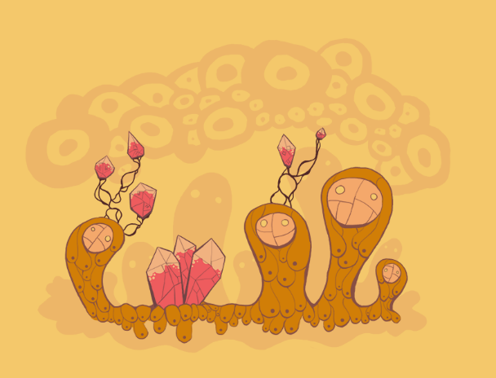
(TODO: cave concept, made of rubies)

Color Theme
Ruby red, burgundy, sand/mud, beige, wood.

Background Assets
All background assets will be grayscale, maximum four shades. This helps with adjusting the color combinations when constructing the level.
Maximum width and height for each asset: 512.
Naming convention: bkgrnd_earth_<type>_<num>.png

Music
Desert, feeling of distance, vastness.

Game Flow
A fairly open space. Using rubies as sort of landmarks. Plenty of caves and mud huts.
- Flying enemies, giant sandworm? (maybe indestructible or becomes the boss once you enter the boss area), insects.
- Safe zones, or just use caves and mud huts.
- Desert storm – player must go into a safe zone or be warped by the desert (random cave or random location in the scene)…or just downright kills the player.
- Small tornadoes?
- Destructible rubies (perhaps can only be destroyed by earth element, so player can go back to the level for extra treasures).
- Ruby stalactites, stalagmites. Conventional spike, and dropping from ceiling.

