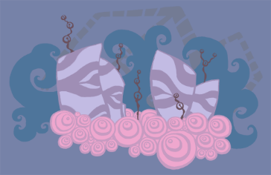
(TODO: cave concept)

Color Theme
Sea blue, flesh, rust.

Background Assets
All background assets will be grayscale, maximum four shades. This helps with adjusting the color combinations when constructing the level.
Maximum width and height for each asset: 512.
Naming convention: bkgrnd_water_<type>_<num>.png

Music
Underwater theme. Should be upbeat.

Game Flow
Islands and water caves. As far as game pacing goes, I imagine this scene to be more upbeat and positive (After the more heavy theme of fire and earth). Fairly relaxing...unless you go deeper underwater.
- Fishes, urchins, jellyfishes, electric eel.
- Water
- Whirlpool?
- Direction field – pushes the player to a given direction.

