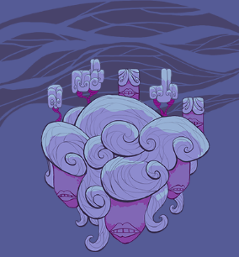
(TODO: cave concept)

Color Theme
Purple, blue.

Background Assets
All background assets will be grayscale, maximum four shades. This helps with adjusting the color combinations when constructing the level.
Maximum width and height for each asset: 512.
Naming convention: bkgrnd_wind_<type>_<num>.png

Music
Alien tune. Wind instruments and/or strings like violin or guitar.

Game Flow
Valleys and jumping. Maybe some speedy escapades (like in Sonic)
- Flying enemies, agile/jumpy opponents. Hard to hit with earth boulders.
- Gravity switching?
- Wind tunnels.

