TEAM
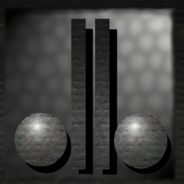

David Dionisio

Present:
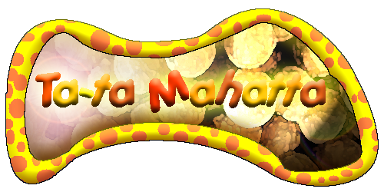

GAM 400
Game Design Document. 1.0v.

Table of Contents.

- High Concept……………………………………………………………………….……..3
- Background………………………………………………………………………………..3
Story………………………………………………………………………………3
- Game Play…………………………………………………………………………………3
  - Single Mode………………………………………………………………………3
  - Networking……………………………………………………………………….4
  - Game Flow………………………………………………………………………..4
  - Input Design………………………………………………………………………5
  - Player Design…………………………………………………………………….5
  - Enemy Design……………………………………………………………………8
  - Game Play Elements……………………………………………………………..9
  - In-game Options…………………………………………………………………9
  - Level Design…………………………………………………………………….11

- User Interface…………………………………………………………………………….11
  - User Flow………………………………………………………………………..15
  - Start Menu……………………………………………………………………….15
  - In-game Menu………………………………………………………..………….16
  - Inventory………………………………………………………………………...16
  - GUI……………………………………………………………………………...17

- Art………………………………………………………………………………………..18
  - Format and Style ………………………………………………………………. 18
  - Art List ………………………………………………………………………….19

- Sound…………………………………………………………………………………….25
  - Format and Style …… ………………………………………………………….25
  - Sound List ………………………………………………………………………26
c) Music…………………………………………………………………………….28

- Technology………………………………………………………………………………30
  - Tools…………………………………………………………………………….30
  - Engines………………………………………………………………………….31
  - Installer………………………………………………………………………….32

- Marketing………………………………………………………………………………...34
  - Target Market Summary………………………………………………………...34
  - Competitor Analysis ……………………………………………………………35
  - Legal Analysis…………………………………………………………………..36
  - Packaging………………………………………………………………………..36

- Schedule………………………………………………………………………………….37

- Risks……………………………………………………………………………………...38
  - Production Risks………………………………………………………………...38
  - Distribution Risks……………………………………………………………….38

- Team Information………………………………………………………………………..39

1 High Concept
  - High Concept - Help the peace loving Ta-tas overcome the fungi invasion from another dimension; in this third-person adventure puzzle game.

  - Key Features –
    - A unique 3D game-play experience.
    - Challenging and rewarding game exploration
    - 10 unique characters to help you on your quest
    - Cute and Involving story, characters, and game environment
    - A great mixture of super fun action and puzzle solving

  - Platform and Minimum Requirements –
WIN NT 4.0 or later.
Windows 98 or later.
DirectX 8.1 required.
~128 mb RAM, and ~400 mhz.

  - Target Market –
The game is designed for an ESRB rating of “E” : Everyone.

  - Production Estimates
Estimated Retail Price - 39.99
Estimated Development Cost – ~$20,000
Estimated Schedule –
This game is designed for a single semester project, and is estimated to require 4 months of work.

  - Technology –
“Ta-ta Mahatta” will be a 3D game, using Direct X 8.1. The game will also use a third party sound engine known as BASS.

2 Background
Story
In a distant land, far away, lived a peaceful race of cute, industrious little fur balls called “Ta-tas”. Everything was going well for the ta-tas until one day a portal opened and the evil Mushroominoid with his fungi army started taking over the ta-ta land, and turning all the cute furry ta-tas into slaves. All was looking grim, until one day a wise-one told the legend of the white-hero who would have the power to save them. A small group of the most courageous ta-tas decided to set out in the search of the legendary white ta-ta. Using the wise-one’s magical powers and their own wit and bravery, 3 ta-tas escape the evil clutches of mushrooms and escape on a cloud. Using the cloud as the base, the ta-tas begin their journey of search for the white ta-ta.

3 Game Play
a) Single Mode –
In the single mode, the player will be the brains behind the “ta-ta”s attempt to find the white ta-ta. The player will start off on the cloud. The cloud is where the player can choose to play a level or hang around and do interesting activities.

Interesting activities in the cloud includes being able to view the collection of artifacts the player has found throughout the game. These are just for viewing pleasure. The player can also talk to the Wise-Ta who will give special advice in the game. The player can also play unlocked mini-games in ‘Ta-Vern’ located within the cloud.

The player can choose to play a level by entering the mysterious ‘Level Select’ house. Once inside the house, the player can select any unlocked level to play. A level can only be unlocked by finishing the previous level.

Each level will start the player off with one up to four Ta-Tas. The level will start with a description pertaining anything to do with the level and the goal. Each level will have a number of goals required to accomplish in order to acquire victory. Once all the goals are met, the player is then returned to the cloud level with a new level unlocked. If all levels are completed, then the ending scene will be displayed.

Some of the levels will contain artifacts that the player can optionally collect. The collected artifact will be brought back to the cloud level once the level is complete. Some of the artifacts can unlock certain activities inside the cloud level, such as mini-games.

The player loses the level when all Ta-Tas die. The player can then choose to restart the level or return to the cloud level.

- Networking –
In the multi-player mode, up to 4 friends can form a team of ta-ta’s and try to conquer the game’s levels in a cooperative mode, where each player will control 1-2 ta-ta’s. The teams efforts will focus on the single player mode of the game that is why the multi-player mode was chosen to be simple in complexity.

- Game Flow –
The game is designed with the following schedule of pacing: The player starts in the cloud level. The player plays a level by entering the ‘level select’ house. The player plays any unlocked levels. Once the player finishes an unlocked level, a new level is unlocked. Once all the levels are done, the ending scene will be played.

- Input Design –
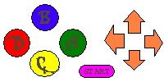
Direction Pad – Used for ta-ta movement as well as Free-Look.
START – Pause Game, Options.
A – OK, Use Ability.
B – NO, Hold for Free-Look using Direction pad
C – Switch Ta-ta Forward in List.
D – Switch Ta-ta, Back in List.

- Player Design
“Ta-ta Mahatta” allows the player control of a variety of “ta-ta”s, and there are 11 total different ta-tas in the game.

NAME – #1 Captain Ta-ta 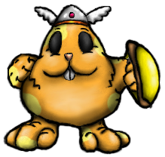
Ability – Defend
Description – This sturdy ta-ta is the leader of the ta-ta’s and has the very important ability of defending against projectile attacks such as mushroom spit.
NAME – #2 Ta-ta Tug 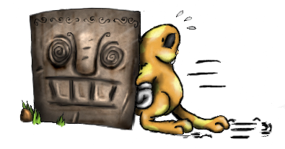
Ability – Push
Description – This diligent ta-ta has the strength to push blocks, as well as some other objects, such as frozen enemies.
NAME – #3 Tinker-Ta 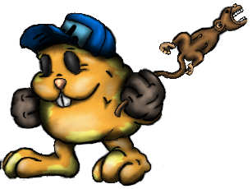
Ability – Mechanic
Description – This smart ta-ta can operate complex machinery, such as levers.
NAME – #4 Ta-Ta-Trample 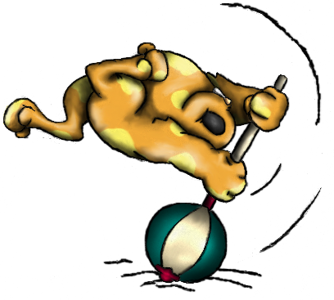
Ability – Attack
Description – This aggressive little ta is the only one brave enough to actually stand up against the mushrooms. His important attacking skill can break blocks or hurt enemy mushrooms.
NAME – #5 Hop-Ta-Hop 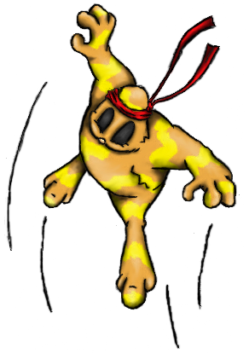
Ability – Jumper
Description – This spunky ta can jump to heights only he can reach.

NAME – #6 Frost-Ta 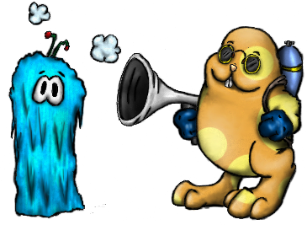
Ability – Freeze
Description – This capable ta can freeze enemy mushrooms and permanently paralyze them as well as make them push able.
NAME – #7 Para-ta-ta 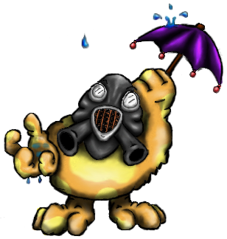
Ability – Glide, Immune to Poison Mist
Description – This advanced unit can glide through air, and is immune to poison in mist covered areas.
NAME – #8 Loop-Ta-Loop 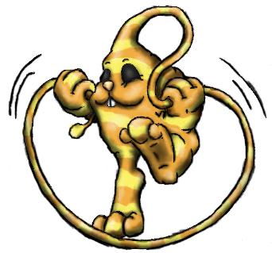
Ability – Whipper
Description – This witty ta can use his whippy head scruff to grab on to stakes and stumps and pull him self to new locations.
NAME – #9 Key-key-ta 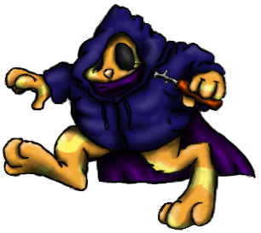
Ability – Thief
Description – This slick little ta can open up doors that are locked.
NAME – #10 Chi-Ta 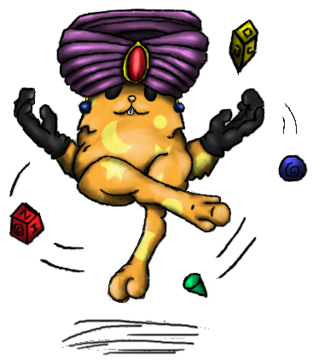
Ability – Psychic
Description – This amazing ta can levitate himself and pull objects, items and creatures to him self from any distance.
NAME – #11 Ta-Vatar 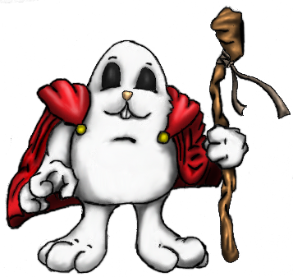
Ability – Temporata
Description – This legendary ta can warp time and space to close portals.

- Enemy Design
“Ta-ta Mahatta” Has a total of 4 puzzle based enemies as well as 3 boss enemies. Each regular enemy can be removed by either an attack tata, a freeze tata, or an enemy can be pushed or pulled off the edge of the map. Boss fungi will have possibly 3-5 hit points which can be deducted by carefully manipulating object and character puzzle each boss contains.

Standard Enemies

Funga-Bark.
This small vicious fungus is although unable to move, is still dangerous due to his sharp fangs.

Funga-Spy
This scary looking fungi maintains a careful look out for any passing ta-ta’s and then attacks them with his underground tentacles.

Shroom-Guard
This mushroom soldier patrols an area charging and attacking any ta-ta he sees.

Shroom-Shooter
This mushroom stump shoots out projectiles that hurt any ta-ta that it touches, but can be blocked by a defender.

Bosses.

Forest Stage – Shroom-Pa
Mountain Stage – Catter-Shroomer.
Swamp Stage – Evil Mushroominoid.

- Game Play Elements
Each level in the game will require a certain type of goal to be accomplished.

Gather ta-tas – you must get all your ta-tas to a certain spot in the level to achieve victory.

Gather Resources/Crates – get all resources/crates to a certain spot in the level to achieve victory.

Rescue Baby Ta-Tas – you must rescue these ta-tas from the clutches of Fungi and return them to a nearby shelter unscathed. Each ta-ta can only carry one baby ta-ta.

Defeat Boss – you must defeat the boss in the level to achieve victory.

There are a number of objects in the game that will be either item to be collected or acted upon to solve the puzzles.

Baby Ta-Ta – these little ta-tas are lost and must be returned to a nearby shelter. This is used in one of the goal types in the game.

Artifacts – Once collected, an artifact will be returned to the cloud level once the level is complete. Certain artifacts unlock interactions in the cloud level.

Button – A button that can be stepped on by a ta-ta to cause an effect.

Hard Button – A button that requires a block or a frozen enemy to be pushed

Lever – A mechanical lever that controls a certain object in the level.

Locked Doors – These tightly shut doors can only be opened by a thief ta-ta.

Stump/Steak – These objects can be grappled on by the Whip using ta-ta and jumped to.

Heavy Block – A block that can not be pushed and can only be broken.

Block – A block that can be pushed or broken. These can also be part of the goal in the level, whereas you must push them to the goal area.

Teleport – These transports any matter instantly to another location.

Goal – The goal area is where you must gather what is required to accomplish the level.

Signs – A small sign, tipping the player with next possible move.

- In-game Options.
There are 2 types of in-game options that will be given to the user. The standard pause menu will be covered in detail in the section 4) User Interface.
The second type of configuration scenario will be presented to the user in the form of an intermediary stage. This stage takes place on a cloud and has the following options for the user to explore.

Choose Level – Select the next level of entrance through a small world map.

Talk to Wise Ta – gives you hint and tips about anything pertaining to the game.

View Artifacts – view all the collected artifacts found throughout the game.

Play Mini-games – play any unlocked mini-games.

- Level Design
There is one tutorial stage with 5 levels and 5 stages each with 3 levels.

Tutorial Stage – this stage contains 5 levels that will show the player the feel of the game. Each level will guide the player through the obstacles, showing how to proceed.

Forest Stage – the forest stage will contain 2 levels and a final boss level.

Ice Stage – the ice stage will contain 3 levels.

Mountain Stage – the mountain stage will contain 2 levels and a final boss level.

Mushroom Stage - the mushroom stage will contain 3 levels.

Swamp Stage - the swamp stage will contain 2 levels and the final boss of the entire game. The ending scene will start once the final boss is defeated.

4 User Interface
- User Flow –
Intro Scene

Main Menu
New
Load
Options
Exit
Enter Name
Cloud Level

Choose File

Game Level

End Scene

- Start Menu –
The initial menu that will be provided for the user is outlined as follows:

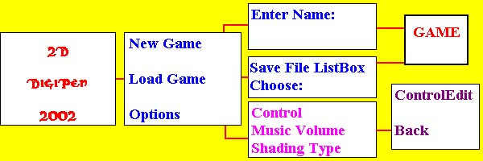
Project Introduction Screen

Main Menu –
Contain 3 animated buttons that link to next screens.

Enter Name –
Screen containing a title and input box for game file name.

Load Game –
Screen containing a title and a list box with all gam.sav files found.

Options Screen –
Screen containing a title, link to control edit screen, music volume bar, and a check box for a types of shading(2 types).

Control Edit room – This screen contains a title and a list of 9 keys with small edit boxes. 3 Keys for “Reset” and “Save”, as well as “Back” will also be present.

- In-game Menu
The player will be able to access an option screen by pausing the game. The following options will be available to the user.

Return to Cloud – This option takes the player back to the main option stage.

Options – This option screen will present the user with the similar options given at the game entrance.

Un-pause – Return to the current game.

- Inventory
The game will not have a standard inventory that can be manipulated by the player through out the game. How ever the eggs found, and also love and care points will be stored on to the player.
Eggs – Up to 8 eggs can be held or found at any time.
Love/Care – The game contains around 350 of these items total.

- GUI –
In “Ta-ta Mahatta” the player will primarily interface with the 3D world of ta-ta’s and spend little time navigating graphic tool bars. For this reason the intermediary level of “The Cloud” was established.

There will be a graphic of current item count and item icon and it will be temporary displayed each time a player picks up an item, the graphics will display amount of Eggs, Love points, and Care points the player has so far. There will also be 4 portraits of your team, and the currently selected ta-ta, as well as the hurting ta-ta will be outlined in special color.

Most Interactions between the environment and user will be in the form of using the action button or navigating a player onto a vital map position, such as a button.

Exceptions to this only occur on the cloud level where the player will encounter 2 in game menus that will redirect the control from controlling the ta-ta to navigating a menu. These menus are outlined as follows:
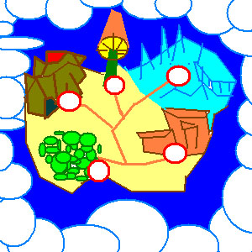
World Map. Choose the next level to visit.
The action button at the right location will prompt this menu, releasing the button will end the menu.
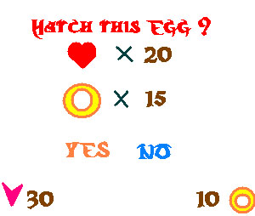
Egg Hatching. Hatch an Egg.
The action button used in front of an egg in the hatchery will bring up this menu.

5 2D and 3D Art Requirements

Format:

Menu/Textures – all menus/textures in the game will consist of 2D art generated by any graphical editors. The ideal format for these images will be JPEG, as this will reduce the disk space required for the game. Although JPEG does not have support for alpha channels, the image will then use TGA image format. All images must have a size of 2^n by 2^n (n > 0), this is a limitation in the graphics engine.

Models – the graphics engine of the game will support a format used by a model editor called ‘Milkshape 3D'. Models can be done in 3DS Max as well and can be imported to Milkshape 3D for the game to use. However, all animations will be done in Milkshape 3D. All model textures will have the limit size of 256x256.

Levels – the levels will be made by a map editor called QUARK and will be compiled to a different format that the game uses. QUARK is a freeware level editor.

Sky Box – each level will have a skybox. For the skybox, we will simply require a texture for each side of the box: top, bottom, left, right, front and back.

Style:

The game will have a cartoony feel to it. As such, the models will be simple and yet compelling. Textures will have various colors to it and must stay far away from the human perspective of ‘reality’. This task can be both easy and daunting at the same time. We must then require that the artist team to be creative and highly imaginative.

Art List

Menus/GUI:

We will need background arts for:

Intro screen, Main Menu, New game, Load and Options

We will only need 3 animated images for the buttons: new game, load game and options.

Models:

a) Miscellaneous:

Ice block – this model is used when a monster is frozen.

Level Doodads – doodads will be placed throughout the levels. These are simply just for viewing pleasure.

b) 3D Menu interaction inside the cloud ship:

Save statue – a Ta-Ta idol statue. Kind of like a totem.
World Btn. – just a button.

c) The ‘Ta-Tas’:

Here are the animation lists of each ‘Ta-Ta’ model that the game will use:

Captain Ta-Ta:

Idle 1 – generic Ta-Ta standing pose.
Idle 2 – remove helmet with left hand. Wipe out sweat on forehead with right hand.
Idle 3 – put the shield on the ground and exercise the right arm.
Walk – generic Ta-Ta hop, with shield
Back Walk – generic Ta-Ta back walk.
Ouch – generic Ta-Ta ouch.
Death – drop on the ground with face up. The shield will spin slowly and eventually drop on the face.
Victory – throws the shield up in the air, spinning and catches it.
Block – puts the shield in front.

Tinker-Ta:

Idle 1 – generic Ta-Ta standing pose.
Idle 2 – grabs the hat with left hand and tosses it on the air. The hat will spin on air and land on the head.
Idle 3 – pat the left hand with the monkey wrench three times.
Walk – generic Ta-Ta walk.
Back Walk – generic Ta-Ta back walk.
Ouch – generic Ta-Ta ouch.
Death – drop on the ground with face up. The hat will fall down slowly like a feather and lands on the belly.
Victory – jumps and throws the hat on the air and catches it.
Use – pokes monkey wrench in front.

Ta-Ta Tug:

Idle 1 – generic Ta-Ta standing pose.
Idle 2 – sits on ground, carefree style. Stands back up after a while.
Idle 3 – performs a mime act. (Invisible wall)
Walk – generic Ta-Ta walk.
Back Walk – generic Ta-Ta back walk.
Ouch – generic Ta-Ta ouch.
Death – lifts one foot up, spins 360 degree and drop dead. (Cartoon death style)
Victory – shakes hands together above head left to right.
Push – puts both hand in front and walks in a pushing manner.

Ta-Ta Trample:

Idle 1 – generic Ta-Ta standing pose.
Idle 2 – sticks big hammer on ground and lean on it.
Idle 3 – tries to balance big hammer with nose but fails. The hammer will be picked up after dropping from the head.
Walk – walking while dragging the hammer behind with great effort.
Back Walk – generic Ta-Ta back walk.
Ouch – generic Ta-Ta ouch.
Death – drop on the ground with face up. Gets up and drops back dead after the hammer falls on the head.
Victory – grabs hammer with both hands above the head. Jumps up and down.
Attack – lifts hammer and bludgeons whatever is in front.

Hop-Ta-Hop:

Idle 1 – warm up jump exercise, like what athletics do.
Idle 2 – does the praying mantis karate pose.
Idle 3 – taps ground with left foot 3 times, then with right foot.
Walk – generic Ta-Ta hop.
Back Walk – generic Ta-Ta back walk.
Ouch – generic Ta-Ta ouch.
Death – drops dead on the ground with both feet up, both feet stutters for a few seconds.
Jump – forward flip (360 degree). The game physics will take care of the arc movement from one spot to another.

Frost-Ta:

Idle 1 – generic Ta-Ta standing pose.
Idle 2 – checks gun condition (polishing…etc)
Idle 3 – throws gun upwards and catches it (with style)
Walk – generic Ta-Ta walk. (Backpack shaking behind)
Back Walk – generic Ta-Ta back walk.
Ouch – generic Ta-Ta ouch.
Death – falls flat on the ground face down.
Attack – thrusts the gun forward. Freezing gas comes out with the use of the graphics engine particle FX.

Loop-Ta-Loop:

Idle 1 – generic Ta-Ta standing pose. Whip moving around, like a cat’s tail.
Idle 2 – plays skip with the whip.
Idle 3 – creates a cowboy hoop with the whip and swirl it around a bit.
Walk – generic Ta-Ta walk with whip moving around, like a cat’s tail.
Back Walk – generic Ta-Ta back walk.
Ouch – generic Ta-Ta ouch.
Death – falls flat on the ground face up. Whip swirls around slowly until it falls flat.
Attack – whip strikes forward. Stretching is done inside the game engine.
Grappling – whip in forward position (after last attack frame) and body facing the ground.

Para-Ta-Ta:

Idle 1 – generic Ta-Ta standing pose.
Idle 2 – swings the umbrella around.
Idle 3 – balances umbrella with left hand and catches it once it falls.
Walk – silly walk with umbrella swinging. (Charlie Chaplin style)
Back Walk – generic Ta-Ta back walk.
Ouch – generic Ta-Ta ouch.
Death – falls flat on ground face up. Umbrella opens and falls like a feather.
Glide – opens umbrella and holds it up.

Key-key-Ta:

Idle 1 – looks left and right cautiously.
Idle 2 – crosses both arm together and tap right foot impatiently.
Idle 3 – stretches both arm sideways.
Walk – walks cautiously like a ninja.
Back Walk – generic Ta-Ta back walk.
Ouch – generic Ta-Ta ouch.
Death – dies honorably…or something.
Unlock – thrusts the lockpick device forward.

Chi-Ta:

Idle 1 – floating with small miscellaneous objects moving around.
Idle 2 – Juggles the miscellaneous objects while floating.
Idle 3 – performs yoga.
Walk – floating with small miscellaneous objects moving around cross-legged.
Back Walk – generic Ta-Ta back walk.
Ouch – generic Ta-Ta ouch in mid-air.
Death – falls flat on the ground face up. Miscellaneous objects fall one by one on the belly.
Telekinesis – puts right hand in front (Like a Jedi)

Ta-Vatar:

Idle 1 – generic Ta-Ta standing pose with cape billowing sideways.
Idle 2 – attempts to fly like Super Man but fails.
Idle 3 – sits down and pray.
Walk – generic Ta-Ta walk with cape billowing.
Back Walk – generic Ta-Ta back walk.
Ouch – generic Ta-Ta ouch.
Death – dramatic cartoony death.
Attack – performs a fireball move. Particle effects are generated in a form of a fireball (Using the graphics engine particle FX).

d) The Enemies:

Here are the animation lists of each enemy model that the game will use:

Shroom-Guard:

Walk – think walking mushroom with feet and you get the idea.
Ouch – imagine beating up a life size mushroom.
Death – what a mushroom looks like after you step on it.
Attack – imagine getting slapped by a mushroom.

Funga-Bark:

Idle 1 – looks around menacingly.
Idle 2 – yawns
Idle 3 – just…Idle
Ouch – body gets push back and recovers.
Death – what a weed looks like after spraying anti-weed.
Attack – thrusts mouth forward and BITES!

Shroom-Shooter:

Idle 1 – resting plant
Ouch – wobbles around.
Death – falls flat on the ground.
Attack – thrusts mouth forward and spit.

Funga-Spy:

Idle 1 – blinks eye.
Ouch – wobbles around.
Death – falls flat on the ground.
Attack – leans a bit forward with an angry expression.

e) The Bosses:

Shroom-Pa:

Idle, Walk, Attack, Dizzy, Ouch, Death

Mushroom Warlord:

Idle, Attack, Ouch 1, Ouch 2, Death,
Catter-Shroom:

Idle, Dig, Attack, Dizzy, Ouch, Death

Fungal Tiger:

Walk, Idle, Shoot, Ouch, Death

Evil Mushroominoid:

Death.

Fonts:

Fonts in the game will use the generic type used by many applications. We will mostly use ‘Comic Sans’ as it fits perfectly to the style of the game. In some cases, static texts like found in buttons and menu titles will be image generated.

Textures:

The textures will be grouped in terms of their usage. Each group will be placed in a different texture folder. Here are the following groups:

Menu – these includes all the backgrounds and buttons for the 2D menus in the game.

Model Textures – the model texture size will be limited to 256x256. Each model will have at least one texture.

Level Textures – all textures used by the level.

Sky Box Textures – all textures for the skyboxes.

Particle FX – all particle effect textures.

6 Sound Requirements

Format:

Music/Sounds – all music and sound effects in the game will use the MP3 format. Each will be limited to 44100 kHZ 16-bit stereo.

Style:

Just like the art, the music and sound in the game will be cartoonish, as far away from ‘reality’ as possible. The music in each level should capture the mood of the landscape and scenery.

Sound List

SFX/VOX:

a) The ‘Ta-Tas’:

These are the general sound used by all ‘Ta-Ta’s:

Ouch – cute high pitch bunny ouch sound.
Death – the sound of a bunny getting choked.
Falling – a high pitch screaming bunny.

Here are the sound lists of each ‘Ta-Ta’:

Captain Ta-Ta:

Block – woosh sound on putting the shield in front.
Projectile deflects – cartoony sound when a projectile hits the shield.

Tinker-Ta:

Use – screaming monkey when the ‘monkey’ wrench is used.

Ta-Ta Tug:

Pushing – sound when pushing an object.

Ta-Ta Trample:

Attack – grunts from effort of lifting the hammer and striking whatever is in front.

Block break – the sound of breaking a rock.

Enemy/ground hit – a big solid THUD

Hop-Ta-Hop:

Jump – a ‘woosh’ sound (think karate)

Frost-Ta:

Attack – use a fire extinguisher

Freezing enemy – ice crystallizing on objects.

Loop-Ta-Loop:

Attack – sound of whip when swung.

Hit – whip *crack*

Para-Ta-Ta:

Any animation - Gas mask breathing.

Key-key-Ta:

Lock pick – using a key on a door.

Chi-Ta:

Telekinesis – super psychedelic telepathic trippin’ sound.

Ta-Vatar:

Fireball attack – shout, in a high pitch bunny like voice: “Taaaa-Taaaa-Maaahhhaaa-TAAAAA!!!”
Fireball strike – big nuclear explosion! BOOM!

b) The enemies:

Shroom-Guard:

Attack – a chiwawa growling.
Ouch – a chiwawa ‘yelping’
Death – a chiwawa ‘whimpering’…fade away

Funga-Bark:

Idle 2 – upon looking around, growls like a monster.
Ouch – monstrous * grunt *
Death - * smack * as the head falls on the ground.
Attack – * roar * and * snap *!!!

Shroom-Shooter:

Death – splat
Attack – take a long deep snort and spit.

Funga-Spy:

Death – splat
Attack – imagine a big thorn emerging from the ground.

c) The Bosses:

Shroom-Pa:

Idle
Walk
Attack
Dizzy
Ouch
Death

Mushroom Warlord:

Idle
Attack
Death

Big-Shroom:

Idle
Dig
Attack
Dizzy
Ouch
Death

Fungal Tiger:

Idle
Attack
Death

Evil Mushroominoid:

Death

d) The Level sounds:

Lever – the sound a lever makes when pulled.
Gate close – the sound produced by a metallic gate when closing. (down direction)
Gate open – the sound produced by a metallic gate when opening. (up direction)
Raising platform – the sound of rumbling ground.
Big button pushed – the sound of a twig snap.

e) Other Sounds:

Item Collection – a happy fairy dust sprinkle sound.
Egg Collection – * WHOOPIE * (high pitch bunny voice)

f) The Menu sounds:

We only need one sound for the button: * BOINK *

Music:

a) Menu Music:

Main Menu – the music for the main menu does not have to loop. The length of the music should be 2 minutes. The music will play the theme of the game. Depicting the happiness of the Ta-Ta’s and the cruel invasion of the fungi colony.

Magical Mystery Cloud – the music must loop and have the minimum time length of 30 seconds. The music will be something mystical and strange…like being in a magical mystery cloud.

b) Level Music:

All level music must loop and at least have a time length of 2 minutes.

Forest – mystical placid song mix with the ambient sounds of nature. (Think ‘Enya’ music)

Cliffs – fast rock and roll music with lots of drum beats.

Snow – cool jazz music.

Mushroom Land – acid trip music.

Purple Swamp – dark moody music slowly becoming fast heavy metal music and slowly returns to the original phase.
7 Technical Analysis

Ta-Ta Mahatta will use the technology of Microsoft DirectX 8.1. The game will have stunning visual effects with the use of Direct Graphics; superb input control with the use of Direct Input; thrilling sounds and music played with the power of Direct Sound.

Ta-Ta Mahatta will utilize a powerful scripting engine for various aspects of the game. This includes: AI, trigger events and the menu. The scripting engine will provide the developer full flexibility on level designs and tweaking gameplay. This will reduce considerable amount of time spent on the development of the game.

Tools

Map Editor:

An external map editor will create all levels in the game. These are the functionalities that will be needed for the map editor:

Creating solid landscapes and doodads.
Placing and editing entities:
Ta-Ta starting positions
Resources
Ta-Ta Eggs
Enemies
Creating triggers for levers and buttons.
Placing waypoints for enemy AI and platforms.
Placing lighting effects and ambient sounds.
Skybox editing (which textures to use for the skybox sides)

Model Editor:

A pre-existing model editor will make all the 3D objects used in the game. This includes modeling, texturing and animating of the model.

Sound Editor:

All sounds will be produced by various free editors, just give us the sounds.
Engines

Graphics:

The graphics engine will include these functionalities:

3D model display with texture and lighting.

3D model animation using skeletal animation.

Smooth camera pathing and the ability to change camera position and direction.

Level display with vertex and lightmap coloring.

2D image display and animation.

The graphics engine will also have particle effects used in various elements of the game:

3D object explosion – a bunch of non-animating 3D models exploding from an area.

Puff emission – puffs emitting from a point moving in a direction and fading away.

Gas area – gaseous particles randomly produced within a bounding area.

Sparks – explosion of particles starting from a point and fades away upon reaching the edge of the radius.

Sound:

The game will be using an external sound library produced by a different developer. The sound library is free so long as the game is also free. The name of the sound engine is BASS. Features and functionalities can be seen through this website:

http://www.un4seen.com/music/

User Interface:

The input in the game can either be a keyboard or a gamepad. There will be no mouse interface (Perhaps for debug purposes).

The menus in the game will use the script engine for most functionality. This will enable the developers to easily tweak and expand the menus should the need arise.

Installer

The game will have an auto start menu whenever the game CD is inserted. The following items will be on the menu:

Play
Install/Uninstall
Visit Website
Exit

Basically we just want a background with the buttons displayed appropriately. The buttons must also highlight when selected.

Installer Flow
Install the game?
NO
Exit

YES Display: ‘Not enough
Disk space’
Disk space sufficient?
Choose hard drive.
Enter directory.

Display available disk space.
Display required disk space.

Install Game

Detect DirectX 8.1
Install DirectX 8.1?

Yes No Already installed

Check box for:
1) Add desktop icon.
2) Add game in start menu.
Install DirectX 8.1

Run Auto start.

Uninstall Flow

Uninstall Game?

No
Exit

Yes

Uninstall the game

DONE
8 Marketing
- Target Market Summary

Currently as reported by the NPD on ConsoleWire.com
Even thought summer time is slow in consumer sales, nearly 20% of top 20 selling games were of E-T rated action adventure games. With up and coming adventure and puzzle games such as Super Mario Sunshine for GameCube© by Nintendo and PacMan2 by Namco, as well as the approaching holiday season, the public demand for a 3D adventure game featuring cute characters, is not expected to abate.

- Competitor Analysis
1) Concept Challengers.
Lost Vikings – The best interpretation of this type of collaborative sprite puzzle game. Interplay..
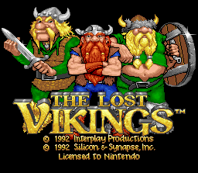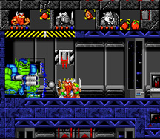
Lost Vikings 2 – The great sequel to the first masterpiece by Interplay
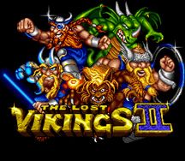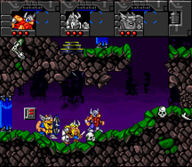
King Arthur’s World – Often missed classic that lead the player through strange and challenging worlds. Jaleco
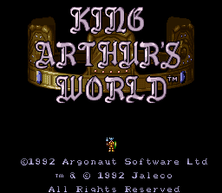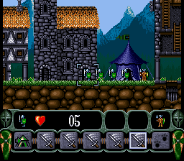

2) Current Competitors.
Lemmings 3D, PS– Latest installment in this multi-series game by Psygnosis Rated: E
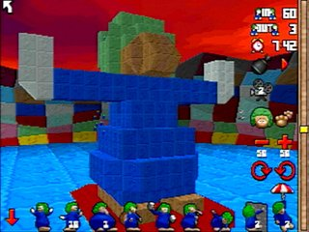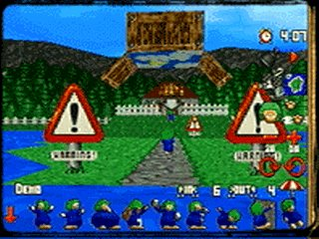
Mario Sunshine, Nintendo GameCube – A fun adventure game in a typical Nintendo trademark fashion. Rated: E
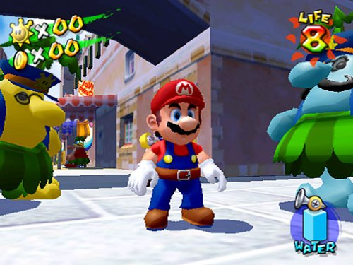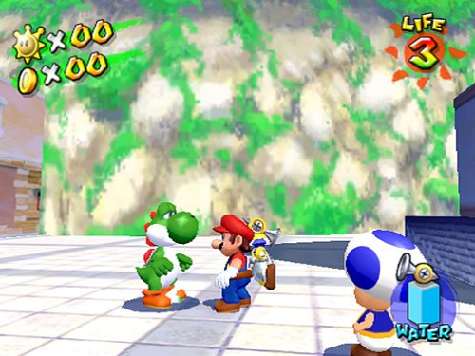
Spyro: Enter the Dragonfly, Universal PS2 – A colorful adventure with a numerous cast of characters. Rated: E
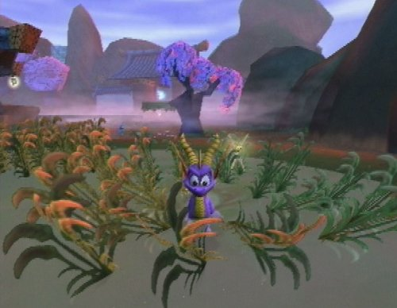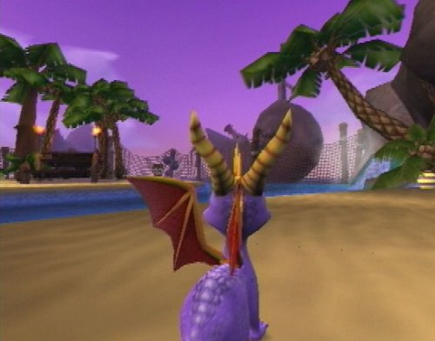

Homies – Exciting new (2003) puzzle game by Overloaded.
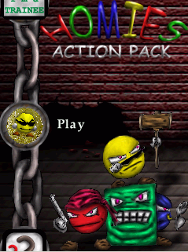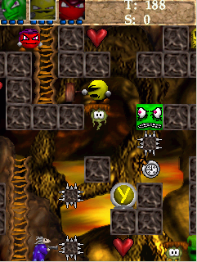
- Feature/ Price Comparison
Lemmings3D (Psygnosis) $14.95
• 3D worlds packed with features and puzzles to solve
• 100 levels
• 9 Lemmings skills
• Over 30 sampled Lemmingese last requests

Super Mario Sunshine (Nintendo GameCube) $49.99
• Encounter a collection of enemies bent on foiling Mario's efforts
• Explore 3-D world filled with expansive environments
• More mobility --jumps, wall bounce, run, slide, climb, and fly

Spyro (Sierra PS2) $49.99
• Over 25 levels, each with unique weather environments
• Avoid obstacles, jump on platforms, ride vehicles, collect gems
• All-new vehicles, including tanks, UFOs and a Spitfire
• New collectibles--thousands of gems plus over 100 dragonflies

Ta-ta Mahatta $39.99

• A unique and colorful 3D game-play experience
• 20 levels of challenging and rewarding game exploration
• 11 unique characters to help you on your quest
• Cute and Involving story, characters, and game environment

As seen above “Ta-ta Mahatta” grabs a comfortable niche with its list and quality of features and its relatively low priced compared to newly released games.
- Legal Analysis

Name - The name “Ta-ta Mahatta” was chosen by the team with out any prior intentions or thoughts. Ta-ta was thought of as a name for creature type, and Mahatta, respectively to mean “chaos”.
The name “Ta-ta” is too basic for legal consideration, however, the word “Mahatta” appears in various occations.

- It is defined as “enormity (int.) 1. mahatta; “ in Englo-Palistinean. Dictionary.
- There is a Mahatta River is located on the north end of Vancouver Island
- Roots/Sepultura contains a song named “Ratamahatta”
- A popular Arabic singer is named FAIRUZ Al Mahatta

None of the above mentioned are considered to pose any legal threat, and the Palistinean translation is even some what fitting.

- Presentation/Distribution

General Presentation Theme- The game is colorful and is supposed to be attractive for even the youngest player due to its “E” rating. Any advertisements or promotion materials should feature animated colorful pictures of the Ta-ta’s, illustrating their variety and likeability aspect, as well as include the screen shoots of the game.

Packaging- The game will be packaged in a DVD case box used to currently hold console games for new generation console systems. The box art will be as described above.

Included Material- Packaging will include
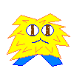 1 – CD containing the game.
1 – Instruction manual, with game basics
1 – 1’x1’ fluffy action figure of Ta-ta

10 Production Schedule
Design GDD Sept 20
TDD Oct 11

Art Resource Models & Textures Oct 4
Menu Art Oct 4
Model Animations Oct 12

1 Playable Prototype One Level Oct 18
Functional Characters
Controls
Sounds
Camera Pathing Oct 18

Testing
2nd level Oct 26

Alpha Nov 1
IGF Submission Nov 15
Beta Nov 23

Testing & Balancing Dec 7

11 Risks
- Production Risks
Technology – The game module libraries are current and up to date and there for is not estimated to suffer from being not up to date with modern games, how ever, the hardware, as well as DirectX API have their own limitations compared to the current interactive market.

Development – The scope of the game is figured to account for amount of work and time the team is capable of contributing. There is still a considerable workload and development roadblocks are predicted. To account, a schedule was designed to correctly account for the entire development process.

Team – The team is both knowledgeable, and dedicated to the success of the project. The design and development process has been split between the team members in the most productive manner.

Equipment – The hardware that the team employs for designing a project is backed by the institution(DigiPen). To prevent failures in both software and hardware, the copy of the current project and resources will be stored on a IOMEGA© zip drive, every 2 weeks.

- Distribution Risks
Competitors – The competing titles have much better distribution and production base considering that both Nintendo and Sierra have much broader and more stable base of distribution, and experience. How ever the uniqueness of the game and the disappearance of the exact genre that the game appeals to again creates a comfortable niche.

Cost – The budget of the game is already provided by the institution and team talent. Market cost of production and distribution does not appear to be higher then ordinary.

Schedule – The schedule is tight due to the deadline for the IGF submission. How ever the size of the game is moderated and so the workload is set to fit into the designed schedule.

12 Team Information
- David Dionisio
Time passed and David Dionisio had grown restless in Digipen. Failure had gotten into David Dionisio’s nerves. Many were unworthy of shedding the visions of David Dionisio to light. But for every failure, there is a lesson and every lesson had struck David Dionisio a thousand times and more.

Three years of blood and sweat, David Dionisio’s power had grown immensely. Experience with graphics engine (both 2D/3D), digital arts, 3D modeling and fancy-shmancy coding. David Dionisio had mastered the arts of P.O.O. (Programming Object Oriented) coding and R.A.P.E (Really Artistic People Eligible). David Dionisio eagerly waits to test his newfound powers.

The result was 2D, a two-man team. David Dionisio is now certain of shedding his visions to light. With all the game development tools he prepared and mustered. Along with creativity and artistic skills…what could go wrong?

- Dimitry Kudlay –
Worked on 3 game projects while attending DigiPen, and one game project outside of school. Have had experience building game engines, complex inventory and graphical user interface modules, as well as working on large work loads under time restrictions and pressure.
Has extensive 2D graphical process knowledge and ability to generate complex sprite interactions. Experience with 3D modeling (3DMAX), through school offered class and level generation from previous 3D game editor experience, mainly "Doom".
College credited course knowledge of sociology, game design, and behavioral science. Experience designing games targeting young audience, as well as experience in game complexity creation to fit multi age groups. Also has large experience base with color theory and game art resource generation.

