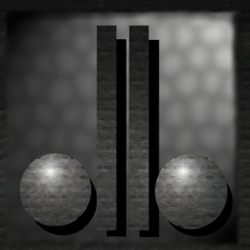
TEAM: DigiBalls
David Dionisio
GAM-450
Game Design

TA-TA MAHATTA

Table of Contents

High Concept……………………………………………………………………………3
Background……………………………………………………………………………...4
Gameplay………………………………………………………………………………..6
User Interface…………………………………………………………………………..18
2D and 3D Art Requirements…………………………………………………………..20
Sound Requirements……………………………………………………………………27
Technical Analysis……………………………………………………………………...31
Tools……………………………………………………………………………………32
Engines………………………………………………………………………………….33
Installer………………………………………………………………………………….35
Installer Flow…………………………………………………………………………....36
Uninstall Flow…………………………………………………………………………...36
Marketing………………………………………………………………………………..37
Product Schedule………………………………………………………………………...41
Risks……………………………………………………………………………………..44
Team Information………………………………………………………………………..45
High Concept

Help the peace loving Ta-Tas overcome the fungi invasion from another dimension; in this third-person adventure puzzle game.

Key Features

- A unique 3D game-play experience.
- Challenging and rewarding game exploration
- 10 unique characters to help you on your quest
- Cute and Involving story, characters, and game environment
- A great mixture of super fun action and puzzle solving

Platform and Minimum Requirements

PC
Windows NT 4.0 or later, Windows 2000
400 MHz IBM or compatible processor
64 MB RAM
Full DirectX 9 compliant 3D accelerated video card with 16MB RAM
DirectX 9
100% Windows compatible sound card
Keyboard

Target Market

The game is designed for an ESRB rating of “E” : Everyone.

Production Estimates

Estimated Retail Price - 19.99
Estimated Development Cost – (priceless)
Estimated Schedule –
This game is designed for a two-semester project, and is estimated to require 8 months of work.

Production Estimates

“Ta-Ta Mahatta” will be a 3D game, using Direct X 8.1. The game will also use a third party sound engine known as BASS.
Background

The Fungi Colony, grown from the bowels of a rotten sandwich lay siege throughout the land of Ta. Infestation grew throughout the once beautiful field of blueberries and flowers buds. The atmosphere of happiness was polluted by the ill rotten scent of the invading forces. The Ta-Tas were no match against the might of the Fungi Colony.

How is it that a land once beautiful now lay waste and corrupted by the Fungi Colony?

It all started in the very faithful day when the White Ta-Ta was born. It was a grand day for all the Ta-Tas. Moha-Ta and Ta-Donna gave birth to a very special Ta. This Ta-Ta is one of a kind. All the other Ta-Tas have orange and yellow patch fur, however this little Ta has pure white. The Ta-Tas throughout the land gathered to celebrate the newly born White Ta-Ta. They all crowded in the little hut, eager to take a glance of the White Ta. As a mysterious Ta-Ta scurried through the crowd towards the White Ta-Ta, the sky darkened and rain poured. The mysterious Ta-Ta laid eyes on the White Ta. All of the Tas in the hut recognized this Ta as Papa-Ra-Ta, the prophet.

Papa-Ra-Ta has once told that the day will come when the greatest of all Mahatta will occur. To them, Mahatta meant “great chaos”. “This Mahatta”, the prophet said, “will occur on the birth of a White Ta-Ta”. All Ta-Tas gave disbelief, until that very day came. The prophecy came true. No known Ta-Ta history has it rained this much. It wasn’t a grand day at all, many Ta-Tas have realized.

In the muddy banks of swamp TiKi-Ta-Ka, lived a Ta-Ta who loves to collect mushrooms. With the rain pouring so heavily, this Ta stayed home. Danger is a brewing inside the hut. There was a sudden change of atmosphere inside the kitchen room, a mixture of various mushrooms inside a sack begun to meld together. A rotten scent lingered throughout the house. The scent has made this Ta hungry. Controlled by the ominous scent, this Ta could not resist hunger. “I’ll make a sandwich!” this Ta has thought. Driven towards the kitchen, this Ta could not control itself from making a sandwich with toppings from the various fungi found inside the sack. With one bite, all is lost for this poor little Ta. For now on, this Ta-Ta has a name, Corrup-Ta. Driven by the fungi, this Ta has one purpose: To create the Fungi Colony and infest the land of Ta.

Now with the infestation throughout the land of Ta, many of the Ta-Tas has become slaves to the Fungi Colony. A few of the Ta-Tas lay refuge to their emergency hide-out in the mountains where no Fungi has reached yet. This hide-out was constructed long ago to help Ta-Tas escape whatever calamity that is bound to happen. The hide-out happens to be a flying cloud fortress. The cloud fortress launched up high above the land where no Fungi can reach.

Papa-Ra-Ta has told them another prophecy before they left. Papa-Ra-Ta told the Ta-Tas that the White Ta-Ta holds the power to invoke “Mahatta”. This is the “Mahatta” that will cleanse the land of the infestation. The Ta-Tas were confused, “Mahatta” has always been associated with calamity (which is what just happened). But “chaos” meant neither good nor bad. “Mahatta” is still a dangerous power and it is all up to the White Ta-Ta.

Unfortunately with the invasion of the Fungi Colony, the White Ta-Ta’s location is not known. The Ta-Tas now begins their journey to find the Legendary White Ta-Ta and cleanse the land of Ta from the Fungi Infestation.
Game Play

Single Player Mode

In the single mode, the player will be the brains behind the “ta-ta”s to vanquish the Fungi Colony. The player will start off on the cloud. The cloud is where the player can choose to play a level or hang around and do interesting activities.

Interesting activities in the cloud includes being able to view the collection of artifacts the player has found throughout the game. These are just for viewing pleasure. The player can also talk to the Wise-Ta who will give special advice in the game. The player can also play unlocked mini-games in ‘Ta-Vern’ located within the cloud. NOTE: We will not include the Wise-Ta and ‘Ta-Vern’ in the game if there is no time.

The player can choose to play a level by entering the mysterious ‘Level Select’ house. Once inside the house, the player can select any unlocked level to play. A level can only be unlocked by finishing the previous level.

Each level will start the player off with one up to four Ta-Tas. The level will start with a description pertaining anything to do with the level and the goal. Each level will have a number of goals required to accomplish in order to acquire victory. Once all the goals are met, the player is then returned to the cloud level with a new level unlocked. If all levels are completed, then the ending scene will be displayed.

Some of the levels will contain artifacts that the player can optionally collect. The collected artifact will be brought back to the cloud level, once the level is complete. Some of the artifacts can unlock certain activities inside the cloud level, such as mini-games.

The player loses the level when all Ta-Tas die. The player can then choose to restart the level or return to the cloud level.

Game Flow

The game is designed with the following schedule of pacing: The player starts in the cloud level. The player plays a level by entering the ‘level select’ house. The player plays any unlocked levels. Once the player finishes an unlocked level, a new level is unlocked. Once all the levels in a stage are done, the end scene will be played.

Input Design

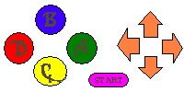
Direction Pad – Used for ta-ta movement as well as Free-Look.
START – Pause Game, Options.
A – OK, Use Ability.
B – NO, Hold for Free-Look using Direction pad
C – Switch Ta-ta Forward in List.
D – Switch Ta-ta, Back in List.

Player Design

Ta-Ta Mahatta allows the player control of a variety of Ta-Tas, and there are 11 different Ta-Ta in the game.

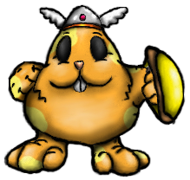

Captain Ta-Ta
Ability – Defend, Deflect projectiles
Description – This sturdy Ta-Ta is the leader of the Ta-Tas and has the very important ability of defending against projectile attacks such as mushroom spit.
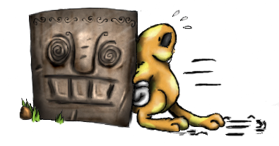
Ta-Ta Tug
Ability – Push
Description – This diligent Ta-Ta has the strength to push blocks, as well as some other objects, such as frozen enemies.
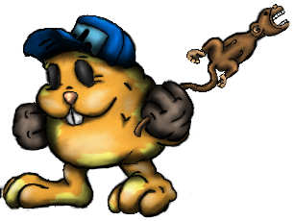
Tinker-Ta
Ability – Mechanic
Description – This smart Ta-Ta can operate complex machinery, such as levers.
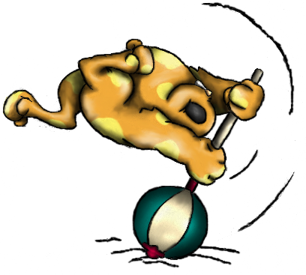
Ta-Ta-Trample
Ability – Attack
Description – This aggressive little Ta is the only one brave enough to actually stand up against the mushrooms. His important attacking skill can break blocks or hurt enemy mushrooms.
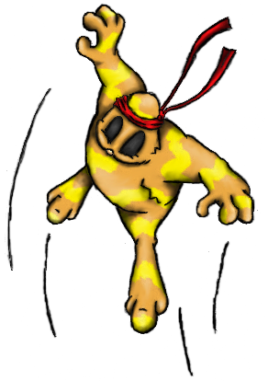
Hop-Ta-Hop
Ability – Jumper
Description – This spunky Ta can jump to heights only he can reach.

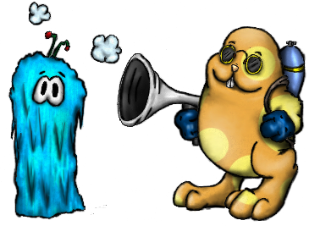
Frost-Ta
Ability – Freeze
Description – This capable Ta can freeze enemy mushrooms and permanently paralyze them as well as make them push able.
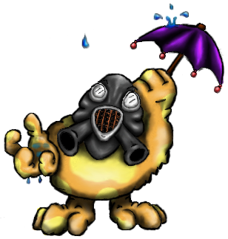
Para-Ta-Ta
Ability – Glide, Immune to Poison Mist
Description – This advanced unit can glide through air, and is immune to poison in fungal spore areas.
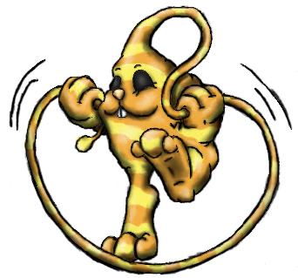
Loop-Ta-Loop
Ability – Whipper
Description – This hyperactive playful Ta can use it’s whippy head scruff to grab on to stakes and stumps and pull him self to new locations.
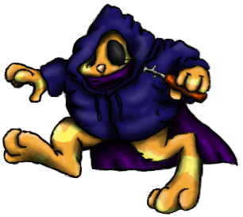
Key-Key-Ta
Ability – Thief, climb wall
Description – This slick little Ta can open up locked doors and climb walls.
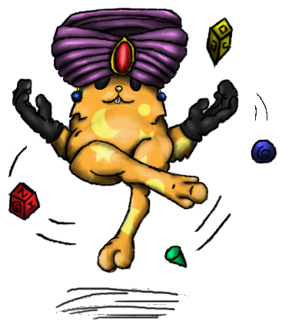
Chi-Ta
Ability – Psychic
Description – This amazing Ta can levitate itself and pull objects, items and creatures to him self from any distance.
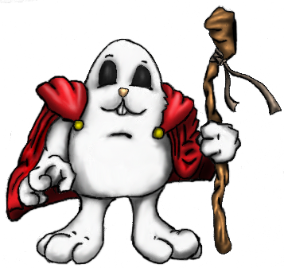
Ta-Vatar
Ability – Ta-Ta Mahatta
Description – This legendary Ta has the ability to purge any evil that threatens Nan-Ta. However, this ability is known to cause ‘Mahatta’, a devastating catastrophe.
Enemy Design

Ta-Ta Mahatta have a total of 4 puzzle-based enemies as well as 3 boss enemies. Each regular enemy can be killed by normal attacks or by being pushed off a level. Boss fungi will have possibly 3-5 hit points which can be deducted by carefully manipulating object and character puzzle each boss contains.

Standard Enemies:

Funga-Bark
This small vicious fungus is although unable to move, is still dangerous due to his sharp fangs.

Funga-Spy
This scary looking fungi maintains a careful look out for any passing ta-ta’s and then attacks them with his underground tentacles.

Shroom-Guard
This mushroom soldier patrols an area charging and attacking any ta-ta he sees.

Shroom-Shooter
This mushroom stump shoots out projectiles that hurt any ta-ta that it touches, but can be blocked by a defender.

Bosses:

Shroom-Pa
Forest Stage

The big boss of the forest stage. Shroom-Pa will be moving around the room using the waypoints. Shroom-Pa will occasionally stop and shoot a projectile upwards. Once the projectile reach high enough (vertically) then the projectile will drop down directly towards the currently selected Ta-Ta. Captain Ta-Ta needs to block the projectile and reflect it towards the boss. Once the boss is knocked out, Ta-Ta Trample needs to attack Shroom-Pa. Once attacked, Shroom-Pa will regain conscious and return to its normal movement and attack.

Catter-Shroom
Mountain Stage

This boss remains stationary in a random spot (using waypoint nodes). Catter-Shroom will be launching underground tentacles within an area where the currently selected Ta-Ta is. Tinker Ta must use the correct switch to knock Catter-Shroom. Ta-Ta Trample then needs to attack Catter-Shroom while it’s knocked out. Catter-Shroom will then dig down and go up on a new random spot. Catter-Shroom will also do this after certain duration while attacking.

Fungi Lord
Swamp Stage

Fungi Lord will be teleporting from random locations spawning random enemies. Frost-Ta must temporarily freeze Fungi Lord. While frozen, Tinker-Ta must activate the switch corresponding to Fungi Lord’s location. After that, Ta-Vatar must use it’s Ta-Ta Mahatta powers to attack Fungi Lord.

Game Play Elements

Each level in the game will require a certain type of goal to be accomplished.

Gather Ta-Tas – you must get all your Ta-Tas to a certain spot in the level to achieve victory.

Gather Resources/Crates – get all resources/crates to a certain spot in the level to achieve victory.

Rescue Baby Ta-Tas – you must rescue these Ta-Tas from the clutches of Fungi and return them to a nearby shelter unscathed. Each Ta-Ta can only carry one baby Ta-Ta.

Defeat Boss – you must defeat the boss in the level to achieve victory.

There are a number of objects in the game that will be either item to be collected or acted upon to solve the puzzles.

Baby Ta-Ta – these little Ta-Tas are lost and must be returned to a nearby shelter. This is used in one of the goal types in the game.

Ar-Ta-Facts – Once collected, an artifact will be returned to the cloud level once the level is complete. Certain artifacts unlock interactions in the cloud level.

Button – A button that can be stepped on by a Ta-Ta to cause an effect.

Hard Button – A button that requires a block or a frozen enemy to be pushed

Lever – A mechanical lever that controls a certain object in the level.

Locked Doors – a thief can only open these tightly shut doors.

Stump/Steak – These objects can be grappled on by Hop-Ta-Hop’s whip.

Heavy Block – A block that cannot be pushed and can only be broken.

Block – A block that can be pushed or broken. These can also be part of the goal in the level, whereas you must push them to the goal area.

Teleport – These transports any matter instantly to another location.

Goal – The goal area is where you must gather what is required to accomplish the level.

Signs – A small sign, tipping the player with next possible move.

These are the Ar-Ta-Facts(artifacts) the player can collect in the game:

Tiki-Ta – this artafact is known to be the creator of Ta-Tas.

Nan-Ta – a small model of the Nan-Ta planet.

Happy Face Sunshine – a model of a smiling sun.

Yellow Boss from Reign – the Yellow Boss in the game known as Reign.

The 4 gemstones from Reign – the four gemstones in the game known as Reign.

TED poster – a poster from the game known as TED.

The Homies – the four main casts of the game known as Homies.

David Dionisio Voodoo Doll – the author of this game’s voodoo doll.

Slime Monument – a stone structure of the hammer slime from the sandwich world.

Parasite Monument – a stone structure of the parasite queen from the sandwich world.

Digipen – a small model of the Digipen building.

Rotten Sandwich – the origin of the Fungi Colony.

In-game Options

There are 2 types of in-game options that will be given to the user. The standard pause menu will be covered in detail in the section User Interface.

The second type of configuration scenario will be presented to the user in the form of an intermediary stage. This stage takes place on a cloud and has the following options for the user to explore.

Choose Level – Select the next level of entrance through a small world map.

Talk to Wise Ta – gives you hint and tips about anything pertaining to the game.
(Might not be implemented)

View Artifacts – view all the collected artifacts found throughout the game.

Play Mini-games – play any unlocked mini-games. (Might not be implemented)

Level Design

There is one tutorial stage with 5 levels and 5 stages each with 3 levels.

Tutorial Stage – this stage contains 5 levels that will show the player the feel of the game. Each level will guide the player through the obstacles, showing how to proceed.

Level 1
Ta-Tas: Captain Ta-Ta
Goal: Home
Artifacts: none
Brief Description: Learn how to control Captain Ta-Ta. First appearance of Shroom Shooter.

Level 2
Ta-Tas: Ta-Ta Tug
Goal: Retrieve Boxes
Artifacts: none
Brief Description: Learn how to control Ta-Ta Tug.

Level 3
Ta-Tas: Tinker Ta
Goal: Rescue baby Ta-Tas
Artifacts: none
Brief Description: Learn how to control Tinker-Ta.

Level 4
Ta-Tas: Captain Ta-Ta, Ta-Ta Trample
Goal: Home
Artifacts: Tiki-Ta
Brief Description: Learn how to control Ta-Ta Trample. Learn about the artifacts and switching between Ta-Ta. First appearance of Shroom Guard and Funga Bark.

Level 5
Ta-Tas: Captain Ta-Ta, Tinker Ta, Ta-Ta Tug, Ta-Ta Trample
Goal: Rescue baby Ta-Tas
Artifacts: none
Brief Description: Learn how to use all 4 Ta-Tas.

Forest Stage – the forest stage will contain 3 levels and a final boss level.

Level 1
Ta-Tas: Ta-Ta Trample, Tinker Ta, Captain Ta-Ta, Hop-Ta-Hop
Goal: Home
Artifacts: Nan-Ta
Brief Description: rescue Hop-Ta-Hop. Learn how to use Hop-Ta-Hop.

Level 2
Ta-Tas: Captain Ta-Ta, Tinker Ta, Ta-Ta Tug, Hop-Ta-Hop
Goal: Retrieve Boxes
Artifacts: Happy Face Sunshine
Brief Description: Food Supply

Level 3
Ta-Tas: Captain Ta-Ta, Ta-Ta Tug, Loop-Ta-Loop
Goal: Retrieve Boxes
Artifacts: Yellow Boss from Reign
Brief Description: more food supply

Level 4
Ta-Tas: Captain Ta-Ta, Ta-Ta Trample
Goal: Defeat Boss
Artifacts: none
Brief Description: Boss Level for Shroom Pa

Ice Stage – the ice stage will contain 3 levels.

Level 1
Ta-Tas: Frost-Ta, Ta-Ta Trample, Tinker-Ta, Loop-Ta-Loop
Goal: Get Tool Box
Artifacts: The 4 gemstones from Reign
Brief Description: Introduction of Frost-Ta

Level 2
Ta-Tas: Captain Ta-Ta, Tinker Ta, Frost-Ta, Ta-Ta Tug
Goal: Rescue baby Ta-Tas
Artifacts: TED poster
Brief Description: use of Frost-Ta, Captain Ta-Ta and Ta-Ta Tug to manipulate enemies to reach goals.

Level 3
Ta-Tas: Frost-Ta, Hop-Ta-Hop, Ta-Ta Tug, Tinker Ta
Goal: sabotage the fungi industry’s power
Artifacts: The Homies
Brief Description: use the switch to deactivate the fungi ‘power plants’

Mountain Stage – the mountain stage will contain 3 levels and a final boss level.

Level 1
Ta-Tas: Chi-Ta, Captain Ta-Ta, Tinker Ta, Hop-Ta-Hop
Goal: Home
Artifacts: David Dionisio Voodoo Doll
Brief Description: climb the mountains to be enlightened

Level 2
Ta-Tas: Para-Ta-Ta, Tinker-Ta, Captain Ta-Ta
Goal: Home
Artifacts: Slime Monument
Brief Description: intro to eye thingy and gas areas

Level 3
Ta-Tas: Para-Ta-Ta, Loop-Ta-Loop, Frost-Ta, Chi-Ta
Goal: rescue baby Ta-Ta
Artifacts: Parasite Monument
Brief Description: rescue Ta-Tas from mining area

Level 4
Ta-Tas: Ta-Ta Trample, Tinker Ta
Goal: defeat boss
Artifacts: none
Brief Description: boss battle with Catter Shroom

Swamp Stage - the swamp stage will contain 3 levels and the final boss of the entire game. The ending scene will start once the final boss is defeated.

Level 1
Ta-Tas: Key-Key Ta
Goal: Home
Artifacts: Digipen
Brief Description: intro to Key-Key Ta

Level 2
Ta-Tas: Key-Key Ta, Loop-Ta-Loop, Ta-Ta Trample
Goal: rescue baby Ta-Ta
Artifacts: Rotten Sandwich
Brief Description: rescue babies from shantytown

Level 3
Ta-Tas: Key-Key-Ta, Captain Ta-Ta, Tinker-Ta, Ta-Vatar
Goal: Home
Artifacts: None
Brief Description: Find Ta-Vatar in this shantytown near swamp

Level 4
Ta-Tas: Frost-Ta, Tinker-Ta, Ta-Vatar
Goal: defeat boss
Artifacts: None
Brief Description: Final battle with Fungi Lord
User Interface

User Flow
Intro Scene

Main Menu
New
Load
Options
Exit
Enter Name
Cloud Level

Choose File

Game Level

End Scene

Start Menu

The initial menu that will be provided for the user is outlined as follows:

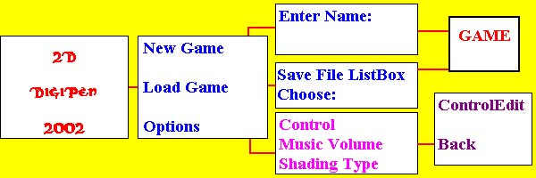
Project Introduction Screen

In-game Menu

The player will be able to access an option screen by pausing the game. The following options will be available to the user.

Return to Cloud – This option takes the player back to the intermediately stage, Cloud level. This option is not available in Cloud Level.

Save and Exit – This option takes the player back to the main menu and saves the player’s profile. This option is only available in Cloud Level.

Options – This option screen will present the user with the similar options given at the game entrance.

Resume – Return to the current game.

Inventory

The game will not have a standard inventory that can be manipulated by the player through out the game. However, the player can view all the collected artifacts in the Cloud Level.

GUI

In Ta-Ta Mahatta, the player will primarily interface with the 3D world of Ta-Ta’s and spend little time navigating graphic tool bars. For this reason the intermediary level “Cloud” was established.

The lower left corner of the screen will display the portrait of each Ta-Ta that are in play. Any Ta-Ta who are killed will display a death portrait. The highlighted portrait is the currently selected Ta-Ta that the player is controlling. At the bottom of each portrait, the number of hits is displayed.

The lower right of the screen will display the goal the player must achieve. An icon represents what the goal is in mind. The ratio next to the icon determines the current number of goals achieved and the maximum needed.

Interaction in the game is mostly done by walking over an area or using the ‘action’ button.
2D and 3D Art Requirements

Format

Menu/Textures – all menus/textures in the game will consist of 2D art generated by any graphical editors. The ideal format for these images will be JPEG, as this will reduce the disk space required for the game. Although JPEG does not have support for alpha channels, the image will then use TGA image format. All images must have a size of 2^n by 2^n (n > 0), this is a limitation in the graphics engine.

Models – the graphics engine of the game will support a format used by a model editor called ‘Milkshape 3D'. Models can be done in 3DS Max as well and can be imported to Milkshape 3D for the game to use. However, all animations will be done in Milkshape 3D. All model textures will have the limit size of 256x256.

Levels – the levels will be made by a map editor called QUARK and will be compiled to a different format that the game uses. QUARK is a freeware level editor.

Sky Box – each level will have a skybox. For the skybox, we will simply require a texture for each side of the box: top, bottom, left, right, front and back.

Style:

The game will have a cartoony feel to it. As such, the models will be simple and yet compelling. Textures will have various colors to it and must stay far away from the human perspective of ‘reality’. This task can be both easy and daunting at the same time. We must then require that the artist team to be creative and highly imaginative.

Art List:

Menu/GUI:

We will need background arts for:

Intro screen, Main Menu, New game, Load and Options

We will only need 3 animated images for the buttons: new game, load game and options.

Models:

- Miscellaneous:

Ice block – this model is used when a monster is frozen.

Level Doodads – doodads will be placed throughout the levels. These are simply just for viewing pleasure.

- 3D Menu interaction inside the cloud ship:

Ar-Ta-Facts – a 3D model of each artifact.

- The ‘Ta-Tas’:

Here are the animation lists of each ‘Ta-Ta’ model that the game will use:

Captain Ta-Ta:

Idle 1 – generic Ta-Ta standing pose.
Idle 2 – remove helmet with left hand. Wipe out sweat on forehead with right hand.
Idle 3 – put the shield on the ground and exercise the right arm.
Walk – generic Ta-Ta hop, with shield
Back Walk – generic Ta-Ta back walk.
Ouch – generic Ta-Ta ouch.
Death – drop on the ground with face up. The shield will spin slowly and eventually drop on the face.
Victory – throws the shield up in the air, spinning and catches it.
Block – puts the shield in front.

Tinker-Ta:

Idle 1 – generic Ta-Ta standing pose.
Idle 2 – grabs the hat with left hand and tosses it on the air. The hat will spin on air and land on the head.
Idle 3 – pat the left hand with the monkey wrench three times.
Walk – generic Ta-Ta walk.
Back Walk – generic Ta-Ta back walk.
Ouch – generic Ta-Ta ouch.
Death – drop on the ground with face up. The hat will fall down slowly like a feather and lands on the belly.
Victory – jumps and throws the hat on the air and catches it.
Use – pokes monkey wrench in front.

Ta-Ta Tug:

Idle 1 – generic Ta-Ta standing pose.
Idle 2 – sits on ground, carefree style. Stands back up after a while.
Idle 3 – performs a mime act. (Invisible wall)
Walk – generic Ta-Ta walk.
Back Walk – generic Ta-Ta back walk.
Ouch – generic Ta-Ta ouch.
Death – lifts one foot up, spins 360 degree and drop dead. (Cartoon death style)
Victory – shakes hands together above head left to right.
Push – puts both hand in front and walks in a pushing manner.

Ta-Ta Trample:

Idle 1 – generic Ta-Ta standing pose.
Idle 2 – sticks big hammer on ground and lean on it.
Idle 3 – tries to balance big hammer with nose but fails. The hammer will be picked up after dropping from the head.
Walk – walking while dragging the hammer behind with great effort.
Back Walk – generic Ta-Ta back walk.
Ouch – generic Ta-Ta ouch.
Death – drop on the ground with face up. Gets up and drops back dead after the hammer falls on the head.
Victory – grabs hammer with both hands above the head. Jumps up and down.
Attack – lifts hammer and bludgeons whatever is in front.

Hop-Ta-Hop:

Idle 1 – warm up jump exercise, like what athletics do.
Idle 2 – does the praying mantis karate pose.
Idle 3 – taps ground with left foot 3 times, then with right foot.
Walk – generic Ta-Ta hop.
Back Walk – generic Ta-Ta back walk.
Ouch – generic Ta-Ta ouch.
Death – drops dead on the ground with both feet up, both feet stutters for a few seconds.
Jump – forward flip (360 degree). The game physics will take care of the arc movement from one spot to another.

Frost-Ta:

Idle 1 – generic Ta-Ta standing pose.
Idle 2 – checks gun condition (polishing…etc)
Idle 3 – throws gun upwards and catches it (with style)
Walk – generic Ta-Ta walk. (Backpack shaking behind)
Back Walk – generic Ta-Ta back walk.
Ouch – generic Ta-Ta ouch.
Death – falls flat on the ground face down.
Attack – thrusts the gun forward. Freezing gas comes out with the use of the graphics engine particle FX.

Loop-Ta-Loop:

Idle 1 – generic Ta-Ta standing pose. Whip moving around, like a cat’s tail.
Idle 2 – plays skip with the whip.
Idle 3 – creates a cowboy hoop with the whip and swirl it around a bit.
Walk – generic Ta-Ta walk with whip moving around, like a cat’s tail.
Back Walk – generic Ta-Ta back walk.
Ouch – generic Ta-Ta ouch.
Death – falls flat on the ground face up. Whip swirls around slowly until it falls flat.
Attack – whip strikes forward. Stretching is done inside the game engine.
Grappling – whip in forward position (after last attack frame) and body facing the ground.

Para-Ta-Ta:

Idle 1 – generic Ta-Ta standing pose.
Idle 2 – swings the umbrella around.
Idle 3 – balances umbrella with left hand and catches it once it falls.
Walk – silly walk with umbrella swinging. (Charlie Chaplin style)
Back Walk – generic Ta-Ta back walk.
Ouch – generic Ta-Ta ouch.
Death – falls flat on ground face up. Umbrella opens and falls like a feather.
Glide – opens umbrella and holds it up.

Key-key-Ta:

Idle 1 – looks left and right cautiously.
Idle 2 – crosses both arm together and tap right foot impatiently.
Idle 3 – stretches both arm sideways.
Walk – walks cautiously like a ninja.
Back Walk – generic Ta-Ta back walk.
Ouch – generic Ta-Ta ouch.
Death – dies honorably…or something.
Unlock – thrusts the lockpick device forward.

Chi-Ta:

Idle 1 – floating with small miscellaneous objects moving around.
Idle 2 – Juggles the miscellaneous objects while floating.
Idle 3 – performs yoga.
Walk – floating with small miscellaneous objects moving around cross-legged.
Back Walk – generic Ta-Ta back walk.
Ouch – generic Ta-Ta ouch in mid-air.
Death – falls flat on the ground face up. Miscellaneous objects fall one by one on the belly.
Telekinesis – puts right hand in front (Like a Jedi)

Ta-Vatar:

Idle 1 – generic Ta-Ta standing pose with cape billowing sideways.
Idle 2 – attempts to fly like Super Man but fails.
Idle 3 – sits down and pray.
Walk – generic Ta-Ta walk with cape billowing.
Back Walk – generic Ta-Ta back walk.
Ouch – generic Ta-Ta ouch.
Death – dramatic cartoony death.
Attack – performs a fireball move. Particle effects are generated in a form of a fireball (Using the graphics engine particle FX).

- The Enemies:

Here are the animation lists of each enemy model that the game will use:

Shroom-Guard:

Walk – think walking mushroom with feet and you get the idea.
Ouch – imagine beating up a life size mushroom.
Death – what a mushroom looks like after you step on it.
Attack – imagine getting slapped by a mushroom.

Funga-Bark:

Idle 1 – looks around menacingly.
Idle 2 – yawns
Idle 3 – just…Idle
Ouch – body gets push back and recovers.
Death – what a weed looks like after spraying anti-weed.
Attack – thrusts mouth forward and BITES!

Shroom-Shooter:

Idle 1 – resting plant
Ouch – wobbles around.
Death – falls flat on the ground.
Attack – thrusts mouth forward and spit.

Funga-Spy:

Idle 1 – blinks eye.
Ouch – wobbles around.
Death – falls flat on the ground.
Attack – leans a bit forward with an angry expression.

- The Bosses:

Shroom-Pa:

Idle – raises front legs upwards like a horse
Walk – front/back legs go inward and outward
Attack – opens mouth and spits
Charge – thrusts head forward
Dizzy – lie down with legs wiggling
Ouch – moves back a bit
Death – goes down with legs up high

Catter-Shroom:

Idle – breathe in, breathe out
Dig – claws go in/out the ground
Attack – claws dig in and spikes come out from ground (spikes are separate model).
Dizzy – wobbles around.
Ouch – moves back a bit.
Death – lies down on the floor with claws twitching

Fungi Lord:

Teleport – does something magical that’s in a for of fungus dance
Attack – moves hands forward and spores come out
Spawn – throws out a handful of fungus dust
Death – explodes and then *poof*

Fonts:

Fonts in the game will use the generic type used by many applications. We will mostly use ‘Comic Sans’ as it fits perfectly to the style of the game. In some cases, static texts like found in buttons and menu titles will be image generated.

Textures:

The textures will be grouped in terms of their usage. Each group will be placed in a different texture folder. Here are the following groups:

Menu – these includes all the backgrounds and buttons for the 2D menus in the game.

Model Textures – the model texture size will be limited to 256x256. Each model will have at least one texture.

Level Textures – all textures used by the level.

Sky Box Textures – all textures for the skyboxes.

Particle FX – all particle effect textures.
Sound Requirements

Format:

Music/Sounds – all music and sound effects in the game will use the MP3 format. Each will be limited to 44100 kHZ 16-bit stereo.

Style:

Just like the art, the music and sound in the game will be cartoonish, as far away from ‘reality’ as possible. The music in each level should capture the mood of the landscape and scenery.

Sound List:

SFX/VOX:

a) The ‘Ta-Tas’:

These are the general sound used by all ‘Ta-Ta’s:

Ouch – cute high pitch bunny ouch sound.
Death – the sound of a bunny getting choked.
Falling – a high pitch screaming bunny.

Here are the sound lists of each ‘Ta-Ta’:

Captain Ta-Ta:

Block – woosh sound on putting the shield in front.
Projectile deflects – cartoony sound when a projectile hits the shield.

Tinker-Ta:

Use – screaming monkey when the ‘monkey’ wrench is used.

Ta-Ta Tug:

Pushing – sound when pushing an object.

Ta-Ta Trample:

Attack – grunts from effort of lifting the hammer and striking whatever is in front.

Block break – the sound of breaking a rock.

Enemy/ground hit – a big solid THUD

Hop-Ta-Hop:

Jump – a ‘woosh’ sound (think karate)

Frost-Ta:

Attack – use a fire extinguisher

Freezing enemy – ice crystallizing on objects.

Loop-Ta-Loop:

Attack – sound of whip when swung.

Hit – whip *crack*

Para-Ta-Ta:

Any animation - Gas mask breathing.

Key-key-Ta:

Lock pick – using a key on a door.

Chi-Ta:

Telekinesis – super psychedelic telepathic trippin’ sound.

Ta-Vatar:

Fireball attack – shout, in a high pitch bunny like voice: “Taaaa-Taaaa-Maaahhhaaa-TAAAAA!!!”
Fireball strike – big nuclear explosion! BOOM!

b) The enemies:

Shroom-Guard:

Attack – a chiwawa growling.
Ouch – a chiwawa ‘yelping’
Death – a chiwawa ‘whimpering’…fade away

Funga-Bark:

Idle 2 – upon looking around, growls like a monster.
Ouch – monstrous * grunt *
Death - * smack * as the head falls on the ground.
Attack – * roar * and * snap *!!!

Shroom-Shooter:

Death – splat
Attack – take a long deep snort and spit.

Funga-Spy:

Death – splat
Attack – imagine a big thorn emerging from the ground.

c) The Bosses:

Shroom-Pa:

Idle – a big loud grunt.
Walk – rhino sound of thumping
Attack – a monstrous spit, more monstrous than Shroom-Shooter
Charge – big *woosh*
Dizzy – monstrous pain
Ouch – *roar*
Death – bigger, louder *roar*

Catter-Shroom:

Idle – breathe like a rattle snake, poorly imitated
Dig – a fast paced shovel-digging sound
Attack – big *thud* as claws go deep down the ground and *whoosh* for spikes.
Dizzy – *grrrrr* *moan*
Ouch – *hssss*
Death – some weird gobble-de-gook sounds

Fungi Lord:

Teleport – does something magical that’s in a for of fungus dance
Attack – moves hands forward and spores come out
Spawn – throws out a handful of fungus dust
Death – explodes and then *poof*

d) The Level sounds:

Lever – the sound a lever makes when pulled.
Gate close – the sound produced by a metallic gate when closing. (down direction)
Gate open – the sound produced by a metallic gate when opening. (up direction)
Raising platform – the sound of rumbling ground.
Big button pushed – the sound of a twig snap.

e) Other Sounds:

Item Collection – a happy fairy dust sprinkle sound.
Egg Collection – * WHOOPIE * (high pitch bunny voice)

f) The Menu sounds:

We only need one sound for the button: * BOINK *

Music:

a) Menu Music:

Main Menu – the music for the main menu does not have to loop. The length of the music should be 2 minutes. The music will play the theme of the game. Depicting the happiness of the Ta-Ta’s and the cruel invasion of the fungi colony.

Magical Mystery Cloud – the music must loop and have the minimum time length of 30 seconds. The music will be something mystical and strange…like being in a magical mystery cloud.

b) Level Music:

All level music must loop and at least have a time length of 2 minutes.

Forest – mystical placid song mix with the ambient sounds of nature. (Think ‘Enya’ music)

Cliffs – fast rock and roll music with lots of drum beats.

Snow – cool jazz music.

Purple Swamp – dark moody music slowly becoming fast heavy metal music and slowly returns to the original phase.
Technical Analysis

Ta-Ta Mahatta will use the technology of Microsoft DirectX 9. The game will have stunning visual effects with the use of Direct Graphics; superb input control with the use of Direct Input; thrilling sounds and music played with the power of Direct Sound.

Ta-Ta Mahatta will utilize a powerful scripting engine for various aspects of the game. This includes: AI, trigger events and the menu. The scripting engine will provide the developer full flexibility on level designs and tweaking gameplay. This will reduce considerable amount of time spent on the development of the game.
Tools

Map Editor:

An external map editor will create all levels in the game. These are the functionalities that will be needed for the map editor:

Creating solid landscapes and doodads.
Placing and editing entities:
Ta-Ta starting positions
Items
Goals
Enemies
Creating triggers for levers and buttons.
Placing waypoints for enemy AI and platforms.
Placing lighting effects and ambient sounds.
Skybox editing (which textures to use for the skybox sides)

Model Editor:

A pre-existing model editor will make all the 3D objects used in the game. This includes modeling, texturing and animating of the model.

Sound Editor:

All sounds will be produced by various free editors, just give us the sounds.
Engines

Graphics:

The graphics engine will include these functionalities:

3D model display with texture and lighting.

3D model animation using skeletal animation.

Smooth camera pathing and the ability to change camera position and direction.

Level display with vertex and lightmap coloring.

2D image display and animation.

The graphics engine will also have particle effects used in various elements of the game:

3D object explosion – a bunch of non-animating 3D models exploding from an area.

Puff emission – puffs emitting from a point moving in a direction and fading away.

Gas area – gaseous particles randomly produced within a bounding area.

Sparks – explosion of particles starting from a point and fades away upon reaching the edge of the radius.

Sound:

The game will be using an external sound library produced by a different developer. The sound library is free so long as the game is also free. The name of the sound engine is BASS. Features and functionalities can be seen through this website:

http://www.un4seen.com/music/

User Interface:

The input in the game can either be a keyboard or a gamepad. There will be no mouse interface (Perhaps for debug purposes).

The menus in the game will use the script engine for most functionality. This will enable the developers to easily tweak and expand the menus should the need arise.
Installer

The game will have an auto start menu whenever the game CD is inserted. The following items will be on the menu:

Play
Install/Uninstall
Visit Website
Exit

Basically we just want a background with the buttons displayed appropriately. The buttons must also highlight when selected.
Installer Flow
Install the game?
NO
Exit

YES Display: ‘Not enough
Disk space’
Disk space sufficient?
Choose hard drive.
Enter directory.

Display available disk space.
Display required disk space.

Install Game

Detect DirectX 8.1
Install DirectX 8.1?

Yes No Already installed

Check box for:
1) Add desktop icon.
2) Add game in start menu.
Install DirectX 8.1

Run Auto start.

Uninstall Flow

Uninstall Game?

No
Exit

Yes

Uninstall the game

DONE
Marketing

Target Market Summary:

Currently as reported by the NPD on ConsoleWire.com
Even thought summer time is slow in consumer sales, nearly 20% of top 20 selling games were of E-T rated action adventure games. With up and coming adventure and puzzle games such as Super Mario Sunshine for GameCube© by Nintendo and PacMan2 by Namco, as well as the approaching holiday season, the public demand for a 3D adventure game featuring cute characters, is not expected to abate.

Competitor Analysis:

- Concept Challengers

Lost Vikings – The best interpretation of this type of collaborative sprite puzzle game. Interplay..
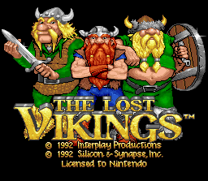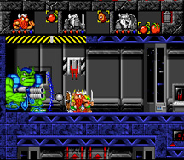

Lost Vikings 2 – The great sequel to the first masterpiece by Interplay
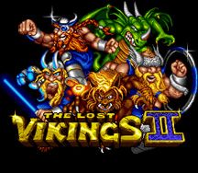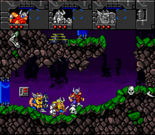

King Arthur’s World – Often missed classic that lead the player through strange and challenging worlds. Jaleco
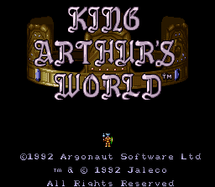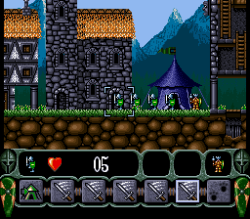

- Current Competitors

Lemmings 3D, PS – Latest installment in this multi-series game by Psygnosis Rated: E
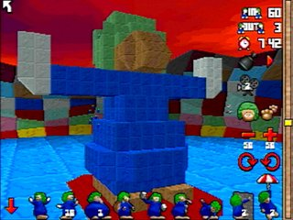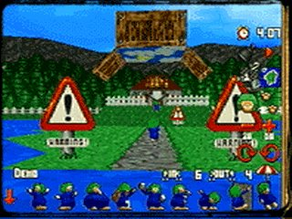

Mario Sunshine, Nintendo GameCube – A fun adventure game in a typical Nintendo trademark fashion. Rated: E
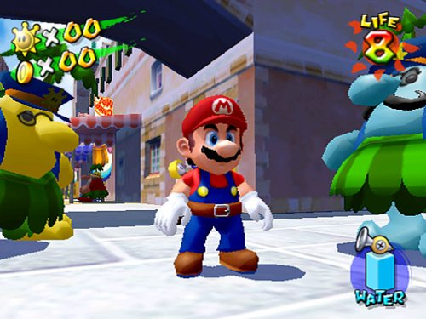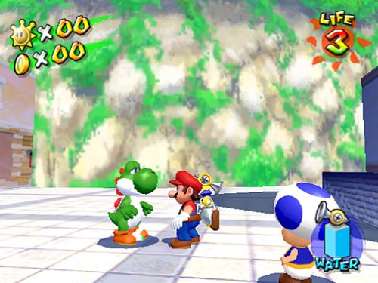

Spyro: Enter the Dragonfly, Universal PS2 – A colorful adventure with a numerous cast of characters. Rated: E
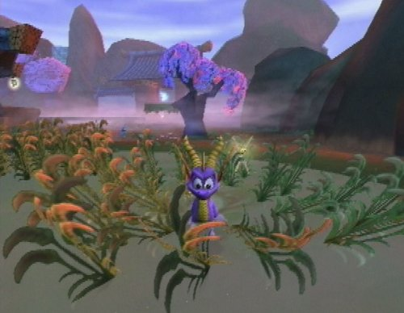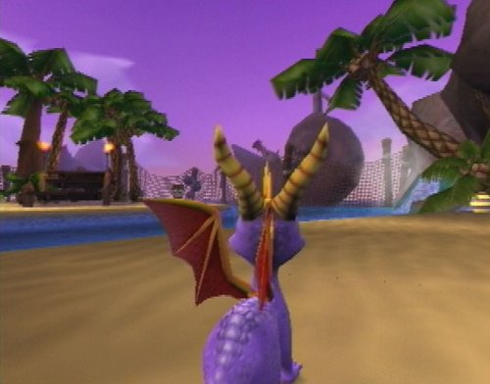

Homies – Exciting new puzzle game by David Dionisio
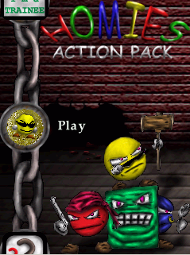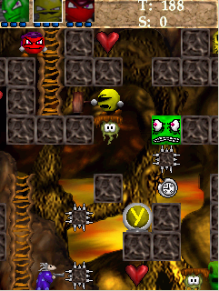

Feature/ Price Comparison:

Lemmings3D (Psygnosis) $14.95
• 3D worlds packed with features and puzzles to solve
• 100 levels
• 9 Lemmings skills
• Over 30 sampled Lemmingese last requests

Super Mario Sunshine (Nintendo GameCube) $49.99
• Encounter a collection of enemies bent on foiling Mario's efforts
• Explore 3-D world filled with expansive environments
• More mobility --jumps, wall bounce, run, slide, climb, and fly

Spyro (Sierra PS2) $49.99
• Over 25 levels, each with unique weather environments
• Avoid obstacles, jump on platforms, ride vehicles, collect gems
• All-new vehicles, including tanks, UFOs and a Spitfire
• New collectibles--thousands of gems plus over 100 dragonflies

Ta-ta Mahatta $39.99

• A unique and colorful 3D game-play experience
• 20 levels of challenging and rewarding game exploration
• 11 unique characters to help you on your quest
• Cute and Involving story, characters, and game environment

As seen above “Ta-ta Mahatta” grabs a comfortable niche with its list and quality of features and its relatively low priced compared to newly released games.
Legal Analysis:

Name - The name “Ta-ta Mahatta” was chosen by the team with out any prior intentions or thoughts. Ta-ta was thought of as a name for creature type, and Mahatta, respectively to mean “chaos”.
The name “Ta-ta” is too basic for legal consideration, however, the word “Mahatta” appears in various occations.

- It is defined as “enormity (int.) 1. mahatta; “ in Englo-Palistinean. Dictionary.
- There is a Mahatta River is located on the north end of Vancouver Island
- Roots/Sepultura contains a song named “Ratamahatta”
- A popular Arabic singer is named FAIRUZ Al Mahatta

None of the above mentioned are considered to pose any legal threat, and the Palistinean translation is even somewhat fitting.

Presentation/Distribution:

General Presentation Theme- The game is colorful and is supposed to be attractive for even the youngest player due to its “E” rating. Any advertisements or promotion materials should feature animated colorful pictures of the Ta-Ta’s, illustrating their variety and likeability aspect, as well as include the screen shoots of the game.

Packaging- The game will be packaged in an old fashion PC game box used in previous years. The box art will be as described above.

Included Material- Packaging will include
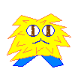 1 – CD containing the game.
1 – Instruction manual, with game basics
1 – 1”x1” fluffy action figure of Ta-Ta
Production Schedule

As of 2003

Monthly Schedule

January:

Fix Bugs (graphics issue with other gfx cards)
Performance Tune
Enhance Menus
Change Level Select
Change Game Over
Art-Ta-Fact Display
Create all Art-Ta-Facts
Forest Levels
Shroom Pa Boss

February:

Snow Particle FX
Ice, Cliff and Swamp Levels
Catter Shroom Boss
Fungi Lord Boss

March:

Fix Ta-Ta animations
Sounds and Music
Cutscenes

April:

Testing/Tuning
Box Art
Manual

Weekly Schedule

January 6-10:

Enhance Menus

January 13-17:

Change Level Select
Change Game Over
Art-Ta-Fact Display
Create all Art-Ta-Facts

January 20-24:

Forest Levels
Shroom Pa Boss

January 27-31:

Leftover work

February 3-7:

Snow Particle FX
Ice Levels

February 10-14:

Cliff Levels
Catter Shroom Boss

February 17-21:

Swamp Levels
Fungi Lord Boss

February 24-28:

Leftover work

March 3-7:

Fix Ta-Ta animations
Implement any music that is done
Plan sound stuff

March 10-14:

Cutscene
Sounds

March 17-21:

Cutscene
Sounds

March 24-28:

Leftover work

March 31 – April 4:

Testing/Tuning
Box Art
Manual

April 7-11:

Testing/Tuning
Box Art
Manual

April 14-18:

Leftover work
Risks

Production Risks:

Technology – The game module libraries are current and up to date and there for is not estimated to suffer from being not up to date with modern games, how ever, the hardware, as well as DirectX API have their own limitations compared to the current interactive market.

Development – The scope of the game is figured to account for amount of work and time the team is capable of contributing. There is still a considerable workload and development roadblocks are predicted. To account, a schedule was designed to correctly account for the entire development process.

Team – The team is both knowledgeable, and dedicated to the success of the project. The design and development process has been split between the team members in the most productive manner.

Equipment – The hardware that the team employs for designing a project is backed by the institution(DigiPen). To prevent failures in both software and hardware, the copy of the current project and resources will be stored on a IOMEGA© zip drive, every 2 weeks.

Distribution Risks:

Competitors – The competing titles have much better distribution and production base considering that both Nintendo and Sierra have much broader and more stable base of distribution, and experience. How ever the uniqueness of the game and the disappearance of the exact genre that the game appeals to again creates a comfortable niche.

Cost – The budget of the game is already provided by the institution and team talent. Market cost of production and distribution does not appear to be higher then ordinary.

Schedule – The schedule is tight due to the deadline for the IGF submission. How ever the size of the game is moderated and so the workload is set to fit into the designed schedule.
Team Information

David Dionisio

Time passed and David Dionisio had grown restless in Digipen. Failure had gotten into David Dionisio’s nerves. Many were unworthy of shedding the visions of David Dionisio to light. But for every failure, there is a lesson and every lesson had struck David Dionisio a thousand times and more.

Three years of blood and sweat, David Dionisio’s power had grown immensely. Experience with graphics engine (both 2D/3D), digital arts, 3D modeling and fancy-shmancy coding. David Dionisio eagerly waits to test his newfound powers.

David Dionisio is now certain of shedding his visions to light. With all the game development tools he prepared and mustered. Along with creativity and artistic skills…what could go wrong?

