TEAM
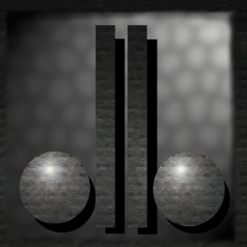
David Dionisio

Present:
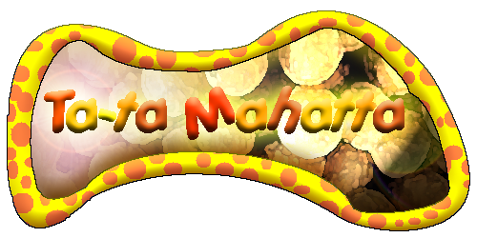

GAM 400
Technical Design Document. 1.0v
Table of Contents

Game Mechanics…………………………………………………………………..3

Platform and OS…………………………………………………………………...12

External Code……………………………………………………………………...13
Control Loop……………………………………………………………………….15
Game Object Data…………………………………………………………………16
Data Flow…………………………………………………………………………...19
AI……………………………………………………………………………………21
Game Physics and Statistics………………………………………………………22
Multiplayer…………………………………………………………………………25
User Interface………………………………………………………………………26
Game Shell………………………………………………………………………….27
Main Game Screens………………………………………………………………..29
Art and Video………………………………………………………………………31
Graphics Engine……………………………………………………………………32
Artist Instructions………………………………………………………………….35
Sound and Music……………………………………………………………………37
Level Specific Code…………………………………………………………………38
Controls……………………………………………………………………………...39
Risk Analysis………………………………………………………………………..40

Resource Allocation Estimate………………………………………………………41
If Something Goes Wrong…………………………………………………………..43
Game Mechanics

Gameplay

In the single mode, the player will be the brains behind the “ta-ta”s attempt to find the white ta-ta. The player will start of on the cloud. The cloud is the intermediary stage of the game. It has the functionality as a training stage as well as a save point and team and mission select stations as well.

The way we will handle this is by having two interfaces in the game: the menu and the game world. The menu is activated through events such as pressing the START button. The game world will always be active in the game. Whenever the menu is activated, the game world will be paused and will remain in the background while the menu takes control. The game world however, will still be able to play any active cutscene.

The game starts by loading the cloud stage and immediately activates the main menu. The cloud stage will start out with a cutscene that endlessly moves the view around the level. Once the player starts a new game, the cutscene will be removed and the player will have control of the first Ta-Ta.

Once inside the cloud, the player is limited to controlling only one Ta-Ta. The player can select and swap Ta-Ta orders in the selection room. The selection is made by pressing the button near a Ta-Ta statue. The player can only select Ta-Tas that have a statue. Once a Ta-Ta is selected, the first Ta-Ta in the roster is removed and the new one is inserted to the back of the roster. The player will have then the control of the first new Ta-Ta in the roster. YOU CAN ONLY SELECT 4 TA-TAs.

The save point is activated by pressing a button near the Ta-Ta totem. This will pop up a text indicating that the game has been saved. The game is saved to the current profile that the player selected when loading or created when starting a new game.

From the cloud the game will provide the player with 5 stages to complete.

Mission select is activated when the player gets near the level selection area. The menu for selecting a level is activated and the player can browse through the available levels. The player can select ‘confirm’ to start the selected level or select ‘return’ to go back to moving around the cloud. A model of a landscape is displayed portraying the environment of the currently selected level.

The training stage is accessible within the cloud vicinity and the player must switch between each Ta-Ta to get to the last egg for achieving the white Ta-Ta, Ta-Vatar.

There will be 10 ta-ta eggs scattered through out the 5 stages, and besides only finding them, the player must also find enough “Tender Love” and “Care” points to allow for those eggs to hatch. These points are also scattered through out the stages of the game and all must be found if the final “white” egg is to be hatched.

The hatchery menu is activated when the player enters the hatchery room inside the cloud level. The player will have information the eggs obtained as well as the number of resources. The player can select an egg and hatch it if the required resources are met.

The player profile will contain the number of resources obtained as well as eggs collected and hatched. There will also be a list in the profile that contains what items are already obtained inside the level. All items in the level are only collected once and are recorded inside the profile. The level loader will recognize which items have already been collected.

Each of the stages will contain puzzle elements, which the player will have to navigate using the different abilities, that each ta-ta possesses. Each stage also contains a boss character, which is another puzzle for the player to solve. In the final level that puzzle will require the use of the final egg, the white ta-ta. Through out the entire game the player will be free to traverse any of the levels, including the cloud to discover and solve all the puzzles since only a small team of 4 ta-tas can be taken to a level at any single given time. The player will be able to control and switch between all the units he takes with him to a level.

The levels will indeed contain puzzle elements. These puzzle elements will be a combination of level obstacles which will be discussed in Game Play Elements. The bosses are special enemies that will contain special scripted A.I. These scripts will determine the obstacles the player must face.

Once a boss is defeated, a victory event will take place and the player is returned to the cloud level with a newly accessible level.

The Ta-Tas are controlled via an input device (keyboard or game pad). The player will only be able to control the currently selected Ta-Ta. Switching controls over another Ta-Ta can be achieved by pressing the ‘Previous’ or ‘Next’ button.

Ta-Tas are limited to 3 health points so if they get hurt, one health point is reduced. Ta-Tas can instantly ‘die’ if they fall into spikes, submerge into spore areas or lose all health points. The player can remain in the level as long as he can control at least 1 ta-ta, however if the player lost all ta-tas in a single mission, the game ends. Otherwise the ta-ta’s that ‘died’ during the game appear back on the cloud.

The game displays all Ta-Tas and their respective health points on the screen for the player to keep track of. The highlighted portrait is the current Ta-Ta the player controls. When a Ta-Ta is hurt, the portrait changes to determine that they got hit. A grim portrait is displayed for the Ta-Tas who ‘died’ portraying their horrible ‘death’.

If all Ta-Tas died, a message will display indicating that the player lost and will immediately be brought back to the cloud level.

During the game, the player can press the ‘pause’ button to activate a menu. The description of the menu can be seen in In-game Options.

Game Character Design

Each character in the game (Ta-Tas, enemies, bosses) shares a basic structure. The structure includes:

Name – unique name for Ta-Ta, enemy, object and boss.

Object – this includes the graphical representation of the character, which encompass: model, texture and animation.

Location – this is the character’s location in the world.

Direction – this is the character’s orientation in the world.

Health points – this includes the maximum and current health points the character has.

Script – when this is active, the script will have control over the character.

Waypoint – when this is active, the character will navigate through the nodes of the waypoints. This also takes control over the character.

Flags – this is used for determining the status of the character such as: is hurt, invulnerable…etc.

Callback – this is used for sending messages to the creature. The callback is important for determining the behavior of the characters.

The Ta-Tas

Captain Ta-Ta – This Ta-Ta uses it’s shield to deflect enemy projectiles. Once the ‘action’ button is pressed, the animation state will change to ‘Block’. The player can only change Captain Ta-Ta’s orientation while blocking.

Ta-Ta Tug – This Ta-Ta can push blocks and frozen enemies with its enormous hands. The player can push blocks by holding the ‘action’ button and walking forward towards the block. The block cannot be pushed when another block or a character is in front. The animation state is changed to ‘push’ when pushing a block.

Tinker Ta – This Ta-Ta is used for activating switches found in levels. Once the ‘action’ button is pressed, the animation state will change to ‘Use’. A level object will be activated when the ‘monkey wrench’ hits it. This will work by extracting the two joints of the ‘monkey wrench’ and use it as a line segment to intersect with the surrounding level object.

Ta-Ta Trample – This Ta-Ta is used for smashing enemies and blocks. Once the ‘action’ button is pressed, the animation state will change to ‘Attack’. An enemy or block will get hit when the ‘mighty hammer’ collides it. This will work by extracting the joint of the hammer and use it as a bounding box to intersect with the enemy or block.

Hop-Ta-Hop – This Ta-Ta can jump from one block to another. Once the ‘action’ button is pressed, the animation state will change to ‘Jump’. The Ta-Ta will then perform a jump toward it’s current direction. Note that the player cannot control the Ta-Ta while jumping.

Frost-Ta – This Ta-Ta can freeze enemies and turn them into solid blocks. Once the ‘action’ button is pressed, the animation state will change to ‘Attack’. A particle effect will then emit from the nozzle of the freeze gun. Any enemy who comes near the area of effect will be frozen. The player cannot move Frost-Ta while firing the freeze gun.

Para-Ta-Ta – This Ta-Ta can safely glide when falling as well as survive spore areas. The Para-Ta-Ta will glide when the ‘action’ button is pressed while falling. The player can then control the Ta-Ta while falling and not take any falling damage. However, the glide has duration before going back to normal fall.

Loop-Ta-Loop – This Ta-Ta can use its whip to cross over areas with a stump or steak. Once the ‘action’ button is pressed, the animation state will change to ‘Attack’. Once the ‘attack’ animation is done, the whip will stretch to a certain length. This is accomplished by setting the whip joints location forward. Once the whip reaches a certain length, a collision is performed to determine if the whip hits a steak or stump.

Key-Key Ta – This Ta-Ta can open locked doors. Key-Key Ta’s functionality is similar to Tinker-Ta except that it is only used for opening locked doors.

Chi-Ta – This Ta-Ta can pull objects and blocks near it. Chi-Ta performs its psychic powers while the ‘action’ button is hold. This will work by creating a line segment with a certain length and pull objects and blocks that intersects the line.

Ta-Vatar – This Ta-Ta is used for closing portals. Ta-Vatar will basically be only used in the last level that will trigger a special cutscene once the final boss is defeated.

The Enemies

Funga-Bark – This enemy is immobile yet dangerous. The Funga Bark will attack any Ta-Ta who comes close to its area. The Ta-Ta will be pushed away from the area if it gets hit.

Funga-Spy – This enemy attacks any Ta-Ta spotted with its underground tentacle. A line segment is created from its eye and any Ta-Ta who intersects this line will instantly get hit. The line segment is also drawn for the player to use as avoidance.

Shroom-Guard – This enemy follows a waypoint and attacks any Ta-Ta who gets in its range. Shroom-Guards will basically just follow a given waypoint and will break from the waypoint and attack a Ta-Ta if it gets in range. The Shroom-Guard will get back to the waypoint once the Ta-Ta gets out of range.

Shroom-Shooter – This enemy endlessly shoots projectiles. The only functionality for this enemy is to shoot from its directions. There will be a delay on the projectile reloading.

The Bosses

Shroom-Pa – The big boss of the first level. Shroom-Pa will be moving around the room using the waypoints. Shroom-Pa will occasionally stop and shoot a projectile upwards. Once the projectile reach high enough (vertically) then the projectile will drop down directly towards the currently selected Ta-Ta. Captain Ta-Ta needs to block the projectile and reflect it towards the boss. Once the boss is knocked out, Ta-Ta Trample needs to attack Shroom-Pa. Once attacked, Shroom-Pa will regain conscious and return to its normal movement and attack.

Mushroom Warlord – Tall big mushroom, scald with hot or cold water to scare and make the shroom hide, you can hit him while he is "hiding". Tinker-Ta needs to operate the hot and cold water to shoot at Mushroom Warlord, depending on its state. Ta-Ta Trample can then attack the Mushroom Warlord.

Catter-Shroom – This boss remains stationary in a random spot (using waypoint nodes). Catter-Shroom will be launching underground tentacles within an area where the currently selected Ta-Ta is. Hop-Ta-Hop needs to jump on the Catter-Shroom to knock it out. Ta-Ta Trample then needs to attack Catter-Shroom while it’s knocked out. Catter-Shroom will then dig down and go up on a new random spot. Catter-Shroom will also do this after certain duration while attacking.

Fungal Tiger - Moving monster. Shoots, and does a close range attack.
Moves around in a pit, must push blocks to lock in one place and then hit.

Gameplay Elements

All gameplay elements will be loaded from the map. These will be called ‘entities’ and is parsed by the game and loaded in their rightful place. All entities will have a class name and the origin inside the level. Here is the list of entities:

Waypoint:
ID = <string name>
Index = <number>
Target = <target name> (used for camera)

Info_Null:
Targetname = <target name>

TaTa:
ID = <TaTa name> (this can be “none” to specify that we will spawn the next available Ta-Ta in the roster)
Waypoint = <waypoint name> (initial waypoint to follow)

Enemy:
ID = <Unique Enemy Name> (this is optional, perhaps used on special events).
Type = <enemy type name> (this is the enemy type: fungalBark…etc)
Waypoint=<waypoint name> (initial waypoint to follow, only works on enemies who can move).
WPMode= <waypoint mode type>

Item:
ID = <item type name>

Light:
Color = r g b (each within 0~1)
Light = <intensity value>

Some of the entities will be attached to polygons. These will be called ‘level objects’ and is parsed just as the entities will be. All ‘level object’ entities will have a class name and model index inside the level. Each ‘level object’ will also have a script attached (can be specified as ‘none’). Each script will be a section inside the main level script file. The script section is then set as: ‘[<name>_begin] and [<name>_end]. Here is the list of ‘level object’ entities:

Block:
bPushable = if the block can be pushed by Ta-Ta Tug. All blocks are breakable.
Lever:
bOn = if it is on (this flag is flipped whenever Tinker-Ta slaps it with a monkey wrench.
bOnce = if true, the lever can only be flipped once.
Target = <target name> (used to move button when pressed)
OnScript = the script to use when turned ‘on’ (script section inside the level script)
OffScript = the script to use when turned ‘off’ (script section inside the level script)

Button:
bPushable = if any Ta-Ta can push this button, otherwise only blocks can.
bOnce = if true, will remain ‘on’ once pushed.
Target = <target name> (used to move button when pressed)
OnScript = the script to use when turned ‘on’ (script section inside the level script)
OffScript = the script to use when turned ‘off’ (script section inside the level script)

Platform:
waypointID = <waypoint string ID>
bActive = if true, then this platform is moving through the waypoint.
bBackward = if true, go through the waypoints backwards.
bDoor = if true, then only the thief can activate this platform.
mode:
STOPATEND = stops once waypoint end reached.
REPEAT = reset to first waypoint once end reached.
BACKTRACE = go backwards once waypoint end reached.
spdDelay = how long it takes for this platform to get from one waypoint node to another.

Steak: (none)

Sign:
String = the string to display when the currently selected Ta-Ta touches it.

Gas:
bOn = if active.
texture = particle effect texture.

Each level will also have global entities. These global entities are activated once they are loaded. Here is the list of global entities:

Scene:
file = if this is specified, then script will be loaded from this file
script = just like the ‘level object’s, the script will be a section in the main level script file. [name_begin], [name_end].

Skybox:
TopTexture, bottomTexture, leftTexture, rightTexture, frontTexture, backTexture = texture used for the sides.

Doodad:
ModelFile = if this is specified, then doodad uses an external model rather than the map model.
angle = used to orient loaded model.
waypointID = <waypoint string ID>
bActive = if true, then this platform is moving through the waypoint.
bBackward = if true, go through the waypoints backwards.
mode:
STOPATEND = stops once waypoint end reached.
REPEAT = reset to first waypoint once end reached.
BACKTRACE = go backwards once waypoint end reached.
spdDelay = how long it takes for this platform to get from one waypoint node to another.

There will be special textures that the game elements will use. The format is: <type>_<texture name>.<jpg/tga>. We will currently only use two types: death (used for spikes), noclip (don’t collide). The rest will be interpreted as solid.

Script Variables

These are the variables inside script files used by the game.

Notation: <variable name> (<constructor parameters>)

int (int) – the basic integer value.
float (float) – floating point.
string (string) – string composed of ascii. Ex: “hello”
file (string) – file used for writing stuff, useful for debug. string = filepath.
vector3(float, float, float) – vector with x,y,z used as vector or position.

Script Functions

These are the functions inside script files used by the game.

Notation: <function name> (<parameters>)

inc_i (int i) – increment given integer i.
dec_i (int i) – decrement given integer i.
add_i (int a, int b, int c) – integer addition. a = b + c.
sub_i (int a, int b, int c) – integer subtraction. a = b – c.
mult_i (int a, int b, int c) – integer multiplication. a = b * c.
div_i (int a, int b, int c) – integer divide. a = b/c.
mod_i (int a, int b, int c) – integer mod. a = b%c.
random_i (int a, int b, int c) – integer randomization. a = random value [b,c].
inc_f (float f) – increment given float f.
dec_f (float f) – decrement given float f.
add_f (float a, float b, float c) – float addition. a = b + c.
sub_f (float a, float b, float c) – float subtraction. a = b – c.
mult_f (float a, float b, float c) – float multiplication. a = b * c.
div_f (float a, float b, float c) – float division. a = b/c.
sin (float a, float b) – sin function in radians. a = sin(b).
cos (float a, float b) – cos function in radians. a = cos(b).
tan (float a, float b) – tan function in radians. a = tan(b).
asin (float a, float b) – arc sin. a = asin(b).
acos (float a, float b) – arc cos. a = acos(b).
atan (float a, float b) – arc tan. a = atan(b).
sqrt (float a, float b) – square root. a = b^(1/2).
degtorad (float a, float b) – degree to radian. a = deg(b).
radtodeg (float a, float b) – radian to degree. a = rad(b).
random_f (float a, float b, float c) – float randomization. a = random value [b,c].
strcat (string a, string b) – string concatenate. a ← b
file_print_int (file a, int b) – print the integer b to file a.
file_print_float (file a, float b) – print the float b to file a.
file_print_string (file a, string b) – print the string b to file a.

vector3getx (float f, vector3 v) – get x component of v.
vector3gety (float f, vector3 v) – get y component of v.
vector3getz (float f, vector3 v) – get z component of v.
vector3set (vector3 v1, vector3 v2) – copy v2 to v1.

targetget (string targetname, vector3 v) – v = <target>.location.
targetset (string targetname, vector3 v) – <target>.location = v.
targetadd (string targetname, vector3 v) – add a new target with given name.

viewsetloc (vector3 v) – set world camera position to v.
viewsettarget (vector3 v) – set world camera target to v.
viewsetdelay (float delay) – set world camera delay for movement.
viewmoveloc (vector3 v) – move world camera position.
viewmovetarget (vector3 v) – move world camera target.
viewfollowwaypoint (string wayptname, int mode, float delay, int isDone) – move world camera to waypoint.
Mode: 0 = stop on end. 1 = repeat to beginning. 2 = reverse on end.
IsDone: this is set to 0 if movement is not done yet, otherwise 1.
Platform and OS

The game will have these minimum requirements:

PC
Windows NT 4.0 or later, Windows 2000
400 MHz IBM or compatible processor
64 MB RAM
Full DirectX 8 compliant 3D accelerated video card with 16MB RAM
DirectX 8.1
100% Windows compatible sound card
Keyboard

The game will have these recommended requirements:

600 MHz IBM or compatible processor
128 MB RAM
Third generation full DirectX 8 compliant 3D accelerated video card with 32MB RAM
Gamepad with at least 5 buttons

For total out of this world experience:

10 GHz ICBM processor
3.1415 GB RAM
Seventh generation full DirectX 13 compliant 4D accelerated video card with 1GB RAM
100% Windows compatible smell card
Virtual Headgear with ultra precise laser accurate high resolution
Ultra Titanium Alloy Satellite

External Code

Direct X 8.1

Most of Supper’s game tools will mainly consist of Direct X 8.1 components; Graphics engine will use Direct 3D; Sound will use Direct Sound and Music; Input will use Direct Input.

Milkshape 3D Model Format

The Graphics Engine allows loading of models made with Milkshape 3D. The model parsing and display will be developed in-house.

Milkshape 3D Model Editor

Milkshape 3D is a freeware model editor that will be used for modeling all of the characters in the game. The model editor also provides the developer model texturing capabilities and skeletal animation. The bone (joint) system in the model editor will play a crucial role in many of the game’s functionality.

QBSP Quake 3 Map Format

John Carmack allows usage of the Quake 3 map format so long as we do not use the tools from Quake 3, which we don’t. The code for loading the map is developed in-house. We will also not use anything Quake 3 related inside the maps such as entities, especially textures.

QUARK Quake 3 Map Editor

QUARK is a freeware Quake 3 map editor that will be used for editing all the levels in the game. These are the functionalities that will be needed for the map editor:

Creating solid landscapes and doodads.
Placing and editing entities:
Ta-Ta starting positions
Resources
Ta-Ta Eggs
Enemies
Creating triggers for levers and buttons.
Placing waypoints for camera, enemy AI and platforms.
Placing lighting effects and ambient sounds.
Skybox editing (which textures to use for the skybox sides)

BASS Sound Engine

The game will be utilizing the BASS sound engine for playing music and sounds. The sound library is free so long as the game is also free. Features and functionalities can be seen through this website:

http://www.un4seen.com/music/

Microsoft Visual C++ 6.0

The game will be compiled using this tool.
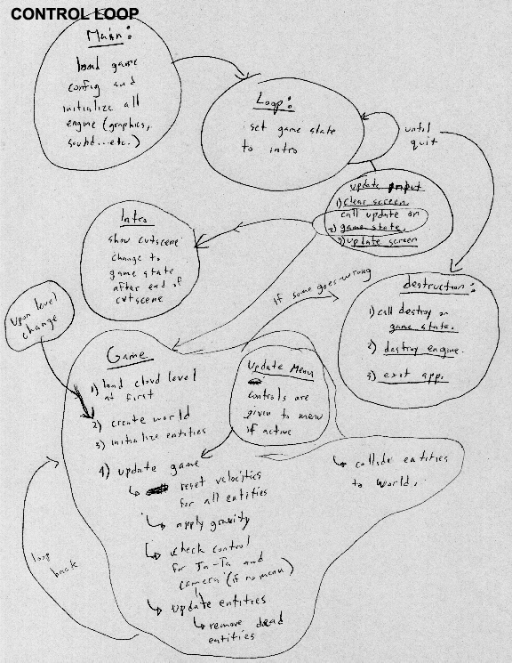
Game Object Data

Menu Objects

Key - Formal Title – (Struct Name) – Type – Description.

MenuApp – (MenuApp) Class -
This Class controls the entire menu application. An instance of this class must be instantiated if menus to be used.
MenuDirector – (MenuDirector) Class –
Support class for MenuApp. This class controls the user control and the flow of the app.

_TATA_IMPORTANT_MENU_ITEM – (TIMI) Structure. –
Main menu object, contains pointers to sprites, and all the information toward the movement and position of an object.

_SCREEN_DSC – (SCREEN) Structure
This structure contains information about each menu screen in terms of objects and loops the screen has.
_CTRL_LOOP – (CTRL_LOOP) Structure
This structure contains information about an individual user control loop and all the items the loop encompasses.

DaList – (daList) Class
Support array based templatized link list used to store menu data.

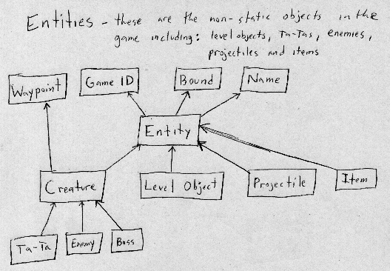
Waypoint - the waypoint consists of a linear list of 3D coordinates. Entities that inherit the waypoint system can call update to follow the path through the coordinates linearly or in curve motion.

Game ID – each entity will have a unique ID in the world. The ID is then queried later on by update. Anything goes after that.

Bound – bound is used for collision that includes the model index (if the entity is a level object) and the Axis Aligned Bounding Box.

Name – name is a unique ID used for scripting language. The difference between Game ID and Name is analogous to the difference between a person’s Social Security number and Full Name.

Level Object – level object holds all the basic common data used by all level object types, such as: block, platform and switches.

Projectile – projectile holds all the basic common data used by melee and ballistics.

Item – item holds all the basic common data used by resources and eggs gathered by the Ta-Tas.

Entity – entity holds all the basic common data used by creatures, level objects, items and projectiles.

Creature – the creature is a common interface used by Ta-Tas, enemies and bosses.

Ta-Ta – the Ta-Ta is a common interface used by each of the different types of Ta-Ta.

Enemy – the enemy is a common interface used by each of the different types of enemy.

Boss – the enemy is a common interface used by each of the different types of boss.

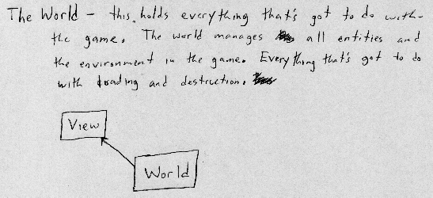 View - the view is the player's visual representation of the world.

World – the world holds everything. Contains the list of Ta-Tas the player controls and the player profile.
Data Flow

Menu Object Flow
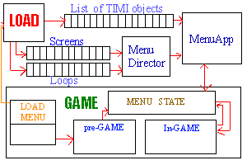
This is a diagram detailing the data flow of the menu system. Once loaded, the MenuApp with the help of the MenuDirector will control the flow of the menu items.

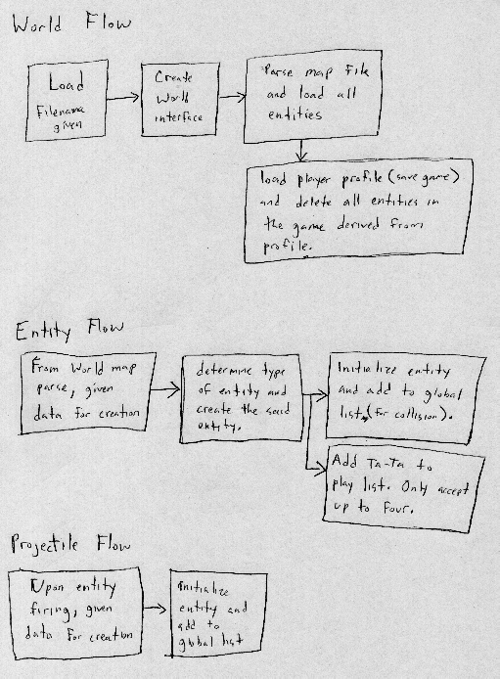
AI

The AI in the game will be basic and very simple. First and foremost, there is no AI. We will simply create an illusion to make the player believe that there is one. This can be achieved by creating a script for the enemy. The realism thus relies on how well the AI script is made.
Game Physics and Statistics

Collision Intersection

There are three types of collision:

AABB (Axis Aligned Bounding Box) – your regular everyday pal for collision. This is represented by a min and max bound.

Sphere Bound – the sphere collision represented by a radius.

Convex Polyhedron – this is obtained in the level data that is composed of planes that constructs the volume of the convex polyhedron.

Intersection is determined by a parametric line equation: p0 + t*(p1-p0).

AABB to Convex Polyhedron Collision – the way this will work is by casting a ray based on the line segment (parametric) p0 + t*(v0), v0 = p1-p0. We will then intersect the ray with a brush from the map. A brush contains the convex polyhedron consisting of planes. These are represented as half spaces (defined by having front and rear space).

Before intersecting with each plane, we must push the plane closer to the origin of the ray based on the min, max of the bound box. Translating the plane does this:

for (j=0 ; j<eMaxPt ; j++)
{
//create the translation based on the normal and min,max
if (pPlane[j] < 0)
ofs[j] = max[j];
else
ofs[j] = min[j];
}
d = pPlane[eX]*ofs[eX] + pPlane[eY]*ofs[eY] + pPlane[eZ]*ofs[eZ];
d += pPlane[ePD];

AABB to AABB Collision – this works the same way as the convex polyhedron except that we use special cases to make collision faster. We again use a ray to collide, but with AABB instead. The AABB is pushed closer to the origin of the ray by adding min and max to AABB.

Collision Response

Once intersection is done, we obtain a trace data that contain:

t = the time interval within p0 and p1. t < 1 means we intersect.
bAllSolid = the whole line segment is inside.
bStartSolid = p0 is inside, this means t < 0.
normal = the normal obtained from the intersection.
d = the plane element ‘d’ a.k.a plane distance from origin.
txtInd = texture index inside the map.

We can now move p0 with t*(p1-p0), t must be subtracted by a small tolerance. Once this is done, we need to do several things:

Sliding – we require that objects slide from walls, this is so that players don’t stick to walls. Note: we will not apply any friction.

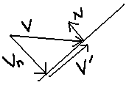
Vn = V*(dot(N,V)
V` = V – Vn

Once V` is achieved, we will check for collision again.

Stairs – a game such as this would certainly require that players are able to go up stairs (going down is no problem). Since we are colliding to the world with a bounding box, one slight change of height can hinder the player’s movement. We solve this by having another line segment check to see if the path forward is clear. Illustration:
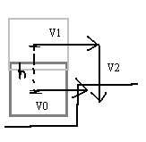
V1 is a new ray with the y component of V1.pt added by h. If V1 does not intersect, proceed with V2 check.

Game Movement

The movement in the game will be based on time. This means that objects and characters in the game will travel in distance over time, rather than distance over iteration. Our current plan:

Init:
TimeSetDelay(millisecond);
Update:
SpdAmt = TimeGetTime();
TimeReset();

We then create the vector Vel = Direction (normalized) * spdAmt. The new velocity is then added to the total velocity of the object/character.

The game will also have some sort of gravity applied to the objects (only blocks) and characters. Gravity will basically be a global speed that will always be added to the total velocity of the object/character.

Once all movement is done, we can then use the velocity to intersect with the world.

NOTE 1: All projectiles also use the same method for movement.
NOTE 2: Total velocity must be reset to 0 in update first before anything else.

Game Statistics

The game will have basic statistics, as this is not a typical game. We will only keep track of health points for characters (current and max). Whenever a character is hit, the ‘ouch’ animation is played. After getting hurt, the character will fade-in and out indicating that it is invulnerable. This will only last a few seconds.

Other statistics will be the resources gathered. This data will be directly stored in the player profile.
Multiplayer

Since Ta-Ta Mahatta’s focus is on single player game experience, multiplayer will not fit well. Besides that, there is not enough manpower to provide the game multiplayer capabilities. As of now, there are no plans on creating multiplayer this semester.

There will be no further discussion about multiplayer until the single player game is totally complete.
User Interface

Menu Control
The menu system will always rely on select/deselect form of activation. User in the “options” screen will preset actual key used.
The user will navigate through menus in a loop system; each loop will use only one type of directional movement such as up/down or left/right. A screen may contain more then a single control loop, child loops can be set under parent control items.

SELECT – Activate currently selected option.
CANCEL or ESC- Cancel selection, Exit control loop.
LEFT/RIGHT or UP/DOWN-
SWITCH ITEM SELECTION – If the direction is the same as the loop type direction, the item selected will be switch depending on the direction pressed.

SWITCH ATIVE LOOP – If the direction is different then the loop type direction, the loop will be exited to a parent loop. If no parent loop is present no action will be registered.
Game Shell

Start Menu –
The initial menu that will be provided for the user is outlined as follows:

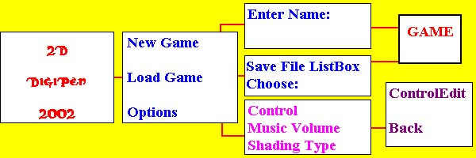
Project Introduction Screen

Main Menu –
Contain 3 animated buttons that link to next screens.

Enter Name –
Screen containing a title and input box for game file name.

Load Game –
Screen containing a title and a list box with all gam.sav files found.

Options Screen –
Screen containing a title, link to control edit screen, music volume bar, and a check box for a types of shading(2 types).

Control Edit room –
This screen contains a title and a list of 9 keys with small edit boxes. 3 Keys for “Reset” and “Save”, as well as “Back” will also be present.
In-Game Menu –
The player will be able to access an option screen by pausing the game. The following options will be available to the user.

Return to Cloud – This option takes the player back to the main option stage.

Options – This option screen will present the user with the similar options given at the game entrance.

Un-pause – Return to the current game.

Leave Game Menu –
If the player looses all the Ta-ta’s that wee under his control, he will be taken to the GAME OVER screen. From which any button press will take him to the main title screen.

If the player defeats the last Boss of the 5th stage, he will be taken to a GAME END screen, where a congratulations message will tell the player of our thanks for playing the game. Main title will be the next destination.
Main Game Screens

In-Game Menu
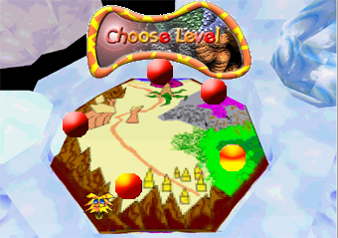
Screen 1: Level Select

In the level select, the user will navigate amongst the levels in a circular fashion. Player selected level will be in orange and have a cursor next to it, the current level that is selected for entrance will be high lit in yellow.

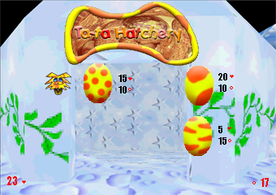
Screen 2: Ta-ta Hatchery
In the hatchery the player will be able to see the un-hatched eggs he currently has, also the quantity of each item he has collected, and the price of the eggs in term of those quantities. The cursor will show the currently selected egg.

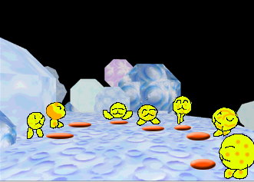
Screen 3: Ta-ta selection.
Ta-ta’s will be selected by stepping on the buttons in front of the still of the ta-ta type. The change in configuration will be displayed using portraits in the HUD.

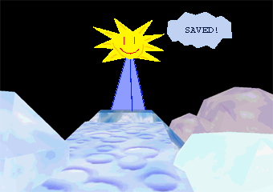
Screen 4: Save Game.
The save point will be automatic, and activated by stepping on a button in front of it.

Out-Of Game Menu
The menu screens for the main game option and mode selection will be similarly displayed to the previously shown shots. The background of those screens will be the cloud level and the camera will fly through the terrain while the user makes his/her selections.
Art and Video

Ta-Ta Mahatta will not use any streaming video technology (for some unfortunate reason), but might do so in the future. The game will consist of 3D Models and 2D sprites. All 3D models will be loaded from MS3D files. The textures associated with the model will be loaded from JPEG or TGA files. These images will be encoded and loaded by the Direct 3D texture file parser. This may sound cheesy, but anything to help lighten the workload for the game is always valuable.

All textures and images in the game will have a 24-bit color depth. Some of the images in the game may be loaded from 32-bit TGA file formats. These will provide some of the look and feel of the game. These are all great aspects that will provide good quality and less work. Again, these images can be loaded with Direct 3D. All images are to be created with several different image-editing packages. All final editing of images will be made with Adobe Photoshop, which is provided by Digipen.

The MS3D file format will provide the loading of the object and it’s animations in one file. These files do not have any compression scheme. Therefore loading them is straightforward. All model editing and animation are done in Milkshape 3D.

All sprites in the game will be loaded from a file containing rectangle offsets within a given image. These are loaded and parsed by the graphics engine. The file format does not contain any compression scheme and is in ascii format. Creating the sprites will only consist of using a notepad, enough said.

All objects, textures and models are stored in an internal list inside the Graphic Engine. Upon update scene, all objects in the list are displayed. An object includes all models that are in a hierarchy and has all the transformation from model to space. Both model and textures are static once loaded.
Graphics Engine

There are many aspects in the graphics engine that will make you go ‘wow!’ These are fully provided thru Direct 3D 8 manipulation. Most visual aspects of the game will have to wait until a fully playable version of the game is finished. Still, most of ‘em are still fantastic and will still make you go ‘wow!’

All of these features will be developed by one of the team member. All of the features are already completed. As soon as Alpha is done, more features will be implemented if enough time is allocated.

Skeletal Animation – This gives all characters smooth animation and provides functionality to some parts of the game. This also provides key frames for animation.

The skeleton of a model is connected using ‘joints’ that follow a hierarchy. These joints are labeled. Each vertex has the label of the joint assigned to it. Each joint basically has a final transformation and is concatenated to the next joint attached. The way this is kept track of is by having two matrices: relative, the transformation of the joint from its parent and absolute, the original transformation of the joint. Each joint also contains the local transformation and rotation that is used by creating these matrices.
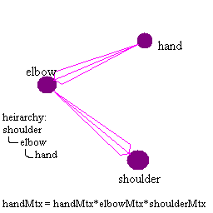

Camera Pathing – This enables more realistic camera movement in the level, allowing the player to virtually acquire the sensation of roller coaster ride.

We will implement the Cat-Mull-Rom spline interpolation for the movement of the camera. Cat-Mull-Rom-Whatever-The-Heck spline is basically a special case of Hermite spline. We use this spline because Hermite spline requires the tangent for each point node and Cat-Mull-Rom spline gets rid of this hassle.

How does it work? Here’s the equation for Hermite Spline, a mathematical explanation will take up more space…oh 10 or so pages…But I won’t, so go buy a book about curves if you want to learn this formula:

VertexFinal = h0*Vi + h1*(Vi + 1 – Vi – 1) + h2*(Vi + 2 – Vi) + h3*Vi + 1

Where:

h0 = 2t^3 – 3t^2 + 1
h1 = -2t^3 + 3t^2
h2 = t^3 – 2t^2 + t
h3 = t^3 – t^2

Remember that Hermite Spline or Cat-Mull-Rom requires four vertex for it’s input.
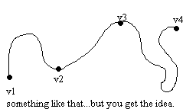

3D world – This is the big one and the most important part of the graphics functionality. This enables us to render the levels as well as store collision data used by the game.

The map is a BSP (Binary Space Partition) structured static world, but it’s more than that. Remember that a BSP tree splits the world into two spaces (back and front) and builds a tree with it. This is great and dandy but the problem is that it will require that you split the polygons and that means more triangles to render. This is fixed by creating PVS (Potential Visibility Set) for each node of the tree. This is used to tell us what is ‘potentially’ visible at a given leaf of a tree. The way this is generated is by looking at every possible direction in a given leaf and stores a flag to the leaf to indicate which ones are visible. So when we traverse the tree and find the leaf we are at, we simply just check which faces the leaf can see and render those.

Another feature inside the map are the brush information for each face. These are a bunch of planes that form a convex polyhedron. Rather than colliding with each triangle, we simply just use the brushes. The brushes are stored in the same manner as the faces, inside the BSP tree.

The map also stores the data of where characters and objects are located. These are read inside the map file in text format. The game will be given this data and parse it at it’s own accord.

Particle Effects – the sparkles that bedazzles the player into a frenzy trance is but a simple coalition of bitmaps thrown out to the screen. Random functionality and nonsensical formulas is what makes up these particle effects. Here are the following particle effects that the graphics engine will provide:

3D object explosion – a bunch of non-animating 3D models exploding from an area.

Puff emission – puffs emitting from a point moving in a direction and fading away.

Gas area – gaseous particles randomly produced within a bounding area.

Sparks – explosion of particles starting from a point and fades away upon reaching the edge of the radius.

2D image display – the basic two-dimensional display of images on the screen using the good old top-left x=0, y=0 position. The implication of this statement is too basic to discuss for technicalities. For this reason, we will simply just list the functionality:

Alpha blending and colouring – the graphics engine will provide this functionality by having the required input: R, G, B and A.

Scaling – allow stretching of images, no problem. Simply just give the
Destination X, Y and width, height.

Rotation – allow rotation of images. Input requires an angle for rotation.

Animation – frame based animation with delay and states. There will be a sprite interface provided by the graphics engine.

Billboards – the idea behind billboards is having a flat image be displayed facing the viewer at all times. Think of it as annoying ads you find when you travel across the cities and you get the idea. They always face you, mocking you in every possible way. This is mostly used by the particle effects and will still be available for the game if the need arise.

Skybox – the skybox is a trick to fool you in believing that there are far away lands to explore. The skybox is composed of 6 sides: top, bottom, left, right, front and back. These sides are the first thing rendered (depth buffer disabled). The camera has to be centered inside the box before rendering.
Artist Instructions

Format:

Menu/Textures – all menus/textures in the game will consist of 2D art generated by any graphical editors. The ideal format for these images will be JPEG, as this will reduce the disk space required for the game. Although JPEG does not have support for alpha channels, the image will then use TGA image format. All images must have a size of 2^n by 2^n (n > 0), this is a limitation in the graphics engine.

Models – the graphics engine of the game will support a format used by a model editor called ‘Milkshape 3D'. Models can be done in 3DS Max as well and can be imported to Milkshape 3D for the game to use. However, all animations will be done in Milkshape 3D. All model textures will have the limit size of 256x256.

Levels – the levels will be made by a map editor called QUARK and will be compiled to a different format that the game uses. QUARK is a freeware level editor.

Sky Box – each level will have a skybox. For the skybox, we will simply require a texture for each side of the box: top, bottom, left, right, front and back.

Style:

The game will have a cartoony feel to it. As such, the models will be simple and yet compelling. Textures will have various colors to it and must stay far away from the human perspective of ‘reality’. This task can be both easy and daunting at the same time. We must then require that the artist team to be creative and highly imaginative.

Conventions:

All models must be stored in their appropriate folders:

Ta-Tas - <drive>:\Ta-Ta Mahatta\Main\Models\TaTa
Enemies - <drive>:\Ta-Ta Mahatta\Main\Models\Enemies
Items - <drive>:\Ta-Ta Mahatta\Main\Models\Items
Doodads - <drive>:\Ta-Ta Mahatta\Main\Models\Doodads
Others (projectiles…) - <drive>:\Ta-Ta Mahatta\Main\Models\Misc

All model textures must be stored in the same place as the models. The filename must have this format:
<model file name>_<whatever>.<image ext>
All other textures will be stored in the texture folder:

Menus - <drive>:\Ta-Ta Mahatta\Main\Textures\Menu
Particles - <drive>:\Ta-Ta Mahatta\Main\Textures\Particles
Skybox - <drive>:\ Ta-Ta Mahatta\Main\Textures\Skybox
Map - <drive>:\ Ta-Ta Mahatta\Main\Textures
Sound and Music

Ta-Ta Mahatta’s sound engine will utilize the power of BASS sound system. BASS will provide us the functionality to load and play sounds without all the hassle. The sound system provides functionality for 3D sounds which the game will take advantage of.

All sounds will be loaded from MP3 files. We need the sound quality to be at most 44kHz and 16-bit. BASS provides all the needs for storing the resources of all sounds and hence will not be further discussed.

All music will be loaded from MP3 files as well. Not much to say, play the music and there you go.

The way we will handle sound in the game is to have each creature have a list of sound. We do not have to worry about duplicate sounds since BASS does the management. All ambient sounds will be loaded to a global list where they will be played endlessly.

Music is simply just played, no plan for anything fancy yet…
Level Specific Code

All level specific codes are made inside the script engine. All script functions are found in Game Play Elements under Script Variables and Script Functions.
Controls

There are two ways the player can use for controls in the game: keyboard or gamepad. Since many players do not have a gamepad, the keyboard will still be available for input.

The game will only allow one input configuration. The input is initialized based on the data given from the game config. Players can configure the controls via a menu in the options screen.

The following are the description of different input the game uses:

Up/Down – this is used to navigate the menu as well as moving the currently selected Ta-Ta forward and backward. This is used to look up and down if the B button is on hold.

Left/Right – this is used to navigate the menu as well as rotate the currently selected Ta-Ta clockwise and counter-clockwise.

A button – this is used as the ‘confirm’ button in the menu as well as the action button for the currently selected Ta-Ta.

B button – this is used as the ‘cancel’ button in the menu as well as the look-around button for the currently selected Ta-Ta. For look-around, the player must hold this button. While on hold, the player can then use the direction to look around.

C button – this is used to switch the currently selected Ta-Ta to the previous Ta-Ta in the play list.

D button – this is used to switch the currently selected Ta-Ta to the next Ta-Ta in the play list.
Risk Analysis

Production Risks
The only risk that the team is making is in generation of all resources for the game.

Version Control
Certain circumstances are known to cause strange version control updates by the Visual Source Save, and the team is being “very careful” when submitting updates to the project and maintains constant schedule of project updates on each machine.
Resource Allocation Estimate

Weeks Remaining: 5 before IGF

Weeks Remaining: 8 before Final Deliverable

David Dionisio’s To-Do List:

October 14 – 21 (Hell week):
Ta-Ta Tug animation and functionality
Tinker Ta animation and functionality
Ta-Ta Trample animation and functionality
Level Object: Lever, sign, steak and door working.
Integrate Menu interface to game.
Integrate cloud level to game. (Include all menu interfaces such as: Ta-Ta select, level select, egg hatching.)
HUD (show current Ta-Ta selected, hitpoints)
Ouch and Death.

October 21-28 (Not so Hell week):
Shroom Shooter functionality.
Funga Bark animation and functionality.
Shroom Guard functionality.
Resource gathering (items and such).
Level 1 complete and integrated to game.
Shroom-Pa animation and functionality.

October 28-November 4:
Funga-Spy animation and functionality.
Hop-Ta-Hop animation and functionality.
Para-Ta-Ta animation and functionality.
Integrate level 2 to game.
Mushroom Warlord complete.
Testing, bug fixes.

November 4-11:
Frost-Ta animation and functionality.
Key-Key Ta animation and functionality.
Chi-Ta animation and functionality.
Testing, bug fixes.

November 11-18:
Finish up stuff for IGF submission (November 15).
Level 3 complete and integrated to game.
Integrate level 4 to game.
Catter Shroom animation and functionality.
Fungal Tiger functionality.

November 18-25:
Ta-Vatar animation and functionality.
Level 5 complete and integrated to game.
Evil Mushroominoid functionality.

November 25-December 2:
Testing and bug fixes.
Any work not done, insert here.

December 2-till winter break:
Any work not done, insert here.
Is this game fun?
No? Fix stuff to make the game fun.
Easter eggs…(I’ll never tell!)
Ta-Ta poster and any other artsy stuff for marketing.

Dimitry Kudlay:

October 14 – 21:
1 character animations.
finish menu integration

October 21-28:
1 character animation
menu control edit menu.

October 28-November 4:
level design
3rd character animation.

November 4-18:
Work on post deadline assignments.
In Case Something Goes Wrong List

In an event of any risk happening, this is the list to look at if something goes horribly bad. The list will show the guaranteed implementation, the ‘if something goes wrong’ and the ambitious list. This is the list to look at if any of the requirements in this document is missing when the final game for IGF submission. The guaranteed list should all be available. The other lists are the ones that might not be added for IGF submission.

The Guaranteed Implementation List:(Required)

- 4 completely playable Ta-Tas (Captain Ta-Ta, Ta-Ta Tug, Tinker-Ta, Ta-Ta Trample)
- All four enemies.
- One completely playable level.
- Cloud level.
- One boss (Shroom-Pa)
- Resource gathering and egg hatching.
- All level objects.
- Collision Detect (good enough to play through the first level)
- Menu Interface
- Saving/Loading player profile

The ‘if something goes wrong’ List:(If there is Exception)

- All Ta-Tas playable.
- Second level complete.
- Fully working collision (platform)
- Complete menu for entire game.
- Music
- Sounds
- Intro

Ambitious List: (If there is time)

- Vertex Shading.
- Pixel Shading.
- Easter Eggs…

