**Tugas 1 Sistem Tersemat**



**Oleh:**

D121171519 - Glenn Claudio Ivan Petrus

**Departemen Teknik Informatika**

**Fakultas Teknik**

**Universitas Hasanuddin**

**2020**

**Diagram *Sketch***

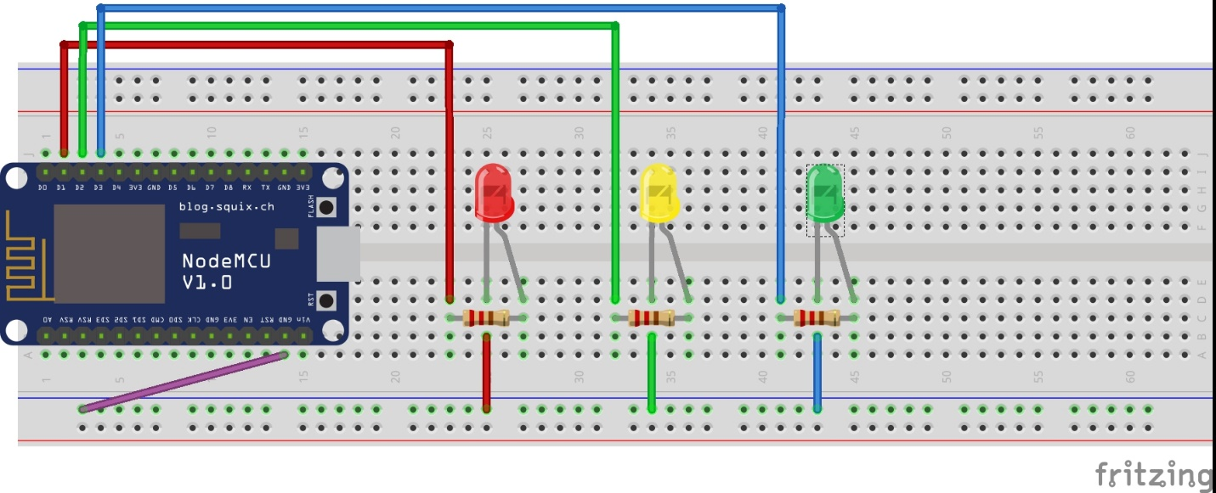

**Kebutuhan Bahan**

|  |  |  |  |
| --- | --- | --- | --- |
| **Bahan** | **Jumlah** | **Nilai** | **Keterangan** |
| LED 5MM | 3 pcs |  | Warna Merah, kuning, dan hijau |
| Resistor ¼ watt | 3 pcs | 220 Ohm |  |

***Source Code***

int redLED = 5; // Pinout D1 is connected with LED (red) anode

int yellowLED = 4; // Pinout D2 is connected with LED (yellow) anode

int greenLED = 0; // Pinout D3 is connected with LED (green) anode

void setup() {

pinMode(redLED, OUTPUT);

pinMode(yellowLED, OUTPUT);

pinMode(greenLED, OUTPUT);

}

void loop() {

digitalWrite(redLED, HIGH); // LED (red) is ON

digitalWrite(yellowLED, LOW); // LED (yellow) is OFF

digitalWrite(greenLED, LOW); // LED (green) is OFF

delay(2000);

digitalWrite(redLED, LOW); // LED (red) is OFF

digitalWrite(yellowLED, HIGH); // LED (yellow) is ON

digitalWrite(greenLED, LOW); //LED (green) is OFF

delay(2000);

digitalWrite(redLED, LOW); // LED (red) is OFF

digitalWrite(yellowLED, LOW); // LED (yellow) is OFF

digitalWrite(greenLED, HIGH); //LED (green) is ON

delay(2000);

}