Module 1 : Introduction to Generative AI

What is Generative AI?
Generative AI is a type of artificial intelligence designed to create new content such as text, images, music or even code by learning patterns from existing data. These models generate original outputs that are often indistinguishable from human-created content. These models use techniques like deep learning and neural networks to generate output.
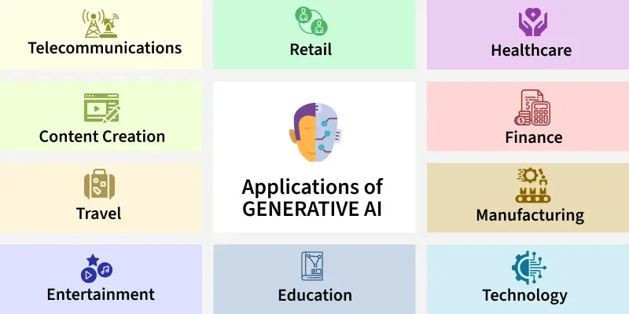
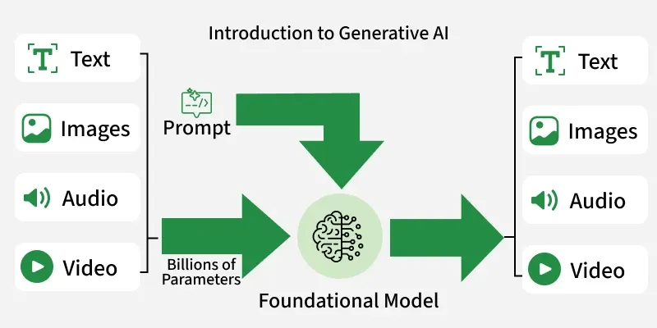

ChatGPT is a prime example of Generative AI, a type of artificial intelligence that creates new content, like human-like text, code, images, and more, rather than just analyzing existing data. It uses large language models (LLMs) to understand prompts and generate original, contextually relevant responses, making it a powerful tool for conversation, writing, and creative tasks.


History and Evolution of Gen AI

1950s–1970s: Theoretical Foundations and Early Rule-Based Systems
- 1950s: Alan Turing introduced the Turing Test, proposing that machines could simulate intelligent behavior.
- 1957: Frank Rosenblatt introduced the Perceptron, the first artificial neural network.
- 1964–1966: Joseph Weizenbaum developed ELIZA, the first chatbot, which used pattern matching and substitution to simulate a psychotherapist.
1980s–1990s: Neural Networks and Initial Machine Learning
- 1982: John Hopfield introduced Hopfield networks, allowing neural networks to learn.
- 1997: Long Short-Term Memory (LSTM) networks were developed to handle long-term dependencies in sequential data.
2000s–2010s: Deep Learning and Revolutionary Models
- 2013: Variational Autoencoders (VAEs) emerged, enabling the generation of new data samples.
- 2014: Ian Goodfellow introduced Generative Adversarial Networks (GANs), which enabled high-quality image generation by using two competing neural networks.
- 2015: Diffusion models were introduced, adding noise to data to train models to generate high-fidelity images.
- 2017: The Transformer architecture ("Attention is All You Need") was introduced, which dramatically improved sequence modeling and allowed for parallel processing, forming the basis of modern LLMs.
2020s: The Era of Large Language Models (LLMs) and Mainstream Adoption
- 2020: OpenAI released GPT-3, demonstrating that large-scale models could generate human-like text with high versatility.
- 2021: Text-to-image models like DALL-E (OpenAI) were introduced, followed by Stable Diffusion (2022).
- 2022: The launch of ChatGPT in November 2022 marked an "iPhone moment" for AI, bringing generative capabilities to the public, with 100 million users in two months.
- 2023–2024: Introduction of multimodal models like GPT-4, Google Gemini, and Meta Llama, capable of processing text, image, audio, and video.
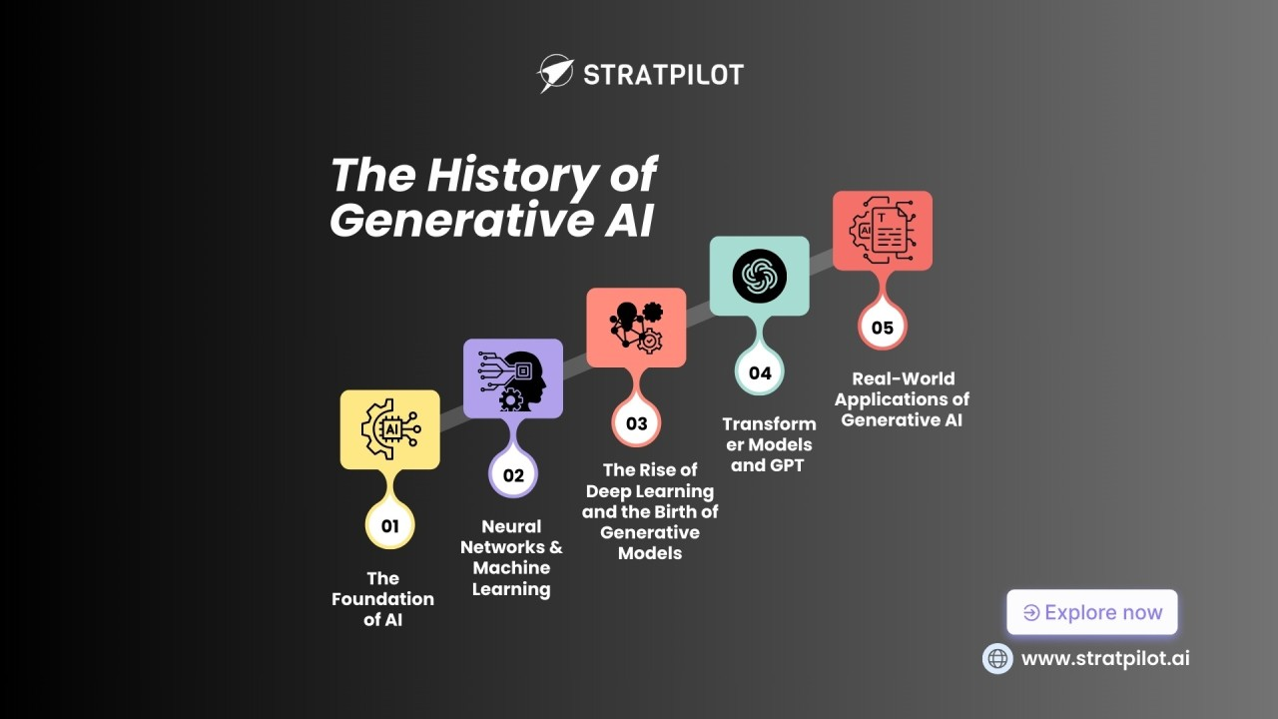

Use Case Across Industries

Cross-Industry Applications
Content Creation: Generating marketing copy, articles, code, images, and video scripts.
Customer Experience: Powering intelligent chatbots, virtual assistants, personalized recommendations, and language translation.
Data Analysis: Augmenting datasets with synthetic data, summarizing reports, and generating business intelligence.
Workflow Automation: Streamlining HR tasks (job descriptions), finance (documentation), and legal (document review).
Knowledge Management: Quickly accessing and synthesizing insights from vast amounts of unstructured data.
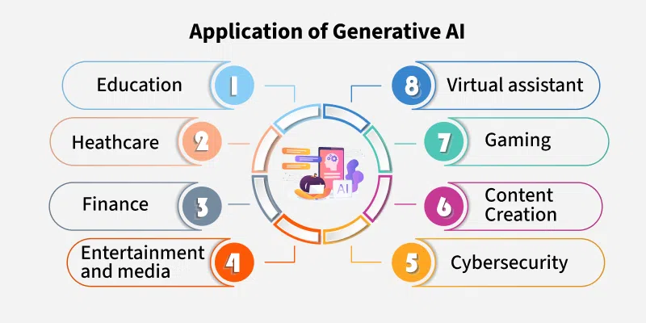
Industry-Specific Examples
Healthcare: Drug discovery, personalized treatment plans, automated transcription, medical image interpretation.
Finance: Fraud detection, personalized financial advice, automated underwriting, risk assessment, error-free transactions.
Manufacturing: Generative design, optimizing production processes, quality control, predictive maintenance.
Retail/E-commerce: Virtual try-ons, personalized shopping, optimizing pricing, conversational commerce.
Legal: AI-powered legal chatbots, document analysis, advice generation, contract review.
Marketing/Media: Targeted campaigns, content personalization, creative asset generation.
Automotive: Vehicle design, customer service, production optimization.
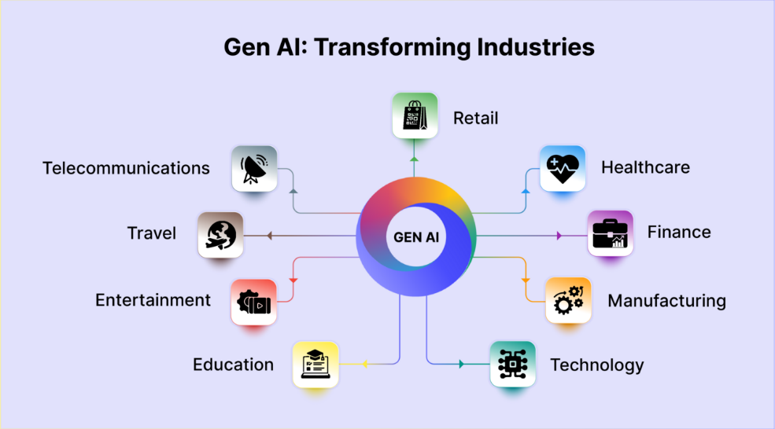

Ethical Considerations in Generative AI

Ethical considerations for generative AI involve preventing bias, ensuring data privacy, protecting intellectual property, combating misinformation (deepfakes), maintaining accountability, managing job displacement, and addressing its environmental cost, requiring transparency, human oversight, fair data practices, and robust governance to balance innovation with societal responsibility. Key issues include how models learn biases from training data, potential misuse for fraud or harmful content, user data security, copyright infringement, and the need for clear human responsibility when AI outputs go wrong.
Ethical Concerns
Bias and Fairness: AI models trained on biased data can perpetuate or amplify societal biases, leading to discriminatory outputs.
Data Privacy & Security: Generative AI uses vast datasets, raising concerns about sensitive user information, consent, and potential leaks.
Intellectual Property (IP): Training on copyrighted material and generating content that mimics existing works creates complex ownership and infringement issues.
Misinformation & Malicious Use: The ability to create realistic deepfakes, fake news, and harmful content (hate speech) threatens trust and security.
Transparency & Explainability: The "black box" nature of some models makes it hard to understand their decisions, hindering accountability.
Accountability: Determining responsibility when AI generates errors, harmful content, or infringes on rights is challenging.
Job Displacement: AI's ability to automate creative and knowledge-based tasks raises concerns about workforce impacts and the need for reskilling.
Environmental Impact: Training large models requires significant energy, contributing to carbon footprints.

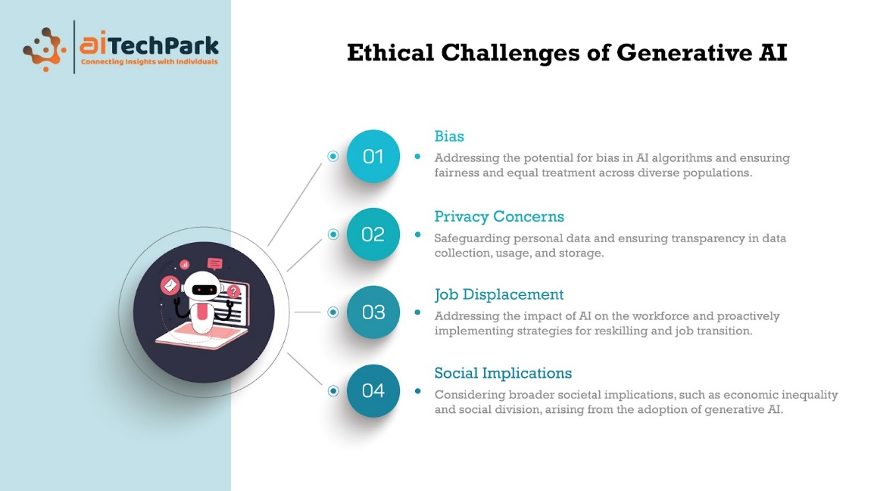
Addressing the Challenges
Ethical Frameworks: Developing clear guidelines, industry standards, and regulations for responsible AI development.
Transparency & Disclosure: Clearly labeling AI-generated content and explaining AI's role.
Human Oversight: Maintaining "human-in-the-loop" systems for critical decisions and ensuring accountability structures.
Data Governance: Implementing strong privacy-preserving techniques and obtaining consent for data usage.
Public Education: Raising AI literacy to help users critically evaluate AI outputs and understand risks
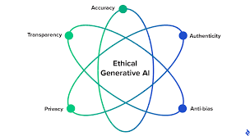
Generative AI vs Predictive AI
Generative AI
- Goal: Create novel, original content.
- Process: Learns underlying data patterns to generate new samples (e.g., a new sentence, image, or song)
- Output: Text, images, audio, code, synthetic data.
- Models: Transformers, GANs (Generative Adversarial Networks), Diffusion models.
- Use Cases: Brainstorming, content creation, chatbots, art, design.
Predictive AI
- Goal: Forecast future events or classify existing data.
- Process: Analyzes historical data to identify patterns and estimate probabilities.
- Output: Numbers, labels, classifications, scores (e.g., "likely fraud," "high-risk customer").
- Models: Regression, classification algorithms (often simpler ML).
- Use Cases: Fraud detection, recommendation engines, sales forecasting, risk assessment.
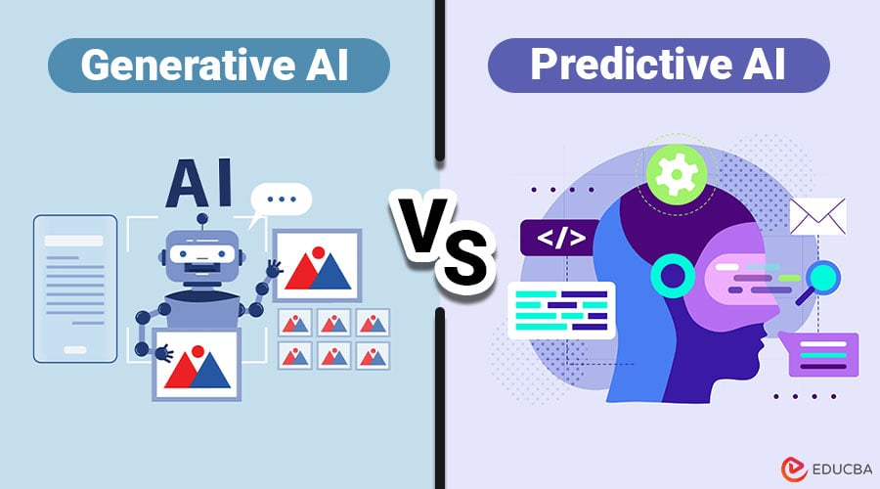

Aspect | Generative AI | Predictive AI
Primary Purpose | Creates new content or data | Predicts future outcomes or probabilities
Core Question Answered | “What can I create?” | “What will happen?”
Output Type | Text, images, audio, video, code, synthetic data | Numbers, categories, risk scores, forecasts
Data Usage | Learns patterns to generate novel outputs | Learns patterns to estimate future events
Creativity Level | High – produces original content | Low – focuses on accuracy, not creativity
Typical Models | Large Language Models (LLMs), GANs, Diffusion Models | Regression, Classification, Time-Series, Decision Trees
Training Objective | Generate realistic and coherent data | Minimize prediction error
Interaction Style | Conversational, interactive | Analytical, often behind the scenes
Examples | Chatbots, image generation, music creation, code assistants | Demand forecasting, fraud detection, churn prediction
Business Use Cases | Content creation, design, customer support, ideation | Sales forecasting, credit scoring, predictive maintenance
Risk Factors | Hallucinations, bias, IP concerns | Model drift, data leakage, bias
Evaluation Metrics | Fluency, coherence, human judgment | Accuracy, precision, recall, RMSE
Real-World Tools | ChatGPT, DALL·E, Midjourney | SAS, scikit-learn, XGBoost

