LegalEase: AI-Powered Legal Document Generator

Project Description:
LegalEase is an AI-powered web application designed to simplify the process of creating legal documents. It helps users generate commonly required legal documents such as rental agreements, affidavits, employment agreements, non-disclosure agreements, and other basic legal forms by collecting relevant information through a simple user-friendly interface.
The system uses Artificial Intelligence and Natural Language Processing (NLP) to convert the user's inputs into a structured legal document. It provides appropriate templates, automatically fills the required details, and generates a downloadable document in a standard format. The system can also provide basic explanations of legal terms to help users understand the generated document.
The main objective of LegalEase is to reduce the time, complexity, and effort involved in preparing basic legal documents, while making the process more accessible to users without requiring advanced legal knowledge. It is intended as a document-generation and assistance tool and does not replace professional legal advice.

Scenarios

Scenario 1: A startup founder enters details about a new employee and selects “Employment Contract” as the document type. LegalEase generates an agreement covering the employee’s role, responsibilities, salary, and confidentiality. The founder can customize the content, add the company logo, and download it as a PDF.

Scenario 2: A freelancer needs a Non-Disclosure Agreement (NDA) for a new client. The freelancer enters the details of both parties, confidential information, and effective date. LegalEase generates a structured NDA that can be reviewed, edited, and downloaded.

Scenario 3: A landlord wants to create a residential lease agreement. The landlord enters the property address, tenant details, rent, and lease duration. LegalEase generates a formatted and editable agreement that can be downloaded in DOCX format.

Pre-requisites

- FastAPI Knowledge: Basic understanding of FastAPI. — FastAPI Docs

- Gemini API: Familiarity with Google Gemini API. — Gemini API Docs

- Streamlit: Basic knowledge of Streamlit UI development. — Streamlit Docs

- Python: Basic Python programming skills. — Python Docs

- Environment Setup: Required Python packages and development environment.

Project Workflow
Activity 1: Model Selection and System Architecture
- 1.1: Select AI Model: Choose Google Gemini API for generating and processing legal documents.
  - 1.2: Design System Architecture:
  - Frontend: Streamlit for user input and document preview/download.
  - Backend: FastAPI to manage requests and application logic.
  - AI Module: Gemini API for generating legal document content.
- 1.3: Configure Environment: Set up the Python environment and store the Gemini API key securely in a .env file.

Activity 2: Core Functionality Development
- 2.1: Develop Document Features:
  - Generate different types of legal documents.
  - Provide an editable document preview.
  - Support export in .txt, .docx, and .pdf formats.
- 2.2: Develop FastAPI Backend:
  - Create a /generate API endpoint.
  - Accept document type, party details, terms, and dates.
  - Send the inputs to Gemini and return the generated legal content.
Activity 3: Backend Setup & API Processing
- 3.1: Configure main.py:
  - Set up the FastAPI application.
  - Create the home (/) route.
  - Connect the API routes from routes.py.
- 3.2: Implement routes.py:
  - Create the DocumentRequest Pydantic model.
  - Receive and validate user inputs.
  - Use GeminiDocumentGenerator.generate_document() to generate the legal document.
Activity 4: Streamlit Frontend Development
- 4.1: Create User Interface:
  - Add input fields for required legal information.
  - Design a simple layout with project title and logo.
- 4.2: Add Document Preview:
  - Display the generated document in an editable format.
  - Provide download options in .txt, .docx, and .pdf formats.
Activity 5: Application Deployment
- 5.1: Deployment Preparation:
  - Install all necessary project dependencies.
  - Create requirements.txt and configuration files for deployment.
- 5.2: Publish the Application:
  - Deploy the Streamlit frontend and FastAPI backend using platforms such as Render, Railway, or Streamlit Community Cloud.
  - Configure environment variables and API keys securely.
Activity 6: Testing and Finalization
- 6.1: Final Testing:
  - Verify complete end-to-end application functionality.
  - Test document generation with different user inputs.
  - Check Gemini API integration and document export features.
MILESTONE 1: Model Selection and Architecture – LegalEase
This milestone focuses on choosing Google Gemini for AI-based legal document generation and designing the overall system architecture. The development environment is configured to support document creation, editing, and exporting in .docx, .pdf, and .txt formats.

Activity 1.1: Identify and Choose the Suitable AI Model
1. Analyze the Application Needs
- LegalEase should generate well-structured legal documents such as contracts, NDAs, and agreements using user-provided information:
  - Type of legal document
  - Details of the parties
  - Terms and condition
  - Start or effective date
2. Review Gemini Model Documentation
3. Assess Model Suitability
Evaluate the model based on its ability to generate well-organized legal content.
    - Refer to the Google Gemini API documentation to understand the available AI models.
    - Examine the model features, focusing on:
    - Large context handling for lengthy legal documents.
    - Structured prompts for detailed user inputs.
    - Reliable and efficient text generation.
Check its performance in handling complex instructions, formatting, and structured document generation.
4. Select the Suitable AI Model
Selected Model: Gemini 1.5 Pro
- Suitable for generating structured and professional legal documents.
- Understands user-provided details and creates relevant legal clauses dynamically.
- Supports detailed prompts and produces clear, well-organized content.
Activity 1.2: Define the Architecture of the Application
1. Architectural Diagram
Components:
- User Interface: Streamlit handles user inputs, document preview, editing, and downloads.
- Application Server: FastAPI processes requests and manages communication with the AI model.
- AI Processing: Gemini API generates legal document content based on the provided information.
- Document Generator: Converts the generated content into DOCX, PDF, and TXT formats.
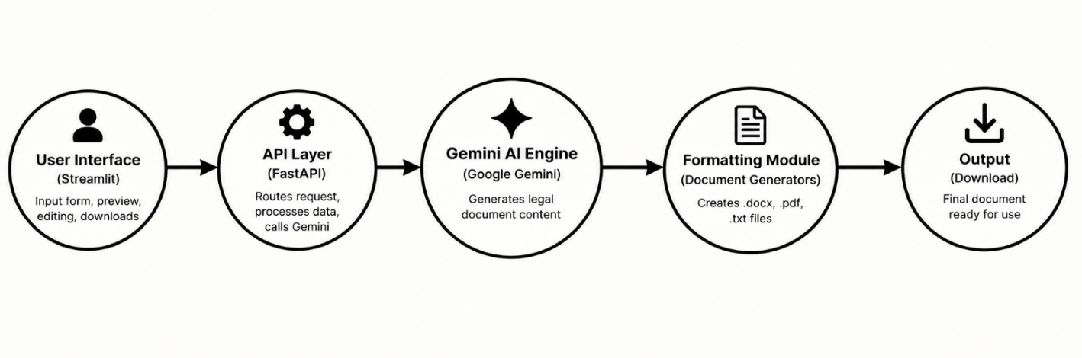

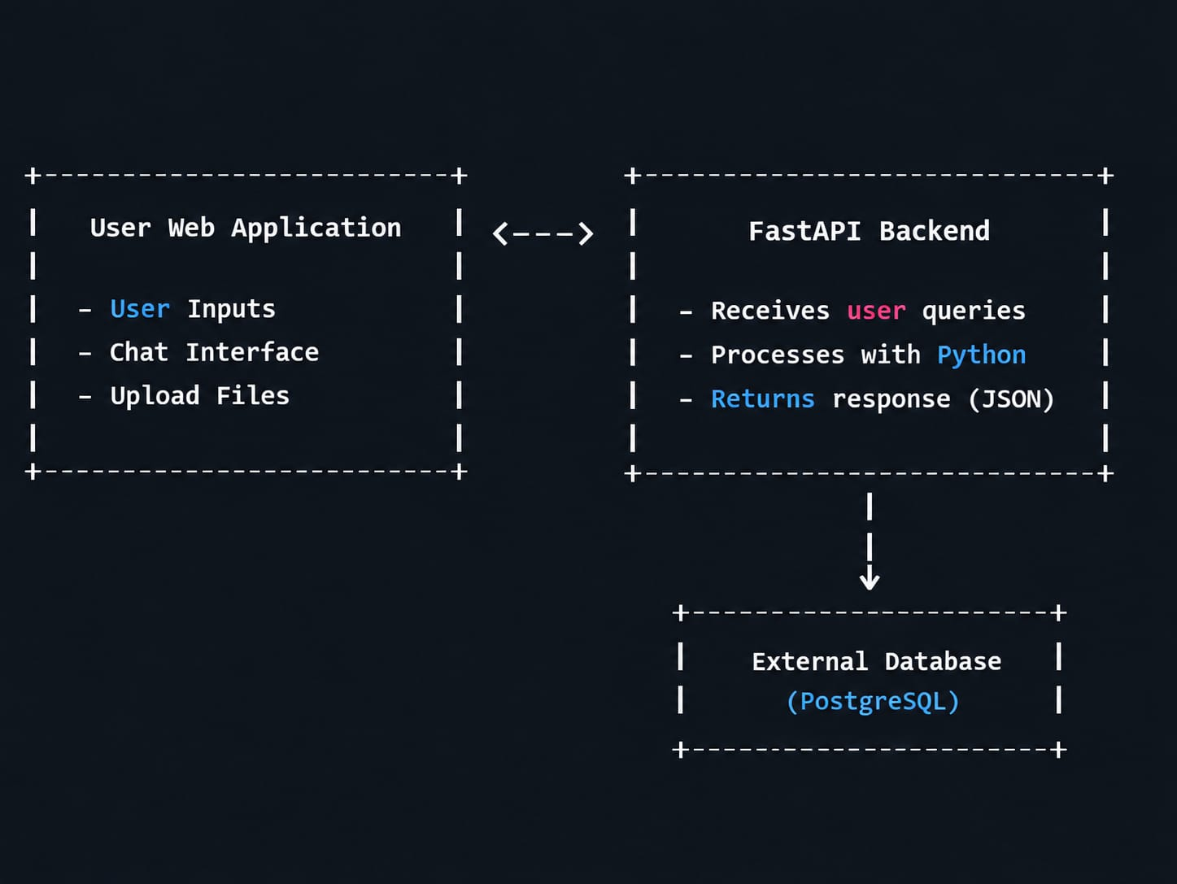

2. Frontend and Backend Integration
Frontend Features:
  - Collect document details such as type, parties, terms, and dates.
  - Provide Generate, Edit, and Download options.
  - Display the generated legal document in a formatted preview.
3.Backend Processing
  - Provide a POST /generate API using FastAPI.
  - Receive and validate user inputs.
  - Send the data to the Gemini AI module and return the generated document content.
4.AI Integration
- GeminiDocumentGenerator prepares user inputs into a structured prompt and sends it to the Gemini API.
- Gemini AI processes the prompt and generates the required legal document content.
- The generated content is returned to the FastAPI backend for further processing.
- Streamlit frontend displays the document and allows users to edit or export it as TXT, DOCX, or PDF.

Activity 1.3: Development Environment Setup
- Install Python:
Install Python 3.10 or above with pip.
- Create Virtual Environment:
Create and activate a separate environment for the LegalEase project.
- Set Up Backend:
Install FastAPI and Uvicorn for API development.
- Set Up Frontend:
Install Streamlit for building the user interface.
- Configure Gemini API:
Install the Google Generative AI package and configure the API key.
- Install Supporting Libraries:
Install python-docx, fpdf, Pillow, requests, and python-dotenv.
- Organize Project Structure:
Create separate folders for frontend, backend, AI processing, and document generation.

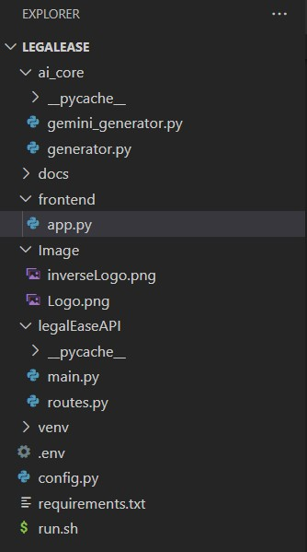

MILESTONE 2: Core Functionalities Development
Activity 2.1: Develop the Core Functionalities
Legal Document Generation
Functionality: Generate customized legal documents such as contracts, agreements, NDAs, and lease documents using user-provided information.
- Accept document type, parties, terms, and effective dates.
- Send the collected details to the Gemini AI model.
- Generate structured and professional legal content.

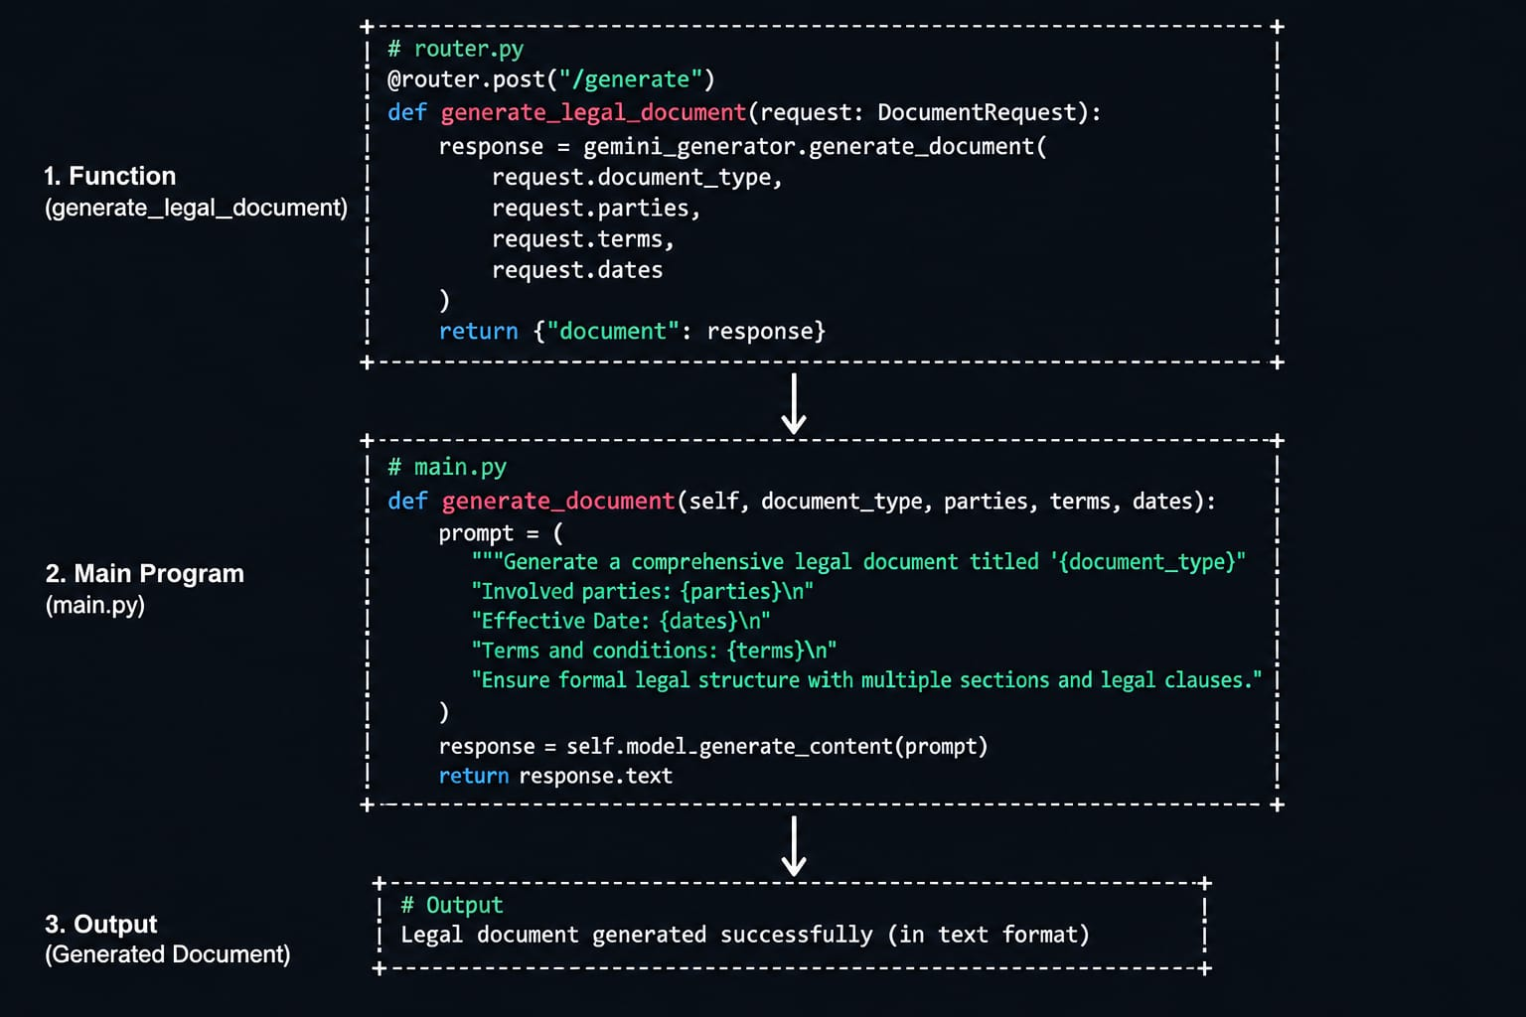
2. Document Output Formatting
Functionality: Convert the generated content into properly formatted legal documents.
- format_docx(text, doc_type) – Creates a formatted Word document.
- format_pdf(text, doc_type) – Generates a professional PDF.
- format_html_preview(text) – Displays the document in the Streamlit interface.
- Add headings, logos, tables, fonts, and footers where required.
3. User Interaction
Functionality: Provide an easy-to-use Streamlit interface for entering legal information.
- Collect user requirements through input fields.
- Display the generated document for review.
- Allow user preferences to be reflected in the final document.

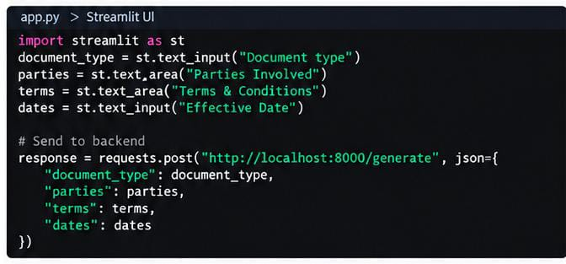
4. Document Editing and Download
Functionality: Allow users to modify the generated content before saving.
- Provide an editable text area.
- Allow users to review and update the document.
- Download the final document as .txt, .docx, or .pdf.
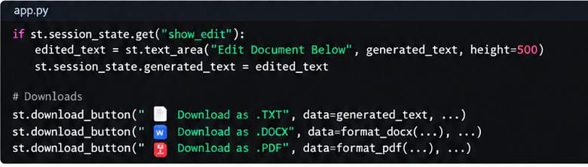

Activity 2.2: Implement the FastAPI Backend
1. Create API Routes
- Develop FastAPI routes for handling document-generation requests.
- Create the /generate endpoint.
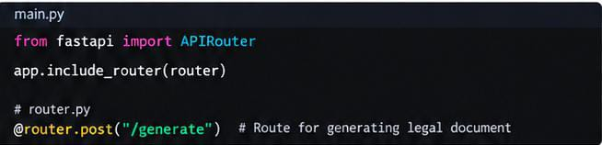
2. Process User Input
- Receive document details from the frontend.
- Validate inputs using Pydantic models.
- Process the request before sending it to the AI module.
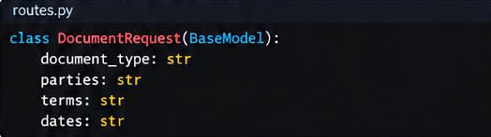
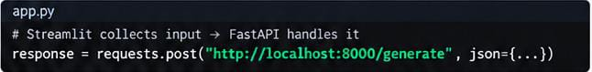
3. Integrate Gemini API
- Connect the FastAPI backend with the Gemini document generator.
- Send the structured user information to Gemini.
- Receive and return the generated legal document content.
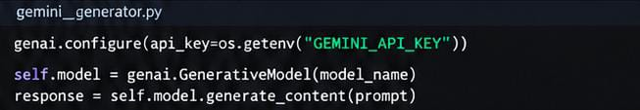

MILESTONE 3: API Logic Integration

Milestone 3 focuses on connecting the FastAPI backend with the Gemini-powered document generation system. It manages frontend requests and routes them to the appropriate API functions.
Activity 3.1: Configure main.py
This activity establishes the main FastAPI application and organizes the API routes.
Steps:
- Initialize FastAPI Application: Create and configure the main FastAPI instance.
- Set Up Root Endpoint: Add the / route to check whether the backend service is running.
- Connect API Routes: Import and include the routes defined in routes.py.
- Prepare Backend Structure: Organize the API so that document-generation requests can be processed efficiently.
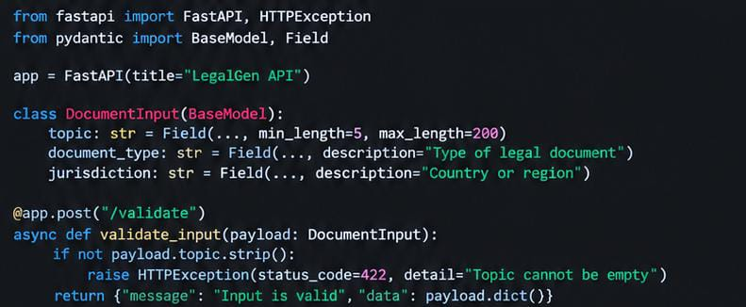

Activity 3.2: Implement Document Generation in routes.py
This activity manages the document-generation request and connects the backend with the Gemini AI module.
Steps:
- Create Request Model: Define DocumentRequest using Pydantic to validate the submitted document details.
- Configure AI Generator: Initialize GeminiDocumentGenerator from ai_core.gemini_generator.
- Create Generation API: Set up the POST /generate endpoint to receive user information.
- Generate Legal Content: Process the request through Gemini and return the generated legal document to the frontend.
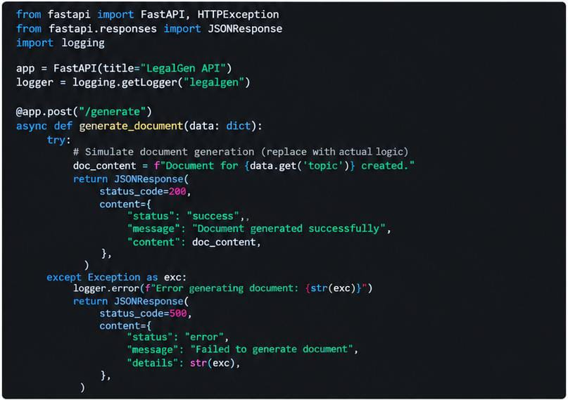

MILESTONE 4: Frontend Development – LegalEase
Milestone 4 focuses on developing an interactive and easy-to-use frontend for LegalEase using Streamlit. It allows users to enter legal information, generate AI-based documents, view and edit the generated content, and download the final documents in TXT, DOCX, or PDF formats proper formatting and branding.

Activity 4.1: Designing and Developing the User Interface
Step 1: Streamlit Page Configuration and Layout Setup
  - Configured the Streamlit application with:

  - Added a three-column layout using st.columns to properly align and display the LegalEase logo.
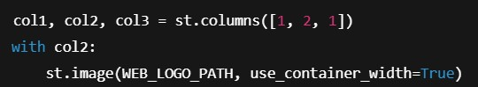
Step 2: Header and Title
  - Displayed a simple center-aligned title below the logo:
  - Added the project name “LegalEase – AI-Powered Legal Document Simplifier” to provide a clear introduction to the application.

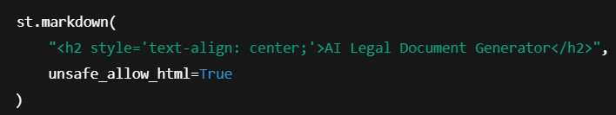
Step 3: User Input Interface
• Created an intuitive user interface for entering legal document details:
- document_type: Type of legal document
o parties: Names of the involved parties
o terms: Important clauses or terms from the document
o dates: Relevant effective or agreement dates
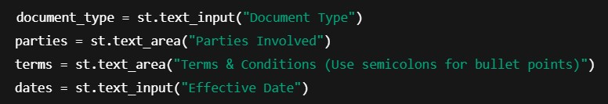

Activity 4.2: Creating Dynamic Previews and Export Options

Step 1: Upload and Process Legal Document with Backend AI
• On clicking “Analyze Document”, the uploaded legal document is sent to the FastAPI backend for processing.
• The AI analyzes the document and generates a simplified explanation dynamically.
  - On clicking "Generate Document", a POST request is sent to the FastAPI backend:
Step 2: Legal Document Preview Rendering
  - The simplified legal content is displayed in a clean and user-friendly scrollable preview area.
  - Important sections such as key terms, obligations, dates, and clauses are presented using structured formatting.

Step 3: Editable Document Preview
  - The user can click “Edit Summary” and modify the generated simplified content using a text area.
  - This allows users to make corrections or add additional notes before exporting the document.

Step 4: Multi-Format Download Options
• Users can download the simplified legal document as:
o .txt (Plain Text Summary)
o .docx (Formatted Word Document with headings and structured content)
o .pdf (Formatted PDF containing the simplified legal information)

Core Functions & Utilities
sanitize_text(text)
• Removes unwanted special characters and formatting symbols to ensure clean and readable legal text.
format_docx(text, doc_type)
• Uses python-docx to:
o Add document title and headings
o Format paragraphs and important sections
o Organize simplified legal information into a structured document
format_pdf(text, doc_type)
• Uses FPDF to generate a professional PDF with:
o Center-aligned LegalEase heading
o Bold section headings
o Properly formatted paragraphs and key points
format_html_preview(text)
  - Converts the AI-generated legal explanation into structured and styled HTML blocks for clear inline display.

MILESTONE 5: Deployment
In Milestone 5, the focus is on deploying the LegalEase application locally using FastAPI as the backend and Streamlit as the frontend. This milestone involves configuring the application environment, installing the required dependencies, and verifying the complete workflow of legal document upload, AI-based analysis, simplification, preview, editing, and downloading. This ensures that all modules work together correctly in a local environment and prepares the application for future cloud deployment.
Activity 5.1: Preparing the Application for Local Deployment
Step 1: Set Up a Virtual Environment
To maintain an isolated development environment and avoid dependency conflicts, create and activate a Python virtual environment for the LegalEase application.

Step 2: Install Dependencies
Ensure that all backend and frontend dependencies required for LegalEase are installed using the requirements.txt file:
pip install -r requirements.txt

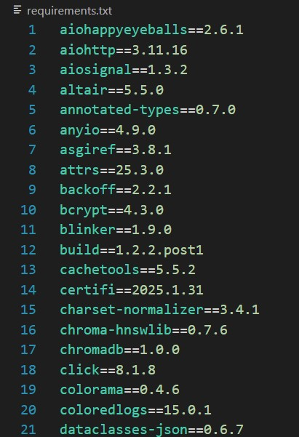
Step 3: Configure Environment Variables
Create a .env file to securely store the required configuration details, including the Gemini API key, without exposing sensitive information directly in the source code.
Activity 5.2: Testing and Verifying Local Deployment
Step 1: Launch the FastAPI Backend
Start the FastAPI backend server using Uvicorn to handle legal document processing and AI-based analysis.
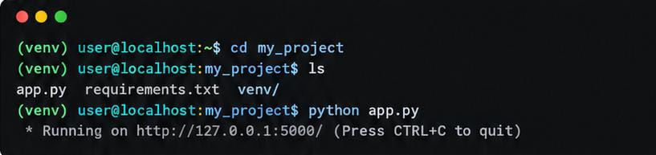

Step 2: Launch the Streamlit Frontend
Run the app.py file to start the LegalEase user interface and access the document analysis features.

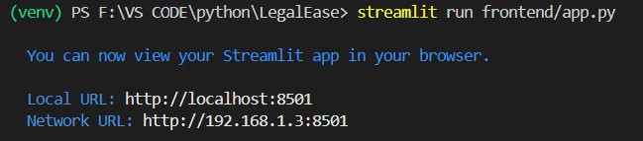
Step 3: Test All Functionalities
- Upload a legal document for analysis.
- Press “Analyze Document” to process the document using Gemini AI.
- Use built-in options to:
- Preview the simplified legal content
- Edit the generated explanation
- View important clauses and key information
- Download the simplified document in .txt, .docx, and .pdf formats
- Check for:
- Proper document upload and processing
- Clear and readable AI-generated explanation
- Correct identification of important legal information
- Proper formatting of downloaded documents

Exploring LegalEase

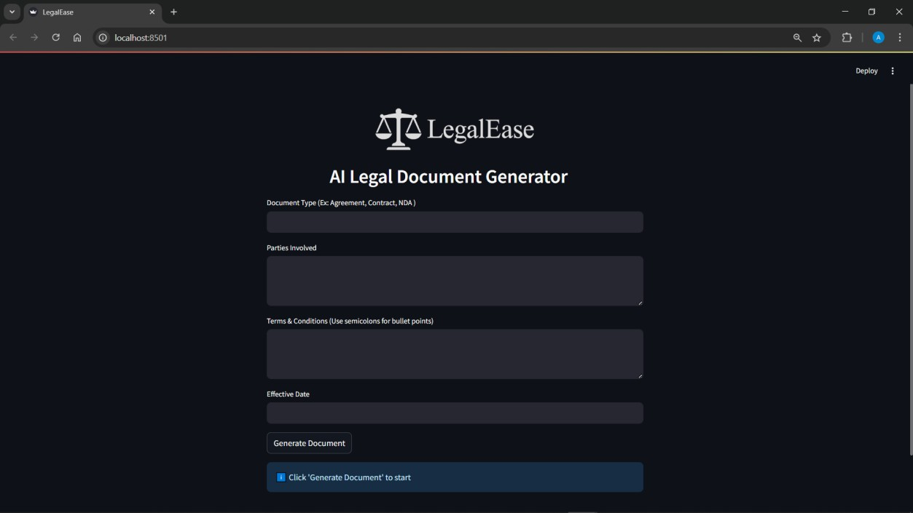

1. Legal Document Upload
Purpose: Upload a legal document that needs to be analyzed and simplified.
Examples:
• Rental Agreement
• Employment Contract
• Non-Disclosure Agreement (NDA)
• Service Agreement
Example input: Rental_Agreement.pdf

2. Document Analysis
Purpose: Analyze the uploaded document using Gemini AI and convert complex legal language into simple, understandable information.
Examples:
• Identify important clauses
• Extract key dates
• Identify responsibilities of the parties
Example input: Upload an Employment Contract for analysis.
3. Key Information Extraction
Purpose: Identify and display important information from the legal document.
Examples:
• Parties involved
• Important dates
• Payment conditions
• Obligations and responsibilities
• Termination conditions
Example output: A structured summary of the important clauses in the uploaded document.
4. Simplified Legal Explanation
Purpose: Provide an easy-to-understand explanation of complex legal terms and clauses.
Examples:
• Original legal clause
• Simplified explanation
• Important points
Example output: “The employee must follow the confidentiality requirements mentioned in the agreement.”
5. Preview and Download
Purpose: Allow users to review, edit, and save the simplified legal information.
Available options:
• Preview the generated explanation
• Edit the content
• Download as .txt
• Download as .docx
• Download as .pdf

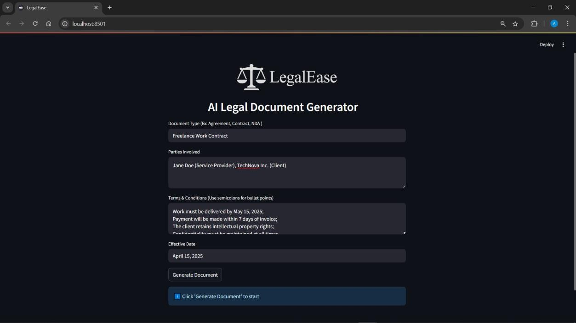

Document Generated

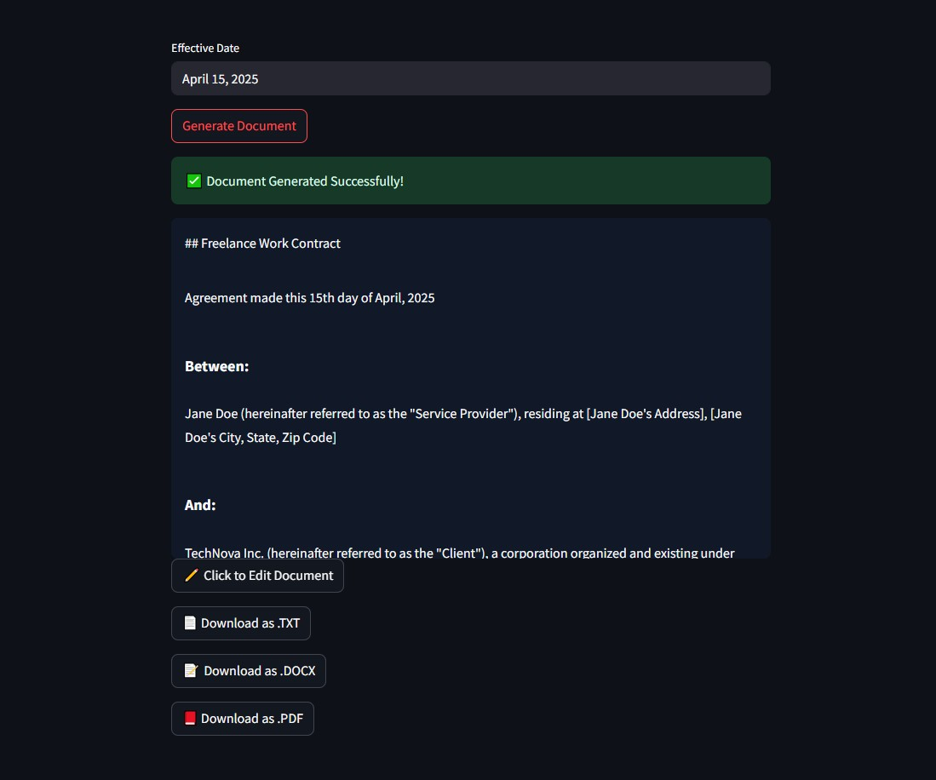

Editing the Legal Explanation
If the user wants to modify the simplified legal explanation, they can do so by clicking on the “Edit Summary” button. A new editing area opens where the user can review, modify, and update the AI-generated legal content before downloading the document.
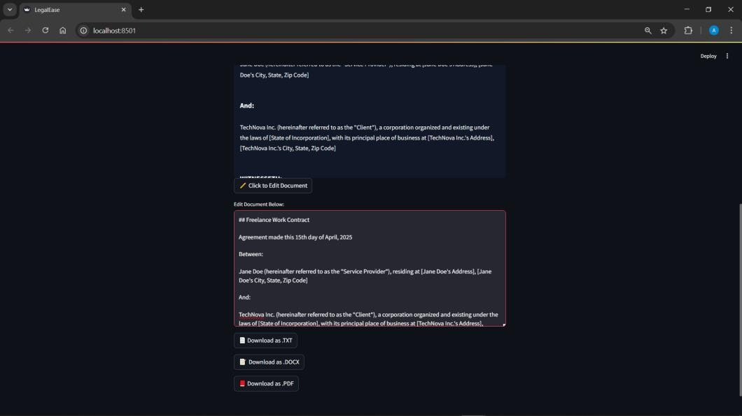

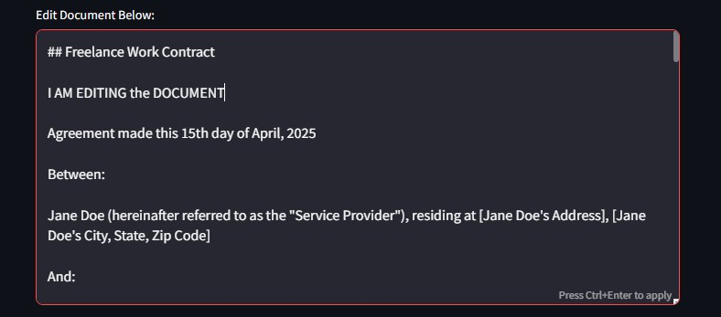
Downloading/ Saving the Generated Document
We can Download and save the documents in any of the following formats.
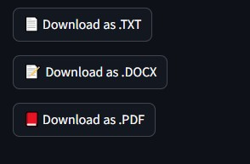
- .txt
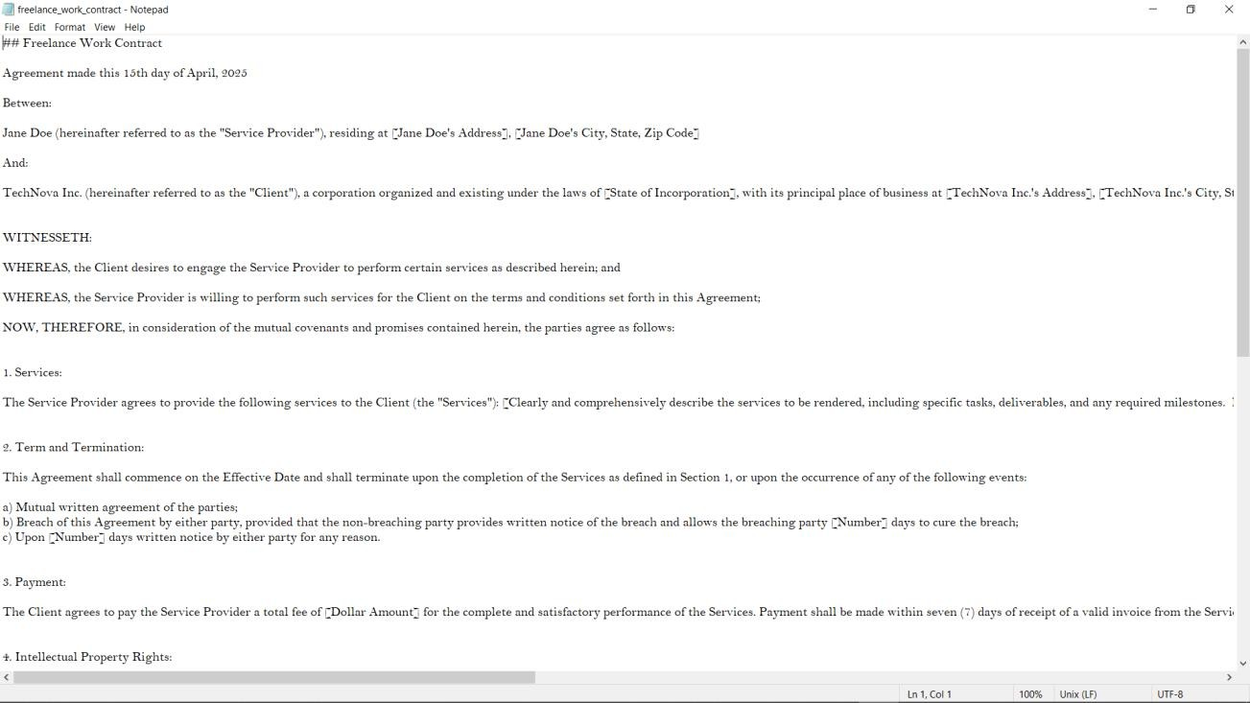
- .docx
The document provided inculcates the use of the logo (front page) as well as the footer in the last page

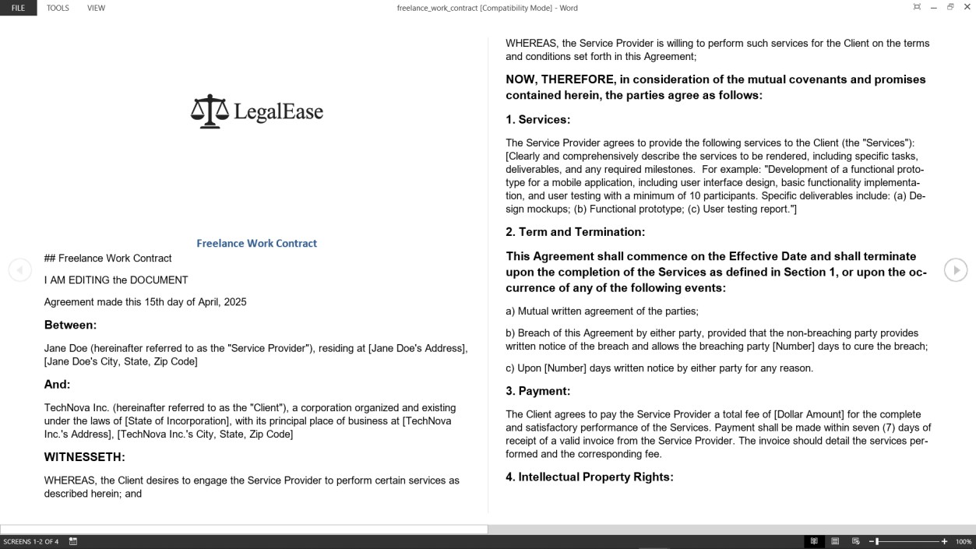
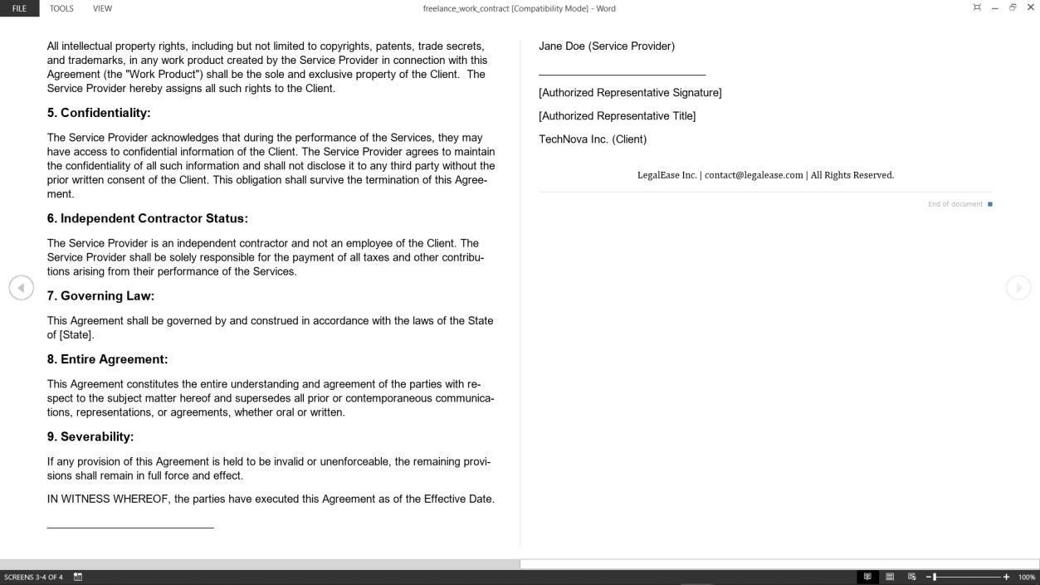

- .pdf
This format provided the user with a well formatted and ready to use legal document with Logo and Footer on all the pages.

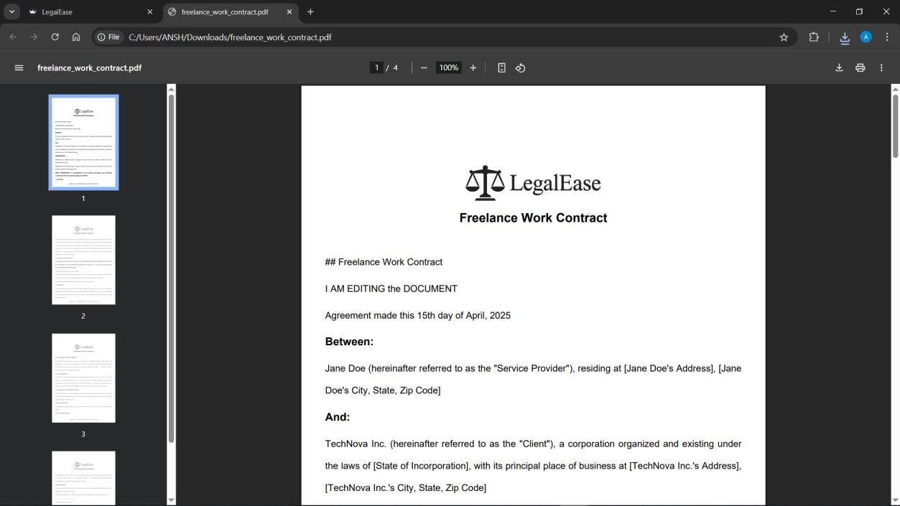

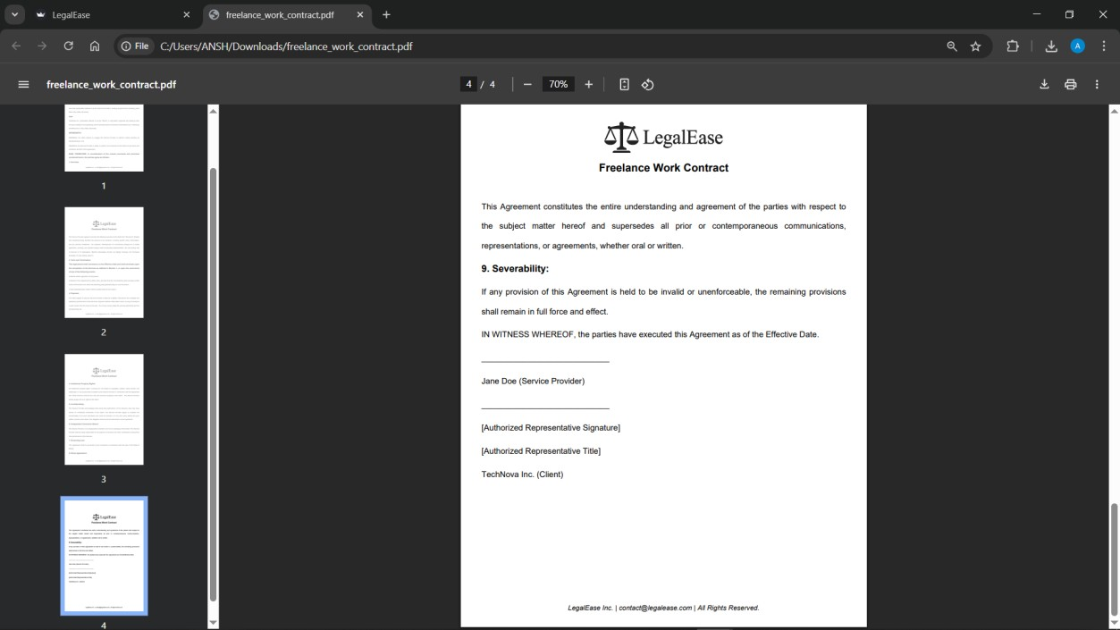

Conclusion

LegalEase demonstrates how artificial intelligence can be used to simplify and automate the process of creating legal documents. By combining a Streamlit-based interface with FastAPI and Gemini AI, the system enables users to provide essential legal details and generate structured documents efficiently.

The platform supports different document types such as employment contracts, lease agreements, and NDAs. Users can review the generated content, make necessary changes, and download the final document in TXT, DOCX, or PDF formats. This workflow makes document preparation more convenient and flexible for users.

From a technical perspective, LegalEase integrates a Streamlit frontend, FastAPI backend, Gemini AI generation module, and document-formatting utilities. The system is designed to connect user inputs with AI-generated legal content while providing preview and export functionalities.

In conclusion, LegalEase provides an efficient AI-powered approach to legal document generation. The project demonstrates the practical use of generative AI, web technologies, and document-processing tools to create customizable legal documents. Future improvements can further enhance its document-generation capabilities, formatting options, and overall user experience.

