# Credit Risk Prediction using R

## 1. Introduction

Credit risk modeling is crucial in the banking and finance sectors to determine the probability of a customer defaulting on a loan. This project uses R to build a logistic regression model on the German Credit dataset to predict default status based on customer attributes.

## 2. Objective

- Load and clean the German Credit dataset  
- Explore data distribution and variable correlation  
- Build a logistic regression model  
- Evaluate model performance using confusion matrix and ROC curve  
- Optimize decision threshold and analyze feature importance

## 3. Prerequisites

Install the following R packages:

* - MASS  
  - dplyr  
  - ggplot2  
  - corrplot  
  - caret  
  - pROC

## 4. Load Libraries

```R  
library(MASS)  
library(dplyr)  
library(ggplot2)  
library(caret)  
library(pROC)  
library(corrplot)  
```

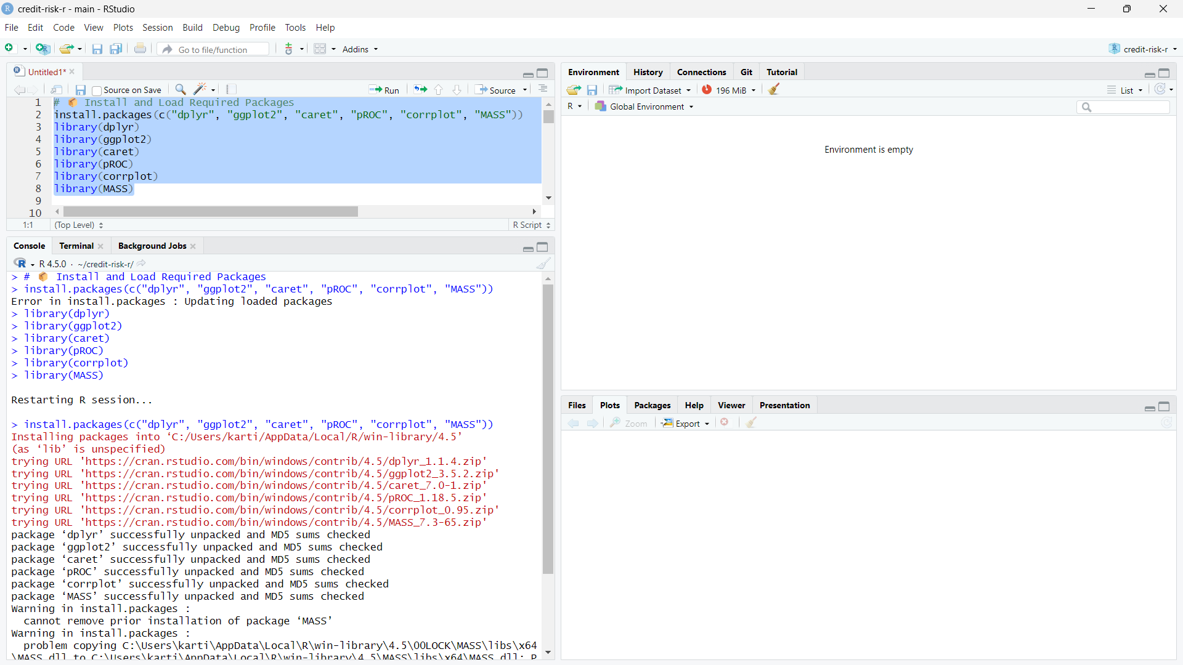

## 5. Load and Explore Data

```R  
data("GermanCredit")  
credit_data <- GermanCredit  
glimpse(credit_data)  
sum(is.na(credit_data))  
```

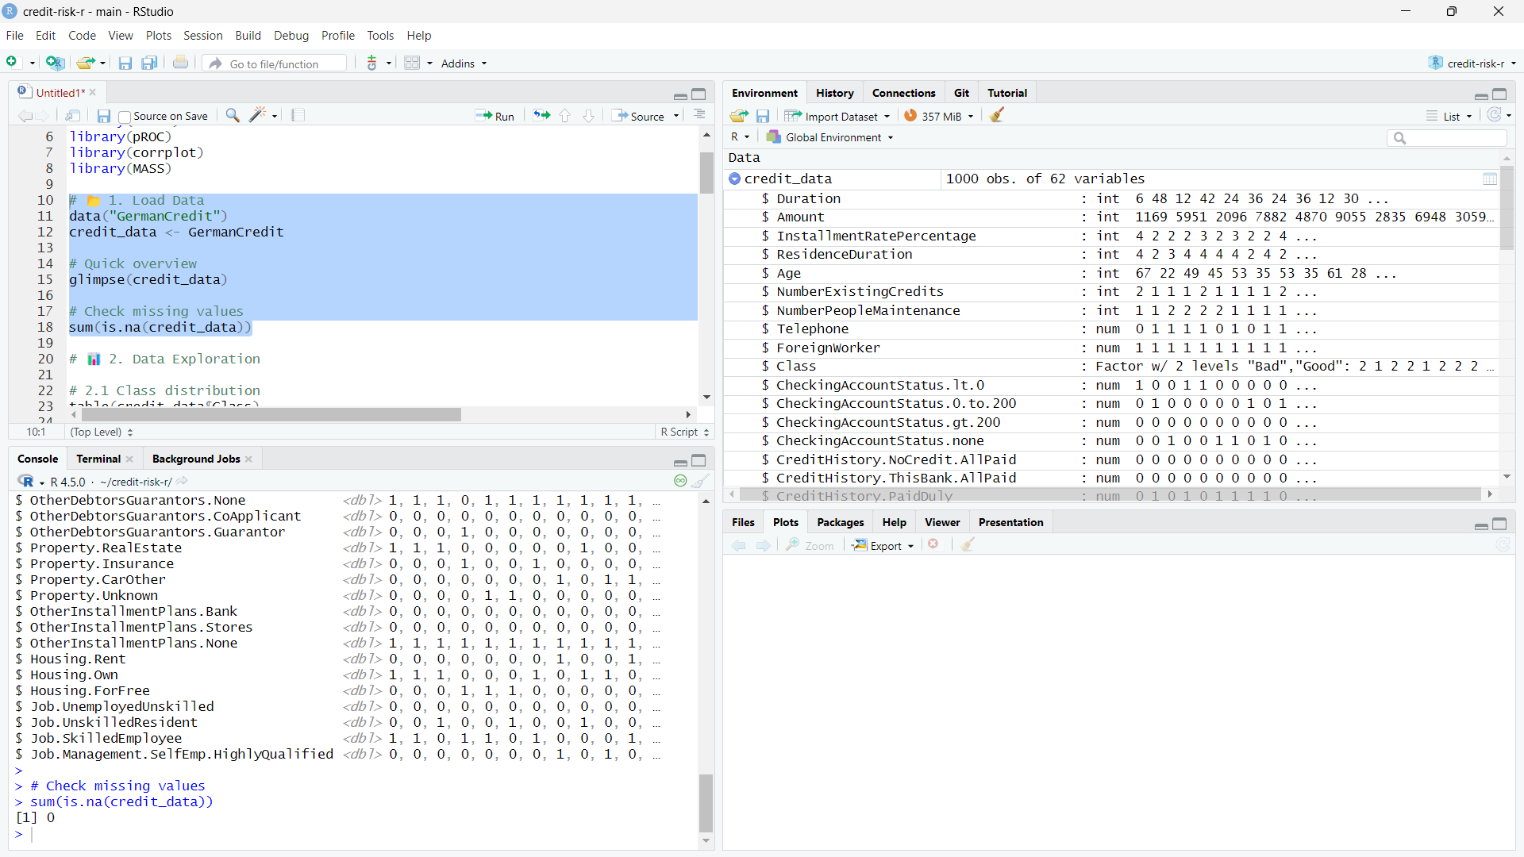

## 6. Data Exploration

```R  
table(credit_data$Class)  
prop.table(table(credit_data$Class))  
ggplot(credit_data, aes(x = Class, y = Amount, fill = Class)) +  
 geom_boxplot() +  
 theme_minimal()  
```

## 7. Correlation Matrix

```R  
numeric_vars <- credit_data %>% select_if(is.numeric)  
numeric_vars <- numeric_vars[, sapply(numeric_vars, function(x) sd(x) > 0)]  
corrplot(cor(numeric_vars), method = "color", type = "upper")  
```

## 8. Logistic Regression Model

```R  
selected_vars <- credit_data %>% select(Class, Age, Amount, Duration,  
 Housing.Rent, Housing.Own, Housing.ForFree,  
 Job.UnemployedUnskilled, Job.UnskilledResident,  
 Job.SkilledEmployee, Job.Management.SelfEmp.HighlyQualified)

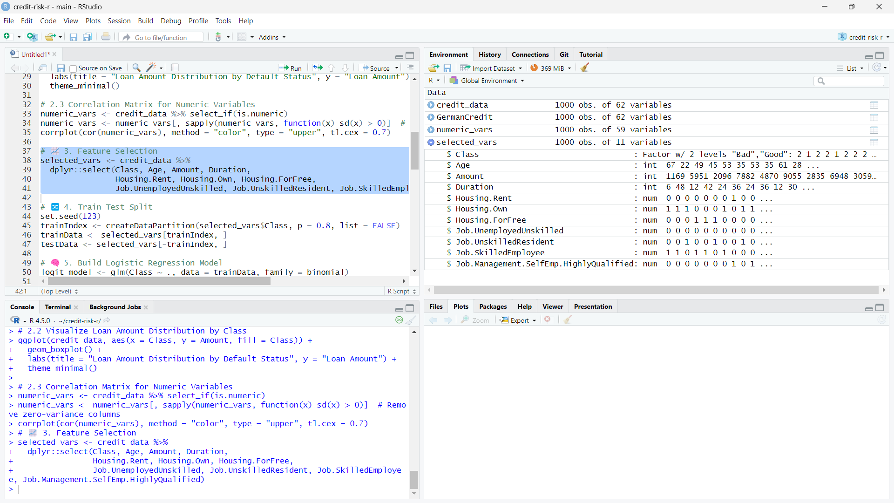

set.seed(123)  
trainIndex <- createDataPartition(selected_vars$Class, p = 0.8, list = FALSE)  
trainData <- selected_vars[trainIndex, ]  
testData <- selected_vars[-trainIndex, ]

logit_model <- glm(Class ~ ., data = trainData, family = binomial)  
summary(logit_model)  
```

## 9. Prediction and Evaluation

```R  
testData_small <- testData %>% select(-Class)  
pred_probs <- predict(logit_model, newdata = testData_small, type = "response")  
pred_class <- ifelse(pred_probs > 0.5, "Bad", "Good")  
pred_class <- factor(pred_class, levels = c("Good", "Bad"))

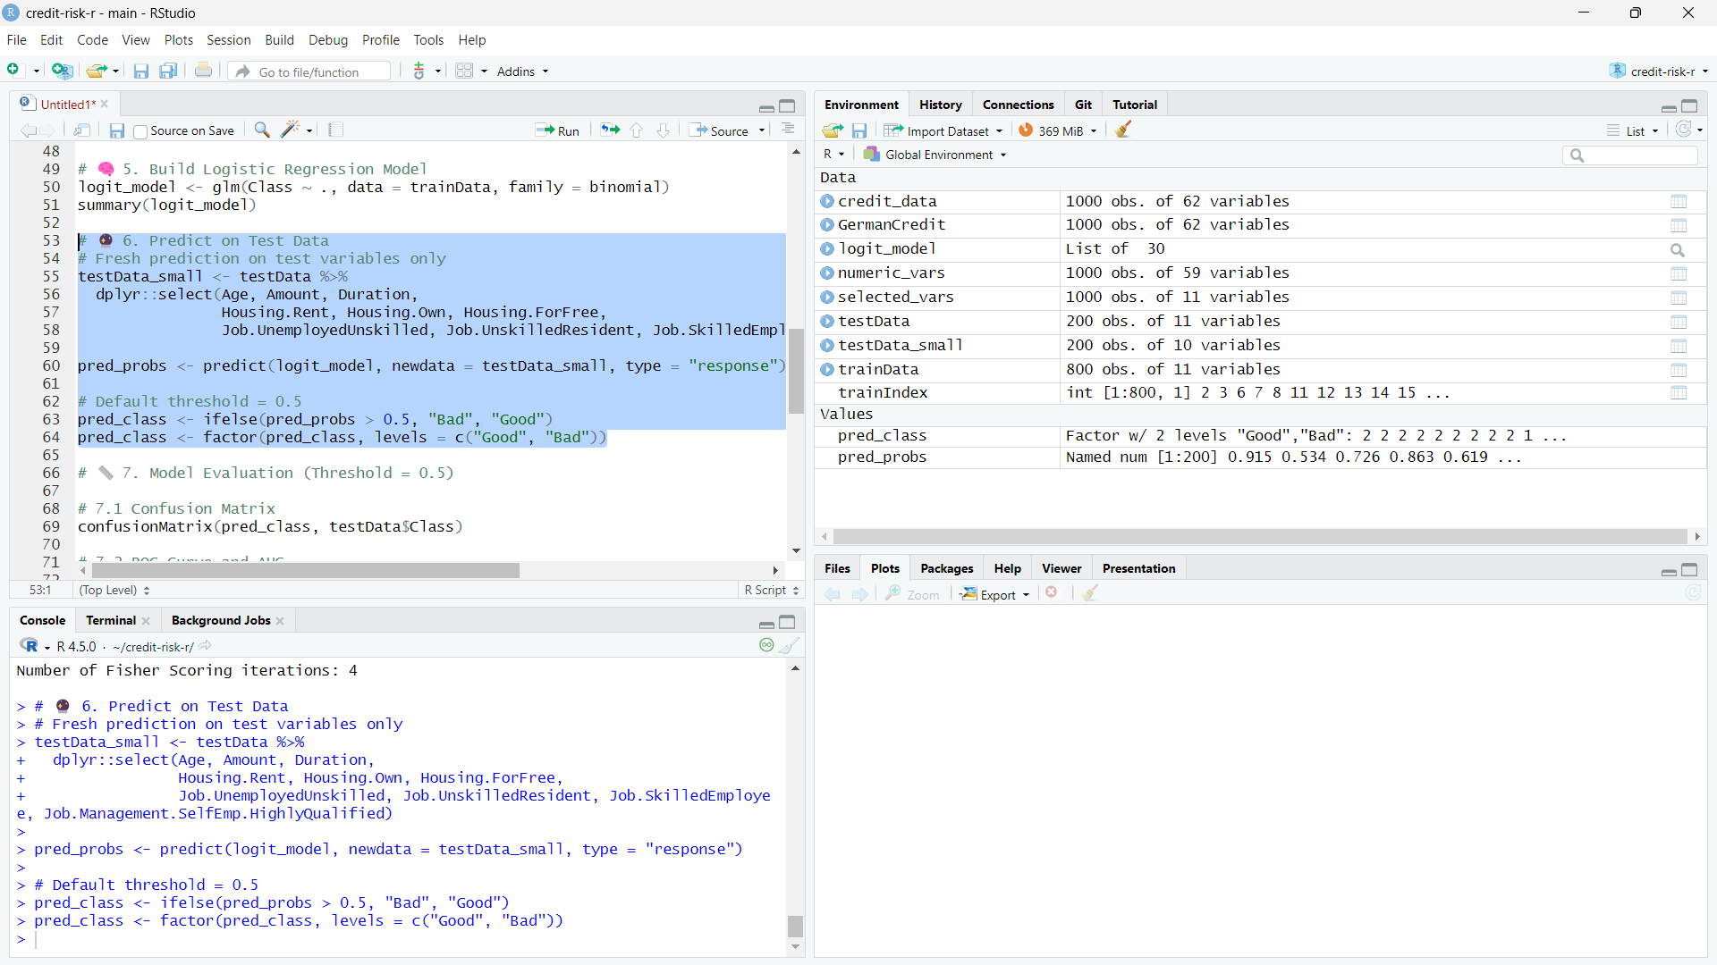

confusionMatrix(pred_class, testData$Class)  
roc_curve <- roc(testData$Class, pred_probs, levels = c("Good", "Bad"))  
plot(roc_curve, col = "blue")  
auc(roc_curve)  
```

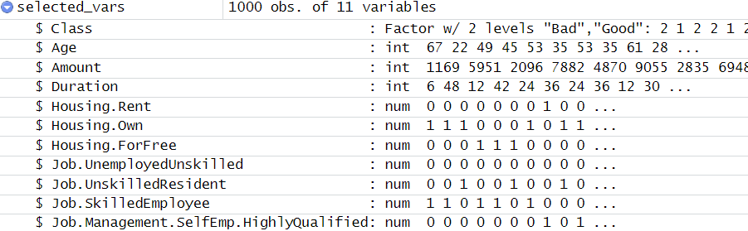

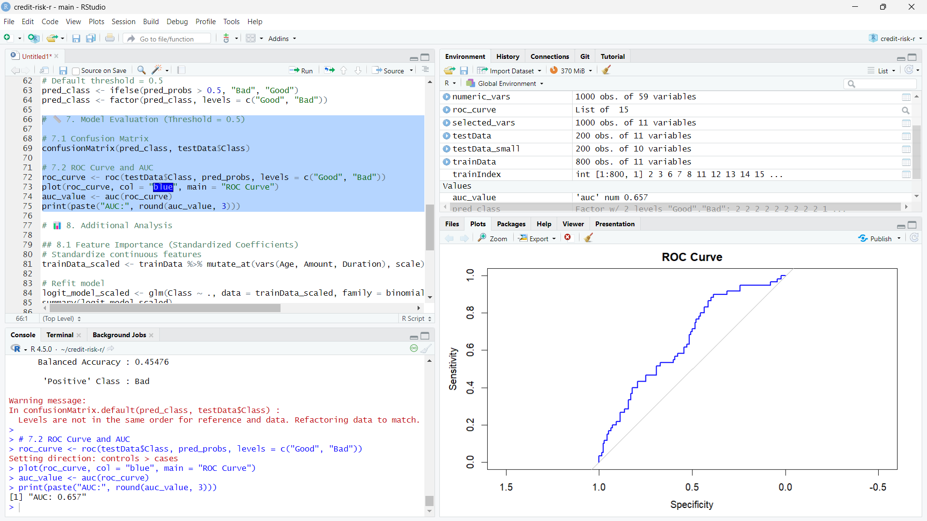

## 10. Threshold Tuning and Final Evaluation

```R  
train_means <- trainData %>% summarise(across(c(Age, Amount, Duration), mean))  
train_sds <- trainData %>% summarise(across(c(Age, Amount, Duration), sd))  
trainData_scaled <- trainData %>% mutate(  
 Age = (Age - train_means$Age) / train_sds$Age,  
 Amount = (Amount - train_means$Amount) / train_sds$Amount,  
 Duration = (Duration - train_means$Duration) / train_sds$Duration  
)  
logit_model_scaled <- glm(Class ~ ., data = trainData_scaled, family = binomial)

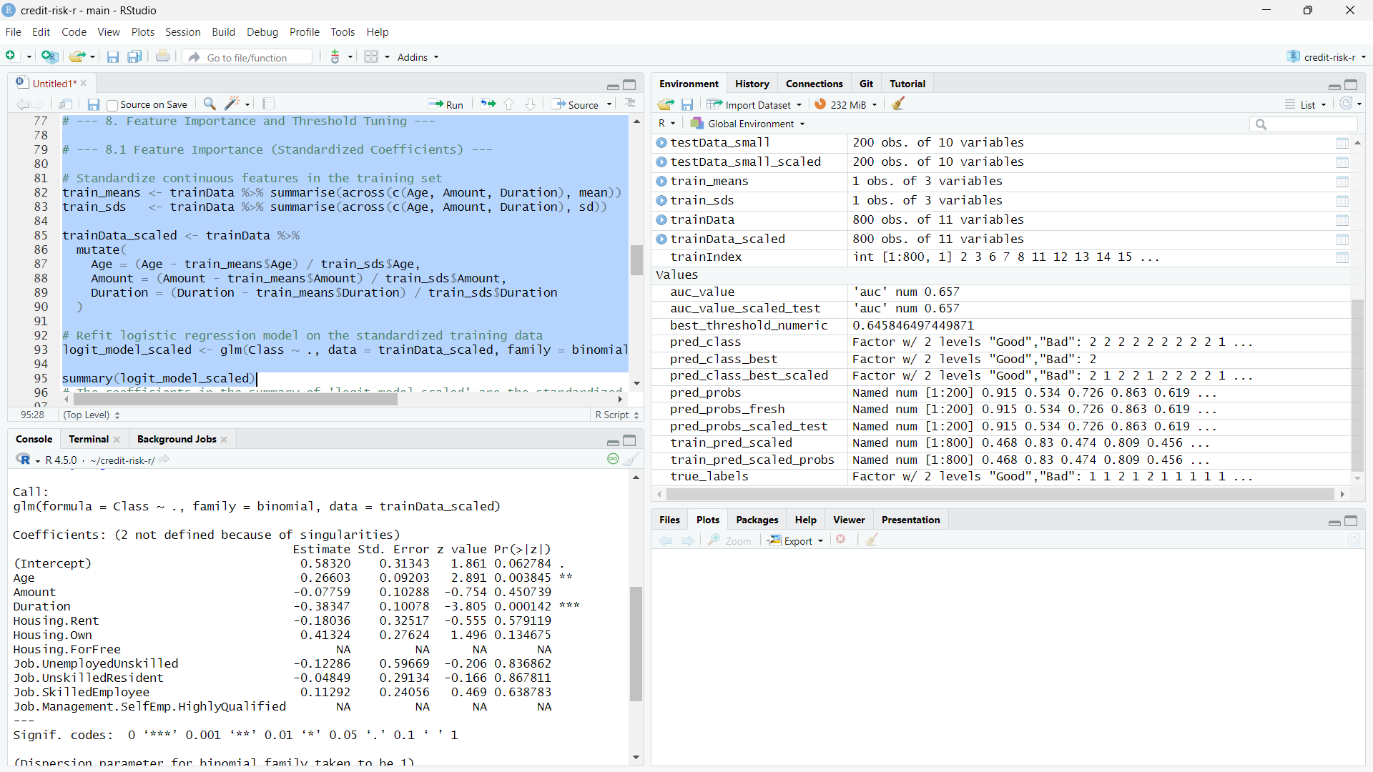

train_pred_scaled_probs <- predict(logit_model_scaled, newdata = trainData_scaled, type = "response")  
roc_curve_scaled_train <- roc(trainData$Class, train_pred_scaled_probs, levels = c("Good", "Bad"))  
best_threshold <- coords(roc_curve_scaled_train, "best", ret = "threshold")  
testData_for_pred_scaled <- testData %>% select(-Class) %>% mutate(  
 Age = (Age - train_means$Age) / train_sds$Age,  
 Amount = (Amount - train_means$Amount) / train_sds$Amount,  
 Duration = (Duration - train_means$Duration) / train_sds$Duration  
)

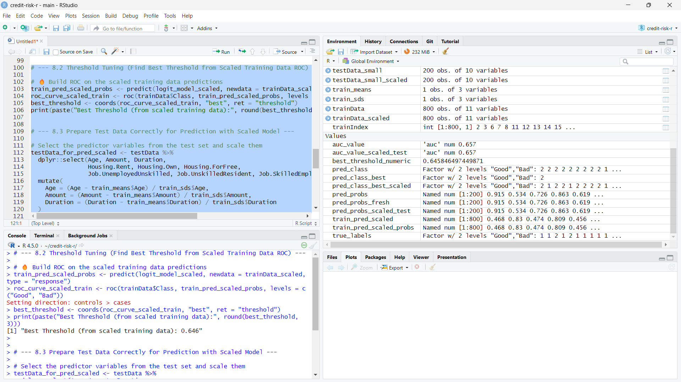

pred_probs_scaled_test <- predict(logit_model_scaled, newdata = testData_for_pred_scaled, type = "response")  
pred_class_best_scaled <- factor(ifelse(pred_probs_scaled_test > as.numeric(best_threshold), "Bad", "Good"), levels = c("Good", "Bad"))

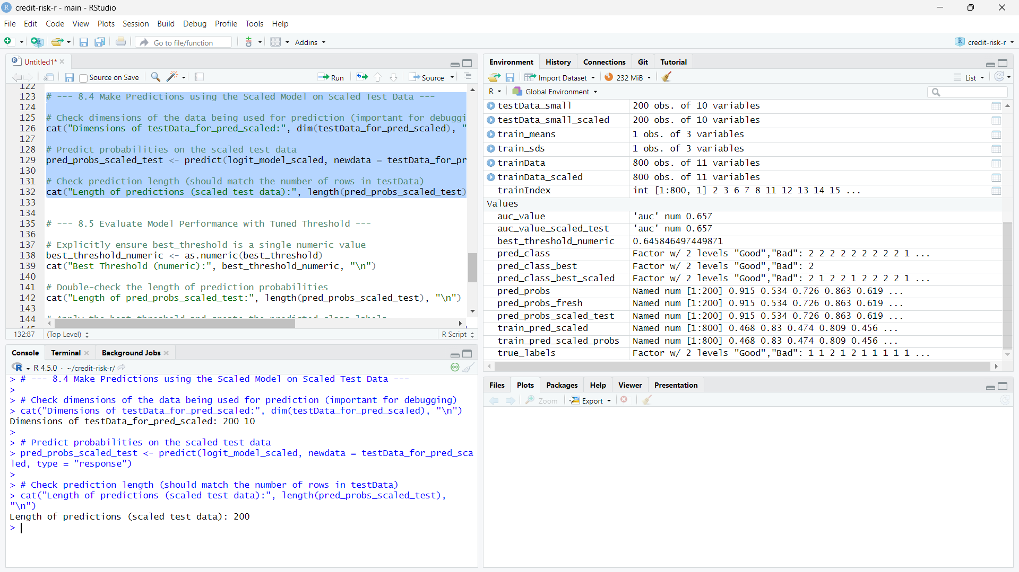

confusionMatrix(pred_class_best_scaled, factor(testData$Class, levels = c("Good", "Bad")))  
roc_curve_test_scaled <- roc(testData$Class, pred_probs_scaled_test, levels = c("Good", "Bad"))  
plot(roc_curve_test_scaled, col = "darkgreen")  
auc(roc_curve_test_scaled)  
```

