OSOC TASK

1. Command for searching pattern line by line in any document with an example.

Ans:

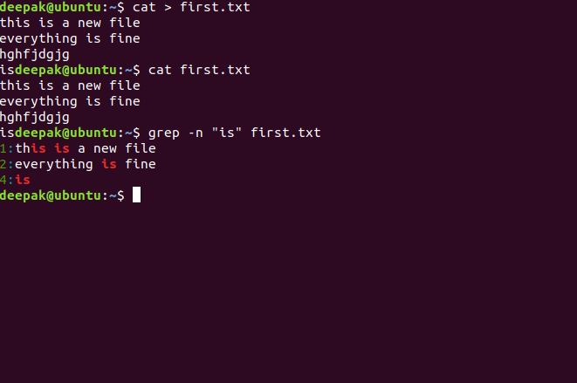

2. What all permissions are there in Linux? State all permissions and different way of changing permissions with example.

Ans:

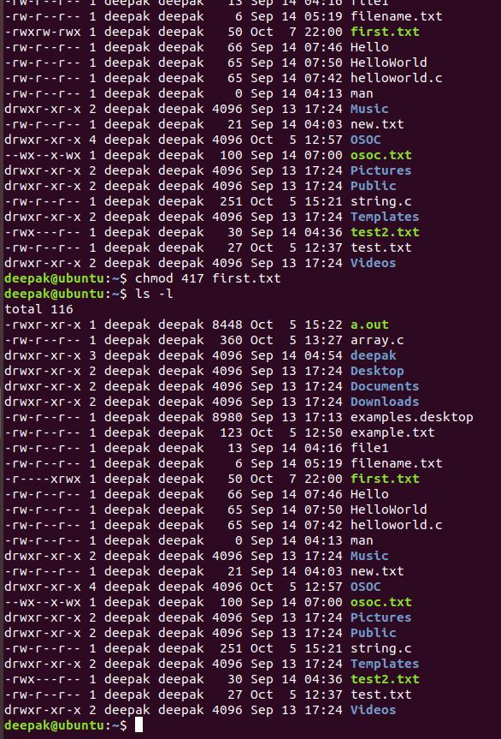

1. Create a folder ***OSOC*** and inside that another folder ***Inductions*** and now create a file ***task.txt*** inside ***Inductions*** with some content now copy this file into another folder ***Workshop*** in ***OSOC.***

Ans:

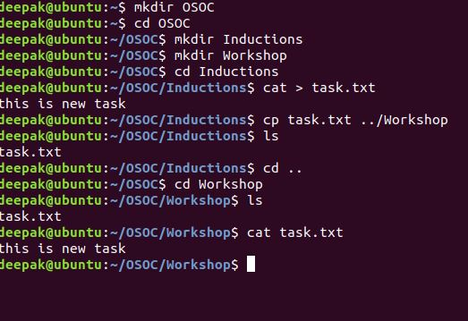

4. I want to check whether my system is connected to any network or not, please suggest appropriate command for this.

Ans: 