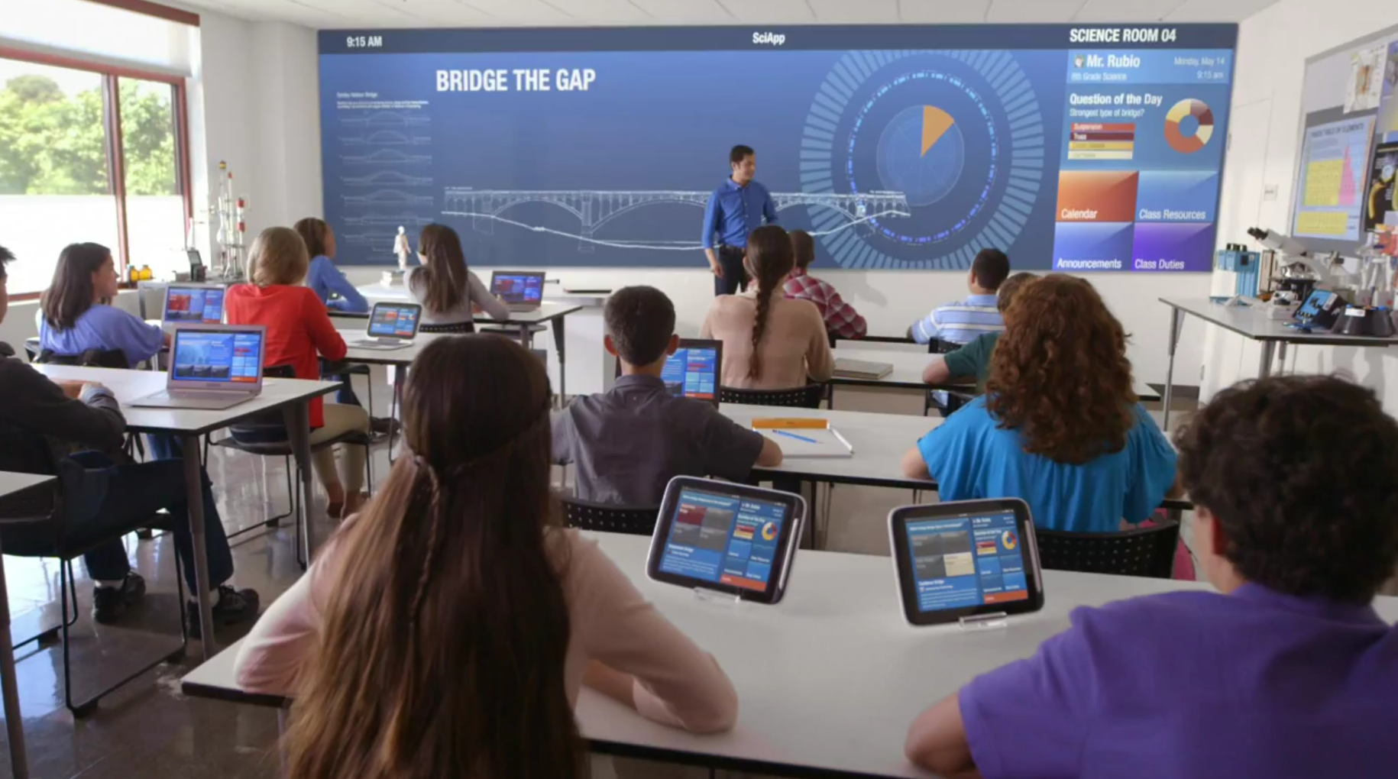

VirtuLearn – interactive school devices

SYstems Engineering**Group 8**

**University College London**

Table of Contents

Executive Summary 3

Chapter 1 4

Project Team 4

Project Introduction 4

Chapter 2 – PoC Demonstrator 5

Chapter 3 - Systems Components Integration 7

Chapter 4 - Test Plan 8

Chapter 5 - Conclusion 9

Appendix I – Working with Kinect 10

Appendix II – Glossary 11

# Executive Summary

# Chapter 1

## Project Team

## Project Introduction

# Chapter 2 – PoC Demonstrator

# Chapter 3 - Systems Components Integration

# Chapter 4 - Test Plan

# Chapter 5 - Conclusion

# Appendix I – Working with Kinect

working

# Appendix II – Glossary