***Izvor (source): F:\_1_etp\[edu.v].Envato@Tutsplus-.Git Essentials***

***Video to snapshots by Snipping Tool -> Excel pictures***

***Pictures to text***

***(Working dir is clean = all changes already staged and committed)***

***Pic 16: Add one more dir and one more file***

***Because .gitignore (ignore) entries for them already exist,***

***git status command’s result === nothing to commit (wd still clean)***

***Pic17: Because of !_prefix = exception = one not to be ignored among all the others which should be ignored w/i noted set of elements/objects***

***Recollection of pic 11***

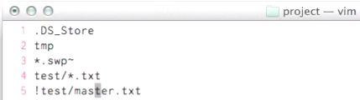

***..All .txt files in test/ should be ignored***

***<-> only master.txt w/i above mentioned dir should not***

***#.not clearly shown by pic 17: displays dir containing exception***







***Not concrete (not until pic 18) excluded file (could be more than one)***

***Pic 18: after 1. cd.. | 2. git add . | 3. git status***

***Shown exception (not ignored file is named)***