Altia 240x320 ByteSized Demo

Infineon CY8CKIT-062S2-43012 + CY8CKIT-028-TFT

# Scope

This document describes the steps necessary to build Altia ByteSized Demo for Infineon PSoC6 Evaluation Board CY8CKIT-062S2-43012 utilizing CY8CKIT-028-TFT.

The IDE used is Infineon ModusToolBox incl. the corresponding arm-none-eabi-gcc tool chain.

# Overview

The demo consists of two components:

1. The Altia HMI project to be used with Altia Launcher (ByteSizedDemo)
2. The ModusToolBox Sample project integrating the Altia HMI (AltiaHMISample_CY8CKIT-028-TFT)

Both components have been checked out from Git-Hub into the folder used to clone the Git-Hub Repo to.

The ByteSizedDemo folder contains a Altia Workspace file ByteSizedDemo.altwrk, which must be imported into the Altia Launcher. Altia Launcher than can be directly used for generating Altia miniGL code and Altia BAM binary files.

After running the build process from the command-line the artifacts are placed in ByteSizedDemo/out folder

The content of the AltiaHMISample_CY8CKIT-028-TFT folder must be imported as a project into the ModusToolBox IDE. After updating the ModusToolBox Libraries one can build and deploy the demo application to the PSoC6 evaluation board.

The ModusToolBox sample project includes a linker-script considering the Altia BAM binary files and includes the required miniGL BSP functions.

# Requirements

* CY8CKIT-062S2-43012 (contact Infineon)

Infineon PSoC6 evaluation board utilizing OpenOCD debug interface and external QSPI flash

* CY8CIT-028-TFT (contact Infineon)

Infineon shield to be mounted on CY8CKIT-062S2-43012 utilizing 240x320 pixel display (st7789v chip-on-glass via emulated 8080-bus-interface).

* ModusToolBox installation (contact Infineon)

This demo was built and tested with v2.4.0

* Altia miniGL SW Render Target

This demo was built and tested with Altia DeepScreen miniGL Software Render Target v13.2.1

# Build Procedure

Structure of the Demo Folder



## Build Altia HMI

Use Altia Launcher -> Add Local Project to add ByteSizedDemo/ByteSitedDemo.altwrk to add the demo project to Altia Launcher.

Ein Bild, das Text, Screenshot, Monitor, Bildschirm enthält.

After this one can trigger the code generation process from Altia Launcher.

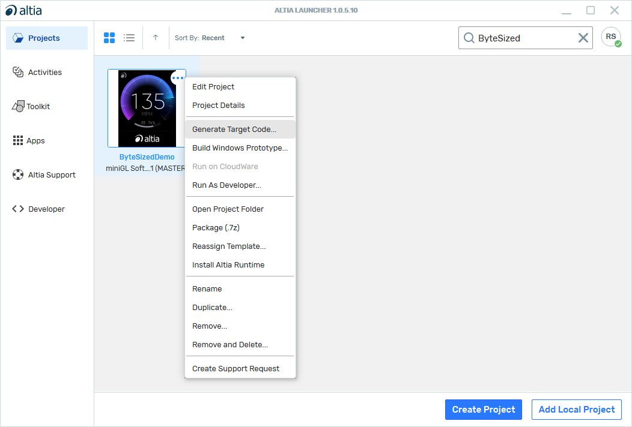

When the code generation process successfully finished one must open a CMD window in the project directory (right-click the project in Altia Launcher and select “Open Project Folder”. In the Windows Explore move into code folder and run CMD in code folder.

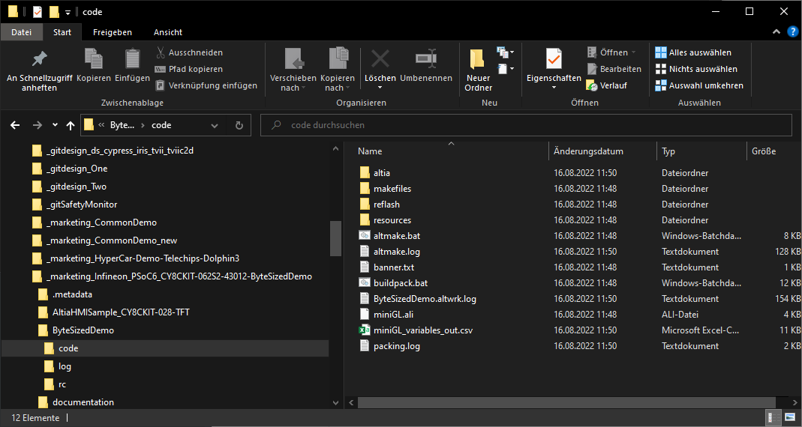

In the CMD Window set the environment variable TOOLCHAIN_BASE_PATH to the installation directory of the arm-none-eabi-gcc tool chain as installed with ModusToolBox (<ModusToolBox_Dir>\tools_2.4\gcc)

Ein Bild, das Text enthält.

and execute altmake.bat.

When the process of building the generated code successfully finished one should find an out folder in the ByteSizedDemo folder, which holds the generated library (libaltia.a), the required header files and the Altia BAM binary files in the reflash folder.

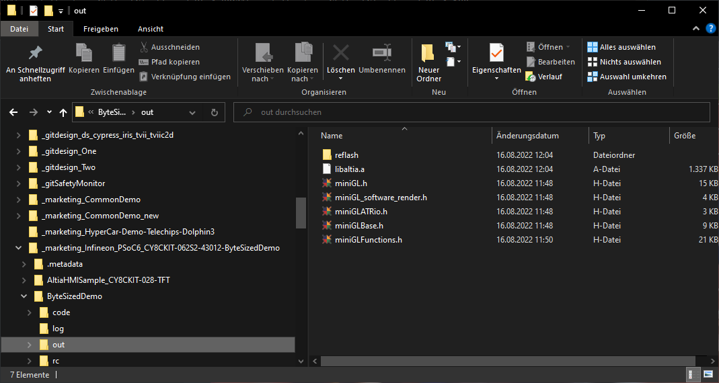

**ModusToolBox Project**

Use File -> Import… function

Ein Bild, das Text enthält.

to import the content of AltiaHMISample_CY8CKIT-028-TFT folder into IDE

Ein Bild, das Text enthält.

When this was successful, AltiaHMISample_CY8CKIT-028-TFT will show-up in the IDE Project Explorer. From there one shall use the Quick Panel to start Infineon “Library Manger” to generate the shared libraries needed for this project.

Ein Bild, das Text enthält.

In the Infineon Library Manger press the “Update” button to generate the library sources (they will be stored in the mtb_shared folder).

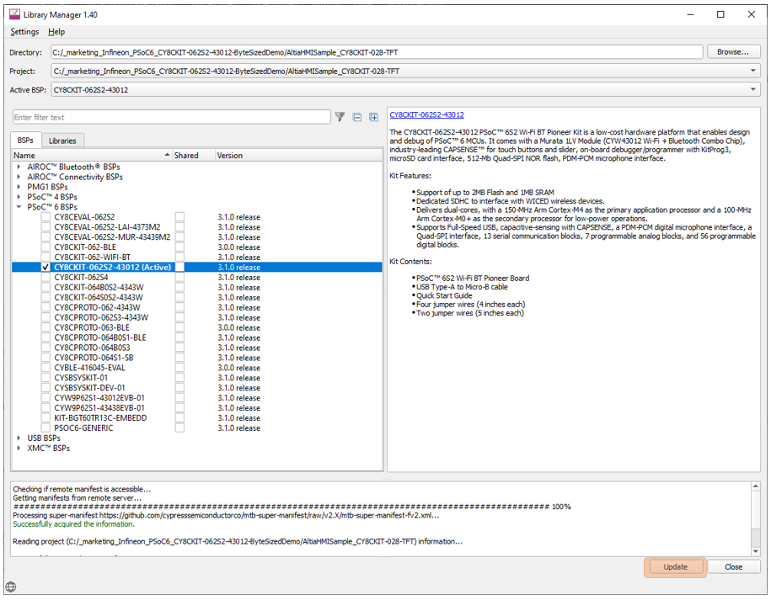

With the project imported and the library sources generated, one can build the demo application for example by right-clicking the AltiaHMISample_CY8CKIT-028-TFT project and selecting “Build Project”.

Alternatively, one can run “make getlibs” in the ModusToolBox Console.

When the application build process finished successfully, one will find the ELF-file of the application named AltiaHMISample_CY8CKIT-028-TFT.elf in AltiaHMISample_CY8CKIT-028-TFT/build/CY8CKIT-062S2-43012/(Debug|Release) folder.

# Demo Deployment to HW

# The following image shows the CY8CKIT-062S2-43012 PSoC6 evaluation board with the CY8CKIT-028-TFT display shield mounted.

# Ein Bild, das Text, Elektronik enthält. Automatisch generierte Beschreibung

# A -> Micro-USB connector (J6) for debugging and flash programming B -> SW4 (USER BTN2) C -> SW2 (USER BTN1) D -> SW1 (XRES) Reset Button

## Programming via ModusToolBox IDE

The demo executable can be programmed to HW via the IDE using the corresponding Application Launcher. For this it is recommended to update the Lauchner Configurations to match the current selected build-type (Debug/Release). This is done by running “Generate Launches for AltiaHIMSample_CY8CKIT-028-TFT”.

Ein Bild, das Text enthält.

After this connect the CY8CKIT-062S2-43012 J6 via micro‑USB‑to‑USB‑A cable (connector A in image above) to the PC and select “AltiaHMISample_CY8CKIT-028-TFT Program (KitProg3_MiniProg4)” from the Quick Panel.

## Programming via Cypress Programmer

Install and Start Cypress Programmer tool (Cypress Programmer can be received via Cypress). Select File -> Open from menu and browse to the location of the ELF-file.

Ein Bild, das Text, Screenshot, Monitor, schwarz enthält.

After connecting the CY8CKIT-062S2-43012 J6 (see connector A in image of EVB above) via micro‑USB‑to‑USB‑A cable (coming with the CY8CKIT-062S2-43012) to the PC. Select “CY8CKIT-062S2-43012…” from drop down menu Probe/Kit

Ein Bild, das Text enthält.

Programming can be started after pressing “Connect” followed by “Program”

Ein Bild, das Text enthält.

# Controlling the Demo

|  |  |
| --- | --- |
| After Power-On or Reset of the CY8C-062S2-43012 board the demo shows an introduction animation. |  |
| SW2 (USER BTN1) can be used to skip through four different Demo Screens. |  |
| Pressing SW4 (USER BTN2) changes from the current Demo Screen into an About Screen and back again. |  |