**1. In Internet Explorer enter address of Report Manager**

(System Administrator should know this, alternatively it could be found in Control Panel/Administrative Tools/Internet Information Services/Web Sites)

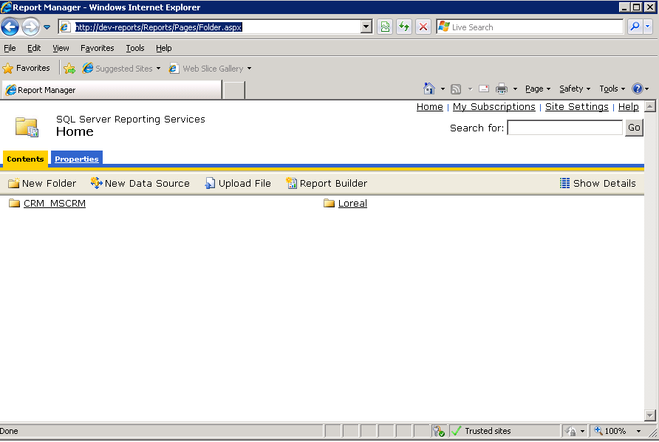

**2. Click New Data Source button**



**2a. Fill the table as follows:**

Name: LorealOptimise

Connection Type: Microsoft SQL Server

Connection String: <<enter connection string to DB (should be same as in DTS config)>>

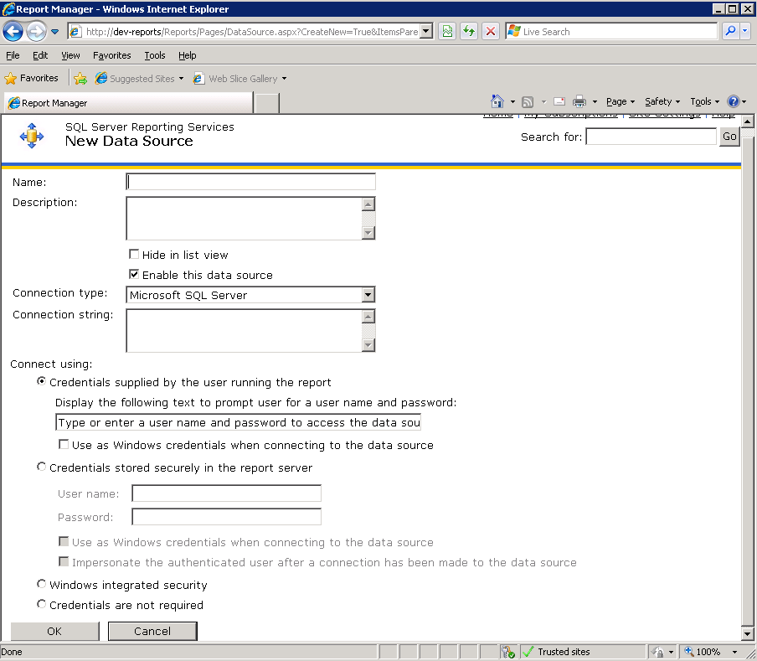

**2b. Click OK**

**3. Click Upload File button**



**3a. Browse to find file 'AlocationReport.rdl' (or 'StoreAllocationReport.rdl')**

**3b. Click ok**

**4. That's all**