Statistical Methods and Results for grasshopper Range Analysis
  - Effects of fertilizer treatment on Senegalese grasshopper (Oedaleus senegalensis) density, crop damage, and millet yield
2026-01-19
Table of contents

1. Statistical analyses

1.1 General statistical and programatic approach
All statistics were conducted in R version 4.5.2 (2025-10-31) (R Core Team, 2024) using generalized additive mixed models (GAMMs) and generalized linear mixed models (GLMMs) implemented with mgcv (Wood 2017, 2011, 2004) and glmmTMB (Brooks et al. 2017; McGillycuddy et al. 2025) packages, respectively. Models were appriased/validated using DHARMa (Hartig 2024) and gratia (Simpson 2024). Model selection when needed was done using AIC. Estimated marginal means and pairwise comparisons were calculated using the emmeans package (Lenth and Piaskowski 2025). Data visualization was performed using the ggplot2 package (Wickham 2016) along with extensions from the tidyverse suite of packages (Wickham et al. 2019). All code and data are versioned on github at: github.com/ddlawton/OSE-Range-Analysis. Upon publication a github archive snapshot will be created and stored in Zenodo for reproducibility with a DOI and citation.

1.2 Overall and mean monthly map generation
Maps of mean annual precipitation (MAP) and monthly rainfall patterns were generated using Climate Hazards Center Infrared Precipitation with Stations (CHIRPS) data (Funk et al. 2015) processed in Google Earth Engine (Gorelick et al. 2017) and imported into R for visualization with the terra (Hijmans 2025) and tidyterra (Hernangómez 2023) packages. Senegal administrative boundaries were obtained from the Natural Earth public domain map dataset using the rnaturalearth package (Massicotte and South 2025).

1.3 Locust density and damage models
For both density and damage, separate models were created for each of the three survey missions to assess how effects changed over time relative to the timing of fertilizer application. We specified the models as generalized linear mixed models (GLMMs) with a Poisson family for density and a tweedie family for damage percent (scaled to proportion). In both cases, we included fertilizer treatment, region, and their interaction as fixed effects, and farmer as a random effect to account for repeated measures since each farmer has a control and fertilized field.

1.4 Millet yield model
For millet yield, we specified a GLMM with a tweedie family to account for the continuous, positive, and right-skewed nature of yield data. Like the locust density and damage models, we included fertilizer treatment, region, and their interaction as fixed effects, and farmer as a random effect to account for repeated measures.

1.5 Ground cover × fertilizer mediation of grasshopper density
To test whether the effect of fertilizer on grasshopper density is mediated by ground cover, we fit a unified generalized additive model (GAM) with a Tweedie family to account for overdispersed count data. The model included fertilizer treatment, mission number, their interaction, and region as fixed effects, a random effect for farmer, and, critically, a by-variable smooth term allowing the relationship between ground cover and grasshopper density to vary by fertilizer treatment. Constructing a unified model allowed as to look directly at the mediation effect of ground cover on the fertilizer treatment effect on grasshopper density while accounting for the main effects of fertilizer treamtment and mission.

2. Results

2.1 Locust density through space and time
Temperature at the time of the survey did not affect O. senegalensis density after accounting for region, mission, and farmer (p = 0.21). The full temperature statistical model is in Table 8 and raw data are shown in Figure 10.

2.2 Locust developmental stages and generations through space and time
The locust surveys enabled us to identify the developmental stages and likely generations of Oedaleus senegalensis present during each mission (?@tbl-dev-stages). We identified three generations (G1, originating from the eggs of the previous season’s last generation, and G2 and G3) in the Thies, Fatick, and Kaffrine regions. In Saint Louis, only the G1 and G2 generations were observed. All developmental stages were identified, from eggs, through nymphal instars (1-5), to adults.
 | Kaffrine | Thies | Fatick | Saint - Louis
Mission 1 | Jul. 27 - Aug. 3 |  | Aug. 13 - 18 | Aug. 15 - 20
 | G1 - 4th instarG1 - 5th instarG1 - AdultEggs laid by G1 | G1 - AdultEggs laid by G1G2 - 1st instar | G1 - 4th instarG1 - 5th instarG1 - AdultEggs laid by G1 | G1 - 1st instarG1 - 2nd instar
Mission 2 | Aug. 30 - Sep. 4 |  | Sep. 6 - 10 | Sep. 20 - 25
 | G1 - AdultG2 - 1st instarG2 - 2nd instar | G1 - AdultEggs laid by G1G2 - 1st instar | G2 - 4th instarG2 - 5th instarG2 - Adult | G1 - AdultEggs laid by G1G2 - 1st instar
Mission 3 | Sep. 28 - Oct. 5 |  | Oct. 4 - 9 | Oct. 19
 | G2 - 4th instarG2 - 5th instarG2 - AdultG3 - 1st instar | G2 - AdultEggs laid by G2G3 - 1st instarG3 - 2nd instar | G2 - AdultEggs laid by G2G3 - 1st instarG3 - 2nd instar | G2 - AdultEggs laid by G2
Developmental stages and generations present during each of the missions across the four regions. The mission dates for each region are noted above the list of stages and generations present. The generations are noted by G followed by the generation number; Senegalese grasshoppers typically have three generations each year, as rains allow.

2.3 Crop impact

2.3.1 Senegalese grasshopper density
Fertilizer treatment progressively suppressed grasshopper density over the growing season, with effects intensifying from non-significant early in the season (Mission 1: p = 0.097) to highly significant by late season (Mission 3: estimate = -1.371, p < 0.001; Table 1). This temporal pattern reflected both fertilizer application and cumulative grasshopper population suppression. Regional responses varied significantly, with Kaffrine showing consistently elevated densities across all treatments and missions. By mission 3, grasshopper densities in control fields were 3.4-times higher than in fertilized fields in Kaffrine and 3.8-times higher in Thiès. Across all missions, the suppressive effect of fertilization in Kaffrine ranged from 1.1–3.4-fold (Table 2).

2.3.2 Grasshopper damage to millet
Crop damage mirrored grasshopper density patterns, intensifying throughout the missions and showing strongest fertilizer suppression by mission 3 (estimate = -2.384, p < 0.001; Table 3). Control fields had 3–11 times higher damage than fertilized fields by the last mission, with effects particularly pronounced in Fatick and Kaffrine (Table 4).

2.3.3 Millet yield
Fertilizer treatment significantly increased millet yield across all harvested regions (estimate = 0.582, p < 0.001), with the strongest effect in Thiès (p < 0.001; Table 5, Table 6). Control fields had 56% lower yield than fertilized fields in Fatick and Kaffrine, representing an approximately 1.8-fold increase from fertilization. Saint Louis was excluded from yield analysis due to insufficient rainfall for crop maturation.
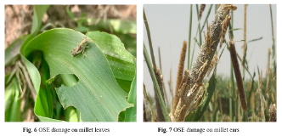
Figure 1: Senegalese grasshopper damage on millet leaves (a) and ears (b). Photo credit XXX.

2.4 Study region maps

2.4.1 Mean Annual Precipitation
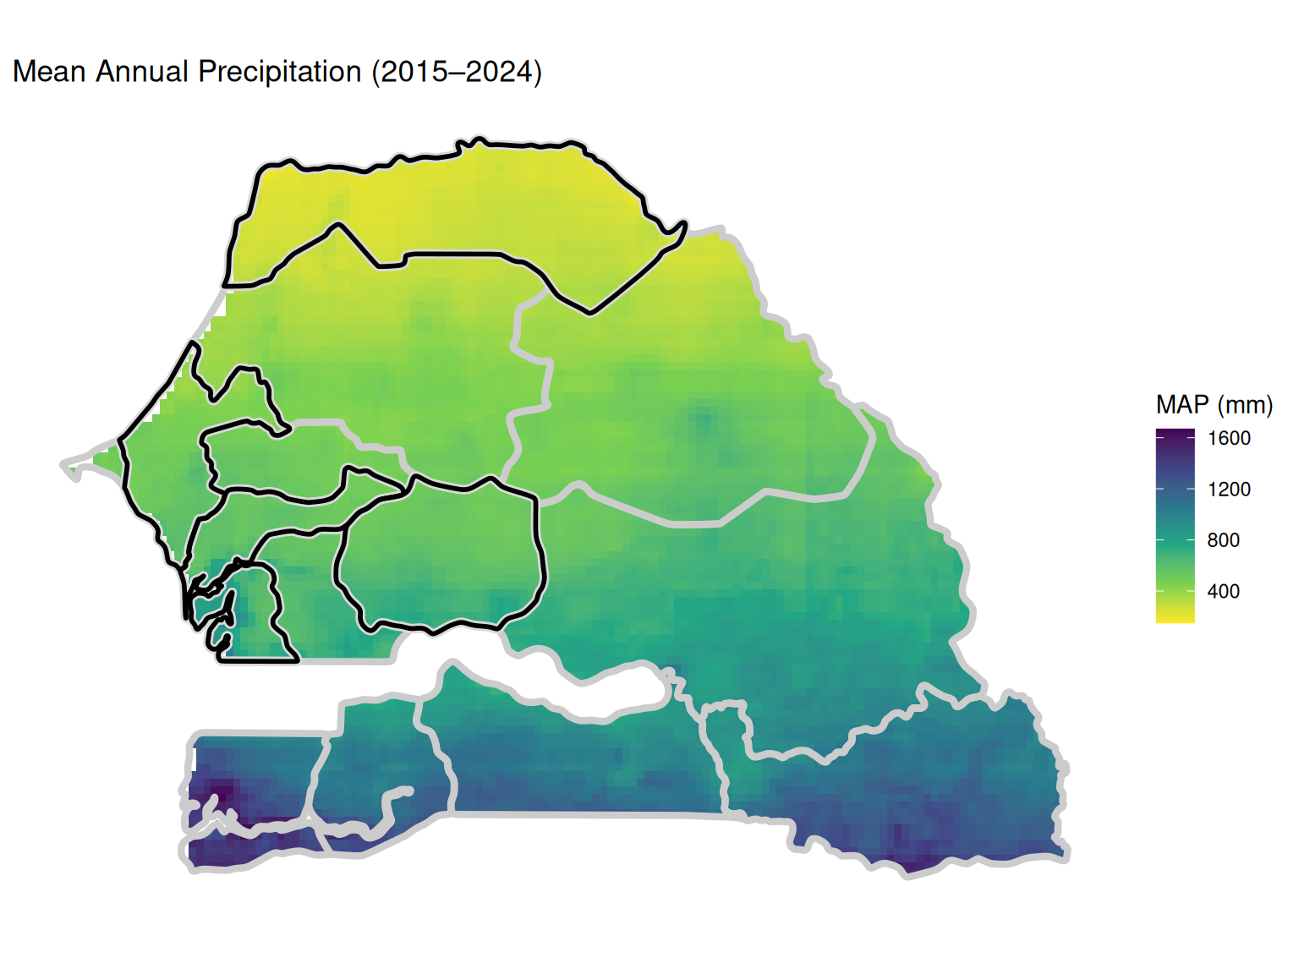
Figure 2: Mean annual precipitation (MAP) for Senegal (2015-2024) based on CHIRPS data. Study regions (Kaffrine, Thiès, Fatick, and Saint-Louis) are outlined in black.

2.4.2 Monthly Rainfall Patterns (2021)
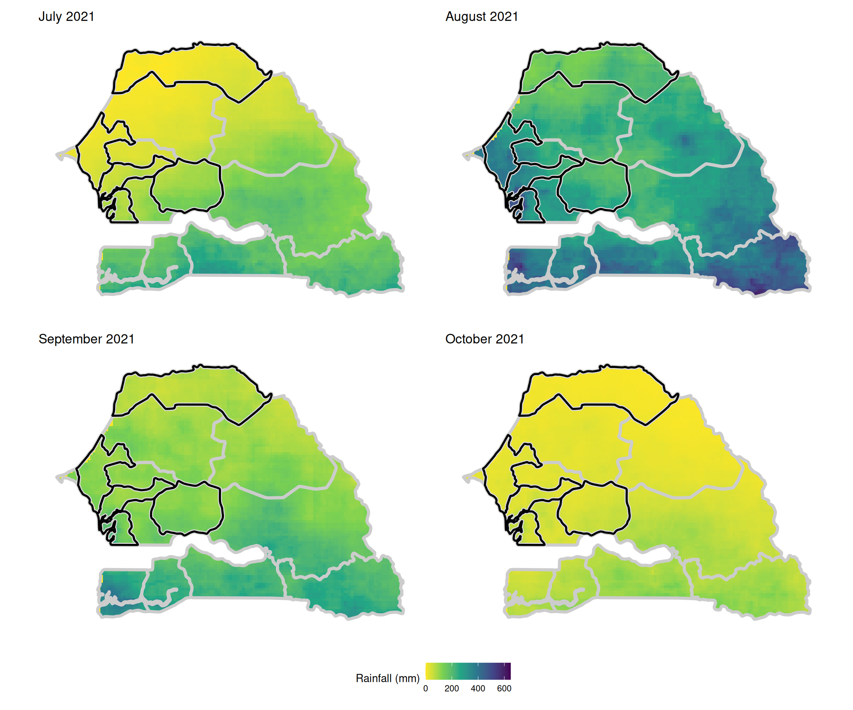
Figure 3: Monthly rainfall patterns during the 2021 growing season (July-October) across Senegal. Study regions are outlined in black.

2.5 grasshopper Density Analysis
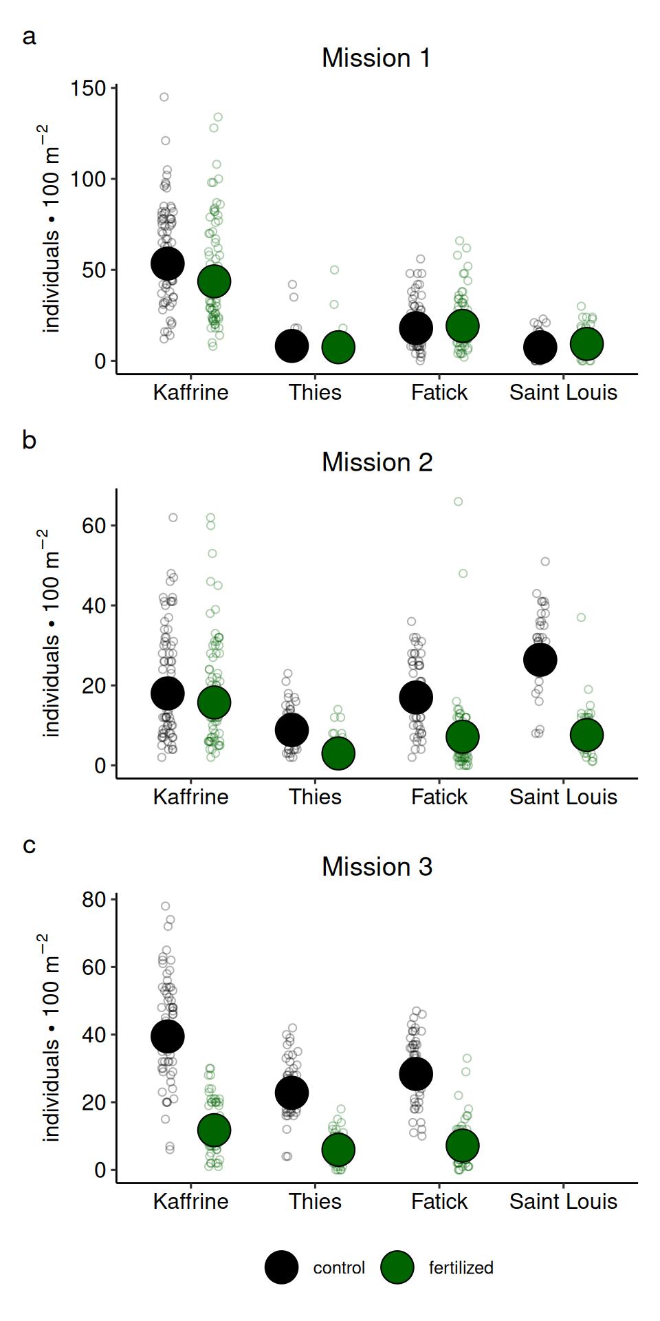
Figure 4: Senegalese grasshopper density was lower in the fertilized fields as compared to control millet fields across all study regions, particularly by missions 2 and 3 which took place after the fertilizer application was complete. Here and in subsequent figures, black and green circles are control and fertilized fields, respectively. Large solid circles are estimated marginal means and small open circles are raw data points. See the supplementary material Supp. Table SX for full statistical analysis.

2.6 OSE Damage Analysis
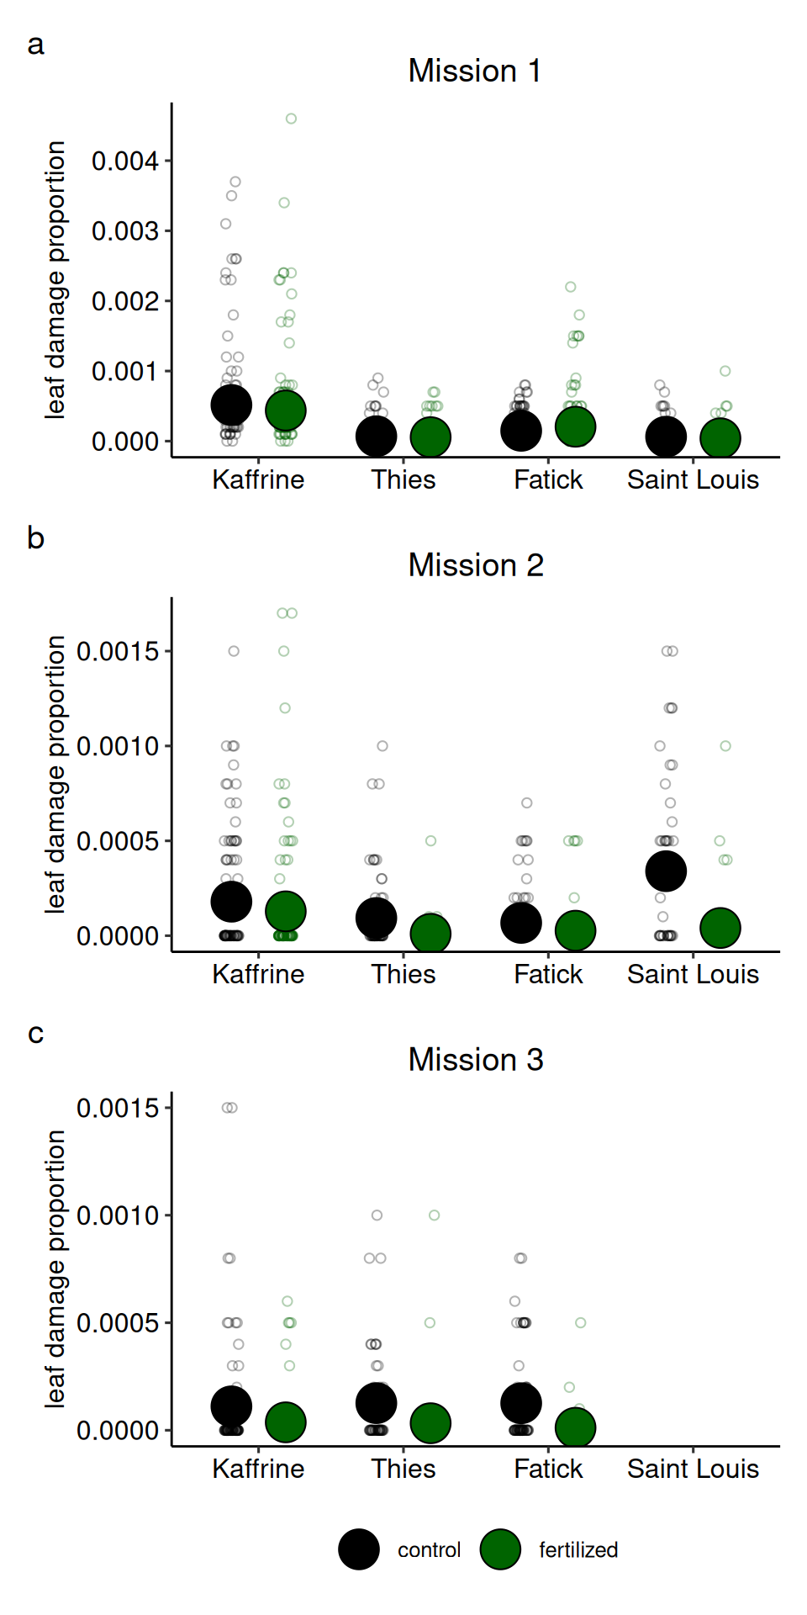
Figure 5: Millet damage from grasshoppers across the study regions and missions remained low in the fertilized fields but was elevated in the control fields during the second and third missions after the fertilizer application was complete. See the supplementary material Supp. Table SX for full statistical analysis.

2.7 Millet Yield Analysis
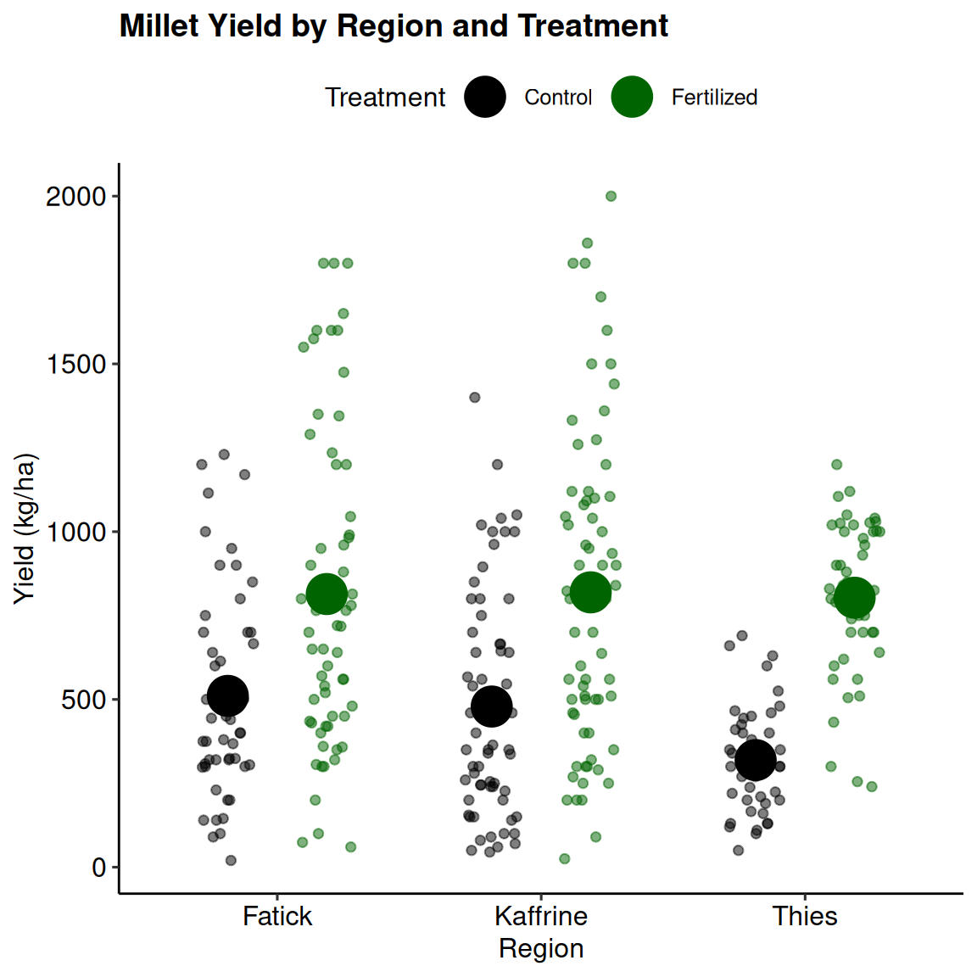
Figure 6: Millet yield was highest in fertilized fields across the three regions where there was sufficient rainfall to support millet to harvest (Fatick, Kaffrine, and Thies). See the supplementary material Supp. Table SX for full statistical analysis.

2.8 Ground Cover Mediation of Fertilizer Effects on grasshopper Density
Ground cover mediated fertilizer effects on grasshopper density differently between treatments (deviance explained: 60%; Table 7). In fertilized fields, density peaked at ~40% ground cover and declined at higher and lower values, whereas control fields showed low densities until 60–70% cover, after which densities increased substantially.
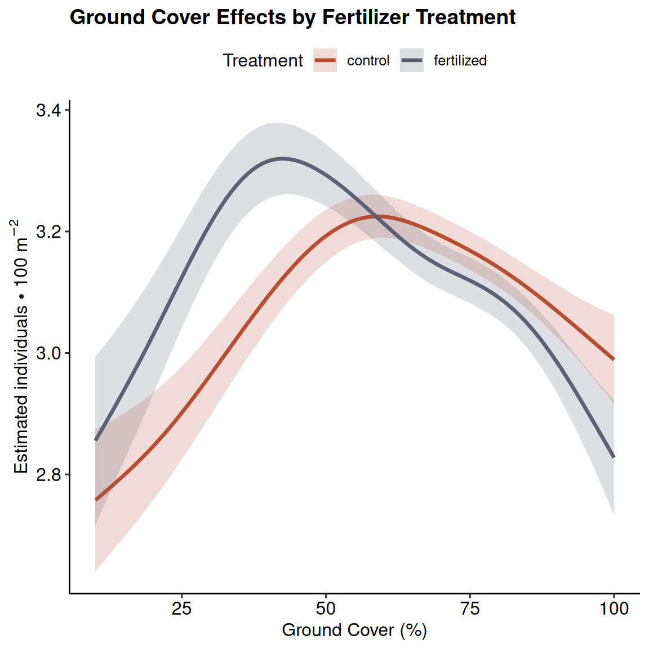
Figure 7: Senegalese grasshopper density peaked at around 40% ground cover in fertilized fields and around 60-70% in control fields. However, ground cover did not differ significantly between fertilizer treatments. See Supp. Tables SX and SX for full statistical analysis and Supp. Fig. SX for raw data points.

3. Supplementary Figures

3.1 Raw grasshopper count by treatment, mission, and region
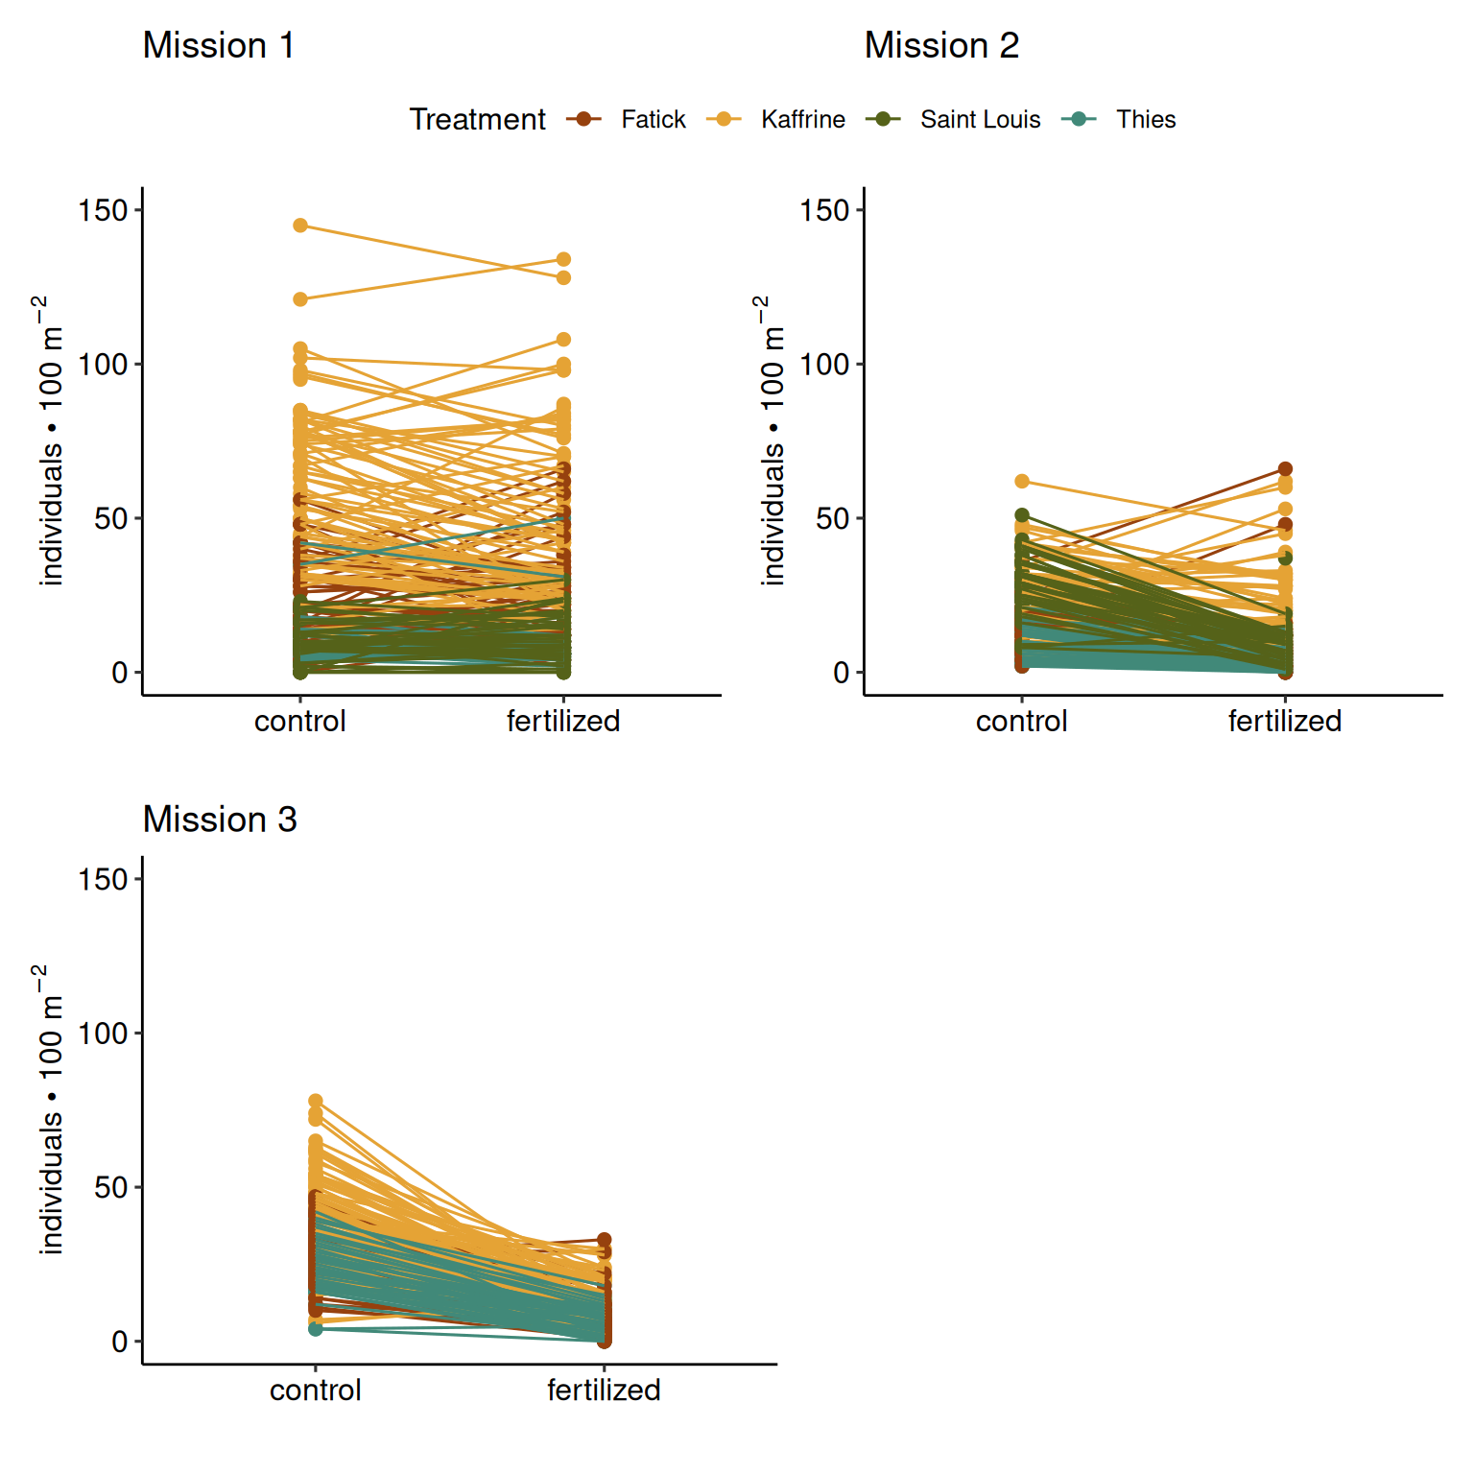
Figure 8: Ground cover by fertilizer treatment and mission across regions. Ground cover increased throughout the growing season across all regions, with minimal differences between control and fertilized treatments. No significant fertilizer × mission interaction was detected.

3.2 Ground Cover by Fertilizer Treatment
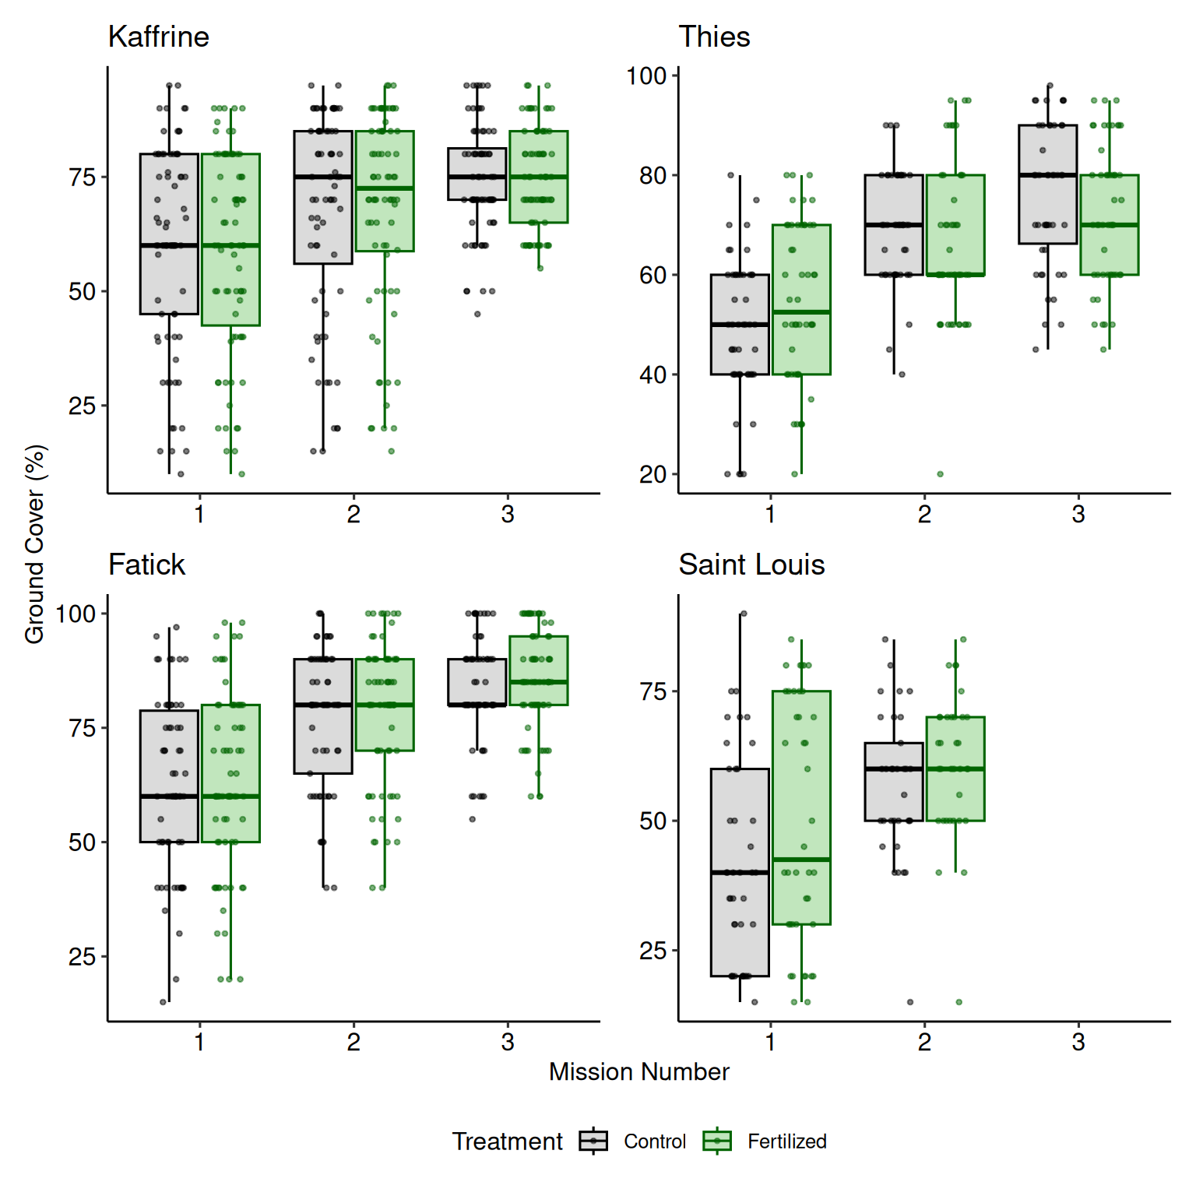
Figure 9: Ground cover by fertilizer treatment and mission across regions. Ground cover increased throughout the growing season across all regions, with minimal differences between control and fertilized treatments. No significant fertilizer × mission interaction was detected.

3.3 Temperature Variation Across Missions and Regions
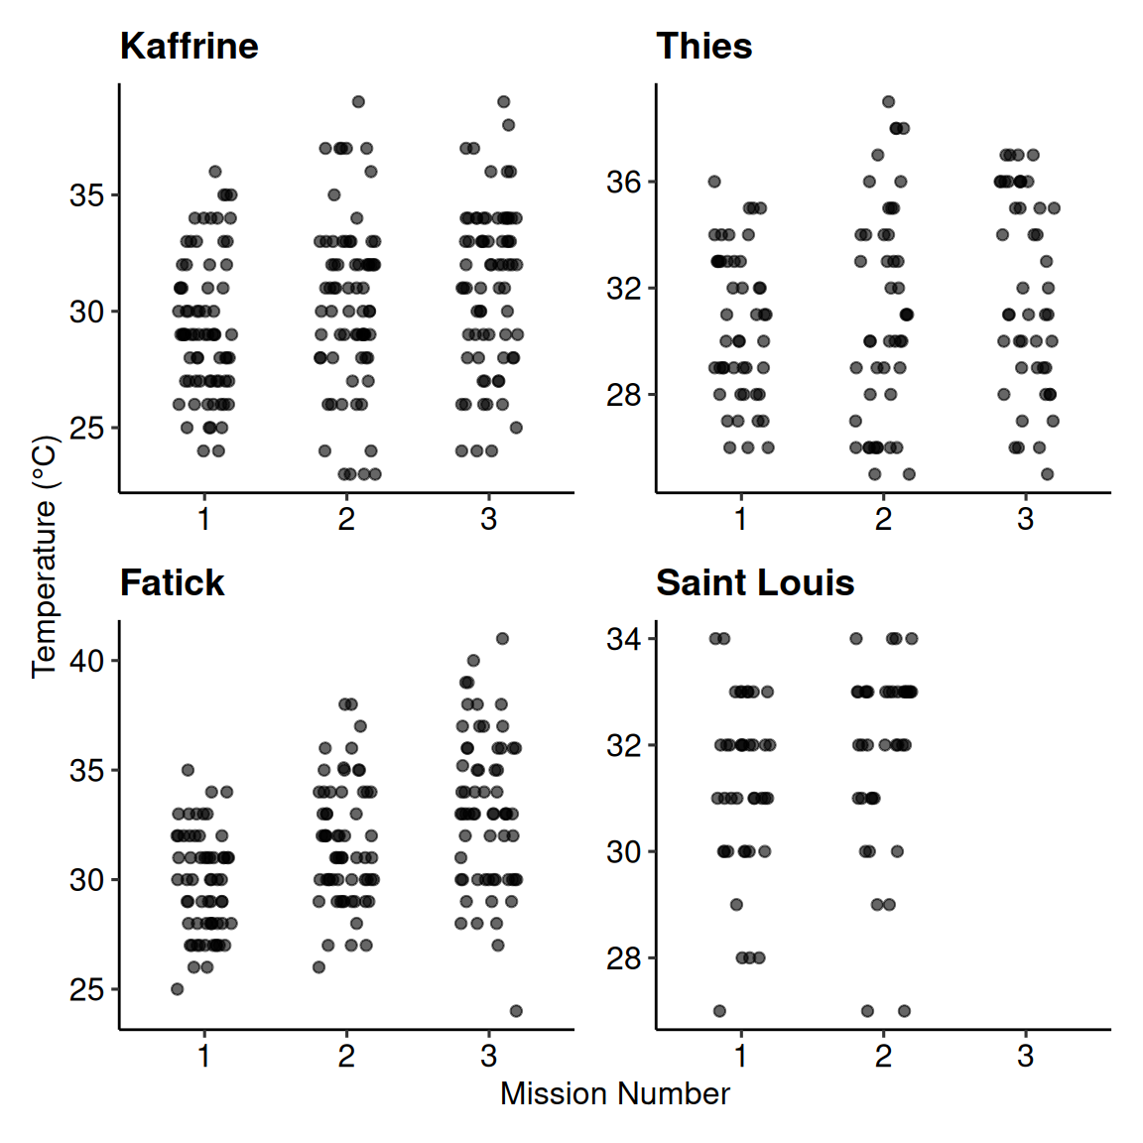
Figure 10: Temperature variation across missions and regions. Fatick showed increasing temperature through the sampling period, while Kaffrine, Thiès, and Saint-Louis remained more stable. Saint-Louis was generally cooler than the other regions. These patterns suggest that temperature at the time of survey is not a primary driver of grasshopper counts once region and mission timing are accounted for.

4. Supplementary Tables

4.1 grasshopper Density Analysis Tables

4.1.1 Model Summaries by Mission
Table 1: Model summaries for grasshopper density by treatment and region across three survey missions. Each mission was modeled separately using generalized linear mixed models (GLMMs) with Tweedie family distribution. Fixed effects include fertilizer treatment, region, and their interaction. Random effects account for farmer-level variation.
Table 1: Grasshopper Density Model Summaries by Mission
Effect | Term | Estimate | Std. Error | Statistic | P-value
1
fixed | (Intercept) | 2.967 | 0.096 | 30.903 | 0.000
fixed | fertilized | 0.065 | 0.039 | 1.658 | 0.097
fixed | Kaffrine | 1.090 | 0.095 | 11.423 | 0.000
fixed | Saint Louis | -0.878 | 0.126 | -6.995 | 0.000
fixed | Thies | -0.789 | 0.117 | -6.767 | 0.000
fixed | percent_ground_cover | -0.001 | 0.001 | -1.322 | 0.186
fixed | fertilized:Kaffrine | -0.267 | 0.045 | -5.890 | 0.000
fixed | fertilized:Saint Louis | 0.153 | 0.081 | 1.883 | 0.060
fixed | fertilized:Thies | -0.155 | 0.079 | -1.964 | 0.050
random | farmer | 0.532 | NA | NA | NA
2
fixed | (Intercept) | 3.491 | 0.140 | 24.988 | 0.000
fixed | fertilized | -0.863 | 0.056 | -15.539 | 0.000
fixed | Kaffrine | 0.057 | 0.098 | 0.582 | 0.561
fixed | Saint Louis | 0.441 | 0.123 | 3.599 | 0.000
fixed | Thies | -0.655 | 0.115 | -5.672 | 0.000
fixed | percent_ground_cover | -0.009 | 0.002 | -6.050 | 0.000
fixed | fertilized:Kaffrine | 0.729 | 0.067 | 10.927 | 0.000
fixed | fertilized:Saint Louis | -0.384 | 0.088 | -4.367 | 0.000
fixed | fertilized:Thies | -0.223 | 0.107 | -2.091 | 0.037
random | farmer | 0.516 | NA | NA | NA
3
fixed | (Intercept) | 3.439 | 0.149 | 23.123 | 0.000
fixed | fertilized | -1.371 | 0.051 | -26.973 | 0.000
fixed | Kaffrine | 0.330 | 0.064 | 5.135 | 0.000
fixed | Thies | -0.218 | 0.074 | -2.953 | 0.003
fixed | percent_ground_cover | -0.001 | 0.002 | -0.717 | 0.474
fixed | fertilized:Kaffrine | 0.161 | 0.063 | 2.533 | 0.011
fixed | fertilized:Thies | 0.026 | 0.083 | 0.317 | 0.751
random | farmer | 0.319 | NA | NA | NA
Note: Models fit separately for each mission. Random effect shown as standard deviation.

4.1.2 Pairwise Comparisons by Mission
Table 2: Pairwise comparisons of estimated marginal means for grasshopper density across treatment × region combinations within each mission. Ratios indicate the multiplicative difference between groups. Tukey adjustment applied for multiple comparisons.
Table 1: Grasshoppe Density Pairwise Comparisons by Mission
Contrast | Ratio | Std. Error | df | null | z Ratio | P-value
1
control Fatick / control Kaffrine | 0.336 | 0.032 | Inf | 1 | -11.423 | 0.000
control Fatick / control Saint Louis | 2.406 | 0.302 | Inf | 1 | 6.995 | 0.000
control Fatick / control Thies | 2.200 | 0.256 | Inf | 1 | 6.767 | 0.000
control Fatick / fertilized Fatick | 0.937 | 0.037 | Inf | 1 | -1.658 | 0.715
control Fatick / fertilized Kaffrine | 0.412 | 0.039 | Inf | 1 | -9.282 | 0.000
control Fatick / fertilized Saint Louis | 1.934 | 0.236 | Inf | 1 | 5.398 | 0.000
control Fatick / fertilized Thies | 2.408 | 0.281 | Inf | 1 | 7.520 | 0.000
control Kaffrine / control Saint Louis | 7.152 | 0.867 | Inf | 1 | 16.236 | 0.000
control Kaffrine / control Thies | 6.541 | 0.732 | Inf | 1 | 16.785 | 0.000
control Kaffrine / fertilized Kaffrine | 1.224 | 0.028 | Inf | 1 | 8.872 | 0.000
control Kaffrine / fertilized Saint Louis | 5.749 | 0.678 | Inf | 1 | 14.838 | 0.000
control Kaffrine / fertilized Thies | 7.158 | 0.804 | Inf | 1 | 17.523 | 0.000
control Saint Louis / control Thies | 0.915 | 0.125 | Inf | 1 | -0.654 | 0.998
control Saint Louis / fertilized Saint Louis | 0.804 | 0.057 | Inf | 1 | -3.062 | 0.046
control Saint Louis / fertilized Thies | 1.001 | 0.138 | Inf | 1 | 0.006 | 1.000
control Thies / fertilized Thies | 1.094 | 0.075 | Inf | 1 | 1.315 | 0.893
fertilized Fatick / control Kaffrine | 0.359 | 0.034 | Inf | 1 | -10.857 | 0.000
fertilized Fatick / control Saint Louis | 2.567 | 0.320 | Inf | 1 | 7.565 | 0.000
fertilized Fatick / control Thies | 2.348 | 0.272 | Inf | 1 | 7.381 | 0.000
fertilized Fatick / fertilized Kaffrine | 0.439 | 0.042 | Inf | 1 | -8.695 | 0.000
fertilized Fatick / fertilized Saint Louis | 2.064 | 0.250 | Inf | 1 | 5.972 | 0.000
fertilized Fatick / fertilized Thies | 2.569 | 0.298 | Inf | 1 | 8.136 | 0.000
fertilized Kaffrine / control Saint Louis | 5.844 | 0.707 | Inf | 1 | 14.584 | 0.000
fertilized Kaffrine / control Thies | 5.345 | 0.598 | Inf | 1 | 14.984 | 0.000
fertilized Kaffrine / fertilized Saint Louis | 4.698 | 0.554 | Inf | 1 | 13.123 | 0.000
fertilized Kaffrine / fertilized Thies | 5.849 | 0.657 | Inf | 1 | 15.712 | 0.000
fertilized Saint Louis / control Thies | 1.138 | 0.153 | Inf | 1 | 0.961 | 0.980
fertilized Saint Louis / fertilized Thies | 1.245 | 0.168 | Inf | 1 | 1.620 | 0.738
2
control Fatick / control Kaffrine | 0.945 | 0.093 | Inf | 1 | -0.582 | 0.999
control Fatick / control Saint Louis | 0.643 | 0.079 | Inf | 1 | -3.599 | 0.008
control Fatick / control Thies | 1.925 | 0.222 | Inf | 1 | 5.672 | 0.000
control Fatick / fertilized Fatick | 2.371 | 0.132 | Inf | 1 | 15.539 | 0.000
control Fatick / fertilized Kaffrine | 1.080 | 0.106 | Inf | 1 | 0.784 | 0.994
control Fatick / fertilized Saint Louis | 2.239 | 0.293 | Inf | 1 | 6.156 | 0.000
control Fatick / fertilized Thies | 5.706 | 0.744 | Inf | 1 | 13.364 | 0.000
control Kaffrine / control Saint Louis | 0.681 | 0.079 | Inf | 1 | -3.302 | 0.022
control Kaffrine / control Thies | 2.038 | 0.227 | Inf | 1 | 6.394 | 0.000
control Kaffrine / fertilized Kaffrine | 1.143 | 0.042 | Inf | 1 | 3.621 | 0.007
control Kaffrine / fertilized Saint Louis | 2.370 | 0.298 | Inf | 1 | 6.868 | 0.000
control Kaffrine / fertilized Thies | 6.041 | 0.762 | Inf | 1 | 14.260 | 0.000
control Saint Louis / control Thies | 2.993 | 0.395 | Inf | 1 | 8.305 | 0.000
control Saint Louis / fertilized Saint Louis | 3.480 | 0.237 | Inf | 1 | 18.307 | 0.000
control Saint Louis / fertilized Thies | 8.870 | 1.279 | Inf | 1 | 15.143 | 0.000
control Thies / fertilized Thies | 2.964 | 0.271 | Inf | 1 | 11.897 | 0.000
fertilized Fatick / control Kaffrine | 0.398 | 0.041 | Inf | 1 | -9.009 | 0.000
fertilized Fatick / control Saint Louis | 0.271 | 0.034 | Inf | 1 | -10.369 | 0.000
fertilized Fatick / control Thies | 0.812 | 0.097 | Inf | 1 | -1.749 | 0.655
fertilized Fatick / fertilized Kaffrine | 0.456 | 0.047 | Inf | 1 | -7.696 | 0.000
fertilized Fatick / fertilized Saint Louis | 0.944 | 0.126 | Inf | 1 | -0.427 | 1.000
fertilized Fatick / fertilized Thies | 2.407 | 0.321 | Inf | 1 | 6.585 | 0.000
fertilized Kaffrine / control Saint Louis | 0.596 | 0.069 | Inf | 1 | -4.448 | 0.000
fertilized Kaffrine / control Thies | 1.783 | 0.199 | Inf | 1 | 5.188 | 0.000
fertilized Kaffrine / fertilized Saint Louis | 2.073 | 0.261 | Inf | 1 | 5.797 | 0.000
fertilized Kaffrine / fertilized Thies | 5.284 | 0.667 | Inf | 1 | 13.190 | 0.000
fertilized Saint Louis / control Thies | 0.860 | 0.121 | Inf | 1 | -1.076 | 0.962
fertilized Saint Louis / fertilized Thies | 2.549 | 0.387 | Inf | 1 | 6.164 | 0.000
3
control Fatick / control Kaffrine | 0.719 | 0.046 | Inf | 1 | -5.135 | 0.000
control Fatick / control Thies | 1.244 | 0.092 | Inf | 1 | 2.953 | 0.037
control Fatick / fertilized Fatick | 3.941 | 0.200 | Inf | 1 | 26.973 | 0.000
control Fatick / fertilized Kaffrine | 2.412 | 0.168 | Inf | 1 | 12.668 | 0.000
control Fatick / fertilized Thies | 4.775 | 0.425 | Inf | 1 | 17.570 | 0.000
control Kaffrine / control Thies | 1.731 | 0.120 | Inf | 1 | 7.882 | 0.000
control Kaffrine / fertilized Kaffrine | 3.357 | 0.127 | Inf | 1 | 32.015 | 0.000
control Kaffrine / fertilized Thies | 6.644 | 0.560 | Inf | 1 | 22.471 | 0.000
control Thies / fertilized Thies | 3.839 | 0.250 | Inf | 1 | 20.643 | 0.000
fertilized Fatick / control Kaffrine | 0.182 | 0.014 | Inf | 1 | -22.922 | 0.000
fertilized Fatick / control Thies | 0.316 | 0.026 | Inf | 1 | -13.964 | 0.000
fertilized Fatick / fertilized Kaffrine | 0.612 | 0.048 | Inf | 1 | -6.234 | 0.000
fertilized Fatick / fertilized Thies | 1.212 | 0.117 | Inf | 1 | 1.988 | 0.349
fertilized Kaffrine / control Thies | 0.516 | 0.038 | Inf | 1 | -8.897 | 0.000
fertilized Kaffrine / fertilized Thies | 1.979 | 0.175 | Inf | 1 | 7.729 | 0.000
Note: Pairwise comparisons conducted within each mission separately.

4.2 Grasshopper Damage Analysis Tables

4.2.1 Model Summaries by Mission
Table 3: Model summaries for grasshopper damage by treatment and region across three survey missions. Each mission was modeled separately using generalized linear mixed models (GLMMs) with Tweedie family distribution. Fixed effects include fertilizer treatment, region, and their interaction. Random effects account for farmer-level variation.
Table 1: Grasshopper Damage Model Summaries by Mission
Effect | Term | Estimate | Std. Error | Statistic | P-value
1
fixed | (Intercept) | -8.823 | 0.198 | -44.472 | 0.000
fixed | fertilized | 0.335 | 0.184 | 1.815 | 0.070
fixed | Kaffrine | 1.253 | 0.240 | 5.214 | 0.000
fixed | Saint Louis | -0.845 | 0.359 | -2.354 | 0.019
fixed | Thies | -0.747 | 0.330 | -2.262 | 0.024
fixed | fertilized:Kaffrine | -0.500 | 0.217 | -2.309 | 0.021
fixed | fertilized:Saint Louis | -0.785 | 0.418 | -1.880 | 0.060
fixed | fertilized:Thies | -0.550 | 0.363 | -1.517 | 0.129
random | farmer | 0.981 | NA | NA | NA
2
fixed | (Intercept) | -9.604 | 0.320 | -30.032 | 0.000
fixed | fertilized | -0.940 | 0.486 | -1.934 | 0.053
fixed | Kaffrine | 0.977 | 0.363 | 2.692 | 0.007
fixed | Saint Louis | 1.617 | 0.380 | 4.259 | 0.000
fixed | Thies | 0.325 | 0.436 | 0.744 | 0.457
fixed | fertilized:Kaffrine | 0.606 | 0.553 | 1.096 | 0.273
fixed | fertilized:Saint Louis | -1.186 | 0.681 | -1.742 | 0.081
fixed | fertilized:Thies | -1.324 | 0.896 | -1.478 | 0.139
random | farmer | 0.787 | NA | NA | NA
3
fixed | (Intercept) | -8.981 | 0.293 | -30.665 | 0.000
fixed | fertilized | -2.384 | 0.698 | -3.417 | 0.001
fixed | Kaffrine | -0.123 | 0.409 | -0.302 | 0.763
fixed | Thies | 0.003 | 0.451 | 0.007 | 0.995
fixed | fertilized:Kaffrine | 1.280 | 0.856 | 1.495 | 0.135
fixed | fertilized:Thies | 1.032 | 0.939 | 1.100 | 0.271
random | farmer | 0.000 | NA | NA | NA
Note: Models fit separately for each mission. Random effect shown as standard deviation.

4.2.2 Pairwise Comparisons by Mission
Table 4: Pairwise comparisons of estimated marginal means for grasshopper damage across treatment × region combinations within each mission. Ratios indicate the multiplicative difference between groups. Tukey adjustment applied for multiple comparisons.
Table 1: Grasshopper Damage Pairwise Comparisons by Mission
Contrast | Ratio | Std. Error | df | null | z Ratio | P-value
1
control Fatick / control Kaffrine | 0.286 | 0.069 | Inf | 1 | -5.214 | 0.000
control Fatick / control Saint Louis | 2.329 | 0.836 | Inf | 1 | 2.354 | 0.264
control Fatick / control Thies | 2.111 | 0.697 | Inf | 1 | 2.262 | 0.315
control Fatick / fertilized Fatick | 0.716 | 0.132 | Inf | 1 | -1.815 | 0.610
control Fatick / fertilized Kaffrine | 0.337 | 0.081 | Inf | 1 | -4.509 | 0.000
control Fatick / fertilized Saint Louis | 3.655 | 1.443 | Inf | 1 | 3.282 | 0.023
control Fatick / fertilized Thies | 2.619 | 0.900 | Inf | 1 | 2.803 | 0.094
control Kaffrine / control Saint Louis | 8.155 | 2.765 | Inf | 1 | 6.191 | 0.000
control Kaffrine / control Thies | 7.392 | 2.274 | Inf | 1 | 6.504 | 0.000
control Kaffrine / fertilized Kaffrine | 1.180 | 0.134 | Inf | 1 | 1.456 | 0.831
control Kaffrine / fertilized Saint Louis | 12.799 | 4.822 | Inf | 1 | 6.767 | 0.000
control Kaffrine / fertilized Thies | 9.173 | 2.950 | Inf | 1 | 6.890 | 0.000
control Saint Louis / control Thies | 0.906 | 0.365 | Inf | 1 | -0.244 | 1.000
control Saint Louis / fertilized Saint Louis | 1.569 | 0.588 | Inf | 1 | 1.202 | 0.932
control Saint Louis / fertilized Thies | 1.125 | 0.465 | Inf | 1 | 0.285 | 1.000
control Thies / fertilized Thies | 1.241 | 0.388 | Inf | 1 | 0.690 | 0.997
fertilized Fatick / control Kaffrine | 0.399 | 0.090 | Inf | 1 | -4.069 | 0.001
fertilized Fatick / control Saint Louis | 3.254 | 1.135 | Inf | 1 | 3.383 | 0.016
fertilized Fatick / control Thies | 2.949 | 0.942 | Inf | 1 | 3.388 | 0.016
fertilized Fatick / fertilized Kaffrine | 0.471 | 0.107 | Inf | 1 | -3.323 | 0.020
fertilized Fatick / fertilized Saint Louis | 5.107 | 1.969 | Inf | 1 | 4.230 | 0.001
fertilized Fatick / fertilized Thies | 3.660 | 1.218 | Inf | 1 | 3.899 | 0.002
fertilized Kaffrine / control Saint Louis | 6.909 | 2.344 | Inf | 1 | 5.698 | 0.000
fertilized Kaffrine / control Thies | 6.263 | 1.928 | Inf | 1 | 5.958 | 0.000
fertilized Kaffrine / fertilized Saint Louis | 10.844 | 4.088 | Inf | 1 | 6.323 | 0.000
fertilized Kaffrine / fertilized Thies | 7.771 | 2.502 | Inf | 1 | 6.368 | 0.000
fertilized Saint Louis / control Thies | 0.578 | 0.251 | Inf | 1 | -1.263 | 0.912
fertilized Saint Louis / fertilized Thies | 0.717 | 0.319 | Inf | 1 | -0.749 | 0.995
2
control Fatick / control Kaffrine | 0.376 | 0.137 | Inf | 1 | -2.692 | 0.125
control Fatick / control Saint Louis | 0.198 | 0.075 | Inf | 1 | -4.259 | 0.001
control Fatick / control Thies | 0.723 | 0.315 | Inf | 1 | -0.744 | 0.996
control Fatick / fertilized Fatick | 2.559 | 1.243 | Inf | 1 | 1.934 | 0.528
control Fatick / fertilized Kaffrine | 0.526 | 0.196 | Inf | 1 | -1.722 | 0.673
control Fatick / fertilized Saint Louis | 1.663 | 0.905 | Inf | 1 | 0.934 | 0.983
control Fatick / fertilized Thies | 6.952 | 5.356 | Inf | 1 | 2.517 | 0.188
control Kaffrine / control Saint Louis | 0.527 | 0.163 | Inf | 1 | -2.076 | 0.430
control Kaffrine / control Thies | 1.921 | 0.720 | Inf | 1 | 1.742 | 0.659
control Kaffrine / fertilized Kaffrine | 1.396 | 0.368 | Inf | 1 | 1.268 | 0.911
control Kaffrine / fertilized Saint Louis | 4.418 | 2.193 | Inf | 1 | 2.993 | 0.056
control Kaffrine / fertilized Thies | 18.471 | 13.620 | Inf | 1 | 3.955 | 0.002
control Saint Louis / control Thies | 3.643 | 1.430 | Inf | 1 | 3.294 | 0.022
control Saint Louis / fertilized Saint Louis | 8.380 | 4.001 | Inf | 1 | 4.453 | 0.000
control Saint Louis / fertilized Thies | 35.033 | 26.183 | Inf | 1 | 4.758 | 0.000
control Thies / fertilized Thies | 9.617 | 7.236 | Inf | 1 | 3.008 | 0.053
fertilized Fatick / control Kaffrine | 0.147 | 0.067 | Inf | 1 | -4.204 | 0.001
fertilized Fatick / control Saint Louis | 0.078 | 0.036 | Inf | 1 | -5.442 | 0.000
fertilized Fatick / control Thies | 0.282 | 0.146 | Inf | 1 | -2.450 | 0.217
fertilized Fatick / fertilized Kaffrine | 0.205 | 0.095 | Inf | 1 | -3.409 | 0.015
fertilized Fatick / fertilized Saint Louis | 0.650 | 0.396 | Inf | 1 | -0.707 | 0.997
fertilized Fatick / fertilized Thies | 2.717 | 2.223 | Inf | 1 | 1.221 | 0.926
fertilized Kaffrine / control Saint Louis | 0.378 | 0.121 | Inf | 1 | -3.027 | 0.051
fertilized Kaffrine / control Thies | 1.376 | 0.529 | Inf | 1 | 0.829 | 0.992
fertilized Kaffrine / fertilized Saint Louis | 3.164 | 1.594 | Inf | 1 | 2.286 | 0.301
fertilized Kaffrine / fertilized Thies | 13.228 | 9.817 | Inf | 1 | 3.479 | 0.012
fertilized Saint Louis / control Thies | 0.435 | 0.240 | Inf | 1 | -1.509 | 0.803
fertilized Saint Louis / fertilized Thies | 4.181 | 3.516 | Inf | 1 | 1.701 | 0.687
3
control Fatick / control Kaffrine | 1.131 | 0.463 | Inf | 1 | 0.302 | 1.000
control Fatick / control Thies | 0.997 | 0.449 | Inf | 1 | -0.007 | 1.000
control Fatick / fertilized Fatick | 10.843 | 7.563 | Inf | 1 | 3.417 | 0.008
control Fatick / fertilized Kaffrine | 3.412 | 1.708 | Inf | 1 | 2.452 | 0.139
control Fatick / fertilized Thies | 3.850 | 2.321 | Inf | 1 | 2.236 | 0.221
control Kaffrine / control Thies | 0.881 | 0.393 | Inf | 1 | -0.283 | 1.000
control Kaffrine / fertilized Kaffrine | 3.016 | 1.497 | Inf | 1 | 2.223 | 0.227
control Kaffrine / fertilized Thies | 3.403 | 2.040 | Inf | 1 | 2.043 | 0.318
control Thies / fertilized Thies | 3.861 | 2.427 | Inf | 1 | 2.150 | 0.262
fertilized Fatick / control Kaffrine | 0.104 | 0.072 | Inf | 1 | -3.254 | 0.014
fertilized Fatick / control Thies | 0.092 | 0.066 | Inf | 1 | -3.316 | 0.012
fertilized Fatick / fertilized Kaffrine | 0.315 | 0.237 | Inf | 1 | -1.537 | 0.640
fertilized Fatick / fertilized Thies | 0.355 | 0.292 | Inf | 1 | -1.257 | 0.808
fertilized Kaffrine / control Thies | 0.292 | 0.155 | Inf | 1 | -2.317 | 0.187
fertilized Kaffrine / fertilized Thies | 1.128 | 0.751 | Inf | 1 | 0.181 | 1.000
Note: Pairwise comparisons conducted within each mission separately.

4.3 Millet Yield Analysis Tables

4.3.1 Model Summary
Table 5: Model summary for millet yield by fertilizer treatment and region. Generalized linear mixed model (GLMM) with Tweedie family distribution. Fixed effects include fertilizer treatment, region, and their interaction. Random effects account for farmer-level variation.
Table 1: Model Estimates for Yield ~ Fertilizer × Region
Fixed effects and random parameter SDs
 | effect | Component | Estimate | Std. error | z | p_value | p-value
Random parameters
sd__(Intercept) | ran_pars | cond | 0.545 | - | - | - | -
Fixed effects
Intercept | fixed | cond | 5.969 | 0.085 | 70.478 | 0.000 | <0.001***
Fertilized | fixed | cond | 0.582 | 0.054 | 10.806 | 0.000 | <0.001***
Kaffrine | fixed | cond | -0.008 | 0.114 | -0.067 | 0.946 | 0.946
Thies | fixed | cond | -0.278 | 0.127 | -2.191 | 0.028 | 0.028*
Fertilized:Kaffrine | fixed | cond | -0.003 | 0.072 | -0.042 | 0.966 | 0.966
Fertilized:Thies | fixed | cond | 0.358 | 0.083 | 4.334 | 0.000 | <0.001***
Significance: *** p < 0.001, ** p < 0.01, * p < 0.05

4.3.2 Pairwise Comparisons
Table 6: Pairwise comparisons of estimated marginal means for millet yield across treatment × region combinations. Ratios indicate the multiplicative difference between groups. Tukey adjustment applied for multiple comparisons.
Table 1: Estimated Marginal Means Pairwise Contrasts
Table of pairwise ratios, z statistics, and p-values
 | Ratio | Std. Error | DF | Null | z Ratio | p-value
control Fatick / fertilized Fatick | 0.559 | 0.030 | Inf | 1 | -10.806 | <0.001***
control Fatick / control Kaffrine | 1.008 | 0.115 | Inf | 1 | 0.067 | 1.000e+00
control Fatick / fertilized Kaffrine | 0.565 | 0.062 | Inf | 1 | -5.165 | <0.001***
control Fatick / control Thies | 1.320 | 0.167 | Inf | 1 | 2.191 | 2.418e-01
control Fatick / fertilized Thies | 0.515 | 0.062 | Inf | 1 | -5.522 | <0.001***
fertilized Fatick / control Kaffrine | 1.804 | 0.197 | Inf | 1 | 5.418 | <0.001***
fertilized Fatick / fertilized Kaffrine | 1.011 | 0.107 | Inf | 1 | 0.101 | 1.000e+00
fertilized Fatick / control Thies | 2.363 | 0.289 | Inf | 1 | 7.042 | <0.001***
fertilized Fatick / fertilized Thies | 0.923 | 0.106 | Inf | 1 | -0.698 | 9.822e-01
control Kaffrine / fertilized Kaffrine | 0.560 | 0.027 | Inf | 1 | -12.181 | <0.001***
control Kaffrine / control Thies | 1.310 | 0.159 | Inf | 1 | 2.216 | 2.301e-01
control Kaffrine / fertilized Thies | 0.511 | 0.059 | Inf | 1 | -5.836 | <0.001***
fertilized Kaffrine / control Thies | 2.338 | 0.278 | Inf | 1 | 7.147 | <0.001***
fertilized Kaffrine / fertilized Thies | 0.913 | 0.102 | Inf | 1 | -0.815 | 9.648e-01
control Thies / fertilized Thies | 0.390 | 0.024 | Inf | 1 | -15.025 | <0.001***
Significance: *** p < 0.001, ** p < 0.01, * p < 0.05

4.4 Ground Cover Mediation Analysis Tables
Table 7: Model summary for the unified ground cover mediation analysis. Generalized additive model (GAM) with Tweedie family distribution examining how ground cover mediates the effect of fertilizer treatment on grasshopper density. The model includes parametric terms for fertilizer treatment, mission number, and region, plus smooth terms for ground cover (varying by fertilizer treatment) and farmer random effects.
Table 1: Ground Cover × Fertilizer Mediation Model
Parametric and smooth terms from GAM
Term | Estimate | Std. Error | Statistic | P-value | EDF | Ref. DF
Parametric
(Intercept) | 3.128 | 0.054 | 57.458 | 0.000 | - | -
fertilizer_treatmentfertilized | -0.140 | 0.054 | -2.602 | 0.009 | - | -
mission_number2 | -0.323 | 0.056 | -5.724 | 0.000 | - | -
mission_number3 | 0.168 | 0.058 | 2.888 | 0.004 | - | -
regionKaffrine | 0.649 | 0.056 | 11.491 | 0.000 | - | -
regionSaint Louis | -0.181 | 0.081 | -2.238 | 0.025 | - | -
regionThies | -0.567 | 0.071 | -8.030 | 0.000 | - | -
fertilizer_treatmentfertilized:mission_number2 | -0.525 | 0.083 | -6.302 | 0.000 | - | -
fertilizer_treatmentfertilized:mission_number3 | -1.117 | 0.090 | -12.416 | 0.000 | - | -
Smooth
s(percent_ground_cover):fertilizer_treatmentcontrol | - | - | 2.735 | 0.000 | 2.642169 | 9
s(percent_ground_cover):fertilizer_treatmentfertilized | - | - | 3.008 | 0.000 | 3.185180 | 9
s(farmer) | - | - | 0.889 | 0.000 | 104.633158 | 234
Model deviance explained: 60%

4.5 Temperature Analysis Table
Table 8: Model summary for temperature effects on grasshopper density. Generalized additive model (GAM) with Tweedie family distribution examining whether temperature influences grasshopper density while accounting for region, mission, and farmer as random effects. Temperature was not significant, indicating that temperature does not meaningfully explain grasshopper density once region and mission timing are accounted for.
Table 1: Temperature Effects on Grasshopper Density
Smooth terms from GAM
 | EDF | Ref. DF | F-statistic | P-value
Temperature (smooth) | 1.941 | 9.000 | 1.551 | 0.213
Region (random effect) | 2.953 | 3.000 | 99.202 | 0.000
Farmer (random effect) | 0.020 | 226.000 | 0.000 | 0.841
Mission (random effect) | 1.945 | 2.000 | 56.963 | 0.000
Model deviance explained: 37%. Analysis restricted to control plots only.
Brooks, Mollie E., Kasper Kristensen, Koen J. van Benthem, Arni Magnusson, Casper W. Berg, Anders Nielsen, Hans J. Skaug, Martin Maechler, and Benjamin M. Bolker. 2017. “glmmTMB Balances Speed and Flexibility Among Packages for Zero-Inflated Generalized Linear Mixed Modeling.” The R Journal 9 (2): 378–400. https://doi.org/10.32614/RJ-2017-066.
Funk, C., P. Peterson, M. Landsfeld, D. Pedreros, J. Verdin, S. Shukla, G. Husak, et al. 2015. “The Climate Hazards Infrared Precipitation with Stations—a New Environmental Record for Monitoring Extremes.” Scientific Data 2: 150066. https://doi.org/10.1038/sdata.2015.66.
Gorelick, Noel, Matt Hancher, Mike Dixon, Simon Ilyushchenko, David Thau, and Rebecca Moore. 2017. “Google Earth Engine: Planetary-Scale Geospatial Analysis for Everyone.” Remote Sensing of Environment 218: 27–37. https://doi.org/10.1016/j.rse.2017.06.031.
Hartig, Florian. 2024. DHARMa: Residual Diagnostics for Hierarchical (Multi-Level / Mixed) Regression Models. https://CRAN.R-project.org/package=DHARMa.
Hernangómez, Diego. 2023. “Using the Tidyverse with Terra Objects: The Tidyterra Package.” Journal of Open Source Software 8 (91): 5751. https://doi.org/10.21105/joss.05751.
Hijmans, Robert J. 2025. Terra: Spatial Data Analysis. https://rspatial.org/.
Lenth, Russell V., and Julia Piaskowski. 2025. Emmeans: Estimated Marginal Means, Aka Least-Squares Means. https://rvlenth.github.io/emmeans/.
Massicotte, Philippe, and Andy South. 2025. Rnaturalearth: World Map Data from Natural Earth. https://docs.ropensci.org/rnaturalearth/.
McGillycuddy, M., D. I. Warton, G. Popovic, and B. M. Bolker. 2025. “Parsimoniously Fitting Large Multivariate Random Effects in glmmTMB.” Journal of Statistical Software 112 (1): 1–19. https://doi.org/10.18637/jss.v112.i01.
Simpson, Gavin L. 2024. “Gratia: An r Package for Exploring Generalized Additive Models.” Journal of Open Source Software 9 (104): 6962. https://doi.org/10.21105/joss.06962.
Wickham, Hadley. 2016. Ggplot2: Elegant Graphics for Data Analysis. Springer-Verlag New York. https://ggplot2.tidyverse.org.
Wickham, Hadley, Mara Averick, Jennifer Bryan, Winston Chang, Lucy D’Agostino McGowan, Romain François, Garrett Grolemund, et al. 2019. “Welcome to the Tidyverse.” Journal of Open Source Software 4 (43): 1686. https://doi.org/10.21105/joss.01686.
Wood, S. N. 2004. “Stable and Efficient Multiple Smoothing Parameter Estimation for Generalized Additive Models.” Journal of the American Statistical Association 99 (467): 673–86.
———. 2011. “Fast Stable Restricted Maximum Likelihood and Marginal Likelihood Estimation of Semiparametric Generalized Linear Models.” Journal of the Royal Statistical Society: Series B (Statistical Methodology) 73 (1): 3–36.
———. 2017. Generalized Additive Models: An Introduction with r. 2nd ed. Chapman; Hall/CRC.

