Leakage-Safe Cross-Domain Benchmarking for Bearing Fault Diagnosis: Time-Frequency Fusion, Calibration, and Self-Training
Anonymous manuscript prepared for double-blind review
Abstract
High in-domain accuracy does not establish that a bearing diagnostic model transfers to a new physical unit and operating condition. This study asks whether time-frequency fusion, recurrent modeling, calibration, and self-training deliver repeatable gains when familiar bearings and conditions are simultaneously removed. The Paderborn benchmark contains 3,939 non-overlapping windows from vibration and two phase-current channels. 4 operating-condition folds and 5 seeds provide 20 matched evaluations per method; inference resamples folds before seeds. Validation Macro-F1 was approximately 0.797-0.853, whereas test Macro-F1 was 0.280-0.307. Fold-aware intervals did not establish a stable advantage for the evaluated magnitude-CWT, recurrent fusion, or SE variants. Validation-fitted temperature scaling improved test ECE and NLL for the CWT models but worsened them for Raw 1D-CNN. Fixed-threshold self-training provided no stable improvement. A per-class top-50% rule selected candidates with mean offline pseudo-label accuracy 0.987, but its 50% budget difference from supervised training was +0.034 (fold-aware interval -0.020 to +0.096). When the same fitted outputs were coarsened from four classes to healthy versus fault, Macro-F1 increased for the four principal models, indicating that part of the failure concerned fault-location boundaries rather than only fault detection. The evidence supports a configuration-specific boundary for cross-domain claims, not universal failure of these method families.
Keywords: bearing fault diagnosis; leakage-safe benchmark; domain generalization; continuous wavelet transform; self-training; probability calibration; negative results

1 Introduction
Bearing condition is central to the reliability of rotating machinery. Deep learning has made end-to-end diagnosis practical by learning discriminative representations from vibration and current measurements [1-3]. High diagnostic accuracies are consequently reported frequently. The interpretation of these values requires care because a fault class can be predicted from a signature tied to one recording, one sensor installation, or one operating point. If those source signatures are shared between training and test data, high accuracy may reflect identification of the source rather than transferable fault evidence.
Time-domain networks learn local impulse patterns directly from ordered waveforms. Their filters are efficient and preserve sample-level timing, but non-stationary modulation and narrow spectral components can remain difficult to separate with local time-domain kernels alone. Time-frequency imaging addresses this issue by exposing scale and frequency structure [4,5]. Continuous wavelet representations are especially relevant to bearing impulses because they offer variable resolution across scales. Multiscale time-frequency convolution and Transformer attention extend this idea by preserving real and imaginary time-frequency components and by modeling long-range dependencies [14]. Decomposition-specific convolution strategies make the same point from a kernel-design perspective [15].
Temporal and multimodal models add another route to improved diagnosis. Residual networks stabilize deep image encoders [7], gated recurrent models represent ordered variation [8], and channel attention can reweight image features [6]. Combining vibration with motor current provides mechanical and electrical views of the same drive [1]. Residual shrinkage and Transformer variants have reported strong performance in noise-oriented and spindle-specific studies [16-18]. These results motivate fusion architectures. They do not establish that a recurrent branch, an attention block, or a second sensor will improve transfer when the test bearing and operating condition are both new.
Semi-supervised learning can reduce annotation cost, while probability calibration can make confidence more useful for maintenance decisions. Pseudo-labeling trains a model on its own confident predictions [9], and temperature scaling adjusts probability sharpness without changing the predicted class [10]. Under distribution shift, however, a confident prediction may reflect consistency with a familiar source domain rather than correctness on the target. A fixed confidence threshold can therefore admit the wrong samples, reject every useful sample, or redistribute labels toward a subset of classes.
The central gap is not a shortage of network components. It is a shortage of evaluations that isolate the claim from the protocol. Many studies use random-window splits, mix recordings from the same physical bearing across partitions, or compare numbers produced under different preprocessing and test settings. Such evidence cannot establish generalization when unseen bearing identity and unseen operating condition occur together. Benchmark audits have shown that split construction can materially change reported performance [2,3], and leakage-safe cross-domain studies have identified similar risks on Paderborn [11-13]. The central question is therefore not whether a model can fit the development domains, but whether its apparent advantage survives the simultaneous removal of familiar bearing identity and operating condition.
This study asks whether a time-frequency representation, a recurrent fusion path, calibrated self-training, and temperature scaling deliver repeatable diagnostic benefits under a single strict protocol. It evaluates Raw 1D-CNN, GRU-only, CWT 2D-CNN, CWT-GRU without SE, full CWT-GRU, temperature-scaled CWT-GRU, and calibrated self-training with the same folds, windows, metrics, and optimization settings. The test bearing codes are never used for fitting or validation, and the test operating condition is absent from every fitting partition.

1.1 Contributions
- A leakage-safe protocol that applies simultaneous physical-bearing and operating-condition holdout to non-overlapping signal windows and audits source-window identity against restored raw files.
- A protocol-controlled comparison of raw waveform, recurrent, magnitude-CWT, fusion, SE, calibration, self-training, and external architecture adaptations on identical fold-seed keys.
- Fold-first statistical inference that resamples operating-condition domains before stochastic seeds and reports exact four-fold sign-flip resolution explicitly.
- A cross-domain evidence analysis that combines raw-signal diagnostics, damage-origin auditing, label-granularity controls, and feature-space visualization without assigning causality to an unisolated factor.

2 Related Work

2.1 Time-frequency fault diagnosis
Time-series imaging creates a matrix representation that convolutional networks can process as an image [4]. Continuous wavelet analysis provides scale-dependent localization for non-stationary signals [5]. In bearing diagnosis, this representation can expose impulse repetition and resonance bands that are less visible in a single time-domain view. Recent work has moved beyond generic images: Wu and Yu [15] design decomposition-specific frequency and time kernels, while Fang et al. [14] combine multiscale time-frequency convolution with Transformer attention.
These methods solve two real problems: local fault morphology is made accessible to convolution, and global spectral or temporal context can be learned through attention. The unresolved question is whether the gain survives a test unit and operating condition that were not represented during development. In addition, a magnitude-only image discards phase, and resampling a large time-frequency field can suppress transient timing. The present study therefore treats CWT as one representation under test, not as an assumed improvement. It preserves the exact magnitude-CWT pipeline used in code and compares it with a raw-waveform model under the same grouped split.

2.2 Temporal and multimodal representation learning
Residual connections make deep encoders easier to optimize [7], and gated recurrent networks model ordered dependencies [8]. These components are attractive for bearing signals because fault-related impacts occur in time and interact with speed, load, and machine dynamics. Channel attention such as squeeze-and-excitation [6] can emphasize informative feature channels. Paderborn provides synchronized vibration and motor-current channels [1], supporting a multimodal input without synthesizing a second view.
Temporal and multimodal learning has improved matched-condition diagnosis and noise robustness in prior studies [14,16-18]. The remaining limitation is that added capacity can improve interpolation on familiar recordings while remaining sensitive to changes in bearing identity. A recurrent layer also introduces sequential computation over long windows, which may increase latency even when FLOPs are not the dominant cost. This study asks whether the implemented two-layer bidirectional GRU adds diagnostic value beyond the same CWT image encoder and measures the corresponding cost.

2.3 Semi-supervised learning and confidence calibration
Pseudo-label self-training uses model predictions as additional supervision [9]. It can improve data efficiency when unlabeled samples are close to the labeled distribution. Temperature scaling fits one scalar to logits and preserves their ordering [10]. It can improve probability calibration without changing the predicted class. Both procedures are useful, but they answer different questions: self-training changes training supervision, whereas temperature scaling changes confidence and probability scores.
Under domain shift, a fixed confidence threshold may not transfer. Selected pseudo-labels can concentrate on classes that the initial model already separates, so retraining can reinforce existing errors. Calibration fitted on a validation condition can also fail when the test bearing and condition differ. The unresolved issue is the joint behavior of selection coverage, pseudo-label accuracy, end-task performance, and calibration under the same held-out protocol. This work reports all four rather than treating calibration or pseudo-label accuracy as a proxy for correct diagnosis.

2.4 Leakage-safe evaluation and domain generalization
Benchmark audits have shown that segment-level random splitting can share nearby signal samples or source signatures between training and test sets [2,3,11]. Hendriks et al. [2] demonstrated that CWRU performance depends on benchmark construction. Wheat et al. [11] quantified the gap between run-to-run and part-to-part evaluation on Paderborn. Domain-generalization benchmarks have also emphasized application-oriented shifts and unseen-domain testing [12], while recent leak-free bearing studies explicitly separate physical units and operating regimes [13].
Prior leakage-aware studies have already shown that split construction materially changes bearing-diagnosis estimates. Some recent cross-domain studies also allow a small labeled target-support set for few-shot adaptation. In contrast, the present benchmark does not expose labels from the held-out bearing-condition test domain during model fitting, calibration, pseudo-label generation, threshold analysis, or model selection.
The contribution is therefore not the discovery of leakage itself. This study jointly evaluates representation choice, recurrent fusion, calibration, self-training, and external architecture adaptations under one bearing-disjoint and condition-disjoint protocol with the same 4-fold, 5-seed keys. The resulting values are benchmark evidence, not a claim that accuracies from other splits are directly comparable.

3 Methodology

3.1 Overall framework
Figure 1 summarizes the complete evaluation pipeline. Public multimodal data are segmented into non-overlapping windows before any split is constructed. Each fold assigns bearing identities to fitting or testing, then separates a test operating condition, a validation condition, and two training conditions. Model selection and temperature fitting use validation data only. Self-training uses the unlabeled remainder of the training partition. Diagnostic metrics, calibration, confusion structure, and computational cost are computed after all fitting is complete.
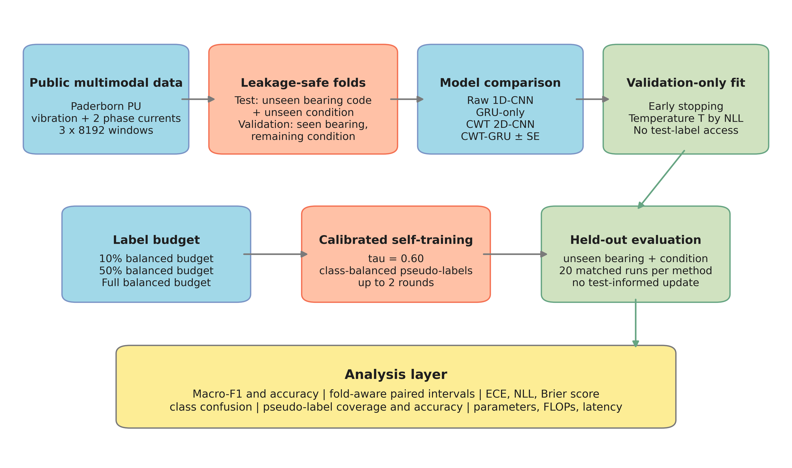
Figure 1. Overall methodology framework. Bearing-code and operating-condition isolation are enforced before model fitting, calibration, or pseudo-label selection.

3.2 Data and leakage-safe protocol
The primary dataset is the Paderborn University bearing dataset [1,21]. The benchmark uses 16 bearing codes and 4 operating conditions. The input channels are vibration, phase-current 1, and phase-current 2 at 64 kHz. For each bearing and condition, measurements 1 and 2 are included. Signals are segmented into windows of 8192 samples with stride 8192, so no sample is shared by two windows.
The four classes are healthy, outer-ring damage, inner-ring damage, and multiple damage. Training bearings are K001-K004, KA01, KA04, KA08, KI01, KI04, KI08, KB23, and KB24. K005, KA15, KI14, and KB27 are reserved for test data and never enter fitting or validation. Operating conditions are denoted C0 = N09_M07_F10, C1 = N15_M01_F10, C2 = N15_M07_F04, and C3 = N15_M07_F10.
Table 1. Bearing-code-disjoint and condition-disjoint folds. Every fold uses the same four held-out codes K005, KA15, KI14, and KB27.
Fold | Training conditions | Validation | Test | Train windows | Validation windows | Test windows
0 | C2, C3 | C1 | C0 | 1488 | 714 | 248
1 | C0, C3 | C2 | C1 | 1489 | 744 | 248
2 | C0, C1 | C3 | C2 | 1459 | 744 | 248
3 | C1, C2 | C0 | C3 | 1458 | 745 | 248

The cached benchmark contains 3,939 windows. The training counts vary across folds because one operating condition is used for validation and another for testing. The held-out bearing codes are excluded from both training and validation in every fold. Windows are grouped by bearing code, so a model cannot obtain the same physical unit through a different segment.
A separate source audit restored the 16 official archives, verified their recorded SHA-256 values, retained exact measurement filenames and start indices, and re-standardized the original-amplitude windows. The resulting raw tensor matched the canonical cache elementwise. The only unreadable source file is the known truncated `N15_M01_F10_KA08_2.mat`, which the canonical preprocessing also excludes.

3.3 Signal normalization and CWT representation
Each channel is standardized independently inside each window. For channel x_c(t), the continuous wavelet coefficient at scale a and position b is
$W_{x_{c}}(a,b)=\frac{1}{\sqrt{a}}\int_{−∞}^{∞}{x_{c}}(t)ψ^{*}\left(\frac{t−b}{a}\right)dt$ (1)
The implementation uses the Morlet wavelet and 48 scales spaced geometrically from 1 to 64. It stores the coefficient magnitude, resizes the magnitude map bilinearly to 96 x 96 pixels, and normalizes each channel by its maximum:
$I_{c}(a,b)=\frac{|W_{x_{c}}(a,b)|}{\underset{a,b}{\text{max}}|W_{x_{c}}(a,b)|+ϵ}$ (2)
Normalization is performed window by window after standardization. No global test statistic is used during preprocessing. The resulting tensor has shape 3 x 96 x 96 and is stored as float16; the model casts it to float32 before convolution.

3.4 CWT-GRU architecture
Figure 2 shows the actual CWT-GRU implementation. The CWT branch starts with a 5 x 5 convolution with 32 output channels, stride 2, batch normalization, SiLU activation, and 2 x 2 max pooling. Three residual stages then map 32 to 64, 64 to 128 with stride 2, and 128 to 192 with stride 2. Each residual block uses two 3 x 3 convolutions and an SE gate with reduction ratio 8. Global average pooling produces a 192-dimensional image feature.
The waveform branch transposes the 3 x 8192 input into an 8192 x 3 sequence. A two-layer bidirectional GRU uses 64 hidden units per direction and dropout 0.15. The last forward and backward hidden states are concatenated into a 128-dimensional recurrent feature. Fusion concatenates the 192- and 128-dimensional vectors, applies layer normalization, and maps 320 to 256, 256 to 128, and 128 to four logits. The projection uses SiLU and dropout rates of 0.25 and 0.15.
The complete model contains 1,101,012 trainable parameters for the four-class problem. This count comes from the executed model and is also recorded in `results/raw_runs.csv`.
Table 2. CWT-GRU tensor flow and layer parameters taken from the implementation.
Module | Operation in code | Output shape
CWT input | Three channel magnitude maps | 3 x 96 x 96
Stem | Conv5x5(32, stride 2) + BN + SiLU + MaxPool2 | 32 x 24 x 24
Residual stage 1 | Two Conv3x3 + BN + optional SE | 64 x 24 x 24
Residual stage 2 | Two Conv3x3, stride 2 + BN + optional SE | 128 x 12 x 12
Residual stage 3 | Two Conv3x3, stride 2 + BN + optional SE | 192 x 6 x 6
Image feature | Global average pooling | 192
Raw sequence | Transpose 3 x 8192 to 8192 x 3 | 8192 x 3
Recurrent feature | Two-layer bidirectional GRU, hidden 64 | 128
Fusion classifier | 320 -> 256 -> 128 -> 4 | 4 logits

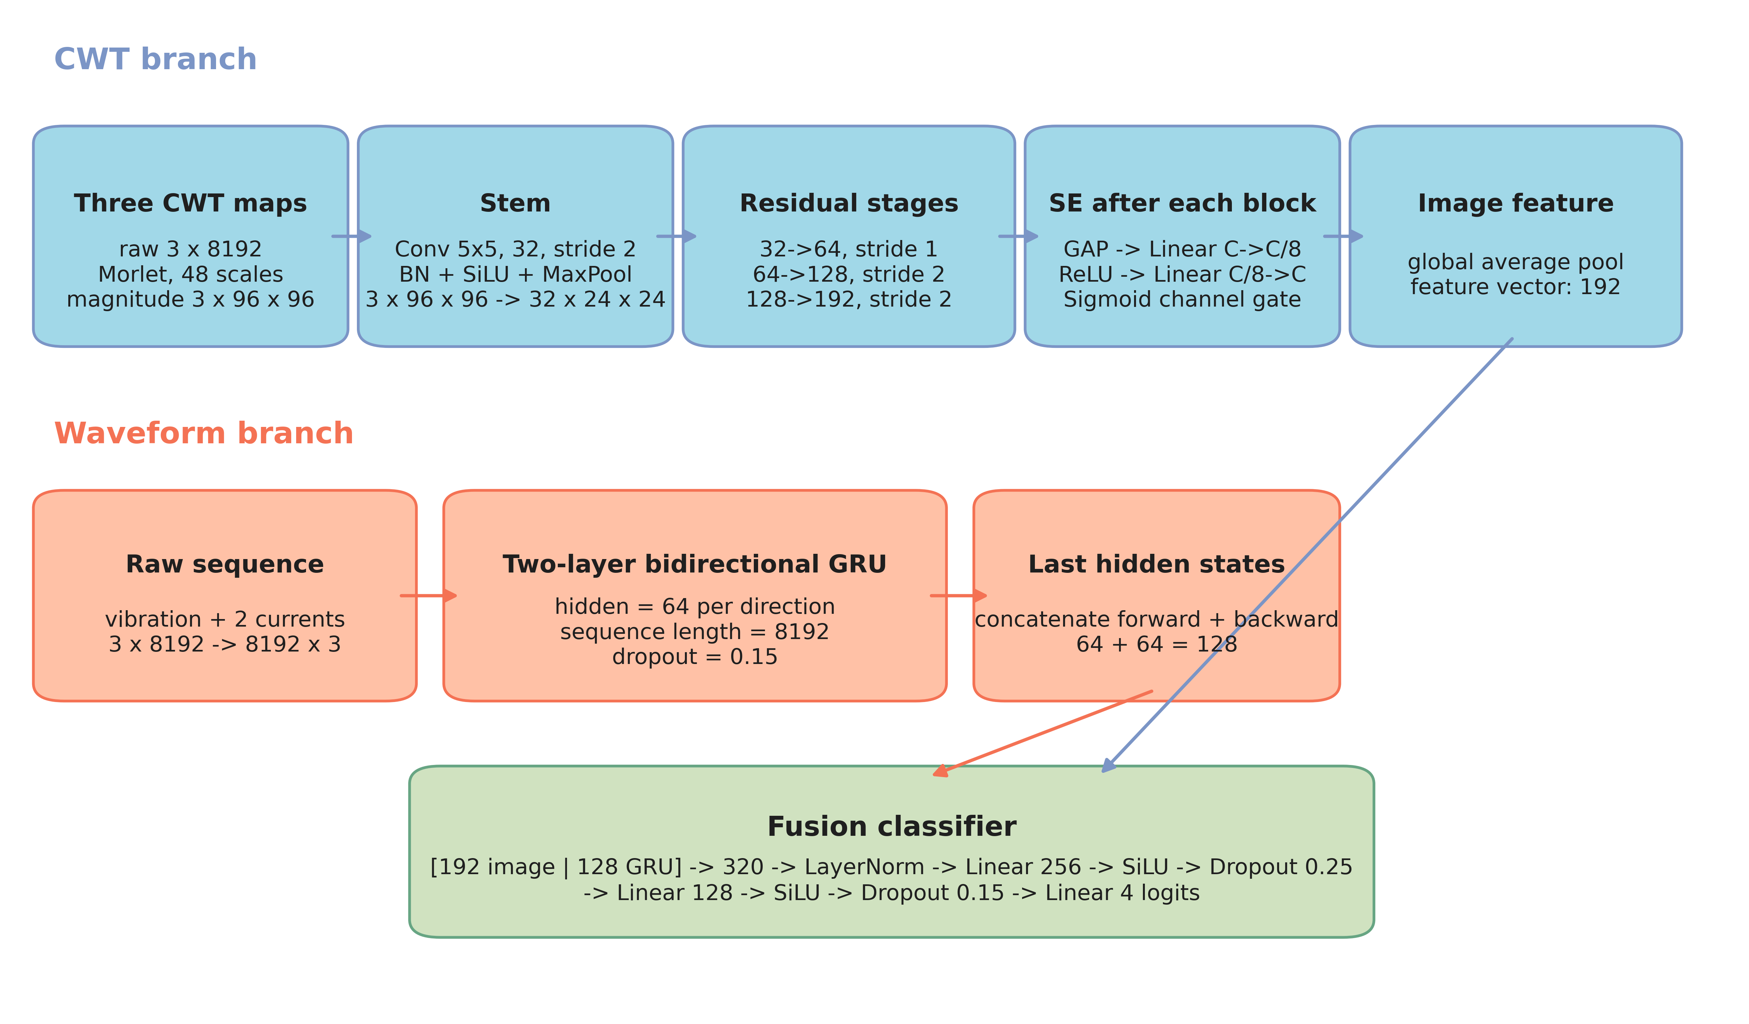
Figure 2. CWT-GRU architecture with actual channel sizes, hidden dimensions, attention placement, and fusion projection.

3.5 Supervised training and baselines
All models use the same configuration. The Full balanced budget uses the smallest class count in that fold and therefore contains about 992-996 windows (992-996 across folds). This leaves additional training windows available for self-training.
Table 3. Training configuration recorded by the canonical experiment runner.
Parameter | Value
Optimizer | AdamW [19,20]
Initial learning rate | 0.002
Weight decay | 0.0001
Batch size | 64
Epochs | maximum 12
Early stopping | validation macro-F1, patience 4
Scheduler | cosine annealing over 12 epochs
Precision | mixed precision on CUDA
Gradient clipping | maximum norm 5.0
Input augmentation | raw circular shift up to +/-32 samples and corresponding CWT shift; 50% probability of additive noise
GPU | NVIDIA GeForce RTX 5080

The recorded execution environment used Python 3.13.5, PyTorch 2.11.0 with CUDA 13.0, NumPy 2.1.3, pandas 2.2.3, SciPy 1.15.3, scikit-learn 1.6.1, and PyWavelets 1.8.0 on an NVIDIA GeForce RTX 5080. These versions are recorded in the reproducibility guide and per-run environment snapshots where available.
Raw 1D-CNN uses three 1D convolution layers with kernel sizes 25, 9, and 5, channels 64, 128, and 256, and a four-class linear head. GRU-only uses the same two-layer bidirectional recurrent encoder and a 128-to-four linear classifier. CWT 2D-CNN uses the image encoder and a linear classifier. CWT-GRU without SE uses the same fusion architecture with all SE gates disabled. Temperature-scaled CWT-GRU reuses the same trained weights and changes only the probability transformation.

3.6 Temperature scaling
For logits z and validation-fitted temperature T, the calibrated probability of class k is
$p_{T}(y=k∣x)=\frac{\text{exp}(z_{k}/T)}{\sum_{j=1}^{K}{\text{exp}}(z_{j}/T)}$ (3)
The temperature is optimized on validation logits by LBFGS with cross-entropy as the objective and a positive range from 0.05 to 20. Test labels are not used. Because T is positive, the argmax and all classification metrics remain unchanged. ECE, NLL, and Brier score can change.

3.7 Calibrated self-training
Let L be the verified training-label set and U the unlabeled remainder of the training partition. Validation and test indices are excluded from U. For predicted class k, the class-conditional candidate set is
$S_{k}=\text{TopM}\{i∈U:{\hat{y}}_{i}=k, p_{i,k}≥τ\}$ (4)
where tau = 0.60 in the main experiment, p_i,k is the temperature-scaled probability, and M is initially twice the number of labeled windows per class. M doubles in the next round. Figure 3 shows the complete loop. After selection, pseudo-labels are combined with verified labels and the model is reinitialized. The weighted training objective is
L=−1i​wii​wilogpθ(yi∣xi), wi=1 for verified labels, wi=pi,yi for pseudo-labels (5)
The main self-training condition permits at most 2 rounds. The threshold experiment uses one controlled selection-and-retraining round at a 50% balanced budget so that the threshold comparison is not confounded by a different number of updates. At a 10% balanced budget, no candidate passed the fixed threshold in any of the 20 main evaluations, so the procedure returned the initial model.
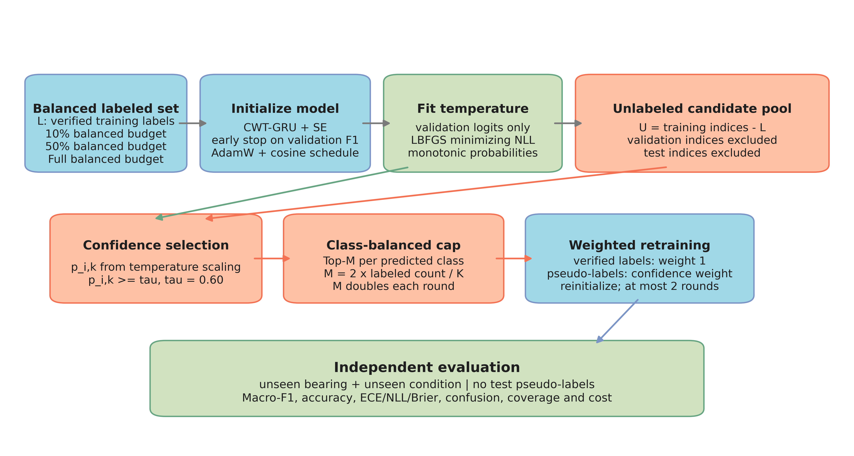
Figure 3. Calibrated self-training pipeline. The candidate pool is the unlabeled portion of the training partition; validation and test data are excluded from label generation.

3.8 Evaluation metrics and statistical analysis
Macro-F1 is the primary metric because it weights each class equally. Accuracy is secondary. The benchmark also records macro precision, macro recall, ECE with 15 equal-width bins, multiclass NLL, and Brier score. ECE is
$ECE=\sum_{m=1}^{M}{\frac{|B_{m}|}{n}}\left|acc(B_{m})−\overline{conf}(B_{m})\right|$ (6)
Each mean and sample standard deviation describes 20 matched evaluations from 4 operating-condition folds crossed with 5 stochastic seeds. Seeds within a fold share the same training, validation, and test partitions. The evaluations are therefore not treated as 20 independent domains. For paired model comparisons, the primary inferential analysis uses a two-stage cluster bootstrap: operating-condition folds are resampled first, and seeds are then resampled within each selected fold. Model differences remain paired at the fold-seed level, and percentile 95% intervals are computed from 20,000 bootstrap samples.
As a coarse sensitivity check, a two-sided exact sign-flip test is applied to the four fold-level mean differences. With only four domain-level units, the smallest attainable nonzero two-sided p-value is 0.125. This coarseness is reported explicitly. Unclustered t intervals and two-sided Wilcoxon signed-rank tests are retained as sensitivity analyses, not as the primary evidence. A result is not described as an improvement when the hierarchical interval includes zero.
The primary benchmark is the predeclared four-class configuration with window-wise standardization, a 48-scale 96 x 96 magnitude CWT, 12 maximum epochs, and the fixed pseudo-label threshold tau = 0.60. Normalization, CWT scale and resolution, magnitude transformation, phase preservation, label granularity, baseline learning rate, training opportunity, and coverage-controlled pseudo-labeling are sensitivity analyses. They are reported in full and do not replace the primary configuration after observing held-out test performance.
Table 4. Canonical experiment matrix. The Full balanced budget view reuses the exact main rows and is not counted as a second training experiment.
Experiment | Purpose | Runs
Main | Seven method conditions; 4 folds x 5 seeds; Full balanced budget | 140
Label efficiency | Supervised and self-training at 10% balanced budget and 50% balanced budget; Full balanced budget reuses main rows | 80
Threshold sensitivity | 5 thresholds at 50% balanced budget; 4 folds x 5 seeds | 100
Total | Canonical successful evaluations | 320

4 Results by Research Question

4.1 RQ1: Do time-frequency representations outperform raw waveform models under leakage-safe cross-domain evaluation?
Raw 1D-CNN reached a macro-F1 of 0.289 +/- 0.104. CWT 2D-CNN reached 0.291 +/- 0.086. The mean paired difference was +0.002, with a fold-aware hierarchical 95% interval from -0.093 to +0.135. The interval includes zero, so the evaluation does not support a stable CWT advantage. This result answers RQ1 negatively for the implemented magnitude-CWT pipeline.
Table 5. Main comparison under the Full balanced budget and simultaneous unseen-bearing and unseen-condition testing. Values are mean +/- standard deviation over 20 matched evaluations.
Method | Macro-F1 | Accuracy | Runs
Raw 1D-CNN | 0.289 +/- 0.104 | 0.392 +/- 0.094 | 20
GRU only | 0.221 +/- 0.030 | 0.242 +/- 0.025 | 20
CWT 2D-CNN | 0.291 +/- 0.086 | 0.399 +/- 0.081 | 20
CWT-GRU without SE | 0.307 +/- 0.103 | 0.408 +/- 0.097 | 20
CWT-GRU | 0.280 +/- 0.107 | 0.383 +/- 0.092 | 20
CWT-GRU + temperature scaling | 0.280 +/- 0.107 | 0.383 +/- 0.092 | 20
CWT-GRU + temperature scaling + self-training | 0.290 +/- 0.116 | 0.387 +/- 0.099 | 20

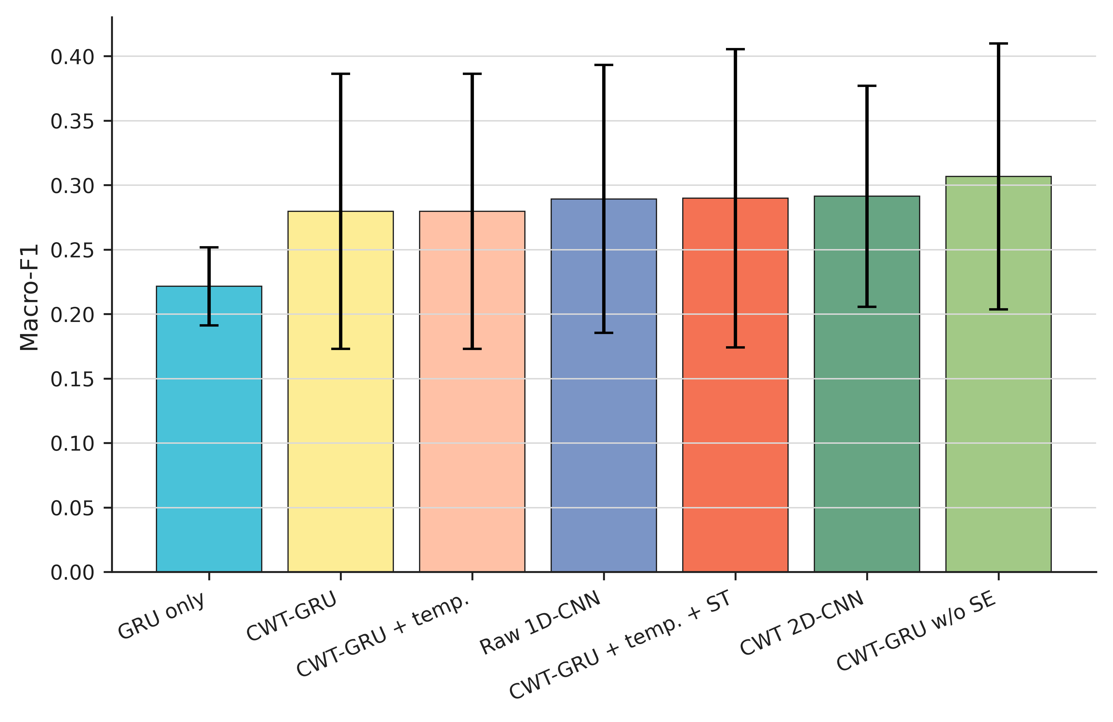
Figure 4. Macro-F1 under the Full balanced budget with one standard-deviation error bars across 20 matched evaluations per method condition.

4.2 RQ2: Does temporal fusion improve CWT-based fault diagnosis?
The paired CWT-GRU minus CWT 2D-CNN difference was -0.012, with a fold-aware hierarchical 95% interval from -0.071 to +0.043. The paired CWT-GRU minus Raw 1D-CNN difference was -0.010, with interval -0.140 to +0.131. GRU-only was lower than Raw 1D-CNN by 0.068; however, its hierarchical interval (-0.129 to +0.002) includes zero. The unclustered Wilcoxon sensitivity result (p = 0.006) and the fold-aware sign-flip result (p = 0.250) therefore disagree in strength. The conservative conclusion is that no stable recurrent gain was established.
Table 6. Fold-aware paired comparisons against Raw 1D-CNN on identical fold-seed keys. Intervals resample folds before seeds. The exact sign-flip p-value has a minimum attainable nonzero value of 0.125. Unclustered t intervals and Wilcoxon p-values are retained in results/statistical_tests.csv as sensitivity analyses.
Method | Paired delta Macro-F1 | Hierarchical 95% interval | Fold-aware p | Stable direction?
GRU only | -0.068 | -0.129 to +0.002 | p = 0.250 | No
CWT 2D-CNN | +0.002 | -0.093 to +0.135 | p = 1.000 | No
CWT-GRU without SE | +0.017 | -0.096 to +0.160 | p = 0.875 | No
CWT-GRU | -0.010 | -0.140 to +0.131 | p = 1.000 | No
CWT-GRU + temperature scaling | -0.010 | -0.139 to +0.132 | p = 1.000 | No
CWT-GRU + temperature scaling + self-training | +0.001 | -0.134 to +0.128 | p = 1.000 | No

4.3 RQ3: What is the contribution of each model component?
CWT-GRU without SE reached 0.307 +/- 0.103, numerically above full CWT-GRU at 0.280 +/- 0.107. The paired full-minus-no-SE difference was -0.027, with a hierarchical interval from -0.073 to +0.022. Equivalently, the no-SE-minus-full difference was +0.027, with interval -0.022 to +0.073. This does not establish that SE improves the model. Adding the recurrent branch to CWT-only did not improve the mean. The complete component matrix is reported in Section 6 and Table 11.

4.4 RQ4: Can calibrated self-training improve diagnostic performance under limited labels?
At a 10% balanced budget, supervised and self-training results are identical in 20 evaluations because no pseudo-label passed the threshold. At a 50% balanced budget, self-training increased the mean from 0.244 to 0.283; the paired difference was +0.039, with a fold-aware interval from -0.029 to +0.112. At the Full balanced budget, the paired difference was +0.010, with interval -0.031 to +0.049. Both intervals include zero. The answer to RQ4 is that the procedure did not demonstrate a reliable diagnostic improvement.
Table 7. Label-efficiency results. Full balanced budget uses the minimum per-class count in each fold and is not all training windows.
Label budget | Method | Macro-F1 | Accuracy | Runs
10% balanced budget | Supervised | 0.128 +/- 0.025 | 0.250 +/- 0.006 | 20
10% balanced budget | Calibrated self-training | 0.128 +/- 0.025 | 0.250 +/- 0.006 | 20
50% balanced budget | Supervised | 0.244 +/- 0.098 | 0.351 +/- 0.090 | 20
50% balanced budget | Calibrated self-training | 0.283 +/- 0.126 | 0.394 +/- 0.110 | 20
Full balanced budget | Supervised | 0.280 +/- 0.107 | 0.383 +/- 0.092 | 20
Full balanced budget | Calibrated self-training | 0.290 +/- 0.116 | 0.387 +/- 0.099 | 20

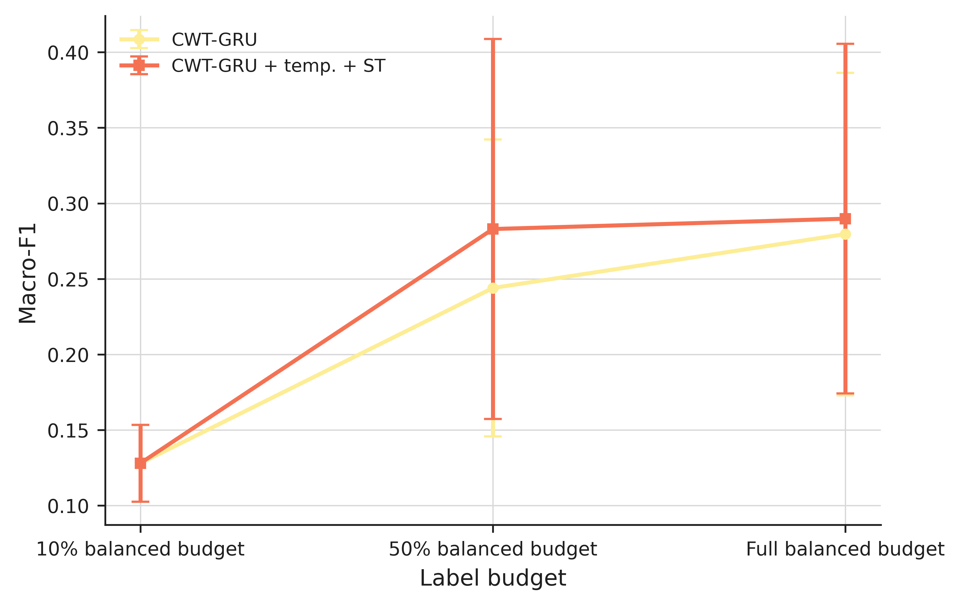
Figure 5. Macro-F1 under 10% balanced budget, 50% balanced budget, and Full balanced budget conditions. Self-training makes no update at the 10% balanced budget because no candidate passes tau = 0.60.

4.5 RQ5: How sensitive is self-training to the pseudo-label confidence threshold?
At a 50% balanced budget, mean macro-F1 ranged from 0.239 to 0.270. Pseudo-label accuracy increased with the threshold, but the end-task response was not monotonic. The highest mean occurred at tau = 0.3, with 77.6% candidate coverage. 2 fold-seed cases produced no pseudo-label at any tested threshold. Higher selected-label precision therefore did not guarantee better classification.
Table 8. Threshold sensitivity at a 50% balanced budget. Pseudo-label accuracy is an offline audit and is never used to train or select the threshold.
Threshold | Mean pseudo-labels | Coverage | Pseudo-label accuracy | Test Macro-F1 | Runs
0.3 | 757.1 | 77.6% | 0.927 | 0.270 +/- 0.130 | 20
0.4 | 750.9 | 77.0% | 0.930 | 0.259 +/- 0.124 | 20
0.5 | 723.9 | 74.2% | 0.942 | 0.239 +/- 0.099 | 20
0.6 | 671.5 | 68.9% | 0.955 | 0.241 +/- 0.093 | 20
0.7 | 573.9 | 58.9% | 0.966 | 0.253 +/- 0.106 | 20

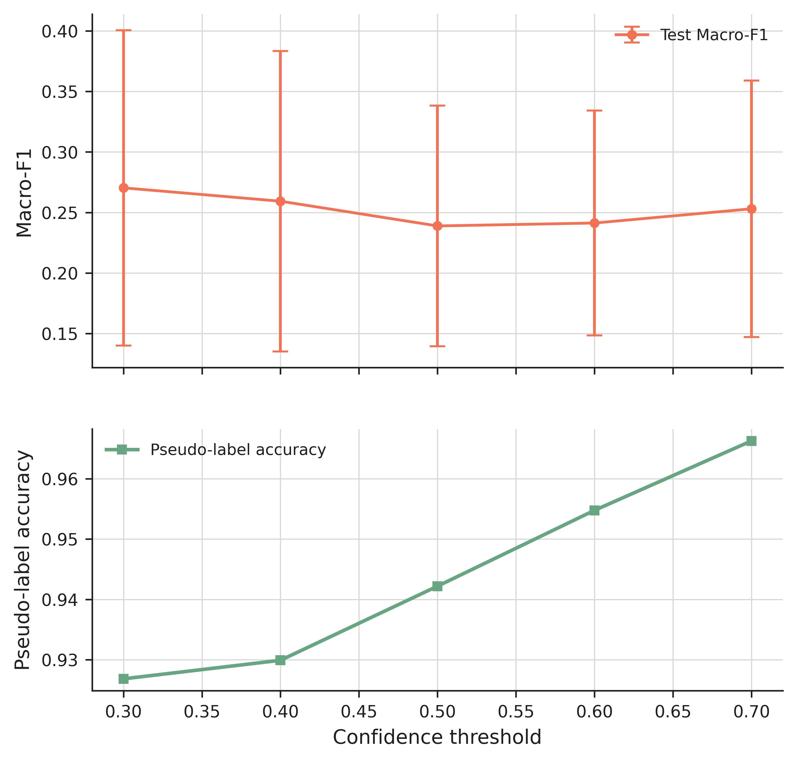
Figure 6. Threshold sensitivity. The lower panel shows pseudo-label accuracy, which rises while end-task macro-F1 remains non-monotonic.

4.6 RQ6: Does probability calibration improve classification performance or only confidence reliability?
Temperature scaling cannot change the argmax, and the accuracy and macro-F1 of each CWT-GRU evaluation are therefore identical before and after temperature fitting. The probability scores change. For CWT-GRU, mean test ECE decreased from 0.543 to 0.391, and NLL decreased from 4.528 to 2.304. For Raw 1D-CNN, the validation-selected temperature worsened test ECE and NLL, which shows that an in-domain calibration fit need not transfer to a new bearing and condition. The answer to RQ6 is that calibration can improve confidence reliability for some models, but it does not correct classification errors.
Table 9. Test-set probability metrics before and after validation-fitted temperature scaling.
Method | ECE raw | ECE scaled | NLL raw | NLL scaled | Brier raw | Brier scaled
Raw 1D-CNN | 0.388 | 0.424 | 2.599 | 6.237 | 0.234 | 0.248
CWT 2D-CNN | 0.487 | 0.375 | 3.615 | 2.498 | 0.260 | 0.228
CWT-GRU | 0.543 | 0.391 | 4.528 | 2.304 | 0.280 | 0.238
CWT-GRU + temperature scaling + self-training | 0.522 | 0.397 | 3.969 | 2.482 | 0.271 | 0.238

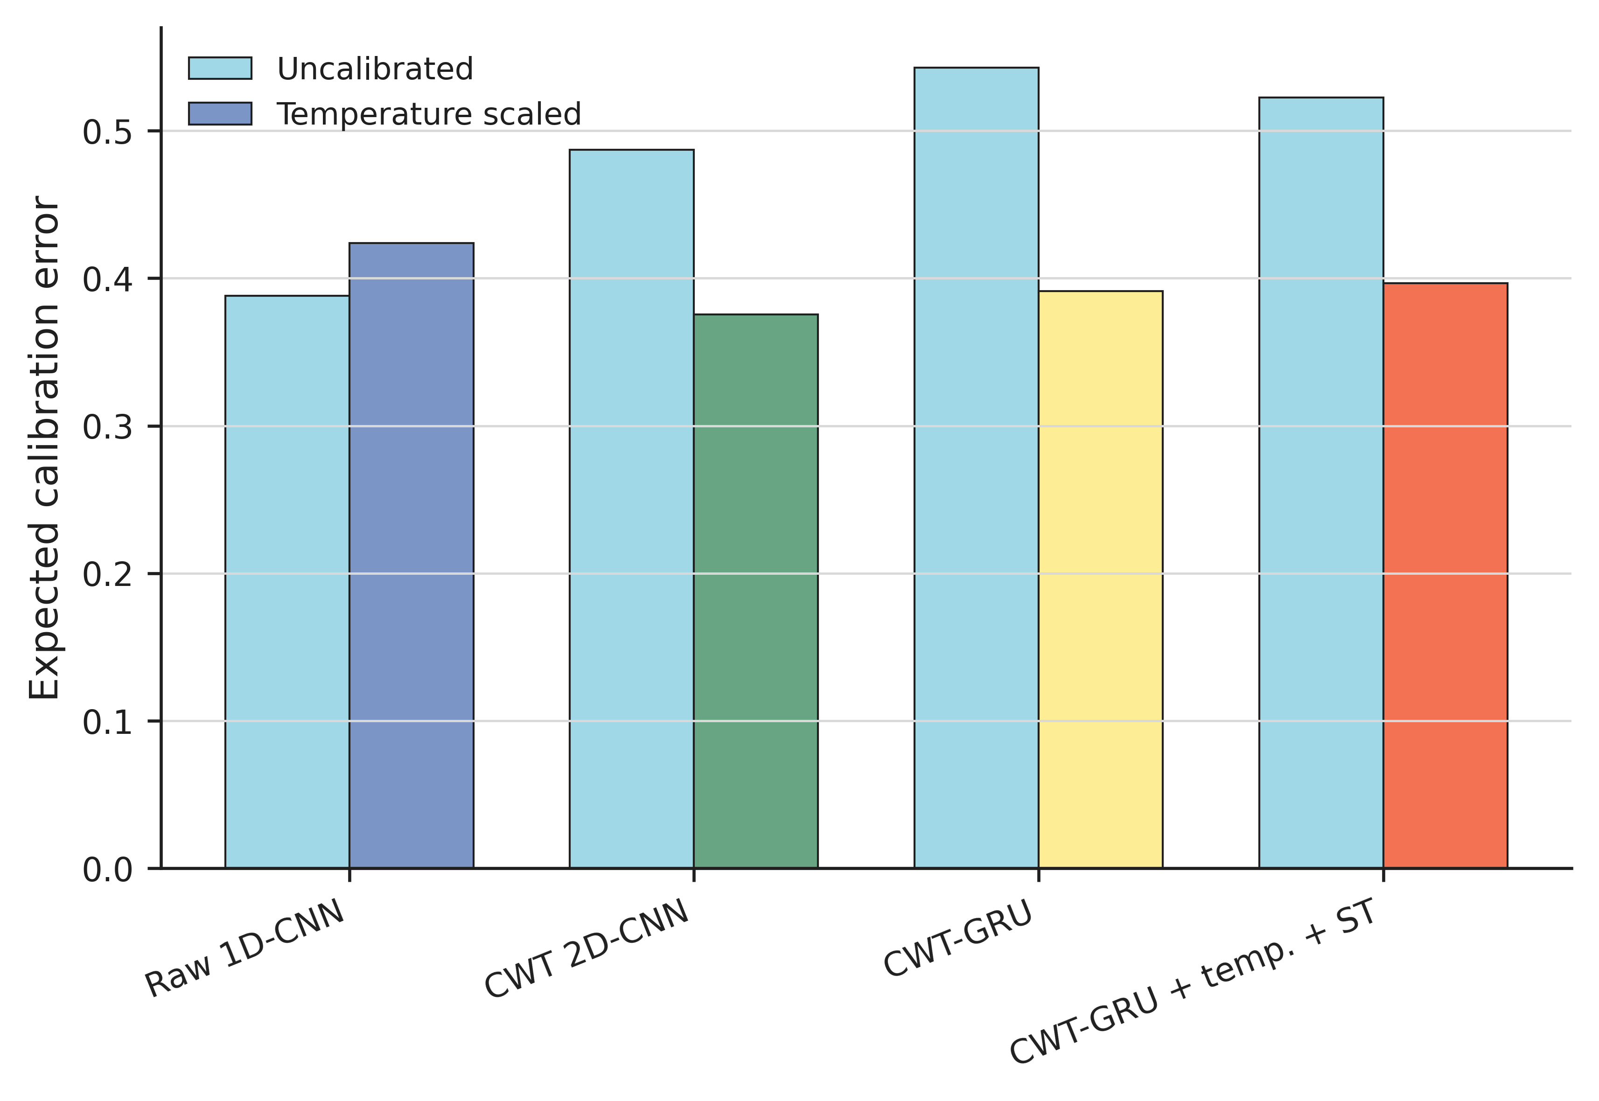
Figure 7. Mean expected calibration error before and after temperature scaling. Improvements are model- and domain-dependent.
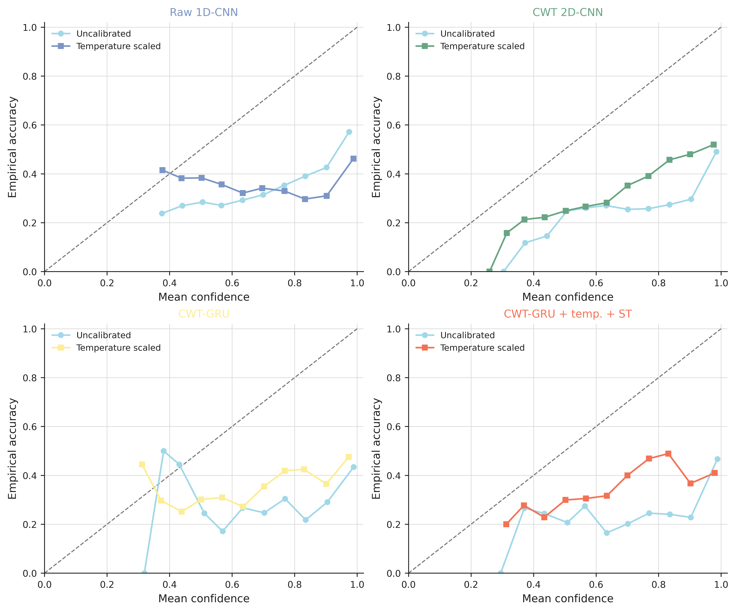
Figure 8. Reliability diagrams aggregated from all 20 Full balanced budget runs. The diagonal represents perfect calibration.

5 Re-trained Model and External Baseline Comparison
A numerical comparison is included here only for models trained by the present project on the same dataset split, windowing, preprocessing, and metric code. The reference MTFC-T study [14] uses multiscale time-frequency convolution and Transformer attention, but its CWRU experiment uses a 70/10/20 split within one operating load and different datasets for its main comparison. Those published values are therefore not inserted into this table and are not used to rank methods across protocols.
Table 10 therefore reports the re-trained model boundary. Raw 1D-CNN and GRU-only represent waveform-only baselines. CWT 2D-CNN isolates the time-frequency image encoder. CWT-GRU without SE and full CWT-GRU isolate temporal fusion and channel attention. The temperature and self-training rows describe evaluation or training procedures applied to the same CWT-GRU architecture, not additional external architectures.
Two external architectures were also adapted and retrained for all 20 fold-seed combinations. DRSN [16] reached 0.149 +/- 0.084 macro-F1 and 0.275 accuracy. TFN [22] reached 0.175 +/- 0.078 macro-F1 and 0.257 accuracy. Their paired macro-F1 differences from Raw 1D-CNN were -0.141 (fold-aware 95% interval -0.207 to -0.067; sign-flip p = 0.125) and -0.114 (interval -0.185 to -0.016; sign-flip p = 0.250), respectively. These are results for the same-protocol adaptations, not estimates of the performance reported by the original studies.
A finite validation-only learning-rate audit compared the predeclared 0.002 setting with 0.001 for Raw, CWT 2D-CNN, DRSN, and TFN. Per-fold selection used validation Macro-F1 only. DRSN changed by +0.005 (-0.001 to +0.021) and TFN changed by +0.014 (-0.044 to +0.083) on held-out test Macro-F1. Both intervals included zero. The 160 candidate rows are retained in full in the result registry.
MTFC-T was not retrained because the authors' linked repository does not yet contain its proposed-model implementation. DRSN-Transformer was also excluded because neither an official implementation nor sufficient architecture and training detail was available in the project materials for a defensible replication. No original-study accuracy was inserted to fill either gap.
Table 10. Models eligible for the same-protocol comparison. DRSN and TFN are three-channel, four-class adaptations under the common training protocol. No unreproduced external result is included.
Method | Input representation | Core architecture | Parameters | Macro-F1 | Accuracy | Runs
Raw 1D-CNN | Raw waveform | Three-layer 1D CNN + linear head | 244,740 | 0.289 +/- 0.104 | 0.392 +/- 0.094 | 20
GRU only | Raw waveform | Two-layer bidirectional GRU + linear head | 118,276 | 0.221 +/- 0.030 | 0.242 +/- 0.025 | 20
CWT 2D-CNN | CWT magnitude maps | Residual CNN with SE + linear head | 884,564 | 0.291 +/- 0.086 | 0.399 +/- 0.081 | 20
CWT-GRU without SE | Raw + CWT | Residual image CNN + two-layer bidirectional GRU | 1,086,244 | 0.307 +/- 0.103 | 0.408 +/- 0.097 | 20
CWT-GRU | Raw + CWT | Residual CNN with SE + two-layer bidirectional GRU | 1,101,012 | 0.280 +/- 0.107 | 0.383 +/- 0.092 | 20
CWT-GRU + temperature scaling | Raw + CWT | CWT-GRU weights; validation temperature scaling | 1,101,012 | 0.280 +/- 0.107 | 0.383 +/- 0.092 | 20
CWT-GRU + temperature scaling + self-training | Raw + CWT | CWT-GRU; thresholded pseudo-label retraining | 1,101,012 | 0.290 +/- 0.116 | 0.387 +/- 0.099 | 20
DRSN (same-protocol adaptation) | Raw waveform | Four-stage residual shrinkage CNN; adaptive soft thresholding | 233,040 | 0.149 +/- 0.084 | 0.275 +/- 0.079 | 20
TFN (same-protocol adaptation) | Raw waveform | Learnable sinusoidal TF convolution + CNN backbone | 184,900 | 0.175 +/- 0.078 | 0.257 +/- 0.066 | 20

6 Ablation Study
Table 11 reports the component matrix. Raw 1D-CNN has no CWT, GRU, SE, calibration, or self-training component. CWT 2D-CNN includes the image encoder and its SE gates. GRU-only includes the recurrent branch without CWT. The remaining rows add recurrent fusion, remove or restore SE, and then apply temperature scaling and self-training.
Table 11. Component-wise ablation under the same leakage-safe split.
Model | CWT | GRU | SE | Calibration | Self-training | Macro-F1 | Accuracy | Runs
Raw 1D-CNN | 0 | 0 | 0 | 0 | 0 | 0.289 +/- 0.104 | 0.392 +/- 0.094 | 20
GRU only | 0 | 1 | 0 | 0 | 0 | 0.221 +/- 0.030 | 0.242 +/- 0.025 | 20
CWT 2D-CNN | 1 | 0 | 1 | 0 | 0 | 0.291 +/- 0.086 | 0.399 +/- 0.081 | 20
CWT-GRU without SE | 1 | 1 | 0 | 0 | 0 | 0.307 +/- 0.103 | 0.408 +/- 0.097 | 20
CWT-GRU | 1 | 1 | 1 | 0 | 0 | 0.280 +/- 0.107 | 0.383 +/- 0.092 | 20
CWT-GRU + temperature scaling | 1 | 1 | 1 | 1 | 0 | 0.280 +/- 0.107 | 0.383 +/- 0.092 | 20
CWT-GRU + temperature scaling + self-training | 1 | 1 | 1 | 1 | 1 | 0.290 +/- 0.116 | 0.387 +/- 0.099 | 20

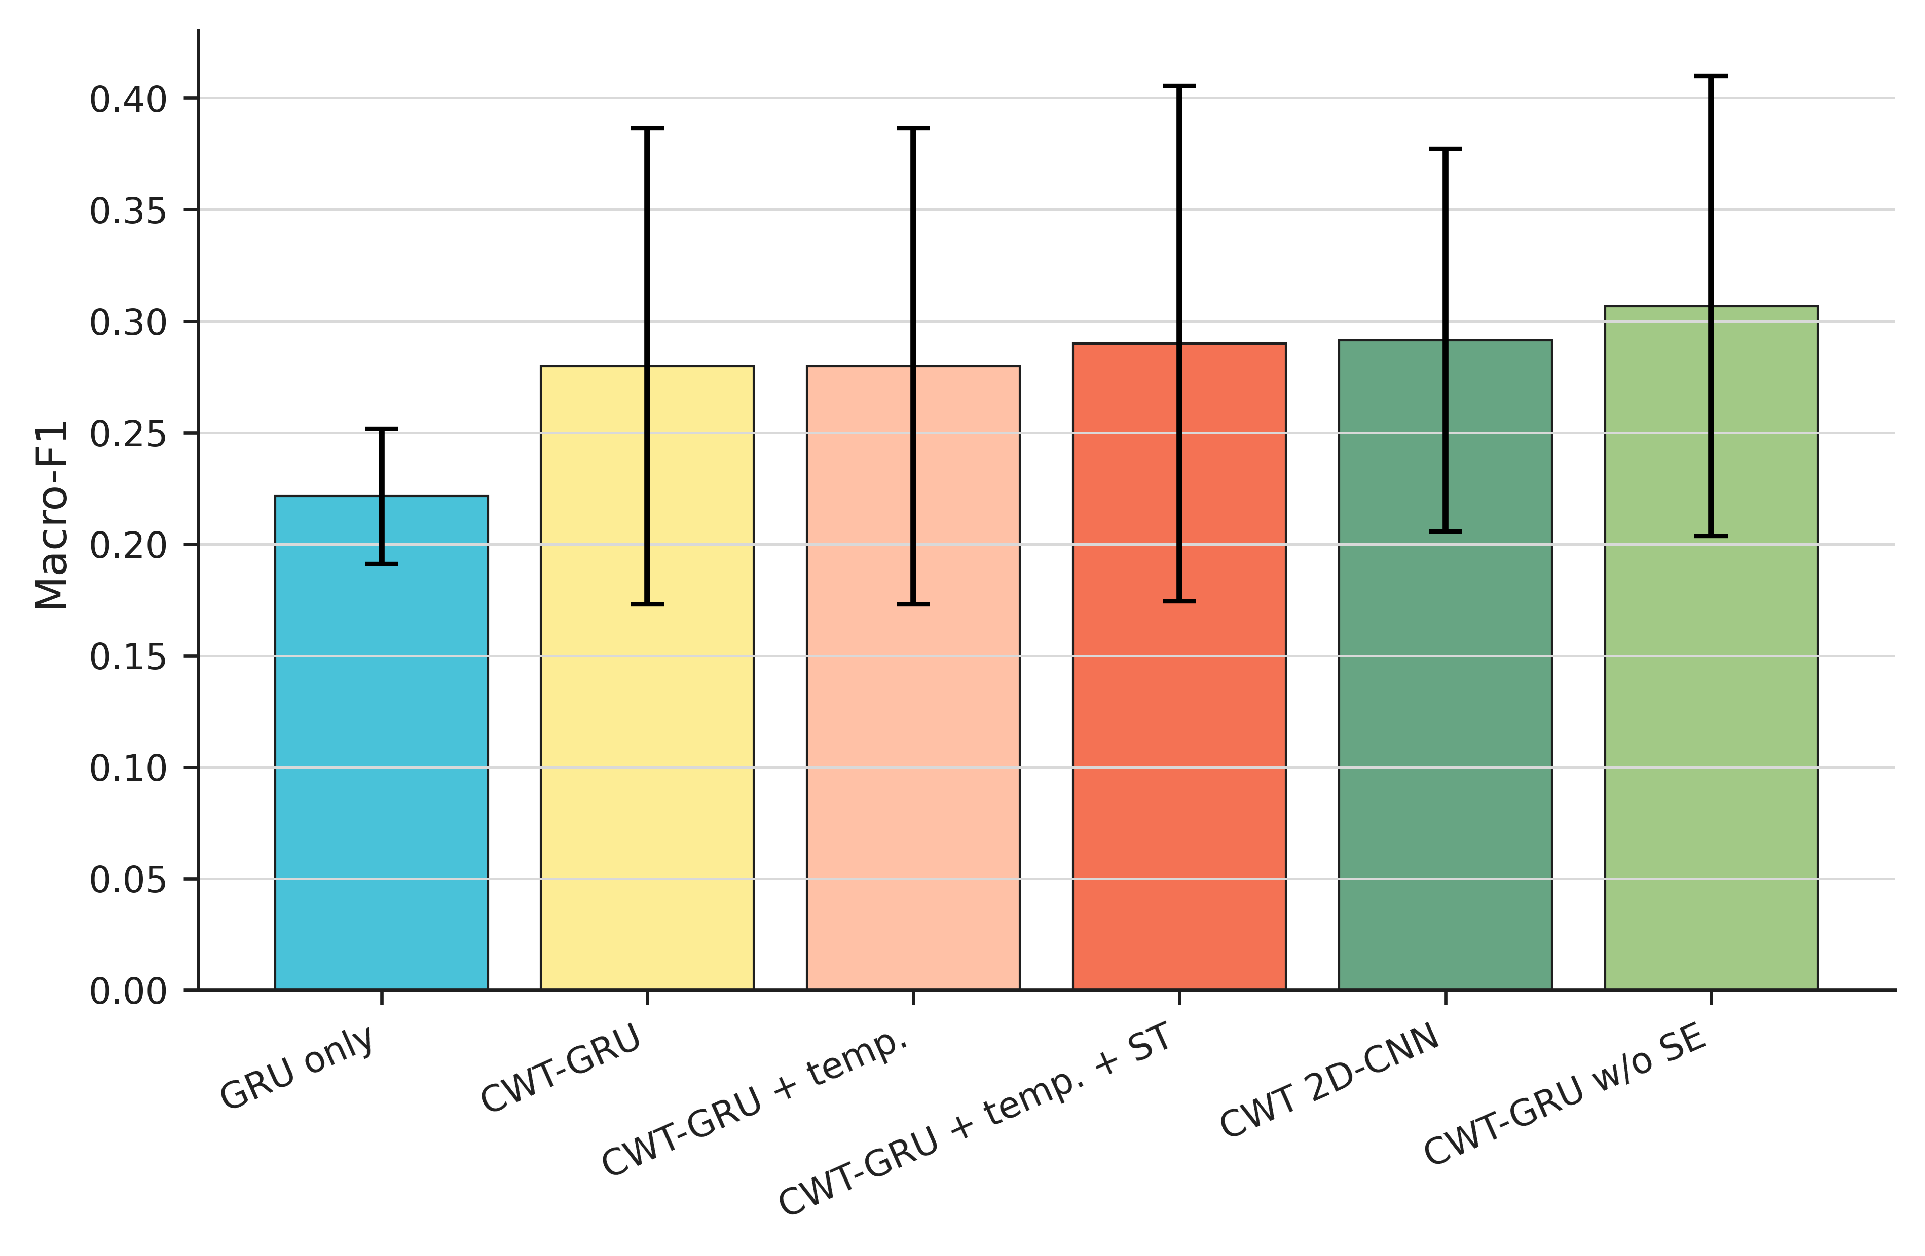
Figure 9. Component ablation. Error bars show one standard deviation over 20 matched evaluations.
On the stored full-minus-no-SE scale, removing SE changed macro-F1 by -0.027, with a fold-aware interval from -0.073 to +0.022. Equivalently, the no-SE-minus-full contrast is +0.027, with interval -0.022 to +0.073. Both intervals include zero. The unclustered two-sided Wilcoxon sensitivity was p = 0.189. This is a numerical direction, not stable evidence of an SE penalty. Adding CWT to GRU-only changed macro-F1 by +0.058 (fold-aware interval -0.036 to +0.153). Adding GRU to CWT-only changed it by -0.012 (fold-aware interval -0.071 to +0.043). The ablation therefore does not support the assumption that every added component improves cross-domain robustness.

7 Experimental Analysis

7.1 Class confusion and partial class collapse
Figure 10 aggregates all 20 Full balanced budget runs of each principal model. Healthy windows are recognized relatively well, but damage classes are strongly confused. CWT-GRU predicts the correct inner-ring class for 51.6% of inner-ring windows, while only 26.5% of outer-ring windows remain outer-ring and 52.1% are assigned to inner-ring. The multiple-damage class is split among healthy, outer-ring, and inner-ring predictions. This asymmetric error structure is consistent with partial class collapse and explains why accuracy can exceed macro-F1.
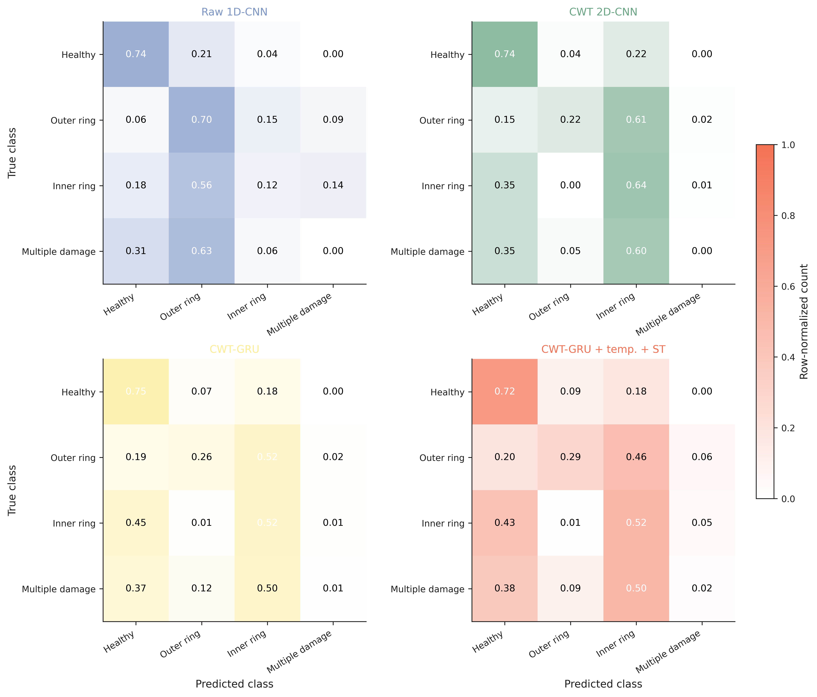
Figure 10. Row-normalized confusion matrices aggregated across 4 folds and 5 seeds (20 runs per method).

7.2 Pseudo-label coverage and threshold behavior
The threshold experiment separates selection quality from end-task behavior. At tau = 0.30, pseudo-label accuracy is 0.927 and coverage is 77.6%. At tau = 0.70, pseudo-label accuracy rises to 0.966, while coverage falls to 58.9%. The corresponding mean test macro-F1 is not ordered by threshold precision. This pattern shows that a fixed threshold operates as a joint selection rule over class coverage and confidence, not as a simple estimate of label quality.
Reconstructing the stored selections reproduced the logged pseudo-label count for all 100 threshold cells. At tau = 0.70, predicted-class coverage ranged from 53.3% to 64.9% across classes. The class-conditional coverage, rather than only total pseudo-label accuracy, determines whether a difficult class receives any additional supervision.

7.3 Calibration and proper scoring rules
ECE is sensitive to binning, so NLL and multiclass Brier score are reported alongside it. For CWT 2D-CNN, CWT-GRU, and self-training, the mean test ECE and NLL decreased after temperature scaling. The Brier score also decreased for these three rows. Raw 1D-CNN shows the opposite test behavior despite using the same validation fitting rule. This difference is consistent with a validation-to-test domain gap rather than a universal failure of temperature scaling. Predicted classes did not change in any row.

7.4 Computational cost and latency
Table 12 reports medians from the 20 main evaluations. CWT-GRU uses 1,101,012 parameters and a median training duration of 24.8 s, compared with 244,740 parameters and a median training duration of 4.3 s for Raw 1D-CNN. The recurrent path also has higher inference time per test batch. These values are implementation- and hardware-dependent, but the direction is consistent with sequential processing over 8192 time steps. Self-training increases median training duration because it repeats model initialization and training.
The recorded training times exclude offline CWT generation and cache loading. A single-process timing sample projected the canonical 3,939-window CWT generation to approximately 536 s before training. The apparent training-time similarity between cached CWT and raw models must not be interpreted as lower end-to-end preprocessing cost.
For recurrent models, profiler counts were supplemented by an explicit two-layer bidirectional GRU multiply-accumulate formula. This FLOP estimate excludes data movement, recurrent control overhead, activation functions, and hardware-specific kernel costs.
Table 12. Median computational cost over the 20 main evaluations. Training time is complete-run wall time; inference is per test batch of up to 128 windows on the recorded RTX 5080 environment.
Method | Parameters | GFLOPs/sample | Training time (s) | Inference (ms/batch)
Raw 1D-CNN | 244,740 | 0.677 | 4.3 | 12.8
GRU only | 118,276 | 1.630 | 23.6 | 43.2
CWT 2D-CNN | 884,564 | 0.185 | 4.2 | 8.3
CWT-GRU without SE | 1,086,244 | 1.814 | 24.4 | 44.9
CWT-GRU | 1,101,012 | 1.815 | 24.8 | 45.2
CWT-GRU + temperature scaling + self-training | 1,101,012 | 1.815 | 83.9 | 44.9

Figure 11. Parameters and median inference time per batch for the principal architectures.

7.5 Validation-to-test generalization gap
Across Raw 1D-CNN, CWT 2D-CNN, CWT-GRU, and CWT-GRU without SE, validation macro-F1 ranged from 0.797 to 0.853, whereas test macro-F1 ranged from 0.280 to 0.307. The absolute gap was 0.503-0.564, corresponding to a 59.6%-66.4% relative drop. Table 13 and Figure 12 summarize these values.
Table 13. Validation-to-test generalization gap under simultaneous unseen-bearing and unseen-condition shift.
Model | Validation Macro-F1 | Test Macro-F1 | Absolute gap | Relative drop | Runs
Raw 1D-CNN | 0.853 +/- 0.153 | 0.289 +/- 0.104 | 0.564 | 66.4% | 20
CWT 2D-CNN | 0.808 +/- 0.112 | 0.291 +/- 0.086 | 0.516 | 62.4% | 20
CWT-GRU | 0.797 +/- 0.115 | 0.280 +/- 0.107 | 0.518 | 63.0% | 20
CWT-GRU without SE | 0.809 +/- 0.139 | 0.307 +/- 0.103 | 0.503 | 59.6% | 20

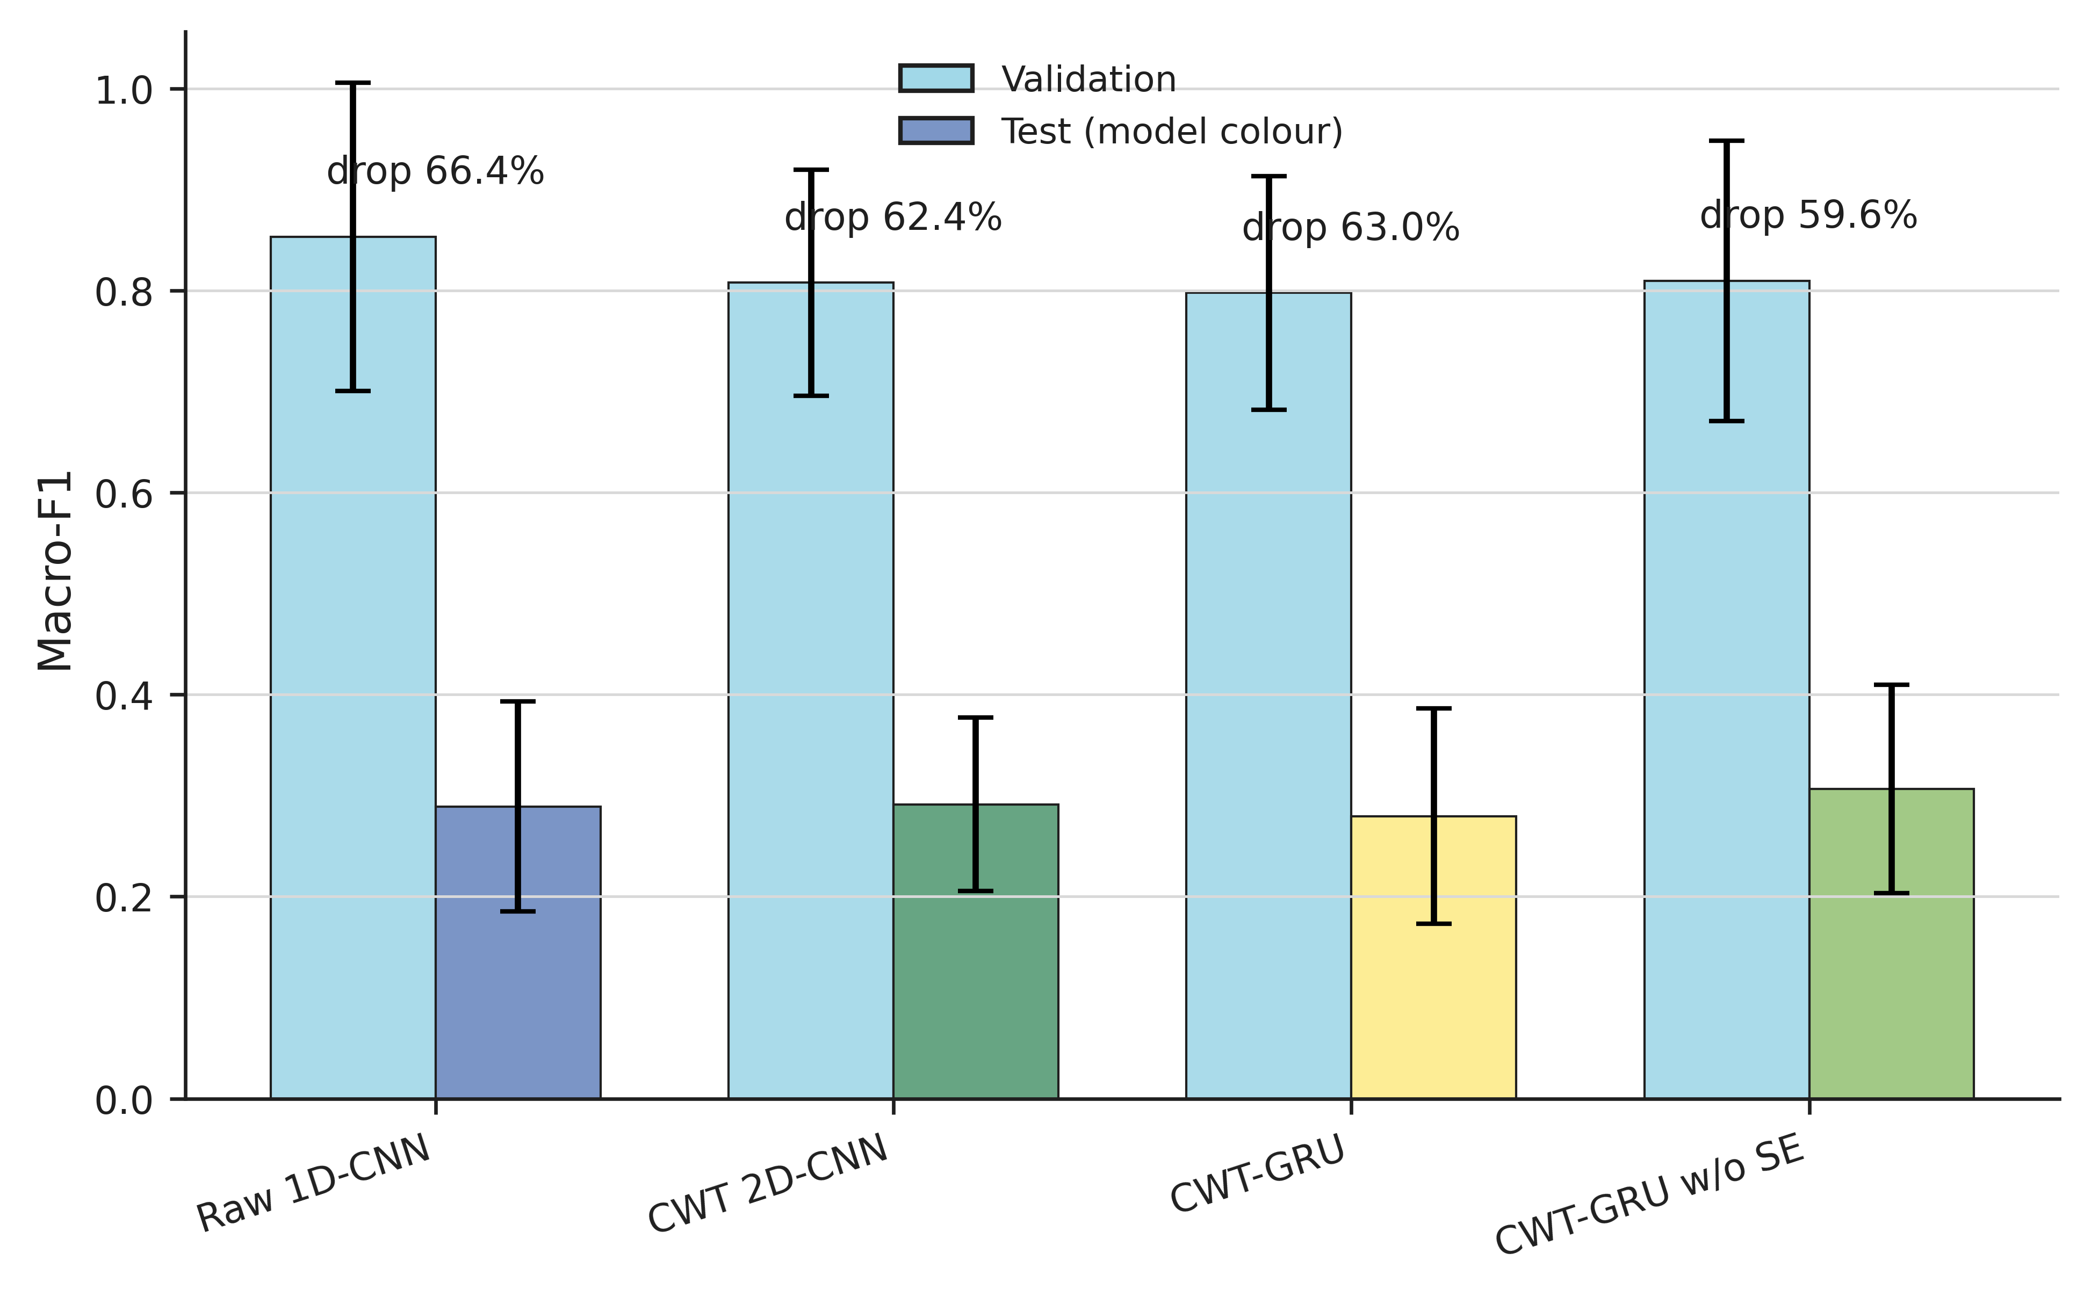
Figure 12. Validation and test macro-F1 for the four principal models. Labels report the mean relative drop from validation to test.

7.6 Domain-shift and label-granularity diagnostics
The raw-signal audit shows that the held-out domains differ from the development partitions in amplitude and spectral structure, and that the direction and magnitude vary by fold. Figure 13 and Table 14 report standardized descriptive contrasts; they are not causal decompositions. The held-out fault bearings all carry real lifetime damage, while artificial and real damage are mixed in the single-location fitting bearings. Bearing identity, operating condition, and damage origin therefore change together.
Figure 13. Raw-signal domain-shift diagnostics for the four held-out condition folds. Panel (d) reports the standardized train-to-test difference; it does not assign causality.
Table 14. Standardized train-to-test differences for vibration statistics. Positive values indicate a larger held-out test mean.
Metric | Fold 0 | Fold 1 | Fold 2 | Fold 3
RMS | -3.35 | -14.20 | +1.34 | +1.03
Kurtosis | +0.70 | +0.21 | -0.85 | -0.40
Crest factor | -0.06 | +3.38 | -1.07 | -0.96
Spectral centroid | -10.09 | +3.50 | -0.32 | -1.07
Spectral entropy | +9.32 | -0.96 | -1.27 | -0.45

Table 15 uses the fitted four-class outputs without retraining. Raw 1D-CNN improves from four-class Macro-F1 0.289 to binary healthy-versus-fault Macro-F1 0.701; the three-class view is 0.410. CWT-GRU shows the same qualitative pattern, from 0.280 to 0.607. This sensitivity distinguishes partial anomaly detection from stable fault-location identification. It does not change the primary four-class task.
Table 15. Post-hoc label-granularity sensitivity. Values are mean +/- standard deviation over 20 matched evaluations.
Model | Four class | Healthy / single / multiple | Healthy / fault
Raw 1D-CNN | 0.289 +/- 0.104 | 0.410 +/- 0.122 | 0.701 +/- 0.203
CWT 2D-CNN | 0.291 +/- 0.086 | 0.396 +/- 0.133 | 0.659 +/- 0.200
CWT-GRU without SE | 0.307 +/- 0.103 | 0.399 +/- 0.139 | 0.669 +/- 0.219
CWT-GRU | 0.280 +/- 0.107 | 0.369 +/- 0.126 | 0.607 +/- 0.196

Figure 14. Macro-F1 after post-hoc grouping of the same trained four-class predictions.

7.7 Sensitivity analyses and audit controls
The CWT controls vary one preprocessing choice at a time while retaining the same folds, seeds, metric code, model family, and training budget. All tested settings are reported; no setting is promoted to the primary method after its test score is observed.
Table 16. CWT preprocessing sensitivity with CWT 2D-CNN on all matched fold-seed keys.
CWT representation | Test Macro-F1 | Validation Macro-F1 | Mean selected epoch | Runs
Baseline 48 scales, 96 x 96, max norm | 0.291 +/- 0.086 | 0.808 | 7.8 | 20
No max normalization | 0.232 +/- 0.116 | 0.819 | 5.0 | 20
Log magnitude | 0.311 +/- 0.091 | 0.789 | 7.2 | 20
128 x 128 | 0.304 +/- 0.129 | 0.828 | 7.7 | 20
32 scales | 0.323 +/- 0.083 | 0.805 | 8.1 | 20
64 scales | 0.294 +/- 0.078 | 0.818 | 8.7 | 20
Real + imaginary | 0.298 +/- 0.083 | 0.812 | 8.0 | 20

Figure 15. Held-out test Macro-F1 for the canonical magnitude CWT and six controlled representation variants.
Training-statistic normalization preserved cross-partition amplitude information but changed the validation-test gap to 0.408-0.518. It remains a sensitivity condition: the primary window-wise normalization is not replaced based on test outcome.
For Raw 1D-CNN, training-statistic normalization changed test macro-F1 by -0.170, with a fold-aware interval from -0.231 to -0.094 and 0 of 4 fold means in its favor. For CWT-GRU, the corresponding difference was +0.020 (interval -0.017 to +0.061). The primary window-wise standardization is retained because changing it after test observation would change the benchmark.
A coverage-controlled rule selects the highest-confidence 50% within each predicted class, avoiding an absolute confidence threshold. Its selection-count and class-conditional accuracy diagnostics are saved for every run. Table 17 compares it with supervised training and the fixed tau = 0.60 procedure on identical keys.
Table 17. Coverage-controlled pseudo-labeling compared with the predeclared fixed-threshold procedure and supervised training.
Label budget | Training procedure | Test Macro-F1 | Runs
50% balanced budget | Supervised | 0.244 +/- 0.098 | 20
50% balanced budget | Fixed tau = 0.60 | 0.283 +/- 0.126 | 20
50% balanced budget | Per-class top 50% | 0.278 +/- 0.099 | 20
Full balanced budget | Supervised | 0.280 +/- 0.107 | 20
Full balanced budget | Fixed tau = 0.60 | 0.290 +/- 0.116 | 20
Full balanced budget | Per-class top 50% | 0.279 +/- 0.075 | 20

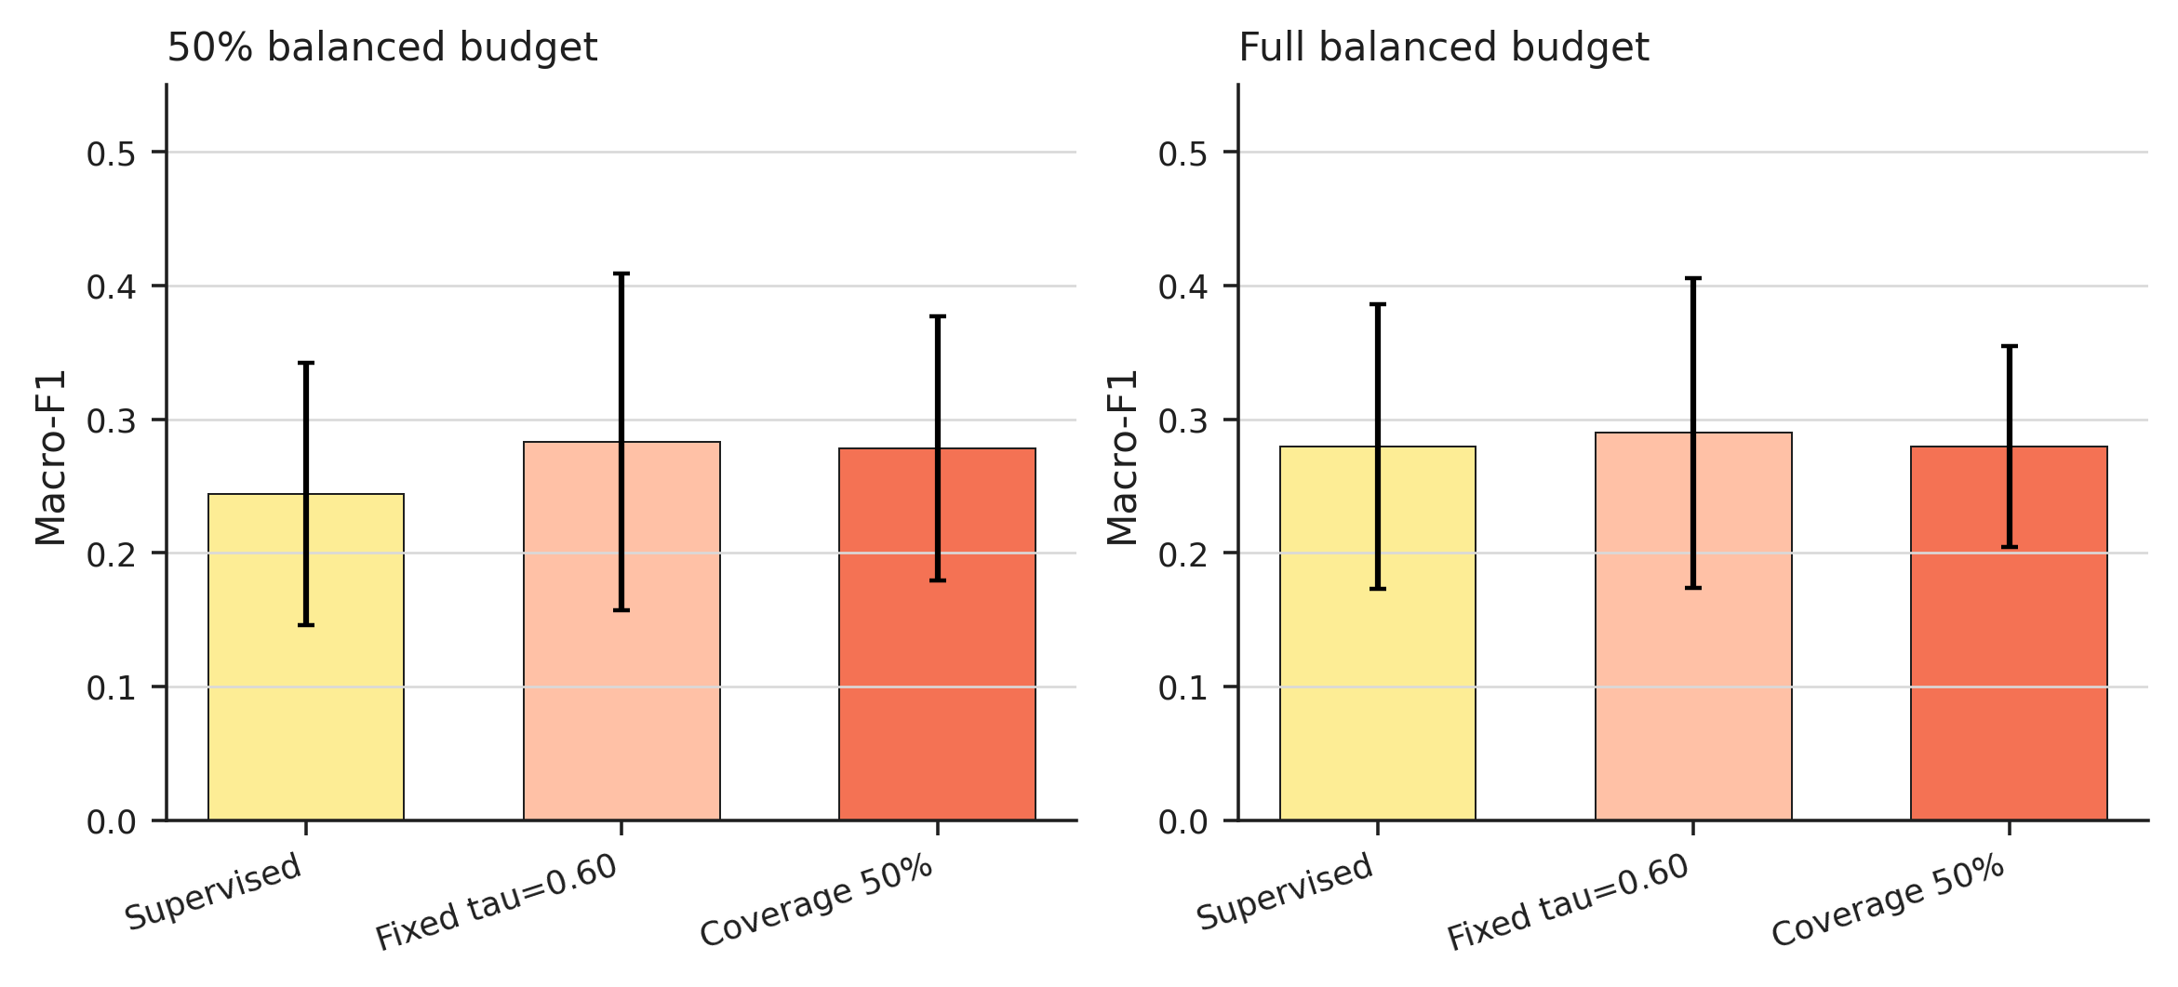
Figure 16. Self-training sensitivity at the 50% and Full balanced budgets. Error bars show one standard deviation over 20 matched runs.
Table 18. Training-opportunity and baseline learning-rate audits. Intervals resample folds before seeds where reported.
Audit | Model | Validation-only difference | Improvement | Mean selected epoch
Training opportunity | Raw 1D-CNN | -0.014 [-0.061, +0.012] | 12/20 | 6.8
Training opportunity | CWT 2D-CNN | +0.039 [+0.019, +0.062] | 17/20 | 8.5
Training opportunity | CWT-GRU without SE | +0.006 [-0.008, +0.018] | 12/20 | 7.8
Training opportunity | CWT-GRU | +0.034 [-0.004, +0.084] | 12/20 | 8.6
Baseline LR tuning | CWT 2D-CNN | -0.008 [-0.031, +0.002] | 0/4 folds | --
Baseline LR tuning | DRSN adaptation | +0.005 [-0.001, +0.021] | 1/4 folds | --
Baseline LR tuning | Raw 1D-CNN | -0.013 [-0.040, +0.007] | 0/4 folds | --
Baseline LR tuning | TFN adaptation | +0.014 [-0.044, +0.083] | 2/4 folds | --

In the 30-epoch opportunity, the latest selected epoch across all four architectures was 19, and no run selected the 30th epoch (cap-selected runs: 0). Validation Macro-F1 improved in 53 of 80 matched checks, but every held-out test interval for the 30-versus-12 difference included zero. The 12-epoch primary protocol was therefore retained rather than changing the benchmark after observing test outcomes.
Post-hoc penultimate embeddings were inspected with PCA and t-SNE after model fitting. The saved diagnostics compare neighbour agreement for fault class, physical bearing, and condition. These labels are used for visualization and offline interpretation only and do not enter feature optimization or model selection.
Across folds, domain silhouette ranged from -0.098 to -0.032, and held-out test class silhouette ranged from 0.149 to 0.411. Nearest-neighbour agreement was higher for fault class (0.923 mean) than for bearing identity (0.761) or condition (0.719). The embeddings are therefore not organized as clean train/test domain clusters, but the low held-out class silhouette shows that class organization remains weak within the unseen domain.
Figure 17. PCA of CWT-GRU penultimate embeddings for train, validation, and held-out test windows under each fold.
Figure 18. t-SNE of one representative fold, coloured by fault class and held-out bearing identity after fitting.

8 Discussion

8.1 Complexity is not the same as robustness
The main comparison does not show that the complicated model is better. The CWT 2D-CNN differs from Raw 1D-CNN by 0.002 macro-F1, and the CWT-GRU mean is lower than both the raw model and the CWT-only model. The no-SE variant has the highest observed mean, but its fold-aware interval is centered near zero. This pattern is consistent with a distinction between representational capacity on the training distribution and invariance to a new bearing and operating condition. More capacity can fit domain-specific cues without acquiring the fault mechanism that transfers.
The two external adaptations did not exceed the simpler baselines under the joint holdout. This observation does not invalidate their published results, which were obtained with different datasets, splits, input channels, and training recipes. It indicates that architecture-level complexity alone did not transfer to this stricter evaluation.
Table 13 and Figure 12 show substantially higher validation macro-F1 than test macro-F1 for every principal model. The held-out test scores therefore cannot be explained merely by an inability to fit the development domains. The performance loss coincides with the joint change in bearing identity and operating condition. This pattern is consistent with joint domain shift, but the design cannot isolate the causal contributions of bearing identity, operating condition, and damage-origin differences, nor can it identify a single failure mechanism.

8.2 Potential information loss in the implemented CWT representation
The implemented representation takes the absolute CWT coefficient and bilinearly resizes the field to 96 x 96. Phase is discarded, and the resize can attenuate short transients, impact timing, and narrow sidebands. The raw waveform retains the ordered samples, although local convolutional filters still need to discover the relevant scales. The result does not show that time-frequency analysis is intrinsically inferior. It shows that a magnitude-only image and a generic image classifier are not automatically better than a waveform model under this distribution shift.
The CWT controls make this boundary more specific. A 32-scale representation changed test Macro-F1 relative to the primary 48-scale representation by +0.032, with a fold-aware interval from +0.000 to +0.069 and 4 of 4 fold means in its favor. Relative to Raw 1D-CNN, however, its difference was +0.034, with interval -0.057 to +0.164 and 1 of 4 fold means in its favor. The scale choice can change CWT performance, but it did not establish a stable advantage over the raw-waveform baseline, and the 32-scale variant was not promoted after inspecting test data.
The MTFC-T reference provides a useful design contrast [14]. Its TFCLayer retains both real and imaginary components before multiscale convolution, and its Transformer attention explicitly models long-range dependencies. Those choices address part of the phase and resolution limitation identified here. The present study did not implement MTFC-T, so its reported results are not ranked against the present benchmark.

8.3 Recurrent fusion adds cost without a stable gain
CWT-GRU uses 4.5 times as many parameters as Raw 1D-CNN and has a higher median training and inference cost. Its paired macro-F1 interval against Raw 1D-CNN is centered near zero. The recurrent branch traverses 8192 time steps and therefore exposes limited parallelism compared with local convolution. The observation is an empirical result for this implementation, not a claim that every temporal model must fail.

8.4 Self-training risks confirmation bias
At a 10% balanced budget, no pseudo-label passed tau = 0.60 in all 20 evaluations. At the 50% balanced and Full balanced budgets, selected pseudo-label accuracy is high in many runs, yet the fold-aware intervals for diagnostic change include zero. The selection rule uses the model's own calibrated confidence, so it is most likely to admit samples that agree with the current decision geometry. The asymmetric confusion matrix shows that this geometry is already biased toward particular classes. A class-balanced cap limits count imbalance but does not create information about systematically confused classes. The observed pattern is consistent with confirmation bias rather than a demonstrated improvement in fault representation.
The per-class top-50% rule selected approximately 50.1% of candidates with offline pseudo-label accuracy 0.987. Despite this high precision, the end-task difference from supervised training was +0.034, with a fold-aware interval from -0.020 to +0.096. The result reinforces the distinction between selection accuracy and transferable end-task benefit.
At the Full balanced budget, the coverage rule selected no multiple-damage pseudo-label in 4 of 20 runs. Coverage is therefore class-conditional in practice even when a global fraction is requested.

8.5 Calibration changes confidence, not decisions
Temperature scaling is monotonic and therefore preserves the argmax. For the CWT models, lower test ECE and NLL indicate more reliable probabilities. For Raw 1D-CNN, the validation-selected temperature worsened both test measures. A lower ECE for one model and domain should not be described as a repaired classifier. Calibration and self-training must be reported separately because one changes confidence and the other changes the training labels.
The Raw 1D-CNN fitted temperature reached the lower bound 0.05 in 3 of 20 runs, whereas the four CWT model conditions had mean fitted temperatures between 1.92 and 2.62. Per-fold reliability diagrams show that aggregate improvement does not imply uniform calibration across held-out domains.

8.6 Toward a reproducible reporting standard
The benchmark supports eight concrete reporting requirements: non-overlapping windows; bearing-code-disjoint fitting and testing; explicit operating-domain holdout; source-file and preprocessing provenance; at least five stochastic seeds per operating-condition fold with fold-aware paired statistics; class-conditional pseudo-label coverage as well as aggregate accuracy; separate reports of classification and calibration; and an explicit damage-origin manifest. It also supports an auditable distinction between numerical improvement and statistical evidence.

9 Conclusion
This study asked whether time-frequency imaging, temporal fusion, temperature scaling, and self-training improve bearing diagnosis when a new bearing and a new operating condition are held out together. Under the Paderborn protocol, the study did not establish stable improvements: fold-aware intervals for CWT and CWT-GRU against Raw 1D-CNN include zero in macro-F1, and intervals for self-training include zero at the tested balanced label budgets. Same-protocol DRSN and TFN adaptations had lower mean macro-F1, although the four held-out condition folds limit inferential precision. These results do not establish a universal failure of time-frequency or recurrent methods. They establish a stricter boundary for claims based on random-window benchmarks. Sensitivity analyses show that representation scale and label granularity can change the observed score, while neither a stronger pseudo-label selector nor a longer training budget produced a stable end-task gain in the evaluated matrix.
The study has several limitations. The Paderborn test rig is not a complete machine-tool spindle assembly, and the held-out physical units are limited to 4 codes. Only four independent operating-condition folds are available, which limits inferential resolution. The benchmark uses one window length, one primary CWT scale range, one principal model family, and a small validation set. The external DRSN and TFN implementations are adaptations under the common protocol, so their results do not estimate performance under the original papers' datasets or training recipes. The held-out fault bearings are lifetime-damaged while several training bearings are artificially damaged, so the test coincides with changes in damage origin, bearing identity, and condition. These factors cannot be separated by the primary design. No reviewed second dataset met the simultaneous unit-disjoint and condition-disjoint criteria, so the conclusions apply to the evaluated configurations and this Paderborn protocol. The same four fixed test folds were reused across the broader model-comparison project. This supports a run-level leakage-free statement, but not a claim that the test set remained cognitively untouched by every human design decision.
Future work should test phase-preserving or complex-valued time-frequency representations, multi-scale kernels that retain real and imaginary components, target-aware domain adaptation with strictly guarded test data, physically informed bearing models, and validation on complete spindle assemblies and naturally degraded bearings. Self-training should be paired with coverage control and an independent audit of class-conditional label quality.

Appendix A Additional Diagnostic Figures
Figure S1. Per-fold reliability diagrams for CWT-GRU before and after validation-fitted temperature scaling.
Figure S2. Per-run validation-fitted temperature distributions for the principal calibrated models.
Figure S3. Fold-level paired differences for the principal comparisons.
Figure S4. Validation and held-out test changes from 12 to 30 maximum training epochs.
Figure S5. Window-wise and training-statistic normalization sensitivity.

Data and Code Availability
The Paderborn data are available from the official Bearing Data Center [21]. The accompanying project archive contains the preprocessing commands, canonical configuration, split manifests, per-run configurations, all 320 result rows and 40 external-baseline retraining rows, automated statistics, separate preprocessing and training sensitivity rows, method figures, and manuscript-generation script. Raw signals, large caches, and model weights are not redistributed.

References
[1] C. Lessmeier, J. K. Kimotho, D. Zimmer, and W. Sextro, "Condition monitoring of bearing damage in electromechanical drive systems by using motor current signals of electric motors: A benchmark data set for data-driven classification," in Proc. European Conf. PHM Soc., vol. 3, no. 1, 2016, doi: 10.36001/phme.2016.v3i1.1577.
[2] J. Hendriks, P. Dumond, and D. A. Knox, "Towards better benchmarking using the CWRU bearing fault dataset," Mech. Syst. Signal Process., vol. 169, Art. no. 108732, Apr. 2022, doi: 10.1016/j.ymssp.2021.108732.
[3] W. A. Smith and R. B. Randall, "Rolling element bearing diagnostics using the Case Western Reserve University data: A benchmark study," Mech. Syst. Signal Process., vol. 64-65, pp. 100-131, 2015.
[4] Z. Wang and T. Oates, "Imaging time-series to improve classification and imputation," in Proc. IJCAI, 2015, pp. 2627-2633.
[5] C. Torrence and G. P. Compo, "A practical guide to wavelet analysis," Bull. Amer. Meteor. Soc., vol. 79, no. 1, pp. 61-78, 1998.
[6] J. Hu, L. Shen, and G. Sun, "Squeeze-and-excitation networks," in Proc. IEEE CVPR, 2018, pp. 7132-7141.
[7] K. He, X. Zhang, S. Ren, and J. Sun, "Deep residual learning for image recognition," in Proc. IEEE CVPR, 2016, pp. 770-778.
[8] K. Cho, B. van Merrienboer, C. Gulcehre, et al., "Learning phrase representations using RNN encoder-decoder for statistical machine translation," in Proc. EMNLP, 2014, pp. 1724-1734.
[9] D.-H. Lee, "Pseudo-label: The simple and efficient semi-supervised learning method for deep neural networks," in Proc. ICML Workshop Challenges Representation Learning, 2013.
[10] C. Guo, G. Pleiss, Y. Sun, and K. Q. Weinberger, "On calibration of modern neural networks," in Proc. ICML, 2017, pp. 1321-1330.
[11] L. Wheat, M. V. Mohrenschildt, S. Habibi, and D. Al-Ani, "Impact of data leakage in vibration signals used for bearing fault diagnosis," IEEE Access, vol. 12, pp. 169879-169895, 2024, doi: 10.1109/ACCESS.2024.3497716.
[12] C. Zhao, E. Zio, and W. Shen, "Domain generalization for cross-domain fault diagnosis: An application-oriented perspective and a benchmark study," Reliab. Eng. Syst. Saf., vol. 245, Art. no. 109964, 2024, doi: 10.1016/j.ress.2024.109964.
[13] S. Alsafari and A. Yafoz, "Few-shot bearing fault diagnosis under joint fault-severity and load shift: A leak-free cross-domain benchmark," Comput. Model. Eng. Sci., vol. 148, no. 1, Art. no. 17, 2026, doi: 10.32604/cmes.2026.084403.
[14] B. Fang, Y. Hu, G. Zheng, X. Zhang, and L. Xie, "Multiscale time-frequency CNN-transformer model for bearing fault diagnosis: A comprehensive feature extraction approach," Eng. Fail. Anal., vol. 184, Art. no. 110312, 2026, doi: 10.1016/j.engfailanal.2025.110312.
[15] B. Wu and G. Yu, "Time-frequency decomposition and convolution strategy for fault diagnosis of rotating machinery," Eng. Fail. Anal., vol. 191, Art. no. 110793, 2026, doi: 10.1016/j.engfailanal.2026.110793.
[16] M. Zhao, S. Zhong, X. Fu, B. Tang, and M. Pecht, "Deep residual shrinkage networks for fault diagnosis," IEEE Trans. Ind. Informat., vol. 16, no. 7, pp. 4681-4690, 2020.
[17] X. Li, J. Wang, J. Wang, J. Wang, J. Chen, and X. Yu, "Research on CNC machine tool spindle fault diagnosis method based on DRSN-GCE model," Algorithms, vol. 18, no. 6, Art. no. 304, 2025, doi: 10.3390/a18060304.
[18] X. Li, J. Chen, J. Wang, et al., "Research on fault diagnosis method of bearings in the spindle system for CNC machine tools based on DRSN-Transformer," IEEE Access, vol. 12, pp. 74586-74595, 2024, doi: 10.1109/ACCESS.2024.3404968.
[19] D. P. Kingma and J. Ba, "Adam: A method for stochastic optimization," in Proc. ICLR, 2015.
[20] I. Loshchilov and F. Hutter, "Decoupled weight decay regularization," in Proc. ICLR, 2019.
[21] Paderborn University, "Bearing Data Center," https://groups.uni-paderborn.de/kat/BearingDataCenter/ (accessed Oct. 27, 2026).
[22] Q. Chen, X. Dong, G. Tu, et al., "TFN: An interpretable neural network with time-frequency transform embedded for intelligent fault diagnosis," Mech. Syst. Signal Process., vol. 207, Art. no. 110952, 2024, doi: 10.1016/j.ymssp.2023.110952.

