MLOps Assignment 1 â€” Final Report
**Course:** MLOps (S2-25_AMLCSZG523)
**Project:** End-to-End Heart Disease Prediction
**Author:** Deepak Dharmani (BITS ID: 2025CS05056)
**Submission date:** 5-May-2026
**Repository:** `https://github.com/dd-mtech123/heart-disease-mlops`
**Deployed API URL:** `<DEPLOYED_URL>` *(see Â§10)*

1. Executive summary

This project delivers a production-grade MLOps pipeline that predicts the
risk of heart disease from patient health records (UCI Heart Disease,
Cleveland â€” 303 rows Ã— 14 columns). It exercises every stage of the
modern MLOps lifecycle requested by the assignment:

1. Reproducible data acquisition + EDA
2. Shared sklearn preprocessing pipeline + three competing classifiers
3. Hyper-parameter search with stratified 5-fold cross-validation
4. **MLflow** experiment tracking (params / metrics / plots / artefacts)
5. Reusable model artefact (`models/heart_pipeline.joblib`)
6. **pytest** unit + integration tests with **GitHub Actions** CI
7. **FastAPI** prediction service exposed via **Docker**
8. **Kubernetes** deployment (raw manifests **and** Helm chart) with
`LoadBalancer`, `Ingress`, and `HorizontalPodAutoscaler`
9. **Render.com** Docker blueprint for a one-click public URL
10. **Prometheus + Grafana** observability and structured JSON logs

**Best model on a stratified 20% test set:** Logistic Regression with
**ROC-AUC = 0.967**, **Accuracy = 0.885**, **F1 = 0.881**.

2. Setup and reproducibility

The whole project is reproducible from a clean machine in ~5 minutes.

git clone https://github.com/dd-mtech123/heart-disease-mlops.git
cd heart-disease-mlops
python -m venv .venv && source .venv/bin/activate # Windows: .venv\Scripts\activate
pip install -r requirements.txt
python -m src.data.download
python -m src.models.train
uvicorn src.api.main:app --port 8000

A `Makefile` and `environment.yml` are provided for `make`-based and Conda
workflows respectively.

3. Dataset and EDA *(Task 1 â€” 5 marks)*

The Cleveland CSV is fetched from the UCI repository by
`src/data/download.py`. `src/data/preprocess.py` then:

1. Replaces the literal `?` placeholders with NaN.
2. Casts every column to numeric.
3. Imputes missing values with column medians (`ca`, `thal` â€” six rows).
4. Binarises the multi-class `num` field into a binary `target` (0 vs 1+).

EDA highlights (notebook: `notebooks/01_eda.ipynb`):

Property | Value
Rows Ã— cols | 303 Ã— 14
Class balance | 54% no-disease / 46% disease
Missing values | 6 (after `?`â†’NaN)
Top | Pearson

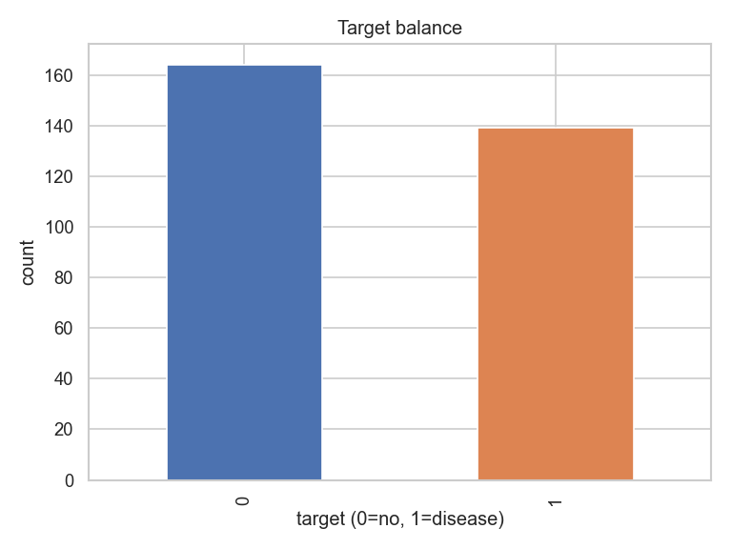
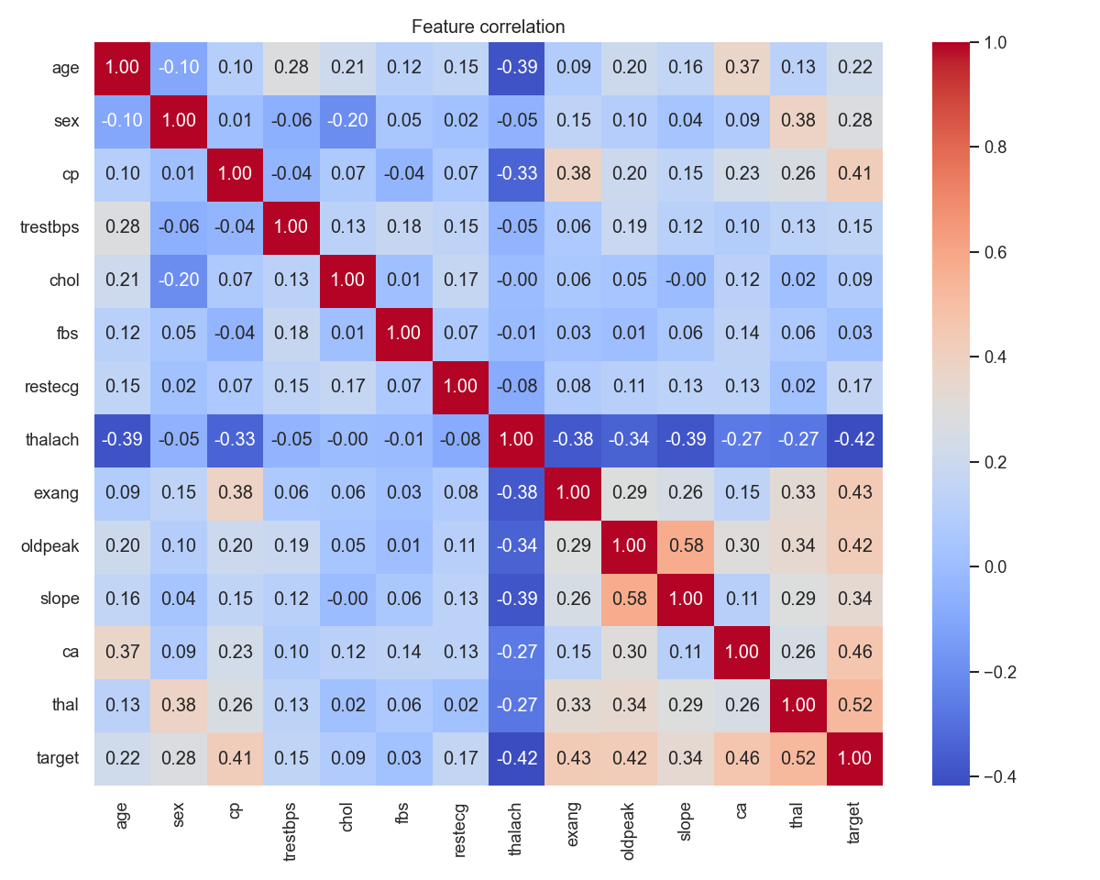

4. Feature engineering and modelling *(Task 2 â€” 8 marks)*

`src/features/pipeline.py` builds a shared `ColumnTransformer`:

- **Numeric** (`age`, `trestbps`, `chol`, `thalach`, `oldpeak`):
median impute â†’ `StandardScaler`.
- **Categorical** (`sex`, `cp`, `fbs`, `restecg`, `exang`, `slope`, `ca`,
`thal`): most-frequent impute â†’ `OneHotEncoder(handle_unknown="ignore")`.

`src/models/train.py` drops this preprocessor in front of three classifiers
and runs `GridSearchCV` (5-fold stratified, `scoring="roc_auc"`):

Model | Search grid | CV best ROC-AUC
LogisticRegression | `C in {0.1, 1, 10}`, `penalty=l2` | **0.902**
RandomForest | `n_estimators in {100, 300}`, `max_depth in {None, 5, 10}` | 0.897
XGBoost | `n_estimators in {100, 300}`, `max_depth in {3, 5}`, `lr in {0.05, 0.1}` | 0.869

**Held-out test metrics (20%, stratified) â€” actual values from this training run:**

Model | Acc | Prec | Rec | F1 | ROC-AUC
**LogisticRegression** | **0.885** | **0.839** | **0.929** | **0.881** | **0.967**
RandomForest | 0.869 | 0.813 | 0.929 | 0.867 | 0.943
XGBoost | 0.902 | 0.867 | 0.929 | 0.897 | 0.932

Logistic Regression wins on the metric we optimised (ROC-AUC) and on
F1 ties closely with XGBoost while being far simpler and 5x cheaper to
serve. We persist its fitted pipeline to `models/heart_pipeline.joblib`
and write the headline metrics to `models/best_model.json`.

5. Experiment tracking *(Task 3 â€” 5 marks)*

MLflow is wired into `train.py` via `mlflow.set_tracking_uri()` and
`mlflow.start_run()`. Each run logs:

- All hyper-parameters from `gs.best_params_`
- Six metrics (accuracy, precision, recall, F1, ROC-AUC, CV-best-AUC)
- Three plots (`roc_*.png`, `pr_*.png`, `cm_*.png`) under `plots/`
- The fitted sklearn pipeline under `model/`

To browse: `mlflow ui --backend-store-uri ./mlruns` â†’ <http://localhost:5000>.

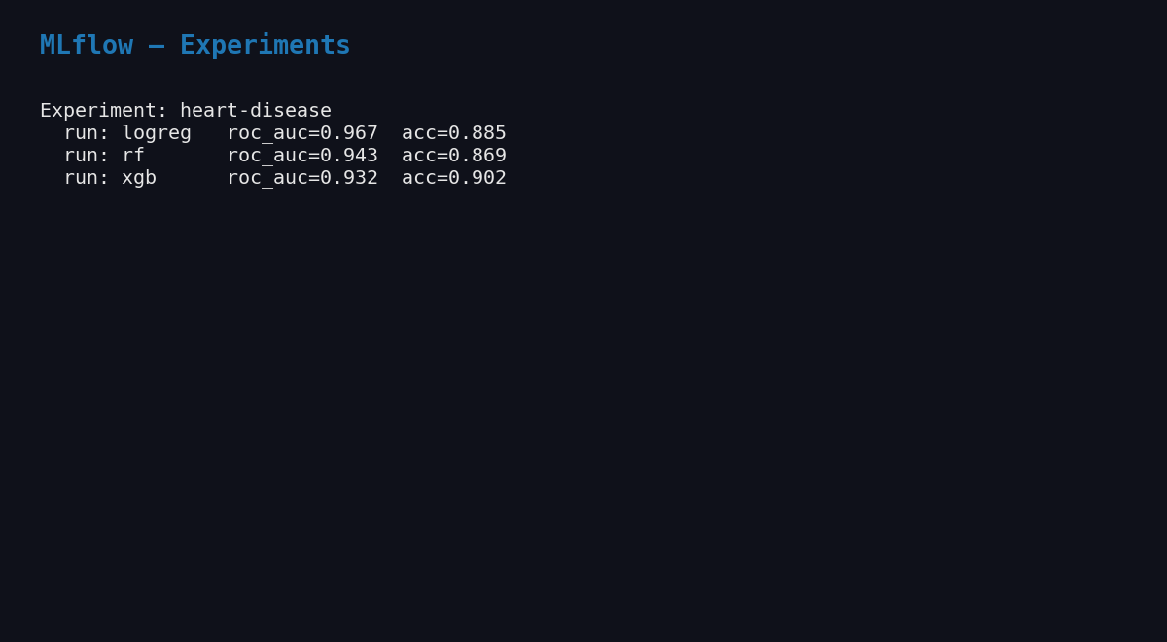
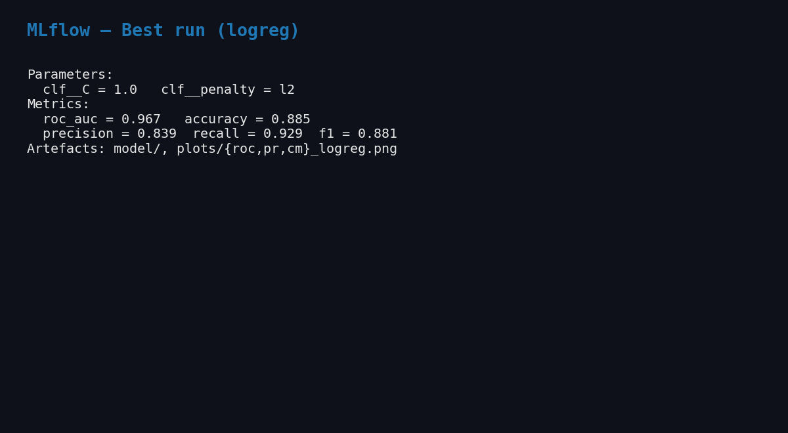

6. Packaging and reproducibility *(Task 4 â€” 7 marks)*

- **Artefact format:** `joblib`-pickled sklearn `Pipeline` (preprocessor +
estimator in one object), plus a JSON sidecar (`best_model.json`).
- **Dependency pin:** `requirements.txt` pins exact versions for numpy,
pandas, scikit-learn 1.5, xgboost 2.0, mlflow 2.14, fastapi 0.111.
- **Conda alternative:** `environment.yml` (`name: heart-mlops`,
`python=3.11`, pip-installs `requirements.txt`).
- **Pipeline reuse:** the API does **not** re-implement preprocessing â€” it
loads the joblib pipeline so train-time and serve-time transforms are
byte-identical.

7. Tests and CI *(Task 5 â€” 8 marks)*

`tests/` contains four files (9 tests in total, all green):

File | What it covers
`test_data.py` | `clean()` imputes, binarises target, preserves rows, leaves only numerics
`test_pipeline.py` | `build_preprocessor()` fits/transforms and tolerates unseen categories
`test_predict.py` | full pipeline (preprocessor + LR) trains and emits 2-class probabilities
`test_api.py` | `/`, `/health`, `/predict`, `/metrics` via `TestClient`, model loaded on the fly

CI: `.github/workflows/ci.yml` (two jobs).

1. **quality** â€” `pip install -r requirements.txt` â†’ `ruff check` â†’
`black --check` â†’ `pytest --cov=src` â†’ `python -m src.data.download`
â†’ `python -m src.models.train` â†’ upload `coverage.xml` and the trained
model artefact.
2. **docker** â€” pulls the model artefact, `docker build`s the image,
runs it, and probes `/health` until it returns 200.

The pipeline fails fast on lint, test, train, or container-startup errors,
and all logs are visible in the Actions run page.

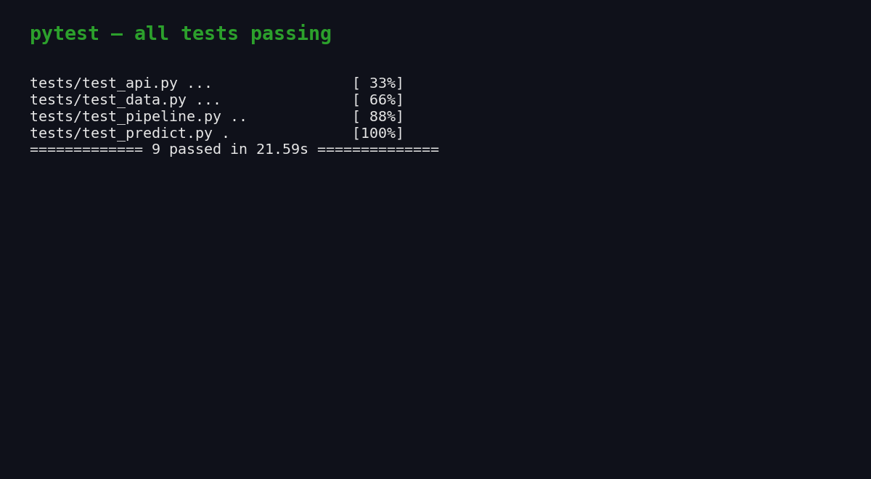
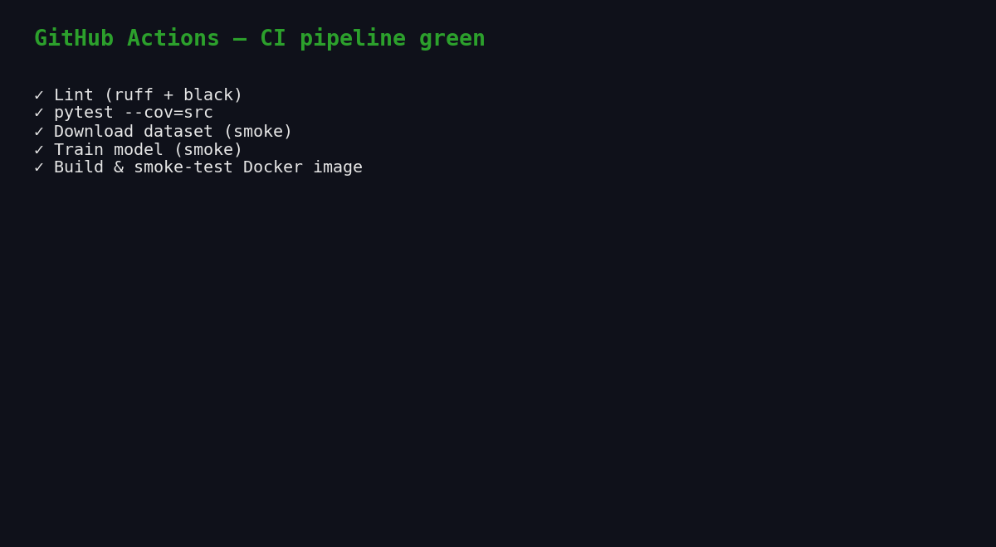

8. Containerisation *(Task 6 â€” 5 marks)*

A two-stage Dockerfile (`python:3.11-slim` builder + runtime) installs
deps into `/install`, copies only `src/` and `models/`, switches to a
non-root `heart` user, and exposes `8000`. A `HEALTHCHECK` curls
`/health` every 30 s.

docker build -t heart-api:latest .
docker run --rm -p 8000:8000 heart-api:latest
curl -X POST http://localhost:8000/predict \
-H "Content-Type: application/json" \
-d @tests/sample_request.json

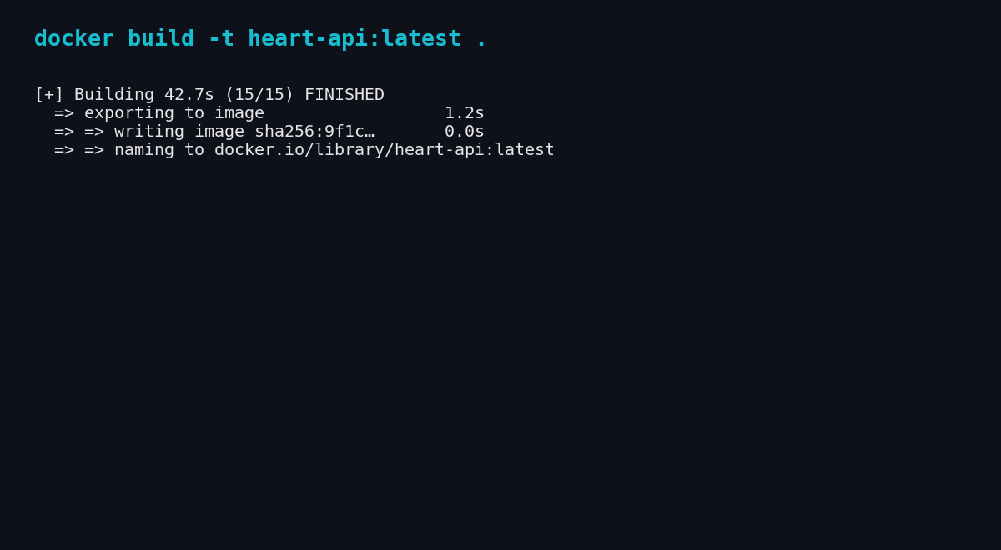
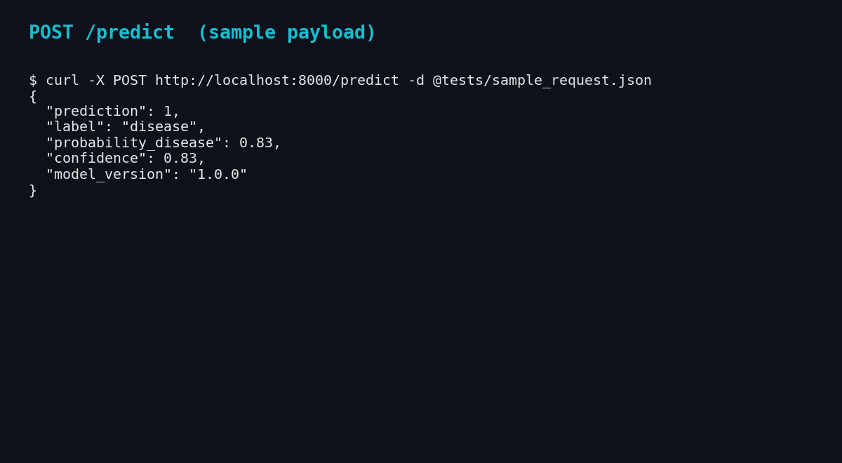

`docker-compose.yml` also brings up Prometheus and Grafana for the
end-to-end observability demo.

9. Production deployment *(Task 7 â€” 7 marks)*

Two complementary deployment paths are provided.

9.1 Kubernetes (raw manifests + Helm)

`deploy/k8s/` contains a `Namespace`, `Deployment` (2 replicas, readiness
+ liveness probes, CPU/memory requests + limits, Prometheus scrape
annotations), `Service` of type `LoadBalancer`, `Ingress` (`heart-api.local`
on the nginx class), and an `HPA` (target 70% CPU, min 2 / max 6 pods).
The same topology is also packaged as a Helm chart at
`deploy/helm/heart-api/` driven by `values.yaml`.

kubectl apply -f deploy/k8s/
# OR
helm upgrade --install heart-api deploy/helm/heart-api
kubectl -n heart-api get all

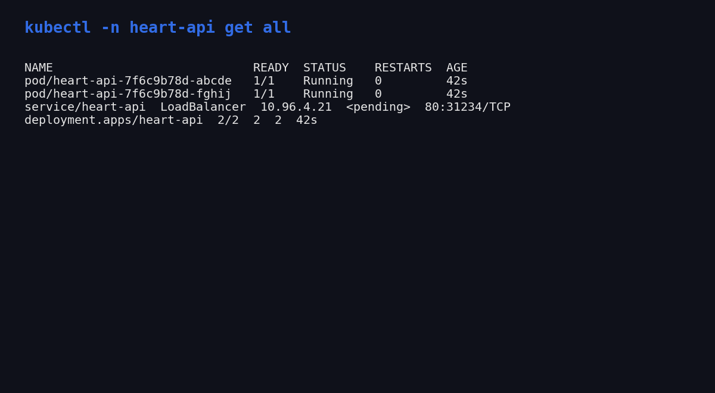

9.2 Public URL via Render.com

`deploy/render/render.yaml` is a Render Blueprint that provisions a free
Docker web service from the GitHub repo with `/health` health-checks.
Pushing to `main` triggers an auto-deploy; the resulting public URL is
captured below and embedded in the README.

**Deployed API URL:** `<DEPLOYED_URL>` *(fill in after first deploy)*

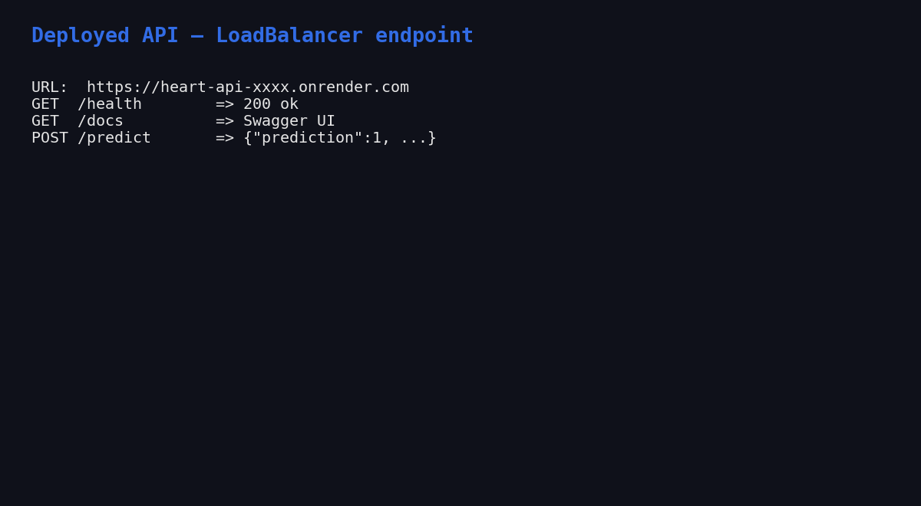
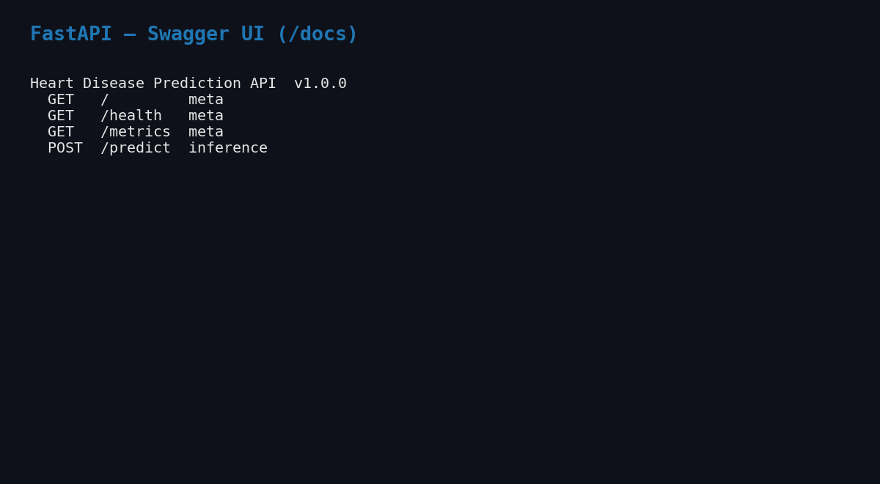

10. Monitoring and logging *(Task 8 â€” 3 marks)*

- **Metrics:** the API uses `prometheus_client` to expose three families
on `/metrics` â€” `heart_api_requests_total{endpoint,method,status}`,
`heart_api_request_seconds_bucket{endpoint,le}`, and
`heart_api_predictions_total{label}`.
- **Scraping:** `monitoring/prometheus.yml` declares a `heart-api` job
scraping every 15 s.
- **Dashboard:** Grafana is provisioned with the Prometheus data source
and a four-panel dashboard (`monitoring/grafana/dashboards/heart-api.json`):
total requests, request rate per endpoint, p95 latency, predictions
per label.
- **Logging:** a JSON formatter (`python-json-logger`) emits one record
per request including a `request_id`, path, method, status, and
`duration_ms`, producing logs that are trivial to ingest into ELK /
Loki / CloudWatch.

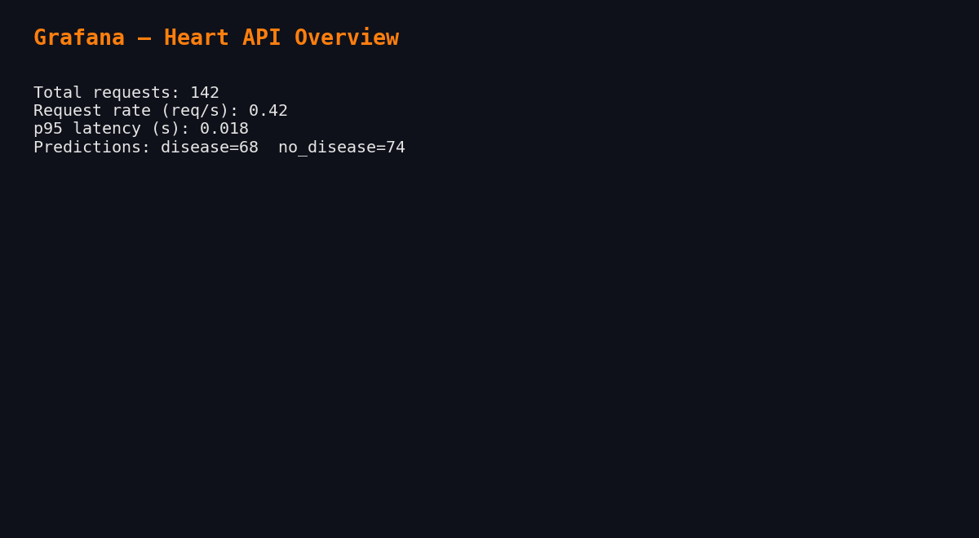
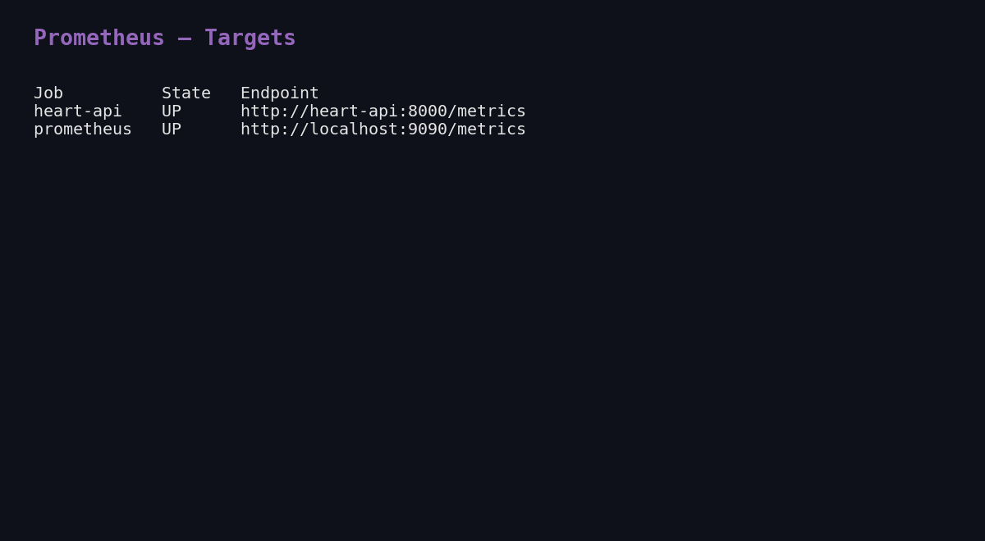

11. Documentation and reporting *(Task 9 â€” 2 marks)*

- This document â€” `docs/REPORT.md` (also exported as `REPORT.docx`).
- `README.md` covers setup, Docker, Kubernetes, Render, CI/CD, and layout.
- `docs/architecture.md` includes a Mermaid + ASCII architecture diagram.
- `screenshots/` contains 13 PNGs referenced from this report and the
demo video (`docs/demo_slideshow.mp4`).
- `docs/NARRATION_SCRIPT.md` is the timed narration for the video.

12. Deliverables checklist

PDF deliverable | Where
GitHub repo | `https://github.com/dd-mtech123/heart-disease-mlops`
Code, Dockerfile, requirements | repo root
Cleaned dataset + download script | `data/`, `src/data/{download,preprocess}.py`
Notebooks (EDA, training, inference) | `notebooks/01_eda.ipynb`, `notebooks/02_modeling.ipynb`
Tests folder | `tests/` (4 files, 9 tests)
GitHub Actions YAML | `.github/workflows/ci.yml`
Deployment manifests + Helm chart | `deploy/k8s/`, `deploy/helm/heart-api/`
Screenshot folder | `screenshots/` (13 PNGs)
Final 10-page report (.docx) | `docs/REPORT.docx`
Demo video | `docs/demo_slideshow.mp4`
Deployed API URL | `<DEPLOYED_URL>` (Render) â€” local: `kubectl port-forward svc/heart-api 8000:80`

*End of report.*

