There are two ways of getting your work out of Scrivener:

Exporting and Printing Individual Documents
You can export or print any individual document in Scrivener by tapping the “share” icon that appears in the toolbar beneath the editor (when you’re not editing). Alternatively, you can swipe left in a row in the binder and tap More to access the same export options. You can export text documents to the following formats:
• Word (.docx). Word documents can also be opened by Pages.
• Rich text (.rtf). RTF documents can be opened by a wide variety of desktop word processors, although there is not yet much support for it among other iOS apps.
• PDF format.
• Plain text (.txt).
• Final Draft (.fdx). This format is only available if scriptwriting features are turned on via the project settings.
Non-text documents such as images are exported using their original format. You can then choose whether to share documents via Mail, Messages or another app, to open them in another app directly, or to print text documents.

Compiling Your Draft
One of the key concepts of Scrivener is that you work on your manuscript in pieces as small or large as you want, but this wouldn’t be of much use if you couldn’t put Humpty together again. As already covered, the “Draft” folder is where you write your manuscript. When you’re ready to export or print your entire draft, you need to “compile” it. Compiling doesn’t affect the original documents—they all stay as they were in the Draft folder—it merely combines them into a new text that is used purely for exporting or printing.
To compile, do one of the following:
• Tap the “share” icon in the toolbar below the editor when viewing a text document stored inside the Draft folder, and choose Compile Draft from the menu that appears.
• Tap the compile icon (two pieces of paper with an arrow pointing up) that appears in the toolbar below the binder.
Upon so doing, you will be presented with an options screen. Here you can choose the export file format (Word, RTF, PDF, plain text or FDX), along with certain other options. Once you’ve selected the options you want, simply tap Compile and wait for the compiled text to be generated. At the end of this process, you’ll see a new screen that shows a preview of how your text will look if you print it, along with a word and character count for the entire Draft—making this a great way to find the total word count for your manuscript. You can now choose to Share the document, which allows you to send it via Mail or Messages (or to print it), or to Open In, which allows you to send the document to any applications that support the selected export format.

Appearances
One of the most powerful aspects of Compile is the “Appearance” setting. This allows you to choose a preset that can completely transform the appearance of your document. For instance, the “Manuscript (Courier)” appearance will convert all of the text to a Courier 12-point font with italics converted to underlines, with folder titles included and centred and hash (#) symbols inserted between each text document. Choosing “Default” for “Appearance”, on the other hand, compiles your text so that it looks exactly as it does in the editor, preset in “Edit” mode allows you to edit the preset. (You can only edit custom Appearances, however, and not the built-in ones, so try duplicating a preset to test this.). Appearance presets in Scrivener for iOS are created using the YAML format, which is a markup language designed to be easily read by humans. When viewing the Appearance editor, tap the icon of the help ring in the navigation bar to view instructions on how to create your own Appearance presets—there you will find a complete list of the commands available. But, for instance, suppose you created an Appearance preset containing only the following:

Font Family: Cochin 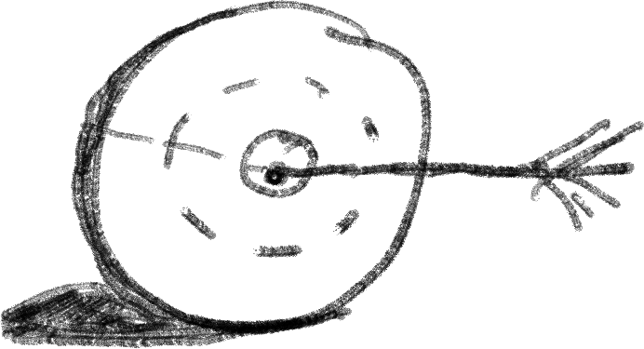 r
This preset would do nothing more than change the font
Tip: the bitte dasitzt gar nicht so ein
. Und los geht's mitbesonders an der nichtigenstelle zu schreiben ist nicht einfach, leiden. Ver muthich ist esabereher ein e übungssache.
Dem Schreiben. Fach möchte ich sagen.
pre'so ich möchte Sekt ein Eugen da etwas sets, such as the Manuscript and Book ones, have tips inside them on how to edit them to suit different project structures. Try duplicating “Manuscript (Times)”, for instance, and then editing it by tapping on the “i” in the duplicate’s row. There you will find information on how to add automatic chapter and part numbering.
Next, on to “Working with Projects”. '

