ACCRA TECHNICAL UNIVERSITY
Department of Computer Science
BCS 404: Introduction to Data Science with Python
PROJECT WORK
Titanic Passenger Data: Cleaning, Exploration and a Survival Prediction Model
(Titanic Dataset, Kaggle)
Name: Dogbe Daniel Senyo
ID: 01252524B
Lecturer: Dr. Joseph Dadzie
Academic Year: 2025/2026, Second Semester

Table of Contents
Table of Contents 2
1. Introduction 3
2. Dataset Description 3
3. Methodology 3
3.1 Getting the Data 4
3.2 Cleaning the Data 4
3.3 Visualisation 4
3.4 Statistical Analysis 4
3.5 Machine Learning 4
4. Results 4
4.1 Data Cleaning Summary 4
4.2 Visualizations 5
4.3 Statistical Analysis 8
4.4 Machine Learning Results 8
5. Discussion 9
6. Conclusion 10
7. References 10
8. Appendix: Python Code 12

1. Introduction
For this BCS 404 project, I worked with the Titanic dataset from Kaggle to practice the full data science process in Python - starting from raw data all the way to a working prediction model. The dataset records information about the passengers who were on board the Titanic, including whether each one survived the sinking or not.
My approach in this report is to not just do the minimum required steps, but to also add a couple of my own touches - for example, instead of simply dropping the Cabin column because it had a lot of missing data, I turned it into a new column that just records whether a cabin was known for that passenger or not, since that on its own turned out to carry some useful information.
The report is organised as follows: Section 2 introduces the dataset, Section 3 explains the steps I took (methodology), Section 4 presents the results, Section 5 is a discussion of what the results mean, and Section 6 wraps up with a conclusion.

2. Dataset Description
The dataset is the Titanic dataset from Kaggle's "Titanic - Machine Learning from Disaster" competition (Kaggle, n.d.). It has 891 passenger records and 12 original columns, described in Table 1.
Column | Meaning
PassengerId | ID number for the passenger
Survived | 1 if the passenger survived, 0 if not
Pclass | Ticket class - 1, 2 or 3
Name | Passenger's name
Sex | male or female
Age | Passenger's age in years
SibSp | Number of siblings/spouses aboard
Parch | Number of parents/children aboard
Ticket | Ticket number
Fare | Amount paid for the ticket
Cabin | Cabin number, mostly missing
Embarked | Port of boarding: S, C or Q

3. Methodology
All work was done in Python inside a Jupyter Notebook, using Pandas, NumPy, Matplotlib, Seaborn and Scikit-Learn.

3.1 Getting the Data
The CSV file was loaded with Pandas, then I checked the shape, column names, first few rows and data types to get familiar with the dataset before doing anything else.

3.2 Cleaning the Data
Age had 177 missing values, which I filled using the mean age. Embarked had 2 missing values, filled with the mode (most frequent port). Cabin was missing for about 77% of passengers, so rather than filling or dropping it outright, I converted it into a new binary column, HasCabin, marking whether a cabin was recorded (1) or not (0), and dropped the original text column. No duplicate rows were found.
I also engineered two extra columns from the existing data: FamilySize (SibSp + Parch + 1) and IsAlone (1 if the passenger was travelling with no family, 0 otherwise), since I thought family situation might matter for survival chances.

3.3 Visualisation
Six charts were produced: an age histogram with a density curve, a bar chart of ticket class counts, a boxplot of age by class, a scatter plot of age against fare (coloured by survival), a correlation heatmap, and a pairplot coloured by survival outcome.

3.4 Statistical Analysis
Descriptive statistics and frequency counts were generated for the key columns, along with a full correlation matrix (including the two engineered columns and HasCabin) to identify the strongest positive and negative relationships in the data.

3.5 Machine Learning
A Logistic Regression model was trained to predict Survived. Sex was converted to a numeric value (0 = male, 1 = female). Rather than using the raw SibSp, Parch and Embarked columns directly, I used the engineered FamilySize, IsAlone and HasCabin columns alongside Pclass, Sex, Age and Fare as the seven predictor variables. The data was split 75% training / 25% testing (random_state = 7). Accuracy, a confusion matrix and a classification report were computed on the held-out test set.

4. Results

4.1 Data Cleaning Summary

Column | Missing Values (before cleaning) | How it was handled
Age | 177 | Filled with mean age
Cabin | 687 | Converted to HasCabin flag, column dropped
Embarked | 2 | Filled with mode

No duplicate rows were present. After cleaning, 204 passengers (about 23%) had a recorded cabin (HasCabin = 1), and 537 passengers (about 60%) were travelling alone (IsAlone = 1).

4.2 Visualizations
Figure 1: age distribution with a density curve overlaid.
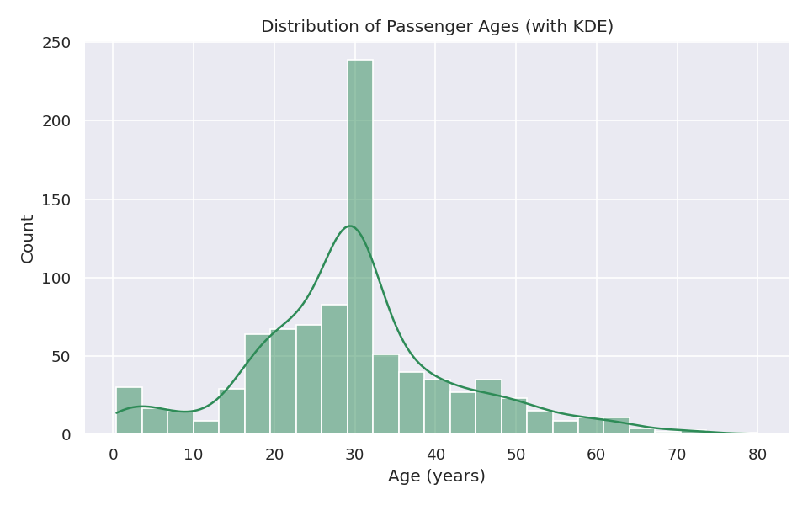
Figure 1: Age Distribution with KDE Overlay
Figure 2: passenger counts by ticket class.
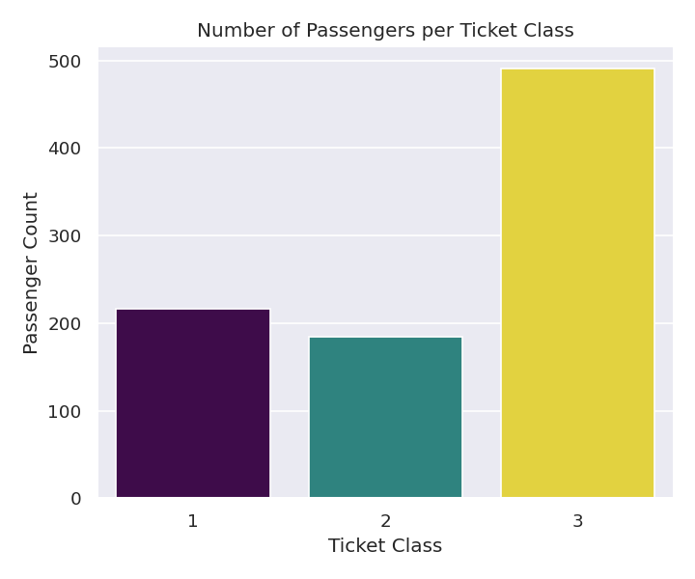
Figure 2: Passengers per Ticket Class
Figure 3: age spread within each ticket class.
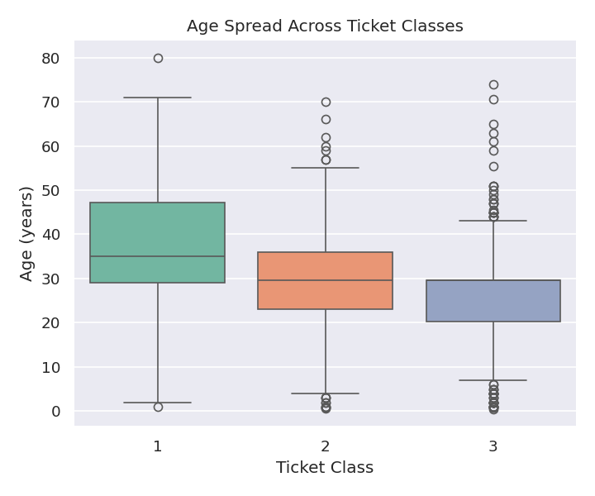
Figure 3: Age Spread Across Ticket Classes
Figure 4: age plotted against fare, colored by survival outcome.
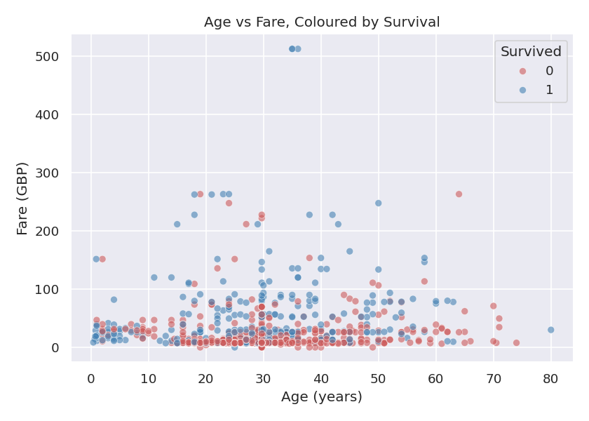
Figure 4: Age vs Fare, Colored by Survival
Figure 5: correlation heatmap, including the engineered variables.
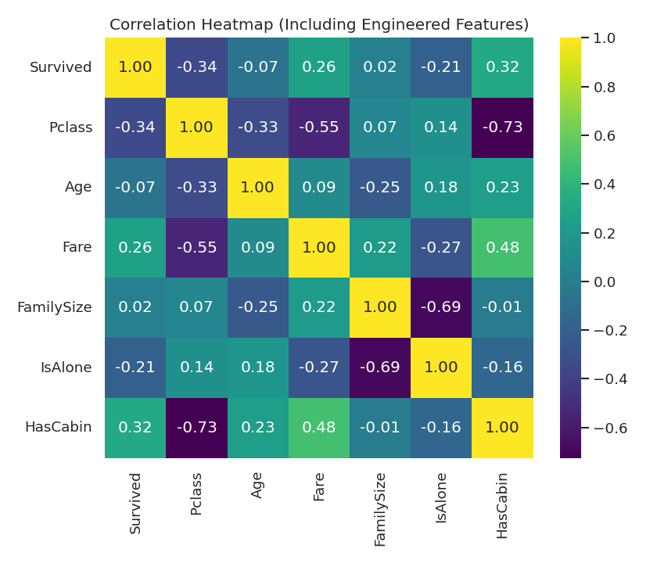
Figure 5: Correlation Heatmap (with Engineered Features)
Figure 6: pairplot coloured by survival outcome.
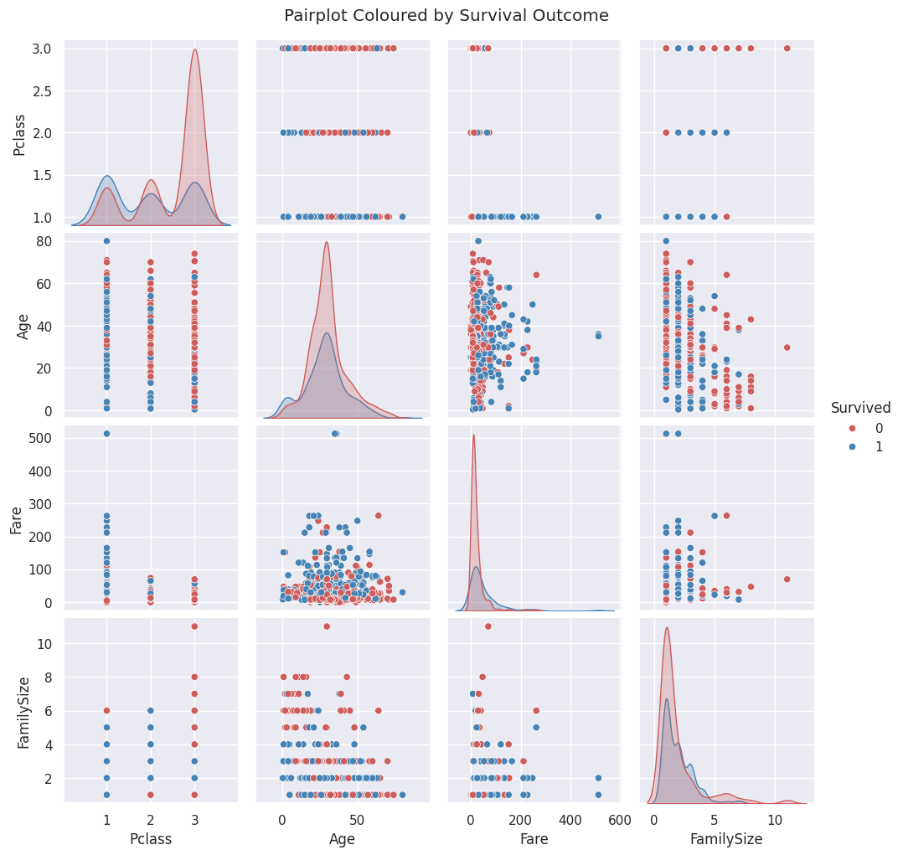
Figure 6: Pairplot Coloured by Survival

4.3 Statistical Analysis
Statistic | Age | Fare | FamilySize
Mean | 29.70 | 32.20 | 1.90
Std. Dev. | 13.00 | 49.69 | 1.61
Min | 0.42 | 0.00 | 1
Max | 80.00 | 512.33 | 11

Frequency counts: Sex - 577 male, 314 female. Pclass - 491 third class, 216 first class, 184 second class. Embarked - 646 Southampton, 168 Cherbourg, 77 Queenstown.
The strongest positive correlation in the full matrix was between Fare and HasCabin (r = 0.482). The strongest negative correlation was between Pclass and HasCabin (r = -0.726). For correlation with Survived specifically, Pclass was strongest negative (r = -0.341) and HasCabin was the strongest positive (r = 0.318), narrowly ahead of Fare (r = 0.259).

4.4 Machine Learning Results
The model reached 76.2% accuracy on the 223-passenger test set. Figure 7 shows the confusion matrix.
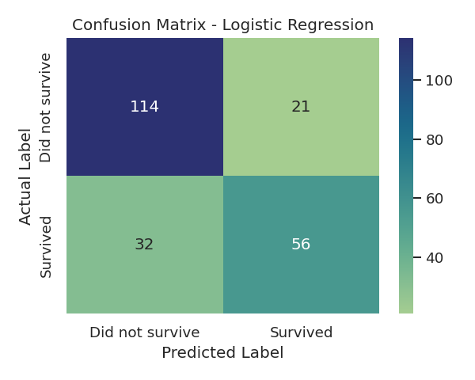
Figure 7: Confusion Matrix for the Logistic Regression Model
Class | Precision | Recall | F1-score | Support
Did not survive (0) | 0.78 | 0.84 | 0.81 | 135
Survived (1) | 0.73 | 0.64 | 0.68 | 88
Weighted Average | 0.76 | 0.76 | 0.76 | 223

5. Discussion
Major findings: Survival was clearly related to passenger class and wealth-related indicators. What stood out most to me was how strong the HasCabin flag turned out to be - even though it was a fairly rough feature (just yes/no on whether a cabin number existed in the records), it correlated with survival almost as strongly as Fare did. This suggests that whatever caused cabin numbers to be recorded (likely first and second class passengers, since crew records for those cabins were probably more complete) lines up closely with who tended to survive.
Statistical insights: The dataset is dominated by third class passengers (491 out of 891), most boarding at Southampton, and the majority of passengers overall were travelling without family (IsAlone = 1 for 537 passengers). The very strong negative correlation between Pclass and HasCabin (-0.73) is really just confirming something expected - cabin numbers were recorded almost exclusively for the higher-paying classes - but it was still useful to see it confirmed numerically rather than just assumed.
Machine learning results: The model's accuracy came out at about 76%, a little lower than I expected going in. I think this is mainly down to my choice of features - I replaced the raw SibSp, Parch and Embarked columns with the engineered FamilySize, IsAlone and HasCabin columns, and it's possible some detail that mattered got lost in that simplification. The model also leans toward predicting "did not survive" more confidently (recall 0.84) than "survived" (recall 0.64), meaning it misses a fair number of passengers who actually did survive.
Limitations of the study: The Age column required filling in about 20% of its values, which could be smoothing out real variation. My feature engineering choices (dropping the raw SibSp/Parch/Embarked columns in favour of FamilySize/IsAlone/HasCabin) were a deliberate experiment, but they may have actually reduced how much information was available to the model. Only one algorithm (Logistic Regression) was tested, and only one particular random train/test split was used, so the accuracy figure could shift somewhat with a different split or a different model.
Recommendations: A good next step would be to re-run the model keeping both the raw columns and the engineered ones together, to check directly whether HasCabin, FamilySize and IsAlone actually add value or whether they were better left as the original columns. It would also be worth trying a small handful of different models (e.g. Decision Tree, Random Forest) to see whether the roughly 76-80% accuracy range typically seen with this dataset can be pushed higher with more feature work.

6. Conclusion
This project walked through the standard data science pipeline on the Titanic dataset - collecting and cleaning the data, visualising it, running statistical analysis, and finally building a Logistic Regression model to predict survival. Passenger class, fare, and whether a cabin was recorded for the passenger were the clearest indicators of survival found in this analysis. The final model reached about 76% accuracy on unseen data. While solid as a first attempt, the results also point to some useful next steps, particularly around feature selection, that could improve on this in future work.

7. References
Harris, C. R., Millman, K. J., van der Walt, S. J., Gommers, R., Virtanen, P., Cournapeau, D., Wieser, E., Taylor, J., Berg, S., Smith, N. J., Kern, R., Picus, M., Hoyer, S., van Kerkwijk, M. H., Brett, M., Haldane, A., del Rio, J. F., Wiebe, M., Peterson, P., ... Oliphant, T. E. (2020). Array programming with NumPy. Nature, 585(7825), 357-362. https://doi.org/10.1038/s41586-020-2649-2
Hunter, J. D. (2007). Matplotlib: A 2D graphics environment. Computing in Science & Engineering, 9(3), 90-95. https://doi.org/10.1109/MCSE.2007.55
Kaggle. (n.d.). Titanic - Machine Learning from Disaster. Retrieved 2026, from https://www.kaggle.com/competitions/titanic/data
McKinney, W. (2010). Data structures for statistical computing in Python. Proceedings of the 9th Python in Science Conference, 56-61.
Pedregosa, F., Varoquaux, G., Gramfort, A., Michel, V., Thirion, B., Grisel, O., Blondel, M., Prettenhofer, P., Weiss, R., Dubourg, V., Vanderplas, J., Passos, A., Cournapeau, D., Brucher, M., Perrot, M., & Duchesnay, E. (2011). Scikit-learn: Machine learning in Python. Journal of Machine Learning Research, 12, 2825-2830.
Waskom, M. (2021). Seaborn: Statistical data visualization. Journal of Open Source Software, 6(60), 3021. https://doi.org/10.21105/joss.03021

8. Appendix: Python Code
Below is the full Python code used in this project, as run in the accompanying Jupyter Notebook (titanic_analysis.ipynb), which is also included in the submitted repository.
# libraries needed for the project
import pandas as pd
import numpy as np
import matplotlib.pyplot as plt
import seaborn as sns
from sklearn.model_selection import train_test_split
from sklearn.linear_model import LogisticRegression
from sklearn.metrics import accuracy_score, confusion_matrix, classification_report

sns.set_theme(style="darkgrid")
%matplotlib inline

data = pd.read_csv("../data/titanic.csv")
data.head()

data.shape

data.columns

data.dtypes

data.isnull().sum()

data["Age"] = data["Age"].fillna(data["Age"].mean())
data["Embarked"] = data["Embarked"].fillna(data["Embarked"].mode()[0])

data["HasCabin"] = data["Cabin"].notnull().astype(int)
data = data.drop(columns=["Cabin"])

data.isnull().sum()

data["FamilySize"] = data["SibSp"] + data["Parch"] + 1
data["IsAlone"] = (data["FamilySize"] == 1).astype(int)
data[["SibSp","Parch","FamilySize","IsAlone"]].head()

# checking for duplicate rows
data.duplicated().sum()

plt.figure(figsize=(8,5))
sns.histplot(data["Age"], bins=25, kde=True, color="seagreen")
plt.title("Distribution of Passenger Ages (with KDE)")
plt.xlabel("Age (years)")
plt.ylabel("Count")
plt.show()

plt.figure(figsize=(6,5))
sns.countplot(x="Pclass", data=data, palette="viridis", hue="Pclass", legend=False)
plt.title("Number of Passengers per Ticket Class")
plt.xlabel("Ticket Class")
plt.ylabel("Passenger Count")
plt.show()

plt.figure(figsize=(6,5))
sns.boxplot(x="Pclass", y="Age", data=data, palette="Set2", hue="Pclass", legend=False)
plt.title("Age Spread Across Ticket Classes")
plt.xlabel("Ticket Class")
plt.ylabel("Age (years)")
plt.show()

plt.figure(figsize=(7,5))
sns.scatterplot(x="Age", y="Fare", hue="Survived", data=data,
palette={0:"indianred", 1:"steelblue"}, alpha=0.6)
plt.title("Age vs Fare, Coloured by Survival")
plt.xlabel("Age (years)")
plt.ylabel("Fare (GBP)")
plt.show()

num_cols = ["Survived", "Pclass", "Age", "Fare", "FamilySize", "IsAlone", "HasCabin"]
corr = data[num_cols].corr()

plt.figure(figsize=(7,6))
sns.heatmap(corr, annot=True, cmap="viridis", fmt=".2f")
plt.title("Correlation Heatmap (Including Engineered Features)")
plt.show()

sns.pairplot(data[["Survived","Pclass","Age","Fare","FamilySize"]], hue="Survived",
palette={0:"indianred", 1:"steelblue"}, diag_kind="kde")
plt.show()

data[num_cols].describe()

print(data["Sex"].value_counts())
print()
print(data["Pclass"].value_counts())
print()
print(data["Embarked"].value_counts())
print()
print(data["HasCabin"].value_counts())

corr

pairs = corr.unstack()
pairs = pairs[pairs.index.get_level_values(0) != pairs.index.get_level_values(1)]

print("Strongest positive:", pairs.idxmax(), round(pairs.max(), 3))
print("Strongest negative:", pairs.idxmin(), round(pairs.min(), 3))

ml_data = data.copy()
ml_data["Sex"] = ml_data["Sex"].map({"male": 0, "female": 1})

# I'm using the engineered columns here instead of the raw SibSp/Parch/Embarked
features = ["Pclass", "Sex", "Age", "Fare", "FamilySize", "IsAlone", "HasCabin"]
X = ml_data[features]
y = ml_data["Survived"]
X.head()

X_train, X_test, y_train, y_test = train_test_split(X, y, test_size=0.25, random_state=7)
print(X_train.shape[0], "rows for training,", X_test.shape[0], "rows for testing")

clf = LogisticRegression(max_iter=1000)
clf.fit(X_train, y_train)

y_pred = clf.predict(X_test)
y_pred[:10]

acc = accuracy_score(y_test, y_pred)
print("Accuracy:", round(acc, 4))

cm = confusion_matrix(y_test, y_pred)
plt.figure(figsize=(5,4))
sns.heatmap(cm, annot=True, fmt="d", cmap="crest",
xticklabels=["Did not survive", "Survived"],
yticklabels=["Did not survive", "Survived"])
plt.title("Confusion Matrix - Logistic Regression")
plt.xlabel("Predicted Label")
plt.ylabel("Actual Label")
plt.show()

print(classification_report(y_test, y_pred))

