Banking Application
Software Requirements Specification
Revision History

Date | Revision | Description | Author
02/10/2026 | 0.1 | Initial upload of docs | Jeremy Bridgeman
2/25/26 | 0.2 | Minor additions to module info (2.2 and 3) | Kayla Imus
2/25/2026 | 0.3 | 1.4, 2.1, 3.1.1, 3.2.1 additions and modifications | Jeremy Bridgeman
02/27/2026 | 0.4 | Additions to description and in depth addition to the ATM module  (1.2, 2.4, 2.5, & 3.1.3.2 - 3.1.3.5) | Dylan Dok
03/01/2026 | 0.5 | Additions to assumptions & dependencies, requirements.  (2.4, 2.5, 3.1.1.7, 3.1.1.8, 3.1.1.9, 3.1.4.4, 3.1.4.5, 3.3.1) | Chris Tse
03/01/2026 | 0.6 | Additions to functional and nonfunctional requirements (1.2, 3.1.3, 3.1.4, 4.1, 4.2, 4.3)  Moved 3.1.1.9 to section 4.1  Begun Use Case Specification | Kayla Imus
03/02/2026 | 0.7 | Additions to Server, ATM, external, environmental requirements, and UC_SEC_002  (3.1.2.6-7, 3.1.3.6-7, 3.2.2.3-4, 3.3.2, 4.2.2) | Dylan Dok
03/02/2026 | 0.8 | Additions (2.5, 3.1.1 | Kayla Imus
03/02/2026 | 0.81 | Fixed formatting throughout doc to use auto-numbering and fixed some style issues | Jeremy Bridgeman
03/05/2026 | 0.9 | Added more use cases in use case specification  Updated reference in 1.3 | Kayla Imus
03/05/2026 | 0.95 | Additions and updates use cases  Additions to assumptions and requirements (2.5, 3.1.1, 4.1)  Organized material for references (1.3)  Fixed formatting of table of contents | Kayla Imus
03/05/2026 | 0.96 | Modified requirements with unnecessary specifications prior to the design phase  (3.1.1.5, 3.1.1.6, 3.1.2.4, 3.1.3.1, 3.1.3.2, 3.1.4.1, 3.1.4.5, 4.1.1, 4.1.4) | Chris Tse

Table of Contents
1. Purpose 4
1.1. Scope 4
1.2. Definitions, Acronyms, Abbreviations 4
1.3. References 4
1.4. Overview 4
2. Overall Description 5
2.1. Product Perspective 5
2.2. Product Architecture 5
2.3. Product Functionality/Features 5
2.4. Constraints 5
2.5. Assumptions and Dependencies 5
3. Specific Requirements 6
3.1. Functional Requirements 6
3.2. External Interface Requirements 6
3.3. Internal Interface Requirements 7
4. Non-Functional Requirements 8
4.1. Security and Privacy Requirements 8
4.2. Environmental Requirements 8
4.3. Performance Requirements 8

Purpose
This document outlines the requirements for the Multi-Threaded Banking Application(MTBA). It will run over the TCP/IP protocol and allow for several different customers and tellers to access and service their accounts simultaneously.

Scope
This document will catalog the user, system, and software requirements for the MTBA system.

Definitions, Acronyms, Abbreviations
MTBA - Multi-Threaded Banking Application
ATM - Automated Teller Machine
TCP/IP - Transmission Control Protocol/ Internet Protocol
PIN - Personal Identification Number
Customer - A live person who has an account with the bank
Teller - A live person who works for the bank and can perform certain actions on behalf of the customer, described later in this document.
GUI - Graphical User Interface
ACC - Account
MT - Money Transaction

References
Use Case Specification – Underneath Section 4: Non-functional Requirements
UML Use Case Diagrams – Underneath UML Case Specification
Class Diagrams – Underneath UML Case Diagrams
Sequence Diagrams – Underneath Class Diagrams

Overview
The MTBA is a multi-threaded Java-based application that is designed to simulate a large-scale banking environment. Operating over TCP/IP, the application supports multiple concurrent clients, including customers, tellers, and ATM interfaces. It also incorporates mechanisms to detect suspicious activity and protect customer account information from unauthorized access.

Overall Description

Product Perspective

This application is designed as a distributed banking simulation that models a brick-and-mortar banking environment along with remote ATM’s. It operates as a client-server architecture where multiple client interfaces connect to a centralized banking server over TCP/IP.
The MTBA uses multi-threading to support multiple concurrent client sessions, ensuring a seamless experience even under high levels of activity. Each client connection is handled separately to reduce interference between clients. It includes fundamental banking operations and features such as account management, deposits, withdrawals, and a Logging system
The MTBA is intended to run on a Java platform and, therefore, is portable across systems that support the JVM platform.

Product Architecture
The system will be organized into 3 major modules: the server module, the ATM module, and the teller module.

Product Functionality/Features
The high-level features of the system are as follows (see section 3 of this document for more detailed requirements that address these features):

Constraints
    - System must be implemented in Java using a multi-threaded client-server solution
    - Communication must use TCP/IP sockets
    - No external databases may be used without approval
    - No web technologies such as HTML, CSS, and JavaScript can be used
    - System scalability shall be constrained by hardware, including CPU, memory, and storage resources.

Assumptions and Dependencies
    - Assumed that the bank has a secure internal network infrastructure
    - Assumed that employees know and are trained to use this system
    - Assumed that PINs are protected by customers
    - Assumed that the system is deployed in a secure environment
    - The system depends on a reliable TCP/IP network connection and the Java Runtime Environment
    - The ATM’s must have a compatible interface to the software provided herein
    - The system depends on the server’s hardware for scalability and concurrency handling.
    - Assumed that the ATM will always hold enough money for the customer to withdraw.

Specific Requirements

Functional Requirements

Common Requirements:
      - A customer should have the ability to deposit money, withdraw money, and check the account balance.
      - There should be confirmation or output for all transactions.
      - Customers will have access to 3 account types: savings, checking, and credit.
      - There will be a GUI for customers and tellers to interact with
      - The PIN will have some limited number of digits 0-9 in length
      - The usernames shall be a specified range of characters long, consisting of an alphanumeric string, and excluding special characters.
      - There should be support for distinct user roles between customers and tellers
      - Confirmation and error messages should be provided and logged when performing user actions
      - There can be multiple people under one bank account, as long as they are approved by a teller.

Server Module Requirements:
      - The MTBA server must be able to handle multiple client and/or ATM connections at the same time.
      - The MTBA server will communicate with each other module.
      - The MTBA server will validate customer, teller, and ATM requests to ensure the account has sufficient funds to cover the requested action.
      - If a user enters an incorrect pin some number of times at an ATM within a certain time period, the server shall lock the customer out of their account until they see a teller and the teller unlocks their account.
      - The server will use the Logger to log failed attempts and flag the account.
      - The logs shall be immutable.
      - The server shall authenticate all client connections before allowing access to system functionality
      - The server should keep logs of all transactions and requests, with a manager who can see the logs and make notes on them
      - The server shall enforce daily transaction limits for ATM and Teller operations.
      - The server shall contain a logging system that is accessible by only the Manager role.
      - The server shall update its records each time there is an attempted operation on a customer’s account including withdrawals, deposits, and account status changes

ATM Module Requirements:
      - Customers will only be able to deposit and withdraw some amount of money per day at a teller.
      - There shall be a limit for customer withdrawals requests from an ATM.
      - The ATM shall allow customers to: withdraw cash, deposit cash, check account balances, and transfer funds between connected accounts.
      - The ATM shall confirm with the Logger that the selected account contains sufficient available funds before processing any withdrawal request
      - The ATM shall display an error message if the requested transaction can not be completed
      - The ATM shall provide input fields for both account ID and PIN entry
      - The ATM shall display confirmation messages for successful transactions
      - The ATM shall log all login attempts via the Logger, including date, time, and success/failure

Teller Module Requirements:
      - Tellers will only be able to deposit and withdraw some amount of money for a customer through their account per day.
      - Upon request by the customer, the teller should be able to create or modify a customer’s account.
      - The teller should be able to freeze and unfreeze customer accounts that are frozen if the customer is present.
      - Tellers should be able to transfer funds between customer accounts
      - Tellers should be able to retrieve and display customer account information including balance, some number of recent transactions, and account status
      - A teller cannot check logs unless they have manager status

External Interface Requirements

ATM Module Requirements
      - The physical ATM must have a compatible interface to the software provided
      - The ATM must have network connectivity to communicate with the server
      - The ATM shall transmit all transaction requests to the server using TCP/IP communication
      - The ATM interface shall restrict users to the operations permitted for customer accounts only

Internal Interface Requirements
    - The system must process transaction requests received from the ATM and from tellers such that account balances and customer account records are correctly and consistently updated. Transaction requests will be transmitted to the server over a TCP/IP socket connection.
    - The server shall validate all data received from client modules before processing requests

Non-Functional Requirements

Security and Privacy Requirements
    - Inactive user sessions will time out after some period of inactivity.
    - There may only be one customer logged into an account at any one time.
    - Another login cannot be made to access the account until the first instance has been logged out.
    - Suspicious activity (attempted multiple login instances of the same account, failed login attempts, withdrawals in unusually large amounts within 24 hours) will be logged and labeled with ‘HIGH PRIORITY’.
    - Every customer account should have a PIN number unique to them.

Environmental Requirements
    - Besides the Java Runtime Environment, the system does not require the installation of any software to run.
    - The system must be compatible with Windows, macOS, and Linux systems that support the Java Virtual Machine

Performance Requirements
    - The server should be able to handle multiple clients and tellers concurrently.

Use Case Specification

Use Case ID: UC_ACC_001
Use Case Name: Open Account
Relevant Requirements: 3.1.4.2
Primary Actor: Person, Teller
Pre-conditions: Person with no bank account
Post-conditions: Person is now a customer who has a bank account with a username and PIN
Basic Flow or Main Scenario: (1) Person will send a request for a bank account to Teller. (2) If Teller chooses to approve Person’s request, then they will create an account. (3) Teller returns the PIN of the new bank account.
Extensions or Alternate Flows: (2) If Teller chooses to reject Person’s request, then they will not create an account for Person.
Exceptions: None
Related Use Cases: UC_ACC_002 (Login)

Use Case ID: UC_ACC_002
Use Case Name: Login
Relevant Requirements:
Primary Actor: Customer, Teller
Pre-conditions: Username and PIN
Post-conditions: Actor is logged into their account
Basic Flow or Main Scenario: (1) Actor will be prompted to enter their username and PIN by the system. Actor enters their username and password into the system. (2) If the information is correct, system will take actor to the user page.
Extensions or Alternate Flows: None.
Exceptions: (2) If the actor enters the incorrect login information, then they will be prompted to try again.
Related Use Cases: UC_ACC_001 (Open Account)

Use Case ID: UC_ACC_003
Use Case Name: Close/Freeze Account
Relevant Requirements:
Primary Actor: Customer, Teller
Pre-conditions: Bank Account
Post-conditions: A customer’s bank account is closed or frozen
Basic Flow or Main Scenario: (1) A customer asks if a teller can close/freeze their bank account. (2) The customer will provide their PIN or some other confirmation for the teller to confirm their decision. (3) If the teller approves the request, then they will close/freeze the customer’s account.
Extensions or Alternate Flows: (3) If the teller does not approve the request, then they will not close/freeze the customer’s account, and it will remain active.
(1) If teller finds suspicious activity on a bank account through the logs (multiple transactions simultaneously for example), then they can choose to freeze a customer’s account until the customer requests for their account to be unfrozen.
Exceptions: None
Related Use Cases: UC_LOG_001 (Check log)

Use Case ID: UC_ACC_004
Use Case Name: Add person
Relevant Requirements: 3.1.1.9, 3.1.4.2
Primary Actor: Customer, Teller
Pre-conditions:
Post-conditions: A person is added to list of authorized customers who can access the account.
Basic Flow or Main Scenario: (1) Customer requests for a teller to add another person’s name under their bank account. (2) If the teller approves, they will add the person to the list of authorized customers for that bank account.
Extensions or Alternate Flows: (2) If the teller does not approve, they will not add the new person to the list of authorized customers for that bank account.
Exceptions: None
Related Use Cases: UC_ACC_02

Use Case ID: UC_LOG_001
Use Case Name: Check log
Relevant Requirements: 3.1.2.8, 3.1.2.10, 3.1.5.6
Primary Actor: Teller
Pre-conditions: A customer’s PIN number
Post-conditions: The teller will see the logs of a customer’s account
Basic Flow or Main Scenario: (1) The teller will enter a customer’s unique PIN number. (2) If the teller has manage status, then they can view the logs on the customer’s account
Extensions or Alternate Flows: (2) If the teller does not have manager status, then they cannot access the logs.
Exceptions: None
Related Use Cases: UC_ACC_03 (Close/Freeze Account)

Use Case ID: UC_MT_001
Use Case Name: Check Account Balance
Relevant Requirements: 3.1.1.1
Primary Actor: Customer, Teller
Pre-conditions: None
Post-conditions: Account balance will be displayed through a message
Basic Flow or Main Scenario: (1) Customer/teller will be prompted with whether they want to see customer’s savings, checking, or credit. (2) The system displays the amount of money in their savings. (3) Customer will choose whether they want to view an account balance again or return to main menu.
Extensions or Alternate Flows: (2) The system displays the amount of money in their checkings. (3) Customer will choose whether they want to withdraw again or return to main menu.
(2) The system displays the customer’s credit.
Exceptions: None
Related Use Cases:

Use Case ID: UC_MT_002
Use Case Name: Withdraw from Account
Relevant Requirements: 3.1.1.1, 3.1.1.2, 3.1.1.8, 3.1.3.1, 3.1.4.1
Primary Actor: Customer, Teller
Pre-conditions: An number of money to withdraw
Post-conditions: Withdrawn money is subtracted from the account.
Basic Flow or Main Scenario: (1)The customer enters the amount of money the customer wants to withdraw (through ATM or teller). (2) Customer will be prompted with whether they want to withdraw from savings or checkings account. (3) If the amount of money does not exceed the daily limit nor is it greater than the amount stored in the selected account, then the money will be subtracted from the account. (4) Successful withdrawal will be added to the log.
Extensions or Alternate Flows: None
Exceptions: (3) If the actor enters an amount of money that is greater than the daily limit, display a message telling the user that. (4) Failed withdrawal will be added to log.
(3) If the actor enters an amount of money that is greater than the balance stored in the account, display a message telling the user that. (4) Failed withdrawal will be added to log
Related Use Cases:

Use Case ID: UC_MT_003
Use Case Name: Deposit to Account
Relevant Requirements: 3.1.1.1, 3.1.1.2, 3.1.1.8, 3.1.3.1, 3.1.4.1
Primary Actor: Customer, Teller
Pre-conditions: An number of money to deposit
Post-conditions: Deposited money is added to the account.
Basic Flow or Main Scenario: (1)The customer enters the amount of money they want to deposit (through ATM or teller). (2) Customer will be prompted with whether they want to deposit money to savings or checkings account. (3) If the amount of money does not exceed the daily limit, then the money will be subtracted from the account. (4) Successful deposit will be added to the log.
Extensions or Alternate Flows: None
Exceptions: (3) If the actor enters an amount of money that is greater than the daily limit, display a message telling the user that. (4) Failed deposit will be added to the log.
Related Use Cases:

Use Case ID: UC_MT_004
Use Case Name: Transfer funds
Relevant Requirements: 3.1.3.3, 3.1.4.4
Primary Actor: Customer, Teller, ATM
Pre-conditions: A number of money to transfer
Post-conditions: Money is transferred from one account to another.
Basic Flow or Main Scenario: (1)The customer enters the amount of money they want to transfer through the teller/ATM. (2) Customer will choose which account (savings/checking) to take money out of. (3) If the amount of money does not exceed the daily limit nor is it greater than the amount stored the selected account, then the customer can choose which account they want to transfer money to (savings/checkings). (4)The money gets transferred from the first selected account to the second selected account. (5) Successful transfer will be added to the log.
Extensions or Alternate Flows: None
Exceptions: (3) If the actor enters an amount of money that is greater than the daily limit, display a message telling the user that. (4) Failed transfer will be added to the log.
(3) If the actor enters an amount of money that is greater than the balance stored in the account, display a message telling the user that. (4) Failed transfer will be added to the log.
Related Use Cases:

Use Case ID: UC_SEC_002
Use Case Name: Account Locks After Failed Pin Attempts
Relevant Requirements : 3.1.2.4, 3.1.3.2, 4.1.3
Primary Actor: Customer (via ATM)
Pre-Conditions: (1) Customer attempts to authenticate at an ATM (2) Account is not currently locked (3) ATM is connected to the server via TCP/IP
Post-Conditions: (1) Account is locked after five incorrect (if we are still sticking to five) PIN attempts within a five minute period (2) Lock event is recorded in the system logs (3) Customer must visit a teller to unlock the account
Basic Flow or Main Scenario: (1) Customer enters account ID and PIN at the ATM (2) The ATM transmits the authentication request to the server (3) The server validates the PIN (4) If the PIN is incorrect, the server increments the failed attempt counter (5) Steps 1-4 repeat until five incorrect attempts occur (6) The server locks the account (7) The ATM displays a message indicating that the account has been locked
Extensions or Alternate Flows: If the customer enters the correct PIN before five failed attempts, the failed attempt counter resets and access is granted
Exceptions: (1) If the network connection fails during authentication, the ATM displays a connection error message and the attempt is not counted (2) If the account is already locked, the ATM immediately displays an account locked message
Related Use Cases: UC_ACC_002 (Login)

UML Use Case Diagrams

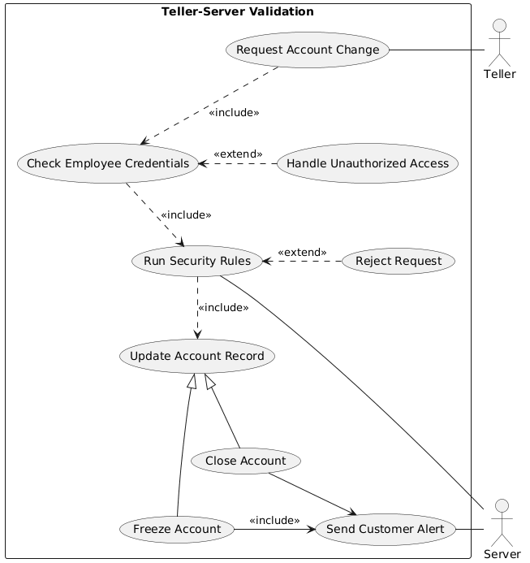
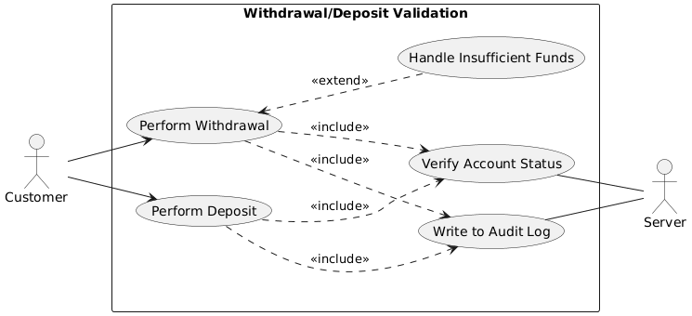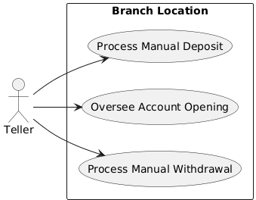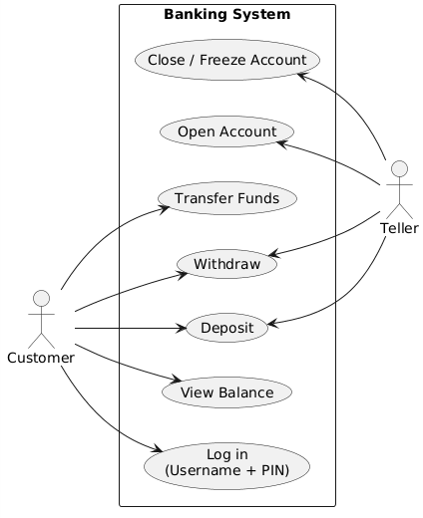

Class Diagrams
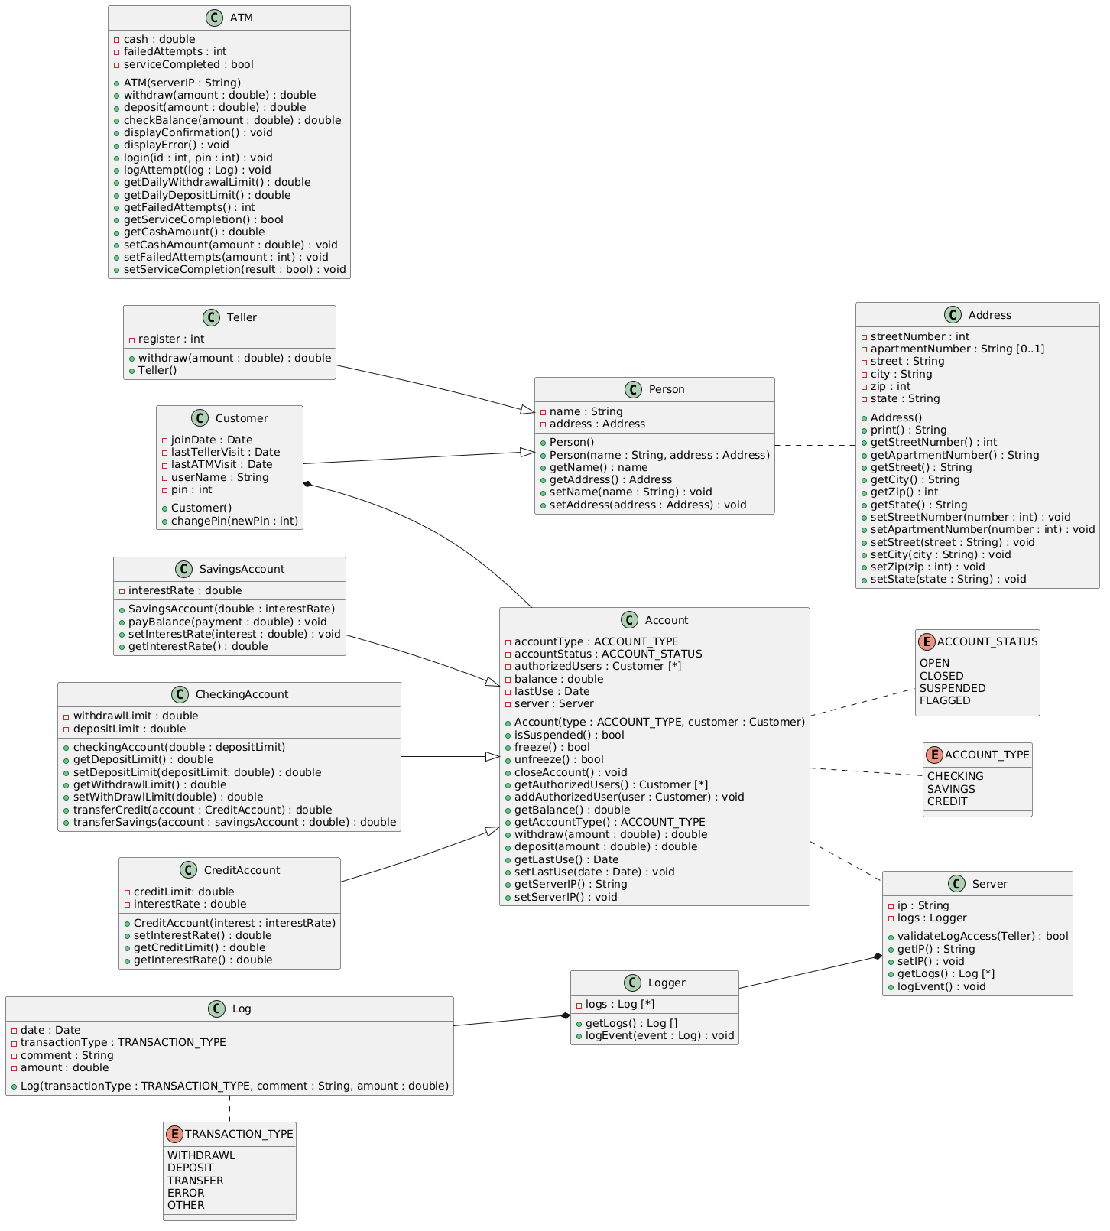

Sequence Diagrams
