Problem Description

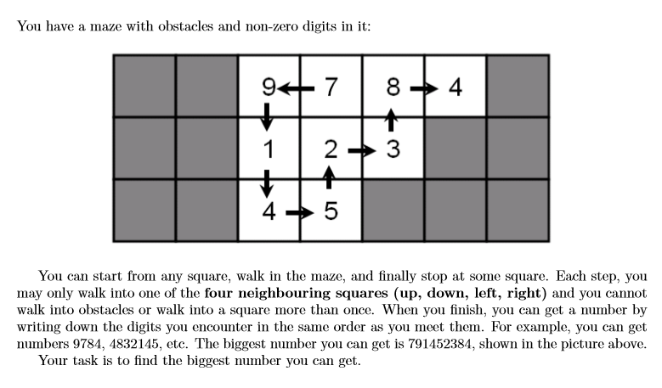

Input
There will be at most 25 test cases. Each test begins with two integers R and C (2 ≤ R,C ≤ 15, R∗C ≤ 30), the number of rows and columns of the maze. The next R rows represent the maze. Each line contains exactly C characters (without leading or trailing spaces), each of them will be either ‘#’ or one of the nine non-zero digits. There will be at least one non-obstacle squares (i.e. squares with a non-zero digit in it) in the maze. The input is terminated by a test case with R = C = 0, you should not process it.

Output
For each test case, print the biggest number you can ﬁnd, on a single line.

Sample Input
3 7
##9784#
##123##
##45###
0 0

Sample Output
791452384

