**Team**Cool Bananas

*Assignment One:*

***3-D Game (Alpha)***

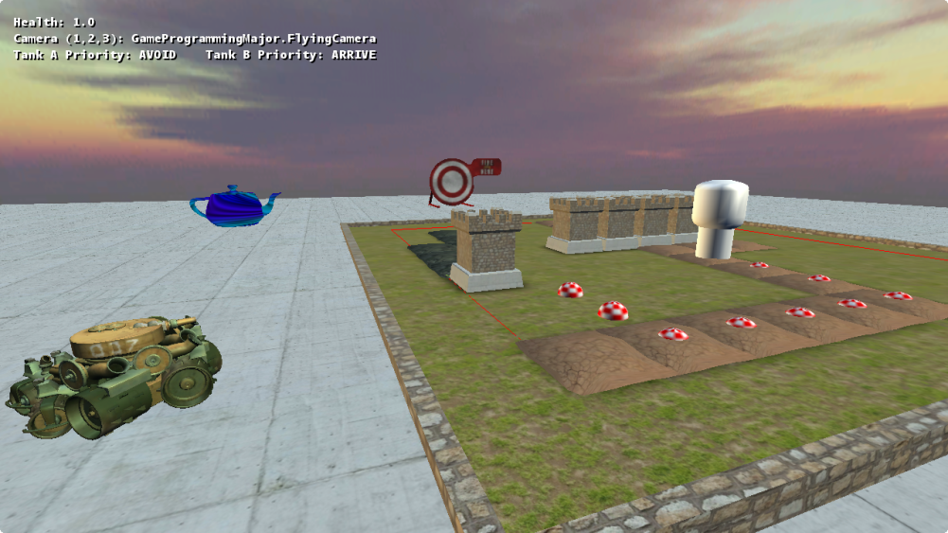

**Team Members:**

**11688025** – Deinyon Davies

**11685740** – Daniel Nelson

**11697822** – Matthew Wale

**11729631** – Jesse Walker

**Introduction**

Welcome to **Cylinder Pathfinding Simulator 2014 (CPS2014)**! CPS2014 shall become a fantasy-themed tower-defence styled game in which the player must stop enemies from destroying their home base. As a prototype, the game works more as a technical demonstration, though it exhibits many of the fundamental algorithms required to continue development.

**Controls**

|  |  |
| --- | --- |
| **Operation** | **Action** |
| Mouse Movement | *In FPS and Flying modes:* Rotate the camera |
| Left Mouse | Fire a projectile **or** place a Wall Tower in the Pathfinding Sandbox |
| Right Mouse | Pathfind to the selected block in the Pathfinding Sandbox |
| Middle Mouse | *In Top-Down mode*: Press and drag to rotate the camera |
|  |  |
| W,A,S,D Keys | Translate the camera about the world |
| Spacebar | *Only in FPS Camera mode:* Have the player jump |
| Shift | Increate the translation speed of the camera or player |
|  |  |
| 1 Key | Use an FPS Camera |
| 2 Key | Use a Top-Down Camera |
| 3 Key | Use a Flying Camera |

**How to Play**

Evade the enemy tanks and their projectiles. Hide behind models in the world to distract the enemies. Use the various camera modes to place obstructive towers (left mouse button) or pathfinding waypoints (right mouse button) in the Pathfinding Sandbox. Fire projectiles at objects with the left mouse button.

**Technical Features.**

The game exhibits a three-dimensional world composed of multiple static models, non-static entities, NPC instances and a pathfinding-and-"tower placement" sandbox area. This abstraction of objects into four distinct classes allows for modular updating and drawing of each component of the game world.

The game demonstrates **two** collision response algorithms. Projectiles fired from the enemy tanks or the player, performed by the ProjectileManager, are tested for intersection against the world and the player - when an intersection occurs, a sound plays, and in the case that it intersects the player, damage is taken and the camera shakes using a Thread delegate function. Enemy tanks implement a ray-sphere intersection algorithm to compute an opposing steering force, and steer away from the nearest collision threat. The nearest collision threat is found using the ray-sphere intersection algorithm, which returns the amount that the NPC's 'eyesight' ray has intersected with the geometry.

The program plays multiple **sound effects** and an **ambience loop** using a dedicated Sound Manager class which is responsible for loading and maintaining a list of sound effects.

The project exhibits **34** distinct classes, of which some contain nested classes. A great deal of polymorphism has been employed to reduce code repetition and to greatly enhance maintainability. Development of new components is made easy by the high level of abstraction and comprehensive framework.

The player, cameras and NPC entities observe the laws of game physics through the implementation of Steering states and Kinematic physics objects. In most cases, entities within the game are translated by means of physically accurate steering forces and velocity computations.

NPCs within the demonstration employ a basic state machine and a *priority stack* to select the most appropriate steering behavior for the situation.

**Four** steering behaviors have been implemented, of which **three** are demonstrated by the two enemy tank NPCs through polymorphic steering classes. The tank usually nearest to the player will **pursue** the player with consideration to their velocity and position. The other tank will **arrive at** the pursuing NPC. Both tanks will **avoid** geometry using a collision-avoidance algorithm.

An advanced **A* Pathfinding Algorithm** has been implemented, and is demonstrated in the Pathfinding Sandbox. The algorithm uses weighted search nodes to traverse the terrain using the fastest and most logical route. It is possible to re-form the search nodes by placing new Wall Towers with the left mouse button.

A custom written HLSL shader program has been composed that generates a plasmatic per-pixel effect with the trigonometric functions, and projects the effect onto a custom model using its texture coordinates.

Having met and exceeded the project requirements, and having implemented a listed bonus feature (**A* pathfinding algorithm**), the team desires the highest grade attainable, minus the two bonus marks for an octree implementation, although we'll gladly take them, too.

The game demonstrates a number of custom models, a custom HLSL plasma shader, a projectile management system, a sound management system, and a weighted A* pathfinding algorithm.

**Peer Evaluation**

*Deinyon*: Lead Programmer, Graphics & Documentation Expansion

**Score:** 5.0

Contributed the majority of the codebase and framework, implemented collision response algorithms, designed graphics and contributed to the readme document.

*Daniel*: Designer & AI Programmer

**Score:** 5.0

Researched A* path-finding and implemented a demonstration for it. Also led design talks and contributed lab code to the project.

*Matthew*: Documentation & Administration

**Score:** 3.0

Organised and compiled elements for the read-me document.

*Jesse* : Documentation & Designer

**Score:** 3.0

Participated and helped with group discussion, contributed lab code to the project helped with elements of the read-me document.

**References**

***Tutorial & Reference:***

Amit's A* Pages 2010, *Pathfinding,* viewed 3 September 2014,   
<http://theory.stanford.edu/~amitp/GameProgramming/index.html>.

Gamedev Tuts+ 2013, *Understanding Steering Behaviors : Collision Avoidance*, viewed 4 September 2014,

<http://gamedevelopment.tutsplus.com/tutorials/understanding-steering-behaviors-collision-avoidance--gamedev-7777>.

Patrick Lester 2005, *A* Pathfinding for Beginners*, viewed ~25 August, 2014,  
<http://www.policyalmanac.org/games/aStarTutorial.htm>.

***Textures:***

Jacobo Cortés Ferreira, *Grass0139_33* (resampled), viewed 3 September 2014,  
<http://www.cgtextures.com/texview.php?id=44371&PHPSESSID=pegmiou3bj4bkrbgvc54jvna25>.

CGTextures, BrickOldRounded0298 (Resampled), viewed 3 September 2014,  
<http://www.cgtextures.com/texview.php?id=52593&PHPSESSID=j6fcl84hlqk61c723qjsdstsq4>.

CGTextures, SoilCracked0157 (Resampled), viewed 13 September 2014,  
<http://www.cgtextures.com/texview.php?id=66844&PHPSESSID=eimacm8d4ftmecu9p3642eo1b4>.

R. Boel, 2006, *Sun altitude of 5 degrees above the horizon*, Roel z'n Boel, viewed April 19 2014, <http://reije081.home.xs4all.nl/skyboxes/>.

Pokemopolis Forum, *Awesome Smiley*, viewed 13 July 2010,  
<http://captionsearch.com/pix/thumb/nqfzkzcwdr-t.png>.

***Audio:***

Valve Corporation 2004, *metal_barrel_impact_2*, sound effect, Half Life 2 Resource.

Valve Corporation 2004, *shotgun_fire6*, sound effect, Half Life 2 Resource.

Valve Corporation 2004, *smg1_fire1*, sound effect, Half Life 2 Resource.

Valve Corporation 2004, *towm_ambience*, sound effect, Half Life 2 Resource.