DATABASES COURSE

MANDATORY I

Student Group 11
Dorin Moldovan 10.09.1999

Table of Contents
Mandatory I 2
Problem Statement 2
Model Creation 2
Conceptual Model 2
Logical Model 3
Physical Model 4
Data Definition 5
Data Manipulation 7
Stored Procedures 7
Events 8
Triggers 8
Views 9
Indexes 10
Future Improvements, Mandatory 2 Preparation 10
Mandatory II 11
Updating the Database 11
Updating the DD and DM Scripts. 11

Mandatory I

Problem Statement
As I was in a small group, my idea was to create a database with fewer tables to eliminate the redundant procedures, but to include all types of relations (one to one, one to many, many to many) to show that I am able to create a backend that would facilitate the needs of a database with all the relations, especially the many to many one, as it has been tricky for me in the past. For this I chose to create a database for a university, because I don’t have any imagination and it seemed to be straighforward.

Model Creation

Conceptual Model
Started by creating the tables for the Student, Programme, Course, Teacher and Elective added some fields and some relations. Was not sure about the direction of the relations though.
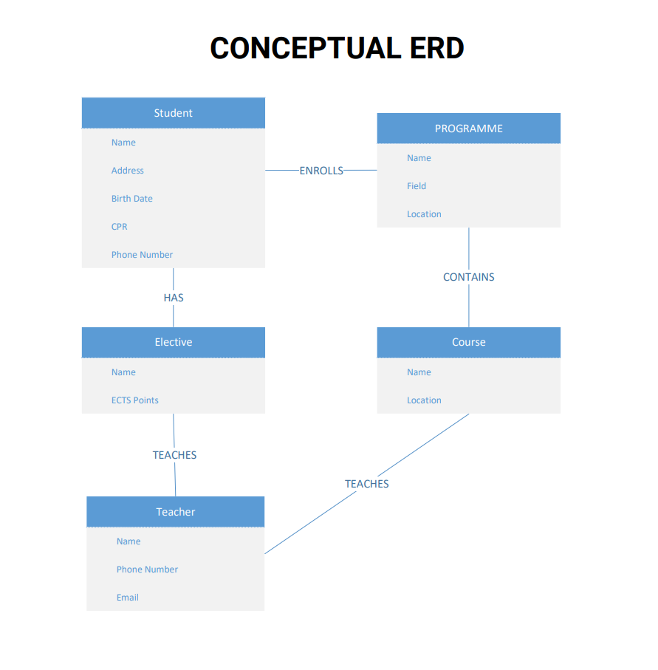

Logical Model
Moving to the Logical ERD, added the Primary and Foreign Keys, as well as updated the fields for the tables. Made the relationships using the crowfoot notation. The relationships were made by following those rules set previously by me:
A student can be enrolled in one and only one Programme.
A student can have many or no electives
A Programme can have 0 or many students
A programme can have 1 or many courses
A Course can be part of one and only one Programme
A Course can have one and only one teacher
A tacher can teach 0 or many courses
A teacher can teach 0 or many electives
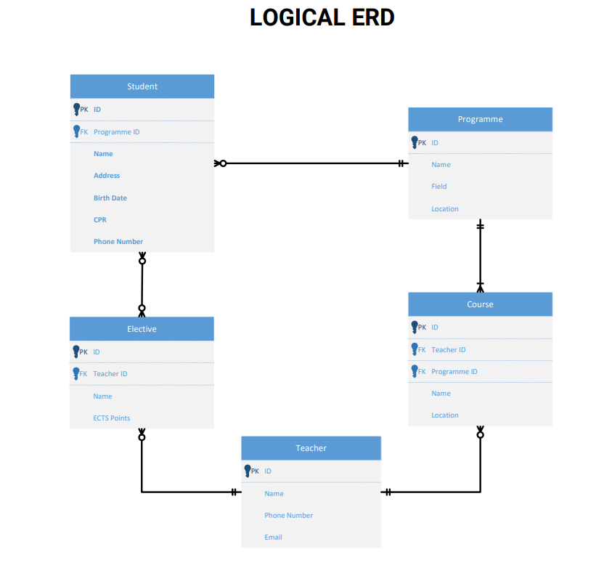

Physical Model
For the Phyisical Model, I described the specific implimentation of the Logical Model, added the junction table for the student to elective many to many relationship. All the fields got their specific types to be as realistic as possible.
There are two identifying relationships:
Student to Programme, as a student cannot exist unless he is in a program.
Course to Programme, for the same reason.
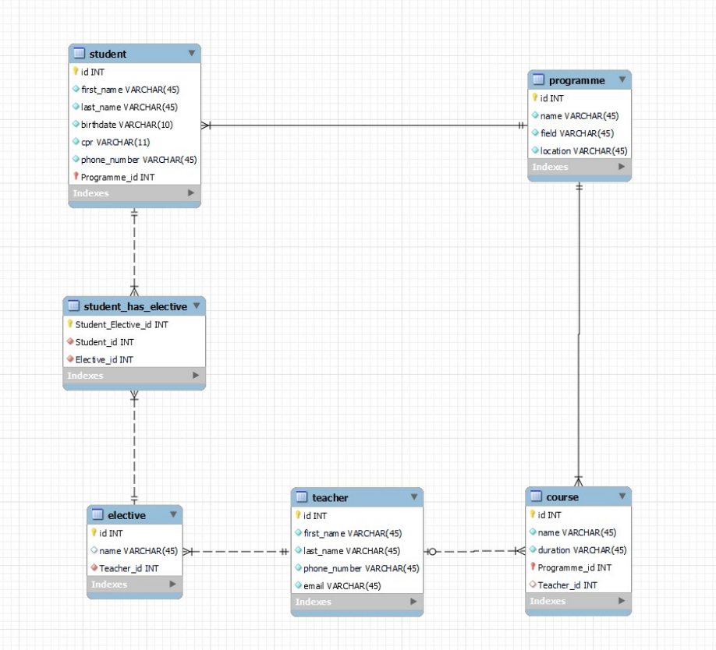

Data Definition
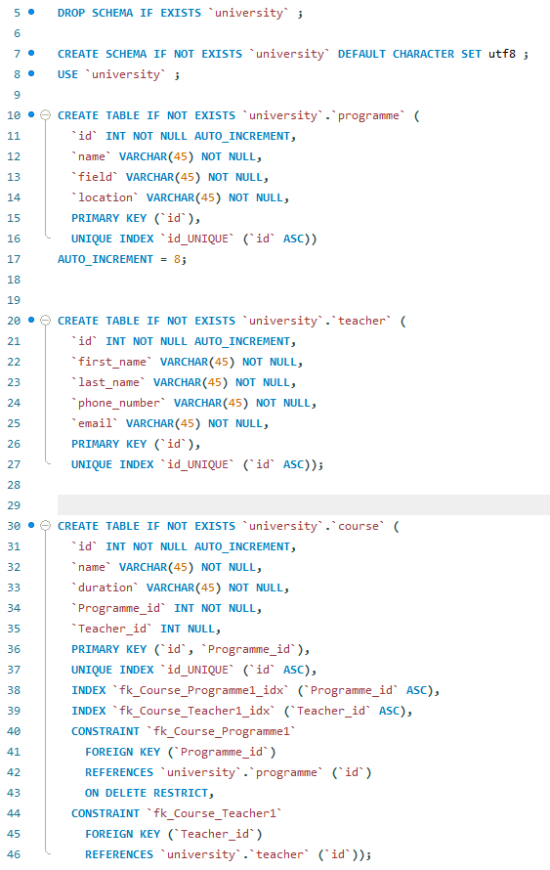
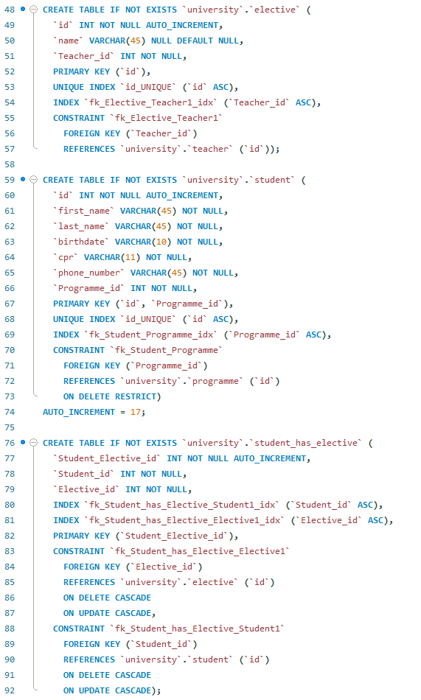

Data Manipulation
I came up with some random names, programmes and courses and inserted them into the database.
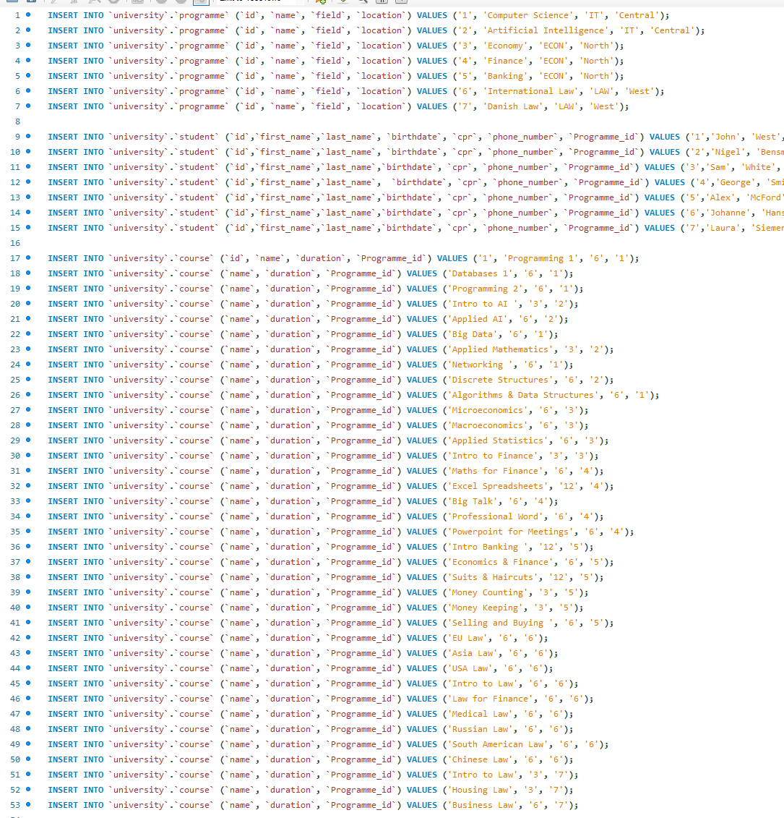
The full script can be seen on the GitHub page of the repository.

Stored Procedures

Events
For the events I thought of adding the functionality of deleting a student after he graduated, but because I did not think about it before, I had to alter the student table by adding a graduation date field.

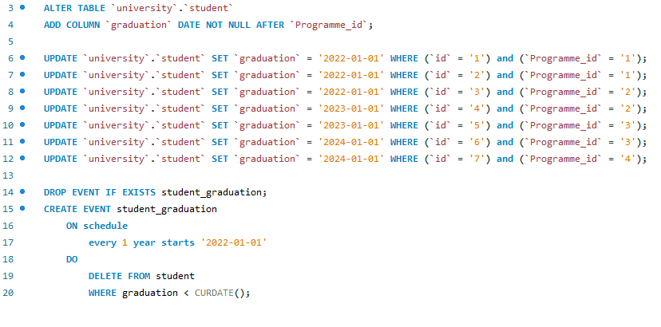
Triggers
For triggers I couldn’t come with a better idea than to trigger a count for how many students, courses, teachers and electives the university has, but because I was not sure where to store this data, I thought it would be a “great” idea to have another, unconnected table in the database, honestly I am not sure about it.
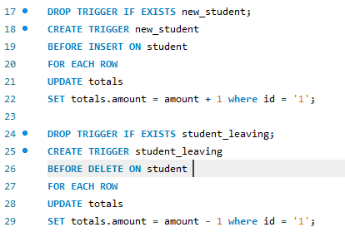
But basically whenever a new student or course is created or deleted, the count is also updated.

The additional scripts for this to work properly:

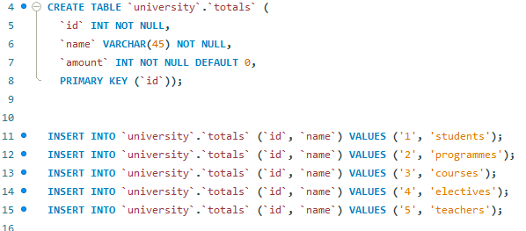
Views
I came up with the idea of two views, one for the students and the programme they are enrolled in, and one for the teachers and the courses they teach.
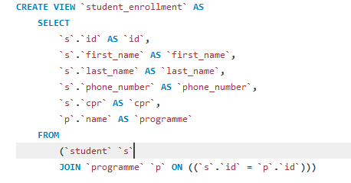
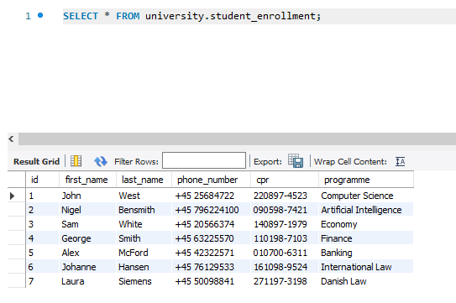

Indexes
Indexed the programme name and the course name because I think most of the queries would be to related to programme names and elective names so it would be nice for them to be retrieved faster, but will probably change or update that for the next mandatory.

Future Improvements, Mandatory 2 Preparation
Honestly, not very proud of my work. I would, If I could do it all again for the second mand. The database is a bit too simple to implement the complex stored procedures required, or maybe I don’t have enough imagination or brain power to think of them. The to do list is to find a better way to do the triggers, add a new table if needed to make use of triggers and stored procedures properly. Generally, update the database to be able to handle the feature requirements. As for login functionality, I guess the student, administration, and the teacher, in this case I would probably add grades, so the teacher could update and insert them and the student could see them, also would allow to check if a course is failed and the average grade for that course.

Mandatory II

Updating the Database
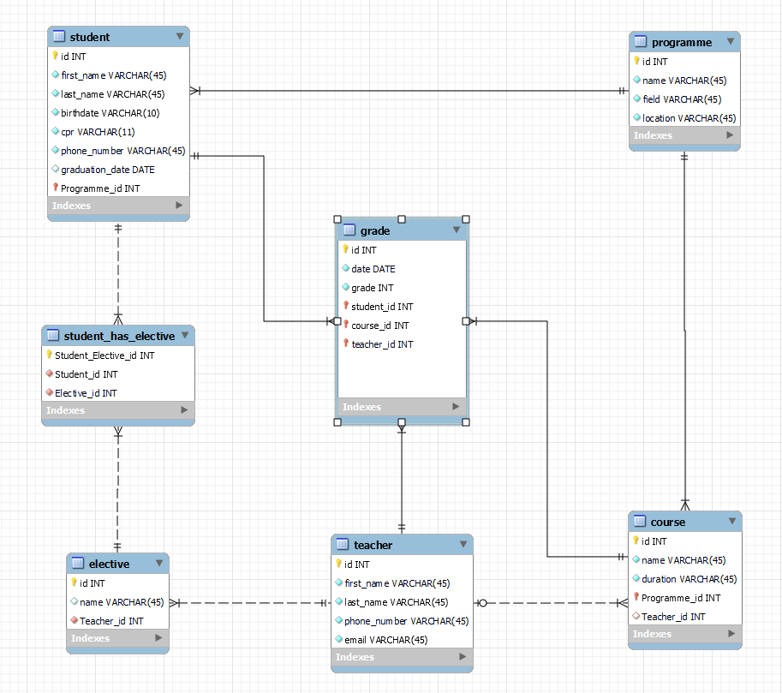
I updated the Database, added a new table ‘grade’ that will replace the ‘totals’ table in terms of the functionality of the database, and will be useful for the login in the futures, as the main changes will be done there, such as the logged in teacher adding a grade or a logged in student seeing his own grades. The Updated physical model now:
The grade cannot be created without being provided with a teacher id, a student id and a course id.

Updating the DD and DM Scripts.
The scripts have been updated to include the new table and its content, as well as the graduation date for the students.

The Backend

