HW 2

* 1. Ewha Burger tries to develop an automatic order system for its menus: It has four menus as follows:
  2. Cheese Burger: 3,000
  3. Bulgogi Burger: 3,700
  4. Fish Burger: 3,500
  5. Soda Drink: 1,200
* The order program shows its menus then prompts users to input their selections, repeatedly. As ordering menus has been finished, it shows the total pay of orders.
* Constraints:
  1. For menu prices, create and use #define.
  2. Use switch statement for conditional selection.
  3. Use “ %c” instead “%c” to get the second input after the first input is entered with a new line.
* Follow the output format of the sample run:

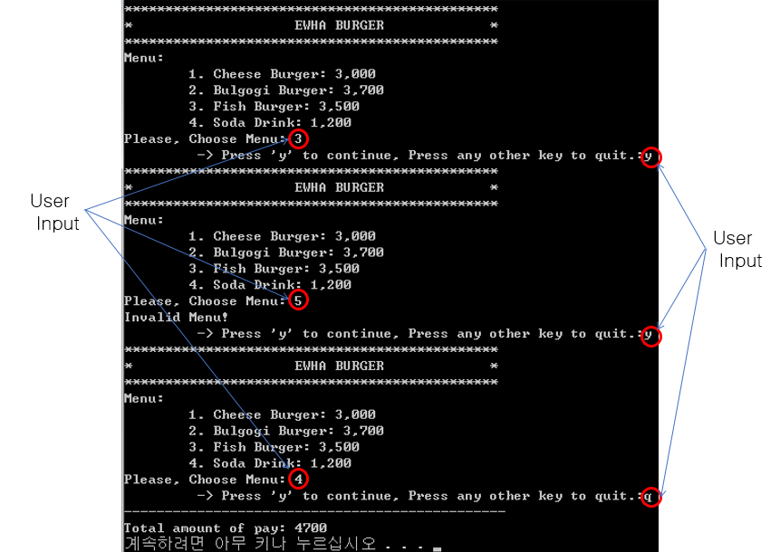

2-2

Modify previous 2-1 code using functions.

Write two functions, func_menu() and func_order().

void func_menu();

=> prints the menu on the screen.(void type)

int func_order(int);

=> receives the menu from main() and returns the price.(Use switch statement in the function)

Make a repetition in the main function.

You need to compute and print the total price in the main().

2-3

Make a program that finds the prime numbers between 1 and the input number. The program shows the result as follows.

Use the function isPrime() in Week9 Lab assignmentII.

Function isPrime() gets an integer number from the main() and returns 1 when the number is a prime number and 0 when the number is not a prime number.

Clue: Use a loop(2~ input number) and in each repetition, call the function isPrime().

prototype : int isPrime(int);

< Input and Output example >

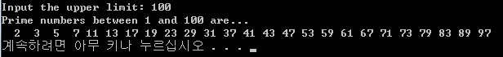

**\* Common Rules**

- File name: HW2_StudentName.zip

- Include your ID and name at the top of source code and report.

**- Never copy the other's source code. Both students will get 0 point for all assignments.**

- Add as many comments as possible for better understanding.

- Don't be Late! **Due Date :2017/11/24 00:00)**

- Submission to CyberCampus

**① .cpp source files**

**② one word/한글 파일: Screenshots of each program execution + (코딩하면서 어려웠던 점, 해결 방법, 느낀 점)**