**Use Case: Process Sale**

## Actor:Cashier

* Preconditions

1. The cashier has already logged into the point-of-sale (POS) system.
2. The POS system is successfully connected to both the catalog and inventory systems.

* Main Flow

1. The cashier begins a new sales transaction.
2. For every item in the transaction: a. The cashier scans the barcode of the item. b. The system retrieves the item's name and price from the product catalog. c. The inventory count is adjusted accordingly. d. The item is added to the ongoing transaction.
3. The system calculates the total transaction amount.
4. If the customer has a gift coupon: a. The cashier applies the coupon to the transaction. b. The system adjusts the total amount after applying the coupon.
5. The cashier informs the customer of the total due.
6. The customer selects a payment method (cash, credit card, or check).
7. The cashier processes the chosen payment method.
8. The system verifies the payment details.
9. A receipt is generated and printed by the system.
10. The transaction is closed and finalized by the system.

* Alternative Flows

**4a. Invalid coupon scenario:**

1. The system alerts the cashier that the coupon is not valid.
2. The cashier informs the customer of the invalid coupon and proceeds with the transaction from step 5.

**8a. Payment validation failure:**

1. The system notifies the cashier that the payment validation has failed.
2. The cashier requests that the customer provide a different payment method.
3. If the customer provides an alternative method, return to step 7; if not, cancel the transaction.

* Postconditions

1. The transaction is logged in the system.
2. Inventory is updated to reflect the sale.
3. The payment is successfully processed.
4. A receipt has been printed.

**Use Case: Processing a Return**

## Actor: Cashier

* Preconditions

1. The cashier is already logged into the POS system.
2. The customer possesses a valid receipt for the items they wish to return.

* Main Flow

1. The cashier begins a new return transaction.
2. The cashier either scans the receipt or manually inputs the receipt details.
3. The system fetches the original transaction information.
4. For each item being returned: a. The cashier scans the item's barcode. b. The system checks that the item matches the original transaction. c. The inventory levels are updated to reflect the return. d. The system adds the item to the ongoing return transaction.
5. The system calculates the total refund that is due.
6. The cashier confirms the return details with the customer.
7. The system processes the refund, using the same payment method as the original purchase.
8. A return receipt is generated and printed by the system.
9. The system closes and completes the return transaction.

* Alternative Flows

**2a. Receipt not found:**

1. The system alerts the cashier that the receipt is invalid or not located.
2. The cashier informs the customer that the return cannot proceed and terminates the process.

**4b. Item verification fails:**

1. The system flags the item as not matching the original transaction.
2. The cashier informs the customer and either moves to the next item or stops the return process.

**7a. Original payment method unavailable:**

1. The cashier selects a different refund option (e.g., store credit or cash).
2. The system processes the refund using the newly chosen method.

## Postconditions

1. The return is recorded in the system.
2. Inventory is updated to reflect the returned item(s).
3. The refund has been successfully processed.
4. A return receipt is printed and given to the customer.

**Identify Entity/Boundary/Control Objects**

Entity Objects:

* Item
* Inventory
* Catalog
* Payment
* Receipt
* Coupon
* User (Cashier/Administrator)
* Return

Boundary Objects:

* POS Terminal Interface
* Scanner Interface
* Payment Processing Interface
* Receipt Printer Interface

Control Objects:

* Sale Manager
* Inventory Manager
* Catalog Manager
* Payment Manager
* User Authentication Manager
* Return Manager

**Sequence Diagram:**

Process Sale Sequence Diagram

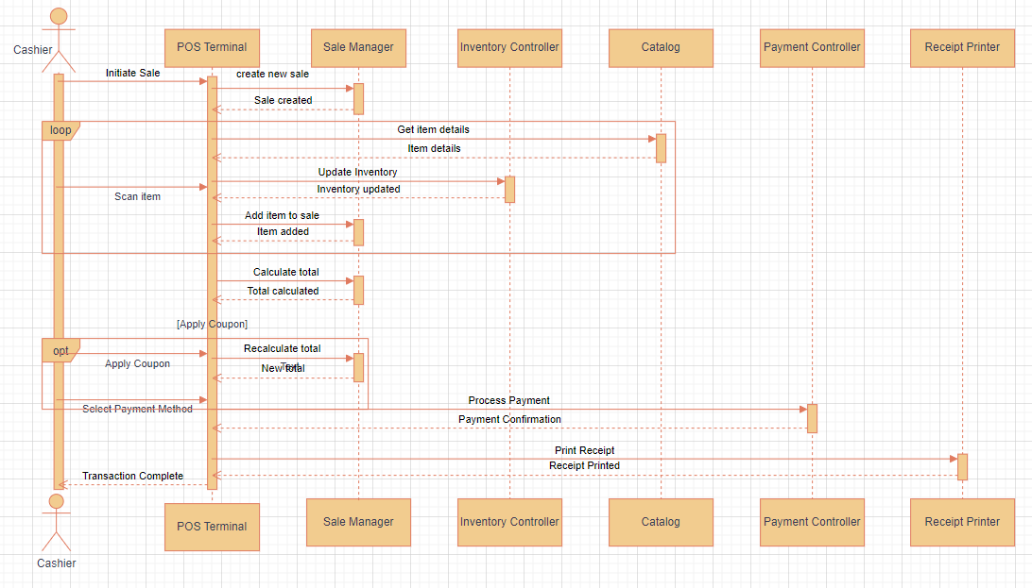

**Sequence Diagram:**

Handle Return Sequence Diagram

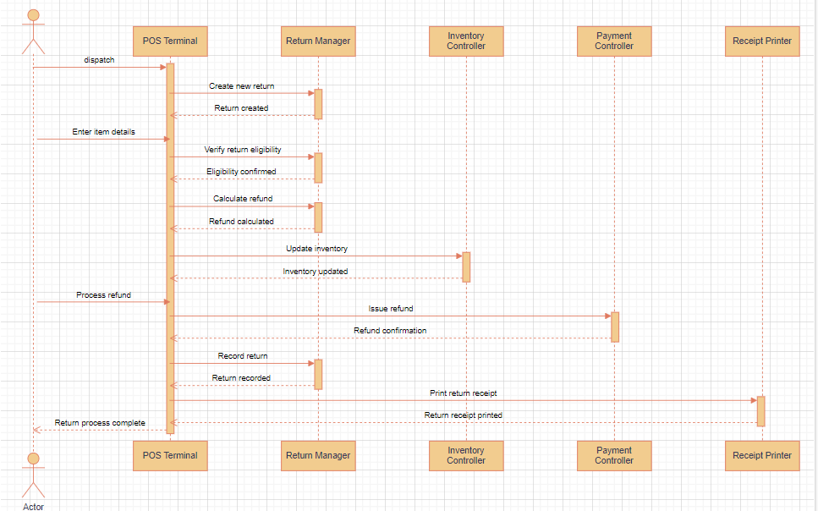

**Analysis Domain Model**

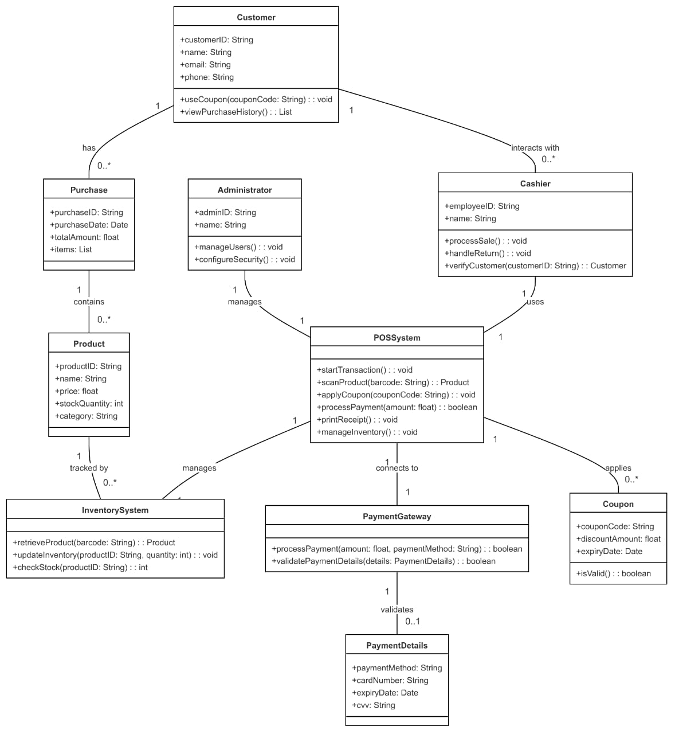

**Process Sale Activity Diagram**

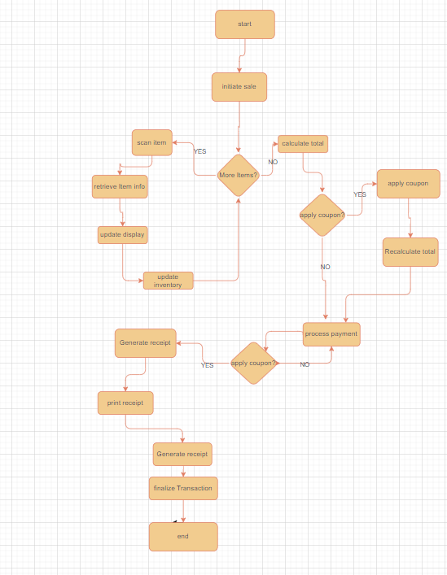

**Handle Return Activity Diagram**

