**文档信息**

|  |  |  |  |
| --- | --- | --- | --- |
| 文档版本编号: | V1.0.0 | 文档版本日期: | 2023年1月18日 |
| 起草人: | 龚长华 | 起草日期: | 2023年1月18日 |

**版本记录**

| 版本编号 | 版本日期 | 创建/修改 | 说明 |
| --- | --- | --- | --- |
| V1.0.0 | 2023-01-18 | 龚长华 | 初稿 |
| V1.0.1 | 2023-01-30 | 龚长华 | DataSource/RuntimeBatchRequest  添加_data_dt变量 |
| V1.1.0 | 2023-01-31 | 龚长华 | 增加custom_actions.py打通短信通路 |
| V1.2.0 | 2023-01-31 | 龚长华 | 调整7.4适配GE工作空间 |

# 文档目的

为数据开发人员、数据质量管理人员执行质量管理行为提供指导性说明。

# 背景

当前应用在生产环境的质量管理组件为Apache Griffin，其存在度量不丰富、与其他组件集成困难、社区不活跃等问题。经过调研，选用Great Expectations（以下简称GE）作为大数据平台的通用质量管理套件。

# 目标

1. 安装GE质量管理组件；
2. GE与Datahub治理中心集成；
3. GE与Airflow调度中心集成；
4. 使用GE完成Iceberg表度量，并将结果推送至Datahub。

# 范围

GE套件仅适用批处理环境（包括微批），不适用于实时处理环境。

# 安装说明

## 环境说明

|  |  |  |  |
| --- | --- | --- | --- |
| 环境 | 版本 | 部署路径 | 服务器IP |
| 研发 | 0.15.28 | /hdp_data/gch/venv/great_expectations | 88.88.16.189 |
| 生产 | 0.15.28 | /hdp_data/gch/venv/great_expectations | 10.50.253.6 |

表 1 - GE部署环境说明

## 前提条件

Python需要3.7~3.10版本。当前生产环境版本为3.9.14，可通过如下命令查看Python版本。

python --version

Python 3.9.14

## 安装步骤

1. 在研发环境/hdp_data/gch/venv/目录下，创建Python虚拟环境

python -m venv great_expectations

1. 激活虚拟环境，并安装GE

source /hdp_data/gch/venv/great_expectations/bin/activate

pip install great_expectations

pip install pyspark==3.0.1

注：pyspark为通过spark连接iceberg数据源，版本号必须为3.0.1。

1. 验证安装

great_expectations --version

great_expectations, version 0.15.28

至此，GE安装成功。

1. 使用附录中configurator_dev.py文件替换lib目录下configurator.py文件，路径：

/hdp_data/gch/venv/great_expectations/lib/python3.9/site-packages/great_expectations/checkpoint/configurator.py

1. 将custom_actions.py文件，放在路径下：

/hdp_data/gch/venv/great_expectations/great_expectations/plugins

1. 将虚拟环境整体打包，复制到生产环境并解压，注意保持部署路径一致，否则导致虚拟环境不可用。

# 升级说明

1. 在5.3安装步骤基础上，升级GE。

source /hdp_data/gch/venv/great_expectations/bin/activate

pip install --upgrade great_expectations==0.15.43

1. 升级后，注意比较configurator_dev.py文件与

/hdp_data/gch/venv/great_expectations/lib/python3.9/site-packages/great_expectations/checkpoint/configurator.py文件差异，无问题再行替换。

1. 将custom_actions.py文件，放在路径下：

/hdp_data/gch/venv/great_expectations/great_expectations/plugins

验证安装成功。

great_expectations --version

此处应输出升级后的版本号，0.15.43.

1. 将虚拟环境整体打包，复制到生产环境并解压，注意保持部署路径一致，则导致虚拟环境不可用。

# 使用说明

## 初始化GE工作空间

为GE创建工作空间，GE在工作空间存储和读取项目所需的各项配置。在激活虚拟环境后，使用如下命令初始化GE环境。

great_expectations init

执行完毕后，会生成对应的目录。

(great_expectations) [root@namenode1 great_expectations]# pwd

/hdp_data/gch/venv/great_expectations/great_expectations

(great_expectations) [root@namenode1 great_expectations]# ls

checkpoints expectations great_expectations.yml plugins profilers uncommitted

* great_expectations.yml为顶层配置文件，目前尚未配置
* checkpoints为checkpoint目录，保存checkpoint配置
* expectations为expectation目录，保存度量标准
* plugins为插件目录，可扩展插件保存此处
* profilers为profiler目录，目前尚未使用到
* uncommitted为文档存储目录，存储经过渲染易读的度量报告，可下载到本地使用浏览器打开index.html浏览报告

## 生成度量依据（标准）

初始化GE工作空间后，借助Data Assistant结合已存数据生成度量标准。

import os

import pyspark

from great_expectations.core import ExpectationSuite

from great_expectations.core.batch import RuntimeBatchRequest

from great_expectations.core.util import get_or_create_spark_application

from ruamel import yaml

import great_expectations as ge

from great_expectations.data_context.data_context import DataContext

os.environ["PYSPARK_PYTHON"] = "/usr/local/bin/python3"

os.environ["PYSPARK_DRIVER_PYTHON"] = "/usr/local/bin/python3"

# Settings

# Table name to profile

table_name = "hadoop_catalog.sdm.s_tft_ups_dc_trip_order"

data_dt = "20230116" # 如果是非分区表，则置为空串

# Columns to profile

include_column_names = ["update_time", "coupon_use_status", "pay_type"]

# datahub_schema and datahub_dataset fields to emit to datahub

datahub_schema = table_name.split(".")[1]

datahub_dataset = app_name = table_name.split(".")[2]

# If Spark type is decimal, raise errors when computing mean. In details, refer to https://github.com/great-expectations/great_expectations/issues/6393

expectation_suite_name = table_name.replace(".", "_")

checkpoint_name = table_name.replace(".", "_")

# Construct a Spark Dataframe

spark_conf = {

"spark.sql.extensions": "org.apache.iceberg.spark.extensions.IcebergSparkSessionExtensions",

"spark.sql.catalog.hadoop_catalog": "org.apache.iceberg.spark.SparkCatalog",

"spark.sql.catalog.hadoop_catalog.type": "hadoop",

"spark.sql.debug.maxToStringFields": "100",

"spark.sql.catalog.hadoop_catalog.warehouse": "hdfs:///hadoop_catalog",

"spark.sql.sources.partitionOverwriteMode": "dynamic",

"spark.sql.adaptive.enabled": "true",

"spark.sql.adaptive.coalescePartitions.enabled": "true",

"spark.sql.adaptive.localShuffleReader.enabled": "true",

"spark.sql.adaptive.advisoryPartitionSizeInBytes": "128M",

"spark.sql.adaptive.coalescePartitions.minPartitionNum": "1",

"spark.sql.shuffle.partitions": "200",

"spark.jars": "hdfs:///spark_tool/jars/iceberg-spark3-runtime-0.11.1.jar",

"spark.app.name": app_name + "_ge",

"spark.master": "spark://namenode1:7077,namenode2:7077",

"spark.cores.max": "1",

"spark.executor.memory": "2G",

"spark.executor.cores": "1"

}

spark_session: pyspark.sql.session.SparkSession = (

get_or_create_spark_application(spark_conf, True)

)

# RuntimeBatchRequest with batch_data as Spark Dataframe

# noinspection SqlDialectInspection,SqlNoDataSourceInspection

sql = "select {} from {} where data_dt = '{}'".format(",".join(include_column_names), table_name,

data_dt) if data_dt else \

"select * from {}".format(",".join(include_column_names), table_name)

df: pyspark.sql.dataframe.DataFrame = spark_session.sql(sql)

# Prerequisites: Init a ge context via great_expectations init

context: DataContext = ge.get_context()

yaml = yaml.YAML(typ="safe")

# Create a expectation suite by context

context.create_expectation_suite(

expectation_suite_name=expectation_suite_name,

overwrite_existing=True

)

suite: ExpectationSuite = context.get_expectation_suite(

expectation_suite_name=expectation_suite_name

)

# Create a datasource

#########################################

# Ensure all datasource using force_reuse_spark_context option which is true, otherwise error `'NoneType' object has no attribute 'setCallSite'` occurs,

# refer to https://github.com/great-expectations/great_expectations/issues/4812

#########################################

datasource_yaml = f"""

name: spark_iceberg_datasource

class_name: Datasource

module_name: great_expectations.datasource

execution_engine:

module_name: great_expectations.execution_engine

class_name: SparkDFExecutionEngine

force_reuse_spark_context: true

data_connectors:

my_runtime_data_connector:

class_name: RuntimeDataConnector

batch_identifiers:

- datahub_schema

- datahub_dataset

- datahub_datadt

"""

context.add_datasource(**yaml.load(datasource_yaml))

# Datasource spark_iceberg_datasource has been added ago

runtime_batch_request = RuntimeBatchRequest(

datasource_name="spark_iceberg_datasource",

data_connector_name="my_runtime_data_connector",

data_asset_name=table_name,

runtime_parameters={"batch_data": df},

batch_identifiers={

"datahub_schema": datahub_schema,

"datahub_dataset": datahub_dataset,

"datahub_datadt": data_dt,

},

)

validator = context.get_validator(

batch_request=runtime_batch_request,

expectation_suite_name=expectation_suite_name

)

# Sample some rows

column_names = [f'"{column_name}"' for column_name in validator.columns()]

print(f"Columns: {', '.join(column_names)}.")

print(validator.head(n_rows=5, fetch_all=False))

# Create a expectation suite

expectation_suite = context.create_expectation_suite(

expectation_suite_name=expectation_suite_name, overwrite_existing=True

)

# Profile

data_assistant_result = context.assistants.onboarding.run(

batch_request=runtime_batch_request,

include_column_names=include_column_names

)

validator.expectation_suite = data_assistant_result.get_expectation_suite(

expectation_suite_name=expectation_suite_name

)

# Save the expectation suite

validator.save_expectation_suite(discard_failed_expectations=False)

checkpoint_yaml_config = f"""

name: {checkpoint_name}

config_version: 1.0

class_name: SimpleCheckpoint

run_name_template: '%Y%m%d-%H%M%S-{datahub_dataset}'

expectation_suite_name: {expectation_suite_name}

action_list:

- name: datahub_action

action:

module_name: datahub.integrations.great_expectations.action

class_name: DataHubValidationAction

server_url: http://10.50.253.9:8080

"""

context.add_checkpoint(**yaml.load(checkpoint_yaml_config))

上述脚本借助Data Assistant创建度量标准，并生成expectation和checkpoint。

标红部分为需要修改部分，生产环境中的运行路径：

/hdp_data/gch/venv/great_expectations/prepare/create_expectation_and_checkpoint.py

注意：当前GE不支持类型为Decimal的数据类型，在配置include_column_names时需将Decimal类型字段剔除，

参考https://github.com/great-expectations/great_expectations/issues/6393

按需配置后，执行create_expectation_and_checkpoint.py脚本。

source bin/activate

cd prepare/

python create_expectation_and_checkpoint.py

最后输出度量依据。

(great_expectations) [root@namenode1 prepare]# python create_expectation_and_checkpoint.py

23/01/17 15:36:05 WARN util.NativeCodeLoader: Unable to load native-hadoop library for your platform... using builtin-java classes where applicable

Setting default log level to "WARN".

To adjust logging level use sc.setLogLevel(newLevel). For SparkR, use setLogLevel(newLevel).

23/01/17 15:36:06 WARN util.Utils: Service 'SparkUI' could not bind on port 4040. Attempting port 4041.

/hdp_data/gch/venv/great_expectations/lib/python3.9/site-packages/pyspark/sql/context.py:75: DeprecationWarning: Deprecated in 3.0.0. Use SparkSession.builder.getOrCreate() instead.

warnings.warn(

Calculating Metrics: 50%|██████████████████████████████████████████████████████████████████▌ Calculating Metrics: 50%|██████████████████████████████████████████████████████████████████▌ Calculating Metrics: 100%|█████████████████████████████████████████████████████████████████████████████████Calculating Metrics: 100%|█████████████████████████████████████████████████████████████████████████████████Calculating Metrics: 100%|█████████████████████████████████████████████████████████████████████████████████Calculating Metrics: 100%|█████████████████████████████████████████████████████████████████████████████████████████████████████████████████████████████████████| 2/2 [00:00<00:00, 24.67it/s]

Columns: "update_time", "coupon_use_status", "pay_type".

Calculating Metrics: 100%|█████████████████████████████████████████████████████████████████████████████████]Calculating Metrics: 100%|█████████████████████████████████████████████████████████████████████████████████Calculating Metrics: 100%|█████████████████████████████████████████████████████████████████████████████████Calculating Metrics: 100%|█████████████████████████████████████████████████████████████████████████████████Calculating Metrics: 100%|█████████████████████████████████████████████████████████████████████████████████████████████████████████████████████████████████████| 1/1 [00:05<00:00, 5.88s/it]

update_time coupon_use_status pay_type

0 2023-01-16 19:15:09 1 TFT_PAY

1 2023-01-16 18:55:40 1 CCB_DCEP_WALLET

2 2023-01-16 18:17:43 1 CCB_DCEP_WALLET

3 2023-01-16 18:55:59 1 CCB_DCEP_WALLET

4 2023-01-16 22:50:44 1 CCB_DCEP_WALLET

Generating Expectations: 0%| | 0/8 [00:00<?, ?it/s]

Profiling Dataset: 0%| | 0/1 [00:00<?, ?it/s]

Calculating Metrics: 50%|█████████████████████████████████████

.......

Generating Expectations: 100%|███████████████████████████████████████████████████████████████████████████████Generating Expectations: 100%|███████████████████████████████████████████████████████████████████████████████ ██████████████████████████████████████████████████| 8/8 [00:23<00:00, 2.93s/it]

一般来说，使用Data Assistant生成的度量标准，基本不符合使用要求，需优化或补充。

## 优化度量依据（标准）

### 优化前的度量标准

在优化度量标准前，必须了解GE的度量标准有哪些，官方链接：

<https://greatexpectations.io/expectations/>。进入expectations目录，修改度量标准。

(great_expectations) [root@namenode1 expectations]# pwd

/hdp_data/gch/venv/great_expectations/great_expectations/expectations

(great_expectations) [root@namenode1 expectations]# ls

hadoop_catalog_sdm_s_tft_tsm_t_trade.json hadoop_catalog_sdm_s_tft_ups_dc_trip_order.json

# hadoop_catalog_sdm_s_tft_ups_dc_trip_order.json

{

"data_asset_type": null,

"expectation_suite_name": "hadoop_catalog_sdm_s_tft_ups_dc_trip_order",

"expectations": [

{

"expectation_type": "expect_table_row_count_to_be_between",

"kwargs": {

"max_value": 17980,

"min_value": 17980

}, # 期望数据集的最小记录数和最大记录数，需要调整

"meta": {

"profiler_details": {

"metric_configuration": {

"domain_kwargs": {},

"metric_dependencies": null,

"metric_name": "table.row_count",

"metric_value_kwargs": null

},

"num_batches": 1

}

}

},

{

"expectation_type": "expect_table_columns_to_match_set",

"kwargs": {

"column_set": [

"coupon_use_status",

"pay_type",

"update_time"

],

"exact_match": null

},

"meta": {

"profiler_details": {

"success_ratio": 1.0

}

}

},

{

"expectation_type": "expect_column_values_to_not_be_null",

"kwargs": {

"column": "update_time"

},

"meta": {

"profiler_details": {

"metric_configuration": {

"domain_kwargs": {

"column": "update_time"

},

"metric_dependencies": null,

"metric_name": "column_values.nonnull.unexpected_count",

"metric_value_kwargs": null

},

"num_batches": 1

}

}

},

{

"expectation_type": "expect_column_values_to_not_be_null",

"kwargs": {

"column": "coupon_use_status"

},

"meta": {

"profiler_details": {

"metric_configuration": {

"domain_kwargs": {

"column": "coupon_use_status"

},

"metric_dependencies": null,

"metric_name": "column_values.nonnull.unexpected_count",

"metric_value_kwargs": null

},

"num_batches": 1

}

}

},

{

"expectation_type": "expect_column_values_to_not_be_null",

"kwargs": {

"column": "pay_type"

},

"meta": {

"profiler_details": {

"metric_configuration": {

"domain_kwargs": {

"column": "pay_type"

},

"metric_dependencies": null,

"metric_name": "column_values.nonnull.unexpected_count",

"metric_value_kwargs": null

},

"num_batches": 1

}

}

},

{

"expectation_type": "expect_column_min_to_be_between", # 该度量删除

"kwargs": {

"column": "update_time",

"max_value": "2023-01-16T00:00:40",

"min_value": "2023-01-16T00:00:40",

"strict_max": false,

"strict_min": false

},

"meta": {

"profiler_details": {

"metric_configuration": {

"domain_kwargs": {

"column": "update_time"

},

"metric_dependencies": null,

"metric_name": "column.min",

"metric_value_kwargs": null

},

"num_batches": 1

}

}

},

{

"expectation_type": "expect_column_max_to_be_between", # 该度量删除

"kwargs": {

"column": "update_time",

"max_value": "2023-01-16T23:56:43",

"min_value": "2023-01-16T23:56:43",

"strict_max": false,

"strict_min": false

},

"meta": {

"profiler_details": {

"metric_configuration": {

"domain_kwargs": {

"column": "update_time"

},

"metric_dependencies": null,

"metric_name": "column.max",

"metric_value_kwargs": null

},

"num_batches": 1

}

}

},

{

"expectation_type": "expect_column_values_to_be_between", # 该度量删除

"kwargs": {

"column": "update_time",

"max_value": "2023-01-16T23:56:43",

"min_value": "2023-01-16T00:00:40",

"mostly": 1.0,

"strict_max": false,

"strict_min": false

},

"meta": {

"profiler_details": {

"column_max_values_range_estimator": {

"metric_configuration": {

"domain_kwargs": {

"column": "update_time"

},

"metric_dependencies": null,

"metric_name": "column.max",

"metric_value_kwargs": null

},

"num_batches": 1

},

"column_min_values_range_estimator": {

"metric_configuration": {

"domain_kwargs": {

"column": "update_time"

},

"metric_dependencies": null,

"metric_name": "column.min",

"metric_value_kwargs": null

},

"num_batches": 1

}

}

}

},

{

"expectation_type": "expect_column_value_lengths_to_be_between",

"kwargs": {

"column": "coupon_use_status",

"max_value": 1,

"min_value": 1,

"mostly": 1.0,

"strict_max": false,

"strict_min": false

},

"meta": {

"profiler_details": {

"column_max_length_range_estimator": {

"metric_configuration": {

"domain_kwargs": {

"column": "coupon_use_status"

},

"metric_dependencies": null,

"metric_name": "column_values.length.max",

"metric_value_kwargs": null

},

"num_batches": 1

},

"column_min_length_range_estimator": {

"metric_configuration": {

"domain_kwargs": {

"column": "coupon_use_status"

},

"metric_dependencies": null,

"metric_name": "column_values.length.min",

"metric_value_kwargs": null

},

"num_batches": 1

}

}

}

},

{

"expectation_type": "expect_column_values_to_match_regex",

"kwargs": {

"column": "coupon_use_status",

"mostly": 1.0,

"regex": "(?:[A-Fa-f0-9]){0,4}(?: ?:? ?(?:[A-Fa-f0-9]){0,4}){0,7}"

},

"meta": {

"profiler_details": {

"evaluated_regexes": {

"(?:25[0-5]|2[0-4]\\d|[01]\\d{2}|\\d{1,2})(?:.(?:25[0-5]|2[0-4]\\d|[01]\\d{2}|\\d{1,2})){3}": 0.0,

"(?:[A-Fa-f0-9]){0,4}(?: ?:? ?(?:[A-Fa-f0-9]){0,4}){0,7}": 1.0,

"-?\\d+": 1.0,

"-?\\d+(?:\\.\\d*)?": 1.0,

"<\\/?(?:p|a|b|img)(?: \\/)?>": 0.0,

"[A-Za-z0-9\\.,;:!?()\\\"'%\\-]+": 1.0,

"\\b[0-9a-fA-F]{8}\\b-[0-9a-fA-F]{4}-[0-5][0-9a-fA-F]{3}-[089ab][0-9a-fA-F]{3}-\\b[0-9a-fA-F]{12}\\b ": 0.0,

"\\d+": 1.0,

"\\s+$": 0.0,

"^\\s+": 0.0,

"https?:\\/\\/(?:www\\.)?[-a-zA-Z0-9@:%._\\+~#=]{2,255}\\.[a-z]{2,6}\\b(?:[-a-zA-Z0-9@:%_\\+.~#()?&//=]*)": 0.0

},

"success_ratio": 1.0

}

}

},

{

"expectation_type": "expect_column_value_lengths_to_be_between",

"kwargs": {

"column": "pay_type",

"max_value": 17,

"min_value": 7,

"mostly": 1.0,

"strict_max": false,

"strict_min": false

},

"meta": {

"profiler_details": {

"column_max_length_range_estimator": {

"metric_configuration": {

"domain_kwargs": {

"column": "pay_type"

},

"metric_dependencies": null,

"metric_name": "column_values.length.max",

"metric_value_kwargs": null

},

"num_batches": 1

},

"column_min_length_range_estimator": {

"metric_configuration": {

"domain_kwargs": {

"column": "pay_type"

},

"metric_dependencies": null,

"metric_name": "column_values.length.min",

"metric_value_kwargs": null

},

"num_batches": 1

}

}

}

},

{

"expectation_type": "expect_column_values_to_match_regex",

"kwargs": {

"column": "pay_type",

"mostly": 1.0,

"regex": "(?:[A-Fa-f0-9]){0,4}(?: ?:? ?(?:[A-Fa-f0-9]){0,4}){0,7}"

},

"meta": {

"profiler_details": {

"evaluated_regexes": {

"(?:25[0-5]|2[0-4]\\d|[01]\\d{2}|\\d{1,2})(?:.(?:25[0-5]|2[0-4]\\d|[01]\\d{2}|\\d{1,2})){3}": 0.0,

"(?:[A-Fa-f0-9]){0,4}(?: ?:? ?(?:[A-Fa-f0-9]){0,4}){0,7}": 1.0,

"-?\\d+": 0.0,

"-?\\d+(?:\\.\\d*)?": 0.0,

"<\\/?(?:p|a|b|img)(?: \\/)?>": 0.0,

"[A-Za-z0-9\\.,;:!?()\\\"'%\\-]+": 1.0,

"\\b[0-9a-fA-F]{8}\\b-[0-9a-fA-F]{4}-[0-5][0-9a-fA-F]{3}-[089ab][0-9a-fA-F]{3}-\\b[0-9a-fA-F]{12}\\b ": 0.0,

"\\d+": 0.0,

"\\s+$": 0.0,

"^\\s+": 0.0,

"https?:\\/\\/(?:www\\.)?[-a-zA-Z0-9@:%._\\+~#=]{2,255}\\.[a-z]{2,6}\\b(?:[-a-zA-Z0-9@:%_\\+.~#()?&//=]*)": 0.0

},

"success_ratio": 1.0

}

}

},

{

"expectation_type": "expect_column_values_to_be_in_set",

"kwargs": {

"column": "coupon_use_status",

"mostly": 1.0,

"value_set": [

"0",

"1"

]

},

"meta": {

"profiler_details": {

"metric_configuration": {

"domain_kwargs": {

"column": "coupon_use_status"

},

"metric_dependencies": null,

"metric_name": "column.distinct_values",

"metric_value_kwargs": null

},

"num_batches": 1,

"parse_strings_as_datetimes": false

}

}

},

{

"expectation_type": "expect_column_unique_value_count_to_be_between",

"kwargs": {

"column": "coupon_use_status",

"max_value": 2,

"min_value": 2,

"strict_max": false,

"strict_min": false

},

"meta": {

"profiler_details": {

"metric_configuration": {

"domain_kwargs": {

"column": "coupon_use_status"

},

"metric_dependencies": null,

"metric_name": "column.distinct_values.count",

"metric_value_kwargs": null

},

"num_batches": 1

}

}

},

{

"expectation_type": "expect_column_proportion_of_unique_values_to_be_between",# 该度量删除

"kwargs": {

"column": "coupon_use_status",

"max_value": 0.00011123470522803115,

"min_value": 0.00011123470522803115,

"strict_max": false,

"strict_min": false

},

"meta": {

"profiler_details": {

"metric_configuration": {

"domain_kwargs": {

"column": "coupon_use_status"

},

"metric_dependencies": null,

"metric_name": "column.unique_proportion",

"metric_value_kwargs": null

},

"num_batches": 1

}

}

},

{

"expectation_type": "expect_column_values_to_be_in_set",

"kwargs": {

"column": "pay_type",

"mostly": 1.0,

"value_set": [

"CMB_SUB_WALLET",

"TFT_WALLET",

"ALI_FAST",

"BOC_DCEP_WALLET",

"CCB_SUB_WALLET",

"ICBC_SUB_WALLET",

"WX_FAST",

"BOC_SUB_WALLET",

"BCM_SUB_WALLET",

"CCB_DCEP_WALLET",

"WEBANK_SUB_WALLET",

"UNION_PAY",

"TFT_PAY"

]

},

"meta": {

"profiler_details": {

"metric_configuration": {

"domain_kwargs": {

"column": "pay_type"

},

"metric_dependencies": null,

"metric_name": "column.distinct_values",

"metric_value_kwargs": null

},

"num_batches": 1,

"parse_strings_as_datetimes": false

}

}

},

{

"expectation_type": "expect_column_unique_value_count_to_be_between",

"kwargs": {

"column": "pay_type",

"max_value": 13,

"min_value": 13,

"strict_max": false,

"strict_min": false

},

"meta": {

"profiler_details": {

"metric_configuration": {

"domain_kwargs": {

"column": "pay_type"

},

"metric_dependencies": null,

"metric_name": "column.distinct_values.count",

"metric_value_kwargs": null

},

"num_batches": 1

}

}

},

{

"expectation_type": "expect_column_proportion_of_unique_values_to_be_between",#该度量删除

"kwargs": {

"column": "pay_type",

"max_value": 0.0007230255839822024,

"min_value": 0.0007230255839822024,

"strict_max": false,

"strict_min": false

},

"meta": {

"profiler_details": {

"metric_configuration": {

"domain_kwargs": {

"column": "pay_type"

},

"metric_dependencies": null,

"metric_name": "column.unique_proportion",

"metric_value_kwargs": null

},

"num_batches": 1

}

}

}

],

"ge_cloud_id": null,

"meta": {

"citations": [

{

"citation_date": "2023-01-17T07:36:41.063745Z",

"comment": "Created by effective Rule-Based Profiler of OnboardingDataAssistant with the configuration included.\n"

}

],

"great_expectations_version": "0.15.28"

}

}

### 优化后的度量标准

cat hadoop_catalog_sdm_s_tft_ups_dc_trip_order.json

{

"data_asset_type": null,

"expectation_suite_name": "hadoop_catalog_sdm_s_tft_ups_dc_trip_order",

"expectations": [

{

"expectation_type": "expect_table_row_count_to_be_between",

"kwargs": {

"max_value": 50000,

"min_value": 1000

},

"meta": {

"profiler_details": {

"metric_configuration": {

"domain_kwargs": {},

"metric_dependencies": null,

"metric_name": "table.row_count",

"metric_value_kwargs": null

},

"num_batches": 1

}

}

},

{

"expectation_type": "expect_table_columns_to_match_set",

"kwargs": {

"column_set": [

"coupon_use_status",

"pay_type",

"update_time"

],

"exact_match": null

},

"meta": {

"profiler_details": {

"success_ratio": 1.0

}

}

},

{

"expectation_type": "expect_column_values_to_not_be_null",

"kwargs": {

"column": "update_time"

},

"meta": {

"profiler_details": {

"metric_configuration": {

"domain_kwargs": {

"column": "update_time"

},

"metric_dependencies": null,

"metric_name": "column_values.nonnull.unexpected_count",

"metric_value_kwargs": null

},

"num_batches": 1

}

}

},

{

"expectation_type": "expect_column_values_to_not_be_null",

"kwargs": {

"column": "coupon_use_status"

},

"meta": {

"profiler_details": {

"metric_configuration": {

"domain_kwargs": {

"column": "coupon_use_status"

},

"metric_dependencies": null,

"metric_name": "column_values.nonnull.unexpected_count",

"metric_value_kwargs": null

},

"num_batches": 1

}

}

},

{

"expectation_type": "expect_column_values_to_not_be_null",

"kwargs": {

"column": "pay_type"

},

"meta": {

"profiler_details": {

"metric_configuration": {

"domain_kwargs": {

"column": "pay_type"

},

"metric_dependencies": null,

"metric_name": "column_values.nonnull.unexpected_count",

"metric_value_kwargs": null

},

"num_batches": 1

}

}

},

{

"expectation_type": "expect_column_value_lengths_to_be_between",

"kwargs": {

"column": "coupon_use_status",

"max_value": 1,

"min_value": 1,

"mostly": 1.0,

"strict_max": false,

"strict_min": false

},

"meta": {

"profiler_details": {

"column_max_length_range_estimator": {

"metric_configuration": {

"domain_kwargs": {

"column": "coupon_use_status"

},

"metric_dependencies": null,

"metric_name": "column_values.length.max",

"metric_value_kwargs": null

},

"num_batches": 1

},

"column_min_length_range_estimator": {

"metric_configuration": {

"domain_kwargs": {

"column": "coupon_use_status"

},

"metric_dependencies": null,

"metric_name": "column_values.length.min",

"metric_value_kwargs": null

},

"num_batches": 1

}

}

}

},

{

"expectation_type": "expect_column_values_to_match_regex",

"kwargs": {

"column": "coupon_use_status",

"mostly": 1.0,

"regex": "(?:[A-Fa-f0-9]){0,4}(?: ?:? ?(?:[A-Fa-f0-9]){0,4}){0,7}"

},

"meta": {

"profiler_details": {

"evaluated_regexes": {

"(?:25[0-5]|2[0-4]\\d|[01]\\d{2}|\\d{1,2})(?:.(?:25[0-5]|2[0-4]\\d|[01]\\d{2}|\\d{1,2})){3}": 0.0,

"(?:[A-Fa-f0-9]){0,4}(?: ?:? ?(?:[A-Fa-f0-9]){0,4}){0,7}": 1.0,

"-?\\d+": 1.0,

"-?\\d+(?:\\.\\d*)?": 1.0,

"<\\/?(?:p|a|b|img)(?: \\/)?>": 0.0,

"[A-Za-z0-9\\.,;:!?()\\\"'%\\-]+": 1.0,

"\\b[0-9a-fA-F]{8}\\b-[0-9a-fA-F]{4}-[0-5][0-9a-fA-F]{3}-[089ab][0-9a-fA-F]{3}-\\b[0-9a-fA-F]{12}\\b ": 0.0,

"\\d+": 1.0,

"\\s+$": 0.0,

"^\\s+": 0.0,

"https?:\\/\\/(?:www\\.)?[-a-zA-Z0-9@:%._\\+~#=]{2,255}\\.[a-z]{2,6}\\b(?:[-a-zA-Z0-9@:%_\\+.~#()?&//=]*)": 0.0

},

"success_ratio": 1.0

}

}

},

{

"expectation_type": "expect_column_value_lengths_to_be_between",

"kwargs": {

"column": "pay_type",

"max_value": 17,

"min_value": 7,

"mostly": 1.0,

"strict_max": false,

"strict_min": false

},

"meta": {

"profiler_details": {

"column_max_length_range_estimator": {

"metric_configuration": {

"domain_kwargs": {

"column": "pay_type"

},

"metric_dependencies": null,

"metric_name": "column_values.length.max",

"metric_value_kwargs": null

},

"num_batches": 1

},

"column_min_length_range_estimator": {

"metric_configuration": {

"domain_kwargs": {

"column": "pay_type"

},

"metric_dependencies": null,

"metric_name": "column_values.length.min",

"metric_value_kwargs": null

},

"num_batches": 1

}

}

}

},

{

"expectation_type": "expect_column_values_to_match_regex",

"kwargs": {

"column": "pay_type",

"mostly": 1.0,

"regex": "(?:[A-Fa-f0-9]){0,4}(?: ?:? ?(?:[A-Fa-f0-9]){0,4}){0,7}"

},

"meta": {

"profiler_details": {

"evaluated_regexes": {

"(?:25[0-5]|2[0-4]\\d|[01]\\d{2}|\\d{1,2})(?:.(?:25[0-5]|2[0-4]\\d|[01]\\d{2}|\\d{1,2})){3}": 0.0,

"(?:[A-Fa-f0-9]){0,4}(?: ?:? ?(?:[A-Fa-f0-9]){0,4}){0,7}": 1.0,

"-?\\d+": 0.0,

"-?\\d+(?:\\.\\d*)?": 0.0,

"<\\/?(?:p|a|b|img)(?: \\/)?>": 0.0,

"[A-Za-z0-9\\.,;:!?()\\\"'%\\-]+": 1.0,

"\\b[0-9a-fA-F]{8}\\b-[0-9a-fA-F]{4}-[0-5][0-9a-fA-F]{3}-[089ab][0-9a-fA-F]{3}-\\b[0-9a-fA-F]{12}\\b ": 0.0,

"\\d+": 0.0,

"\\s+$": 0.0,

"^\\s+": 0.0,

"https?:\\/\\/(?:www\\.)?[-a-zA-Z0-9@:%._\\+~#=]{2,255}\\.[a-z]{2,6}\\b(?:[-a-zA-Z0-9@:%_\\+.~#()?&//=]*)": 0.0

},

"success_ratio": 1.0

}

}

},

{

"expectation_type": "expect_column_values_to_be_in_set",

"kwargs": {

"column": "coupon_use_status",

"mostly": 1.0,

"value_set": [

"0",

"1"

]

},

"meta": {

"profiler_details": {

"metric_configuration": {

"domain_kwargs": {

"column": "coupon_use_status"

},

"metric_dependencies": null,

"metric_name": "column.distinct_values",

"metric_value_kwargs": null

},

"num_batches": 1,

"parse_strings_as_datetimes": false

}

}

},

{

"expectation_type": "expect_column_unique_value_count_to_be_between",

"kwargs": {

"column": "coupon_use_status",

"max_value": 2,

"min_value": 2,

"strict_max": false,

"strict_min": false

},

"meta": {

"profiler_details": {

"metric_configuration": {

"domain_kwargs": {

"column": "coupon_use_status"

},

"metric_dependencies": null,

"metric_name": "column.distinct_values.count",

"metric_value_kwargs": null

},

"num_batches": 1

}

}

},

{

"expectation_type": "expect_column_values_to_be_in_set",

"kwargs": {

"column": "pay_type",

"mostly": 1.0,

"value_set": [

"CMB_SUB_WALLET",

"TFT_WALLET",

"ALI_FAST",

"BOC_DCEP_WALLET",

"CCB_SUB_WALLET",

"ICBC_SUB_WALLET",

"WX_FAST",

"BOC_SUB_WALLET",

"BCM_SUB_WALLET",

"CCB_DCEP_WALLET",

"WEBANK_SUB_WALLET",

"UNION_PAY",

"TFT_PAY"

]

},

"meta": {

"profiler_details": {

"metric_configuration": {

"domain_kwargs": {

"column": "pay_type"

},

"metric_dependencies": null,

"metric_name": "column.distinct_values",

"metric_value_kwargs": null

},

"num_batches": 1,

"parse_strings_as_datetimes": false

}

}

},

{

"expectation_type": "expect_column_unique_value_count_to_be_between",

"kwargs": {

"column": "pay_type",

"max_value": 13,

"min_value": 13,

"strict_max": false,

"strict_min": false

},

"meta": {

"profiler_details": {

"metric_configuration": {

"domain_kwargs": {

"column": "pay_type"

},

"metric_dependencies": null,

"metric_name": "column.distinct_values.count",

"metric_value_kwargs": null

},

"num_batches": 1

}

}

}

],

"ge_cloud_id": null,

"meta": {

"citations": [

{

"citation_date": "2023-01-17T07:36:41.063745Z",

"comment": "Created by effective Rule-Based Profiler of OnboardingDataAssistant with the configuration included.\n"

}

],

"great_expectations_version": "0.15.28"

}

}

## 在Airflow中执行GE

至此，GE的expectation和Checkpoint准备完毕，接下来在Airflow中执行GE质量度量任务。其实，GE官方提供了Airflow的Operator，但是。

这里，采用PythonOperator执行GE作业，以s_tft_tsm_t_trade_ge.py为例。

#!/usr/bin/env python

# -*- coding:utf-8 -*-

# author: Changhua Gong

import pendulum

from airflow.decorators import dag

from airflow.operators.python import PythonOperator

from airflow.utils.trigger_rule import TriggerRule

# noinspection PyPep8Naming

import tft.util.common_util as CommonUtil

from tft.util.ge_util import run_ge_checkpoint, ge_env

ge_env()

table_name_full_path = "hadoop_catalog.sdm.s_tft_tsm_t_trade"

data_dt = CommonUtil.data_dt # If no data_dt column exists, set to empty string ""

col_list = ["order_state", "trade_channel"]

table_name = table_name_full_path.split(".")[2]

@dag(

catchup=False,

dag_id=f"{table_name}_ge",

schedule="32 16 * * *",

start_date=pendulum.datetime(2022, 10, 28, tz="Asia/Shanghai"),

max_active_runs=1,

tags=['great_expectation', f'{table_name}']

)

# If Obtain spark session here, spark session would be created by airflow when scanning dags code

# So, dataframe reference must be in a single piece code .

def run_this():

# Queue only for operator level

PythonOperator(python_callable=run_ge_checkpoint,

task_id=f"{table_name}_ge_task",

op_kwargs={"table_name": table_name_full_path, "data_dt": data_dt,

"col_list": col_list},

trigger_rule=TriggerRule.ALL_SUCCESS,

retries=0,

queue="ge")

run_this()

红色部分，请与7.2和7.3中度量字段保持一致，将上述DAG中部署在生产环境并启用。GE作业触发并且成功完成后，则将度量结果投递至Datahub中。

## 在Datahub查看度量结果

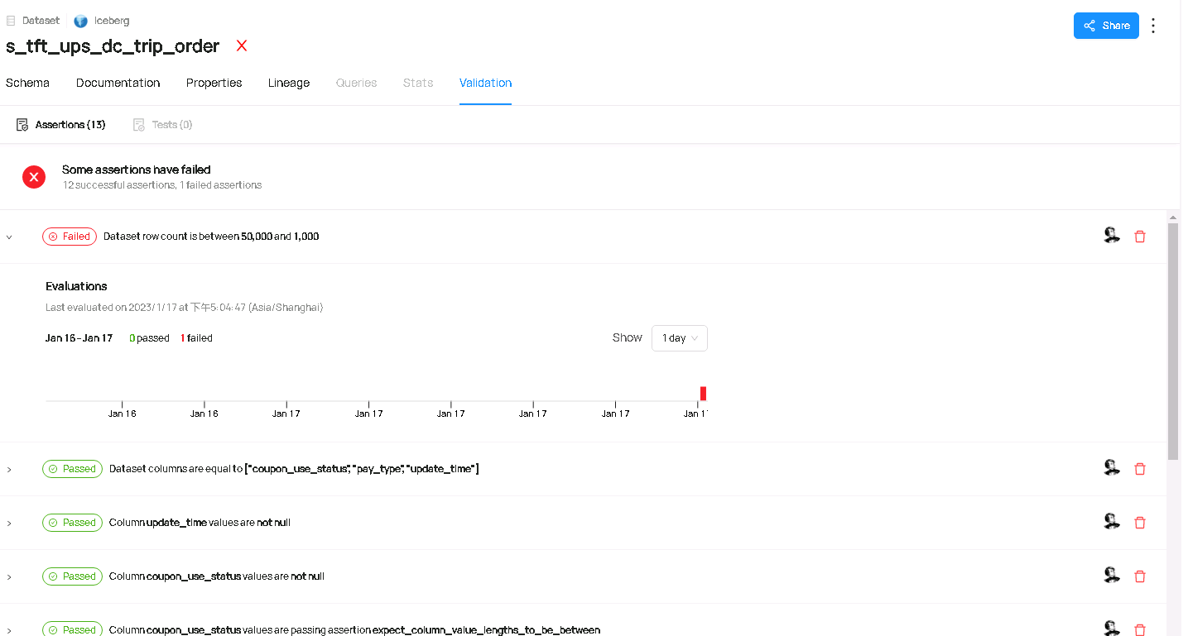

图 1 - 未通过的度量结果

图中红叉表示最近一次度量并未通过，只要一个度量规则未通过，则判定为未通过。假设成功的度量结果再次推送至Datahub中，则以最新的度量结果为准，图中红叉会变更为绿勾，例如：

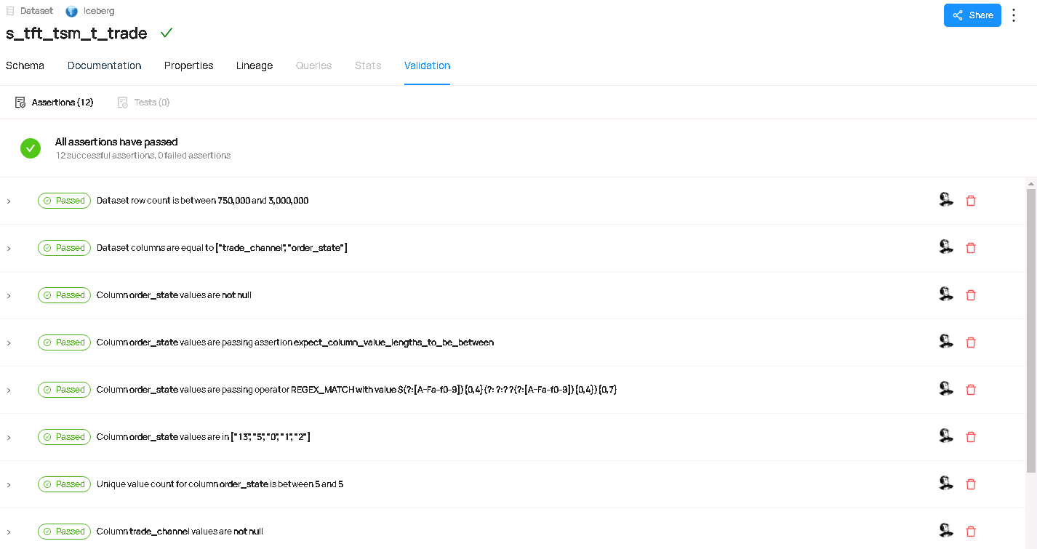

图 2 - 通过的度量标准

### 修订度量标准

当度量标准正常被执行，由于某些原因需调整度量标准后重新上线。这时，需执行以下两步：

1. 执行如7.3中的步骤，改善GE工作空间expectations目录下度量标准；
2. 将Datahub中Validation Tab下的所有度量结果删除，让GE重新推送结果生成。

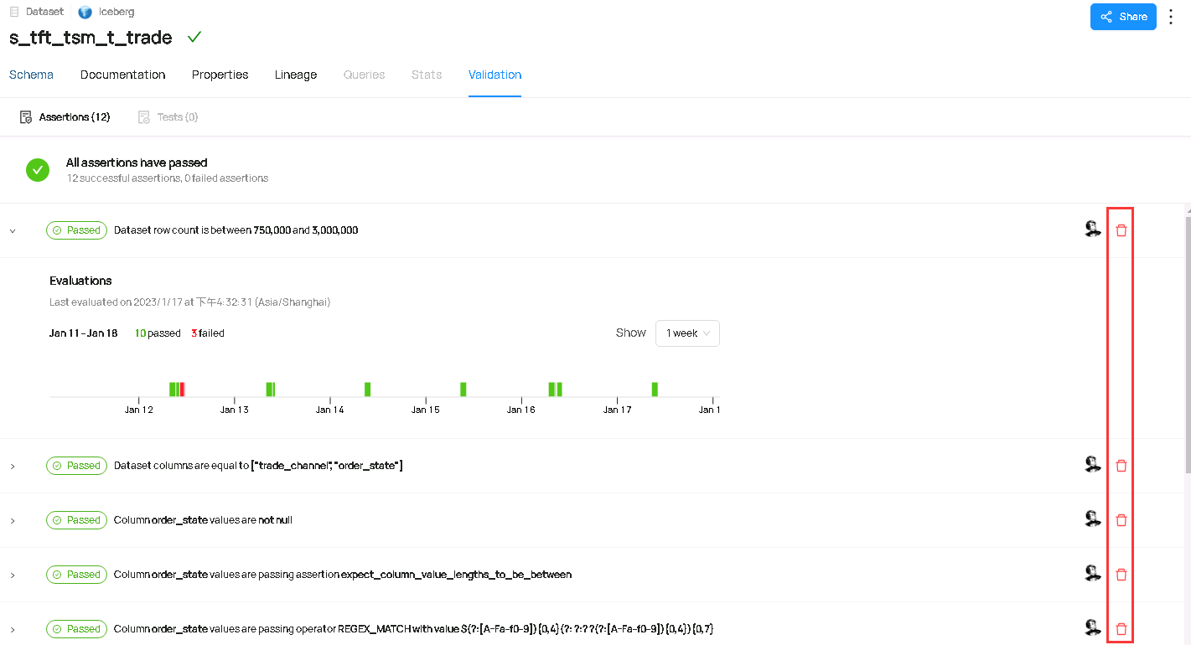

图 3 - 删除度量结果

注：如果不执行删除，重新推送的度量结果将错乱覆盖，具体原因尚未调查。

## 设置异常度量结果短信告警

将附录中custom_actions.py上传至plugins目录，如果安装过程中已上传则忽略，生产环境路径为

/hdp_data/gch/venv/great_expectations/great_expectations/plugins

[root@namenode1 plugins]# pwd

/hdp_data/gch/venv/great_expectations/great_expectations/plugins

[root@namenode1 plugins]# ls

custom_actions.py

### 在生成度量依据时设置

在7.2生成度量依据中，直接设置短信告警的action。

checkpoint_yaml_config = f"""

name: {checkpoint_name}

config_version: 1.0

class_name: SimpleCheckpoint

run_name_template: '%Y%m%d-%H%M%S-{datahub_dataset}'

expectation_suite_name: {expectation_suite_name}

action_list:

- name: datahub_action

action:

module_name: datahub.integrations.great_expectations.action

class_name: DataHubValidationAction

server_url: http://10.50.253.9:8080

"""

找到如上类似代码段，添加短信告警action。

checkpoint_yaml_config = f"""

name: {checkpoint_name}

config_version: 1.0

class_name: SimpleCheckpoint

run_name_template: '%Y%m%d-%H%M%S-{datahub_dataset}'

expectation_suite_name: {expectation_suite_name}

action_list:

- name: datahub_action

action:

module_name: datahub.integrations.great_expectations.action

class_name: DataHubValidationAction

server_url: <http://10.50.253.9:8080>

- name: sms_action

action:

module_name: custom_actions

class_name: SmsNotificationAction

sms_webhook: http://10.50.253.7:18888/sms/push

app_name: great_expectations

phones:

- 18011449543

- 15888888888

notify_on: failure

"""

红色部分为添加代码，这样在制作checkpoint时直接配置。

配置说明：

1. Module_name为自定义插件的模块名，对应custom_actions.py，如果模块名发生变更或新增模块，则需调整；
2. Class_name为上述模块中实现ValidationAction类的子类，如果类名发生变更，则需调整；
3. Sms_webhook为短信服务地址，如果短信服务地址发生变更，则需调整；
4. App_name为短信内容“大数据应用服务”名，一般来说不需要调整；
5. Phones为送达手机列表，一般来说需要调整；
6. Notify_on定制发送内容，可选值为"all", "failure", "success"，"all"表示无论成功失败都发送短信，"failure"表示只有失败时才发送短信，"success"表示只有成功时才发送短信，成功失败说明：所有度量均成功则为成功，只要由一个度量失败则为失败，该配置根据需要更改。

发送短信内容示例：

【天府通】大数据应用服务[great_expectations],运行情况[sdm.s_tft_tsm_t_trade(20230129) - success],请知晓

### 修改checkpoint配置

在checkpoint中配置短信通知的action，这里以sdm.s_tft_tsm_t_trade表为例。

[root@namenode1 checkpoints]# pwd

/hdp_data/gch/venv/great_expectations/great_expectations/checkpoints

[root@namenode1 checkpoints]# more hadoop_catalog_sdm_s_tft_tsm_t_trade.yml

name: hadoop_catalog_sdm_s_tft_tsm_t_trade

config_version: 1.0

template_name:

module_name: great_expectations.checkpoint

class_name: Checkpoint

run_name_template: '%Y%m%d-%H%M%S-s_tft_tsm_t_trade'

expectation_suite_name: hadoop_catalog_sdm_s_tft_tsm_t_trade

batch_request: {}

action_list:

- name: store_validation_result

action:

class_name: StoreValidationResultAction

- name: store_evaluation_params

action:

class_name: StoreEvaluationParametersAction

- name: update_data_docs

action:

class_name: UpdateDataDocsAction

site_names: []

- name: datahub_action

action:

module_name: datahub.integrations.great_expectations.action

class_name: DataHubValidationAction

server_url: http://10.50.253.9:8080

- name: sms_action

action:

module_name: custom_actions

class_name: SmsNotificationAction

sms_webhook: http://10.50.253.7:18888/sms/push

app_name: great_expectations

phones:

- 18011449543

- 15888888888

notify_on: failure

evaluation_parameters: {}

runtime_configuration: {}

validations: []

profilers: []

ge_cloud_id:

expectation_suite_ge_cloud_id:

# 总结

Great Expectations套件的引入，将质量管理工作从石器时代推进至半自动化时代。采用插件式设计架构，使其能够丰富适配各项数据源、度量引擎、Action，支持可扩展式接口开发。Great Expectations套件与Airflow、Datahub集成，使资源得以有效整合，数据治理工作一站化。

# 待办（TODO）

1. 或采取ExternalPythonOperator执行GE作业，以达到执行环境解耦；
2. 适配StarRocks数据源，执行GE作业。

# 附录



Great Expectations官方网站：https://docs.greatexpectations.io/docs/