NAME___________________________ NINE PAGES
The sheet resistance is 10⁴ ohms per square for a turned-on NMOS and use double that value for PMOS. Cg=10-14 Farads for a transistor whose size is 2 units by 2 units. Cg is the capacitance of a 2 x 2 NMOS or PMOS gate. Use V_{T} = 1 V for nmos and –1V for pmos. Unless stated otherwise, assume Vdd=5V. Note: variables are given by single characters, e.g. A, B, …, and concatenated character strings such as AB are to be read as A and B. A’ means Acomplement. A + B means A or B.
- (10)Consider a fully complementary CMOS NAND(A,B,C) using three transistors in parallel to ground. Estimate pullup and pulldown (PU/PD) times for each input combination switching from high to low or low to high.Assume an ideal pulse source that drives the changes in A, B, and C. For each of the changes, fill in the table with estimated rise and fall times against a load that is 10**-13 F Assume the pullup transistors are 4w x 2long and the pulldowns are 2 x 2. Assume the sheet resistance of an “on” NMOS transistor is 10 kohms and double that for PMOS. Assume Cgate is 10**-14 F for a 2 x 2 transistor.
A | B | C | PU or PD? | time
0 | 0 | 0
0 | 0 | 1
0 | 1 | 0
0 | 1 | 1
1 | 0 | 0
1 | 0 | 1
1 | 1 | 0
1 | 1 | 1

- (8)Design NAND(A,B) such that the following pullup and pulldown times are achieved. Use transistor lengths of 2. AB=00, pullup time constant is 0.4ns. AB=01, pullup time constant is 0.8 ns. For AB= 11, pulldown time constant is 2.0 ns. Let the load be 100fF. One more step: (2) What is the pullup time constant for AB=10?

- (10) Realize (means draw the circuit) the function F=(AB+CD ) using a fully-complementary, fully switched (as contrasted with ratioed) CMOS circuit. Show the transistor level schematic. The signal, F, should be true at the output of the circuit. Use a design style that DOES require the use of an inverter, so that F appears true at the output.

- (10) Realize the function F=(AB+CD ) using a fully-complementary, fully switched (as contrasted with ratioed) CMOS circuit. Show the transistor level schematic. The signal, F, should be true at the output of the circuit. Use a design style that DOES NOT require the use of an inverter, so that F appears true at the output. Assume the variables and their complements are all available.

- (10)Now, realize the function in the previous problem (#4) using a pseudo-NMOS design style.

- (10)Expand using Shannon’s theorem the function F=AB+C to create a bubble tree. Expand in the order A,B,C. In other words, A is most significant. Stop expanding when you reach the point that both inputs to a bubble are either a zero or one. NOTE. I want to CLEARLY SEE A SHANNON’S expansion or a Boolean algebraic alternative (Which is really a disguised Shannon’s expansion.) Write out your steps, so I can follow them. I suggest you put your expansions in a region just below the bubble that you are expanding through. If an expansion has been done once (e.g. going out to the final 0’s and 1’s) you do not need to repeat it again and again.

- (10)Realize the function F=AB+CD using three domino stages. Indicate the precharge and evaluate signals. Be sure the output is a “valid” domino signal that can be fed to other NMOS logic, and that signal should be “true”, not “false”.

10) (10 points) Draw a seven stage ring oscillator. Then, estimate the frequency of the oscillator if it is comprised using 1X inverters. 1X inverters have 2x2 pulldowns and 2x4 pullups (4 is the width). Do not load the oscillator with a “final output load” , i.e. C_{load}.

11.(6) Write the Boolean expressions for K and P. Please stop after the point you get K’ (that’s K_bar) into the expression for P. Do not simplify further, as it becomes a mess.

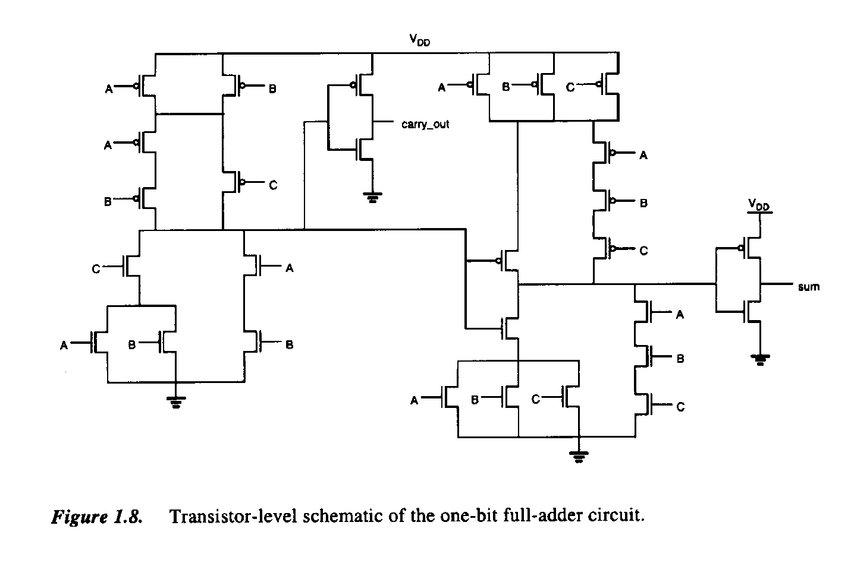
K
P

12.(6) Write the Boolean formulas for f₀ and f₁ Note: Ignore the little black mark across the blue line. I can’t get rid of it.
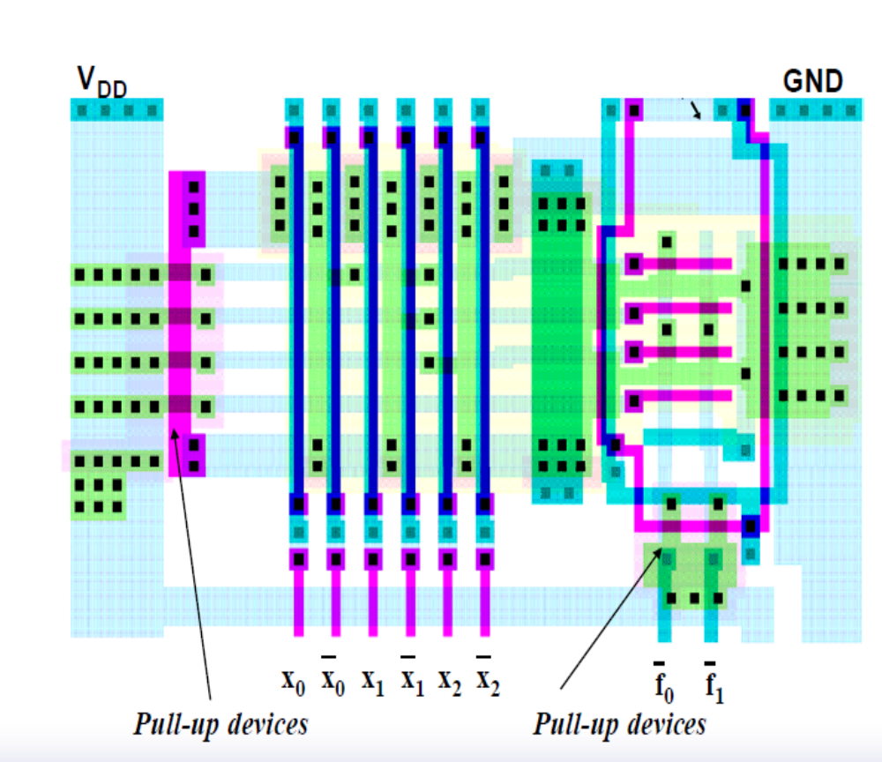

What is the name of the overall structure? _____________________________________

Note: Poly under Metal2 shows up as a very dark blue color. Metal2 is a darker blue than Metal1. Metal1 can connect to both Metal2 and Poly, but not in the same location. Poly cannot connect directly with Metal2. Examine very closely where the green rectangles terminate in the input plane: None go both directions (left and right). There are no “tricks”: the green horizontal rectangles in the input plane either connect to the right or to the left. In the output plane, one programmed cut connects both up and down.
13. (10)What is this picture trying to convey? Explain what’s going on.

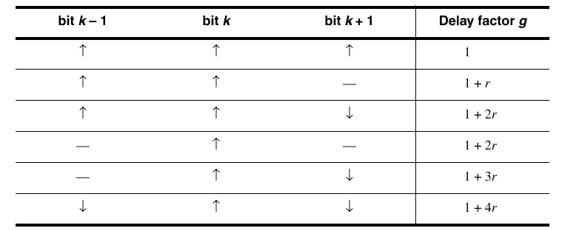
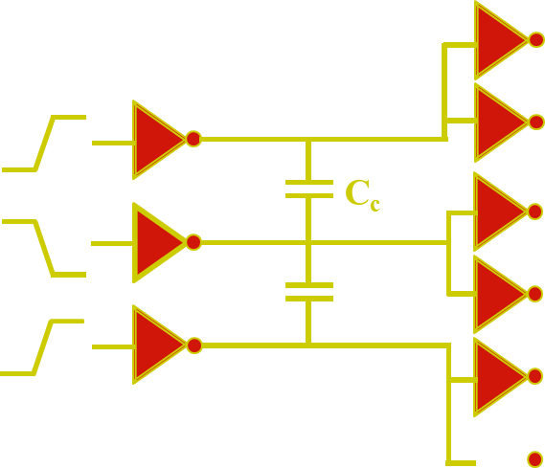
+2
+2
+1
+1
+1
+2
+2
+1

