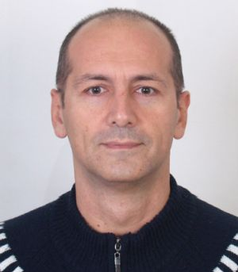
Dmytro Dudnyk
Personal information
- 08.11.1971
- 3-33 Bakulina st., Kharkiv, 61166, Ukraine
- (098)732-19-98
- ddudnik@gmail.com
- Skype: dudnik
Objective | Position of DevOps Engineer
Skills | 11 years’ experience as System Administrator/Engineer with  - Windows client(XP/7/10) and server(2008) OS  - Linux based OS (Ubuntu, CentOS, Debian) and services  - experience at virtualization (Vbox, KVM(Postfix), Hyper-V)  - knowledge principles of networking TCP/IP Stack, DNS, DHCP  - knowledge of monitoring tools (Munin, Dude, Zabix)  - basic knowledge in AWS, Git, Docker, Kubernetes  - understanding of principles of CI/CD  - excellent communication and problem-solving skills
Experience | 2017 - present Ukrainian Research Institute of Forestry and Forest Melioration  Lead Engineer  - IT-budgeting and IT-Infrastructure development and planning, policies and procedures development. Support for management structure, accounting, research departments - AD, DNS, DHCP, GPO, RDP(Terminal Server), mail(Postfix,Roundcube), backup(Acronis, Veeam), accounting(MeDoc, Liga, 1C/UaBudget, etc) and clienst's OS(Windows XP-WIndows 10, Ubuntu Linux), network and monitoring system, cctv system, corporate website support.  2007 - 06.2016 Freelance  System Engineer  System Administrator  Support Engineer  - Small to medium projects - configuring and administering servers and workstations Windows(AD, RDP) / Linux (DNS, DHCP, SAMBA, firewall), virtualization (Vbox, KVM, Proxmox, Hyper-V), backup, monitoring (Munin, Dude, Zabix), mail (Postfix) planning, installation and configuration of the local network, installation of Mikrotik, 1C (RDS), video surveillance, support.  2003 - 2005 Incom-Kharkiv, JSC  System Engineer  - Worked with corporate customers on implementation of large IT projects. Attended seminars on servers and storage systems Prime, HP, IBM; Cisco products and solutions, Allied Telesyn, ZyXEL, D-Link; PBX Meridian and Samsung.  2001 - 2003 MKS, LLC  Advertising Manager  Sales Manager  - Planning and conducting promotions with vendors: Intel, AMD, LG, Samsung, APC  - Worked with corporate customers of MKS LLC. Maintained the direction of peripheral computer equipment, attended seminars by HP, Xerox, Samsung, OKI, Lexmark, Canon, Epson. Authorization certificates received from HP, Xerox. Attended a training on the topic "Quality of customer service”.
Education | 1988 - 1994 Kharkiv Technical University of Radioelectronics  - System Engineer, Computer Systems and Networks  1999 - 2002, 2007 Language Center “International House”, Kharkiv  - English courses  2008 Vostok, LLC, Kharkiv  - Installing, Administering and Maintenance of Linux-systems  2019 EPAM, Kharkiv  - External preDevOps courses
Additional information | - English- B1/B2  - Ukrainian- native  - Russian – native

