Dan Dujmich

15 October 2017

Using KiCAD, design a circuit schematic for an analog amplifier with the following features:

* Uses a 5VDC power supply. Assumes the signal to be amplified shares the same ground as the power supply.
* Amplifies an input analog signal that can range from 0 to 2.0V so that the output ranges from 0 to 5V.
* Contains a bill of materials (BOM) specifying the chosen components and how to source them.
* Has an adjustable gain
* A low-pass filter with adjustable cut-off to filter-out noise from the input analog signal.
* OPTIONAL: Is implemented as a routed PCB.

The design can be submitted as a GitHub repository file containing the KiCAD project and a printable (Letter) PDF with the schematic and if available another PDF in 1:1 scale of the routed PCB.

**Proposed Circuit:**

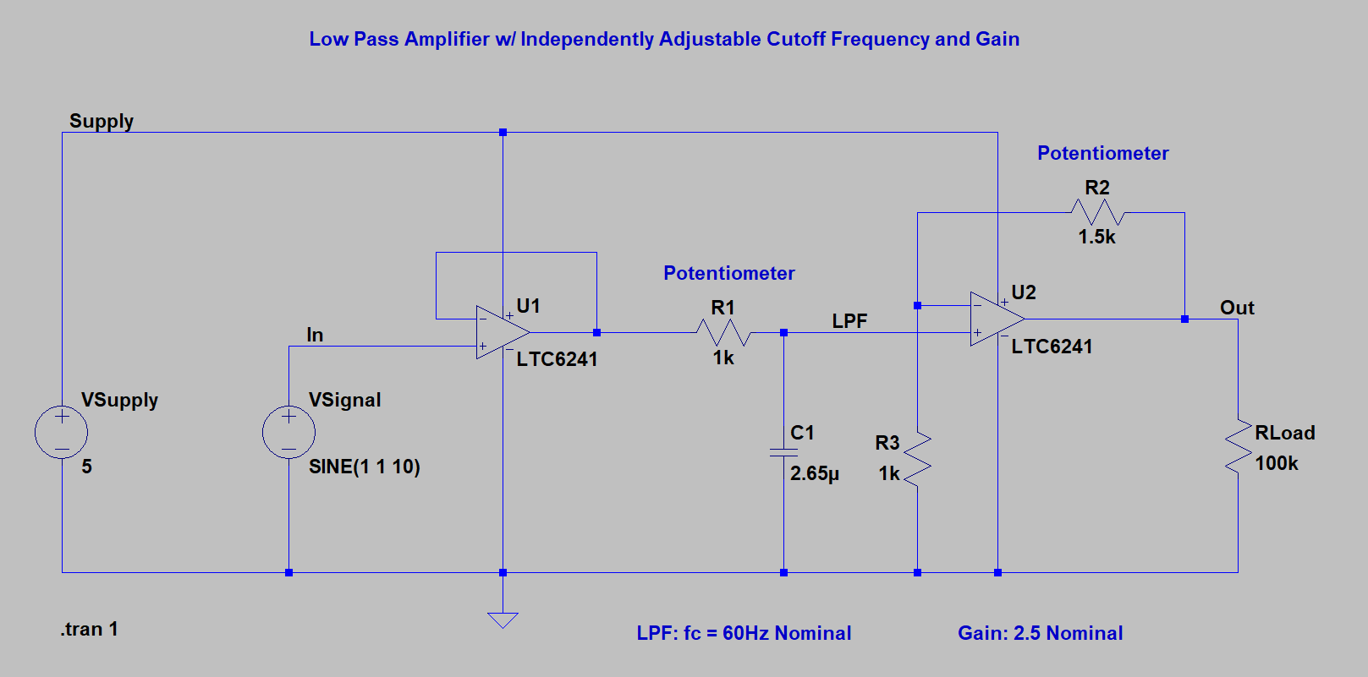

The above circuit assumes a 5VDC power supply provides the bias voltage for the active components U1 and U2. The circuit is designed to allow for the adjustment of the cut off frequency of the Low Pass Filter and the gain of the circuit independently from one another. Operational Amplifiers U1 and U2 are in a dual circuit package from Linear Technologies, “LTC6214”. The input signal “VSignal” first goes into a buffer before a first order passive low pass filter. This is to make use of the dual circuit package as well as to separate the passive Low Pass Filter’s cut-off frequency from the external impedance of the input. The cut-off frequency of the filter is adjustable via potentiometer R1. The next op-amp U2 is the gain stage of the circuit. The nominal gain is 2.5 and is adjustable via potentiometer R2. The gain stage is after the Low Pass Filter so unwanted noise is not amplified before filtering.

**Equations:**

$$f_{C}=\frac{1}{2πR_{1}C_{1}}$$

$$G=1+\frac{R_{3}}{R_{2}}$$

**Simulations:**

**Transient Simulation 1:**

|  |  |
| --- | --- |
| **Parameters** | **Values** |
| **Vin** | 2Vpp, 1VDC offset, 10Hz |
| ***f*c** | 60Hz |
| **Gain** | 2.5 |

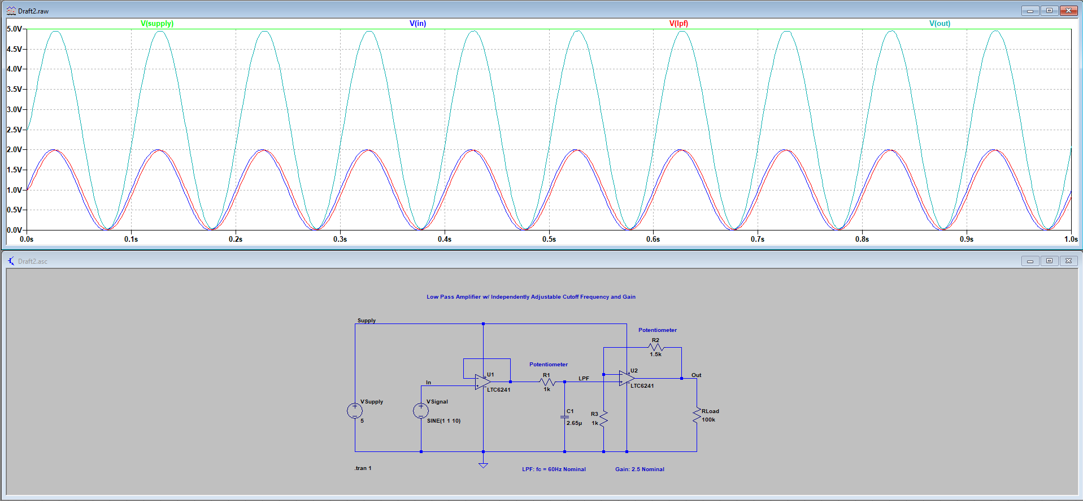

**Transient Simulation 2:**

|  |  |
| --- | --- |
| **Parameters** | **Values** |
| **Vin** | 2Vpp, 1VDC offset, 60Hz |
| ***f*c** | 60Hz |
| **Gain** | 2.5 |

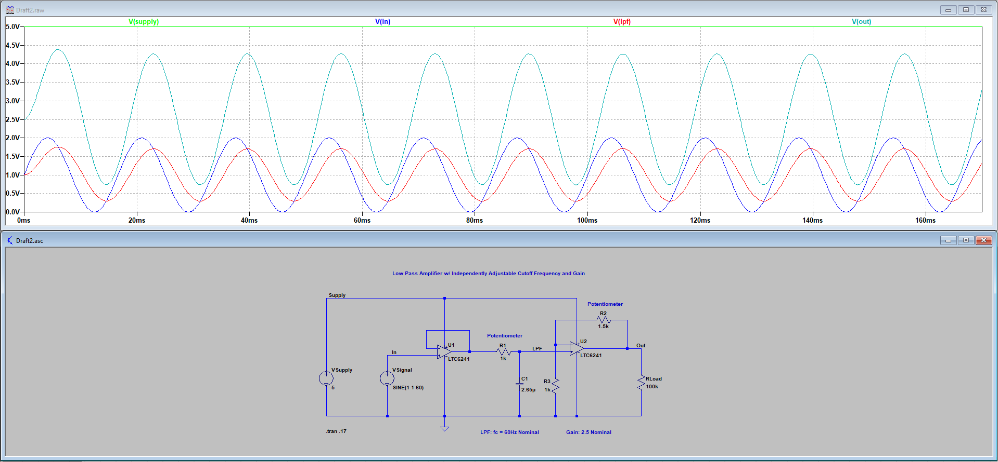

**Transient Simulation 3:**

|  |  |
| --- | --- |
| **Parameters** | **Values** |
| **Vin** | 2Vpp, 1VDC offset, 250Hz |
| ***f*c** | 60Hz |
| **Gain** | 2.5 |

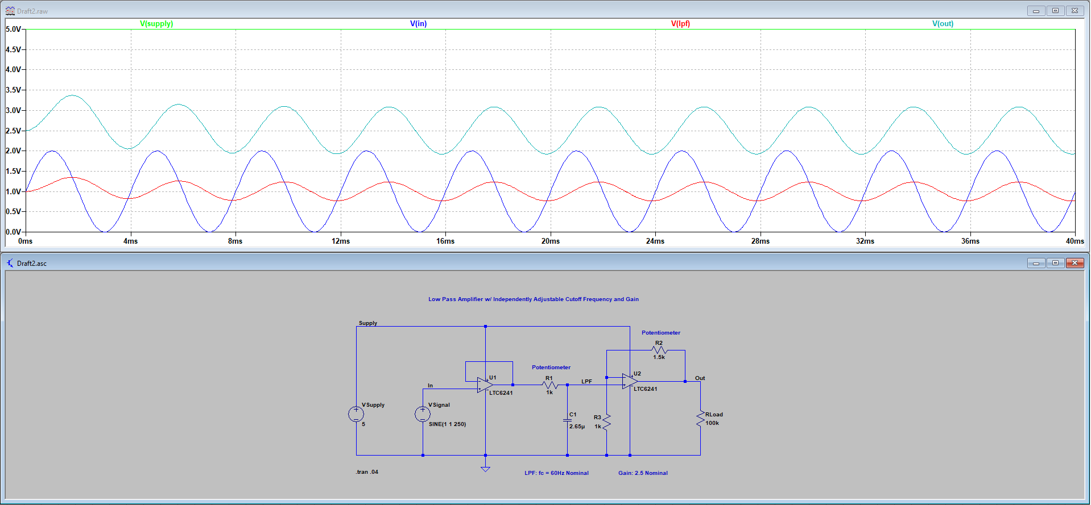

**Transient Simulation 4:**

|  |  |
| --- | --- |
| **Parameters** | **Values** |
| **Vin** | 2Vpp, 1VDC offset, 1kHz |
| ***f*c** | 60Hz |
| **Gain** | 2.5 |

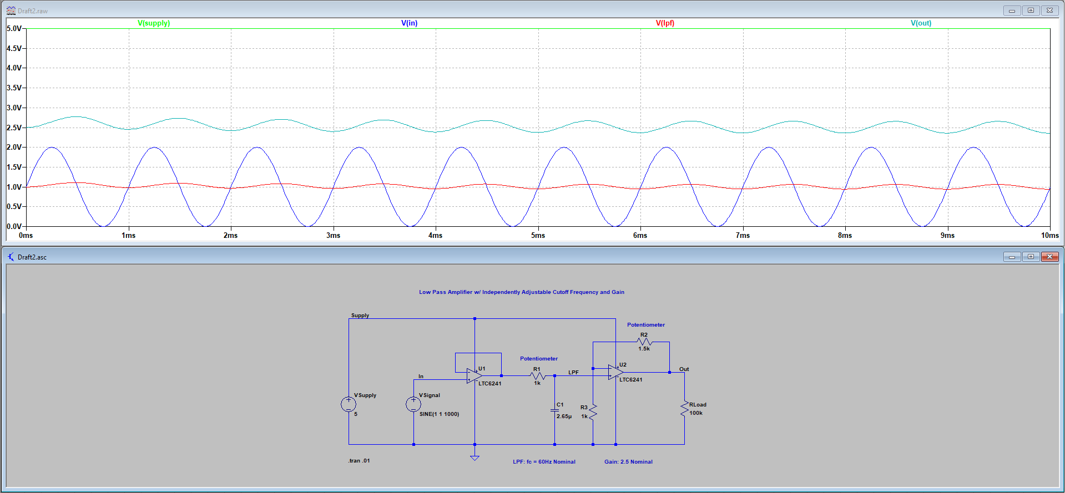

**Transient Simulation 5:**

|  |  |
| --- | --- |
| **Parameters** | **Values** |
| **Vin** | 2Vpp, 1VDC offset, 10kHz |
| ***f*c** | 60Hz |
| **Gain** | 2.5 |

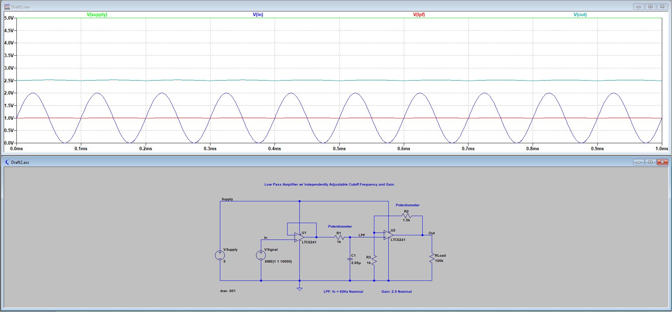

**Bill of Materials:**

All components are sourced from Digikey and available for purchase in units of 1. Each component is PCB mount.

|  |  |  |  |  |  |  |
| --- | --- | --- | --- | --- | --- | --- |
| **Component** | **Type** | **Desired Value** | **OEM P/N** | **Digikey P/N** | **Cost** | **Comment** |
| **R1** | Potentiometer | 1.5kOhm | 3314J-1-502E | [3314J-502ECT-ND](https://www.digikey.com/products/en?keywords=3314J-502ECT-ND) | $2.18 | 5kOhms, 1/4W, Single Turn |
| **R2** | Resistor | 1kOhm | RC1206FR-071KL | [311-1.00KFRCT-ND](https://www.digikey.com/products/en?keywords=311-1.00KFRCT-ND) | $0.10 | 1k, 1/4W, 1% Tolerance |
| **R3** | Potentiometer | 1kOhm | 3314J-1-502E | [3314J-502ECT-ND](https://www.digikey.com/products/en?keywords=3314J-502ECT-ND) | $2.18 | 5kOhms, 1/4W, Single Turn |
| **C1** | Capacitor | 2.65uF | C0805C275K8PACTU | [399-3127-1-ND](https://www.digikey.com/products/en?keywords=399-3127-1-ND) | $0.47 | 2.7uF, 10V, +/- 10% |
| **U1/U2** | Dual Op Amp |  | LTC6241IS8#PBF | [LTC6241IS8#PBF-ND](https://www.digikey.com/products/en?keywords=LTC6241IS8%23PBF-ND) | $2.81 | Dual Circuit, Rail-to-Rail, -40C to 85C, Vsupply 2.8 to 6V |
| **Total:** | | | | | **$7.74** |  |

**KiCAD Schematic:**

