TOWSON UNIVERSITY
Department of Computer and Information Sciences

COSC 612 / AIT 624 – Software Engineering I

Semester: Fall 2025
Team Name: Team Penguin
Project Title: Penguin Healthcare Solutions – A Fine-Tuned Approach to Medical Information Management

Group Members:
Ifeoluwa Testimony Tella
Stanley Ekomaye
Dylan Dulmaine (Team Coordinator)
Neha Sanjay Savalgi
Jasmeen Kaur

Date Submitted: December 1, 2025

Planning and Scheduling

Team Name: Team Penguin
Project Title: Penguin Healthcare Solutions
Sprint Lead / Coordinator: Dylan Dulmaine

Task/Deliverables | Assigned To | Contact Info | Task Duration | Completion Target Dates
Planning & Scheduling  Communication & Collaboration  Report. | Jasmeen K | jkaur17@students.towson.edu | 7 Days | 11/24/2025  To  11/30/2025
Implementation. ( Frontend) | Ifeoluwa T | itella@students.towson.edu | 6 Days | 11/25/2025  To  11/30/2025
Implementation  ( Backend ) | Dylan D | ddulmai1@student.towson.edu | 6 Days | 11/25/2025  To  11/30/2025
Architectural Modeling | Neha S | nsavalg1@students.towson.edu | 5 Days | 11/24/2025  To  11/28/2025
Testing | Stanley E | sekomay1@students.towson.edu | 8 Days | 11/24/2025  To  11/01/2025

Problem Statement
Penguin Healthcare Solutions

Overall Project Description
Penguin healthcare solutions is a secure, user-friendly platform designed to streamline healthcare information management. It allows doctors, nurses, and patients to access and manage medical records while maintaining strict privacy and confidentiality standards. The system integrates artificial intelligence (AI) to assist with preliminary diagnoses and decision support, helping healthcare professionals provide timely and accurate care.

High-Level Product Concept
At its core, the system provides a centralized digital platform for healthcare record management. Authorized users (doctors, nurses, patients) can securely view, update, and share patient information. AI modules analyze patient symptoms and medical history to suggest possible diagnoses, enabling healthcare staff to make more informed clinical decisions.

Target Users
- Doctors & Nurses: For reviewing patient histories, updating treatment plans, and receiving AI-assisted diagnostic suggestions.
- Patients: For securely accessing their own records, lab results, prescriptions, and receiving health insights.
- Healthcare Administrators: For managing staff, scheduling, and ensuring compliance with privacy regulations.

Problem Being Solved
Traditional patient record systems often face:
- Fragmentation (records stored across different departments or paper files).
- Limited patient access (patients lack transparency over their own records).
- Inefficiencies in diagnosis and treatment planning.
- Security risks when handling sensitive medical data.
Our system solves these problems by offering a secure, centralized, and intelligent platform that integrates AI-powered diagnosis support with seamless access for both patients and providers.

Alternatives Available
Existing solutions include electronic health record (EHR) systems like Epic, Cerner, and Allscripts. However:
- They are expensive and difficult to customize.
- Many lack direct patient-facing features.
- AI integration for diagnosis is limited or non-existent in mainstream platforms.

Why This Project is Compelling
Healthcare is rapidly digitizing, yet accessibility, affordability, and usability remain significant challenges. Our project:
- Empowers patients by giving them authorized access to allowed records and health insights.
- Supports clinicians with AI-based diagnostic tools to improve efficiency and reduce errors.
- Focuses on affordability and simplicity to be scalable even for smaller hospitals or clinics.

Top-Level Objectives, Differentiators, and Scope
- Objectives:
  - Build a secure and compliant patient management system.
  - Enable seamless access for patients, doctors, and nurses.
  - Integrate AI for symptom analysis and preliminary diagnosis.
  - Ensure scalability and adaptability to different healthcare environments.
- Differentiators:
  - AI-assisted diagnosis embedded directly in the system.
  - Strong privacy and security mechanisms to protect sensitive health data.
  - Patient empowerment features (self-access, notifications, transparency).
- Scope:
  - Patient record storage and retrieval.
  - Role-based access control (doctor, nurse, patient).
  - AI-driven diagnosis suggestions.
  - Secure communication between healthcare staff and patients.
  - Audit trails and compliance with data regulations.

Competitors and Novelty
Competitors: Epic, Cerner, Allscripts, and smaller EMR/EHR systems.
Novelty in our approach:
- Lightweight, affordable, and adaptable system.
- Built-in AI diagnostic support for efficiency.
- Patient-first design (direct record access and transparency).

Feasibility
The system can be built using existing technologies:
- Backend: PHP, Python, or Node.js with secure APIs.
- Database: SQL/NoSQL for structured patient records.
- Frontend: Web-based (HTML, CSS, JavaScript frameworks).
- AI Module: Machine learning models (scikit-learn, TensorFlow, or PyTorch) trained on open medical datasets.
- Security: Encryption, authentication, and compliance with HIPAA/GDPR.

Technical Interest
From a technical standpoint, this project is engaging because it combines:
- Database engineering for secure, scalable record storage.
- Artificial intelligence for medical diagnosis support.
- Software engineering best practices (requirements, modular design, role-based access).
- Cybersecurity and privacy considerations in a sensitive real-world domain.

System Requirements

Use Case

Use Case Number | UC – 1
Use Case Name | Authenticate user
Actors | Clinician, Nurse, Patient, Admin
Description | The user logs into the system, and their credentials are validated to determine their access permissions if authentication is successful.
Alternate Path | If authentication fails due to invalid credentials, the system displays an error and prompts for re-entry. After three failed attempts, the account is temporarily locked.
Precondition | The user must be registered in the system and have valid credentials stored in the database.

Use Case Number | UC – 2
Use Case Name | View Patient Record
Actors | Clinician, Nurse, Patient
Description | The actor retrieves a patient’s medical record, including demographics, history, medications, and test results.
Alternate Path | If the patient record does not exist or access is denied due to insufficient permissions, the system displays an error message.
Precondition | The user must be authenticated and have permission to access the requested patient’s data.

Use Case Number | UC – 3
Use Case Name | Update Patient Record
Actors | Clinician, Nurse
Description | The actor updates patient records with new information such as diagnoses, prescriptions, or treatment progress.
Alternate Path | If validation fails, like missing fields, the update is rejected, and the user is prompted to correct errors.
Precondition | The actor must be logged in and authorized to modify clinical data.

Use Case Number | UC – 4
Use Case Name | Admission notifications
Actors | Admissions System, Clinician
Description | The system receives and processes admission, discharge, or transfer messages and updates patient encounter details.
Alternate Path | If an admission message is malformed or duplicated, the system rejects it and logs an error for administrative review.
Precondition | The Admissions subsystem must be integrated and configured to send standardized Admission Discharge Transfer messages.

Use Case Number | UC – 5
Use Case Name | Schedule Appointment
Actors | Patient, Clinician, Appointments System
Description | The actor books, modifies, or cancels an appointment.
Alternate Path | If scheduling conflicts occur, the system suggests alternative time slots.
Precondition | Both clinician and patient accounts must exist and have valid access to the appointment system.

Use Case Number | UC – 6
Use Case Name | Send Appointment Reminders
Actors | Notification Service, Patient
Description | The system automatically sends appointment reminders through preferred communication channels
Alternate Path | If notification fails, the system retries and flags the issue for admin follow-up.
Precondition | Patient must have a valid appointment and contact details in their profile.

Use Case Number | UC – 7
Use Case Name | Create e-Prescription
Actors | Clinician, Pharmacy System
Description | Clinician creates an electronic prescription that is securely transmitted to the pharmacy system.
Alternate Path | If validation fails, like invalid dosage or allergy conflict, the system notifies the clinician for correction.
Precondition | - Patient must have a valid active record  - clinician must be authorized to prescribe.

Use Case Number | UC – 8
Use Case Name | Track Prescription Status
Actors | Pharmacy System, Clinician, Patient
Description | The system tracks the fulfillment status of prescriptions and updates both clinician and patient views.
Alternate Path | If the pharmacy system is unavailable, the update is retried automatically when the connection restores.
Precondition | Prescription must exist in the system with a valid transaction ID.

Use Case Number | UC – 9
Use Case Name | Request AI-Assisted Diagnosis
Actors | Clinician, AI Diagnostic Module
Description | Clinician submits patient data to the AI module for diagnostic suggestions.
Alternate Path | If the AI service is unavailable, the request is queued for later processing or manual review.
Precondition | Clinician must be authenticated and have patient data ready for analysis.

Use Case Number | UC – 10
Use Case Name | Generate Reports
Actors | Admin, Reporting Module
Description | Admin generates analytical or operational reports on system activities or clinical data.
Alternate Path | If data filters are invalid or the dataset is empty, the system returns an error message.
Precondition | The user must be an authorized administrator with access to reporting modules.

Use Case Number | UC – 11
Use Case Name | Audit & Compliance Review
Actors | Auditor, Admin
Description | Actor retrieves and reviews system audit logs to ensure adherence to data protection and access rules.
Alternate Path | If logs are missing or tampered with, the system alerts security administrators.
Precondition | The audit module must be active, and only authorized users may access it.

Use Case Number | UC – 12
Use Case Name | Attach Clinical Document
Actors | Clinician, Nurse
Description | The actor uploads external documents such as lab reports or imaging files into the patient’s record.
Alternate Path | If file type or size is invalid, the upload is rejected with an error message.
Precondition | Patient record must exist, and document upload permissions must be enabled.

Use Case Number | UC – 13
Use Case Name | Patient Profile Update
Actors | Patient
Description | Patient updates personal details such as phone number, address, and language preference.
Alternate Path | If data validation fails, the system requests correction before saving.
Precondition | Patient must be authenticated and have an active system account.

Use Case Diagram

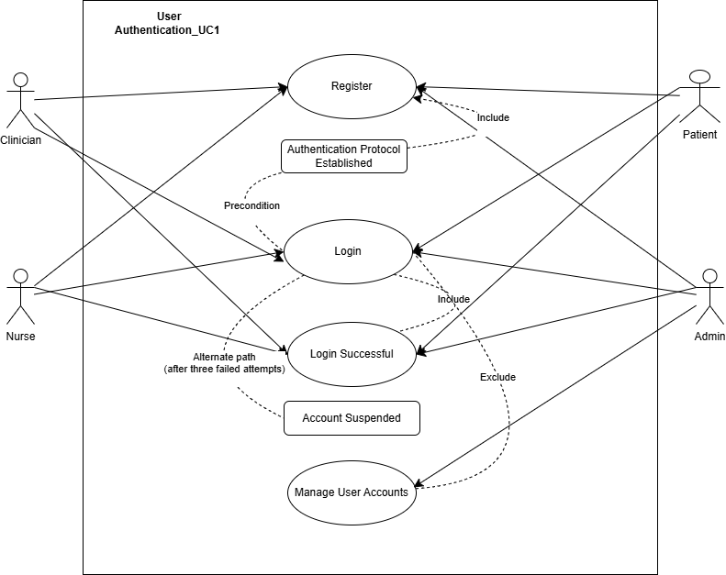

Requirements

Requirements Number | RE - 1
Use case number | UC - 1
Introduction | This requirement defines how users securely log into the system and are authorized to access data based on their assigned roles and permissions.
Inputs | Username, password, role selection, and multi-factor authentication code.
Requirements description | The system must validate credentials against the database, assign access scopes based on role. Failed login attempts must trigger security logging and lockout after three consecutive failures.
Outputs | - Successful login redirects the user to their respective dashboard  - unsuccessful attempts return an error message and are logged in the audit system.

Requirements Number | RE – 2
Use case number | UC - 2
Introduction | Defines how users retrieve and view patient information from the system.
Inputs | Patient ID
Requirements description | The system must retrieve patient data while enforcing access control.
Outputs | Displayed patient record

Requirements Number | RE – 3
Use case number | UC - 3
Introduction | Specifies the process of editing or adding new clinical information to a patient record.
Inputs | Patient ID, clinical data fields, and user credentials.
Requirements description | Authorized users can update or append information to patient records. The system must validate data fields and update linked systems.
Outputs | - Confirmation message of successful update  - Updated record visible to authorized users

Requirements Number | RE – 4
Use case number | UC – 4
Introduction | Defines how the system processes admission, discharge, or transfer messages from the Admissions subsystem.
Inputs | ADT message containing patient ID, admission type, and timestamps.
Requirements description | Upon receiving the ADT message, the system must update the patient’s encounter status, notify the assigned clinician, and ensure idempotent message processing to prevent duplication.
Outputs | - Updated patient status displayed in dashboard  - confirmation sent to Admissions system.

Requirements Number | RE – 5
Use case number | UC - 5
Introduction | Describes appointment management functions between patients, clinicians, and the scheduling subsystem.
Inputs | Patient ID, clinician ID, date/time, reason for visit.
Requirements description | System must validate availability, prevent overlapping appointments, and confirm with both clinician and patient.
Outputs | - Appointment confirmation message and calendar entry created  - Notification sent to participants.

Requirements Number | RE – 6
Use case number | UC – 7
Introduction | Specifies automatic reminder notifications to patients before scheduled appointments.
Inputs | Appointment details, contact information, notification preferences.
Requirements description | System triggers reminders 24 hours before the appointment via SMS, email, or app notification, depending on patient preferences. Delivery failures must be retried once and logged.
Outputs | - Notification delivered to patient  - Status updated in notification log.

Requirements Number | RE – 7
Use case number | UC – 7
Introduction | Covers electronic prescription creation and transmission to the pharmacy subsystem.
Inputs | Patient ID, medication name, dosage, duration, clinician credentials.
Requirements description | System must validate drug interactions, check allergies, and ensure data integrity before sending the e-prescription securely to the pharmacy system.
Outputs | - Prescription confirmation displayed to clinician  - Pharmacy receives order and returns acknowledgment.

Requirements Number | RE – 8
Use case number | UC – 8
Introduction | Defines how the system tracks the dispensing status of a prescribed medication.
Inputs | Prescription ID, patient ID, status update message from pharmacy
Requirements description | The system periodically syncs with the pharmacy to update the prescription’s state and notify the clinician and patient.
Outputs | Updated prescription status displayed in both clinician and patient dashboards

Requirements Number | RE – 9
Use case number | UC – 9
Introduction | Describes the use of AI-based diagnostic tools to assist clinicians with decision support.
Inputs | Patient symptoms, vitals, and history.
Requirements description | The system must submit patient data to the AI module, receive diagnostic predictions, and present them with confidence levels. AI outputs must remain advisory and not alter records automatically.
Outputs | List of AI-suggested diagnoses and confidence scores displayed to the clinician

Requirements Number | RE – 10
Use case number | UC – 10
Introduction | Details the reporting functionality for administrators.
Inputs | Date range, report type, and filter parameters
Requirements description | System generates operational or compliance reports based on aggregated, anonymized data. Reports must support export formats.
Outputs | Generated report displayed in user interface and available for download.

Requirements Number | RE – 11
Use case number | UC – 11
Introduction | Specifies how audit logs are retrieved and reviewed for compliance purposes.
Inputs | Date/time range, user ID, patient ID.
Requirements description | The system must provide tamper-proof access logs that record all user actions, including reads, edits, and deletions, accessible only to compliance officers.
Outputs | - Audit report displayed or exported  - Retrieval logged in audit trail.

Requirements Number | RE - 12
Use case number | UC - 12
Introduction | Defines how external documents are uploaded to patient records.
Inputs | Document file, patient ID.
Requirements description | System validates file type and stores securely.
Outputs | - Document successfully attached  - confirmation message displayed.

Requirements Number | RE – 13
Use case number | UC – 13
Introduction | Specifies how patients can edit personal and contact information.
Inputs | User ID, updated contact details, preferences.
Requirements description | System validates new information, updates contact databases.
Outputs | - Profile updated successfully  - synchronization confirmation shown

Test ID | TS1-BE-001
Purpose of Test | Verify that the authentication service correctly authenticates an operator with valid username and valid password credentials. This test validates Equivalence Class EC1 (Valid username + valid password) and ensures compliance with security requirement SR-001: "System shall authenticate users using username/password credentials.
Test Environment | Platform: Java 17, Spring Boot 3.x, Gradle 8.x  IDE: IntelliJ IDEA  Testing Framework: JUnit 5.9.3, Mockito 5.3.1  AUT State: Fresh application context with mocked repositories  Database State: Not required (mocked)  Test Data: Pre-configured Operator object with username "admin" and password "admin123"
Test Steps | Initialize test environment with mocked OperatorRepository and PatientRepository  Create a valid Operator object with username="admin" and hashed password  Configure mock to return the valid Operator when findByUsername("admin") is called  Call authenticationService.authenticate("admin", "admin123")  Verify the return value  Verify repository method calls
Test Input | Test Input:  Username: "admin"  Password: "12345"  Username: "Rita"  Password: "pass"
Expected Result | Method returns true  OperatorRepository.findByUsername() called exactly once with "admin"  Password verification successful  No exceptions thrown
Likely Problem/Bugs Revealed | N/A

System Modeling
Architecture Modeling
The Penguin Healthcare Management System uses a straightforward mix of design patterns to keep things clear, modular, and easy to maintain. The system is built around the Model–View–Controller (MVC) pattern. In this setup, controllers handle outside requests, pass tasks to service classes, and work with data through repository components. This setup keeps the user interface or API separate from the business logic and data storage. The Service Layer pattern brings together the main operations, like managing patients, handling admissions, and sending notifications, so the workflow stays organized across all parts of the system. The Repository pattern puts all database operations into dedicated classes, making it easier to adapt to database changes and helping keep data accurate. The Observer pattern is also used for event-based features. For example, an AdmissionListener watches for new hospital admissions and triggers the NotificationService, so the system can react quickly to real-time updates. The DBConnectionManager and AuditLogger classes use the Singleton pattern to ensure consistent access to shared resources, such as database connections and audit logs. Using these patterns together provides the system with a simple, maintainable structure and supports the key features of healthcare applications.

After selecting the design patterns, we updated the class diagram to better separate responsibilities and added key structural components. We introduced controller classes such as PatientController and AdmissionController to indicate where external requests enter the system in the MVC model. Each controller now works with a matching service class, such as PatientService or AdmissionService, which handles business logic and manages communication between controllers and repositories. With the Repository pattern, we added repository classes such as PatientRepository to handle database operations and to connect directly to the database entity (DB). To support event-driven communication, we created two new classes, AdmissionListener and NotificationService, that use the Observer pattern to demonstrate how the system responds to real-time hospital events. The Singleton pattern led to two global utility classes, DBConnectionManager and AuditLogger, which are now shared by several service classes. These changes ensure the class diagram accurately reflects the system’s layered structure, modular design, and the patterns that keep it scalable and easy to maintain.

Behavioral Modeling
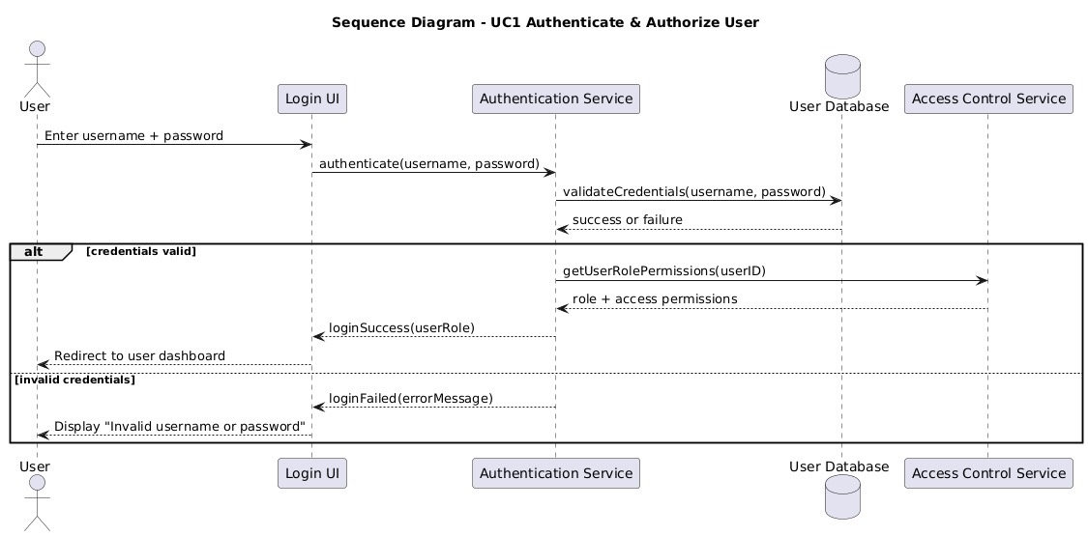

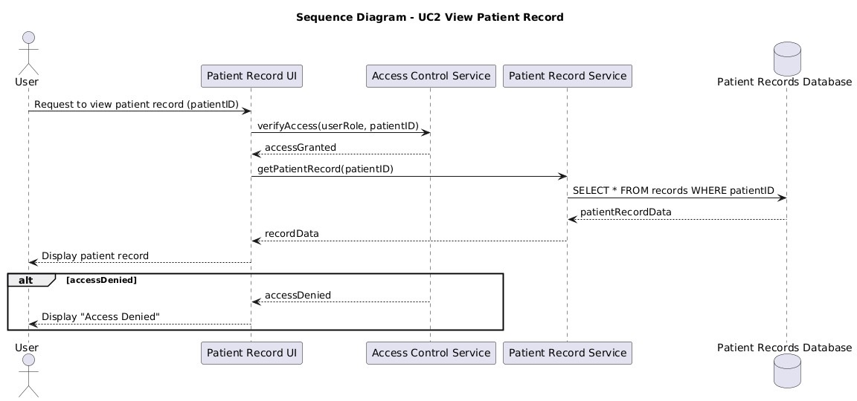
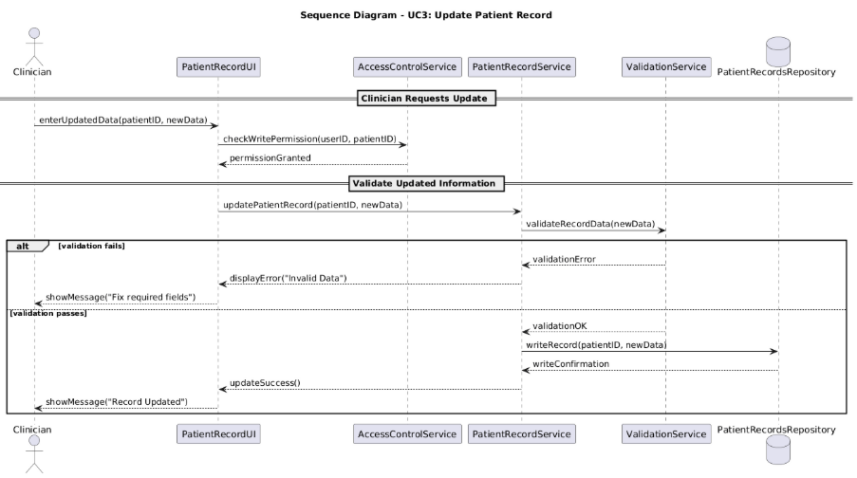
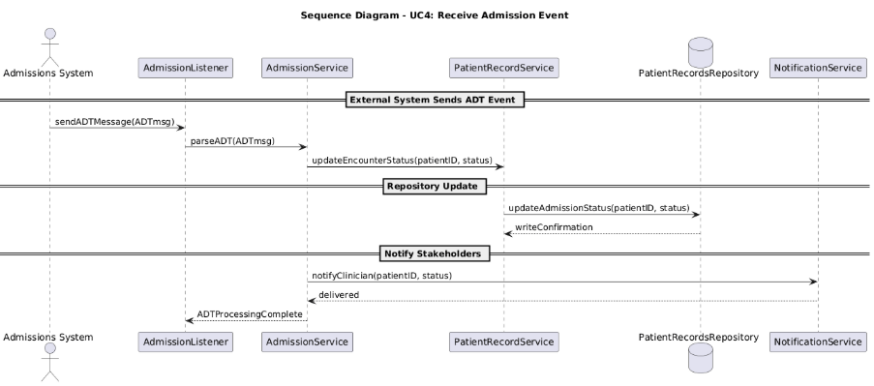

System Class Diagram

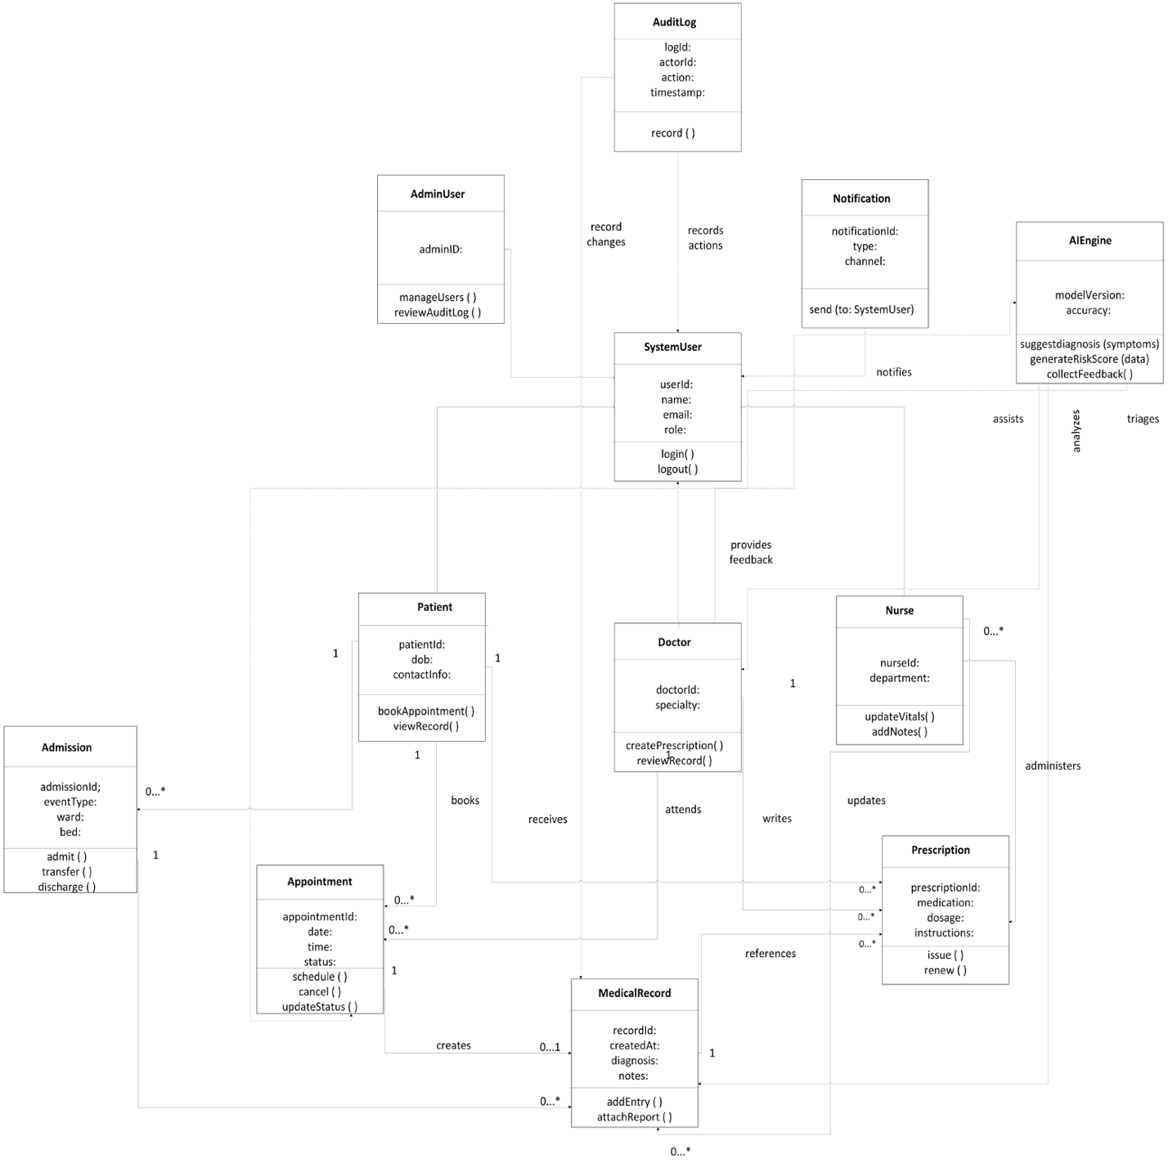
The class diagram illustrates the organization of the Penguin Healthcare Solutions system. This includes models for users, workflows (appointments, records, prescriptions, admissions), and supporting modules (AIEngine, Notification, AuditLog). Inheritance, associations, and multiplicities signify the relationships between the objects in the system, achieving the goal of structural modeling.

4 + 1 Architecture Diagram

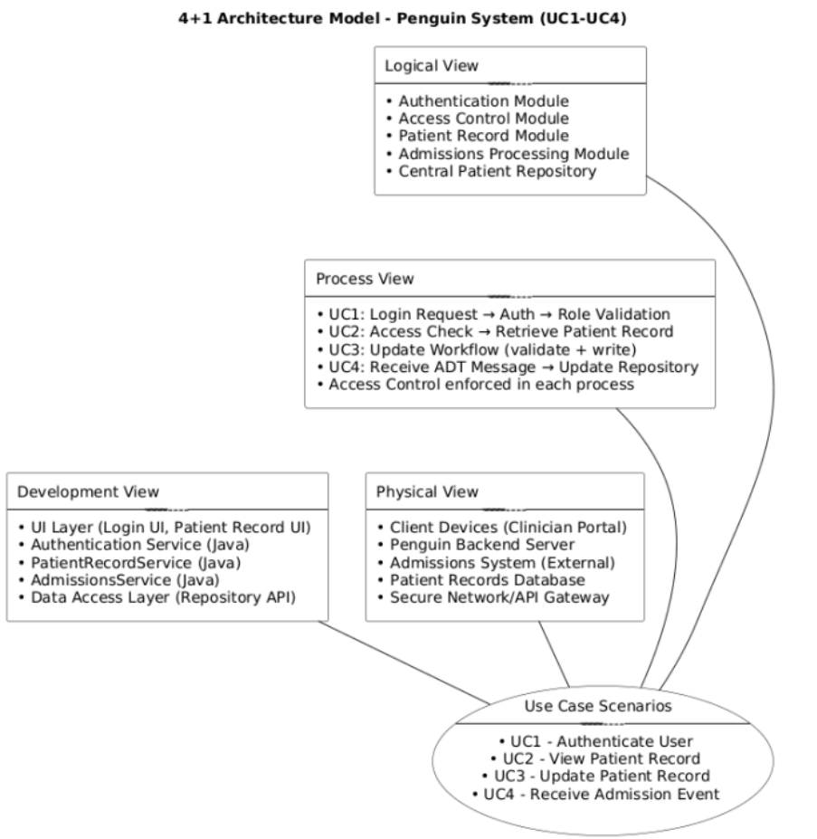

Database Specification and analysis

Database (Mysql)
Operator | [Primary Key] long id | Enum Type | String Username | String PasswordHash | Date dob | Enum gender | String notes
Patient | [Primary Key] long id | String Username | String PasswordHash | Date dob | Enum sex | Enum gender | String healthConcerns | String notes
Medical Record | [Primary Key] long id | [Foreign Key] long patientId | [Foreign Key] long operatorId | [Foreign Key] long appointmentId | string notes | Date date | Time time
Prescriptions | [Primary Key] long id | [Foreign Key] long patientId | [Foreign Key] long operatorId | [Foreign Key] long medicalRecordId | [Foreign Key] long medicationId | long dose | Date prescribedDate | Boolean renew | Time renewalTime
Lab Reports | [Primary Key] long id | [Foreign Key] long patientId | [Foreign Key] long operatorId | [Foreign Key] long medicalRecordId | Enum type | Date date | String results
Apointment | [Primary Key] long id | [Foreign Key] long patientId | [Foreign Key] long operatorId | Date date | Time time | Enum Type | String Notes
Medication | [Primary Key] long id | String name | String brandName | Enum Type | Enum doseType | long safeDose | String sideEffects

Implementation

Technologies:
Backend: Spring Boot REST API (Java)
Frontend: React

Use Case Number | UC – 1
Use Case Name | Authenticate user
Actors | Clinician, Nurse, Patient, Admin
Description | The user logs into the system, and their credentials are validated to determine their access permissions if authentication is successful.
Alternate Path | If authentication fails due to invalid credentials, the system displays an error and prompts for re-entry. After three failed attempts, the account is temporarily locked.
Precondition | The user must be registered in the system and have valid credentials stored in the database.

Use Case Number | UC – 2
Use Case Name | View Patient Record
Actors | Clinician, Nurse, Patient
Description | The actor retrieves a patient’s medical record, including demographics, history, medications, and test results.
Alternate Path | If the patient record does not exist or access is denied due to insufficient permissions, the system displays an error message.
Precondition | The user must be authenticated and have permission to access the requested patient’s data.

Use Case Number | UC – 3
Use Case Name | Update Patient Record
Actors | Clinician, Nurse
Description | The actor updates patient records with new information such as diagnoses, prescriptions, or treatment progress.
Alternate Path | If validation fails, like missing fields, the update is rejected, and the user is prompted to correct errors.
Precondition | The actor must be logged in and authorized to modify clinical data.

Use Case Number | UC – 4
Use Case Name | Admission notifications
Actors | Admissions System, Clinician
Description | The system receives and processes admission, discharge, or transfer messages and updates patient encounter details.
Alternate Path | If an admission message is malformed or duplicated, the system rejects it and logs an error for administrative review.
Precondition | The Admissions subsystem must be integrated and configured to send standardized Admission Discharge Transfer messages.

Testing

Use Case 1 & 2 Test Cases: Authentication & View Patient Records
UC-1 Authenticate User
Functionality:
User Login Authentication ensures system validates user credentials (username/email and password) and grants or denies access based on authentication success.
Input Parameter | Equivalence Classes | Description/Constraints
Username | Empty  Valid length (5–12 chars)  Too short (<5)  Too long (>12)  With specials chars (allowed: _, ., -) | Username must be between 5 – 12 characters. Only _, . , and – are allowed as special characters.  Must use either username or email, not both
Email (optional login) | Valid format (e.g., user@domain.com)  Invalid format (missing @ or .)  Empty | Used as alternative login credential.  Format must follow RFC 5322 compliance  Must use either username or email, not both
Password | Empty  Valid length (8 – 16 characters)  Too short (<8)  Too long (>16)  Includes allowed special characters (!@#$%) | Password must be between 8 – 16 characters and can include letters, numbers, and approved specials characters.
Login Attempts | 0 – 2 (Valid), 3 (Boundary), >3 (Locked) | Tracks failed login attempts for lockout policy enforcement

Boundary Value Tests
- Username with 2 characters → Below minimum length
- Username with 5 characters → At lower boundary
- Username with 12 characters → At upper boundary
- Username with 13 characters → Exceeds upper boundary
- Password with 7 characters → Below minimum length
- Password with 8 characters → At lower boundary
- Password with 16 characters → At upper boundary
- Password with 17 characters → Exceeds upper boundary
- Email format tests: user@example.com → Valid; userexample.com, user@com, @example.com → Invalid
- Login attempts at 2, 3, and 4 → Validate lockout thresholds

Feature: Validate username/email and password combinations with length, format, and lockout rules.
Input Combinations: Include valid, invalid, and boundary entries for authentication.
Test ID | Input Condition | Expected Output | Remarks
UC1-T1 | Valid username (5 chars) and valid password (10 chars) | Successful login | Nominal case
UC1-T2 | Username 2 chars (<3) | Error: “Username too short” | Boundary – lower limit
UC1-T3 | Username with 13 characters (>12) | Error: “Username too long” | Boundary – upper limit
UC1-T4 | Password 7 chars (<8) | Error: “Password too short” | Boundary – lower limit
UC1-T5 | Password 17 chars (>16) | Error: “Password too long” | Boundary – upper limit
UC1-T6 | Valid username with invalid email format userexample.com | Error: “Invalid email address” | Equivalence – invalid format
UC1-T7 | Valid email user@mail.com, valid password | Successful login | Valid email credential
UC1-T8 | Username with invalid special character user@name | Error: “Invalid character in username” | Input constraint
UC1-T9 | Password with allowed special chars (Pa$$word!) | Successful login | Valid password class
UC1-T10 | 3 consecutive failed logins | Account locked | Boundary – lockout threshold
UC1-T11 | Call Administrator/IT,  Verify ID, Login after lockout timeout expires | Access restored, prompt for credentials | Boundary – lockout recovery

UC-2: View Patient Record
Functionality:
Retrieve and display a patient’s record, including demographics, history, medications, and test results, based on access permissions.
Input Parameter | Equivalence Classes | Description / Constraints
Patient ID | Valid / Invalid / Non-existent / Boundary (max 12 chars) | Patient IDs must be 5–12 alphanumeric characters.
User Role | Clinician / Nurse / Patient / Unauthorized Role | Defines access permissions
Session Status | Active / Expired | Session must be active for access

Boundary Value Tests

- Test Patient ID length = 5 (minimum)
- Test Patient ID length = 12 (maximum)
- Test Patient ID length = 13 (beyond limit)
- Test Expired session access → must redirect to login
- Test Role boundaries: Nurse tries to access Clinician-only data, Patient accesses own vs. others’ record

Feature: Retrieve patient record while validating permissions and session state.
Test ID | Input Condition | Expected Output | Remarks
UC2-T1 | Clinician requests valid Patient ID (5 or more chars) | Record retrieved successfully | Nominal case
UC2-T2 | Patient requests another patient’s record | Access denied | Permission violation
UC2-T3 | Invalid Patient ID | Error: “Record not found” | Invalid class
UC2-T4 | Patient ID exceeds 12 chars | Validation error | Boundary – ID limit
UC2-T5 | Valid Patient ID but session expired | Redirect to login | Boundary – session timeout
UC2-T6 | Nurse accesses restricted section | Partial access or error | Permission edge
UC2-T7 | Clinician with active session requests record at boundary ID (12 chars) | Record retrieved successfully | Boundary – upper valid ID length

1. Creating Testing environment and Test Cases
o Prepare the Testing Environment : Identify the appropriate Unite test framework for the languages / technology you chose to implement your design.
The backend of the Penguin Healthcare Solutions platform is developed using Java, Spring Boot, and Gradle, and therefore JUnit 5 is a natural choice for the unit test framework. JUnit is the default unit test framework for applications written on Java, and Spring Boot supports it fully using the spring-boot-starter-test dependency. JUnit 5 was decided as the main testing framework for unit testing for this project.
6.1(a) Installing the Testing Framework
For this project, the backend is built in Java with Gradle, which is a recommended unit-testing framework for Java. Since Gradle is already setup to build the backend, the only thing needed to add JUnit is to configure the build.gradle and make sure Gradle can run the tests.
Step 1 – Open the Backend Project in VS Code
- Launch Visual Studio Code.
- Click File → Open Folder.
- Select the project folder:
penguin-healthcare-solutions
Step 2 – Verify JUnit Dependencies in build.gradle
JUnit comes preconfigured in the project.
Inside build.gradle, the following testing dependencies were already included:
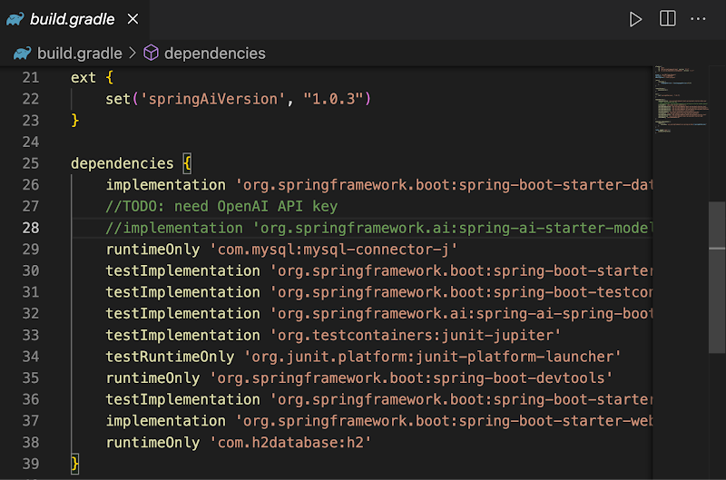
build.gradle dependencies, this confirms that JUnit 5 is installed through Gradle.
Step 3 – Run Tests to Confirm JUnit Installation
- Go to View → Terminal
- This opens the integrated terminal at the bottom of VS Code.
- On MacOS, run:
./gradlew test
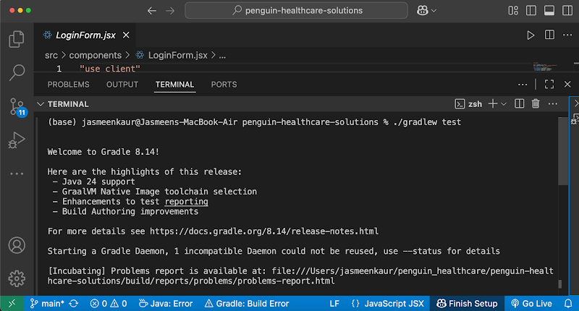
6.1(b) Requirements-Based Functional Testing
1. Identifying Features (Functionality Related to Main Use Cases)
The two major use cases selected for testing from the Penguin Healthcare Solutions system are:
- Feature F1 – User Authentication (Login)
Function signature (conceptual):
authenticate(username, password)
- Feature F2 – Patient Record Retrieval
Function signature (conceptual):
getPatientRecord(patientId)
These represent the core system functionalities used by both patients and administrators.
2. Partition Inputs into Equivalence Classes
Input Parameter | Valid Class | Invalid Classes
Username | Existing Username | Non-existing username / Empty username
Password | Correct password | Incorrect password / Empty password
Equivalence Classes for Login:
- EC1: Valid username + valid password
- EC2: Valid username + invalid password
- EC3: Invalid username
- EC4: Empty username or password
Feature F2 – View Patient Record (getPatientRecord)
Input Parameter | Valid Class | Invalid Classes
patientId | Existing patient ID | Non-existing ID / Invalid format / Empty value
Equivalence Classes for Patient Record:
- EC5: Existing patient ID
- EC6: Non-existing patient ID
- EC7: Invalid ID format (empty string, special characters)
3. Test Specification (Based on Each Equivalence Class)
For Feature F1 – Login
- TS1: authenticate(valid username, valid password)
- TS2: authenticate(valid username, wrong password)
- TS3: authenticate(unknown username, any password)
- TS4: authenticate("", "")
For Feature F2 – Patient Record
- TS5: getPatientRecord(existing ID)
- TS6: getPatientRecord(non-existing ID)
- TS7: getPatientRecord(invalid format)
3. Test Specification (Based on Each Equivalence Class)
For Feature F1 – Login
- TS1: authenticate(valid username, valid password)
- TS2: authenticate(valid username, wrong password)
- TS3: authenticate(unknown username, any password)
- TS4: authenticate("", "")
For Feature F2 – Patient Record
- TS5: getPatientRecord(existing ID)
- TS6: getPatientRecord(non-existing ID)
- TS7: getPatientRecord(invalid format)
4. Test Cases
Test ID | Feature | Input Class | Test Input | Expected Output
T1 | Login | EC1 – Valid credentials | username = "admin", password = "12345" | Login successful, returns user session
T2 | Login | EC2 – Wrong password | username = "admin", password = "wrong" | Authentication fails
T3 | Login | EC3 – Username does not exist | username = "unknown", password = "test" | “User not found” error
T4 | Login | EC4 – Empty fields | username = "", password = "" | “Invalid input” error
T5 | Patient Record | EC5 – Existing patient ID | patientId = "P001" | Returns patient record object
T6 | Patient Record | EC6 – Non-existing ID | patientId = "P999" | “Record not found”
T7 | Patient Record | EC7 – Invalid ID format | patientId = "" | “Invalid ID format” error

Appendix

GitHub Repository: https://github.com/ddulmai1/penguin-healthcare-solutions

Code Documentation

Penguin Healthcare Solutions — Project Documentation

This document provides complete setup, installation, and run instructions for the project across macOS, Windows, and Linux. It also documents how the frontend connects to the backend server.

Clone from GitHub
You can clone the repository using HTTPS, SSH, or GitHub CLI.
HTTPS
```bash
git clone https://github.com/ddulmai1/penguin-healthcare-solutions.git
cd penguin-healthcare-solutions
```
GitHub CLI
```bash
gh repo clone ddulmai1/penguin-healthcare-solutions
cd penguin-healthcare-solutions

Code Contents
- Full source code available in this repository under:
- `src/` (frontend and backend source)
- `bin/` (utility scripts)
- Setup script: `bin/setup.sh` (macOS/Linux)

Architecture Overview
- Backend: Spring Boot REST API (Java)
- Frontend: React

Directory Structure (Key Files)
penguin-healthcare-solutions/
├── build.gradle
├── settings.gradle
├── gradlew / gradlew.bat
├── package.json
├── bin/
│ └── setup.sh
├── docs/
│ └── Documentation.md
├── public/
│ └── index.html
├── src/
│ ├── main/
│ │ ├── java/com/SWE_Team_Penguin/Penguin_Healthcare_Solutions/
│ │ │ ├── PenguinHealthcareSolutionsApplication.java
│ │ │ ├── controller/
│ │ │ ├── model/
│ │ │ ├── repositories/
│ │ │ └── services/
│ │ └── resources/
│ │ └── application.properties
│ ├── test/
│ │ └── java/com/SWE_Team_Penguin/Penguin_Healthcare_Solutions/
│ ├── components/
│ │ ├── AppointmentScheduler.jsx
│ │ ├── AdmissionsNotifications.jsx
│ │ ├── PrescriptionForm.jsx
│ │ ├── PatientRecordView.jsx
│ │ ├── UpdatePatientRecord.jsx
│ │ ├── dashboard.jsx
│ │ └── LoginForm.jsx
│ ├── services/
│ │ ├── appointmentsService.js
│ │ ├── prescriptionsService.js
│ │ ├── admissionsService.js
│ │ └── authService.js
│ ├── data/
│ │ └── mockPatientData.js
│ ├── App.jsx
│ └── index.js
└── gradle/wrapper/gradle-wrapper.properties
```

Prerequisites
- Java JDK 17+ (OpenJDK recommended)
- Gradle Wrapper (included: `gradlew` / `gradlew.bat`)
- Node.js 18+ and npm

macOS (zsh)
- Optional installers via Homebrew:
```bash
brew install openjdk@17
brew install node
```
- One-time setup:
```bash
chmod +x bin/setup.sh
./bin/setup.sh
```
- Run backend:
```bash
./gradlew bootRun
```
- Run frontend:
```bash
npm install # or npm ci
npm run start
```
- URLs:
- Backend: `http://localhost:8080`
- Frontend: `http://localhost:3000`

Windows (PowerShell)
- Install JDK 17+ (Temurin/Adoptium or Oracle) and add `JAVA_HOME`/PATH.
- Install Node.js 18+ from nodejs.org.
- Verify tools:
```powershell
java -version
node -v
npm -v
```
- Install frontend deps and run:
```powershell
npm ci # or npm install
npm run start
```
- Run backend:
```powershell
./gradlew.bat bootRun
```
- URLs:
- Backend: `http://localhost:8080`
- Frontend: `http://localhost:3000`

Linux (bash)
- Install JDK 17+ and Node.js via your distro:
```bash
sudo apt update && sudo apt install -y openjdk-17-jdk nodejs npm # Debian/Ubuntu
or
sudo dnf install -y java-17-openjdk nodejs npm # Fedora
```
- Verify tools:
```bash
java -version
node -v
npm -v
```
- Install deps and run:
```bash
npm ci # or npm install
npm run start
```
- Run backend:
```bash
./gradlew bootRun
```
- URLs:
- Backend: `http://localhost:8080`
- Frontend: `http://localhost:3000`

## Connecting Frontend to Backend
- Frontend services call the backend at `http://localhost:8080` (see `src/services/*.js`).
- Start the backend before using routes that require authentication or server data.

Demo Mode (No Backend Required)
- Demo routes allow testing without the backend:
- `http://localhost:3000/patient-record-demo`
- `http://localhost:3000/admissions-demo`
- Demo mode uses mock data and bypasses authentication.

Available Routes
- `/` — Login (backend required)
- `/dashboard` — App dashboard
- `/patient-record` — Patient record viewer (backend required)
- `/patient-record-demo` — Patient record viewer (demo)
- `/admissions` — ADT submission (backend required)
- `/admissions-demo` — ADT submission (demo)
- `/update-patient` — Update medical information (backend required)
- `/update-patient-demo/P001` (also P002, P003) — Update medical information (demo)
- `/appointments` — Schedule/manage appointments (backend required)
- `/appointments-demo` — Appointments (demo)
- `/prescriptions` — Create e-prescriptions (backend required)
- `/prescriptions-demo` — Prescriptions (demo)

Test Credentials
- Admin: `admin` / `12345`
- Clinician: `Rita` / `pass`

Demo: https://docs.google.com/videos/d/1pA4R4Pp4tKcPJvseUCcZls805RhUSwbjCT2D2fRVjP0/play

