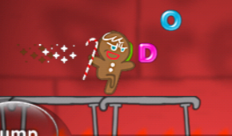

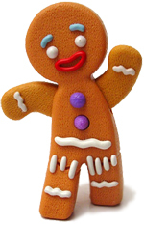

var Cat=new animal("Cat");

VM95:1 Uncaught ReferenceError: animal is not defined

at <anonymous>:1:13

(anonymous) @ VM95:1

Cat.go_left();

VM114:1 Uncaught TypeError: Cannot read property 'go_left' of undefined

at <anonymous>:1:4

(anonymous) @ VM114:1

Cat.display();

VM132:1 Uncaught TypeError: Cannot read property 'display' of undefined

at <anonymous>:1:4

(anonymous) @ VM132:1

Cat.speak=function(){ document.writeln("Cat says Meoow!")};

VM251:1 Uncaught TypeError: Cannot set property 'speak' of undefined

at <anonymous>:1:10

(anonymous) @ VM251:1