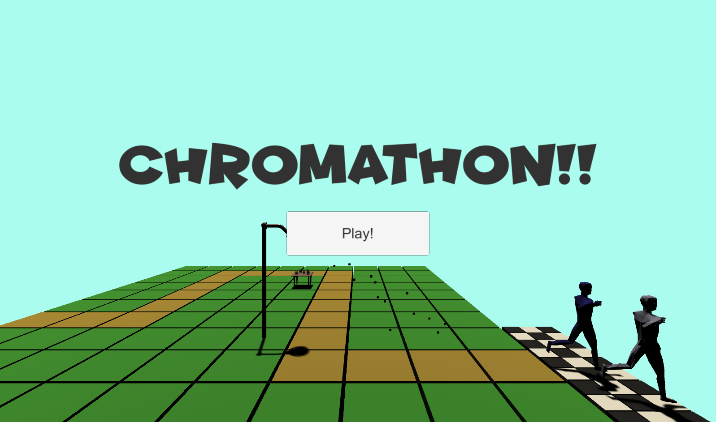

Chromathon is a tower defense game in which you attempt to help the Chromarunners finish their race. The Chromarunners aren’t so good at running, so you have to help them by placing drink stands and showers along the way to keep them cool and hydrated. If a Chromaunner gets too hot or dehydrated, they will be disqualified from the race. If less than 50 Chromarunners get disqualified, you did a great job organizing your race! Otherwise, you lose. You can tell how the Chromarunners are doing by checking their color. A red or pink Chromarunner needs to cool down, and a blue Chromarunner needs some water. Upgrade the drink stands to replenish the racers’ electrolytes and make them run faster!

