Bob Massey and David Wilson


a dying dream in four acts

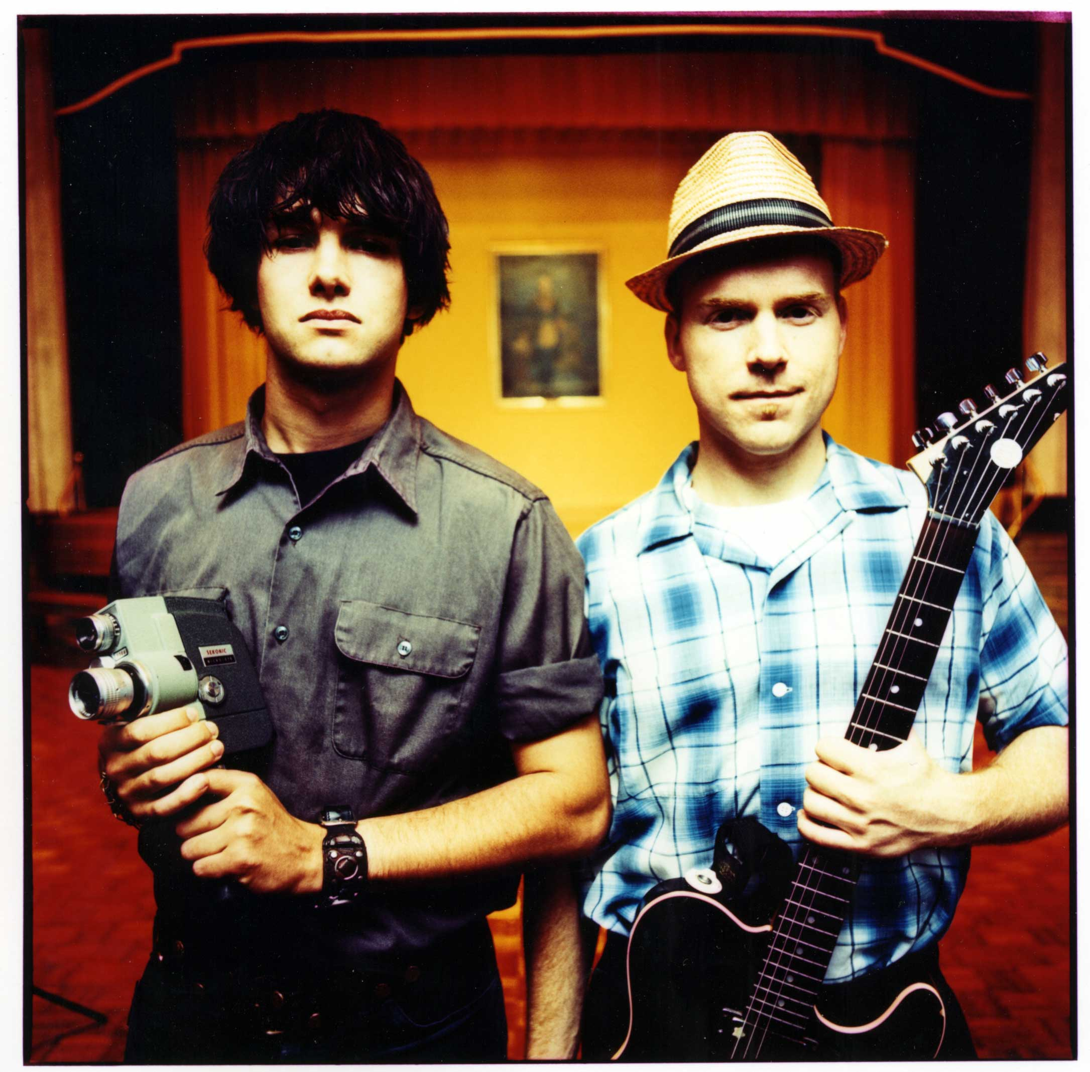

AN INTRODUCTION

