Overview
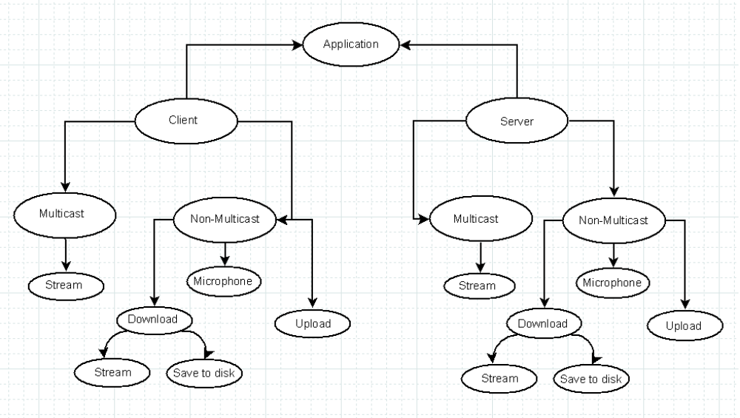
Application
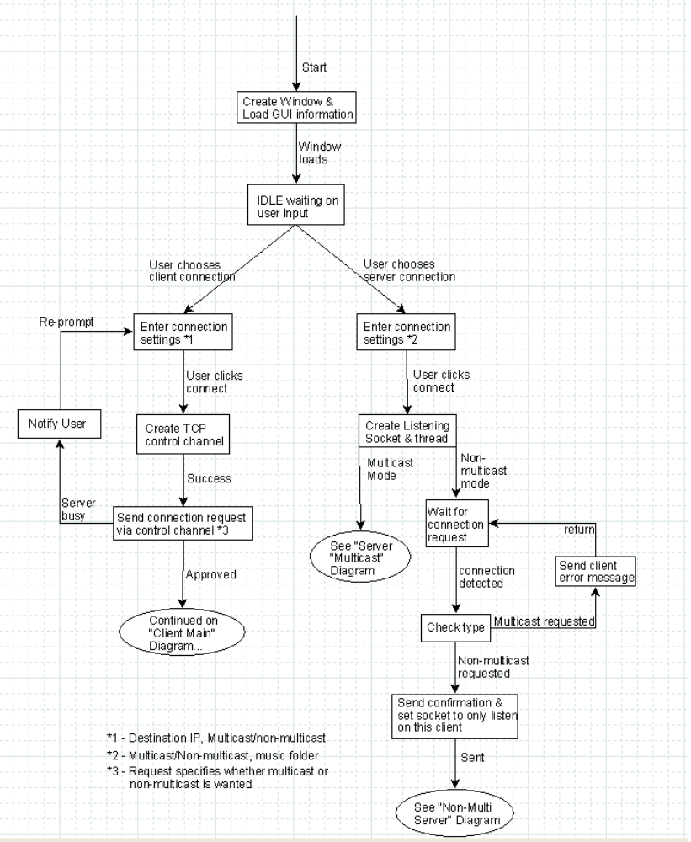
Client Download
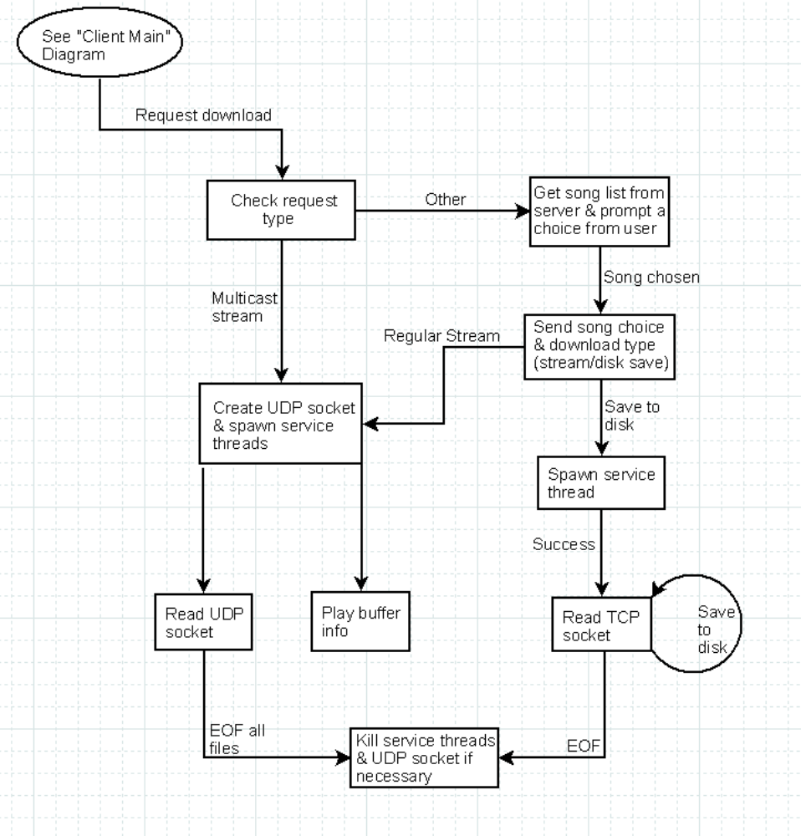

Client Main
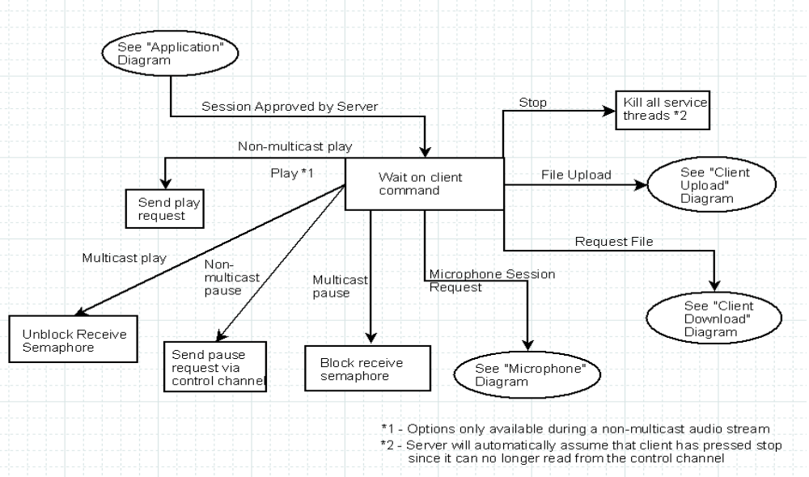
Non-multi cast server
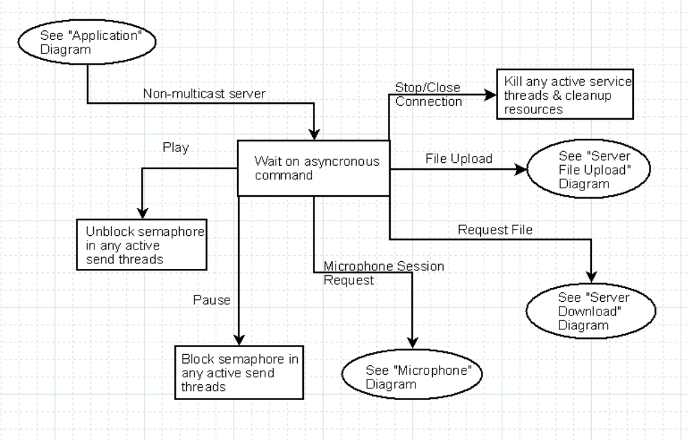
Microphone

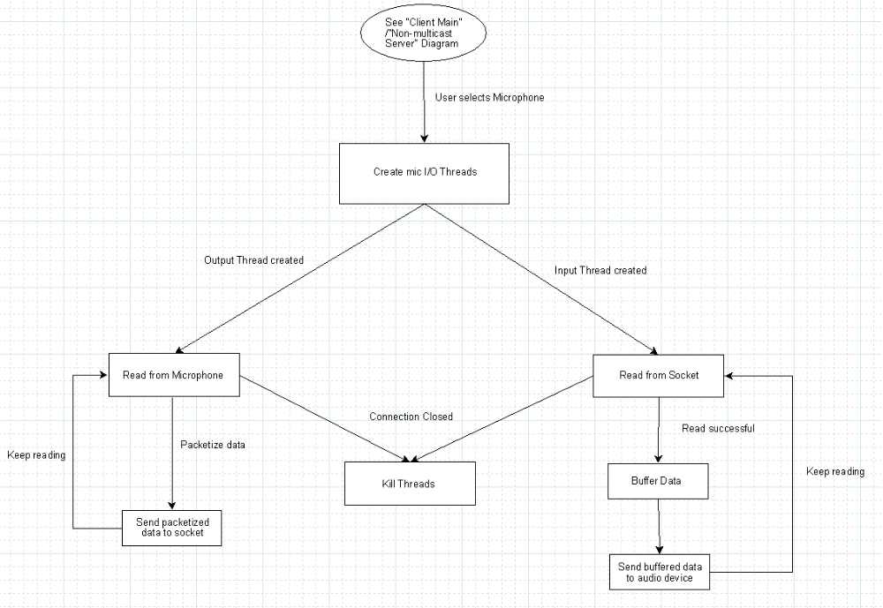
Multi cast Server

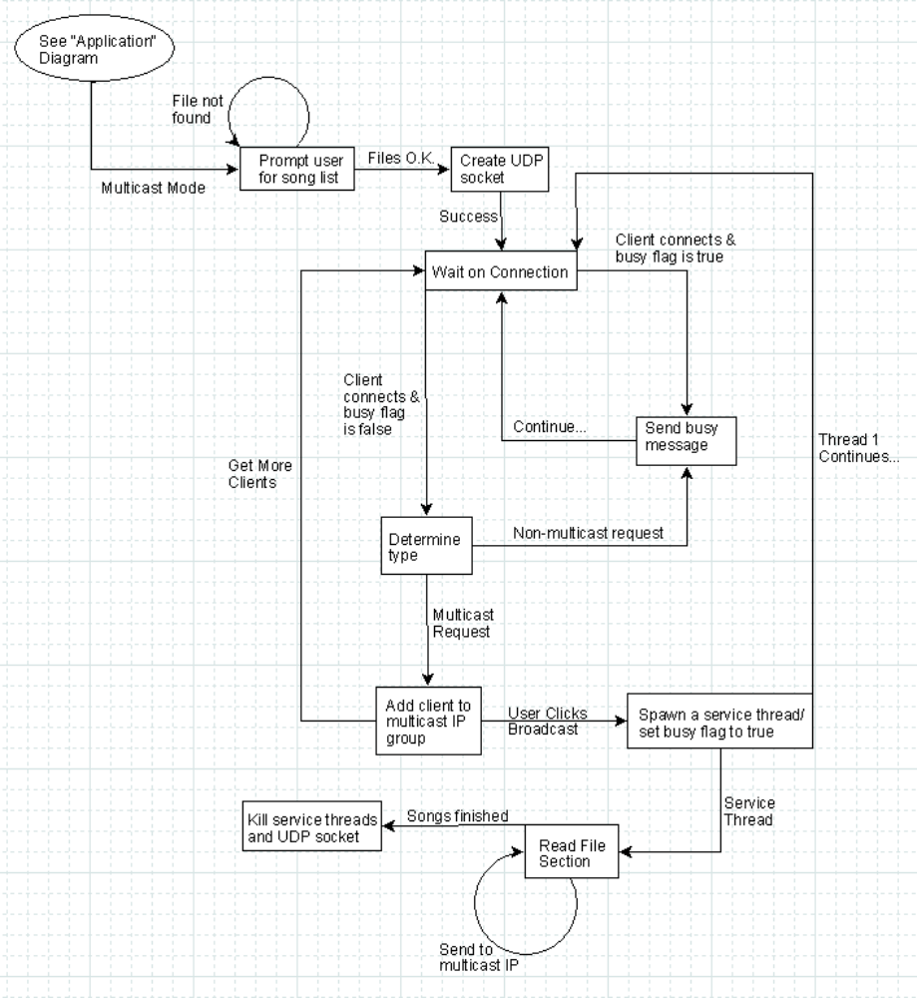
Server Download
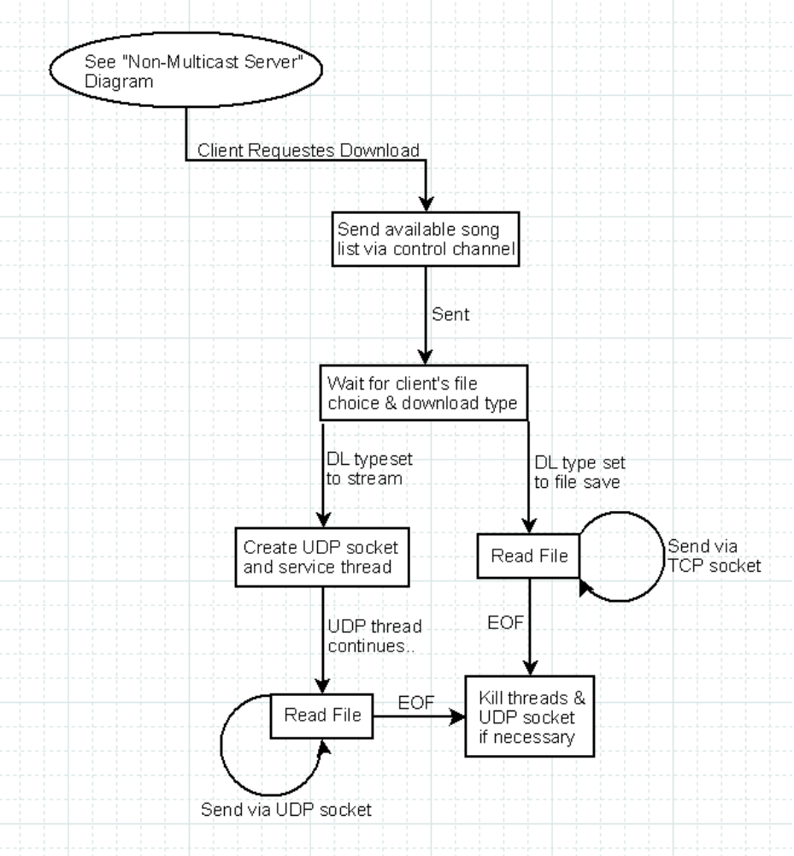
Upload
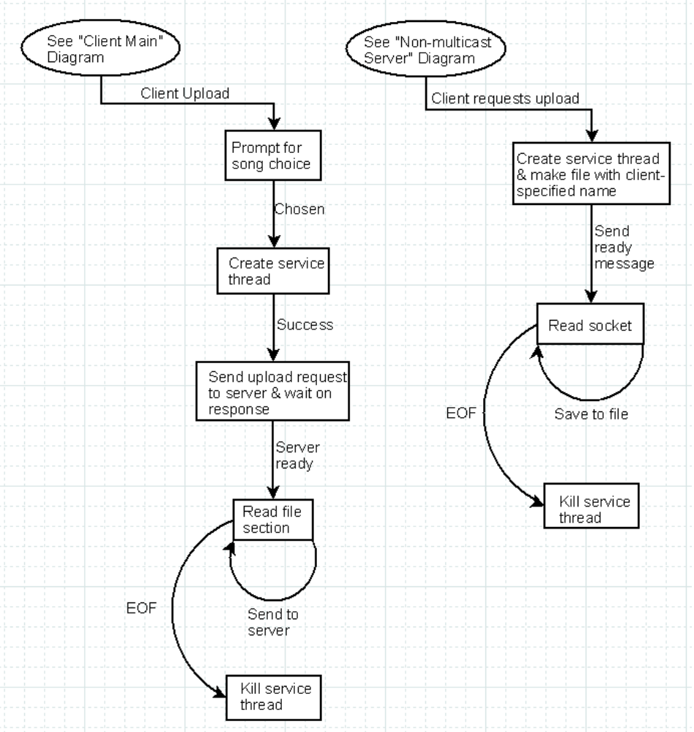

Application
Main start
set the window properties
register the window properties
create the window
enter wndProc message loop
Main end

wndProc start
allowable messages:
WM_CREATE:
initialize any data structures necessary for tracking state information
enable/disable GUI items as necessary
WM_SIZE
move main window
move all child windows
WM_PAINT
redraw the window items & text fields
WM_COMMAND
call handle_inputs function
wndProc end

handle_inputs start
input messages:
connection choice:
if server, set type to server
if client, set type to client

connect button:
get connection settings from the text fields
if settings are set to multicast server:
call serverMulticast function
if settings are set to non-multicast server:
listen for client connection request
on connection, check the request type:
if muticast requested:
send error message & continue listening
if non-multicast requested:
send confirmation & set socket to listen to only this client
call nm_server function
if settings are set to client:
create a TCP control channel
send a connection request to the server via the control channel
if server is busy or connection type does not match:
notify the user and re-prompt connection settings
if server approves the session:
call client_main function
handle_inputs end

Client Main
client_main start
user inputs/requests:
Non-Multicast Play (only available during a stream)
send play request to server via control channel
Non-multicast Pause
send pause request to server via control channel
Multicast Play
unlbock receive semaphore
Multicast Pause
block receive semaphore
File Upload
call client_upload function
Microphone Session
send microphone request to server via control channel
if accepted
call microphone function
Request File
call client_download function
Stop
kill all service threads & UDP socket (if exists)
client_main end

Non-Multi Server
nm_server start
client requests:
Play
unblock send semaphore
Pause
block send semaphore
Stop/Close connectoin
kill all send threads
cleanup resources (such as sockets)
Request File
call server_download function
File Upload
call server_upload function
Microphone
call microphone function
nm_server end

Upload
server_upload start
create file with specified name
create service thread
send ready message
while not EOF
read socket data and save to the file
kill service thread
server_upload end

client_upload start
create service thread
prompt for file choice
create service thread
send upload request //wait for response

while not EOF
read file & send data over control channel //TCP
kill service thread
client_upload end

Microphone
microphone start
Create input thread
Create output thread
microphone end

input thread start
Open socket
if open successful
read while connection active
add data to buffer
play buffer
input thread end

output thread start
Open socket
If open successful
Read while play button active
Packetize buffer
Send packetized buffer to socket
output thread end
Client Download
client_download start
if request is multicast:
call udp_services function
if request is non-multicast:
get song list from the server
prompt the user to choose a song from the list
send the server our song choice & download type (TCP/UDP)
if we want to stream (UDP):
call udp_services function
if we want to save to disk (TCP):
create a service thread
service thread:
read the TCP socket, storing it to a buffer
save buffer data to file
if EOF is found:
kill service thread
client_download end

udp_services start
create UDP socket
create service threads
thread 1:
play information stored in buffer
thread 2:
read UDP socket & store in buffer
if we have read to EOF on all files
kill service threads
kill UDP socket
udp_services end

Server Download
server_download start
Send song list via control channel
wait for response
if response is ‘stream’
create stream thread
if response is ‘download’
create save thread
server_download end

Stream thread start
create & bind UDP socket
loop reading contents from file
store in buffer
send buffer to UDP socket
if EOF
close socket
Stream thread end

Save thread start
create & bind TCP socket
loop reading contents from file
store in buffer
send buffer to TCP socket
if EOF
close socket
Save thread end
Multicast Server
serverMulticast start
prompt user for song list
if the file isn't found:
re-prompt
create UDP socket
wait for a client to connect until the user clicks broadcast
client connects and busy flag is set to true:
send a busy message to that client
client connects and busy flag is set to false:
if client's request is for a non-multicast session
send a busy message to that client
if client's request is for a multicast session
add the client's IP to the multicast IP group
continue getting more clients

set the busy flag to true
spawn a service thread
loop copying sections of file to the buffer
send buffer information to the multicast IP group
when all songs are finished:
kill service thread
close UDP socket & resources
serverMulticast end

