Лабораторная работа 3

Example: Create two tasks and a queue in FreeRTOS system. One task detects the number of button presses and sends them to the queue, and the other task is responsible for turning the LED light on or off based on the message received from the queue.

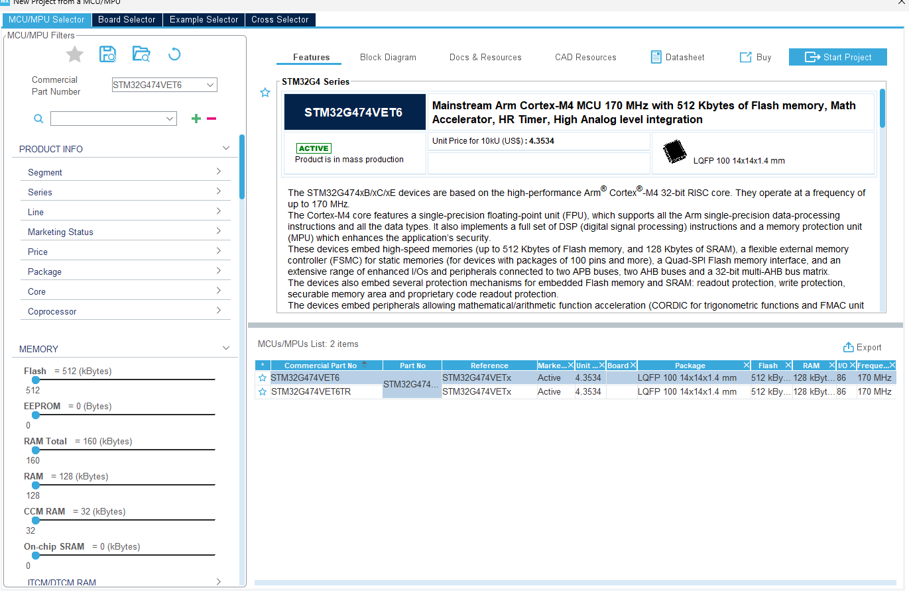

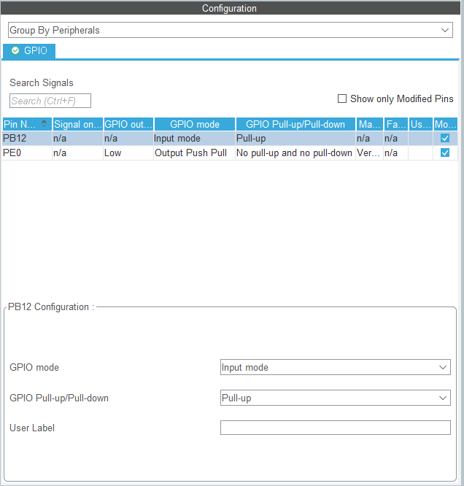
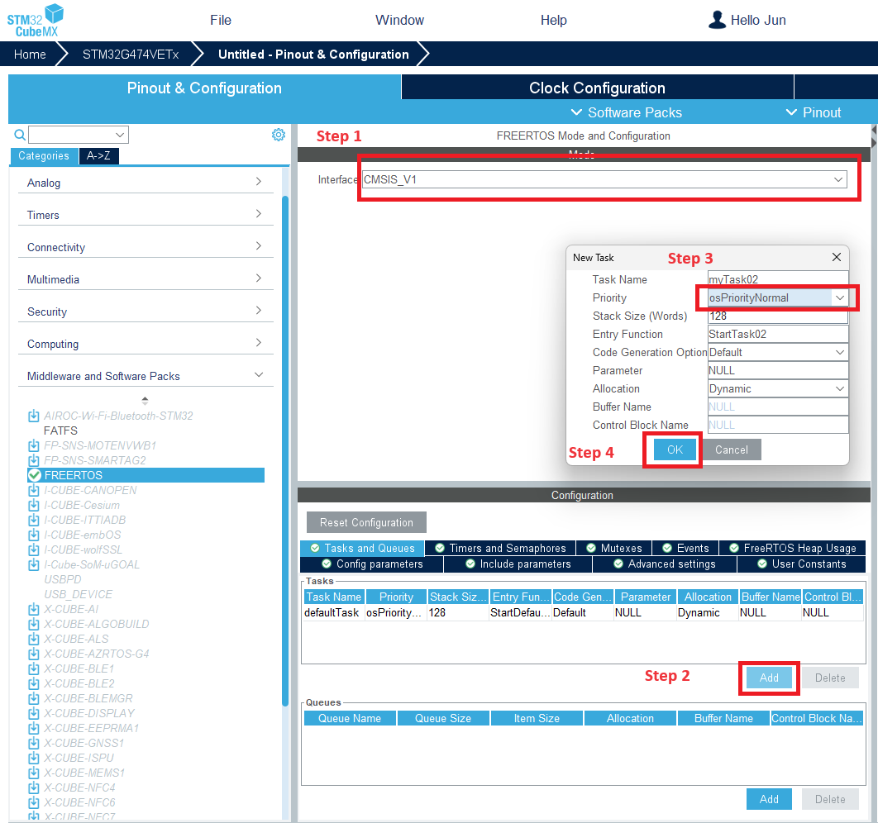

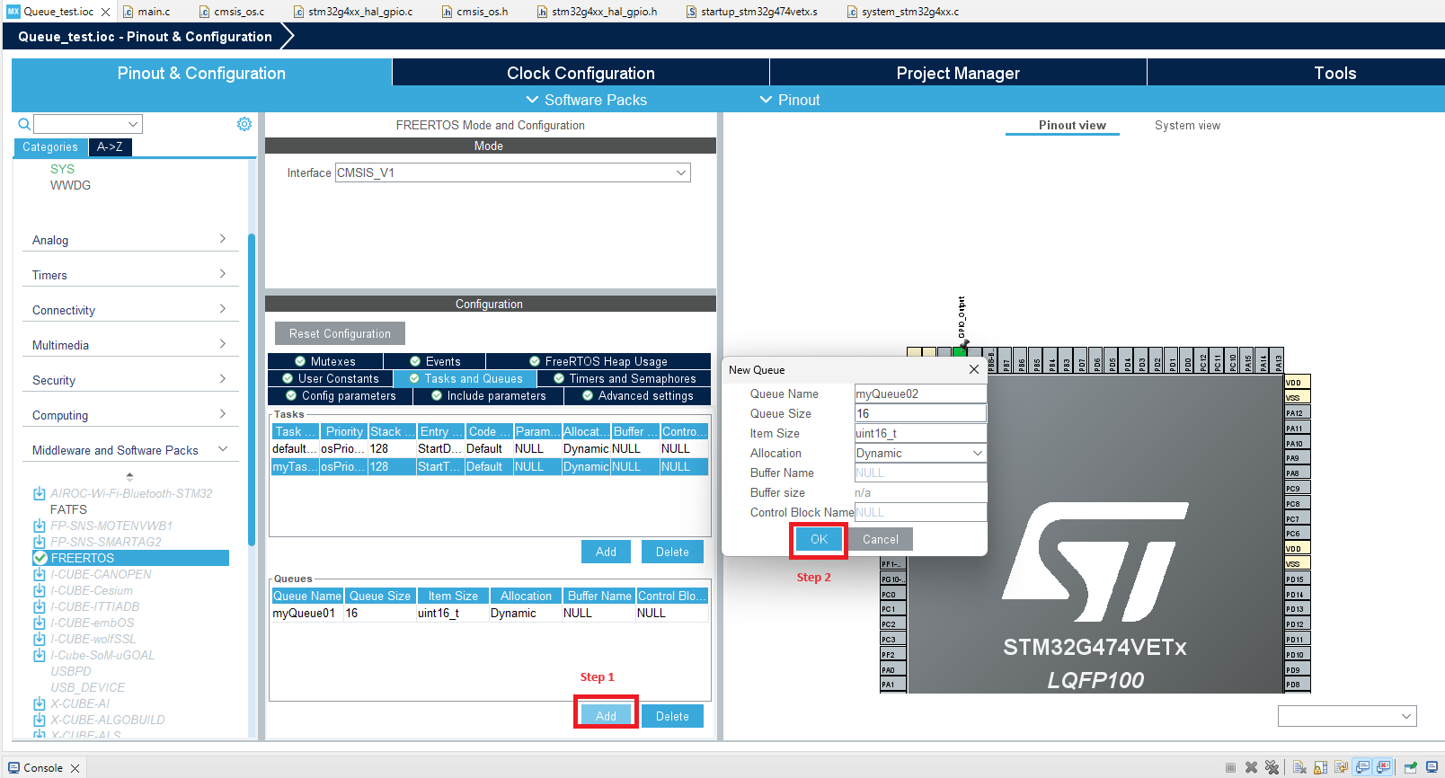
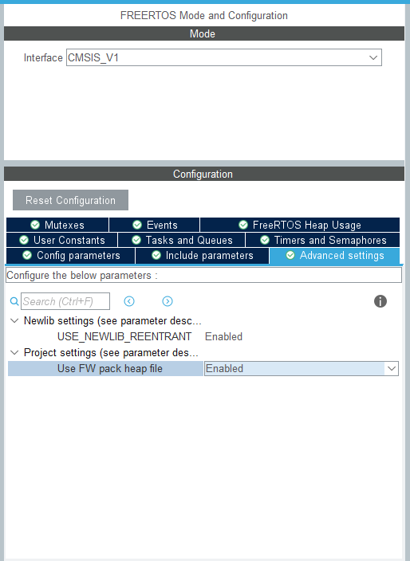

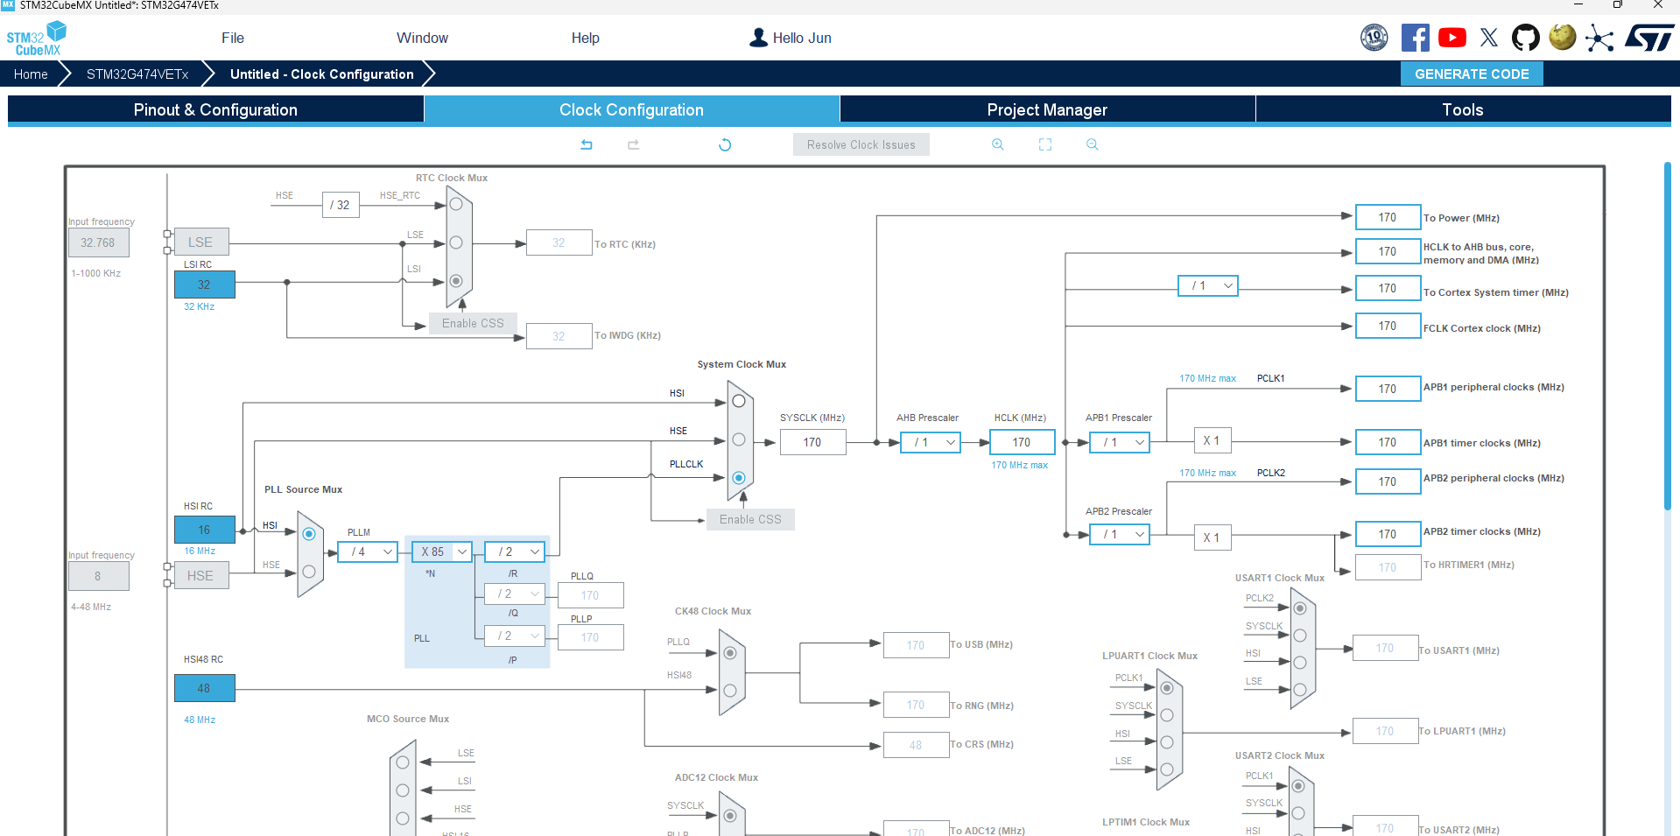

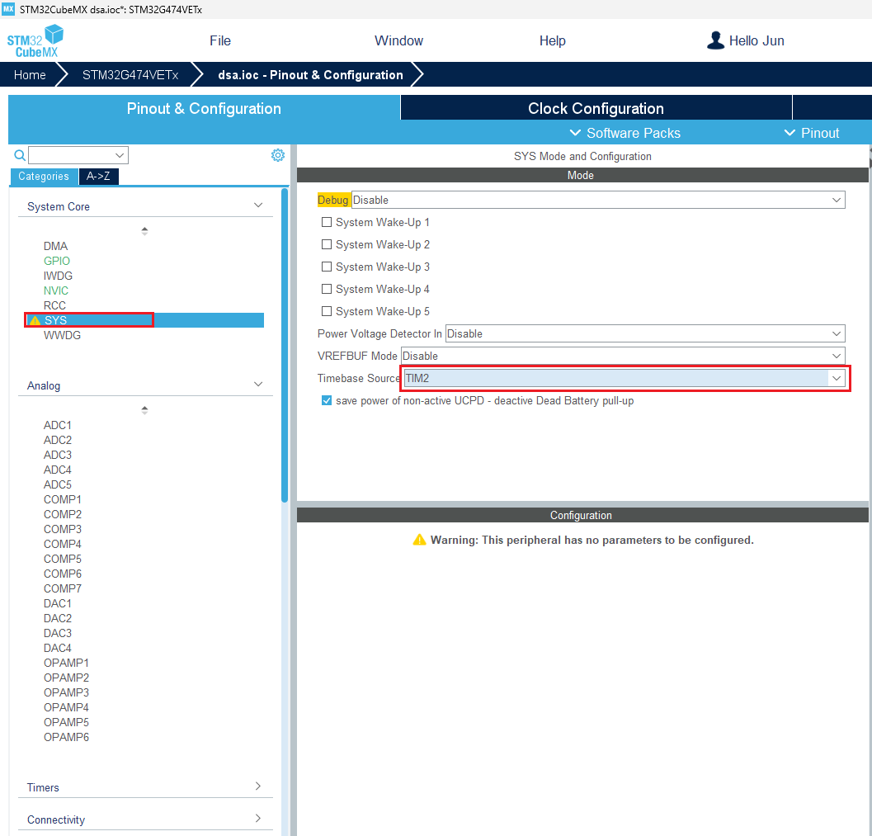

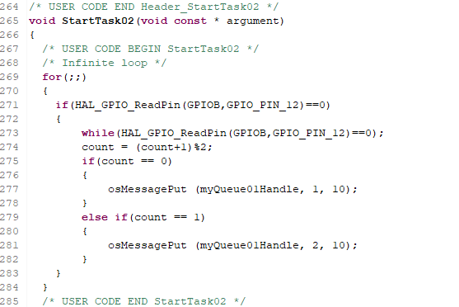

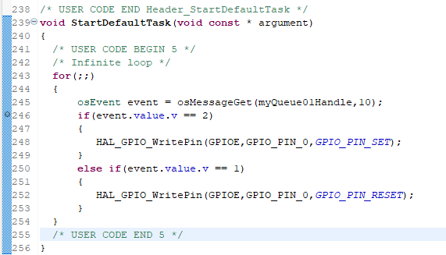

Задача:
Create one set of flowing Led lights (the default frequency is 10HZ), configure three buttons A, B and C. button A is the start/stop button. B button increase the speed of the flowing Led lights. C button decrease the speed of the flowing Led lights.

