Lab work 4
- Setting the LED PE0-PE9 as output (as previous works).
- Conduct the Clock configure (as previous works).
- Setting the SyS
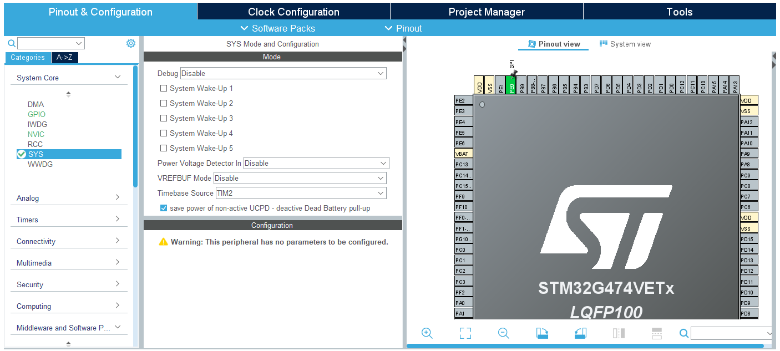
- Create two tasks in FreeRTOS
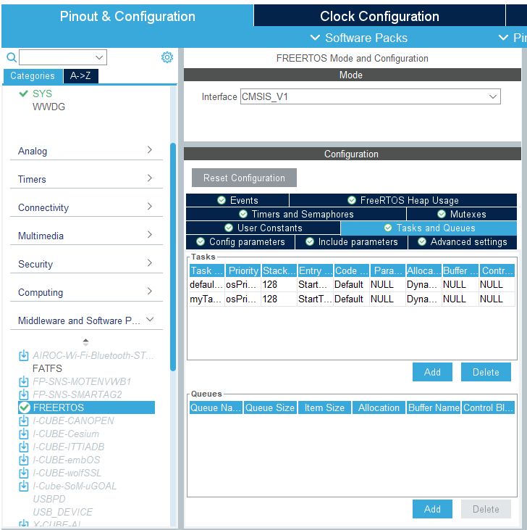
- Conduct the advanced setting as following:
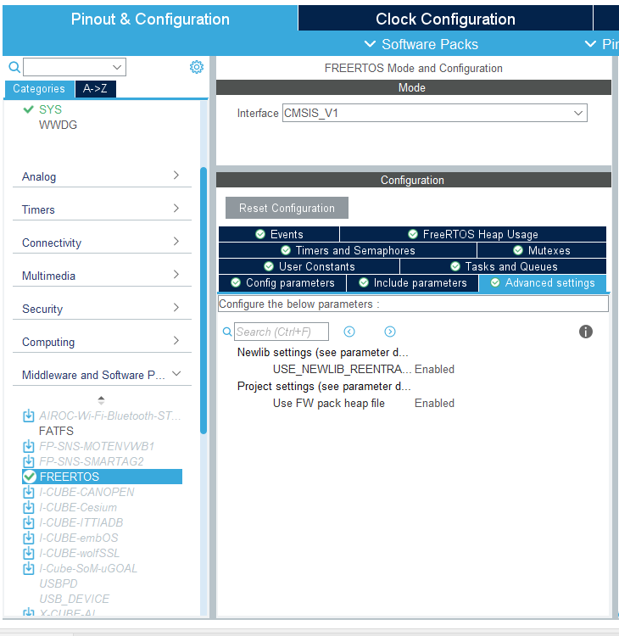
- Adding Semaphore:
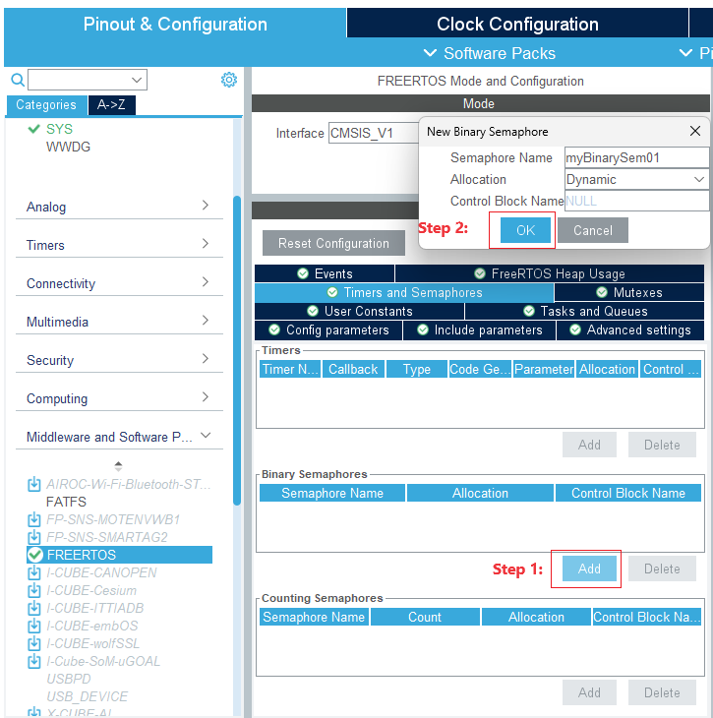
After configuration, we can obtain:
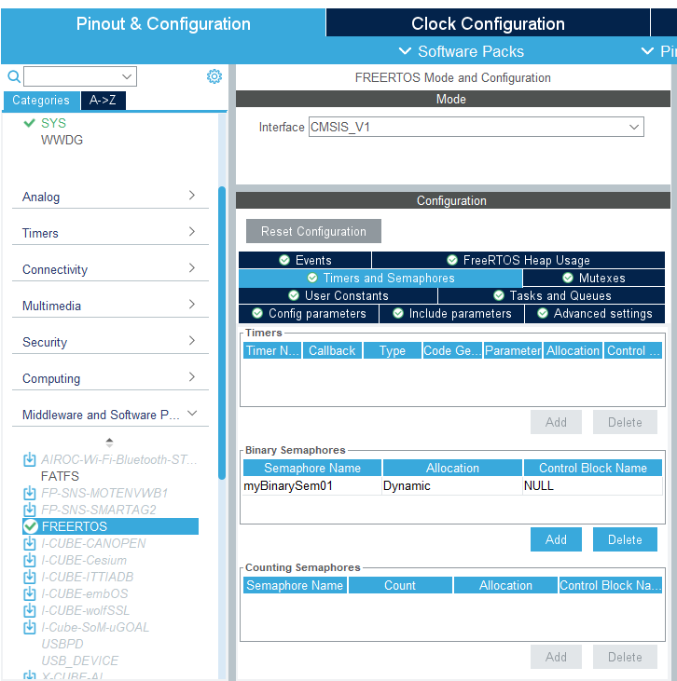
- Write the code in two tasks.
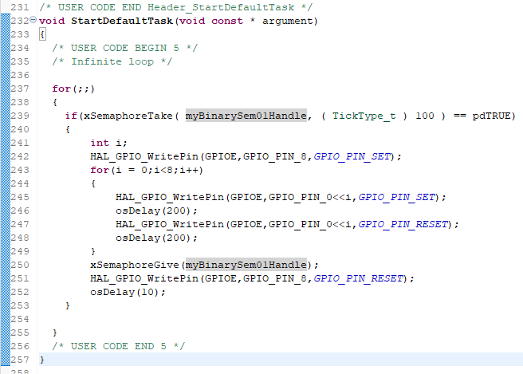

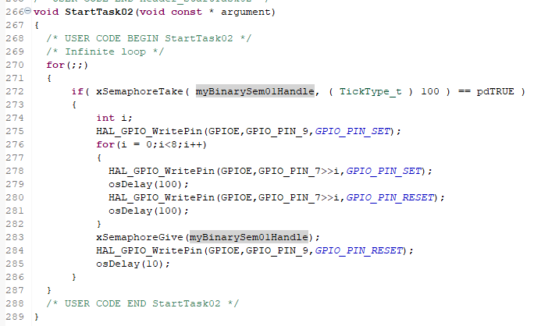

Task:
You can select either to answer five questions or write the program.
Questions.
- What’s the function of the semaphore?
- When should we introducing semaphore into project?
- Can you tell me some concrete examples of the situation that require to use semaphore?
- What will happen after the sentence of “xSemaphoreTake” has been conducted?
- What will happen after the sentence of “xSemaphoreGive” has been conducted?
Program requirement.
LED PE0 - PE15 can work on two modes. In the first mode, the LED keep flowing from PE0 to PE15, and in the second mode, the flowing direction of LED is inverse.
In addition, there are three buttons are used: PB12, PB13 and PB14. PB12 is the key that entered the first mode and PB13 is the key that entered the second mode. The system cannot change the working mode only when the system detects the press of the PB14.
The initial mode of the system can set as you like.
Besides, you can add more function to this system as you like.
(Note: You need to use semaphore)

