ASIM KUMAR DE

## SUMMARY

Pursuing electrical engineering at Tech no International New Town. I’m pretty much confident in web development specially using restfull api’s with node.js & mongodb.

Looking forward to pursue a career in an IT profile.

# EXPERIENCE

IMern, 12/2021 - Current Sanji«ani - India

* Bu ilt frontend for websites
* Currently Working with Angular
* has the team spokesperson for 2 projects

# EDUCATION

B. Tech, Electrical Engineering, 2o23

Techno International New Town - New Town, Rajarhat

Higher Secondary, Science(PCfñ), 2019

xidnapore Collegiate School - Paschim Medinipur , west Bengal

Secondary education, 2017

}awahar Navodaya Vidyalaya - Pachim Medinipur, West Bengal

# CERTIFICATIONS

* Front-End Web Development with React -Coursera
* Server-side Development with Node S, Express and MongoDB - Coursera
* Developing Cloud Applications with Node.js and React - Edx
* Front-End Web Development with React - CourseraSS, and javascript

- Edx

LANGUAGES

Bengali: First Language

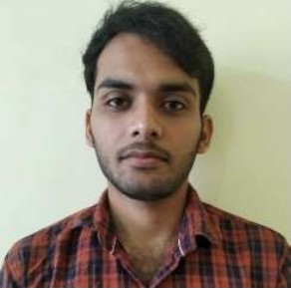

## CONTACT

Add¥'ES6i H 6ti m6S6n, Amjore, W6St

filed ini pur,Ind ia,721157

Phone: 7718243653

Email: info.asimde01@gma\I.com

## SKILLS

* Html & Css
* Javascript
* Node.js
* REST Api
* MongoDB

•SQL

•Angular

* Python