TM5 FORMULAIRE

Exercice 1 :
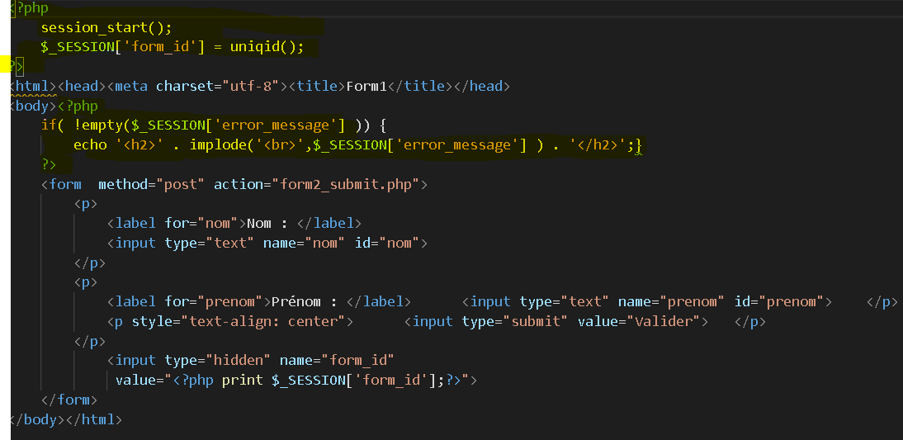
Les parties en jaune sont les parties en php

3. Les situations que j’ai prévue de tester sont des valider le formulaire sans le remplir ensuite d’essayer quand on le remplit.

4. On rajoute le sex dans le formulaire

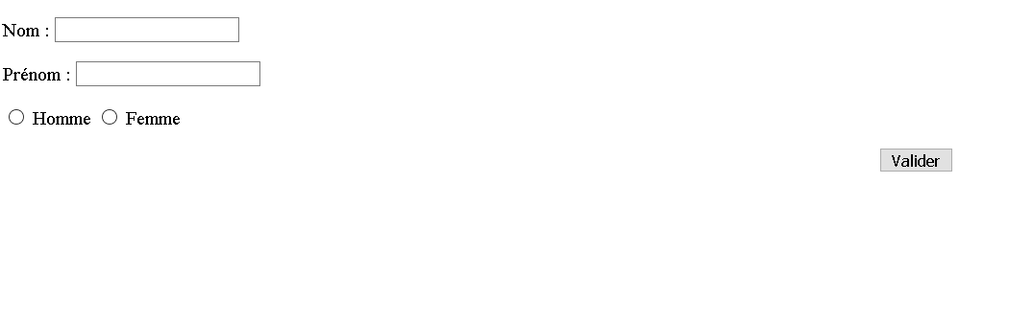

Exercice2

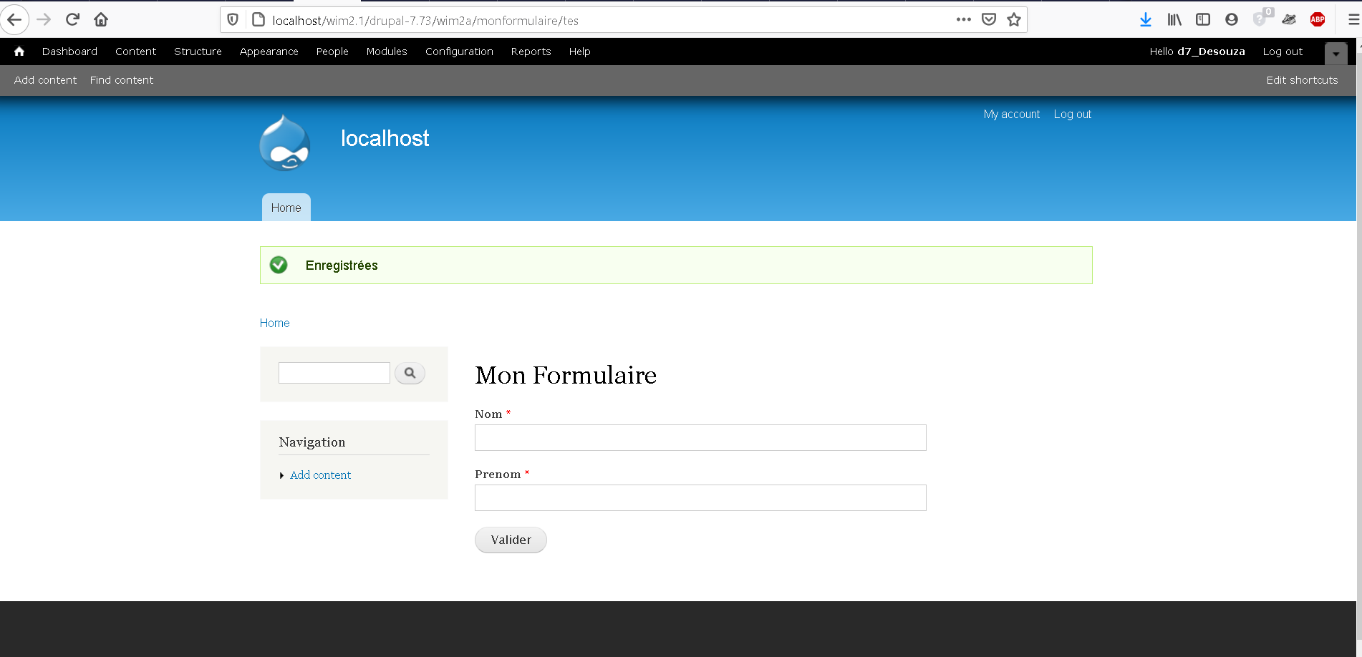

<body class="html not-front logged-in one-sidebar sidebar-first page-wim2a page-wim2a-monformulaire page-wim2a-monformulaire-tes toolbar toolbar-drawer" >
<div id="skip-link">
<a href="#main-content" class="element-invisible element-focusable">Skip to main content</a>
</div>
<div class="region region-page-top">
<div id="overlay-disable-message" class="clearfix"><h3 class="element-invisible">Options for the administrative overlay</h3><a href="/wim2.1/drupal-7.73/user/1/edit?destination=wim2a/monformulaire/tes#edit-overlay-control" id="overlay-profile-link" class="overlay-exclude element-invisible">If you have problems accessing administrative pages on this site, disable the overlay on your profile page.</a> <a href="/wim2.1/drupal-7.73/overlay/dismiss-message?destination=wim2a/monformulaire/tes&amp;token=LMnhiNKZg0YRfr5W3E2L4ebf0x_sbRI75X2QIjGvjB4" id="overlay-dismiss-message" class="overlay-exclude element-invisible">Dismiss this message.</a></div><div id="toolbar" class="toolbar overlay-displace-top clearfix">
<div class="toolbar-menu clearfix">
<ul id="toolbar-home"><li class="home first last"><a href="/wim2.1/drupal-7.73/" title="Home"><span class="home-link">Home</span></a></li>
</ul> <ul id="toolbar-user"><li class="account first"><a href="/wim2.1/drupal-7.73/user" title="User account">Hello <strong>d7_Desouza</strong></a></li>
<li class="logout last"><a href="/wim2.1/drupal-7.73/user/logout">Log out</a></li>
</ul> <h2 class="element-invisible">Administrative toolbar</h2><ul id="toolbar-menu"><li class="menu-11 path-admin-dashboard first"><a href="/wim2.1/drupal-7.73/admin/dashboard" id="toolbar-link-admin-dashboard" title="View and customize your dashboard."><span class="icon"></span>Dashboard <span class="element-invisible">(View and customize your dashboard.)</span></a></li>
<li class="menu-9 path-admin-content"><a href="/wim2.1/drupal-7.73/admin/content" id="toolbar-link-admin-content" title="Administer content and comments."><span class="icon"></span>Content <span class="element-invisible">(Administer content and comments.)</span></a></li>
<li class="menu-21 path-admin-structure"><a href="/wim2.1/drupal-7.73/admin/structure" id="toolbar-link-admin-structure" title="Administer blocks, content types, menus, etc."><span class="icon"></span>Structure <span class="element-invisible">(Administer blocks, content types, menus, etc.)</span></a></li>
<li class="menu-7 path-admin-appearance"><a href="/wim2.1/drupal-7.73/admin/appearance" id="toolbar-link-admin-appearance" title="Select and configure your themes."><span class="icon"></span>Appearance <span class="element-invisible">(Select and configure your themes.)</span></a></li>
<li class="menu-18 path-admin-people"><a href="/wim2.1/drupal-7.73/admin/people" id="toolbar-link-admin-people" title="Manage user accounts, roles, and permissions."><span class="icon"></span>People <span class="element-invisible">(Manage user accounts, roles, and permissions.)</span></a></li>
<li class="menu-16 path-admin-modules"><a href="/wim2.1/drupal-7.73/admin/modules" id="toolbar-link-admin-modules" title="Extend site functionality."><span class="icon"></span>Modules <span class="element-invisible">(Extend site functionality.)</span></a></li>
<li class="menu-8 path-admin-config"><a href="/wim2.1/drupal-7.73/admin/config" id="toolbar-link-admin-config" title="Administer settings."><span class="icon"></span>Configuration <span class="element-invisible">(Administer settings.)</span></a></li>
<li class="menu-19 path-admin-reports"><a href="/wim2.1/drupal-7.73/admin/reports" id="toolbar-link-admin-reports" title="View reports, updates, and errors."><span class="icon"></span>Reports <span class="element-invisible">(View reports, updates, and errors.)</span></a></li>
<li class="menu-12 path-admin-help last"><a href="/wim2.1/drupal-7.73/admin/help" id="toolbar-link-admin-help" title="Reference for usage, configuration, and modules."><span class="icon"></span>Help <span class="element-invisible">(Reference for usage, configuration, and modules.)</span></a></li>
</ul> <a href="/wim2.1/drupal-7.73/toolbar/toggle?destination=wim2a/monformulaire/tes" title="Hide shortcuts" class="toggle toggle-active">Hide shortcuts</a> </div>

<div class="toolbar-drawer clearfix">
<div class="toolbar-shortcuts"><ul class="menu clearfix"><li class="first leaf"><a href="/wim2.1/drupal-7.73/node/add">Add content</a></li>
<li class="last leaf"><a href="/wim2.1/drupal-7.73/admin/content">Find content</a></li>
</ul></div><a href="/wim2.1/drupal-7.73/admin/config/user-interface/shortcut/shortcut-set-1" id="edit-shortcuts">Edit shortcuts</a> </div>
</div>
</div>
<div id="page-wrapper"><div id="page">

<div id="header" class="with-secondary-menu"><div class="section clearfix">

<a href="/wim2.1/drupal-7.73/" title="Home" rel="home" id="logo">
<img src="http://localhost/wim2.1/drupal-7.73/themes/bartik/logo.png" alt="Home" />
</a>

<div id="name-and-slogan">

<div id="site-name">
<strong>
<a href="/wim2.1/drupal-7.73/" title="Home" rel="home"><span>localhost</span></a>
</strong>
</div>

</div> <!-- /#name-and-slogan -->

<div id="main-menu" class="navigation">
<h2 class="element-invisible">Main menu</h2><ul id="main-menu-links" class="links clearfix"><li class="menu-219 first last"><a href="/wim2.1/drupal-7.73/">Home</a></li>
</ul> </div> <!-- /#main-menu -->

<div id="secondary-menu" class="navigation">
<h2 class="element-invisible">Secondary menu</h2><ul id="secondary-menu-links" class="links inline clearfix"><li class="menu-2 first"><a href="/wim2.1/drupal-7.73/user">My account</a></li>
<li class="menu-15 last"><a href="/wim2.1/drupal-7.73/user/logout">Log out</a></li>
</ul> </div> <!-- /#secondary-menu -->

</div></div> <!-- /.section, /#header -->

<div id="messages"><div class="section clearfix">
<div class="messages status">
<h2 class="element-invisible">Status message</h2>
Enregistrées</div>
</div></div> <!-- /.section, /#messages -->

<div id="main-wrapper" class="clearfix"><div id="main" class="clearfix">

<div id="breadcrumb"><h2 class="element-invisible">You are here</h2><div class="breadcrumb"><a href="/wim2.1/drupal-7.73/">Home</a></div></div>

<div id="sidebar-first" class="column sidebar"><div class="section">
<div class="region region-sidebar-first">
<div id="block-search-form" class="block block-search contextual-links-region">

<div class="contextual-links-wrapper"><ul class="contextual-links"><li class="block-configure first last"><a href="/wim2.1/drupal-7.73/admin/structure/block/manage/search/form/configure?destination=wim2a/monformulaire/tes">Configure block</a></li>
</ul></div>
<div class="content">
<form action="/wim2.1/drupal-7.73/wim2a/monformulaire/tes" method="post" id="search-block-form" accept-charset="UTF-8"><div><div class="container-inline">
<h2 class="element-invisible">Search form</h2>
<div class="form-item form-type-textfield form-item-search-block-form">
<label class="element-invisible" for="edit-search-block-form--2">Search </label>
<input title="Enter the terms you wish to search for." type="text" id="edit-search-block-form--2" name="search_block_form" value="" size="15" maxlength="128" class="form-text" />
</div>
<div class="form-actions form-wrapper" id="edit-actions"><input type="submit" id="edit-submit" name="op" value="Search" class="form-submit" /></div><input type="hidden" name="form_build_id" value="form-eWIoOsaSSzgWh3VYC7xKZ26G74g6otwVeHhGvYc7Emw" />
<input type="hidden" name="form_token" value="oD27dye8g7RInJLvNaKDxVm8-b_9NTF3bBg0s7D1D-Y" />
<input type="hidden" name="form_id" value="search_block_form" />
</div>
</div></form> </div>
</div>
<div id="block-system-navigation" class="block block-system contextual-links-region block-menu">

<h2>Navigation</h2>
<div class="contextual-links-wrapper"><ul class="contextual-links"><li class="menu-list first"><a href="/wim2.1/drupal-7.73/admin/structure/menu/manage/navigation/list?destination=wim2a/monformulaire/tes">List links</a></li>
<li class="menu-edit"><a href="/wim2.1/drupal-7.73/admin/structure/menu/manage/navigation/edit?destination=wim2a/monformulaire/tes">Edit menu</a></li>
<li class="block-configure last"><a href="/wim2.1/drupal-7.73/admin/structure/block/manage/system/navigation/configure?destination=wim2a/monformulaire/tes">Configure block</a></li>
</ul></div>
<div class="content">
<ul class="menu clearfix"><li class="first last collapsed"><a href="/wim2.1/drupal-7.73/node/add">Add content</a></li>
</ul> </div>
</div>
</div>
</div></div> <!-- /.section, /#sidebar-first -->

<div id="content" class="column"><div class="section">
<a id="main-content"></a>
<h1 class="title" id="page-title">
Mon Formulaire </h1>
<div class="tabs">
</div>
<div class="region region-content">
<div id="block-system-main" class="block block-system">

<div class="content">
<form action="/wim2.1/drupal-7.73/wim2a/monformulaire/tes" method="post" id="wim2a-monformulaire" accept-charset="UTF-8"><div><div class="form-item form-type-textfield form-item-nom">
<label for="edit-nom">Nom <span class="form-required" title="This field is required.">*</span></label>
<input type="text" id="edit-nom" name="nom" value="" size="60" maxlength="128" class="form-text required" />
</div>
<div class="form-item form-type-textfield form-item-prenom">
<label for="edit-prenom">Prenom <span class="form-required" title="This field is required.">*</span></label>
<input type="text" id="edit-prenom" name="prenom" value="" size="60" maxlength="128" class="form-text required" />
</div>
<input type="submit" id="edit-valider" name="op" value="Valider" class="form-submit" /><input type="hidden" name="form_build_id" value="form-QD8PpRmk7-KoMONSm2Vfb70Lfwvf8s58nOcnhr40WLo" />
<input type="hidden" name="form_token" value="PnwaAoKkTcueZw6ZudSc1RtJ1YaQ1buWCFljUdcIRfo" />
<input type="hidden" name="form_id" value="wim2a_monformulaire" />
</div></form> </div>
</div>
</div>

</div></div> <!-- /.section, /#content -->

</div></div> <!-- /#main, /#main-wrapper -->

<div id="footer-wrapper"><div class="section">

<div id="footer" class="clearfix">
<div class="region region-footer">
<div id="block-system-powered-by" class="block block-system contextual-links-region">

<div class="contextual-links-wrapper"><ul class="contextual-links"><li class="block-configure first last"><a href="/wim2.1/drupal-7.73/admin/structure/block/manage/system/powered-by/configure?destination=wim2a/monformulaire/tes">Configure block</a></li>
</ul></div>
<div class="content">
<span>Powered by <a href="https://www.drupal.org">Drupal</a></span> </div>
</div>
</div>
</div> <!-- /#footer -->

</div></div> <!-- /.section, /#footer-wrapper -->

</div></div> <!-- /#page, /#page-wrapper -->
</body>

Expérimentation

1. La page :
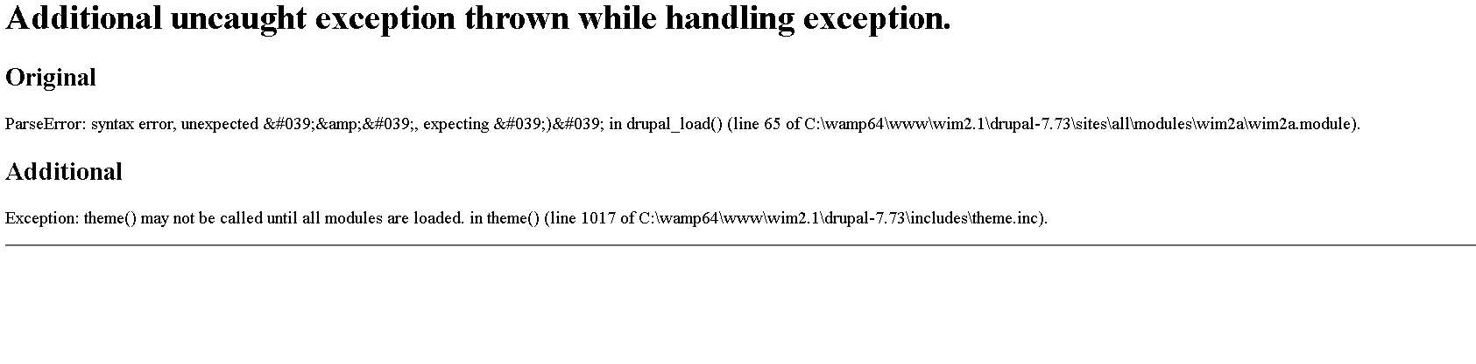
On observe qu’il y a une erreur. L’erreur montre que le formulaire n’arrive pas à ce générer. Il lui manque le nom de la fonction génératrice qui doit être passer à fonction drupal_get_from.

4. Après la correction le formulaire marche à nouveau

Oui il fonctionne car un formulaire est générer.

