**Week 7 - Binary Trees, Binary Search Trees**

**Q1.** For the following Binary Trees:

1. List, in order, the vertices, resulting from a depth-first pre-order traversal.
2. List, in order, the vertices, resulting from a depth-first in-order traversal.
3. List, in order, the vertices, resulting from a depth-first post-order traversal.
4. List, in order, the vertices, resulting from a breadth-first traversal.
5. **i) 32， 7， 10， 63 ，97 44 ii)10, 7, 32, 97 63, 44 iii)10, 7, 97, 44, 63, 32. Iv) 32, 7, 63 ,10 ,97, 44**

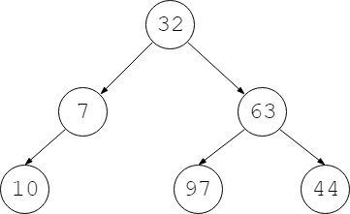

1. 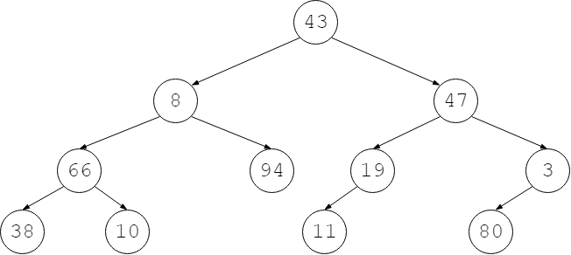**i) 43, 8, 66, 38 ,10, 94, 47, 19, 11, 3, 80 ii) 38, 66, 10, 8, 94, 43, 11, 19, 80, 10， 3, 47,iii)38, 10, 11, 80, 66, 94, 19, 3, 8, 47, 43 iv) 10, 8, 47, 66, 94, 19, 3, 38, 11, 80**
2. List, in order, the vertices, resulting from a depth-first pre-order traversal.
3. List, in order, the vertices, resulting from a depth-first in-order traversal.
4. List, in order, the vertices, resulting from a depth-first post-order traversal.
5. List, in order, the vertices, resulting from a breadth-first traversal.
6. **I)13, 59, 10, 40, 8, 92, 60, 45, 49, 99, 55, 76, 2, 86, 21, 35, 79, 28**

**ii) 8, 40 ,10 ,92 ,60, 45, 49, 59, 76, 55, 99, 13, 21, 86, 2, 21, 86, 38, 79, 35**

**iii 8， 40， 45， 60， 49， 92， 10， 76， 55， 99， 21， 28， 79， 86， 35， 2， 13**

**Iv)13, 59, 2, 10 ,99, 86 ,35, 40 ,92, 55, 21 ,79, 8 ,60 ,49, 76, 28, 45**

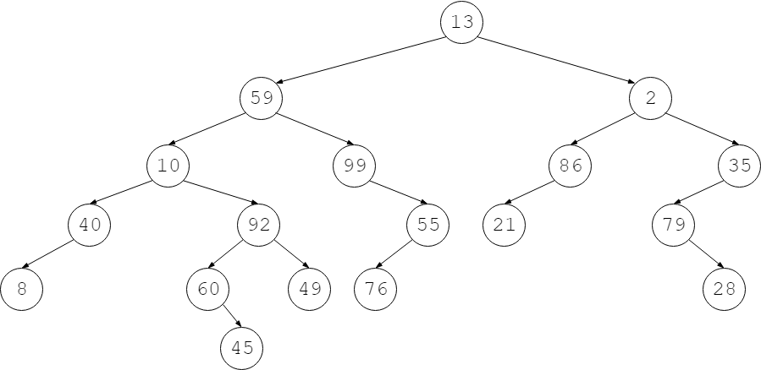

**Q2.**

1. Refer to Binary Tree **c)** as a Binary Search Tree (BST). Determine where a vertex, with value 11, will be located after insertion.

**60- 11**

1. Refer to Binary Tree **a)** as a Binary Search Tree (BST). Determine where a vertex, with value 57, will be located after insertion.

97 - 57

1. Refer to Binary Tree **b)** as a Binary Search Tree (BST). Determine where a vertex, with value 52, will be located after insertion.

3- 52

1. Refer to Binary Tree **b)** as a Binary Search Tree (BST). Determine where a vertex, with value 21, will be located after insertion.

94-21

1. Refer to Binary Tree **c)** as a Binary Search Tree (BST). Determine where a vertex, with value 18, will be located after insertion.