**DERICK JAMES M ESPINOSA 11.05.2022**

**BSIT-S-T-1A-T Prof. J. Andong**

**COMPUTER PRORAMMING: LOOPS SEATWORK**

1. Please type in the total number of data values to be averaged:  In response to this prompt, the program should accept a user-entered number, and then use it to control the number of times the while loop is executed. So if the user enters 6 in response to the prompt, the program should request an input of six numbers and display the average of the six numbers entered.

CODE:

OUTPUT:

1. Write a C++ program to convert Celsius degrees to Fahrenheit. The program should request the starting Celsius value, the number of conversions to be made, and the increment between Celsius values. The display should have appropriate headings and list the Celsius value and the corresponding Fahrenheit value. Use the relationship that Fahrenheit = (9.0 / 5.0) * Celsius + 32.0.

CODE:

OUTPUT:

1. Program an old Arabian legend has it that a fabulously wealthy but unthinking king agreed to give a beggar 1 cent and double the amount for 64 days. Using this information, write, compile, and run a C++ program that displays how much the king must pay the beggar each day. The output of your program should appear as follows:

Day Amount Owed

--- -----------

1 0.01

2 0.02

3 0.04

. .

. .

64

CODE:

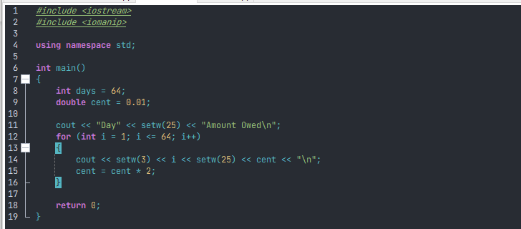

OUTPUT:

1. Write, compile, and run a C++ program that converts gallons to liters. The program should display gallons from 10 to 20 in 1-gallon increments and the corresponding liter equivalents. Use the relationship that 1 gallon = 3.785 liters.

CODE:

OUTPUT:

