**Derick James M Espinosa**

**BSIT-S-T-1A-T**

**UNIT TEST**

Unit Exam 1

1. Write a program that allows the user to compute for the salary of an employee for a month given the following conditions:

Position Paygrade A PayGrade B TaxRate

M-Messenger 5,500 6500 5%

E-Encoder 6,500 7500 6%

T-Technician 7,500 8500 7%

P-programmer 10,000 10500 8%

S-System Analyst 12,500 12,500 9%

Regular working hours for one month is 160 hrs.  Beyond 160 is paid 1.5 times of the regular wage rate.

Deductions are sss = 200, pag-ibig = 100. Withholding tax = gross * taxRate

 Net = PaySalary – (sss+pagibig +withholdingTax).

Display also the actual employee’s name, company, department, actual description of the position, hours worked, overtime pay, pay grade, deductions, and net salary. The user can input and process data as he wants.

**Code:  
**

**OUTPUT**

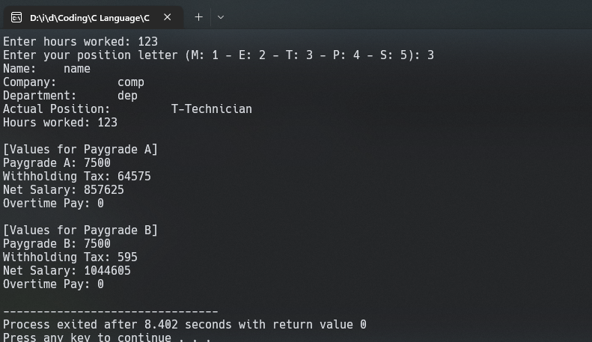

1. Schedule X – Single Taxpayers

Over But not over Of the amt. over

P20,000 P22,000 P5,230 + 38% P20,000

P22,000 P26,000 P5,990 + 40% P22,000

P26,000 P32,000 P7,590 + 45% P26,000

P32,000 P38,000 P10,290 + 50% P32,000

P38,000 P44,000 P13,290 + 55% P38,000

A program may be written to compute the income tax for a single taxpayer if her or taxable (X) is given. A number of decision-branching blocks may be used in the program to determine the appropriate tax formula used in the computations of the income tax.

Example: Assume X = 21500

Incometax = X – (5230 +(38% of the amount over 20000))

Display on the screen the taxable income (salary) and income tax. The user can input data as long as he wants.

**CODE:**

