**Derick James M Espinosa**

**BSIT-S-T-1A-T**

Unit 2

(30 pts) Create a program that will input 3 quizzes, 3 unit tests, 4 machine problems, and a term exam. The total number of items per exam is fixed at 100. For each examination, the lowest grade that the instructor could give is 20 pts.

Condition:

If the student misses three exams he will be given a grade of “INC” and a remark of “incomplete”

If the student misses 4 or more exams he will be given a grade of “DRP” and a remark of “dropped”

Otherwise, compute his grade.  If his grade is less than 50 then the remark is “failed” otherwise “passed”

Computation

Total exam score = (score/100) * percent * 100

Q - 20%

U – 25%

M – 35%

T – 20%

Weighted Grade is the summation of all weighted grades of the examination.

For the Final Grade follow the following condition

|  |  |
| --- | --- |
| Weighted Grade | Final Grade |
| 98-100 | 1.0 |
| 91 -97 | 1.25 |
| 85-90 | 1.50 |
| 79-84 | 1.75 |
| 73-78 | 2.00 |
| 67-72 | 2.25 |
| 61-66 | 2.50 |
| 55-60 | 2.75 |
| 50-54 | 3.00 |
| Below 60 | 5.00 |

Count the number of students who got passed, the number of students who got failed, the number of students who got dropped, and the number of students who got incomplete.

Display on the screen all inputted quizzes, unit tests, machine problem and term tests, each examination’s weighted grade, weighted grade, and final grade. You are warned to input data as long as you want.

**CODE:**

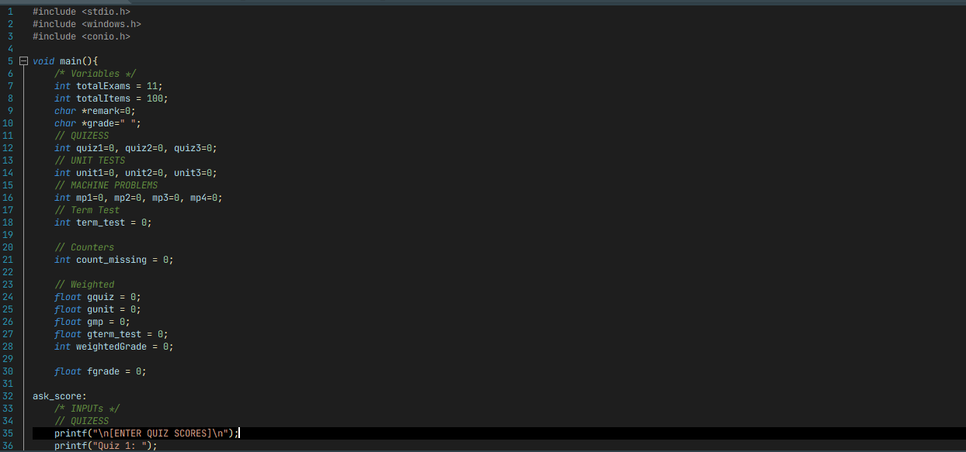

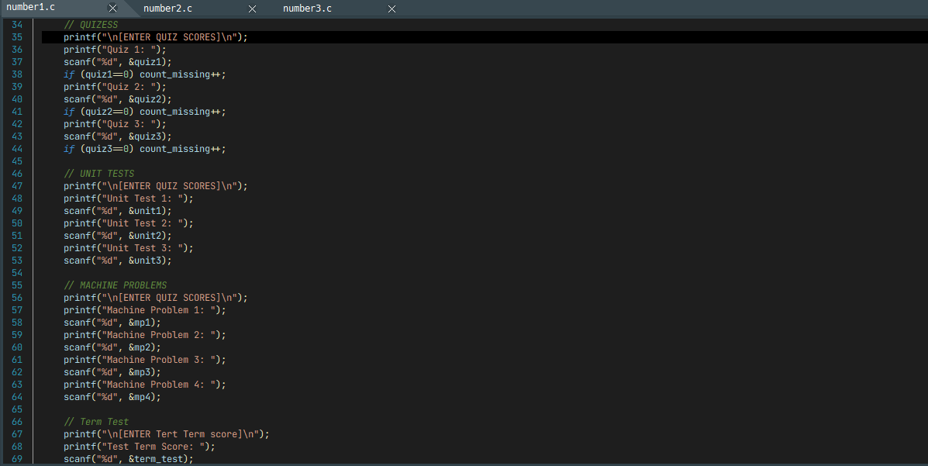

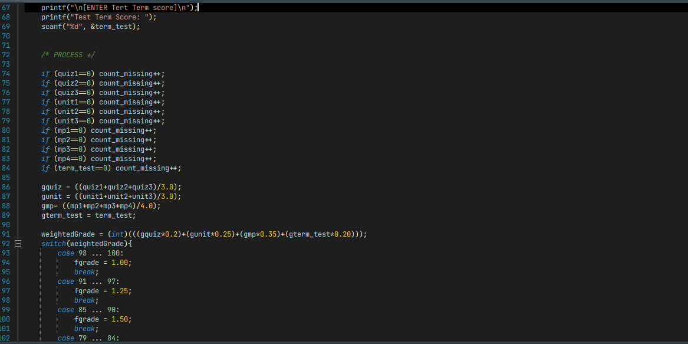

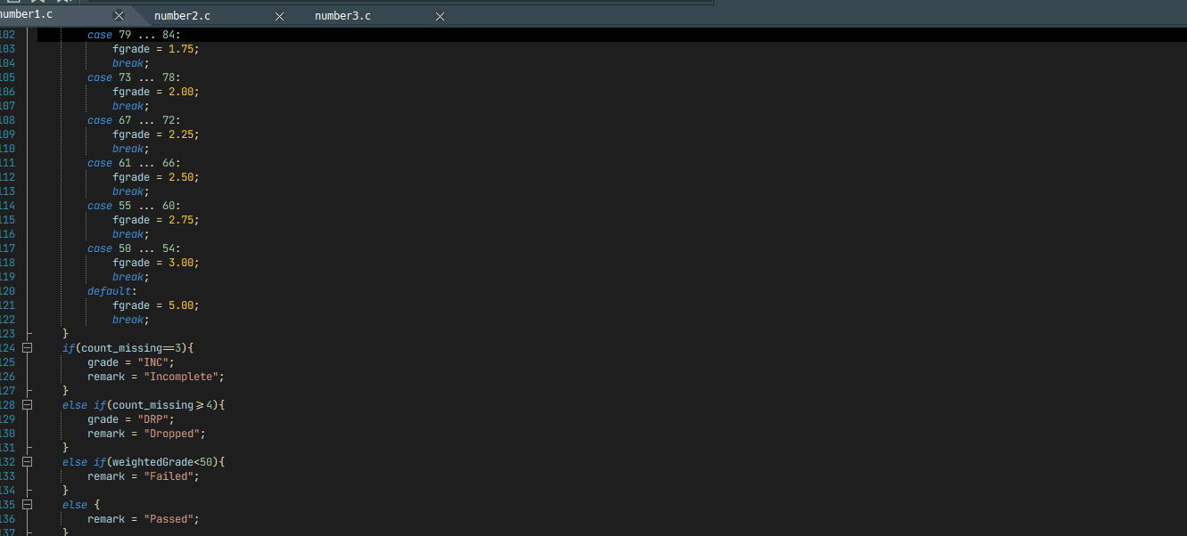

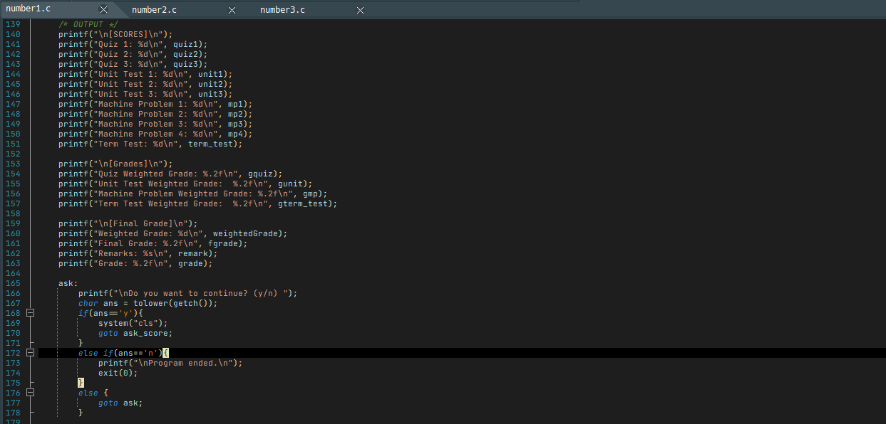

**OUTPUT:**

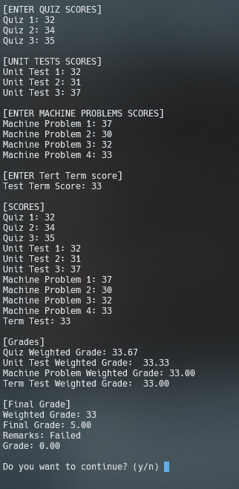

(15pts) Write a program that allows the user to compute the weekly salary of an employee based on the given condition.

      Position Description       Wage Rate

M Messenger 250

E Encoder 300

T Technician 350

P Programmer 500

S System Analyst                600

Regular working hours for one week is 40 hours. Beyond 40 hours is paid 1.5 times the regular wage rate. Input the name, the number of hours worked, and the position of an employee and compute the weekly employee salary.  Display the name, the number of hours worked, the actual employee description, weekly employee salary, and overtime if any. The user is warned to input data as long as he wants.

Basic Salary = Number hours * wage

**CODE:**

**OUTPUT:**

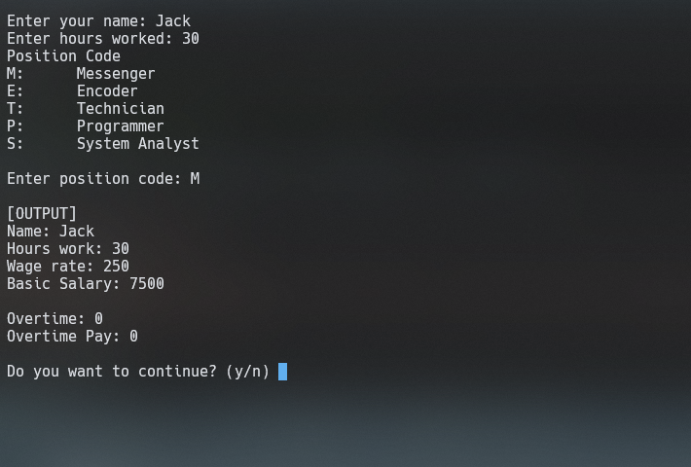

(15 pts.)The tolerance of critical components in a system is determined according to the

following schedule:

|  |  |
| --- | --- |
| Specifications Status | Tolerance |
| Space exploration | Less than 0.1% |
| Military grade | Greater than or equal to 0.1% and less than 1% |
| Commercial grade | Greater than or equal to 1% and less than 10% |
| Toy grade | Greater than or equal to 10% |
|  |  |

Using this information to create an application program that accepts a component’s tolerance reading and determine the specification that should assigned to it. Accumulate tolerance of each specification status. Display specification status, tolerance and the accumulated tolerance of each specification status. Note: the user is warned to input data as long as he wants.

**CODE:**

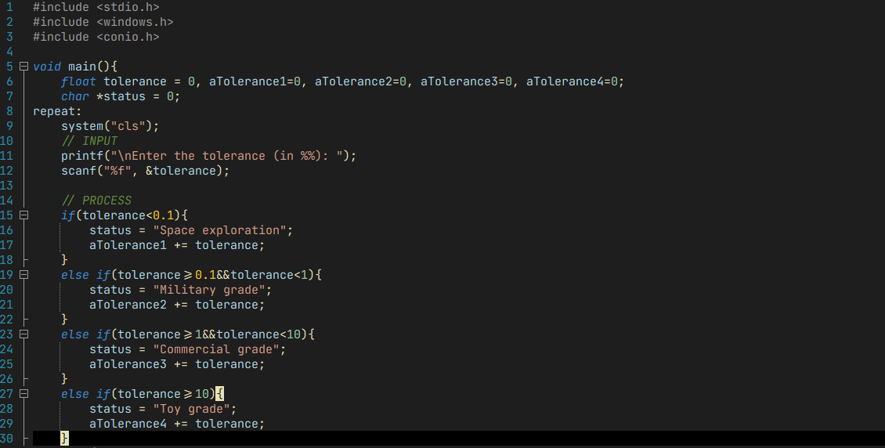

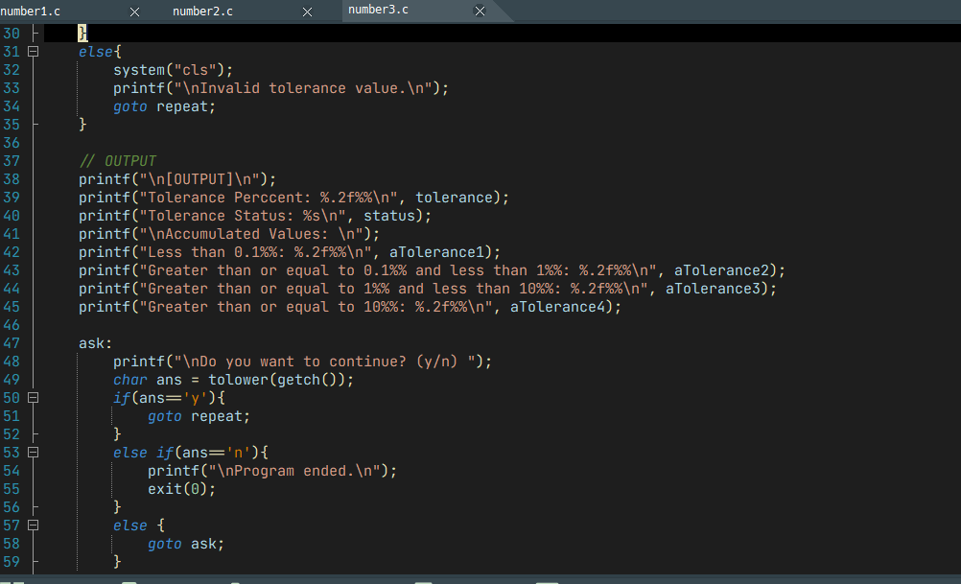

**OUTPUT:**



