***ESPINOSA DERICK JAMES M.***

***BSIT S 2A***

***DATABASE***

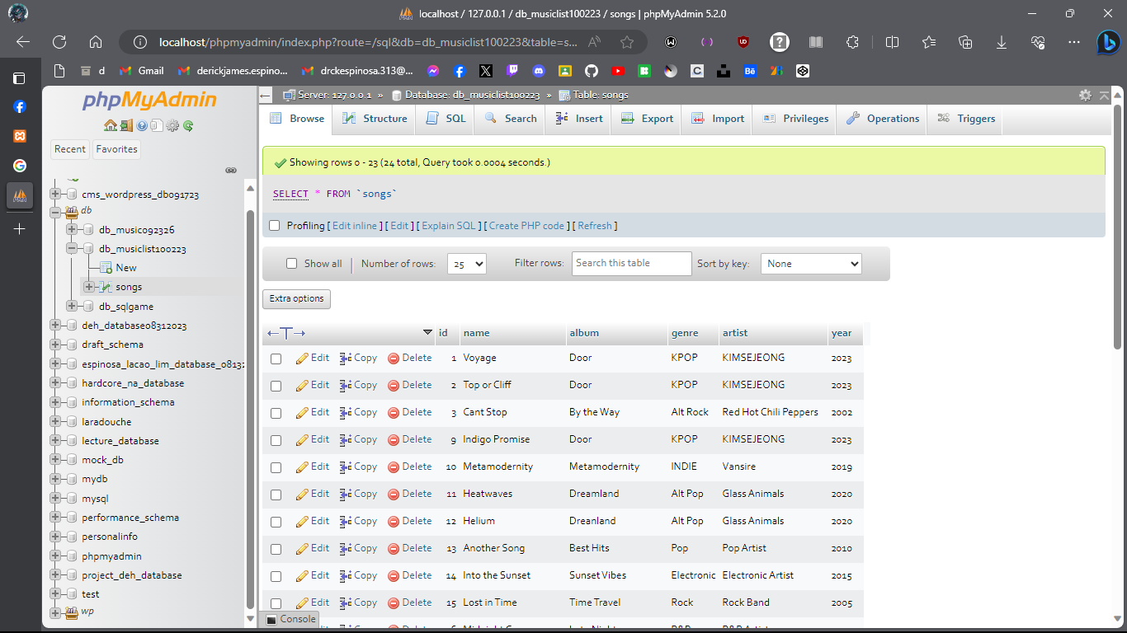

**INTERFACE**

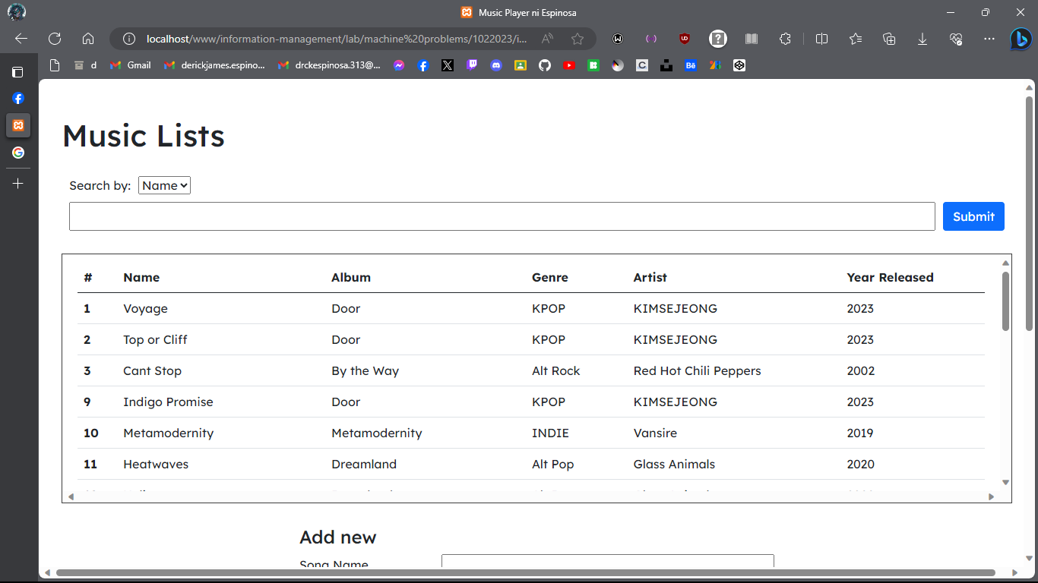

**CRUD – ADD, EDIT, DELETE**

**ADDING OF SONGS**

**EDITING OF SONGS**

**

**DELETING OF SONGS**

**SEARCHING SONGS**

