**Project 2**

*Python Decoder Report*

By:

Richard Remigoso

1. Group Activity Log

|  |  |  |  |
| --- | --- | --- | --- |
| **Time/ Location** | **Activity** | **Achieved/ To-Do** | **Member(s)** |
| Tuesday (2/19/19)  6:00 PM - 8:00 PM  @ Library 2nd floor | In-person group meeting | Done:   * Outlined decoder algorithm * Python installation * PRPG selection discussion   To-do:   * Fix chosen project 1 for incorrect hexadecimal | Richard, Syed |
| Wednesday (2/20/19)  6:00 PM - 9:15 PM  @ Library 2nd floor | Test case 1A milestone | Done:   * Added 1 function for two's comp * Instruction conversions for branches * Passed testcase 1A   To-do:   * Continue to work on logic instructions testcase 2A | Richard, Syed |
| Friday (2/22/19)  6:00 PM - 2:00 AM  @ Library 2nd floor | Test case 2A milestone | Done:   * Passed testcase 2A * Python code for sll * Fix bugs from previous instructions   To-do:   * Fix potential srl functionality * Move to testcase 3A | Richard, Syed |
| Monday (2/25/19)  6:00 PM - 12:00 PM  @ CS Lounge | Test case 3A milestone | Done:   * Passed testcase 3A * Implemented printing function to output file * Added sw and lw   To-do:   * Move to testcase 4A | Richard, Syed |
| Wednesday (2/27/19)  6:00 PM - 10:30 PM  @ CS Lounge | Test case 4A milestone | Done:   * Passed testcase 4A   To-do:   * Fix sll instruction in Python * Get Project 1 hamming weight and distance to work | Richard, Syed, Rami |
| Wednesday (2/27/19)  6:00 PM - 3:30 AM  @ CS Lounge | PRPG, Hamming weight, and Hamming distance integration | Done:  To-do:   * Fix sll instruction in Python | Richard, Syed |
| Thursday (2/28/19)  6:00 PM - 11:59 PM  @ CS Lounge | Finish the project, clean source folders, create testcase #Bs, write lab reports | Done:   * Fixed sll instruction * Successfully ran PRPG, Hamming weight, and Hamming distance * Created testcase #Bs * Submitted!   To-do:   * N/A | Richard, Syed |

Team Members: Richard, Syed, Rami

1. Personal Activity Log

|  |  |  |  |
| --- | --- | --- | --- |
| **Time/ Location** | **Activity** | **Achieved/ To-Do** | **Member(s)** |
| Sunday (2/24/19)  4:00 PM - 5:00 PM  @ Home | Bug fixing | Done:   * Fixed srl functionality   To-do:   * Make a printing function | Richard |
| Tuesday (2/26/19)  1:30 PM - 2:30 PM  @ Home | Adding instructions to python | Done:   * Accommodated lw and sw for output file   To-do:   * Test the decoder using Project 1 code | Richard |
| Tuesday (2/26/19)  6:00 PM - 3:00 AM  @ CS Lounge | Debugging | Done:   * Fixed debugging issues * Ran PRPG program successfully   To-do:   * Test the decoder using Project 1 code part 2 | Richard |

1. Test Case Screenshots
2. 1. 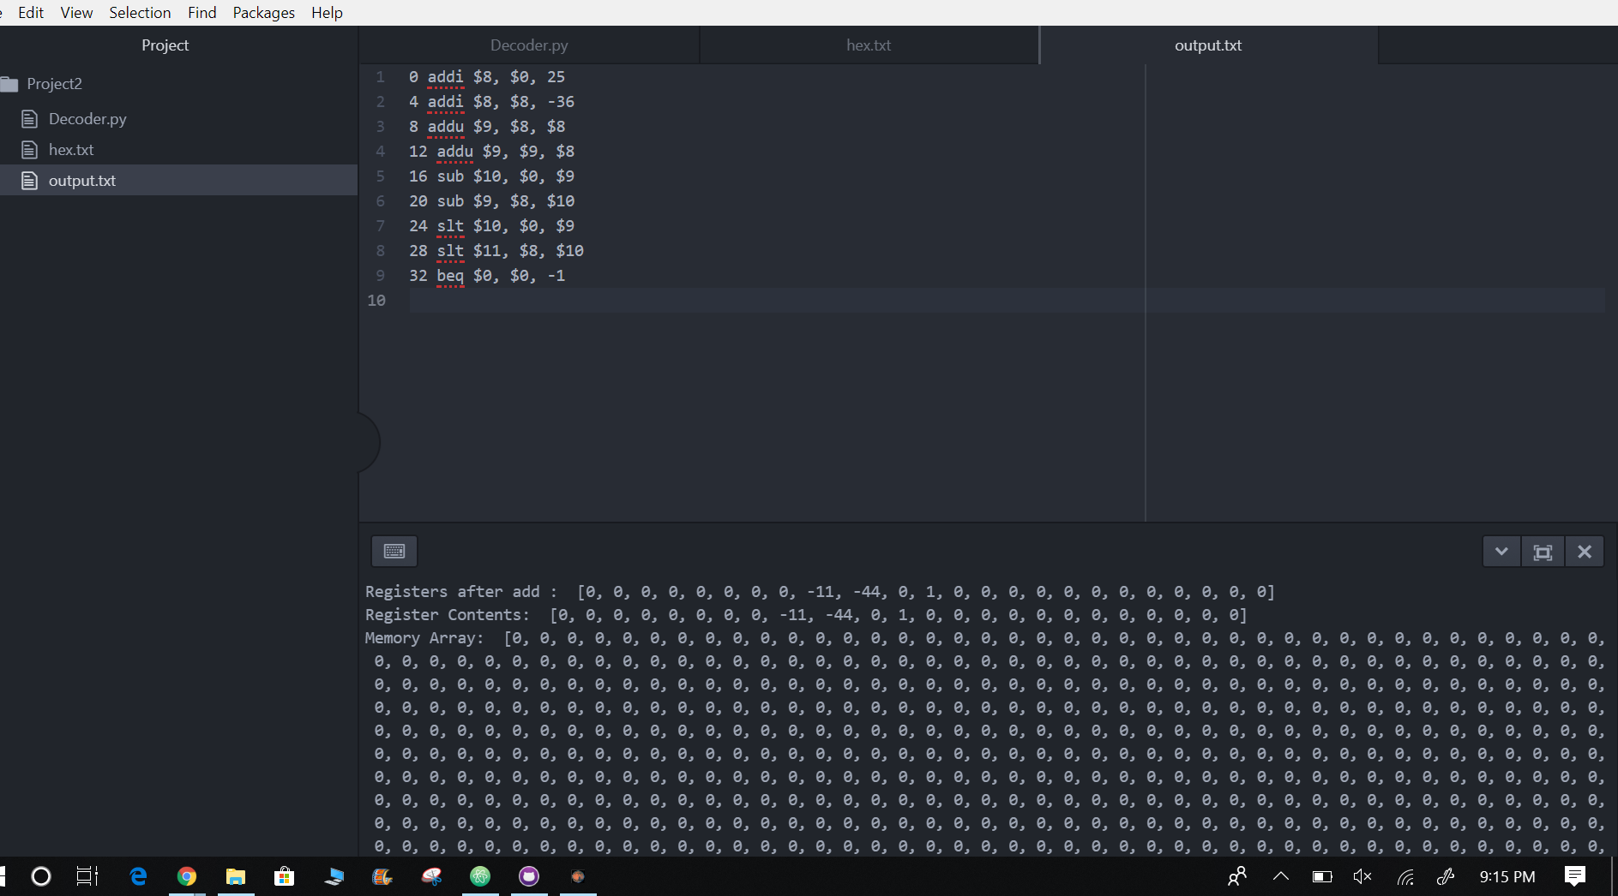

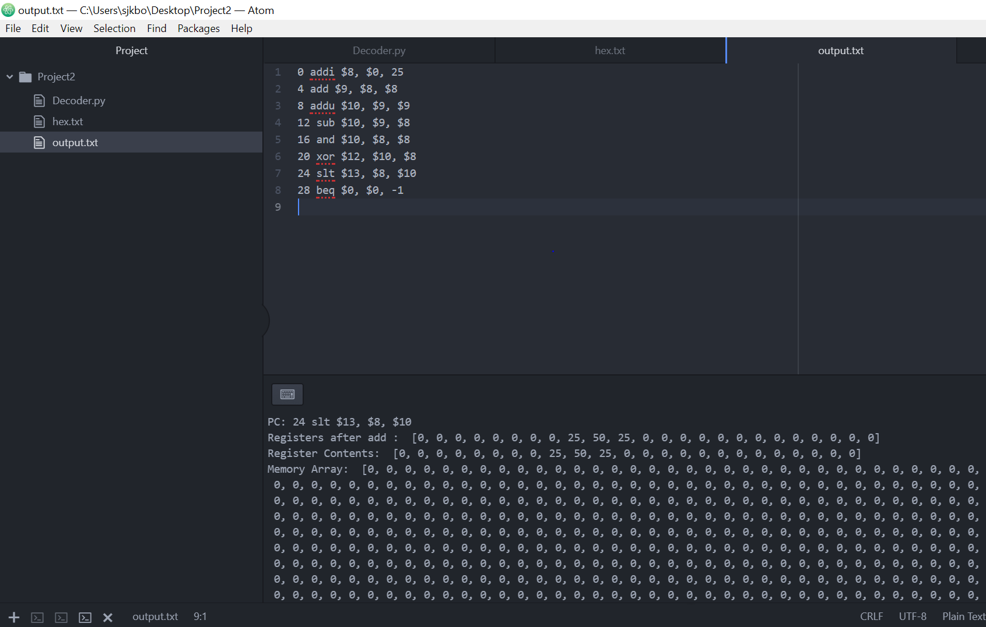



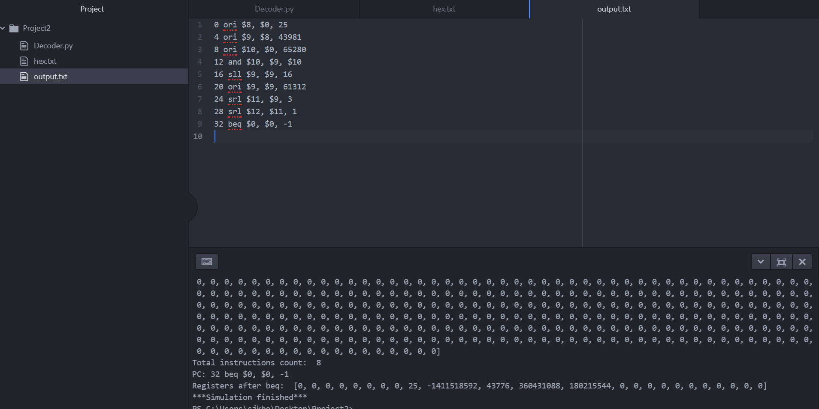



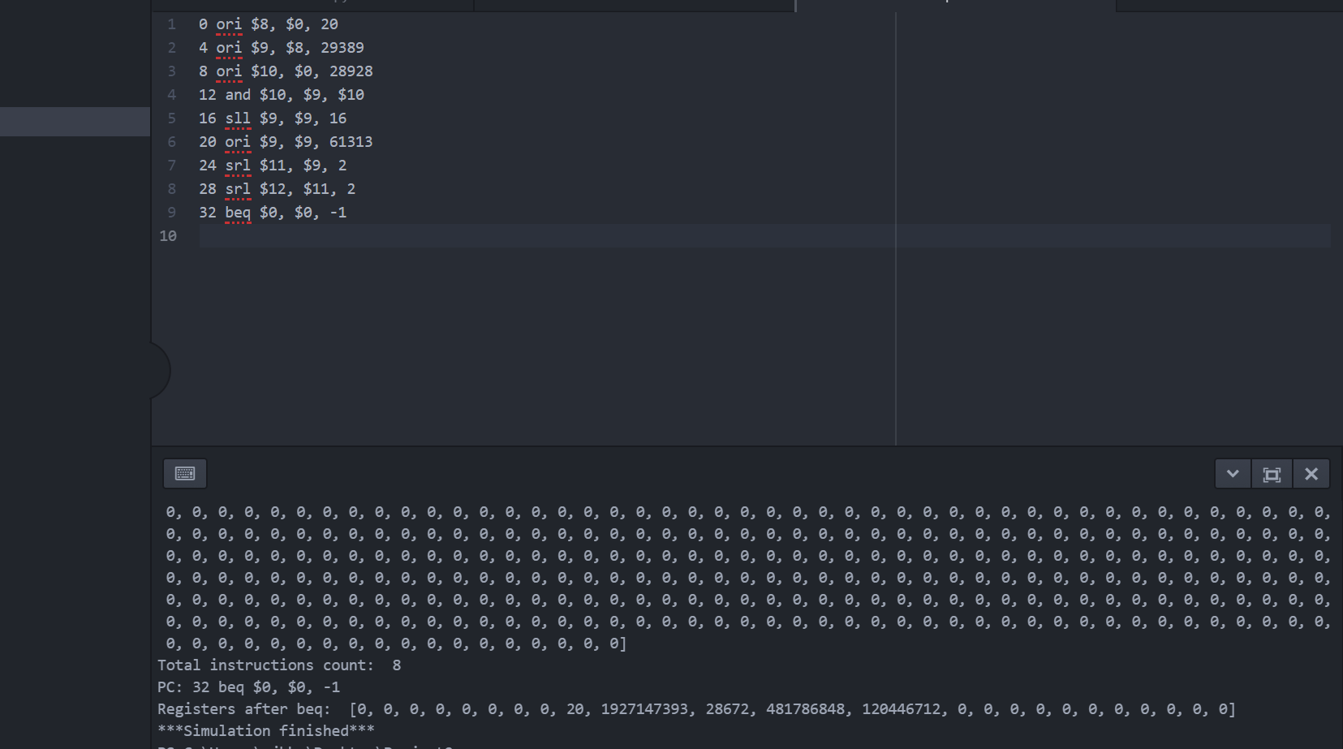



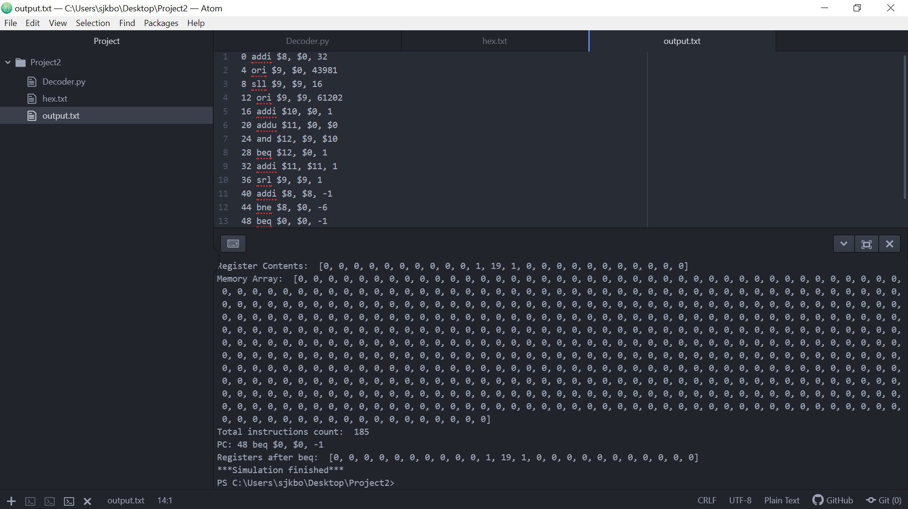

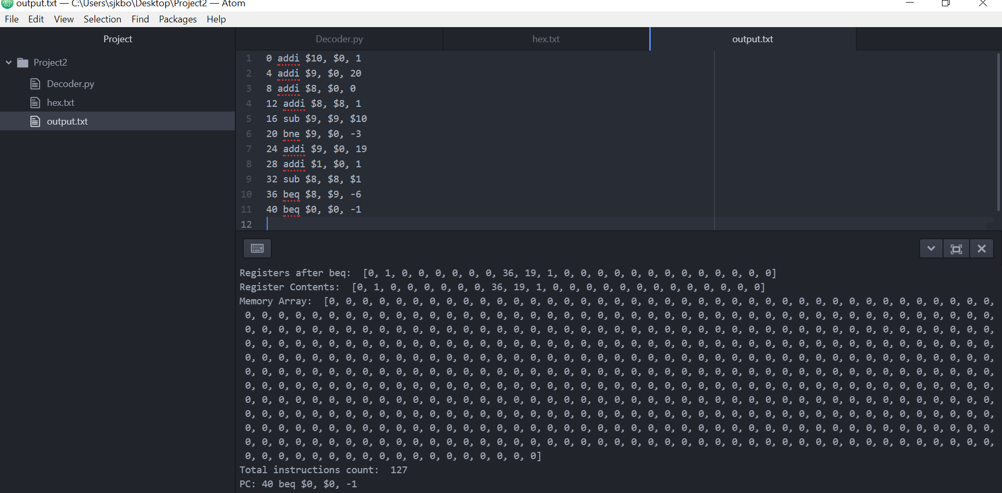



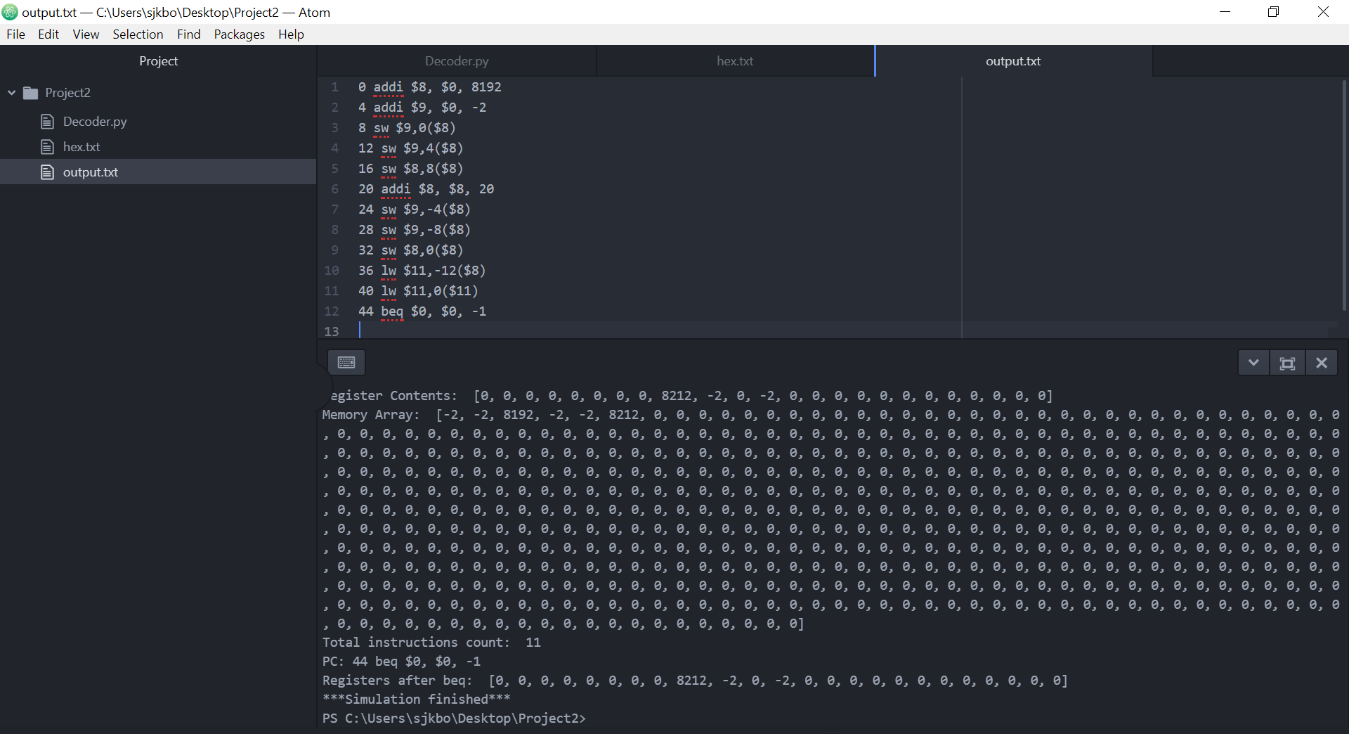

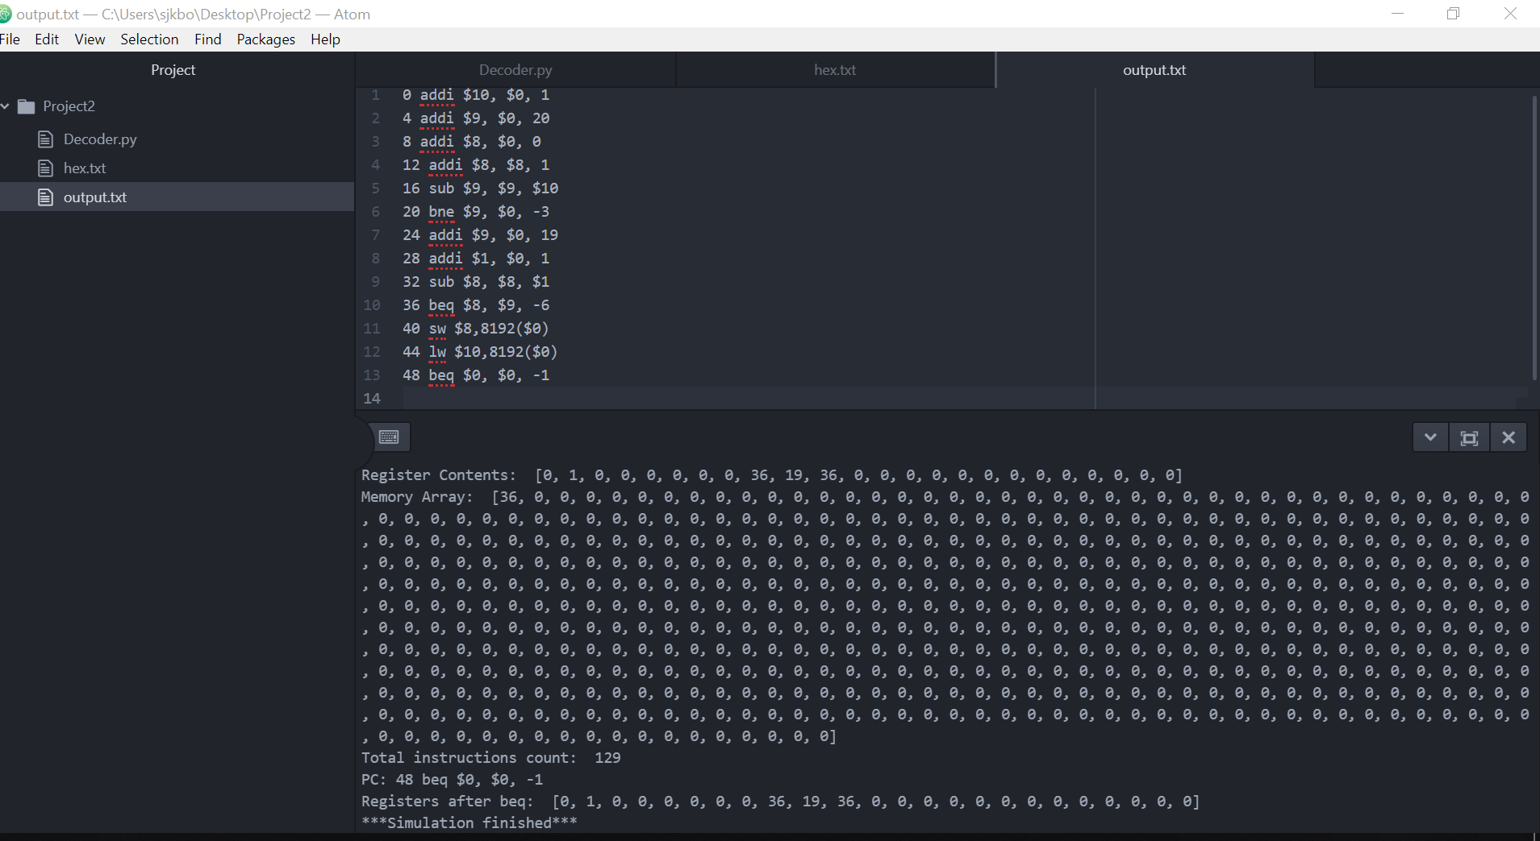

1. PRPG

Q1.

Our project should be able to achieve all of the project’s requirements. We chose my PRPG algorithm, which was using the project 1 PRPG. We used mine because I had the fastest ALU, and we did not have enough time to try new algorithms.

Q2.

We verified the correctness of our simulator by running MARS side by side and comparing the results. We mainly used Google search for binary, hex, and decimal calculators. One of the main bugs we found was that Python does not really care have big the number can be whereas MARS can only handle up to 32 bits.

1. PRPG Screenshots

3

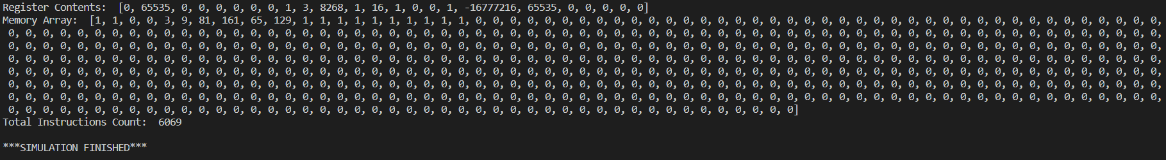

19

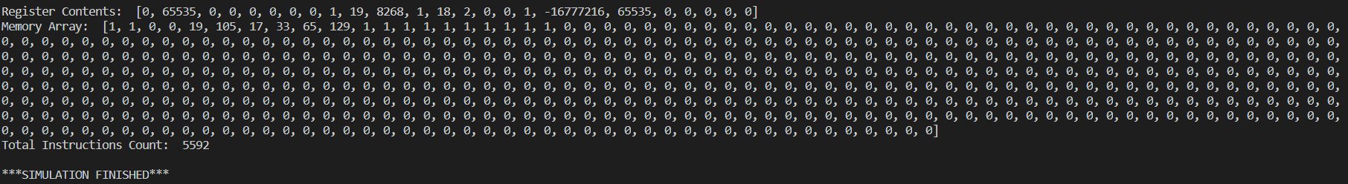

24

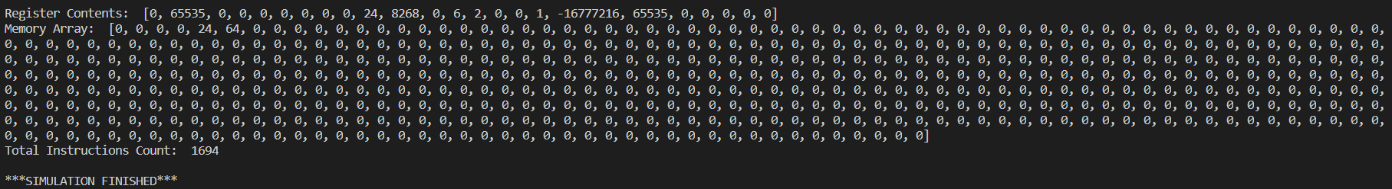

100

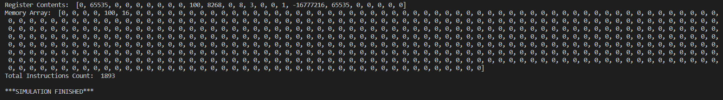

2019

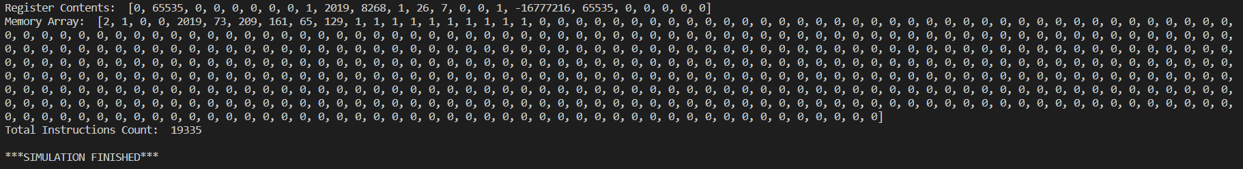

34567

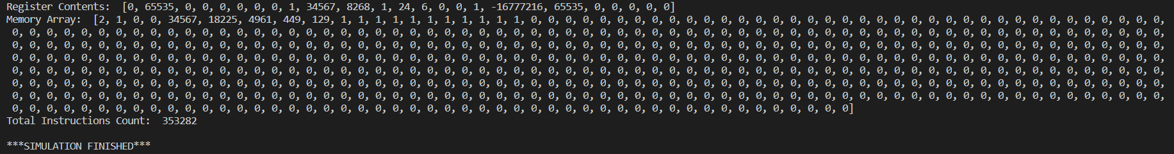

1. Special Instructions

N/A