SOURAV 12/04/2022
1NT19IS159

db.sourav.find({$or: [{dept: "cse"},{dept:"ise"}]}).pretty()
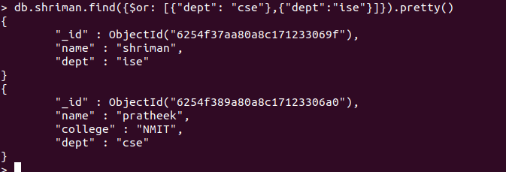

> db.sourav.find({$and:[{dept:"cse"},{name:"pratheek"}]}).pretty()

