1NT19IS159
SOURAV

BIG DATA LAB : 5/4/22

- mongo –version
MongoDB shell version v5.0.1

- mongo

- create the database
> use sourav

- to check the current data base
> db

- insert One

db.ssourav.insertOne({name:"sourav",dept:"ise"})
{
"acknowledged" : true,
"insertedId" : ObjectId("624bb7d41cc3a584762a14c7")
}

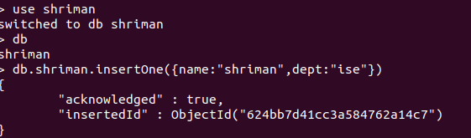

- insert Many

db.shriman.insertMany([{name:"pratheek",dept:"ise"},{name:"rajesh",dept:"cse"}])
{
"acknowledged" : true,
"insertedIds" : [
ObjectId("624bbc7a6d6917c280bfac7e"),
ObjectId("624bbc7a6d6917c280bfac7f")
]
}

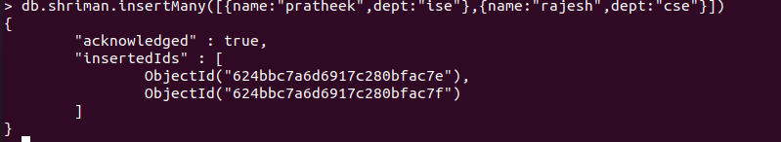

- db.sourav.find()
{ "_id" : ObjectId("624bb7d41cc3a584762a14c7"), "name" : "shriman", "dept" : "ise" }
{ "_id" : ObjectId("624bbc7a6d6917c280bfac7e"), "name" : "pratheek", "dept" : "ise" }
{ "_id" : ObjectId("624bbc7a6d6917c280bfac7f"), "name" : "rajesh", "dept" : "cse" }

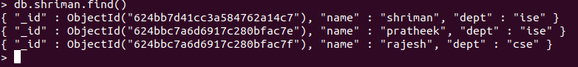

- db.sourav.find().pretty()

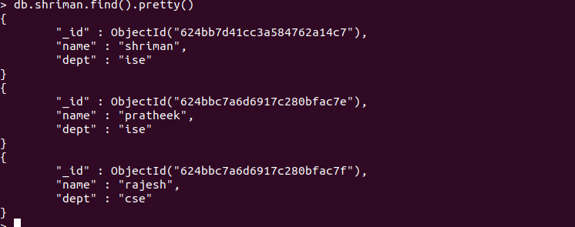

- db.sourav.updateMany({},{$set : {college:"NMIT"}})
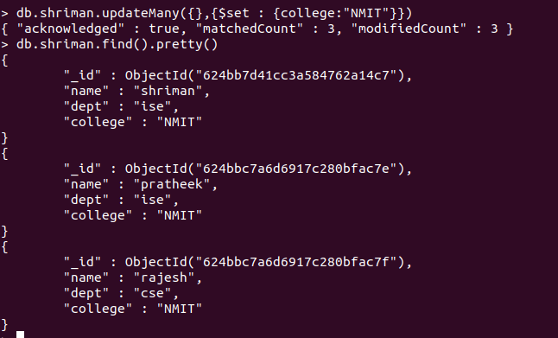

- > db.sourav.updateOne({name:"shriman"},{$set : {dept:"cse"}})

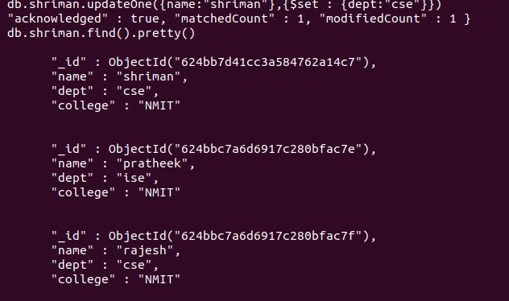

- delete One
> db.shriman.deleteOne({name:"rajesh"})

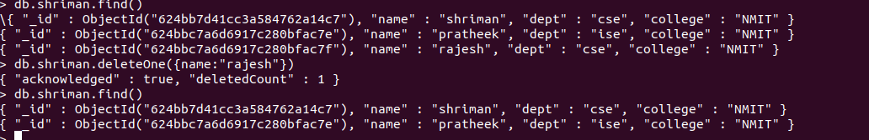

- > db.sourav.updateOne({name:"shriman"},{$unset : {dept:""}})
