SOURAV
1NT19IS159

EXERCISE 3:

Word Count Program:
package wcsample;

import java.io.IOException;
import java.util.Iterator;
import java.util.StringTokenizer;

import org.apache.hadoop.fs.Path;
import org.apache.hadoop.io.IntWritable;
import org.apache.hadoop.io.LongWritable;
import org.apache.hadoop.io.Text;
import org.apache.hadoop.mapred.FileInputFormat;
import org.apache.hadoop.mapred.FileOutputFormat;
import org.apache.hadoop.mapred.JobClient;
import org.apache.hadoop.mapred.JobConf;
import org.apache.hadoop.mapred.MapReduceBase;
import org.apache.hadoop.mapred.Mapper;
import org.apache.hadoop.mapred.OutputCollector;
import org.apache.hadoop.mapred.Reducer;
import org.apache.hadoop.mapred.Reporter;
import org.apache.hadoop.mapred.TextInputFormat;
import org.apache.hadoop.mapred.TextOutputFormat;

public class wordcount {
public static class Map extends MapReduceBase implements Mapper<LongWritable, Text, Text, IntWritable> {

private final static IntWritable one = new IntWritable(1);
private Text word = new Text();
@Override
public void map(LongWritable key, Text value, OutputCollector<Text, IntWritable> output, Reporter arg3)
throws IOException {

String line = value.toString();
StringTokenizer tokenizer = new StringTokenizer(line);

while (tokenizer.hasMoreTokens()) {
word.set(tokenizer.nextToken());
output.collect(word, one);
}
}
}

public static class Reduce extends MapReduceBase implements Reducer<Text, IntWritable, Text, IntWritable> {

@Override
public void reduce(Text key, Iterator<IntWritable> value, OutputCollector<Text, IntWritable> output,
Reporter arg3) throws IOException {
// TODO Auto-generated method stub
int sum = 0;
while (value.hasNext()) {
sum += value.next().get();
}
output.collect(key, new IntWritable(sum));

}

}

public static void main(String[] args) throws IOException {
// TODO Auto-generated method stub
JobConf conf = new JobConf(wordcount.class);
conf.setJobName("wordcount");

conf.setOutputKeyClass(Text.class);
conf.setOutputValueClass(IntWritable.class);

//Providing the mapper and reducer class names
conf.setMapperClass(Map.class);
conf.setCombinerClass(Reduce.class); //set theCombiner class
conf.setReducerClass(Reduce.class);

conf.setInputFormat(TextInputFormat.class);

conf.setOutputFormat(TextOutputFormat.class);

FileInputFormat.setInputPaths(conf, new Path(args[0]));
FileOutputFormat.setOutputPath(conf, new Path(args[1]));

JobClient.runJob(conf);

}

}

OUTPUT:
hdoop@admin1-HP-280-G4-MT-Business-PC:~$ cd $HADOOP_HOME
hdoop@admin1-HP-280-G4-MT-Business-PC:~/hadoop-3.2.1$ cd sbin
hdoop@admin1-HP-280-G4-MT-Business-PC:~/hadoop-3.2.1/sbin$ jps
11174 Jps
10646 NodeManager
10311 ResourceManager
9688 NameNode
9867 DataNode
10123 SecondaryNameNode
9342 org.eclipse.equinox.launcher_1.5.600.v20191014-2022.jar
hdoop@admin1-HP-280-G4-MT-Business-PC:~/hadoop-3.2.1/sbin$ start-all.sh
WARNING: Attempting to start all Apache Hadoop daemons as hdoop in 10 seconds.
WARNING: This is not a recommended production deployment configuration.
WARNING: Use CTRL-C to abort.
Starting namenodes on [localhost]
localhost: namenode is running as process 9688. Stop it first.
Starting datanodes
localhost: datanode is running as process 9867. Stop it first.
Starting secondary namenodes [admin1-HP-280-G4-MT-Business-PC]
admin1-HP-280-G4-MT-Business-PC: secondarynamenode is running as process 10123. Stop it first.
Starting resourcemanager
resourcemanager is running as process 10311. Stop it first.
Starting nodemanagers
localhost: nodemanager is running as process 10646. Stop it first.
hdoop@admin1-HP-280-G4-MT-Business-PC:~/hadoop-3.2.1/sbin$ hdfs dfs -mkdir -p ~/input
hdoop@admin1-HP-280-G4-MT-Business-PC:~/hadoop-3.2.1/sbin$ hdfs dfs -appendToFile - ~/input/text.txt
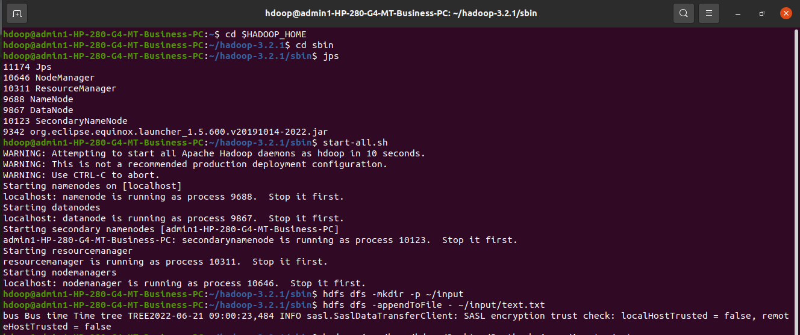
bus Bus time Time tree TREE2022-06-21 09:00:23,484 INFO sasl.SaslDataTransferClient: SASL encryption trust check: localHostTrusted = false, remoteHostTrusted = false

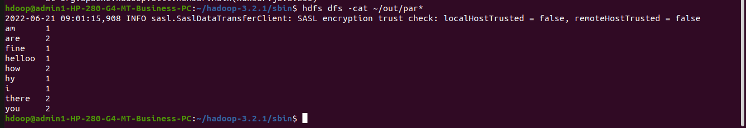
hdoop@admin1-HP-280-G4-MT-Business-PC:~/hadoop-3.2.1/sbin$ hdfs dfs -cat ~/out/par*

