E-Voting System Using Ethereum Blockchain

Abstract: In this project we are implementing Blockchain based E-Voting system which works as a decentralized server where multiple nodes will maintain user’s voting details and if one node crashed or down then users can get voting details from other working nodes. In existing centralized server voting details were managing in single server and if this server hacked or down then all voting details will be unavailable and this server can be attacked or hacked and can alter vote counting data. Blockchain storage support immutable data storage which means data cannot be alter or hacked as each node in the Blockchain will verify each Block storage with the help of hashcodes and if verification failed then Blockchain or users will get notification of data changed.

Algorithms: Ethereum is the public Blockchain software and include multiple algorithms such POW (proof of work), Hashcode verification, proof of stake (POS), ripple protocol consensus algorithm (RPCA), delegated proof of stake (dPOS), stellar consensus protocol (SCP), and proof of importance (POI).

In propose E-Voting system we are managing all voter details in Ethereum Blockchain tool as its supports immutable data storage and to implement this project we have designed following modules

1. Admin Login; using this module admin can login to system by using username as ‘admin’ and password as ‘admin’
2. View Count: after login admin can use this module to get count of vote for each candidate by entering his candidate ID
3. Cast Your Vote: using this module user will get list of candidates and then choose desired candidates to cast his vote:
4. Voter details: using this module user has to enter his name and AADHAR number. All details will be save inside Ethereum Blockchain
5. Ganache Tool: using this tool we can see each transaction details whenever any voting transaction done by user which means whenever user cast vote then its transaction hashcode we can see in GANACHE

We don’t know about ETHERSCAN so we are using GANACHE tool to monitor transactions

We are using below solidity program to manager voter and party details

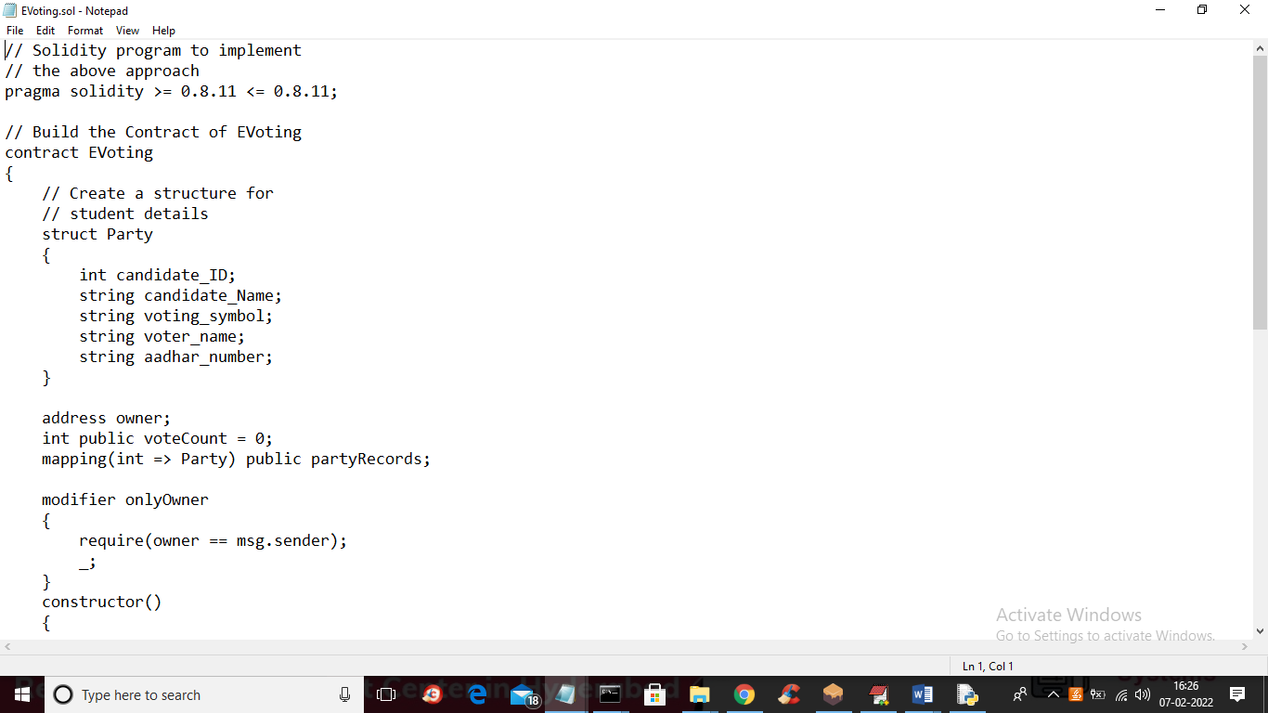

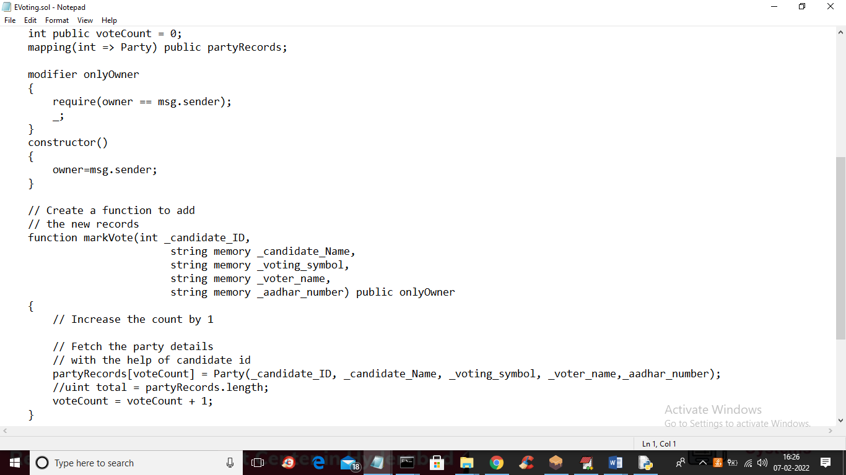

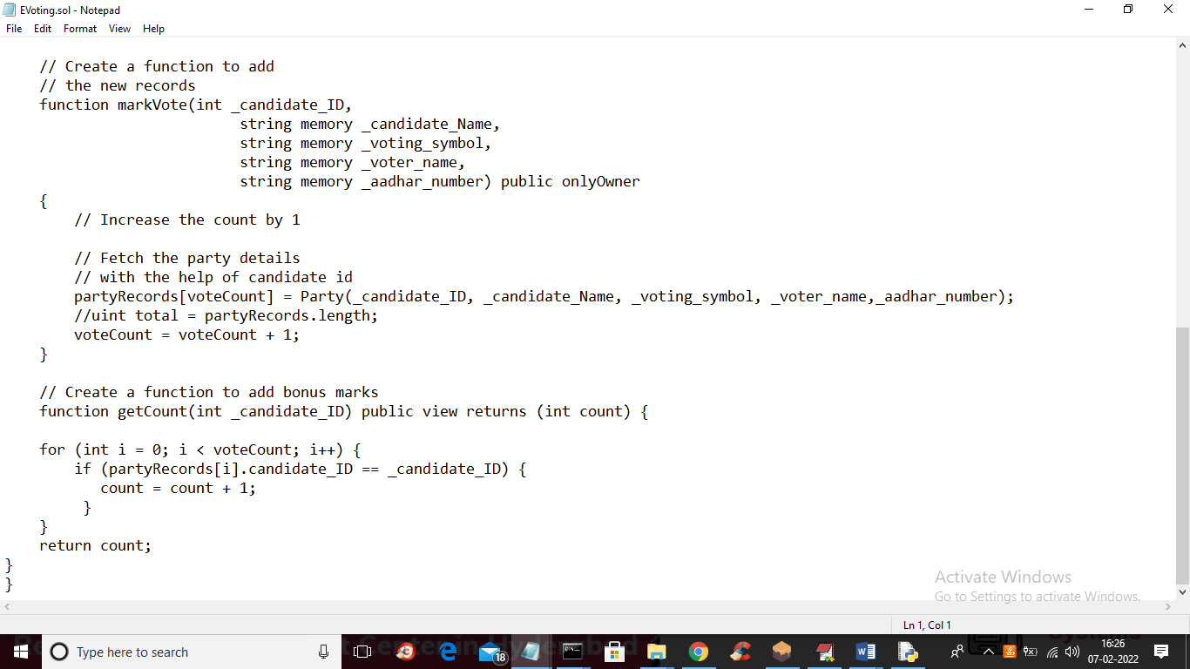

In above 3 screens you can see we have wrote solidity code to add party details and mark vote function and getCount function to get count of votes for the party and you can read comments to know about code and we can deploy this contract using TRUFFLE Ethereum tool and you can use below instructions to deploy it

Now we need to deploy above code to store and access EVOTING data into Ethereum Tool and to deploy go inside ‘hello-eth\node_modules\.bin’ folder and in this folder double click on ‘runBlockchain.bat’ file to get below screen

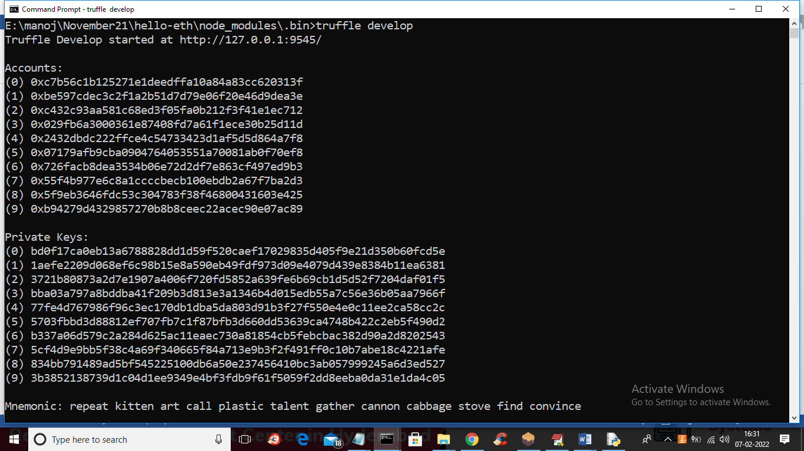

In above screen we can see some accounts and private keys are generated and now press enter key in above black console to deploy solidity to Ethereum and to get below screen

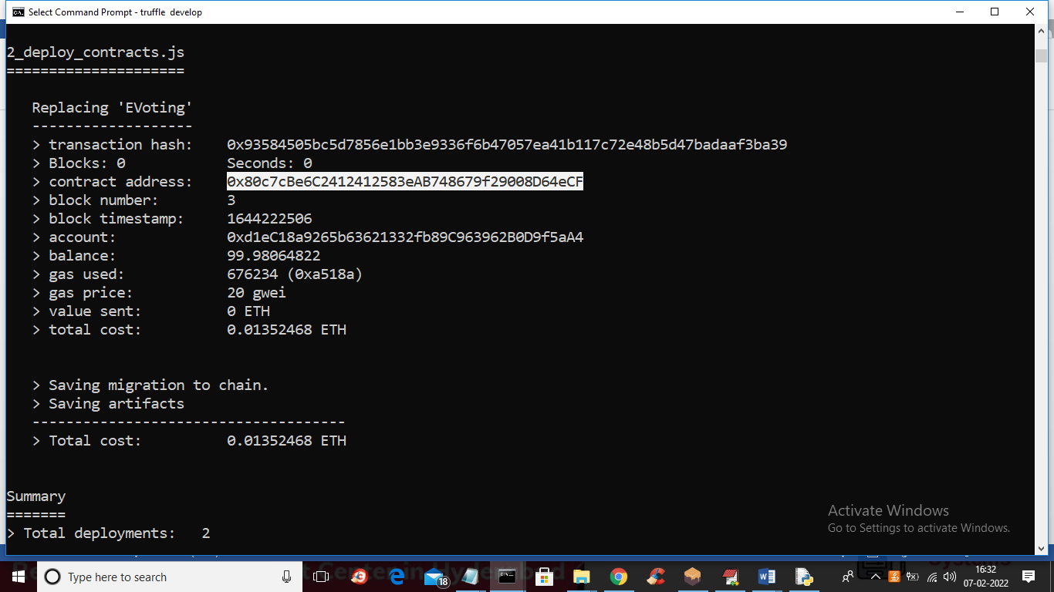

In above screen EVoting contract is deployed and in white colour text we can see the contract address and same address we can see in GANACHE tool like below screen

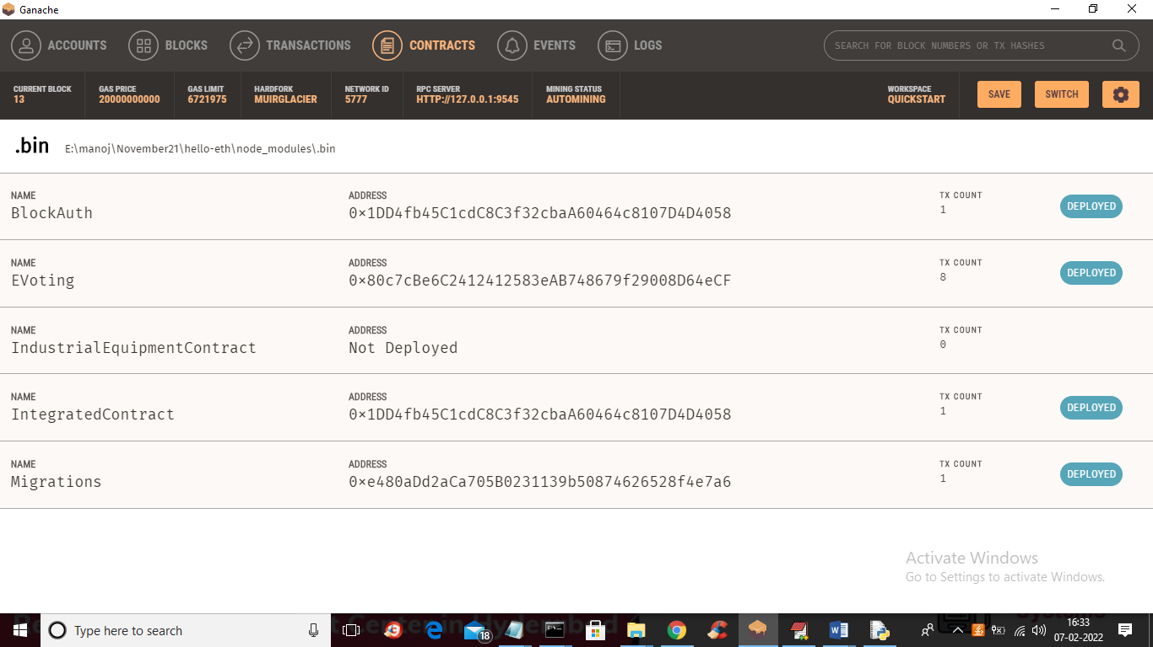

In above GANACHE screen we can see EVoting solidity contract deployed and now click on Blocks on above screen to see available blocks

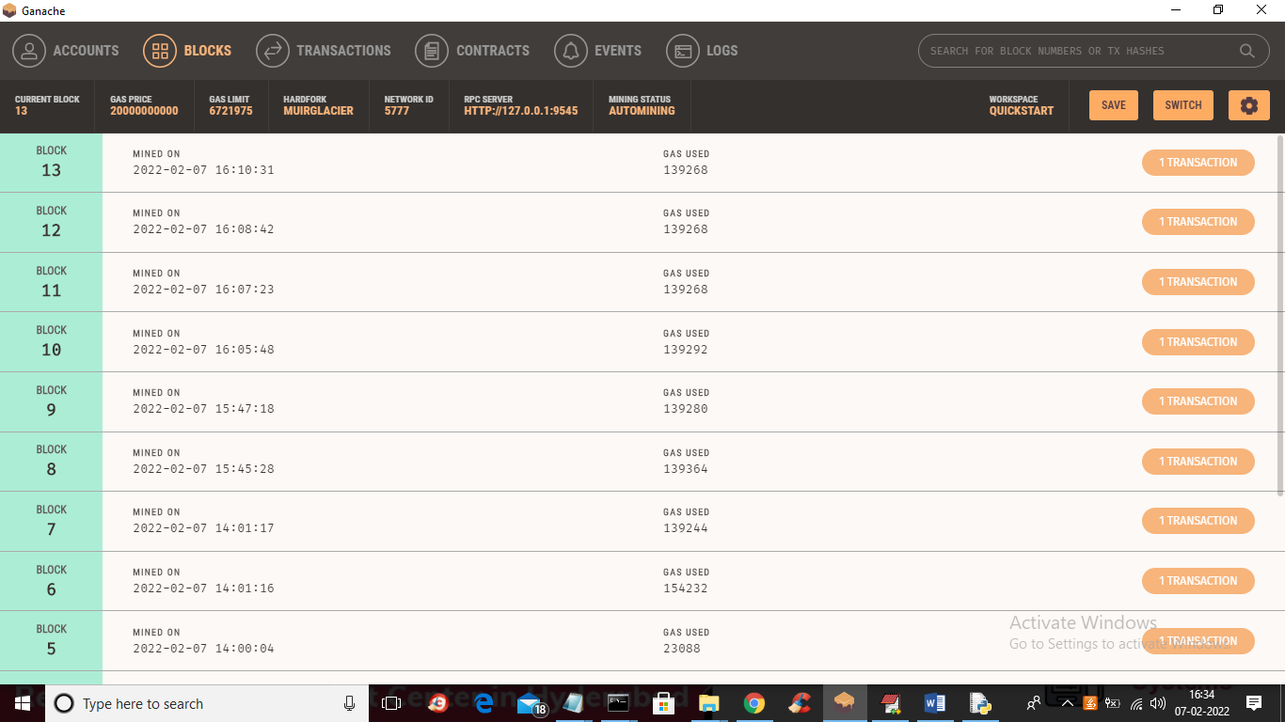

In above screen we can see total 13 blocks create and if I cast vote then new block will be created and we can see 14th block.

SCREEN SHOTS

To run project double click on ‘run.bat’ file to start python WEB DJANGO server and to get below screen

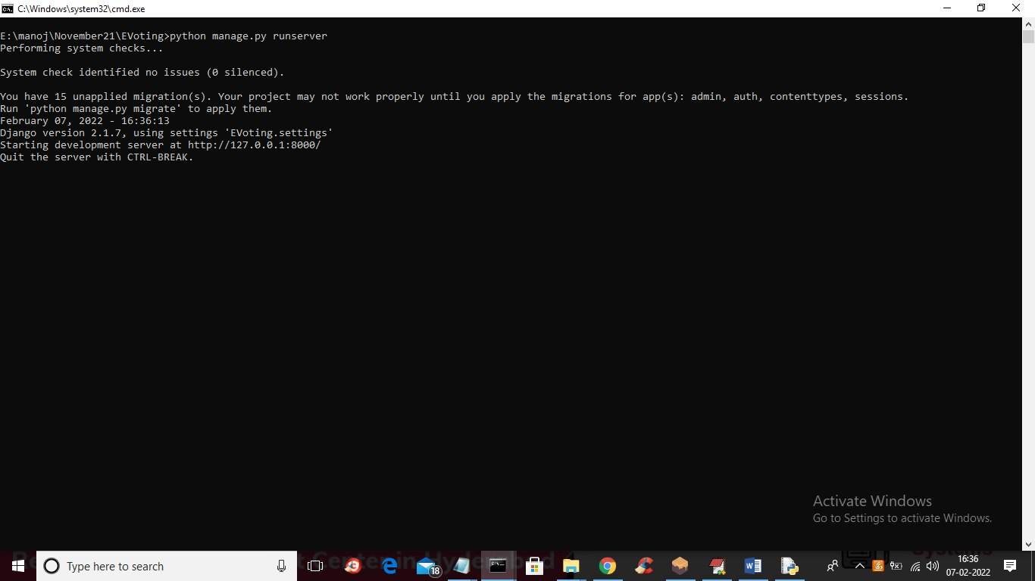

In above screen DJANGO server started and now open browser and enter URL as <http://127.0.0.1:8000/index.html> and press enter key to get below page

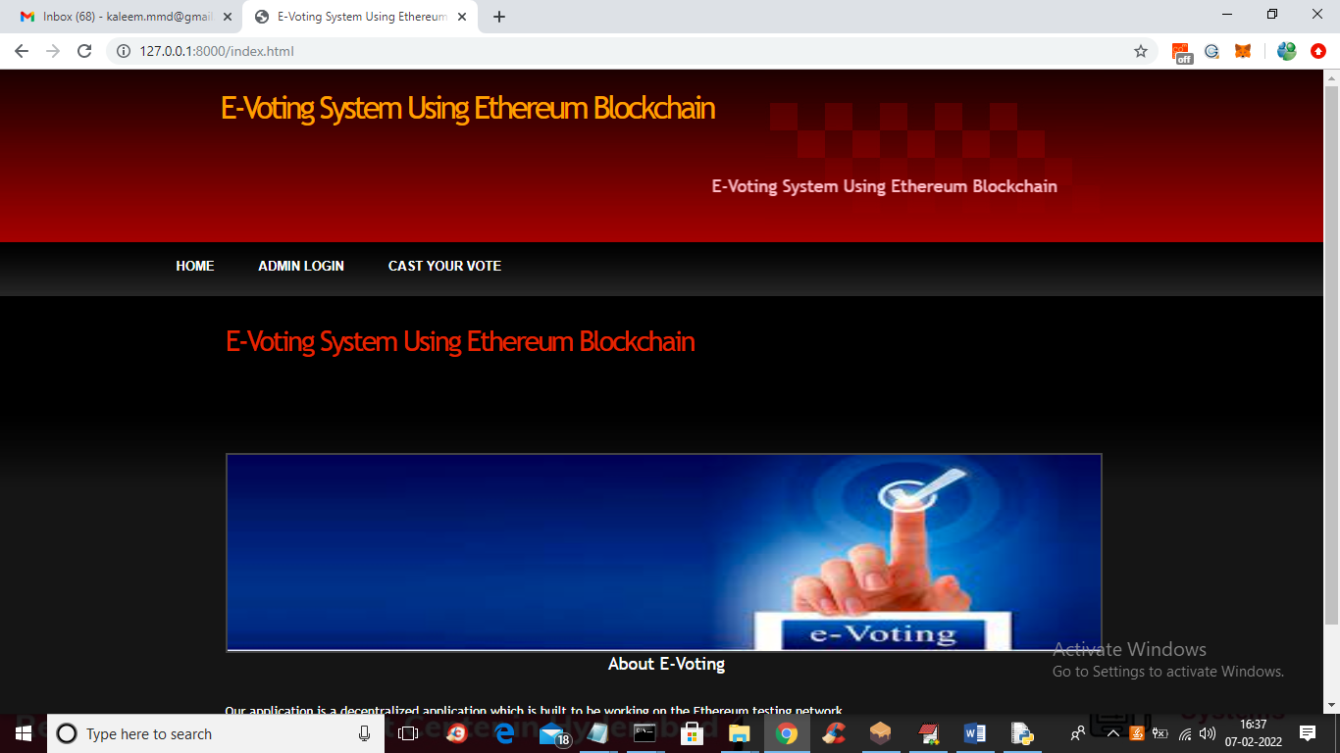

In above screen click on ‘Cast Your Vote’ link to get below screen

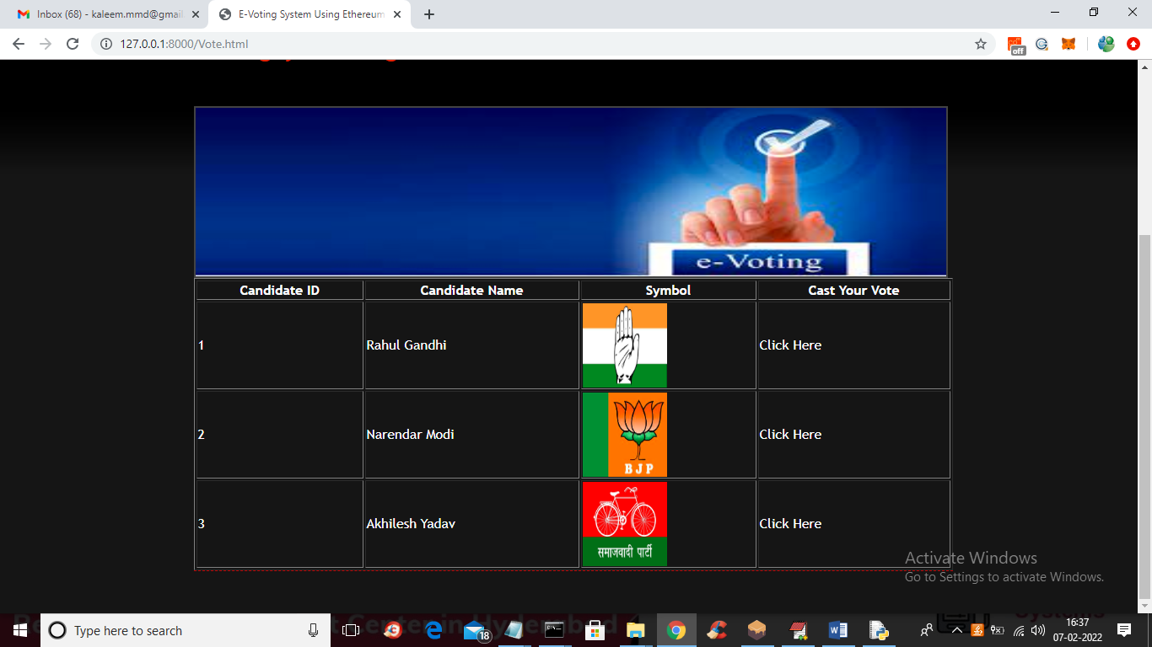

In above screen user can view list of available parties and I added 3 party details and now user can click on ‘Click Here’ link on any candidate row to cast his vote and to get below SCREEN and in above screen I am clicking on ‘Rahul Gandhi’ row to get below screen

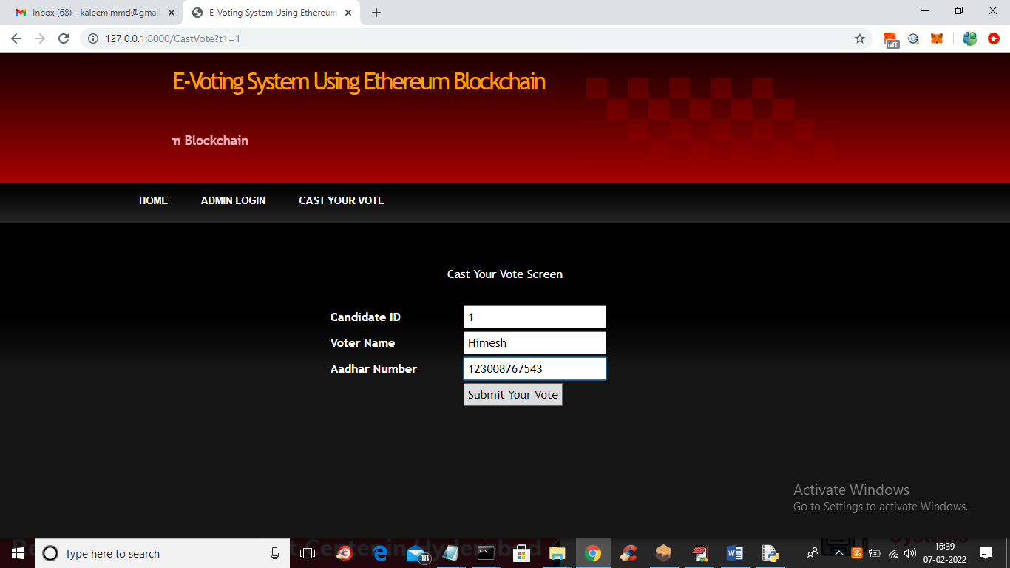

In above screen user has to enter his name and his AADHAR number and press submit button to get below output

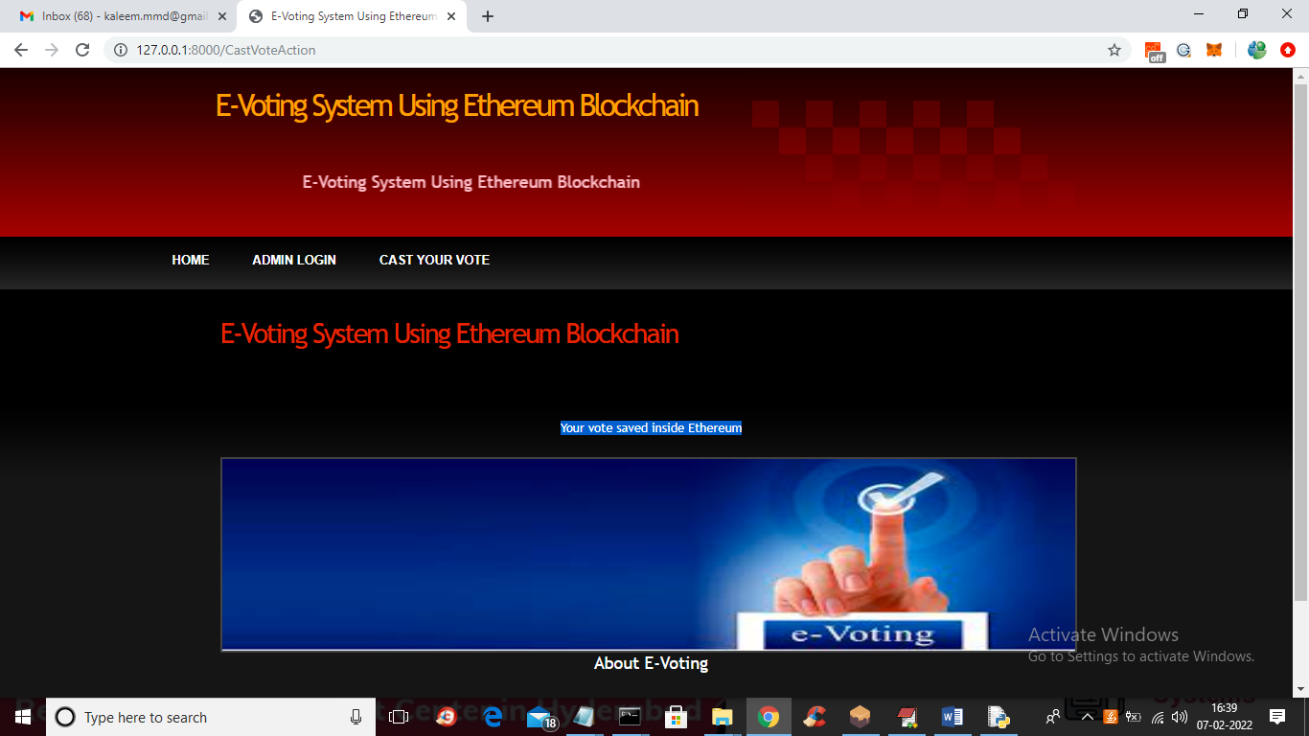

In above screen in blue colour text we can see user vote details saved in Blockchain ETHERUM and we can see this transaction details in below GANACHE screen

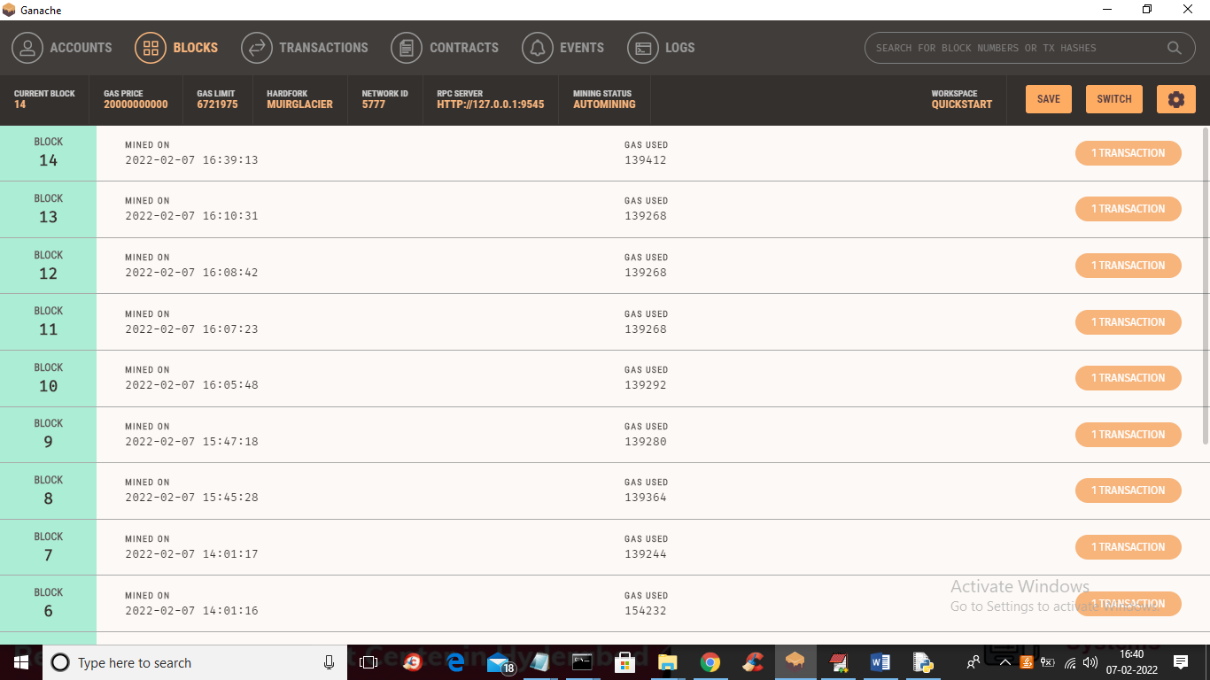

In above screen we can see after casting vote new Block or transaction created with block number 14 and in previous screen you saw only 13 blocks were available and after casting voted new 14th block created and now in application screen click on ‘Admin Login’ link to get below screen

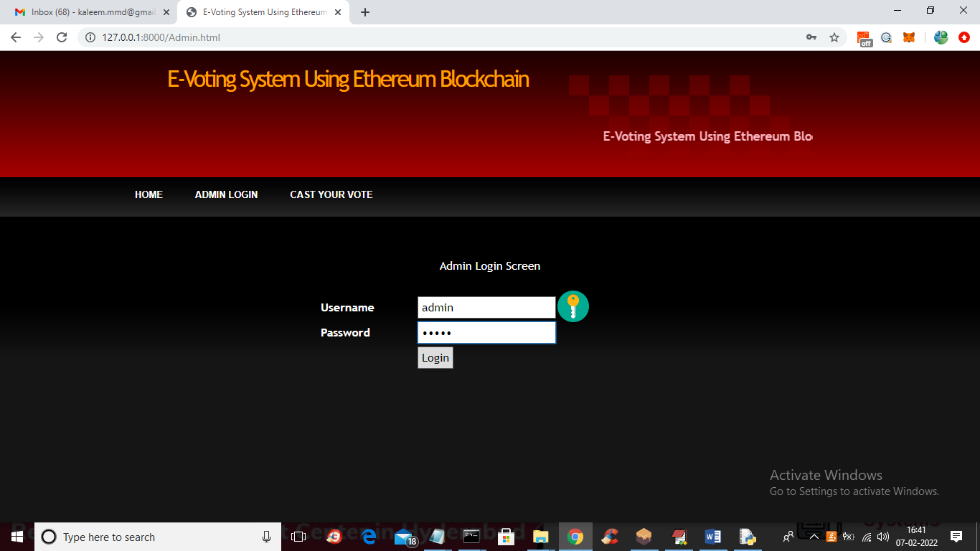

In above screen admin is login and press button to get below screen

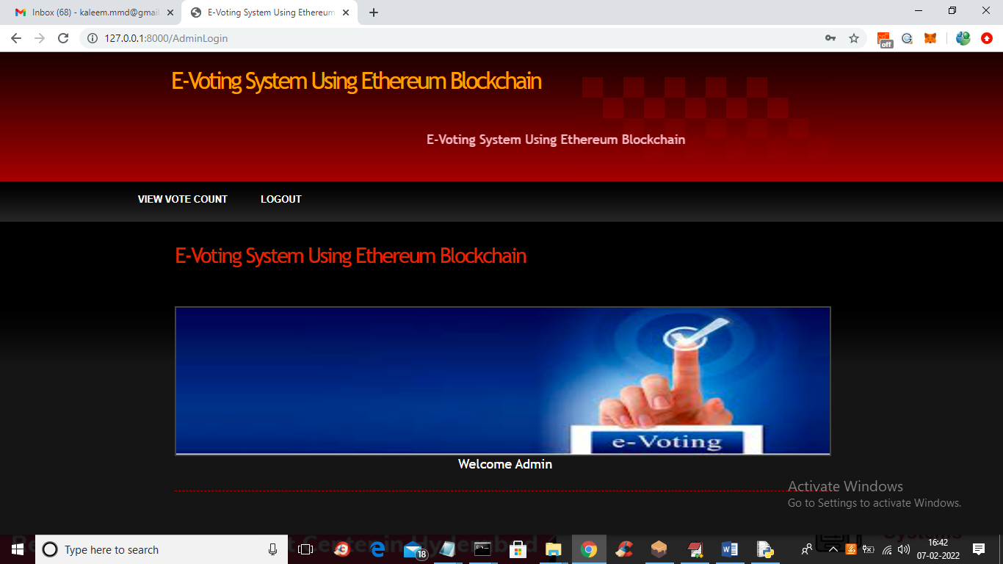

In above screen admin can click on ‘View Vote Count’ link to get below screen

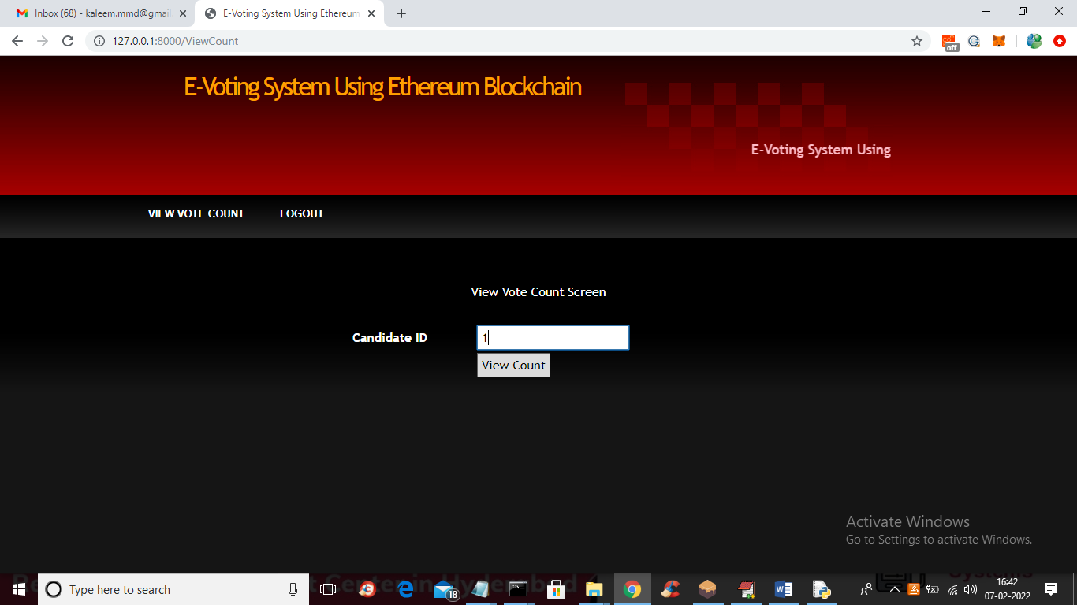

In above screen enter candidate id and then press button to get below output

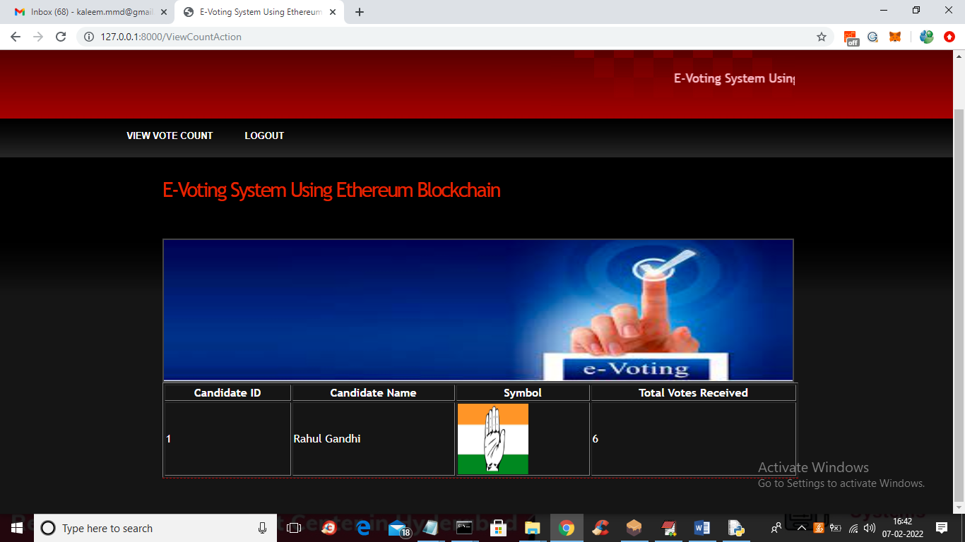

In above screen candidate id 1 got 6 votes and similarly you can enter other ID’s and get their count details

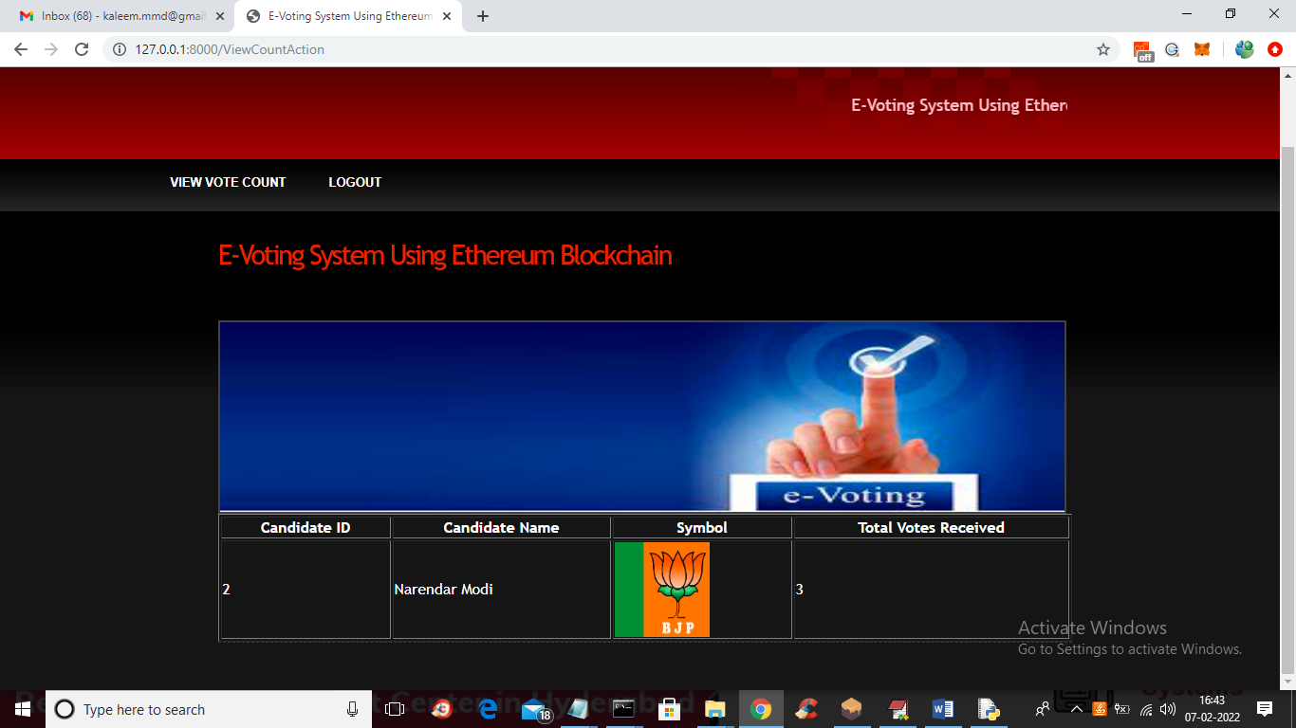

In above screen you can view count for other party and similarly any number of users can participate in voting and all details will saved inside Ethereum tool